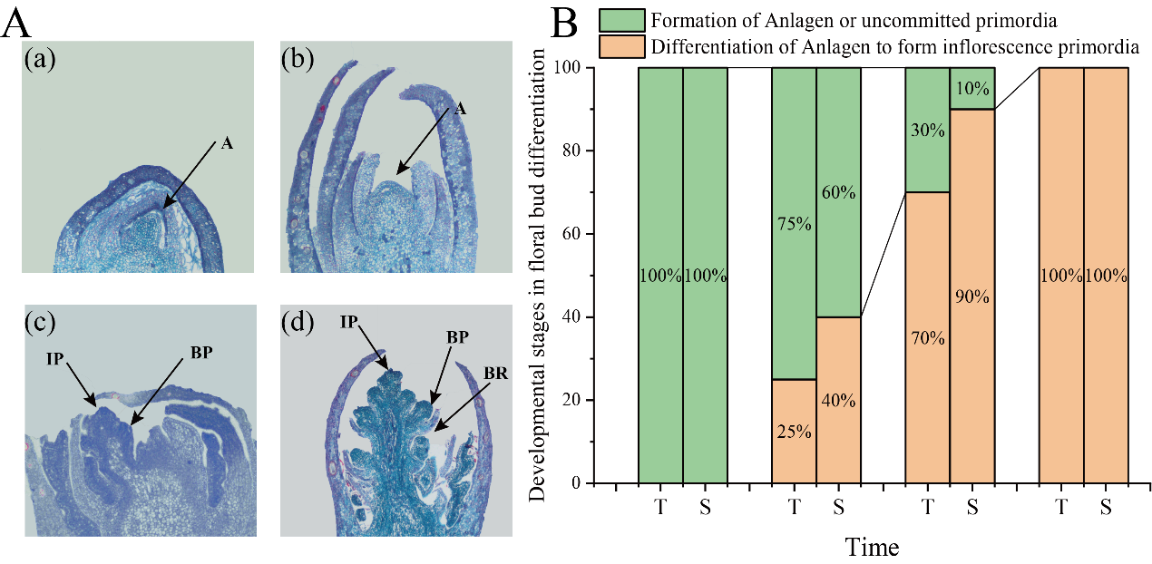
Figure S1. Development stages in flower bud differention. (A) Paraffin sections of flower buds, (a) and（b）are satge of formationof anlagen or uncommited primordia, (c) and (d) are satge of Differentiation of anlagen to form inflorescence primordia. (B) Stacked chart of development stages in floral bud differention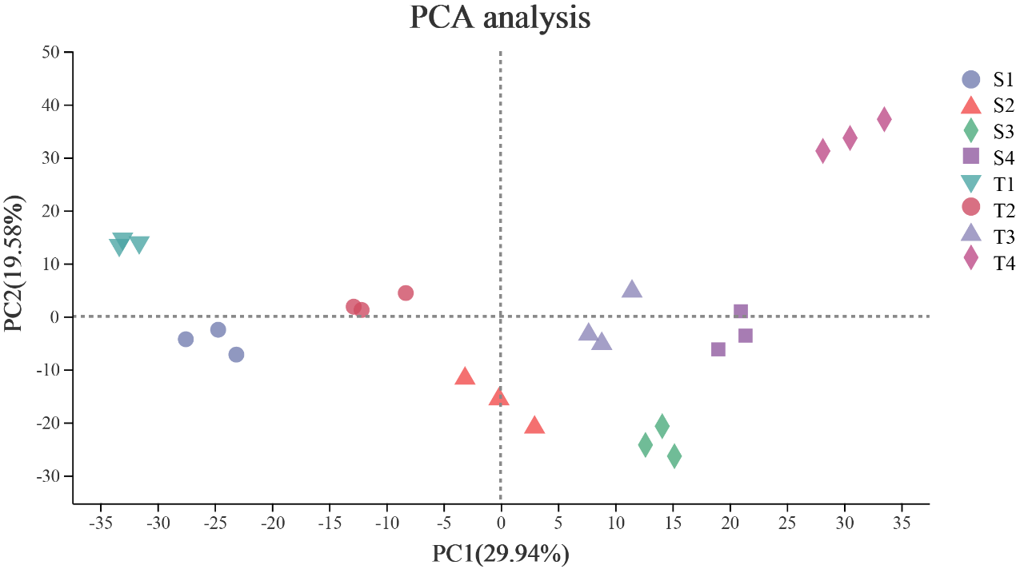

Figure S2. Principal component analysis of the different sample based on the gene expression profiles.
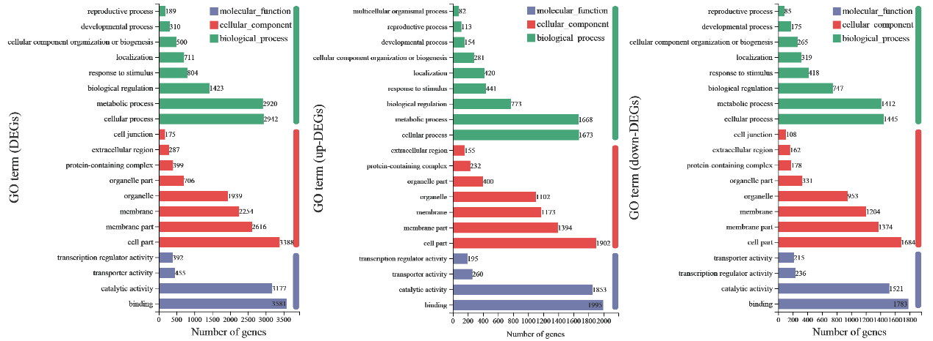
Figure S3. GO classification of DEGs. From left to right are total DEGs, up-regulated DEGs, down-regulated DEGs.

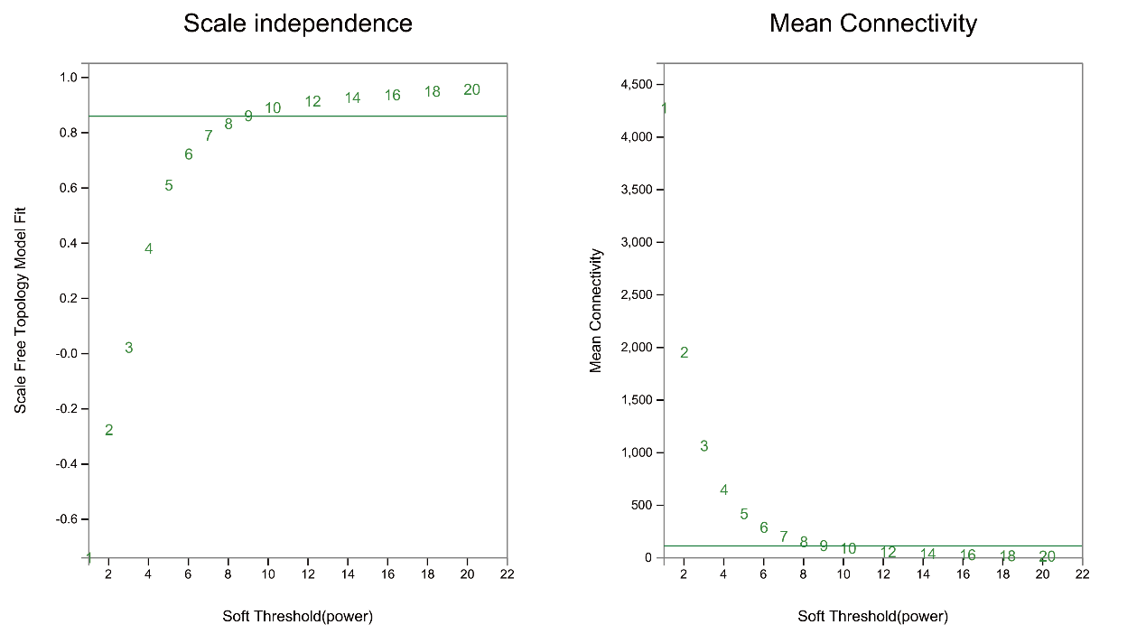
Figure S4. Scale independence and mean connectivity by calculating 25844 genes. Correlation relation was set 0.8 and β was 9.

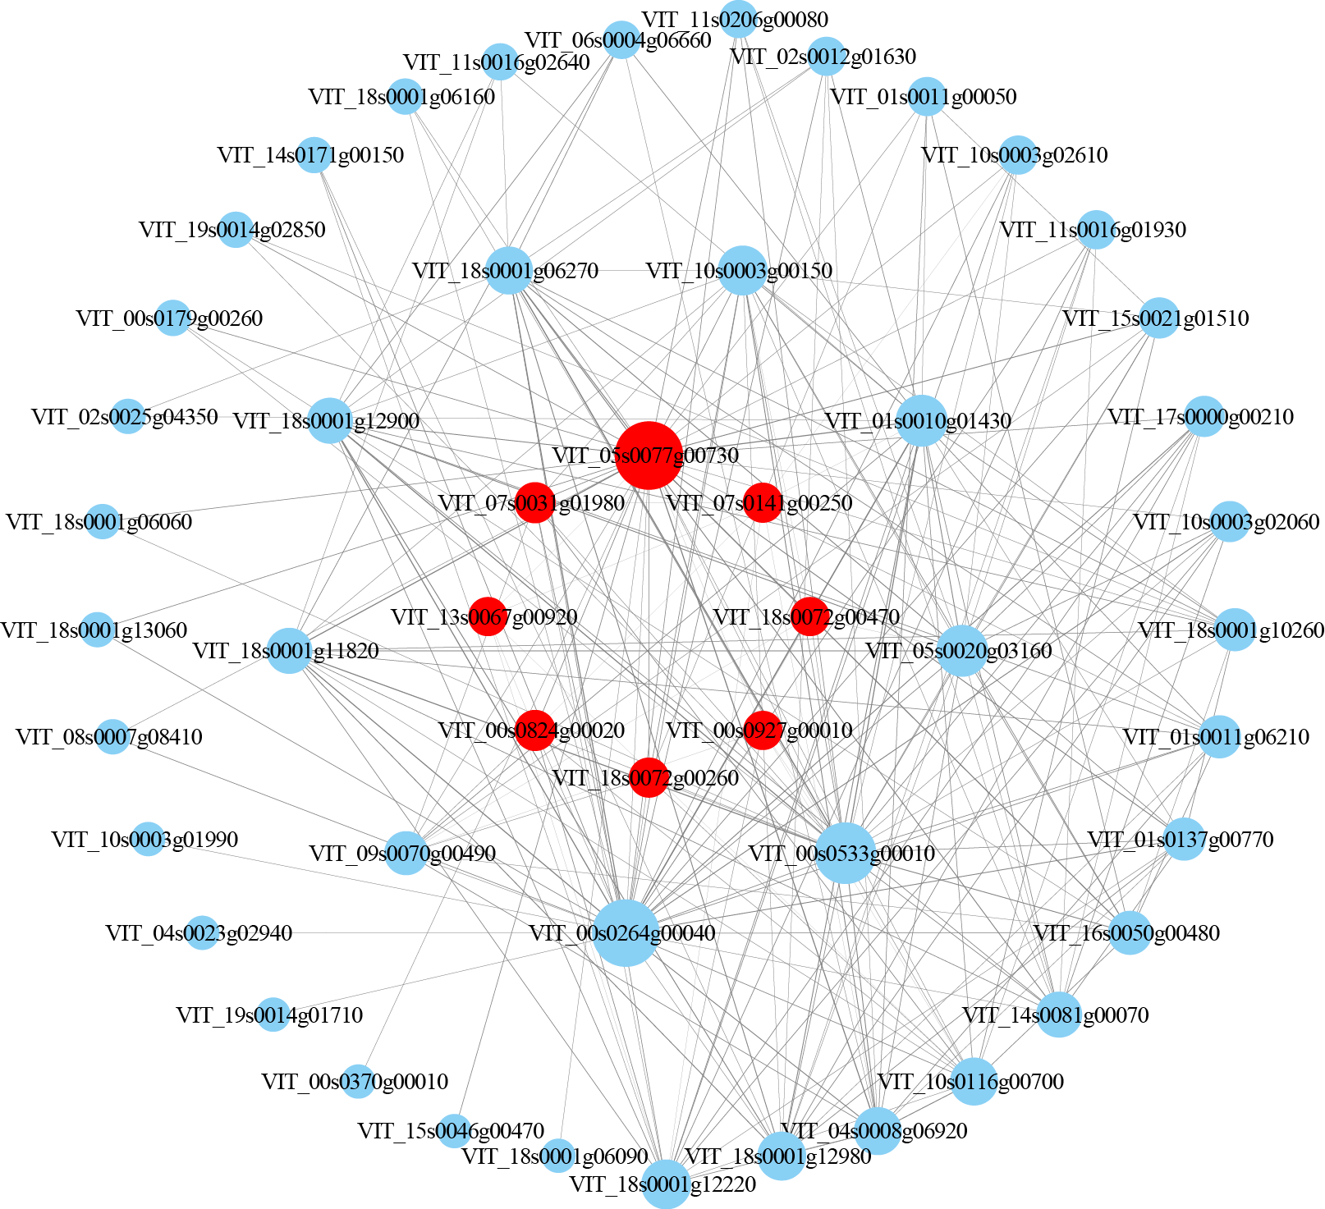
Figure S5. Co-expression network analysis of flower bud differentiation stage-specific modules.

