Supplementary information

A novel technique for large-fragment knock-in animal production without ex vivo handling of zygotes

Manabu Abe^{1*,#}, Ena Nakatsukasa^{1, #†}, Rie Natsume^{1, #}, Shun Hamada², Kenji Sakimura¹, Ayako M. Watabe³, and Toshihisa Ohtsuka²

¹Department of Animal Model Development, Brain Research Institute, Niigata University, Niigata 951-8585, Japan
²Department of Biochemistry, Faculty of Medicine, University of Yamanashi, Yamanashi 409-3898, Japan
³Institute of Clinical Medicine and Research, Research Center for Medical Sciences, The Jikei University School of Medicine, Chiba, Japan
#These authors contributed equally to this work.
†Deceased

*Corresponding author
Manabu Abe
Department of Animal Model Development
Brain Research Institute
Niigata University
1-757 Asahimachidori
Chuo-ku Niigata 951-8585, Japan
Phone: +81-25-227-0621
Fax: +81-25-227-0816
E-mail: manabu@bri.niigata-u.ac.jp

Supplementary figures

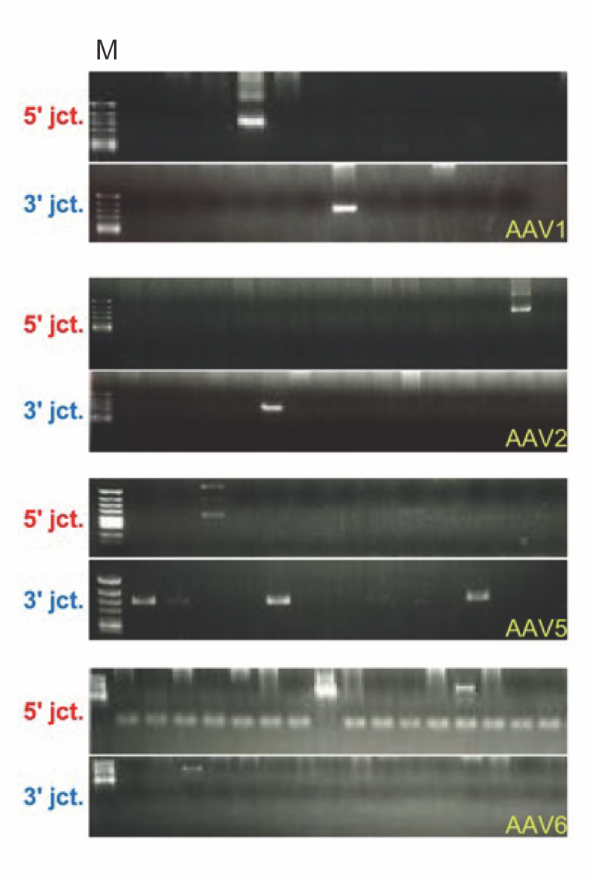
Figure S1

Supplementary Fig. S1. Genomic PCR of embryos transduced with each serotype of AAV vectors
PCR products from knock-in embryos were substantially detected in all serotypes, including serotype 2 and serotype 5, which have low infectivity described below. M, φX174-HincII digested. 5′ expected band size: 0.6 kb, 3′ expected band size: 0.6 kb.
Figure S2

Supplementary Fig. S2. The ability of AAV serotypes to infect mouse embryos and failure of physiologic infection by electroporation of AAV
a. We verified infectivity by exposing embryos to higher concentrations (3.0 × 10¹⁰ vg/mL) of fluorescent protein-expressing AAV for 48–72 hours, although AAV concentrations of approximately 0.1–1.0 × 10⁸ vg/mL were tested in previous reports. The results showed that serotype 1 and serotype 6 were infectious, as previously reported, but that serotype 2 and serotype 5 were less infectious even at high concentrations.
b. AAV serotype 1 and serotype 6, which should be infectious by exposure to embryos, did not express fluorescent protein when the virus solution was washed off immediately after electroporation, indicating that physiological infection had not occurred under this condition. Likewise, serotype 2 and serotype 5 were not infectious either.

Figure S3

Supplementary Fig. S3. mCherry-ELKS knock-in mice
a. Validation of novel anti-ELKS monoclonal antibody. The specificity of anti-ELKS monoclonal antibodies was confirmed by western blot using ELKS conditional KO (cKO) mouse brains. Western blot of WT and cKO cerebellar homogenates was performed with the ELKS monoclonal antibody. The band intensity at about 120 kDa disappeared in the cKO.
b. The cerebellar homogenates from wild type (WT) and mCherry-ELKS hetero knock-in mouse (HT) were analyzed by western blot using the indicated antibodies. Both anti-ELKS and anti-RFP antibodies detected mCherry-ELKS fusion protein. The fusion protein expression appears comparable to that of endogenous ELKS protein.
c. Immunohistochemistry using the RFP and NeuN antibodies revealed the expression of the fusion protein in the stratum lucidum (Lu) of the hippocampal CA3 region and the molecular layer (ML) of the cerebellum (Cb), as previously described. GL, granular layer; Py, pyramidal cell layer; Ra, stratum radiatum; Scale bars, 100 μm.

Supplementary tables

Supplementary Table S1. crRNA target sequences for each gene
Species | locus |  | Sequence (5′ to 3′) |  | MIT score
Mouse | Rosa26 |  | CGCCCATCTTCTAGAAAGAC |  | 75
Mouse  Mouse  Rat  Rat  Rat | Erc1  Erc2  Rosa26  Thy1 (left)  Thy1 (right) |  | CACTTCCATACATGGTTGCA  ATCACAGAAGAAAAATGTAC  GAGTCTTTCTGGAAGATAGG  GGAGAGTGATGCTGATGACT  TCACAGAGAAATGAAGTCCG |  | 76  47  64  65  60

Supplementary Table S2. Sequences of primers for genotyping
Species | Gene | Primer | Sequence (5′ to 3′)
Mouse  Mouse  Mouse  Rat  Rat | Rosa26  (5′ junction)  Rosa26  (3′ junction)  Erc1  (Knock-in)  Erc1  (5′ junction)  Erc1  (3′ junction)  Erc2  (Knock-in)  Rosa26  (5′ junction)  Rosa26  (3′ junction)  Thy1  (Knock-in) | Forward  Reverse  Sequencing  Forward  Reverse  Sequencing  Forward  Reverse  Forward  Reverse  Sequencing  Forward  Reverse  Sequencing  Forward  Reverse  Forward  Reverse  Sequencing  Forward  Reverse  Sequencing  Forward  Reverse | CTTGCCATTGGCTCGTGTTC  TCCATATATGGGCTATGAAC  AGAAAGGTATTGCAACACTC  CCTCTTCTCTTATGGAGATC  GACTTCTAAGATCAGGAAAG  TAGTCATCTGGGGTTTTATG  GACTCTTCCCCAGATAAAGG  TTGTTCGCCGATGACCTAAG  CGACACATCAGCTTGGTTTG  TTCACGTAGGCCTTGGAGCCGTAC  AAACCTCTCCTTGATATCAG  GACTCTTCCCCAGATAAAGG  GAAGCAGAAGCGTTCCAGAC  CCTTTAATCCTAGCACTCAG  AAGATGCAATGCAATCATAG  CATTAAGGGACTGGATATTC  GCTCTCGGGGCTCAGAAAAC  CCAGCTTACTTACCATGTCAGATC  TGTAACCATTATTCATTCAGGCGC  AGAAAAGCCTTGACTTGAGG  GCTACAGCCTCGATTTGTGG  CCTCTTCTCTTATGGAGATC  TGTAGACCAGGCTGGGCTAG  GGGCCCAACCAGTCACAGAG

GEL BLOT IMAGES

Supplementary Fig. S4: This is full gel image of given figure, with figure number Figure 1c. We used λ-StyI (Lower) and φX174-HincII (Upper) as Digested DNA Markers for 0.8% and 2.0% agarose gels, respectively. The λ-StyI yields the following 11 discrete DNA fragments: 19329, 7743, 6223, 4254, 3472, 2690, 1882, 1489, 925, 421, and 74 bp. The φX174-HincII yields the following 13 DNA fragments: 1057, 770, 612, 495, 392, 345, 341, 335, 297, 291, 210, 162, and 79 bp.

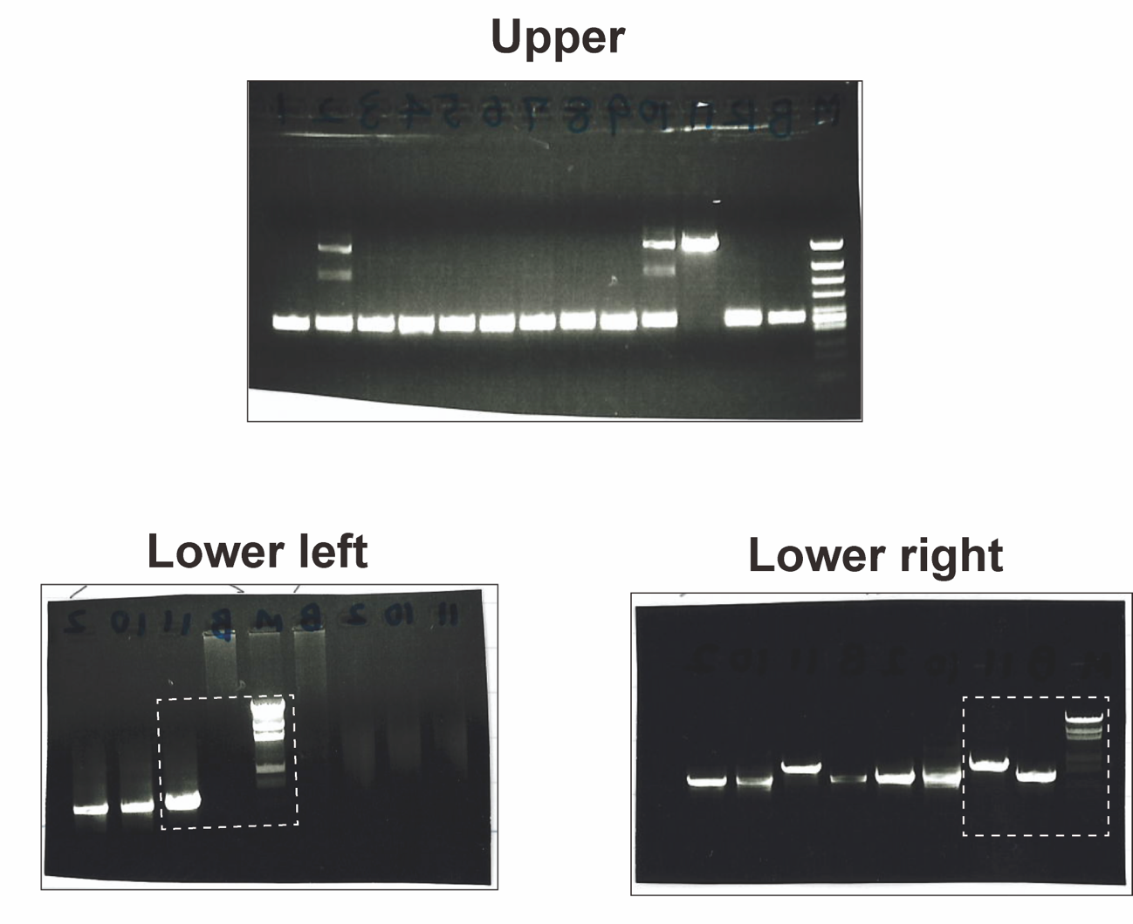
Supplementary Fig. S5: This is full gel image of given figure, with figure number Figure 2d. Since the photographs were cropped after the image was taken, we do not have a full-length image where the edges of the gel can be visible.

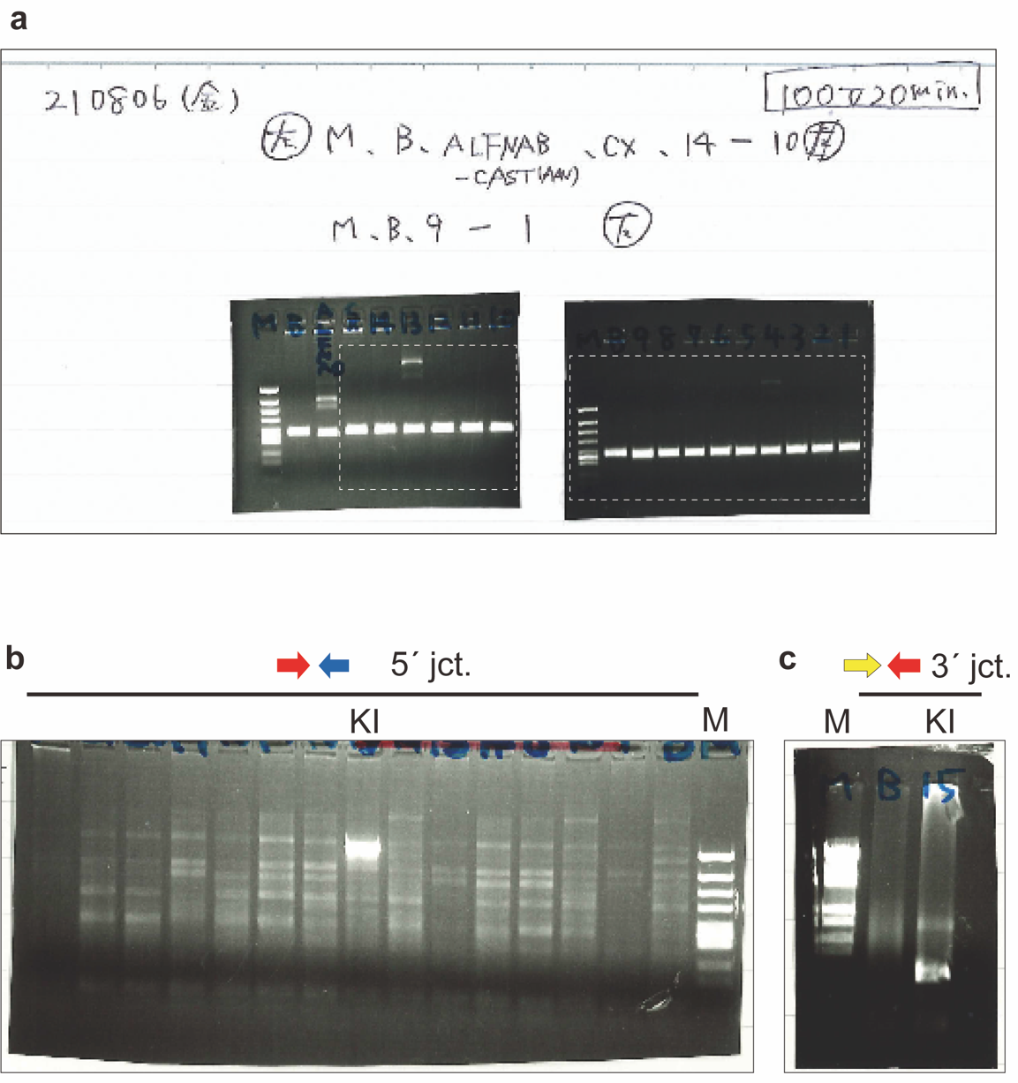

Supplementary Fig. S6
a. This is full gel image of given figure, with figure number Figure 2e.
b. Confirmation of insertions by genomic PCR for Erc2 locus. 5′ expected band size: 1.1 kb. M, φX174-HincII digested DNA marker.
c. Confirmation of insertions by genomic PCR. 3′ expected band size: 1.5 kb. M, λ-StyI digested DNA marker.

Supplementary Fig. S7: This is full gel image of given figure, with figure number Figure 3d.

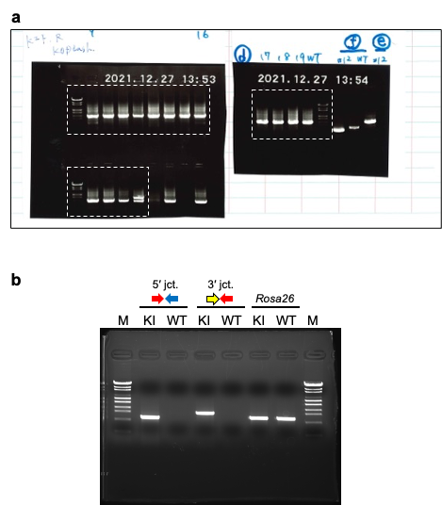

Supplementary Fig. S8
a. This is full gel image of given figure, with figure number Figure 3e.
b. Confirmation of insertions by genomic PCR for Thy1 locus. KI, Thy1 knock-in rats; WT, wild-type rats. 5′ expected band size: 1.1 kb; 3′ expected band size: 1.5 kb; Rosa26 expected band size: 1.1 kb. M, λ-StyI digested DNA marker.

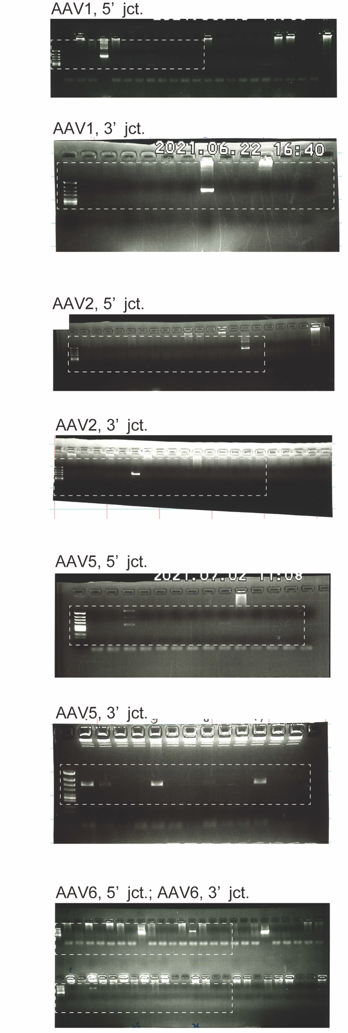
Supplementary Fig. S9: This is full gel image of given figure, with figure number Figure S1.
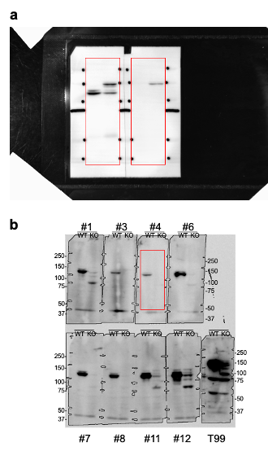
Supplementary Fig. S10
a. This is full gel image of given figure, with figure number Figure S3b.
b. These western blots are screening of monoclonal-ELKS antibodies by using wild type of ELKS cKO mouse brain samples. Clone #4 antibody was used in Figure S3a.

