Supplementary Information for

Genomic architecture of migration timing in a long-distance migratory songbird

Evelien de Greef*, Alexander Suh, Matt J. Thorstensen, Kira E. Delmore†, Kevin C. Fraser†

Evelien de Greef
Email: eveliendegreef@gmail.com

Methods

Reference genome

Genome assembly
Data for the reference genome came from a second-year female purple martin from Manitoba, Canada (49°44’ N, 97°7’ W). DNA from this individual’s blood was extracted using an in-situ agarose plug extraction procedure at the Science for Life Laboratory in Sweden. Pacific Biosciences (PacBio) long-read libraries [1] and 10X Genomics Chromium (10X) linked-read libraries were prepared from this DNA [2], and sequenced on a PacBio Sequel instrument (5 SMRT cells) and an Illumina HiSeq X instrument (1 lane, 2x 150 bp paired-end reads), respectively. The initial reference was assembled with the PacBio sequences using FALCON algorithms with SMRT Link v7.0.0 [3,4]. We polished the genome using two rounds of the program ArrowGrid v0.6.0 with the PacBio subreads bam files [5]. To prepare for the next polishing step, we aligned 10X fastq files to the arrow-corrected genome using BWA v0.7.17 [6] and sorted the resulting bam file with SAMtools v1.9 [7]. We then polished the genome with Pilon v1.23 using 10X reads to correct bases, fixed mis-assemblies, and filled gaps [8]. We scaffolded the genome with ARKS v1.0.4 [9], using interleaved 10X reads assembled with LongRanger v2.2.2 [10]. We checked the genome for duplicated scaffolds using dedupe.sh in BBMap v38.44 [11]. To look for possible contaminants, we used the nucleotide database from the National Center for Biotechnology Information [12] and the program BLAST+ v2.9 [13] to identify any foreign DNA. The final genome was evaluated with QUAST v5.0.2 [14], Assemblathon 2 [15], and BUSCO v4.0.5 with the aves dataset (aves_odb10) and augustus species set to chicken [16].

Genome annotation
We annotated the genome using four rounds of the program MAKER v2.31.10 [17]. The first round included RepeatMasker and Exonerate using protein data from three model species: chicken (Gallus gallus; assembly GRCg6a), collared flycatcher (Ficedula albicollis; assembly FicAlb_1.4), zebra finch (Taeniopygia guttata; assembly bTaeGut1_v1) obtained from Ensembl database [18]. A hidden Markov model (HMM) was created using the outputs from the first round. This HMM was then used in the second round to train SNAP using computational gene prediction. The third round used the updated HMM model from the second round and included the Augustus chicken model. The fourth and final round had the same parameters as the third, but additionally filtered out genes of annotation edit distance (AED) score over 0.5. After completing the MAKER rounds, the annotation was aligned with protein data from the uniprot database [19] using BLAST+ v2.9 [13] and protein functions from InterProScan v5.4 [20].

Resequencing data

Sample collection and DNA extractions
All birds were captured with drop door traps while feeding their young at their nesting colonies in artificial housing. Sampling locations and numbers are listed in Table S2. These samples were collected between 2008–2015. Blood collection and DNA extraction followed the same methods seen in de Greef et al. 2022 [21], where up to 150 µl of blood was drawn from each bird’s brachial vein and stored in Queen’s Lysis buffer and DNA was extracted using the Qiagen DNeasy Blood & Tissue kits.

Sequencing & Imputation
We used a low-coverage whole-genome approach (skimSeq) to generate resequencing data for these birds [22-24], following the methods of de Greef et al. 2022 [21]. Specifically, libraries were prepared with NEXTFLEX Rapid XP DNA-SEQ Kit and sequenced on Novaseq 6000 platform (2x 150bp paired-end reads) to 3x coverage. This approach for assaying the entire genome with low coverage has been validated in the 3K rice genome project which simulated low coverage sequencing from high quality high coverage public data [25,26]. Our data were filtered and trimmed using Trimmomatic v0.38 [27] then aligned to the reference genome using Bowtie2 v2.3.4.2 [28]. These alignments were sorted, realigned, and filtered (MQ>5) using SAMtools v1.9 [7] and PICARD v.2.18.4 [29]. The variants were called in GATK v3.5 using HaplotypeCaller [30]. Missing genotypes were imputed with Beagle v.4.0 [25], using information from surrounding genotypes, linkage disequilibrium structure, and haplotype blocks [22]. Imputation performance was evaluated by masking a random 3% of genotypes as missing then imputed, which resulted in 0.9 accuracy with a 0.9 genotype probability cut-off. SNPs were filtered with this 0.9 genotype probability threshold.

SNP filtering
We filtered the final set of SNPS using vcflib v1 [31] and VCFtools v.0.1.16 [32], limiting analyses to SNPs with quality score (QUAL) > 20 and mapping quality (MQ) > 20. We removed sites with indels, and then filtered the SNPs to a dataset with minor allele frequency (MAF) > 0.05 (5%), max-missing genotype score of 0.2, matching Hardy-Weinberg equilibrium, and containing only biallelic sites. We removed scaffolds with abnormally high read depths (4 or higher), as they likely represent repetitive regions. We also removed Z and W-linked scaffolds to generate an autosomal dataset. These sex-linked scaffolds were identified from mapping the genome to a chicken genome with SatsumaSynteny [33] and by using F_{ST} values through VCFtools v.0.1.16 [31] between males and female samples. We used a PCA on to control for population structure in our GWAS. We ran the PCA using smartpca in the Eigensoft program [34], using SNPs that were pruned for linkage disequilibrium with PLINK v1.9 [35].

Genome-wide association studies

Light-level geolocator analysis
To define sunrises and sunsets, we used the preprocessLight function in the R-package BAStag [36]. Here, the light-intensity threshold was set at 32 to systematically separate day and night, and false twilights or outliers due to shading or light pollution were removed through manual inspection. In addition, the sudden onset of extreme light fluctuations in spring indicated the bird entering and exiting nest cavities, signifying the spring arrival date. Next, we estimated daily coordinates using the twilight data with the coord function in R-package GeoLight [37]. Here, the calibration for the sun elevation angle was calculated using two weeks of light data at the end of the breeding season, where the bird was known to stay in their respective colony before departing on fall migration. Since there is little variation in day lengths around the spring and fall equinox, the latitudes around the equinox were removed using a tol (the tolerance on the sine of solar declination) of 0.13 [37] as these would result in inaccurate locations. We determined spring departure and arrival dates from the location coordinates based on sudden shifts in latitude, and confirmed with the changeLight function, which defined residency periods throughout the year.

Association Mapping
BSLMMs were run in GEMMA [38] after converting the SNP dataset from a vcf file to a binary plink format (bim, bed, fam files) using PLINK v1.9 [35]. GEMMA includes uses a kinship matrix to control for factors that influence phenotypes and are correlated with genotypes (e.g., population structure). We also included several additional covariates in our model to control for these effects: sex, year, age, and the first principal component (PC1) from a PCA summarizing genetic variation in our dataset. PC1 was the only significant component in our PCA and showed only weak clustering by latitude with 1.5% variance explained. BSLMMs do not permit the inclusion of covariates and thus we regressed these covariates out of the timing phenotypes and used the residuals as the corrected phenotype for our models. We ran four independent chains for each BSLMM, with a burn-in of 5 million steps and a subsequent 20 million MCMC steps.

Polygenic score
LMM results obtained in GEMMA [41] were used to estimate polygenic scores (PGS) using covariates sex, year, age, PC1, colony, distance travelled, and duration. Polygenic models were created using the PLINK v1.9 [35] and following Choi et al. (2020)’s PGS pipeline [42]. To assess the predictive power of the PGS model, we used jackknife cross-validation partitions and randomly sampled from the overall dataset with a training/test dataset of an 85/15 split for 100 iterations [43]. We examined the accuracy in terms of R² in the training data and plotted PGS deciles.

Differentiation across genome
Mixed models run in GEMMA did not identify any specific genomic regions linked to migration timing. This result could suggest there is a polygenic basis to migratory timing, or our sample size was too small. Accordingly, we took a second approach to identify genomic variants underlying timing, estimating differentiation (F_{ST}) across the genome between the earliest and latest migrants (n = 10 for each extreme phenotype). Latest migrants included samples from Lacombe, Alberta (n = 6), Camrose, Alberta (n = 2), Virginia (n = 1), and Pennsylvania (n = 1). Earliest migrant included samples from Naples, Florida (n = 1) and Bay Lake, Florida (n = 9). F_{ST} could be elevated by processes unrelated to migration, including linked background selection and population structure [44]. We controlled for these potential effects by subtracting F_{ST} between Alberta and Florida (representing the northernmost and southernmost breeding regions) from values estimated between extreme timing phenotypes. This approach has been used in crows [45] and blackcaps [46] to isolate differentiation associated with specific phenotypes. Additionally, F_{ST} estimated between early and late migrants within Alberta (n = 8) and Florida (n = 8) separately was also elevated in this region, further supporting that this region is related to migration timing as opposed to population structure. We used VCFtools v.0.1.16 [32] to estimate F_{ST}, nucleotide diversity, and Tajima’s D. Pairwise F_{ST} across sampling groups in the study ranged between regions ranged from 0.009 (Alberta & Florida) to 0.001 (Texas & Florida)

References

- Rhoads, A. & Au, K. F. PacBio Sequencing and Its Applications. Genomics, Proteomics & Bioinformatics 13, 278–289 (2015).

- Zheng, G. X. Y. et al. Haplotyping germline and cancer genomes with high-throughput linked-read sequencing. Nature Biotechnology 34, 303–311 (2016).

- Chin, C. S. et al. Phased diploid genome assembly with single-molecule real-time sequencing. Nature Methods 13, 1050–1054 (2016).

- Chin, C. S. et al. Nonhybrid, finished microbial genome assemblies from long-read SMRT sequencing data. Nature Methods 10, 563–569 (2013).
- Koren, S. et al. Canu: scalable and accurate long-read assembly via adaptive k-mer weighting and repeat separation. Genome Research 27, 722–736 (2017).

- Li, H. & Durbin, R. Fast and accurate short read alignment with Burrows-Wheeler transform. Bioinformatics 25, 1754–1760 (2009).

- Li, H. et al. The Sequence Alignment/Map format and SAMtools. Bioinformatics 25, 2078–2079 (2009).

- Walker, B. J. et al. Pilon: An integrated tool for comprehensive microbial variant detection and genome assembly improvement. PLoS ONE 9, e112963 (2014).

- Coombe, L. et al. ARKS: Chromosome-scale scaffolding of human genome drafts with linked read kmers. BMC Bioinformatics 19, 1–10 (2018).

- Marks, P. et al., Resolving the full spectrum of human genome variation using Linked-Reads. Genome Research 29, 635–645 (2019).

- Bushnell, B. BBMap: A Fast, Accurate, Splice-Aware Aligner. United States. (2014).
- National Center for Biotechnology Information (NCBI) Bethesda (MD): National Library of Medicine (US), National Center for Biotechnology Information (2020).

- Camacho, C. et al. BLAST+: Architecture and applications. BMC Bioinformatics 10, 1–9 (2009).

- Gurevich, A., Saveliev, V., Vyahhi, N. & Tesler, G. QUAST: Quality assessment tool for genome assemblies. Bioinformatics 29, 1072–1075 (2013).

- Bradnam, K. R. et al. Assemblathon 2: Evaluating de novo methods of genome assembly in three vertebrate species. GigaScience 2 (2013).
- Seppey, M., Manni, M. & Zdobnov, E. M. BUSCO: Assessing Genome Assembly and Annotation Completeness. In: Kollmar M. (eds) Gene Prediction. Methods in Molecular Biology 1962. Humana, New York, NY. (2019).

- Campbell, M. S., Holt, C. Moore, B. & Yandell, M. Genome Annotation and Curation Using MAKER and MAKER‐P. Current Protocols in Bioinformatics 48, 4.11.1-4.11.39 (2014).
- Cunningham, F. et al. Ensembl 2019. Nucleic Acids Research 47, D745–D751 (2019).

- Bateman, A. UniProt: A worldwide hub of protein knowledge. Nucleic Acids Research 47, D506–D515 (2019).
- Jones, P. et al. InterProScan 5: Genome-scale protein function classification. Bioinformatics 30, 1236–1240 (2014).
- de Greef, E., Brashear, W., Delmore, K. E., & Fraser, K. C. Population structure, patterns of natal dispersal, and demographic history in a declining aerial insectivore, the purple martin Progne subis. Journal of Avian Biology 2022, e02929 (2022).

- Golicz, A. A., Bayer, P. E. & Edwards, D. Skim-Based Genotyping by Sequencing. Methods in Molecular Biology 1245, 257–270 (2015).

- Malmberg, M. M. et al. Evaluation and Recommendations for Routine Genotyping Using Skim Whole Genome Re-sequencing in Canola. Front. Plant. Sci. 9 (2018).

- Li, J. H., Mazur, C. A., Berisa, T. & Pickrell, J. K. Low-pass sequencing increases the power of GWAS and decreases measurement error of polygenic risk scores compared to genotyping arrays. Genome Res. 31, 529-537 (2021).

- Browning, B. L. & Browning, S. R. Genotype Imputation with Millions of Reference Samples. American Journal of Human Genetics 98, 116–126 (2016).

- Browning, S. R. & Browning, B. L. Rapid and Accurate Haplotype Phasing and Missing-Data Inference for Whole-Genome Association Studies By Use of Localized Haplotype Clustering. American Journal of Human Genetics 81, 1084-1097 (2007).

- Bolger, A. M., Lohse, M. & Usadel, B. Trimmomatic: A flexible trimmer for Illumina Sequence Data. Bioinformatics 30, 2114-2120 (2014).
- Langmead, B. & Salzberg, S. L. Fast gapped-read alignment with Bowtie 2. Nature Methods 9, 357–359 (2012).

- Broad Institute, GitHub Repository, Picard Toolkit. http://broadinstitute.github.io/picard/ (2019).
- Poplin, R. et al. Scaling accurate genetic variant discovery to tens of thousands of samples. BioRxiv, 201178 (2017).

- Garrison, E. Vcflib, a simple C++ library for parsing and manipulating VCF files. https://github.com/vcflib/vcflib (2016).

- Danecek, P. et al. The variant call format and VCFtools. Bioinformatics 27, 2156–2158 (2011).

- Grabherr, M. G. et al. Genome-wide synteny through highly sensitive sequence alignment: Satsuma. Bioinformatics 26,1145–1151 (2010).

- Price, A. L. et al. Principal components analysis corrects for stratification in genome-wide association studies. Nature Genetics 38, 904-909 (2006).

- Purcell, S. et al, PLINK: a toolset for whole-genome association and population-based linkage analysis. American Journal of Human Genetics 81, 559-575 (2007).

- Wotherspoon, S. Summer, M. & Lisovski, S. BAStag: Basic Data Processing for Light Based Geolocation Archival Tags. Version 0.1.3. (2016).

- Lisovski, S. & Hahn, S. GeoLight-processing and anslysing light-based geolocator data in R. Methods in Ecology and Evolution 3, 1055-1059 (2012).

- Zhou, X., Carbonetto, P. & Stephens, M. Polygenic Modeling with Bayesian Sparse Linear Mixed Models. PLoS Genetics 9, e1003264 (2013).

- Gompert, Z., Lucas, L. K., Nice, C. C. & Buerkle, C. A. Genome divergence and the genetic architecture of barriers to gene flow between Lycaeides idas and L. melissa. Evolution 67, 2498–2514 (2013).

- Pfeifer, S. P. et al. The evolutionary history of Nebraska deer mice: local adaptation in the face of strong gene flow. Molecular Biology and Evolution 35, 792-806 (2018).

- Zhou, X. & Stephens, M.. Genome-wide efficient mixed model analysis for association studies. Nat Genet 7, 821-824 (2013).

- Choi, S. W., Mak, T. S. & O’Reilly, P. F. Tutorial: a guide to performing polygenic risk score analysis. Nat Protoc 15, 2759-2772 (2020).

- Fuller, Z. L. et al. Population genetics of the coral Acropora millepora: Towards a genomic predictor of bleaching. Science 369, eaba4674 (2020).

- Cruickshank, T. E. & Hahn, M. W. Reanalysis suggests that genomic islands of speciation are due to reduced diversity, not reduced gene flow. Molecular Ecology 23, 3133-3157 (2014).

- Vijay, N. et al. Evolution of heterogeneous genome differentiation across multiple contact zones in a crow species complex. Nature Communications 7, 13195 (2016).

- Delmore, K. et al. The evolutionary history and genomics of European blackcap migration. eLife 9, e54462 (2020).

Table S1. Purple martin (P.s. subis) draft reference genome assembly metrics
Assembly metrics
Genome size (bp) | 1,165,951,862
Number of scaffolds | 2,896
Longest scaffold (bp) | 45,082,031
Shortest scaffold (bp) | 16,249
Mean scaffold length (bp) | 402,608
N50 scaffold length (bp) | 6,129,949
N50 contig length (bp) | 3,084,734
L50 scaffold count | 44
GC content (%) | 43.06
N’s per 100 kb | 3.99
Complete BUSCOs | 7592 (91.0%)
Complete single-copy BUSCOs | 7431 (89.1%)
Complete duplicated BUSCOs | 161 (1.9%)
Fragmented BUSCOs | 118 (1.4%)
Missing BUSCOs | 628 (7.6%)
Number of identified genes | 12,686

Table S2. Sampling locations for 87 geolocator-tracked purple martins.
Province/State | Colony | Latitude | Longitude | N | Year(s)
Alberta | Camrose | 53.011 | -112.864 | 5 | 2012-2014
Alberta | Lacombe | 52.391 | -113.612 | 17 | 2012-2014
Florida | Bay Lake | 28.360 | -81.588 | 19 | 2013-2015
Florida | Naples | 26.149 | -81.746 | 2 | 2013
Minnesota | Millie Lacs | 46.146 | -93.724 | 1 | 2011
New Jersey | Middletown | 40.390 | -74.001 | 3 | 2011
Ontario | Ottawa | 45.351 | -75.827 | 2 | 2014
Pennsylvania | Erie | 42.115 | -80.145 | 14 | 2008-2013
South Dakota | Columbia | 45.598 | -98.310 | 2 | 2011-2013
Texas | Amarillo | 35.040 | -101.933 | 4 | 2013
Texas | Corpus Christi | 27.680 | -97.407 | 4 | 2013
Texas | Sandia | 27.997 | -97.879 | 8 | 2013
Virginia | Woodbridge | 38.613 | -77.263 | 6 | 2010-2013

Table S3. List of genes in elevated F_{ST} region on chromosome one.
scaffold | position start | position end | gene | description
scaffold110 | 46198 | 72361 | SLC6A15 | Solute Carrier Family 6 Member 15
scaffold110 | 660079 | 668953 | CEPT1 | Choline/ethanolamine phosphotransferase 1
scaffold110 | 1317685 | 1336461 | METTL25 | Methyltransferase like 25
scaffold110 | 1336917 | 1356721 | CCDC59 | Coiled-coil domain containing 59
scaffold110 | 1767838 | 1859397 | PPFIA2 | PTPRF interacting protein alpha 2
scaffold110 | 1899350 | 1967674 | ACSS3 | Acyl-CoA synthetase short chain family member 3
scaffold22 | 74157 | 151868 | ALX1 | ALX homeobox 1
scaffold22 | 205263 | 213135 | CEPT1 | Choline/ethanolamine phosphotransferase 1
scaffold22 | 366758 | 368017 | RASSF9 | Ras association domain family member 9
scaffold22 | 419805 | 431374 | NTS | Neurotensin/neuromedin N
scaffold22 | 464152 | 471608 | MGAT4C | MGAT4 family member C
scaffold22 | 1228676 | 1250364 | C12orf50 | Chromosome 12 open reading frame 50
scaffold22 | 1252756 | 1257492 | C12orf29 | Chromosome 12 open reading frame 29

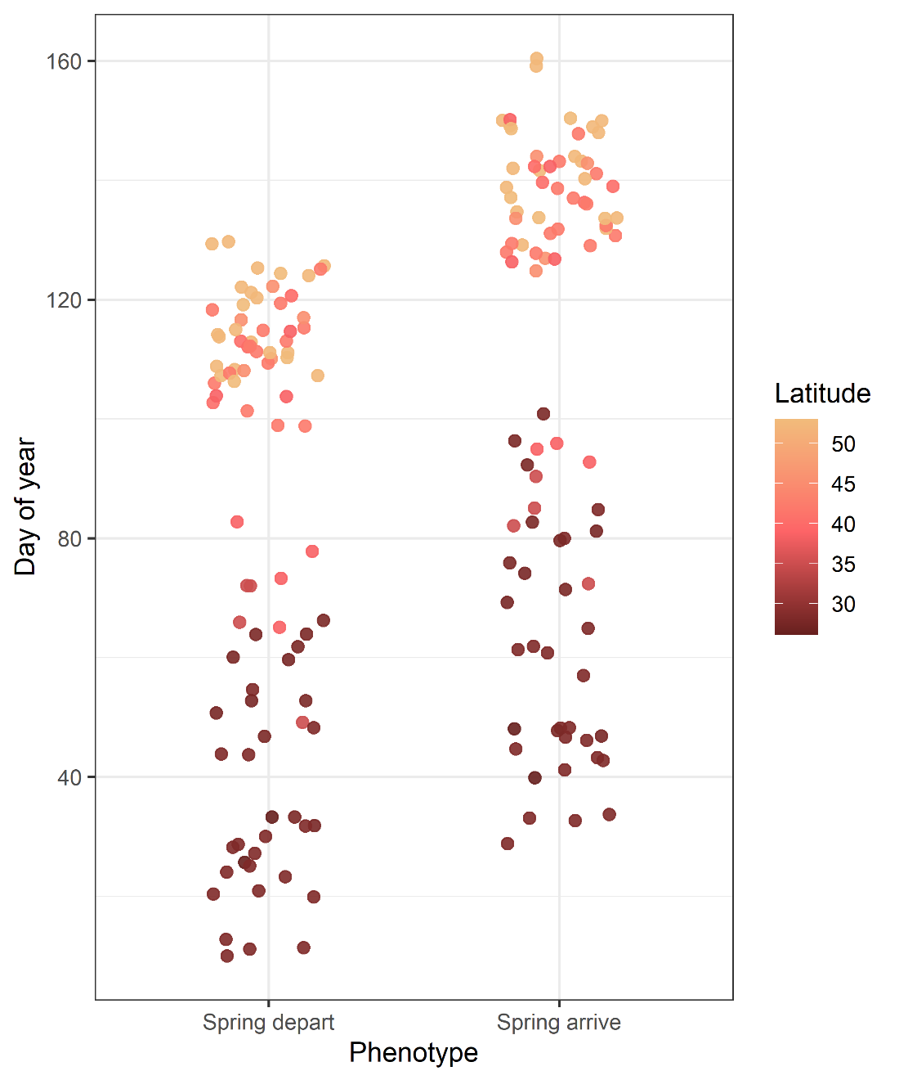

Figure S1. Migratory timing phenotypes of 87 geolocator-tracked purple martins, including the start and end of spring migration in Julian date format for each bird. Migration timing follows a latitudinal trend, where individuals breeding at higher latitudes exhibit later timing.

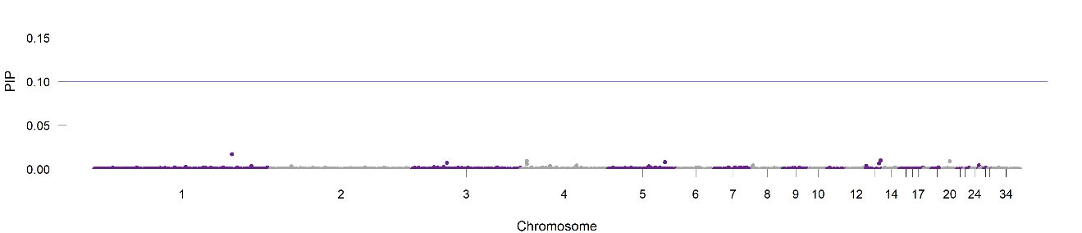
Figure S3. Bayesian sparse linear mixed model of spring migration timing

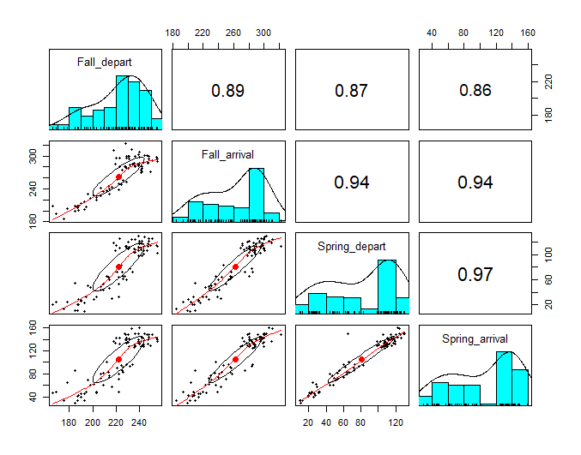
Figure S2. Upper-right plots show high correlation (ranging between 0.86-0.97) between migratory phenotypes: fall departure, fall arrival, spring departure, and spring arrival. Blue hisograms show the frequency distribution of the phenotypes. The lower-left plots show the coorelations between each phenotype pair.

