Supplementary Figures
MSPNKGELILPSEVLEPYVSEWSANYPTLDPSEAQLFKDWFDGLSDSSLKDYCKEPEEVSEADSCLLLLTACRLLANNQPPPSSLARRVKAWFLFTPQGDALYKILQSKDGFAVDAVIEALDRIQ
Supplementary figure 1. Amino acid sequence of the Foc specific molecular marker selected for the Foc diagnostic assays

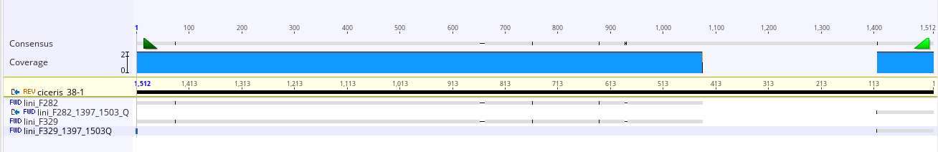
Supplementary figure 2. Alignment of the forward (Foc0-12f) and reverse primers (Foc0-12r) of Fusarium oxysporum f. sp. ciceris PCR diagnostic assay developed by Jiménez-Gasco et al. based on the impala transposon sequence with the impala transposon sequences of Fusarium oxysporum f. sp. ciceris strain 38-1 and Fusarium oxysporum f. sp. lini strains F282 and F329. As shown in the above image, the primer pair binds well to the transposon sequences in both Fusarium oxysporum f. sp. ciceris and Fusarium oxysporum f. sp. lini.
Ladder

negative control

Fo from tomato

Fo f. sp. lycopersici

Fo f. sp. tulipae

Fo from natural ecosystems

Fo f. sp. zingiberi

Fo f. sp. niveum

Fo f. sp. melonis

Fo f. sp. canariensis

Fo from chickpea

Fo f. sp. medicaginis

Fo f. sp. cubense

Fo f. sp. passiflorae

Fo f. sp. tracheiphilum

Fo f. sp. pisi race 5

Fo f. sp. dianthi

Fo f. sp. vasinfectum (endemic)

Fo f. sp. ciceris (positive control)

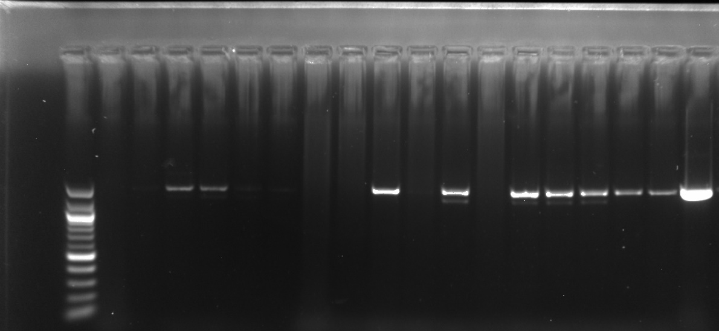
Supplementary figure 3. Agarose gel showing amplification products from PCR diagnostic assay developed by Jiménez-Gasco et al. based on the impala transposon sequence. There are amplifications from Foc (positive control) (lane 19) as well as from some other ff. spp. (lanes 4, 5, 10, 12, 14-18 showing a product size of 1500bp.

