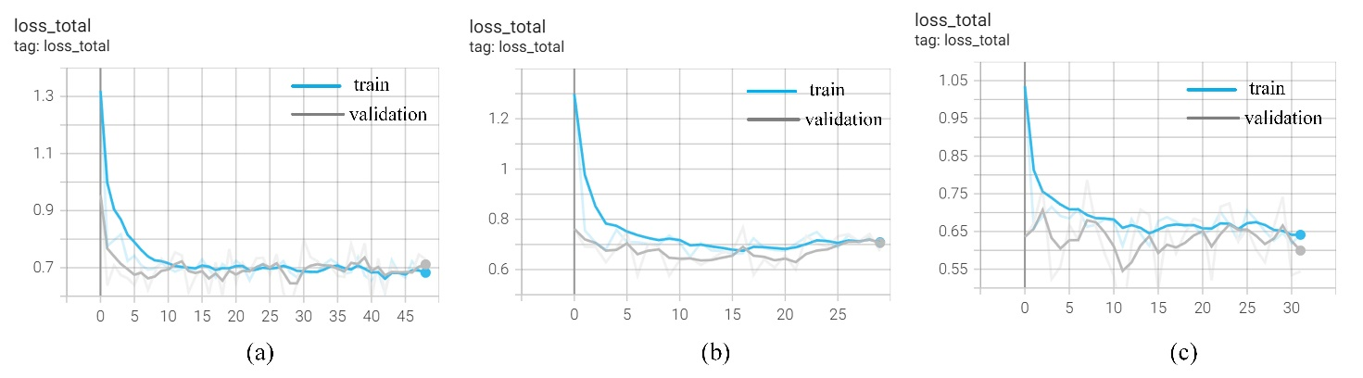Figure 1. The change of the training and validation loss function with epochs using (a) the sagittal T2WI images, (b) the coronal T2WI images, (c) the axial T1WI images in the training process.

