SUPPLEMENTARY MATERIAL
Total and Regional Appendicular Skeletal Muscle Mass: Prediction from Dual-Energy X-ray Absorptiometry Body Composition Models
Cassidy McCarthy¹, Grant M. Tinsley², Anja Bosy-Westphal³, Manfred J. Muller³, John Shepherd⁴, Dympna Gallagher⁵, Steven B. Heymsfield¹

¹Pennington Biomedical Research Center, Louisiana State University System, Baton Rouge, LA, USA; ²Department of Kinesiology & Sport Management, Texas Tech University; ³Department of Human Nutrition and Food Science, Christian-Albrecht’s-University of Kiel, Kiel,
Germany; ⁴University of Hawaii Cancer Center, Honolulu, HI, USA; ⁵New York Obesity Research Center, Department of Medicine, College of Physicians and Surgeons, Columbia University, New York, NY, USA.

Address Correspondence to:
Steven B. Heymsfield, MD
Pennington Biomedical Research Center
6400 Perkins Road
Baton Rouge, LA, USA 70808
Tel: 225-763-2541
Fax: 225-763-3030
E-mail: steven.heymsfield@pbrc.edu
Contents
Table 1. Kim study participant characteristics
Table 2. Initial stepwise selection regression models for skeletal muscle estimation
Table 3. Developed SM mass prediction models in males only
Table 4. Developed SM mass prediction models in females only
Figure 1. Predicted skeletal muscle validation in males
Figure 2. Predicted skeletal muscle validation in females
Figure 3. Appendicular lean mass (ALM) measured by Discovery/Horizon W and
iDXA/Prodigy scanners
Figure 4. Consort diagram showing participant samples
Table 1. Kim’s study participant characteristics (X±SD)¹.
 | Total Sample (n=270)
 | Women (n= 174) | Men (n= 96)
Age (y) | 45.2 ± 17.6 | 46.4 ± 19.0
Height (cm) | 162.3 ± 7.5 | 176.4 ± 7.9
Weight (kg) | 64.5 ± 13.6 | 79.2 ± 12.2
BMI (kg/m²) | 24.4 ± 4.4 | 25.4 ± 3.0
MRI-SM (kg) | 19.8 ± 3.9 | 31.7 ± 5.9
DXA-ALM (kg) | 18.0 ± 3.2 | 28.1 ± 4.6
Values are X ± SD. Abbreviations: ALM, appendicular lean mass; BMI, body mass index; DXA, dual-energy X-ray absorptiometry; MRI, magnetic resonance imaging; SM, skeletal muscle.

- Kim J, Heshka S, Gallagher D, Kotler DP, Mayer L, Albu J, Shen W, Freda PU, Heymsfield SB. Intermuscular adipose tissue-free skeletal muscle mass: estimation by dual-energy X-ray absorptiometry in adults. J Appl Physiol. 2004;97:655-60. doi: 10.1152/japplphysiol.00260.2004. Epub 2004 Apr 16. PMID: 15090482.
Table 2. Initial stepwise selection regression models for skeletal muscle estimation.
 | Predictors | RMSE | RMSE SD |  | R² | R² SD |  | MAE | MAE SD
Total SM | ALM | 1.80 | 0.14 |  | 0.93 | 0.02 |  | 1.38 | 0.11
Total SM | ALM, Sex | 1.70 | 0.22 |  | 0.94 | 0.02 |  | 1.32 | 0.14
Total SM | ALM, Sex, Age | 1.70 | 0.23 |  | 0.94 | 0.02 |  | 1.31 | 0.14
Leg SM | Leg LM | 0.93 | 0.15 |  | 0.91 | 0.03 |  | 0.71 | 0.13
Leg SM | Leg LM, Sex | 0.91 | 0.14 |  | 0.92 | 0.03 |  | 0.70 | 0.12
Leg SM | Leg LM, Sex, Age | 0.87 | 0.15 |  | 0.92 | 0.03 |  | 0.65 | 0.13
Arm SM | Arm LM | 0.40 | 0.04 |  | 0.88 | 0.02 |  | 0.32 | 0.04
Arm SM | Sex, Age | 0.55 | 0.07 |  | 0.77 | 0.05 |  | 0.42 | 0.05
Arm SM | Arm LM, Sex, Age | 0.37 | 0.04 |  | 0.90 | 0.02 |  | 0.29 | 0.04
10-fold cross-validation values are displayed. RMSE: root mean square error; MAE: mean absolute error.
Table 3. Developed SM mass prediction models in males only.
 |  |  |  |  | Validation (n=95)
Dependent  Variable | Model | Equation | Slope  95% CI | Intercept  95% CI | RMSE (kg) | R²
Total SM | Development (n=168) | 1.18 x ALM – 2.23 | 1.09, 1.28 | -4.90, 0.43 | 1.80 | 0.80
Total SM | Final (n=216) | 1.18 x ALM – 2.13 | 1.10, 1.26 | -4.40, 0.14 | - | -
Leg SM | Development (n=168) | 0.83 x leg lean – 2.02 | 0.77, 0.89 | -3.23, -0.81 | 0.99 | 0.81
Leg SM | Final (n=216) | 0.84x leg lean – 2.36 | 0.79, 0.90 | -3.41, -1.31 | - | -
Arm SM | Development (n=168) | 0.70 x arm lean – 0.75 | 0.62, 0.79 | -1.38, -0.13 | 0.47 | 0.65
Arm SM | Final (n=216) | 0.70 x arm lean – 0.78 | 0.63, 0.77 | -1.33, -0.24 | - | -
ALM and lean mass units are in kg. Abbreviations: ALM, appendicular lean mass; RMSE, root mean square error; SM, skeletal muscle.
Table 4. Developed SM mass prediction models in females only.
 |  |  |  |  | Validation (n=95)
Dependent  Variable | Model | Equation | Slope  95% CI | Intercept  95% CI | RMSE (kg) | R²
Total SM | Development (n=212) | 0.96 x ALM + 1.98 | 0.89, 1.03 | 0.66, 3.30 | 1.69 | 0.72
Total SM | Final (n=259) | 0.98 x ALM + 1.63 | 0.91, 1.05 | 0.36, 2.91 | - | -
Leg SM | Development (n=212) | 0.73 x leg lean – 0.43 | 0.67, 0.78 | -1.22, 0.36 | 0.89 | 0.74
Leg SM | Final (n=259) | 0.73x leg lean – 0.38 | 0.67, 0.78 | -1.35, 0.60 | - | -
Arm SM | Development (n=212) | 0.57 x arm lean + 0.19 | 0.50, 0.64 | -0.09, 0.46 | 0.37 | 0.50
Arm SM | Final (n=259) | 0.59 x arm lean + 0.10 | 0.56, 0.60 | -0.22, 0.43 | - | -
ALM and lean mass units are in kg. Abbreviations: ALM, appendicular lean mass; RMSE, root mean square error; SM, skeletal muscle.

Figure 1. Predicted skeletal muscle validation in males
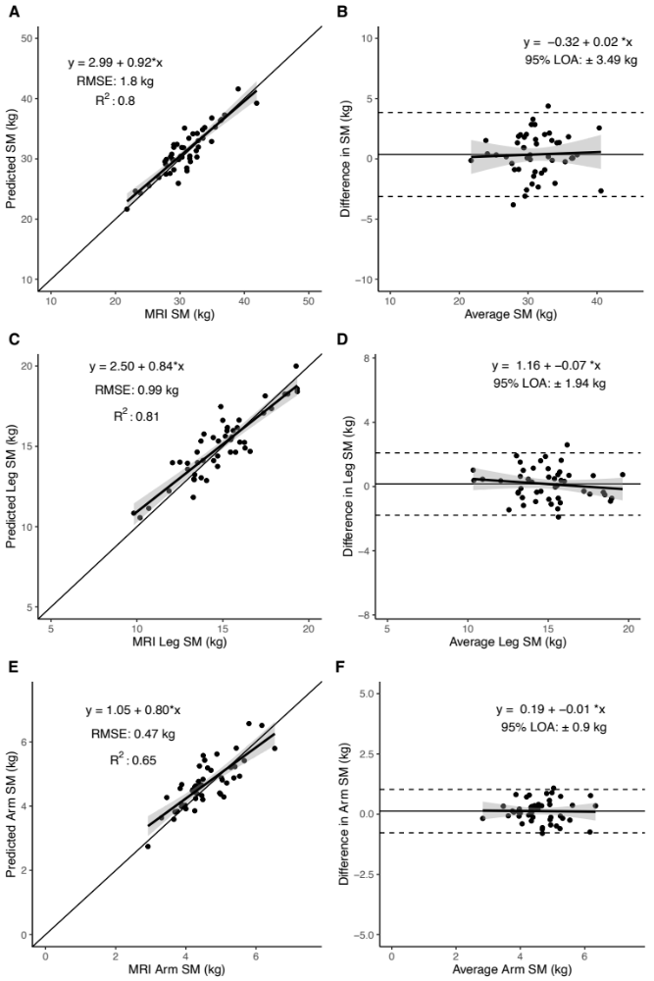
Figure 2. Predicted skeletal muscle validation in females
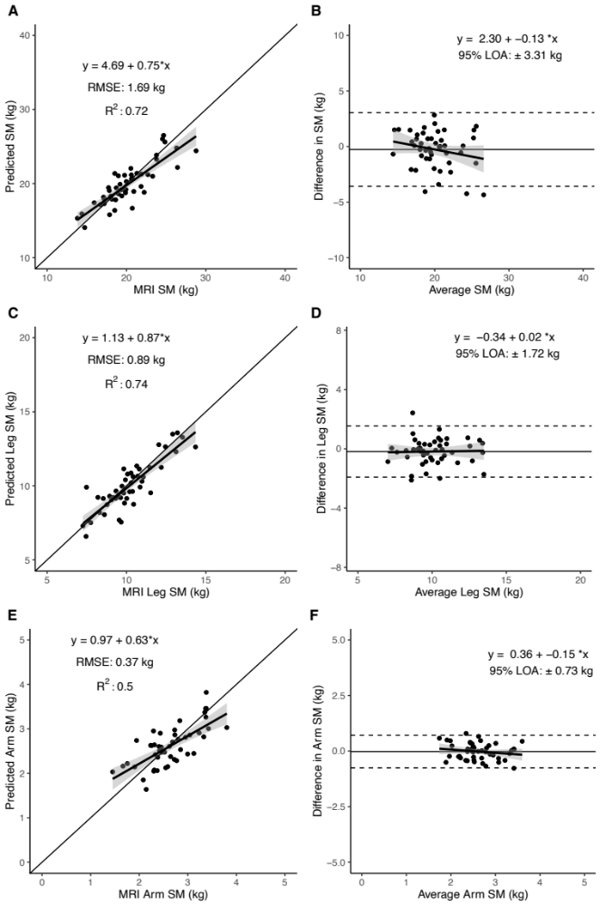

Figure 3. Appendicular lean mass (ALM) measured by Discovery/Horizon W (Hologic, Marlborough, Massachusetts) and iDXA/Prodigy (GE Healthcare, Madison, WI) scanners (n=45).
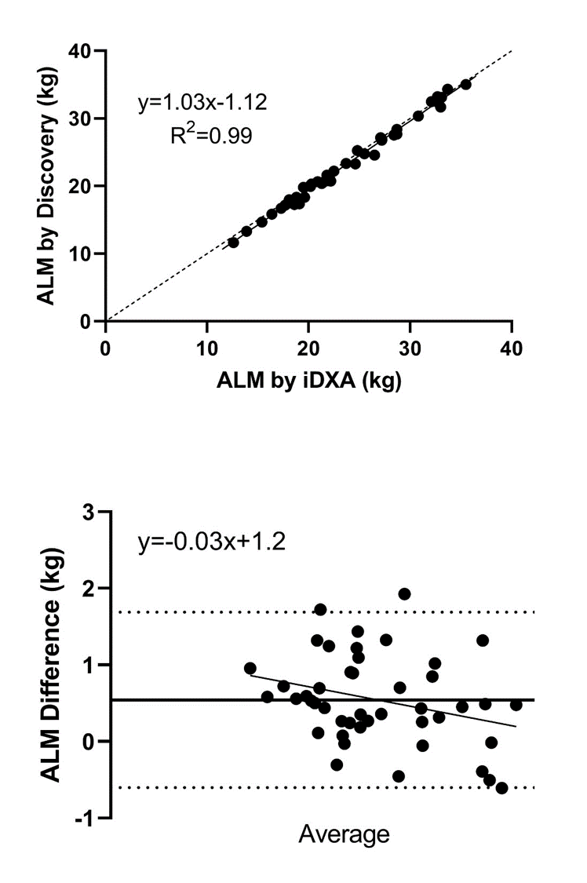
ALM (kg) | Discovery | iDXA | Δ (kg)
Current Study† | 22.9±6.0 | 23.5±5.8 | 0.54±0.58
 | Horizon W | Prodigy
Park et al. | 23.0±4.0 | 24.8±4.3 | 1.79±0.92
Results are X±SD. †Bland-Altman, R², 0.09; p<0.05. Mean Δs are both p<0.001.

Figure 4. Consort diagram showing participant samples.

