Systematic Analysis Identifies REST as an Oncogenic and Immunological Biomarker in Glioma

Authors: Guan Wang ª, Xiaxin Yang ^{b}, Mei Qi ^{c}, Meng Li ª, Meng Dong ª, Rui Xu ª, and Chen Zhang ^{a*}
Institutional affiliations:
ª Department of Pediatrics, Qilu Hospital of Shandong University, No.107 West Wenhua Road, Jinan, 250012, Shandong Province, China
^{b} Department of Neurology, Qilu Hospital of Shandong University, No.107 West Wenhua Road, Jinan, 250012, Shandong Province, China
^{c} Department of Pathology, Qilu Hospital of Shandong University, No.107 West Wenhua Road, Jinan, 250012, Shandong Province, China
*Correspondence Author:
Chen Zhang, Department of Pediatrics, Qilu Hospital of Shandong University, No.107 West Wenhua Road, Jinan, 250012, Shandong Province, China
Email: zczc_8888@163.com

Supplementary material
Figure1 The essential information and staining intensity evaluation of immunohistochemistry (IHC) images from the Human Protein Atlas (HPA) database. 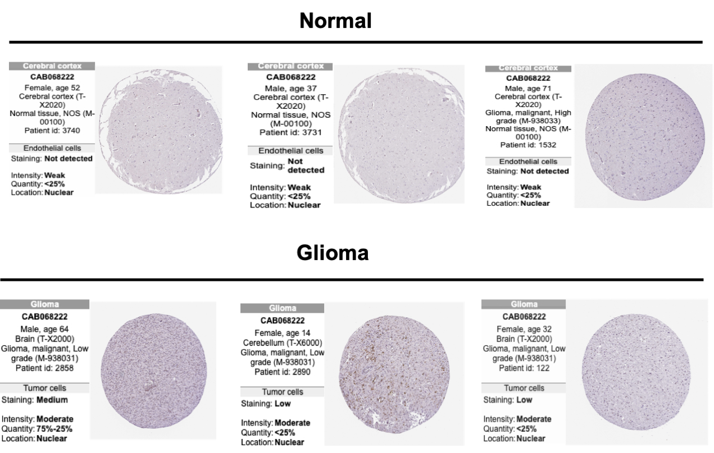
Figure 2 The prognostic value of predicted miRNAs in glioma assessed by Kaplan-Meier plotter.
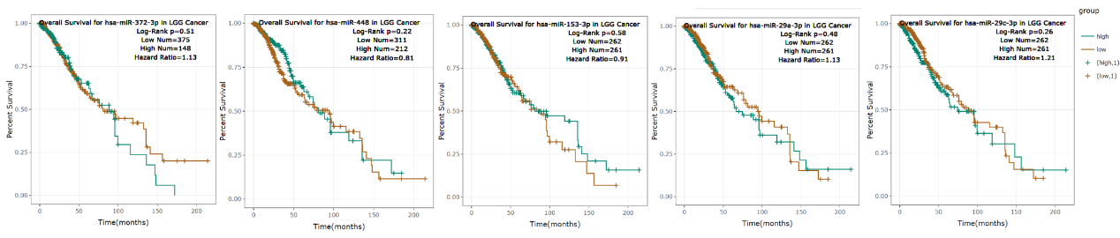

Table 1 Tumor abbreviations.
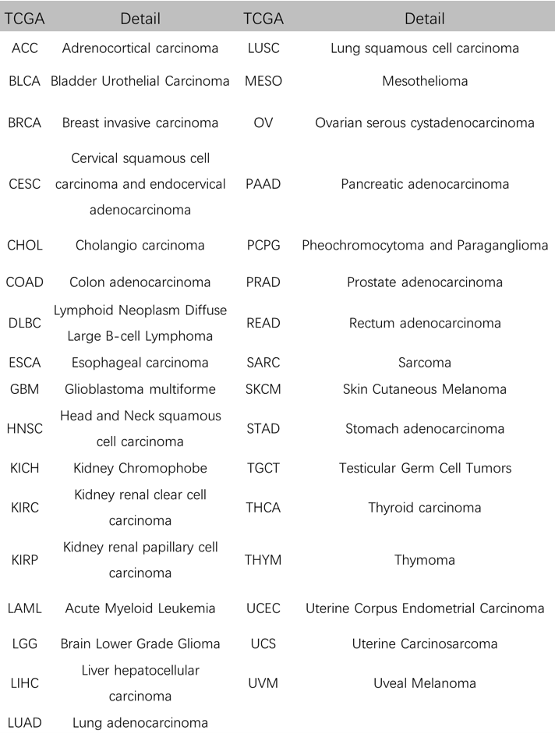
Raw Data Images
Figure 7H in the main text: Western blots were cut prior to antibody hybridization.
