Supplementary material
Table S1. Subject characteristics, social group, date of surgery, and cohort for all study primates housed in cages (n=44).
Cage | Animal  ID | Social group | Sex | Age | Surgery date  (dd/mm/yyyy) | Cohort ^{L, A}
1 | 1M  2M | 2 | M | 2.12  2.16 | 27/10/2020  27/10/2020 | 1
2 | 3M  4M | 2 | M | 2.16  2.14 | 28/10/2020  28/10/2020 | 1
3 | 5M  6M | 2 | M | 2.13  2.16 | 29/10/2020  29/10/2020 | 1
4 | 7M  8M | 2 | M | 2.13  2.14 | 29/10/2020  29/10/2020 | 1
5 | 9M  10M  11M | 3 | M | 2.24  2.12  2.15 | 27/10/2020  28/10/2020  30/10/2020 | 1
6 | 12M  21M  22M | 3 | M | 2.14  2.16  2.25 | 26/01/2021  26/01/2021  26/01/2021 | 2
7 | 13M  14M | 2 | M | 2.17  2.14 | 02/02/2021  02/02/2021 | 2
8 | 15M  16M | 2 | M | 2.14  2.13 | 01/01/2021  01/01/2021 | 2
9 | 17M  18M  19M  20M | 4 | M | 2.18  2.15  2.24  2.19 | 28/01/2021  28/01/2021  28/01/2021  28/01/2021 | 2
10 | 23F  24F | 2 | F | 2.12  2.15 | *  30/10/2020 | 1
11 | 25F  26F | 2 | F | 2.12  2.13 | 02/11/2020  02/11/2020 | 1
12 | 27F  28F | 2 | F | 2.15  2.18 | 03/11/2020  03/11/2020 | 1
13 | 29F  30F | 2 | F | 2.13  2.12 | 04/11/2020  04/11/2020 | 1
14 | 31F  32F  33F | 3 | F | 2.12  2.12  2.13 | 02/11/2020  03/11/2020  04/11/2020 | 1
15 | 34F  43F  44F | 3 | F | 2.16  2.17  2.14 | 25/01/2021  25/01/2021  25/01/2021 | 2
16 | 35F  36F | 2 | F | 2.13  2.12 | 27/01/2021  27/01/2021 | 2
17 | 37F  38F | 2 | F | 2.16  2.16 | 27/01/2021  29/01/2021 | 2
18 | 39F  40F | 2 | F | 2.13  2.14 | 29/01/2021  29/01/2021 | 2
19 | 41F  42F | 2 | F | 2.14  2.12 | 02/02/2021  01/02/2021 | 2
*Does not have a surgery date as the primate died during surgery and was removed from the analysis. The primate was paired with 34F post-surgery.
L: Cohorts differed between 12:12 Dark:Light cycle (±30 min), A: Cohort differed between analgesic protocols (buprenorphine versus slow-release buprenorphine, F: Female, M: Male

Figure S1: Detailed summary of image capture and extraction process for CMGS development.
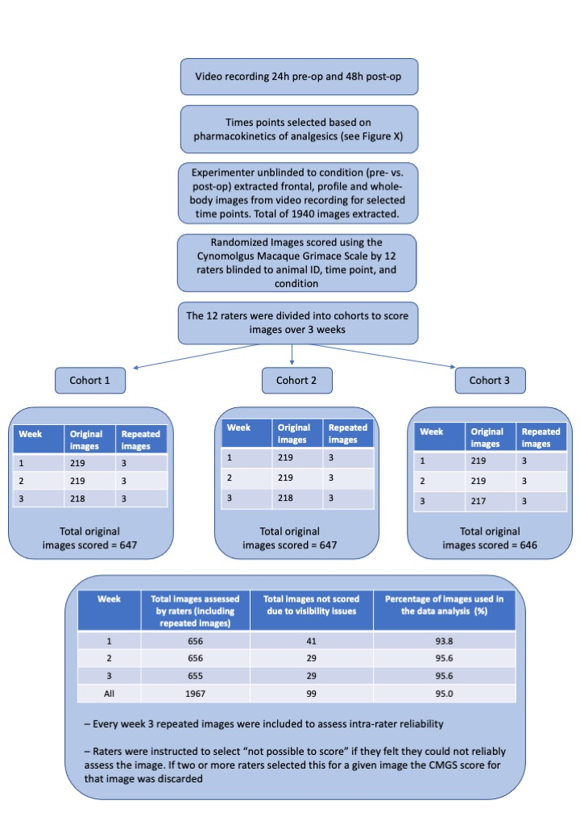
Table S2. Number of images captured baseline and post-surgery in cohort 1 males.
Baseline | Time point | 1M | 2M | 3M | 4M | 5M | 6M | 7M | 8M | 9M | 10M | 11M
Baseline | 1 | 2F,2P,2WB | 1F,1P,1WB | 1F,1P,1WB | 2F,0P,1WB | 2F,1P,1WB | 3F,1P,1WB | 1F,1P,1WB | 2F,1P,0WB | 2F,1P,1WB | 1F,1P,1WB | -
Baseline | 2 | - | - | 0F,1P,1WB | 3F,1P,1WB | - | - | - | 1F,1P,1WB | 2F,1P,1WB | - | -
Baseline | 3 | 2F,2P,1WB | 3F,1P,1WB | 1F.1P.1WB | 1F,1P,1WB | 1F,1P,1WB | 3F,1P,1WB | 2F,1P,2WB | 1F,1P,1WB | - | 1F,1P,1WB | 0F,2P,1WB
Baseline | 4 | 3F,3P,1WB | 2F,1P,2WB | 1F,1P,1WB | 2F,1P,1WB | 3F,1P,1WB | 1F,1P,1WB | 2F,1P,2WB | 1F,1P,1WB | - | - | 0F,1P,1WB
Total  (F,P,WB) |  | 7F,7P,4WB | 6F,3P,4WB | 3F,4P,4WB | 8F,3P,4WB | 6F.3P.3WB | 7F,3P,3WB | 5F,3P,5WB | 5F,4P,3WB | 4F,2P,2WB | 2F,2P,2WB | 0F,3P,2WB
Total Baseline |  | 18 | 13 | 11 | 15 | 12 | 13 | 13 | 12 | 8 | 6 | 5
Post-OP | 1 | 2F,3P,1WB | 2F,1P,1WB | 2F,3P,1WB | 1F,1P,1WB | 2F,1P,1WB | 2F,2P,2WB | 1F,1P,1WB | 1F,1P,1WB | - | 1F,1P,1WB | 2F,1P,1WB
Post-OP | 2 | 3F,3P,2WB | 2F,2P,2WB | 2F,1P,2WB | 2F,1P,1WB | 2F,1P,1WB | 3F,2P,1WB | 2F,1P,1WB | 0F,1P,1WB | 2F,1P,2WB | 2F,1P,2WB | 2F,1P,1WB
Post-OP | 3 | 2F,4P,2WB | 2F,4P,0WB | 1F,1P,1WB | 2F,1P,1WB | 3F,2P,1WB | 2F,1P,1WB | 1F,2P,1WB | - | 1F,2P,1WB | 2F,2P,2WB | 0F,1P,2WB
Post-OP | 4 | 0F,1P,1WB | 2F,2P,1WB | 1F,1P,1WB | 1F,1P,1WB | 2F,2P,1WB | 3F,1P,1WB | 1F,1P,1WB | 1F,1P,1WB | 2F,1P,1WB | 2F,1P,2WB | 0F,2P,1WB
Post-OP | 5 | 1F,3P,2WB | 1F,1P,1WB | 1F,2P,2WB | 1F,1P,1WB | 3F,2P,2WB | 2F,1P,2WB | 1F,2P,2WB | 2F,1P,1WB | 2F,1P,2WB | 1F,2P,2WB | 1F,2P,2WB
Post-OP | 6 | 2F,2P,2WB | 0F,3P,1WB | 0F,4P,3WB | 1F,1P,1WB | 1F,2P,1WB | 1F,2P,1WB | 1F,1P,1WB | 4F,1P,1WB | 2F,2P,2WB | 1F,2P,1WB | 1F,2P,2WB
Total  (F,P,WB) |  | 10F,16P,10WB | 9F,13P,6WB | 7F,12P,10WB | 8F,6P,6WB | 13F,10P,7WB | 13F,9P,8WB | 7F,8P,7WB | 8F,5P,5WB | 9F,7P,8WB | 9F,9P,10WB | 6F,9P,9WB
Total |  | 36 | 28 | 29 | 20 | 30 | 30 | 22 | 18 | 24 | 28 | 24
Over Total |  | 54 | 41 | 40 | 35 | 42 | 43 | 35 | 30 | 32 | 34 | 29

Cohort 1: Primates underwent surgery in October 2020, had a 12 h light cycle from 07:00 to 19:00
F: Frontal, P: Profile, WB: Whole body

Table S3. Number of images captured baseline and post-surgery in cohort 2 males.
Baseline | Time point |  | 12M | 13M | 14M | 15M | 16M | 17M | 18M | 19M | 20M | 21M | 22M
Baseline | 1 | 0F,1P,0WB |  | 2F,2P,2WB | 3F,2P,1WB | 2F,1P,1WB | 0F,1P,2WB | 2F,3P,2WB | 2F,1P,2WB | 0F,2P,1WB | - | 2F,1P,0WB | 1F,1P,1WB
Baseline | 2 | 0F,1P,0WB |  | 2F,3P,2WB | 2F,2P,2WB | 2F,4P,2WB | 3F,3P,2WB | 2F,3P,3WB | 1F,1P,1WB | 0F,1P,0WB | 1F,1P,1WB | 1F,0P,0WB | 2F,1P,1WB
Baseline | 3 | 3F,2P,1WB |  | 1F,2P,2WB | 3F,2P,1WB | 1F,3P,1WB | 1F,1P,1WB | 3F,3P,1WB | 2F,2P,2WB | 1F,1P,1WB | 0F,1P,1WB | 2F,0P,0WB | -
Baseline | 4 | 3F,1P,3WB |  | 2F,1P,2WB | 1F,2P,1WB | 3F,2P,1WB | 0F,1P,1WB | 0F,3P,1WB | 1F,3P,2WB | 0F,1P,1WB | 1F,1P,0WB | 2F,0P,1WB | 0F,3P,1WB
Total  (F,P,WB) |  | 6F,5P,4WB |  | 7F,8P,8WB | 9F,8P,5WB | 8F,10P,5WB | 4F,6P,6WB | 7F,12P,7WB | 6F,7P,7WB | 1F,5P,3WB | 2F,3P,2WB | 7F,1P,1WB | 3F,5P,3WB
Total Baseline |  | 15 |  | 23 | 22 | 23 | 16 | 26 | 20 | 9 | 7 | 9 | 11
Post-OP | 1 | 1F,1P,1WB |  | 0F,4P,2WB | 4F,2P,2WB | 4F,4P,3WB | 2F,4P,3WB | 2F,3P,4WB | 3F,6P,1WB | 4F,2P,3WB | 8F,1P,2WB | 1F,2P,1WB | 3F,0P,1WB
Post-OP | 2 | 0F,3P,1WB |  | 1F,2P,1WB | 2F,2P,1WB | 3F,4P,2WB | 2F,0P,3WB | 4F,1P,3WB | 3F,1P,2WB | 2F,0P,1WB | 5F,2P,1WB | 4F,2P,2WB | 1F,1P,1WB
Post-OP | 3 | 1F,2P,1WB |  | 2F,2P,2WB | 1F,1P,2WB | 4F,1P,2WB | 1F,0P,1WB | 5F,3P,4WB | 0F,0P,1WB | 4F,0P,1WB | 3F,3P,1WB | 4F,2P,0WB | 2F,0P,0WB
Post-OP | 4 | 2F,1P,1WB |  | 2F,1P,1WB | 1F,2P,3WB | 1F,8P,2WB | 1F,3P,4WB | 6F,2P,2WB | 3F,1P,3WB | 5F,3P,3WB | 1F,2P,1WB | 4F,2P,1WB | 1F,2P,2WB
Post-OP | 5 | 1F,2P,1WB |  | 1F,3P,1WB | 0F,0P,1WB | 1F,2P,1WB | 0F,2P,0WB | 3F,1P,2WB | 0F,0P,1WB | 2F,2P,2WB | 3F,1P,1WB | 3F,2P,3WB | 3F,1P,1WB
Post-OP | 6 | 1F,2P,1WB |  | 1F,3P,2WB | 2F,2P,1WB | 3F,3P,2WB | 2F,1P,3WB | 4F,1P,2WB | 1F,1P,1WB | 1F,1P,1WB | 2F,1P,1WB | - | 1F,2P,1WB
Total  (F,P,WB) |  | 6F,11P,6WB |  | 7F,15P,9WB | 10F,9P,10WB | 16F,22P,12WB | 8F,10P,14WB | 24F,11P,17WB | 10F,9P,9WB | 18F,8P,11WB | 22F,10P,7WB | 16F,10P,7WB | 11F,6P,6WB
Total |  | 23 |  | 31 | 29 | 50 | 32 | 52 | 28 | 37 | 39 | 33 | 23
Over Total |  | 38 |  | 54 | 51 | 73 | 48 | 78 | 48 | 46 | 46 | 42 | 34
Cohort 2: Primates underwent surgery in January 2021, had a 12 h light cycle from 06:30 to 18:00
F: Frontal, P: Profile, WB: Whole body

Table S4. Number of images captured baseline and post-surgery in cohort 1 females.
Baseline | Time  point | 34F | 35F | 36F | 37F | 38F | 39F | 40F | 41F | 42F | 43F | 44F
Baseline | 1 | 1F,3P,2WB | 4F,1P,1WB | 0F,1P,3WB | 1F,3P,2WB | 3F,1P,2WB | 1F,1P,1WB | 2F,4P,2WB | 1F,1P,3WB | 3F,0P,3WB | 3F,2P,1WB | 1F,1P,1WB
Baseline | 2 | 1F,1P,0WB | 2F,1P,1WB | 1F,2P,1WB | 3F,2P,3WB | 4F,1P,2WB | 2F,2P,1WB | 2F,1P,2WB | 1F,1P,1WB | 1F,3P,1WB | 1F,1P,1WB | 0F,1P,1WB
Baseline | 3 | 0F,1P,1WB | 2F,1P,1WB | 3F,1P,2WB | 2F,1P,1WB | 2F,2P,1WB | 1F,0P,0WB | 1F,1P,0WB | 1F,1P,2WB | 2F,2P,1WB | 1F,1P,1WB | -
Baseline | 4 | 0F,1P,1WB | 2F,3P,1WB | 1F,1P,1WB | 1F,1P,2WB | 2F,0P,1WB | 3F,1P,2WB | 3F,2P,2WB | 4F,1P,1WB | 2F,3P,1WB | 1F,0P,0WB | 0F,2P,1WB
Total  (F,P,WB) |  | 2F,6P,4WB | 10F,6P,4WB | 5F,5P,7WB | 7F,7P,8WB | 11F,4P,6WB | 7F,4P,4WB | 8F,8P,6WB | 7F,4P,7WB | 8F,8P,6WB | 6F,4P,3WB | 1F,4P,3WB
Total Baseline |  | 12 | 20 | 17 | 22 | 21 | 15 | 22 | 18 | 22 | 13 | 8
Post-OP | 1 | 4F,5P,3WB | 2F,2P,1WB | 2F,1P,1WB | 4F,4P,4WB | 2F,3P,3WB | 2F,4P,2WB | 6F,3P,2WB | 1F,2P,2WB | 2F,4P,5WB | 0F,1P,1WB | 4F,4P,1WB
Post-OP | 2 | 1F,1P,1WB | 6F,3P,2WB | 4F,1P,1WB | 4F,1P,3WB | 2F,1P,4WB | 3F,4P,3WB | 9F,3P,3WB | 4F,2P,3WB | 0F,4P,2WB | 3F,1P,1WB | 3F,3P,1WB
Post-OP | 3 | 1F,1P,1WB | 4F,1P,2WB | 1F,1P,2WB | 3F,1P,0WB | 1F,2P,1WB | 0F,3P,2WB | 6F,4P,4WB | 0F,3P,2WB | 4F,1P,3WB | 1F,1P,1WB | 2F,2P,1WB
Post-OP | 4 | 1F,1P,1WB | 3F,2P,2WB | 3F,3P,3WB | 3F,5P,4WB | 4F,1P,1WB | 1F,2P,1WB | 1F,1P,1WB | 1F,2P,2WB | 3F,2P,4WB | 1F,1P,1WB | 1F,1P,2WB
Post-OP | 5 | 3F,2P,1WB | 0F,1P,1WB | 1F,0P,1WB | 3F,2P,2WB | 6F,7P,2WB | 2F,0P,1WB | 3F,1P,1WB | 1F,1P,1WB | 2F,3P,2WB | 1F,0P,1WB | 2F,2P,2WB
Post-OP | 6 | 1F,1P,2WB | 4F,2P,1WB | 2F,1P,1WB | 3F,1P,1WB | 4F,2P,1WB | 2F,5P,2WB | 1F,1P,2WB | 1F,1P,2WB | 2F,3P,2WB | 2F,1P,2WB | 4F,1P,1WB
Total |  | 11F,11P,9WB | 19F,11P,9WB | 13F,7P,9WB | 20F,14P,14WB | 19F,16P,12WB | 10F,18P,11WB | 26F,13P,13WB | 8F,11P,12WB | 13F,17P,18WB | 8F,5P,7WB | 16F,13P,8WB
Total  (F,P,WB) |  | 31 | 39 | 29 | 48 | 47 | 39 | 52 | 31 | 48 | 20 | 37
Over Total |  | 43 | 59 | 46 | 70 | 68 | 54 | 74 | 49 | 70 | 33 | 45

Cohort 1: Primates underwent surgery in October 2020, had a 12 h light cycle from 07:00 to 19:00
F: Frontal, P: Profile, WB: Whole body

Table S5. Number of images captured baseline and post-surgery in cohort 2 females.
Baseline | Time point | 24F | 25F | 26F | 27F | 28F | 29F | 30F | 31F | 32F | 33F
Baseline | 1 | 2F,1P,1WB | 1F,1P,1WB | 1F,1P,1WB | 2F,1P,1WB | - | 1F,1P,1WB | 1F,1P,2WB | 1F,1P,1WB | 2F,2P,1WB | 2F,2P,1WB
Baseline | 2 | - | - | - | 3F,1P,1WB | 1F,1P,1WB | - | 1F,1P,1WB | 0F,1P,1WB | 1F,2P,1WB | 1F,1P,1WB
Baseline | 3 | 1F,1P,1WB | - | - | 1F,0P,0WB | 1F,1P,1WB | 1F,1P,1WB | 2F,1P,2WB | 2F,2P,1WB | 1F,1P,1WB | 1F,1P,1WB
Baseline | 4 | 2F,1P,1WB | 1F,1P,1WB | - | 2F,1P,1WB | 1F,1P,1WB | 1F,1P,1WB | 1F,1P,2WB | 2F,1P,2WB | 0F,1P,1WB | 1F,2P,2WB
Total  (F,P,WB) |  | 5F,3P,3WB | 2F,2P,2B | 1F,1P,1WB | 8F,3P,3WB | 3F,3P,3WB | 3F,3P,3WB | 5F,4P,7WB | 5F,5P,5W | 4F,6P,4WB | 5F,6P,5WB
Total Baseline |  | 11 | 6 | 3 | 14 | 9 | 9 | 16 | 15 | 14 | 16
Post-OP | 1 | 1F,1P,1WB | 3F,1P,1WB | 4F,0P,1WB | 1F,1P,1WB | 2F,0P,1WB | 0F,1P,1WB | - | 3F,3P,3WB | 1F,2P,0WB | 0F,2P,2WB
Post-OP | 2 | 1F,1P,2WB | 2F,1P,1WB | 0F,1P,1WB | 1F,1P,1WB | 0F,1P,1WB | 0F,1P,1WB | - | 3F,2P,2WB | 0F,0P,1WB | 2F,2P,1WB
Post-OP | 3 | 1F,1P,1WB | 2F,3P,1WB | - | 2F,2P,0WB | 2F,1P,1WB | 0F,1P,1WB | 1F.1P.1WB | 2F,2P,2WB | 1F,0P,1WB | 4F,3P,1WB
Post-OP | 4 | 2F,1P,1WB | 1F,2P,1WB | 0F,1P,1WB | 1F,2P,1WB | 3F,2P,1WB | 1F,1P,1WB | 1F,1P,1WB | 2F,2P,1WB | 2F,0P,1WB | 0F,4P,1WB
Post-OP | 5 | 1F.2P.1WB | 2F,3P,1WB | 3F,1P,1WB | 1F,2P,2WB | 2F,2P,2WB | 3F,1P,1WB | 0F,2P,2WB | 1F,2P,2WB | 1F,2P,1WB | 2F,3P,2WB
Post-OP | 6 | 1F,1P,1WB | 4F,2P,1WB | 1F,1P,2WB | 2F,2P,2WB | 2F,1P,2WB | 0F,3P,1WB | 0F,2P,1WB | 3F,1P,2WB | 1F,2P,2WB | 1F,2P,2WB
Total  (F,P,WB) |  | 7F,7P,7WB | 14F,12P,6WB | 8F,4P,6WB | 8F,10P,7WB | 11F,7P,8WB | 4F,8P,6WB | 2F,6P,5WB | 14F,12P,12WB | 6F,6P,6WB | 9F,16P,9WB
Total |  | 21 | 32 | 18 | 25 | 26 | 18 | 13 | 38 | 18 | 34
Over Total |  | 32 | 38 | 21 | 39 | 35 | 27 | 29 | 53 | 32 | 50

Cohort 2: Primates underwent surgery in January 2021, had a 12 h light cycle from 06:30 to 18:00
F: Frontal, P: Profile, WB: Whole body

Figure S2. Cynomolgus macaque training manual

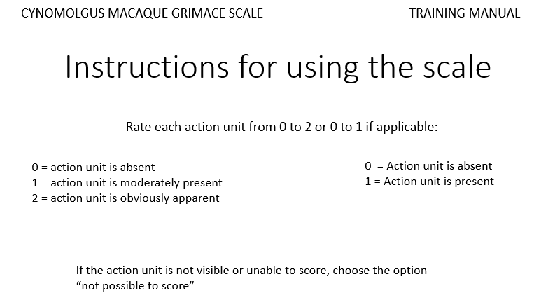
(a)
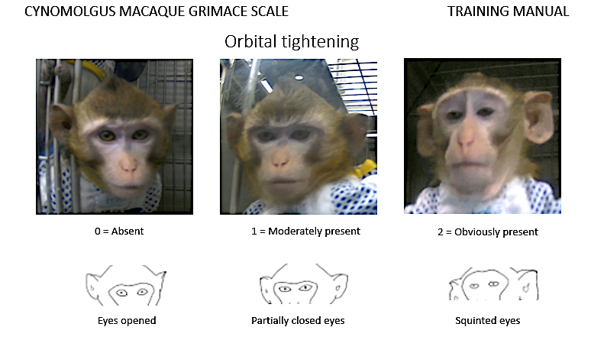

(b)
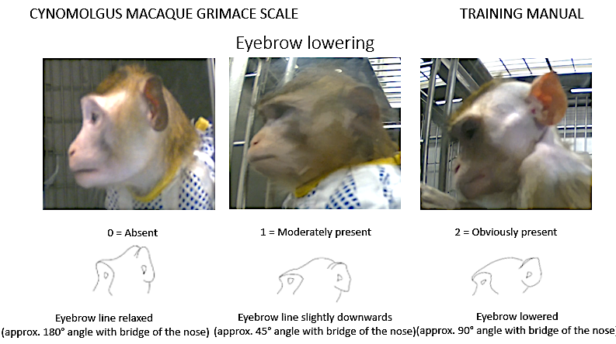
(c)
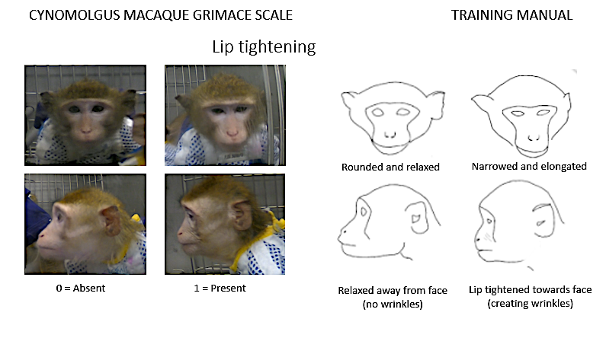

(d)
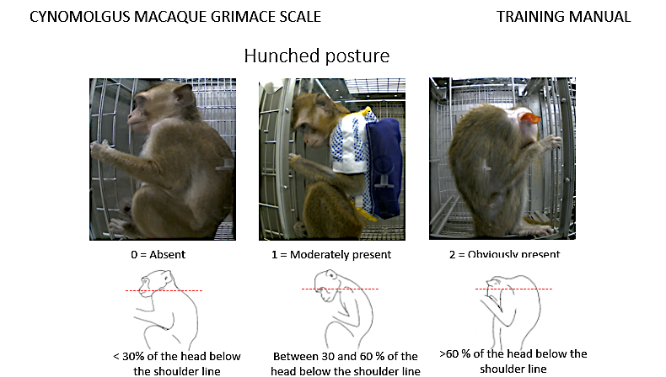

Survey questions
- Job title
- Gender
- How many years have you worked with primates?
- How much time would you say it took you to score images during Week 1?
Less than 1 h
1 – 2 h
More than 3 h
- How much time would you say it took you to score images during Week 2?
Less than 1 h
1 – 2 h
More than 3 h
- How much time would you say it took you to score images during Week 3?
Less than 1 h
1 – 2 h
More than 3 h
- How confident did you feel when scoring images Week 1 on a scale from 0 -2?
0: Not confident
1: Confident
2: Very confident
- How confident did you feel when scoring images Week 2 on a scale from 0 -2?
0: Not confident
1: Confident
2: Very confident
- How confident did you feel when scoring images Week 3 on a scale from 0 -2?
0: Not confident
1: Confident
2: Very confident
- Do you think this is a useful tool that you could use at your facility?
Yes
No
- Do you think it would be straight forward to train technical staff to use this tool?
Yes
No
- In your opinion which was the most difficult parameter to score?
Eyebrow lowering
Lip tightening
Orbital tightening
Posture
- In your opinion which was the easiest parameter to score?
Eyebrow lowering
Lip tightening
Orbital tightening
Posture
- Please write out any other comments about your experience using the grimace scale?

Table S6. Sampling strategy of 6 subject characteristics and time point assessed.
Cage | Animals  ID | Social group | Sex | Age | Time of day and condition
7 | 13M  14M | 2 | M | 2.17  2.14 | 19:00-20:00  (baseline)
8 | 15M  16M | 2 | M | 2.14  2.13 | 17:00 -18:00  (post-op)
16 | 35F  36F | 2 | F | 2.13  2.12 | 16:00-17:00  (baseline)

F: Female, M: Male

Table S7. Intra-observer reliability of 12 raters of the cynomolgus macaque grimace scale.
Cohort | 1 |  |  |  | 2 |  |  |  | 3
Rater | 3 | 6 | 10 | 12 | 5 | 7 | 8 | 9 | 1 | 2 | 4 | 11
Gender | F | M | F | M | F | M | F | M | F | F | F | M
ICCsingle (95% CI) | 0.94 (0.85-0.97) | 0.71 (0.34-0.87) | 0.62 (0.17-0.85) | 0.67 (0.33-0.86) | 0.79 (0.58-0.91) | 0.66 (0.35-0.84) | 0.86 (0.71-0.94) | 0.68 (0.34- 0.85) | 0.85 (0.60-0.95) | 1  (-) | 1  (-) | 0.66 (0.25-0.87)

Intraclass correlation coefficient (ICC) estimates with respective 95% confidence intervals (95% CI) were calculated using a two-way random effects model for absolute agreement based on single (ICC_{single}) and average (ICC_{average}) measures (4 raters per cohort, total of 12 raters). The interpretation of ICC values was based ICC_{single} and is as follows: below 0.5 = poor reliability, between 0.5 and 0.75 = moderate reliability, between 0.75 and 0.9 = good reliability, and above 0.9 = excellent reliability (Koo and Li, 2016).

Table S8. Facial grimace scores in relation to pre- and post-surgical time points (N=43 primates).
 | Time  points | Absolute time | Time relative to surgery (h) | LS Mean  (95% CI) | Standard  Error
Baseline | 1B | ¹6:30-7:30  ²7:00-8:00 | -72 - 168 | 0.21 (0.14-0.28) | 0.02
Baseline | 2B | 16:00-17:00 | -72 -168 | 0.19 (0.11-0.26) | 0.02
Baseline | 3B | 17:00-18:00 | -72 -168 | 0.20 (0.13-0.27) | 0.02
Baseline | 4B | 18:00-19:00 | -72 -168 | 0.19 (0.13-0.27) | 0.02
Post-Op | 1P | 16:00-17:00 | +3 | 0.47 (0.39-0.54) | 0.02
Post-Op | 2P | 17:00-18:00 | +4 | 0.49 (0.42-0.56) | 0.02
Post-Op | 3P | 18:00-19:00 | +5 | 0.48 (0.41-0.54) | 0.02
Post-Op | 4P | ¹6:30-7:30  ²7:00-8:00 | +17 | 0.36 (0.29-0.42) | 0.02
Post-Op | 5P | 17:00-18:00 | +24 | 0.27 (0.20-0.33) | 0.02
Post-Op | 6P | ¹6:30-7:30  ²7:00-8:00 | +36 | 0.28 (0.21-0.35) | 0.02

Least-square (LS) means and their 95% confidence interval (95% CI) were calculated using a Gaussian linear mixed model (n=43) and respective standard errors are presented.

⁻Indicative of pre-surgical period
⁺Indicative of post-surgical period
¹Cohort 1 animals (different time due to different light cycle)
²Cohort 2 animals (different time due to different light cycle)
^{B}Baseline period
^{P}Post-operative period

Table S9. Pre- and post-operative Cynomolgus Macaque Grimace Scale (CMGS) score respective time interval comparison.
Time point comparison | Absolute time comparison |  | Size effect estimate (±SE) (P value)
1P-2B |  | 16:00-17:00 | 0.28 (0.03) (p<0.0001)
2P-3B |  | 17:00-18:00 | 0.29 (0.03) (p<0.0001)
3P-4B |  | 18:00-19:00 | 0.28 (0.03) (p<0.0001)
4P-1B |  | ¹6:30-7:30  ²7:00-8:00 | 0.15 (0.03) (p<0.0001)
5P-3B |  | 17:00-18:00 | 0.07 (0.03) (p=0.208)
6P-1B |  | ¹6:30-7:30  ²7:00-8:00 | 0.07 (0.03) (p=0.188)

Absolute size effect estimates, and their standard error (SE) and P values were calculated using a pairwise comparison with a Turkey’s adjustment for multiple comparison. Significant effects are indicated in bold.

¹Cohort 1 animals (different time due to different light cycle)
²Cohort 2 animals (different time due to different light cycle)
^{B}Baseline period
^{P}Post-operative period

Table S10. Comparison of pre- and post-operative behaviour effect size estimates (mean ± SE) of respective time interval comparison (absolute values presented).
 |  | Behaviour Category
 |  | Positive species-typical |  |  | General activity/maintenance |  | Social interactions |  | Pain-associated behaviours
Time point comparison | Absolute time comparison | Forage | Play | MCR* | Active | Eat | Allo-grooming | Embrace/  huddle | MVTW* | Hunched | Self-groom
5P-3B | 16:00-17:00 | 0.06  (0.03)  p=0.8041 | 0.02  (0.03)  p=1.0000 | 0.10  (0.04)  p=0.1708 | 0.23  (0.04)  p<0.0001 | 0.25  (0.07)  p=0.0098 | 0.00  (0.01)  p=1.0000 | 0.26  (0.07)  p=0.0130 | 0.04  (0.02)  p=0.5520 | 0.17  (0.04)  p=0.0034 | 0.01 (0.02)  p=1.0000
6P-4B | 17:00-18:00 | 0.16  (0.03)  p=0.0002 | 0.08  (0.03)  p=0.3542 | 0.17  (0.04)  p=0.0005 | 0.17  (0.04)  p=0.0014 | 0.28  (0.07) p=0.0013 | 0.00  (0.01)  p=1.000 | 0.23  (0.07)  p=0.0502 | 0.06  (0.02)  p=0.0683 | 0.17  (0.04) p=0.0023 | 0.01  (0.02)  p=1.0000
7P-5B | 18:00-19:00 | 0.16  (0.03)  p=0.0001 | 0.12  (0.03)  p=0.0174 | 0.24  (0.04)  p<0.0001 | 0.24  (0.04)  p<0.0001 | 0.28  (0.06)  p=0.0010 | 0.00  (0.01)  p=1.0000 | 0.31  (0.07)  p=0.0004 | 0.07  (0.02)  p=0.0391 | 0.20  (0.04)  p<0.0001 | 0.03  (0.02)  p=0.9765
20P-1B | ¹6:30-7:30  ²7:00-8:00 | 0.09  (0.03)  p=0.2530 | 0.23  (0.03)  p<0.0001 | 0.14  (0.04)  p=0.0057 | 0.00  (0.04)  p=1.0000 | 0.02  (0.06)  p=1.0000 | 0.06  (0.01)  p=0.0003 | 0.10  (0.07)  p=0.9577 | 0.11  (0.02)  p<0.0001 | 0.02  (0.04)  p=1.0000 | 0.07  (0.02)  p=0.0510
21P-2B | 12:00-13:00 | 0.05  (0.04)  p=0.9780 | -0.02  (0.04)  p=1.0000 | 0.08  (0.04)  p=0.6437 | 0.02  (0.04)  p=1.0000 | 0.02  (0.07)  p=1.0000 | 0.02  (0.01) p=0.9848 | 0.01  (0.07)  p=1.0000 | 0.06  (0.02)  p=0.2311 | 0.08  (0.04)  p=0.7879 | 0.06  (0.02)  p=0.2196
22P- 4B | 17:00-18:00 | 0.10  (0.03)  p=0.1274 | 0.03  (0.03)  p=0.9989 | 0.16  (0.04)  p=0.0012 | 0.07  (0.04)  p=0.7864 | 0.15  (0.07)  p=0.4828 | 0.02  (0.01) p=0.8482 | 0.36  (0.07)  p<0.0001 | 0.05  (0.02)  p=0.2910 | 0.11  (0.04)  p=0.3135 | 0.08  (0.02)  p=0.0201

Absolute size effect estimates, and their standard error (SE) and P values were calculated using a pairwise comparison with a Turkey’s adjustment for multiple comparison. Significant effects are indicated in bold.

*MVTW: Movement Directed Towards the Wound; MCR: Manipulation of Cage Resources
¹Cohort 1 animals (different time due to different light cycle)
²Cohort 2 animals (different time due to different light cycle)
^{B}Baseline period
^{P}Post-operative period

