Supplementary Table 1. Baseline characteristics of study participants, National Health and Nutrition Examination Survey (US, 1999-2006) and Korea National Health and Nutrition Examination Survey (Korea, 2008-2011)

 | NHANES |  |  | Korea NHANES
 | Men | Women |  | Men | Women
 | Mean (SE) or W% |  | p-value | Mean (SE) or W% |  | p-value
Unweighted N | 9,141 | 8,920 |  | 8,107 | 10,754
Sex | 49.3% | 50.7% |  | 49.7% | 50.3%
Age, years | 43.2 (0.3) | 45.3 (0.3) | < 0.001 | 43.2 (0.3) | 45.5 (0.3) | < 0.001
18-29 | 23.6% | 20.1% | < 0.001 | 22.4% | 19.7% | < 0.001
30-39 | 20.7% | 19.4% |  | 22.1% | 20.2%
40-49 | 21.9% | 22.3% |  | 22.2% | 21.6%
50-59 | 16.7% | 17.2% |  | 17.1% | 17.0%
60-69 | 10.3% | 11.3% |  | 9.7% | 10.7%
≥70 | 6.8% | 9.6% |  | 6.5% | 10.7%
BMI*, kg/m² | 27.9 (0.1) | 28.2 (0.1) | 0.014 | 24.0 (0.1) | 23.1 (0.1) | < 0.001
< 18.5 | 1.4% | 2.7% | < 0.001 | 3.4% | 6.8% | < 0.001
18.5-24.9 | 29.9% | 36.6% |  | 35.8% | 45.8%
25-29.9 | 39.9% | 27.6% |  | 25.1% | 20.8%
≥ 30 | 28.8% | 33.2% |  | 35.7% | 26.6%
WC*, cm | 99.3 (0.3) | 93.0 (0.3) | < 0.001 | 83.7 (0.2) | 77.6 (0.2) | < 0.001
≥ 102 cm (men)  or ≥ 88 cm (women) | 39.5% | 57.8% | < 0.001 | 24.1% | 39.0% | < 0.001
Height, cm | 176.3 (0.1) | 162.3 (0.1) | < 0.001 | 170.7 (0.1) | 157.2 (0.1) | < 0.001
Waist-height ratio | 0.56 | 0.57 | < 0.001 | 0.49 | 0.50 | < 0.001
Fat mass, kg | 25.2 (0.2) | 30.7 (0.2) | < 0.001 | 15.5 (0.1) | 18.9 (0.1) | < 0.001
FMI, kg/m2 | 8.1 (0.06) | 11.6 (0.09) | < 0.001 | 5.3 (0.03) | 7.7 (0.4) | < 0.001
PBF, % | 27.7 (0.1) | 39.6 (0.1) | < 0.001 | 22.0 (0.1) | 32.9 (0.1) | < 0.001
Lean body mass, kg | 59.9 (0.2) | 42.1 (0.1) | < 0.001 | 51.1 (0.1) | 35.8 (0.07) | < 0.001
LMI, kg/m2 | 19.2 (0.05) | 15.9 (0.05) | < 0.001 | 17.5 (0.03) | 14.5 (0.03) | < 0.001
Truncal fat, kg | 13.1 (0.08) | 14.5 (0.09) | < 0.001 | 8.4 (0.06) | 9.4 (0.06) | < 0.001
ASMI, kg/m2 | 8.6 (0.02) | 6.7 (0.02) | < 0.001 | 7.7 (0.02) | 5.9 (0.01) | < 0.001
Ethnicity
Non-Hispanic white | 71.5% | 70.7% | < 0.001 | NA | NA | NA
Non-Hispanic black | 10.3% | 11.7% |  | NA | NA | NA
Mexican-American | 8.4% | 6.8% |  | NA | NA | NA
Other Hispanic | 4.9% | 5.6% |  | NA | NA | NA
Other | 4.9% | 5.1% |  | NA | NA | NA
Smoking statusª |  |  |  | NA | NA | NA
Never | 43.2% | 57.0% | < 0.001 | 40.2% | 90.5% | < 0.001
Past | 28.7% | 22.2% |  | 13.7% | 2.9%
Current | 28.1% | 20.8% |  | 46.1% | 6.6%
MVPA, yes | 68.5% | 65.3% | < 0.001 | 26.8% | 21.8% | < 0.001
Blood pressureª
SBP, mmHg | 123.0 (0.2) | 120.9 (0.2) | < 0.001 | 120.4 (0.3) | 115.5 (0.3) | < 0.001
DBP, mmHg | 73.1 (0.1) | 70.7 (0.1) | < 0.001 | 79.9 (0.2) | 74.0 (0.2) | < 0.001
Obesity-related biomarkers
Total cholesterol, mg/dL | 199.4 (0.5) | 201.5 (0.4) | 0.001 | 185.6 (0.6) | 185.8 (0.5) | < 0.001
LDL-C, mg/dL | 155.6 (2.2) | 129.9 (1.9) | 0.005 | 110.3 (0.5) | 113.1 (0.4) | < 0.001
HDL-C, mg/dL | 47.1 (0.1) | 57.6 (0.2) | < 0.001 | 45.8 (0.2) | 50.9 (0.2) | < 0.001
TG, mg/dL^{b} | 128.0 | 109.8 | < 0.001 | 126.2 | 93.0 | < 0.001
CRP, mg/dL | 0.315 (0.008) | 0.577 (0.01) | < 0.001 | NA | NA | NA
FBG, mg/dL | 103.3 (0.5) | 99.6 (0.5) | < 0.001 | 98.0 (0.3) | 94.8 (0.3) | < 0.001
HbA1c, %^{c} | 5.5 (0.01) | 5.4 (0.01) | 0.002 | 6.7 (0.07) | 6.6 (0.07) | 0.002
Insulin, μU/ml^{c} | 12.5 (0.2) | 11.4 (0.2) | < 0.001 | 10.1 (0.1) | 10.1 (0.1) | 0.325
Chronic diseases
No | 79.5% | 69.3% | < 0.001 | 89.1% | 84.7% | < 0.001
Yes^{d} | 20.5% | 30.7% |  | 10.9% | 15.3%
Cancer | 5.9% | 8.8% | < 0.001 | 1.6% | 3.2% | < 0.001
Coronary heart disease | 6.4% | 4.6% | < 0.001 | 1.7% | 1.7% | 0.322
Congestive heart failure | 2.2% | 1.7% | < 0.001 | NA | NA | NA
Stroke | 1.7% | 2.5% | < 0.001 | 1.5% | 1.1% | 0.026
Thyroid disease | 3.0% | 13.1% | < 0.001 | 0.9% | 5.4% | < 0.001
Chronic pulmonary disease | 5.2% | 9.3% | < 0.001 | 4.0% | 4.4% | 0.233
Liver disease | 3.7% | 2.6% | < 0.001 | 2.3% | 1.5% | < 0.001
WC, waist circumference; FMI, fat mass index; PBF, percentage body fat; LMI, lean mass index; MVPA, Moderate to vigorous physical activity; SBP, systolic blood pressure; DBP, diastolic blood pressure; LDL-C, low density lipoprotein cholesterol; HDL-C, high density lipoprotein cholesterol; TG, triglyceride; CRP, C-reactive protein; FBG, fasting blood glucose; NA, not applicable

ª Information on smoking status and blood pressure measurement was available in 16,020 and 16,962 participants, respectively
^{b} Geometric mean
^{c} Information on HbA1c and insulin was available in 3748 and 15823 Korean participants, respectively.
^{d} The presence of chronic diseases was defined when individuals have as least one disease among cancer, coronary heart disease, congestive heart failure, stroke, thyroid disease, chronic pulmonary disease, and liver disease.

*For Koreans, BMI was categorized into < 18.5, 18.5-22.9, 23-24.9, and ≥25 kg/m² and cut-off of WC was 90cm in men and 80cm in women.

Supplementary Table 2. Baseline characteristics of participants included versus excluded.

 | NHANES |  |  | Korea NHANES
 | Inclusion  (n=18,061) | Exclusion  (n=2,317) |  | Inclusion  (n=18,861) | Exclusion  (n=640)
 | Mean (SE) or W% |  | p-value | Mean (SE) or W% |  | p-value
Sex, male | 49.4% | 32.5% | < 0.001 | 49.7% | 48.3% | 0.803
Age, years | 43.9 (0.3) | 43.1 (0.8) | < 0.001 | 44.4 (0.3) | 46.1 (2.1) | 0.208
18-29 | 22.5% | 32.9% | < 0.001 | 21.0% | 13.3% | 0.074
30-39 | 20.6% | 22.0% |  | 22.2% | 27.3%
40-49 | 21.9% | 12.8% |  | 21.9% | 26.6%
50-59 | 16.6% | 9.7% |  | 17.1% | 8.9%
60-69 | 10.8% | 6.9% |  | 10.2% | 10.3%
≥70 | 7.6% | 15.7% |  | 8.6% | 13.6%
BMI*, kg/m² | 28.0 (0.1) | 29.6 (0.3) | < 0.001 | 23.6 (0.03) | 23.8 (0.6) | 0.908
< 18.5 | 2.1% | 2.2% | 0.001 | 5.1% | 4.4% | 0.966
18.5-24.9 | 33.4% | 29.0% |  | 63.8% | 61.8%
25-29.9 | 33.5% | 29.7% |  | 27.2% | 29.9%
≥ 30 | 31.0% | 39.1% |  | 4.0% | 4.0%
WC*, cm | 96.0 (0.3) | 99.9 (0.7) | < 0.001 | 80.7 (0.1) | 92.6 (3.5) | 0.003
Height, cm | 169.3 (0.1) | 165.9 (0.4) | < 0.001 | 170.7 (0.1) | 157.2 (0.1) | < 0.001
WHtR | 0.57 | 0.61 |  | 0.49 | 0.53
Fat mass, kg | 27.9 (0.2) | 31.0 (0.8) | < 0.001 | 17.3 (0.1) | 17.7 (0.7) | 0.645
FMI, kg/m2 | 9.9 (0.1) | 11.3 (0.3) | < 0.001 | 6.5 (0.03) | 6.8 (0.3) | 0.573
PBF, % | 33.7 (0.1) | 35.8 (0.5) | < 0.001 | 27.5 (0.1) | 28.3 (0.9) | 0.590
Lean body mass, kg | 53.4 (0.1) | 53.2 (0.9) | 0.224 | 43.4 (0.1) | 43.2 (1.5) | 0.776
LMI, kg/m2 | 18.4 (0.04) | 19.0 (0.3) | < 0.001 | 16.0 (0.03) | 15.9 (0.4) | 0.769
Truncal fat, kg | 13.8 (0.1) | 15.5 (0.4) | < 0.001 | 9.0 (0.1) | 9.3 (0.5) | 0.468
ASMI, kg/m2 | 8.1 (0.02) | 8.3 (0.1) | 0.109 | 6.8 (0.02) | 6.7 (0.2) | 0.826
Ethnicity
Non-Hispanic white | 71.1% | 62.5% | <0.001 | NA | NA | NA
Non-Hispanic black | 11.0% | 15.8% |  | NA | NA | NA
Mexican-American | 7.0% | 9.5% |  | NA | NA | NA
Other Hispanic | 5.3% | 5.7% |  | NA | NA | NA
Other | 5.1% | 6.5% |  | NA | NA | NA

Supplementary Table 3. Pearson correlation of waist circumference, percentage body fat, lean body mass index and fat mass index with waist-height ratio by sex and age group in National Health and Nutrition Examination Survey (NHANES) and Korea NHANES

Age group (years) | WC | FMI | PBF | TF | LMI | ASMI
NHANES
Men | 0.958 | 0.941 | 0.859 | 0.915 | 0.758 | 0.606
18-29 | 0.966 | 0.961 | 0.888 | 0.942 | 0.818 | 0.727
30-39 | 0.954 | 0.950 | 0.849 | 0.921 | 0.801 | 0.695
40-49 | 0.957 | 0.944 | 0.834 | 0.914 | 0.833 | 0.720
50-59 | 0.940 | 0.935 | 0.818 | 0.881 | 0.807 | 0.678
60-69 | 0.947 | 0.928 | 0.799 | 0.880 | 0.796 | 0.666
≥70 | 0.934 | 0.903 | 0.781 | 0.843 | 0.745 | 0.615
Women | 0.970 | 0.904 | 0.798 | 0.904 | 0.817 | 0.727
18-29 | 0.972 | 0.923 | 0.821 | 0.923 | 0.859 | 0.795
30-39 | 0.971 | 0.922 | 0.810 | 0.920 | 0.855 | 0.784
40-49 | 0.971 | 0.915 | 0.793 | 0.924 | 0.864 | 0.804
50-59 | 0.969 | 0.899 | 0.768 | 0.905 | 0.853 | 0.786
60-69 | 0.964 | 0.874 | 0.726 | 0.877 | 0.836 | 0.759
≥70 | 0.955 | 0.841 | 0.683 | 0.826 | 0.783 | 0.689
Korea NHANES
Men | 0.939 | 0.783 | 0.664 | 0.771 | 0.631 | 0.479
18-29 | 0.963 | 0.871 | 0.748 | 0.868 | 0.721 | 0.649
30-39 | 0.948 | 0.831 | 0.692 | 0.808 | 0.698 | 0.609
40-49 | 0.945 | 0.812 | 0.664 | 0.801 | 0.678 | 0.579
50-59 | 0.931 | 0.752 | 0.588 | 0.722 | 0.630 | 0.531
60-69 | 0.944 | 0.763 | 0.635 | 0.734 | 0.651 | 0.530
≥70 | 0.952 | 0.819 | 0.699 | 0.791 | 0.668 | 0.526
Women | 0.954 | 0.787 | 0.616 | 0.781 | 0.698 | 0.560
18-29 | 0.960 | 0.837 | 0.669 | 0.838 | 0.716 | 0.653
30-39 | 0.961 | 0.830 | 0.632 | 0.831 | 0.753 | 0.690
40-49 | 0.957 | 0.800 | 0.601 | 0.804 | 0.697 | 0.611
50-59 | 0.951 | 0.773 | 0.553 | 0.743 | 0.633 | 0.527
60-69 | 0.946 | 0.768 | 0.581 | 0.737 | 0.623 | 0.485
≥70 | 0.946 | 0.820 | 0.698 | 0.768 | 0.610 | 0.437
Supplementary Table 4. Partial correlation of waist circumference, percentage body fat, lean body mass index and fat mass index with body mass index by presence of comorbidities adjusted for age (as continuous variable)

 | WC, cm | BMI, kg/m² | FMI, kg/m2 | PBF, % | LMI, kg/m² | WC | FMI | PBF | LMI
Presence of comorbidities | Mean (SE) | Mean (SE) | Mean (SE) | Mean (SE) | Mean (SE) | Correlation coefficients with BMI
Comorbidities
Men
No | 98.0 (0.3) | 27.7 (0.1) | 7.9 (0.1) | 27.2 (0.1) | 19.2 (0.1) | 0.936 | 0.947 | 0.925 | 0.927
Yes | 104.3 (0.5) | 28.8 (0.2) | 8.9 (0.1) | 30.0 (0.2) | 19.3 (0.1) | 0.933 | 0.949 | 0.927 | 0.930
Women
No | 91.4 (0.4) | 27.8 (0.1) | 11.3 (0.1) | 39.0 (0.2) | 15.9 (0.1) | 0.919 | 0.977 | 0.956 | 0.930
Yes | 96.5 (0.4) | 29.1 (0.2) | 12.4 (0.1) | 41.1 (0.2) | 16.1 (0.1) | 0.908 | 0.979 | 0.955 | 0.932
Cancer
Men
No | 99.0 (0.3) | 27.9 (0.1) | 8.1 (0.1) | 27.6 (0.1) | 19.3 (0.1) | 0.936 | 0.948 | 0.926 | 0.929
Yes | 103.7 (0.6) | 28.0 (0.2) | 8.7 (0.1) | 30.2 (0.2) | 18.6 (0.1) | 0.934 | 0.936 | 0.919 | 0.895
Women
No | 92.8 (0.4) | 28.2 (0.1) | 11.6 (0.1) | 39.5 (0.2) | 16.0 (0.1) | 0.918 | 0.978 | 0.957 | 0.932
Yes | 95.1 (0.7) | 28.1 (0.3) | 11.8 (0.2) | 40.6 (0.3) | 15.7 (0.1) | 0.895 | 0.977 | 0.949 | 0.928
Coronary heart disease
Men
No | 98.8 (0.3) | 27.9 (0.1) | 8.0 (01) | 27.5 (0.1) | 19.2 (0.1) | 0.936 | 0.947 | 0.926 | 0.928
Yes | 105.5 (0.7) | 29.1 (0.3) | 9.2 (0.2) | 30.7 (0.3) | 19.3 (0.1) | 0.930 | 0.943 | 0.921 | 0.919
Women
No | 92.7 (0.3) | 28.1 (0.1) | 11.6 (0.1) | 39.5 (0.1) | 16.0 (0.1) | 0.916 | 0.978 | 0.956 | 0.932
Yes | 99.2 (0.8) | 29.7 (0.4) | 13.0 (0.2) | 42.5 (0.3) | 16.1 (0.2) | 0.894 | 0.971 | 0.949 | 0.915
Congestive heart failure
Men
No | 99.1 (0.3) | 27.9 (0.1) | 8.1 (0.1) | 27.7 (0.1) | 19.2 (0.1) | 0.936 | 0.947 | 0.926 | 0.928
Yes | 107.2 (1.4) | 29.5 (0.5) | 9.5 (0.3) | 31.1 (0.6) | 19.4 (0.2) | 0.938 | 0.941 | 0.914 | 0.919
Women
No | 92.8 (0.3) | 28.1 (0.1) | 11.6 (0.1) | 39.6 (0.1) | 15.9 (0.1) | 0.916 | 0.978 | 0.956 | 0.931
Yes | 104.0 (1.6) | 32.1 (0.9) | 14.5 (0.6) | 43.5 (0.6) | 17.1 (0.3) | 0.880 | 0.983 | 0.958 | 0.947
Stroke
Men
No | 99.1 (0.3) | 27.9 (0.1) | 8.1 (0.1) | 27.2 (0.1) | 19.2 (0.1) | 0.936 | 0.947 | 0.926 | 0.928
Yes | 106.3 (1.2) | 29.6 (0.5) | 9.7 (0.3) | 31.7 (0.4) | 19.2 (0.2) | 0.926 | 0.941 | 0.920 | 0.911
Women
No | 92.8 (0.3) | 28.1 (0.1) | 11.6 (0.1) | 39.6 (0.1) | 16.0 (0.1) | 0.917 | 0.978 | 0.956 | 0.932
Yes | 99.2 (1.0) | 29.5 (0.5) | 12.7 (0.3) | 41.6 (0.5) | 16.2 (0.2) | 0.880 | 0.970 | 0.951 | 0.912
Thyroid disease
Men
No | 99.1 (0.3) | 27.9 (0.1) | 8.1 (0.1) | 27.7 (0.1) | 19.2 (0.1) | 0.937 | 0.947 | 0.926 | 0.927
Yes | 104.2 (1.3) | 28.9 (0.5) | 8.9 (0.3) | 29.7 (0.6) | 19.4 (0.2) | 0.925 | 0.949 | 0.914 | 0.933
Women
No | 92.4 (0.4) | 28.0 (0.1) | 11.5 (0.1) | 39.3 (0.2) | 15.9 (0.1) | 0.917 | 0.977 | 0.956 | 0.931
Yes | 97.0 (0.5) | 29.4 (0.3) | 12.7 (0.2) | 41.5 (0.2) | 16.2 (0.1) | 0.907 | 0.980 | 0.954 | 0.936
Chronic pulmonary disease
Men
No | 99.0 (0.3) | 27.9 (0.1) | 8.0 (0.1) | 27.6 (0.1) | 19.2 (0.1) | 0.936 | 0.947 | 0.925 | 0.926
Yes | 104.9 (1.1) | 29.1 (0.4) | 9.1 (0.2) | 29.9 (0.4) | 19.4 (0.2) | 0.945 | 0.958 | 0.938 | 0.945
Women
No | 92.5 (0.4) | 28.0 (0.1) | 11.5 (0.1) | 39.5 (0.1) | 15.9 (0.1) | 0.915 | 0.977 | 0.955 | 0.930
Yes | 98.0 (0.7) | 29.8 (0.3) | 12.8 (0.2) | 41.2 (0.3) | 16.4 (0.1) | 0.915 | 0.981 | 0.959 | 0.939
Liver disease
Men
No | 99.1 (0.3) | 27.9 (0.1) | 8.1 (0.1) | 27.7 (0.1) | 19.2 (0.1) | 0.937 | 0.947 | 0.926 | 0.927
Yes | 102.7 (1.1) | 28.5 (0.4) | 8.6 (0.2) | 28.9 (0.4) | 19.4 (0.2) | 0.928 | 0.948 | 0.928 | 0.932
Women
No | 92.9 (0.3) | 28.1 (0.1) | 11.6 (0.1) | 39.6 (0.1) | 16.0 (0.1) | 0.915 | 0.978 | 0.956 | 0.931
Yes | 97.3 (1.5) | 29.5 (0.7) | 12.5 (0.4) | 40.5 (0.6) | 16.4 (0.3) | 0.936 | 0.979 | 0.961 | 0.929

WC, waist circumference; FMI, fat mass index; PBF, percentage body fat; LMI, lean mass index; BMI, body mass index
All p values < 0.001

Supplementary Figure 1. Flow chart of the study population in National Health and Nutrition Examination Survey (NHANES)

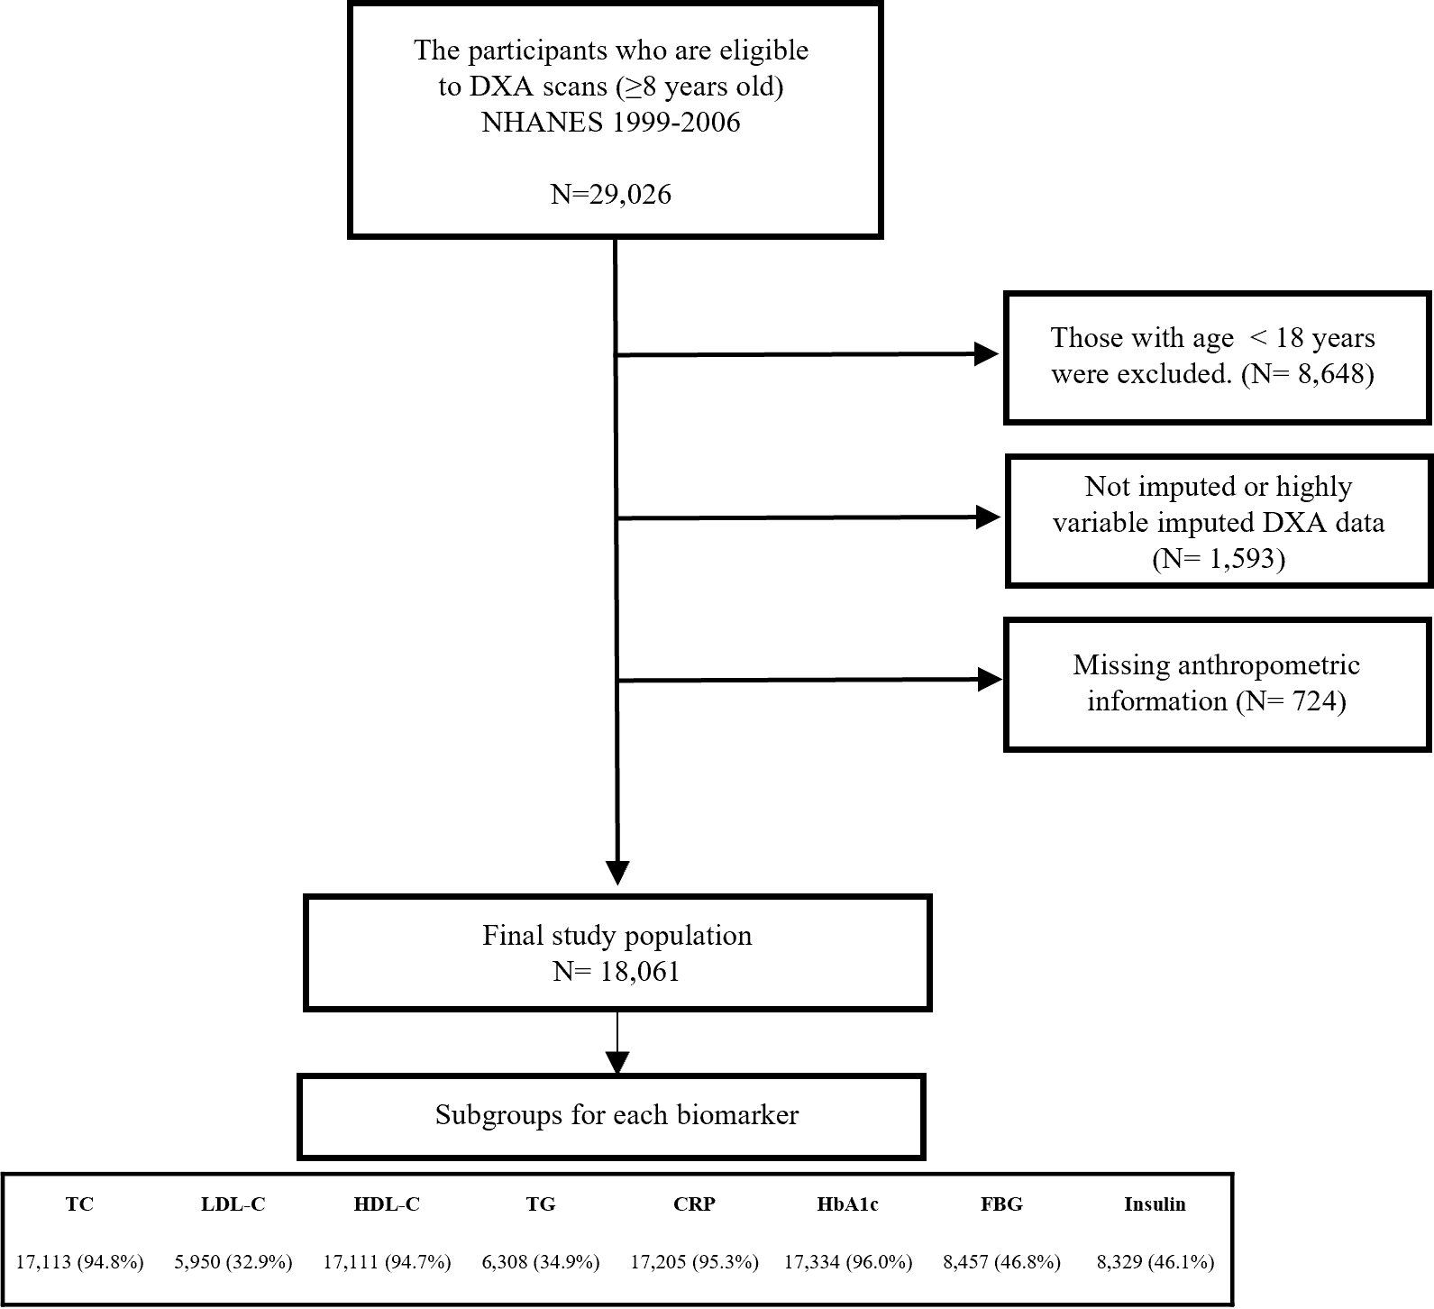

DXA, dual-energy X-ray absorptiometry TC, total cholesterol, LDL-C, low-density lipoprotein cholesterol, HDL-C, high-density lipoprotein cholesterol, TG, triglycerides, CRP, C-reactive protein, HbA1c, hemoglobinA1c, FBG, fasting blood glucose
Supplementary Figure 2. Flow chart of the study population in Korea National Health and Nutrition Examination Survey (KNHANES)

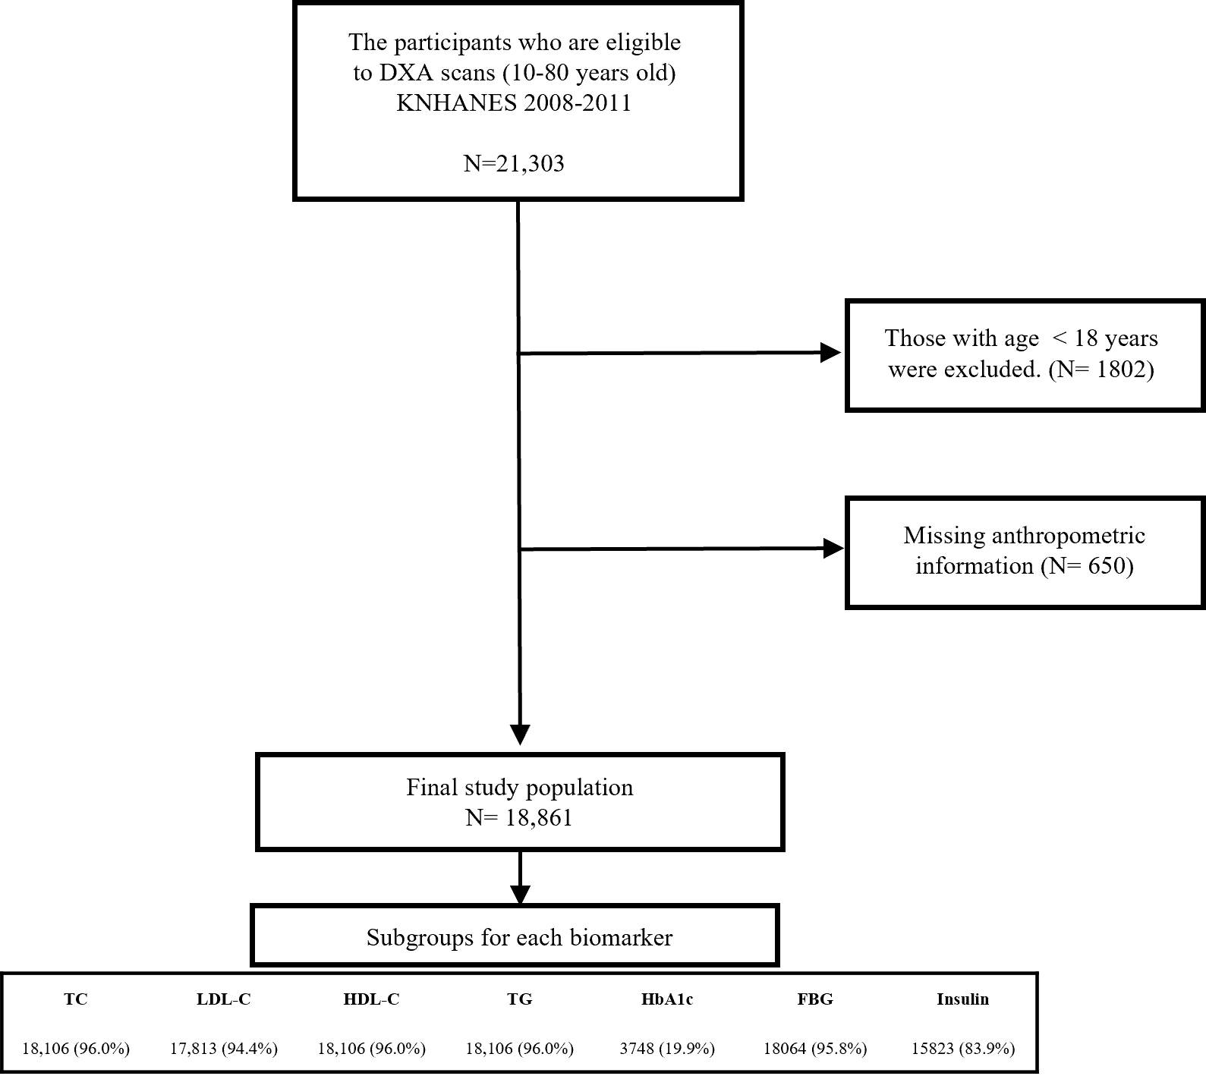
DXA, dual-energy X-ray absorptiometry TC, total cholesterol, LDL-C, low-density lipoprotein cholesterol, HDL-C, high-density lipoprotein cholesterol, TG, triglycerides HbA1c, hemoglobinA1c, FBG, fasting blood glucose

Supplementary Figure 3. Scatter plots for body mass index and fat mass index by sex and age groups
Legend: The plots of A - F show relationships between body mass index and fat mass index (FMI) in (A) 18-29 years (B) 30-39 years (C) 40-49 years, (D) 50-59 years (E) 60-69 years, and (F) ≥ 70 years.

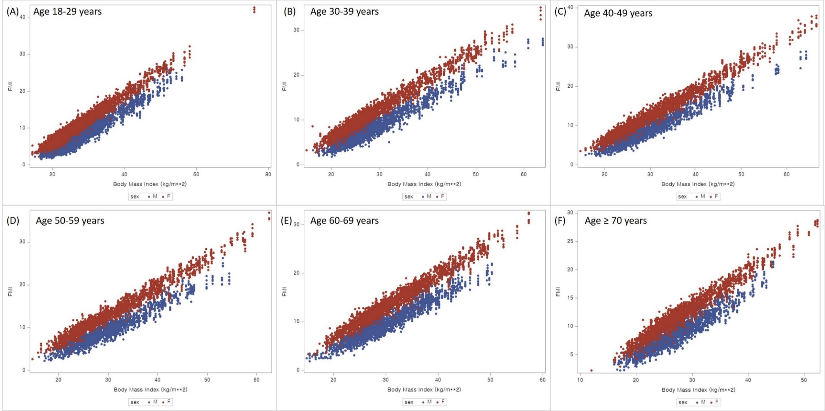

Supplementary Figure 4. Scatter plots for body mass index and percentage body fat by sex and age groups
Legend: The plots of A - F show relationships between body mass index and percentage body fat in (A) 18-29 years (B) 30-39 years (C) 40-49 years, (D) 50-59 years (E) 60-69 years, and (F) ≥ 70 years.

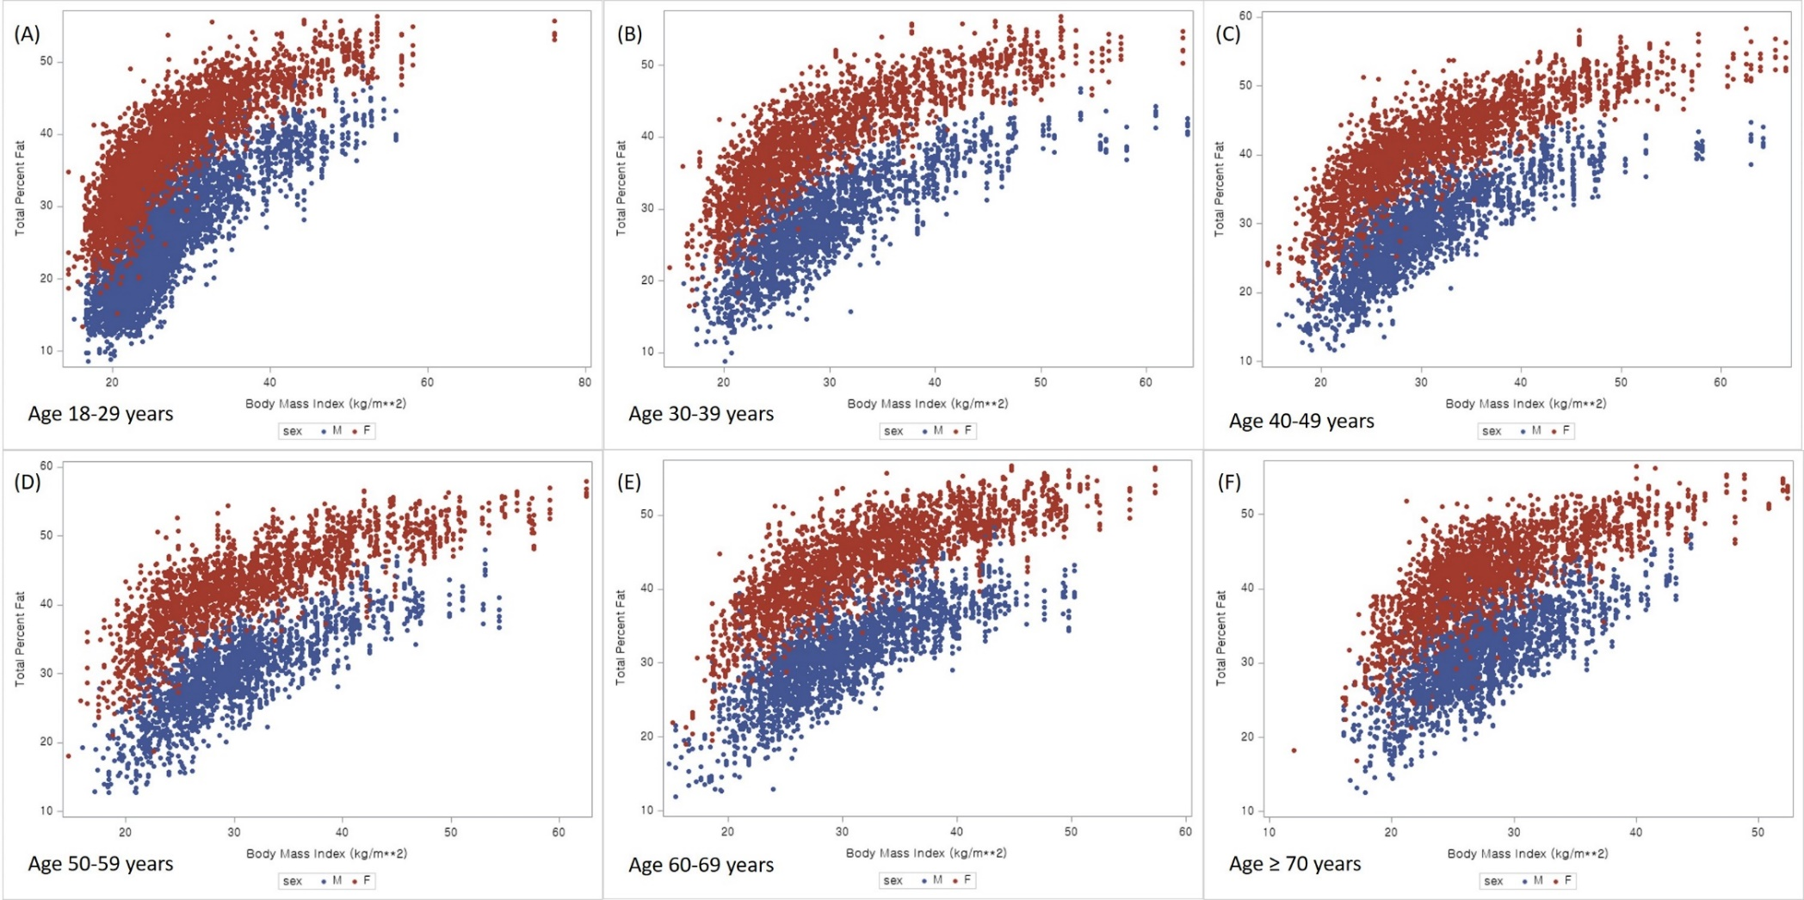

Supplementary Figure 5. Scatter plots for body mass index and fat mass index by race-ethnicity and sex

Legend: The plots of A - D show relationships between body mass index and fat mass index (FMI) in (A) whites (B) blacks (C) Mexican-Americans, and (D) Asians (Korean).
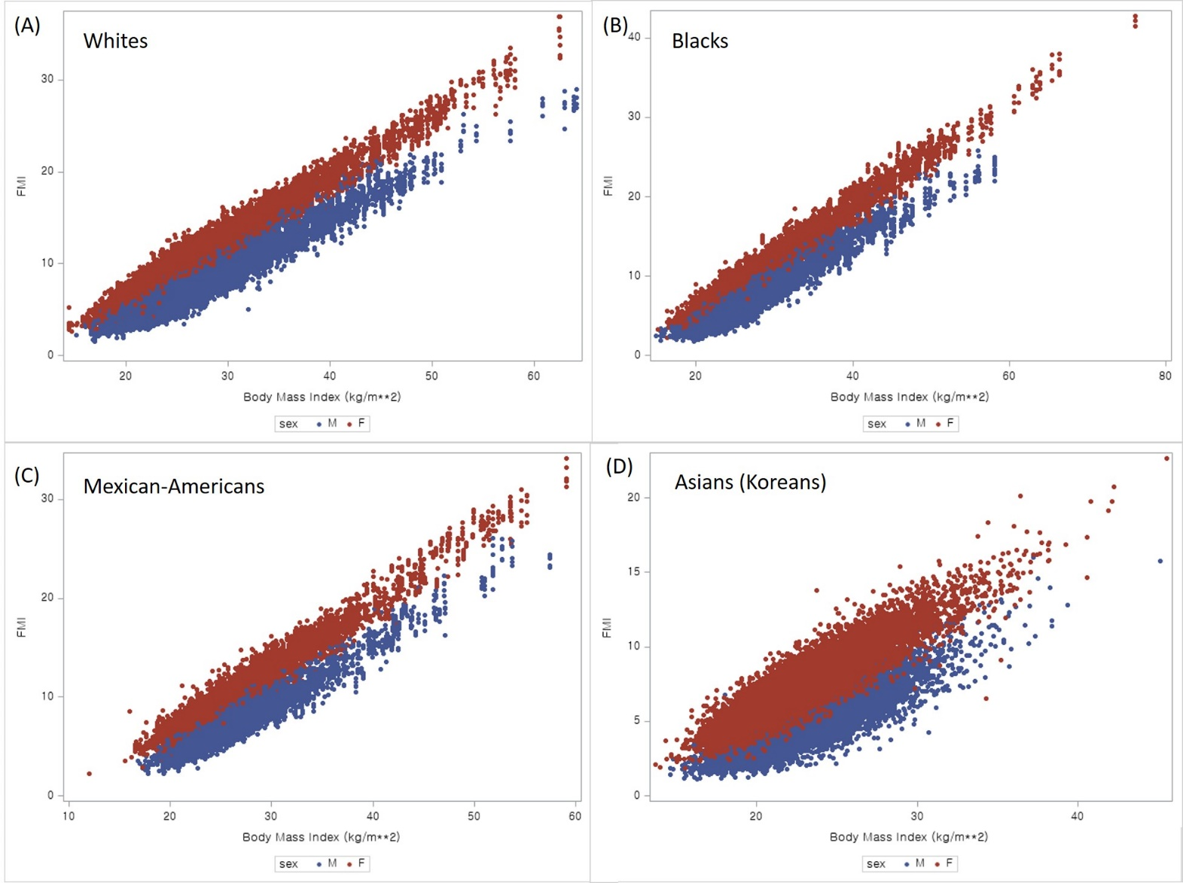
Supplementary Figure 6. Scatter plots for body mass index and percentage body fat by race-ethnicity and sex

Legend: The plots of A - D show relationships between body mass index and percentage body fat in (A) whites (B) blacks (C) Mexican-Americans, and (D) Asians (Korean).

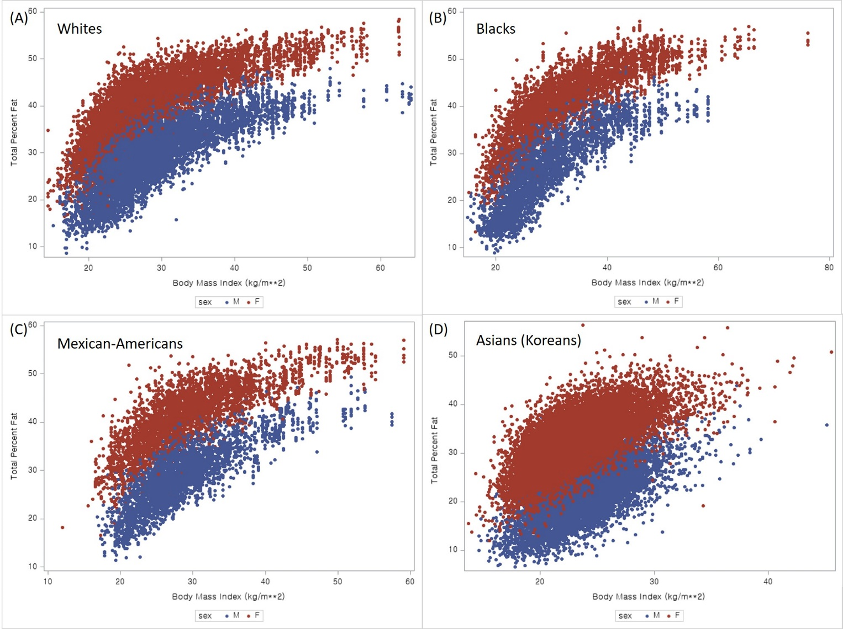
Supplementary Figure 7. Pearson correlation coefficients between obesity-related biomarkers and abdominal obesity indices (waist circumference and truncal fat mass) by sex and age
Legend: The bar graphs of panel A show coefficients between obesity-related biomarkers (total cholesterol, low-density lipoprotein cholesterol [LDL-C], high-density lipoprotein cholesterol [HDL-C], triglycerides [TG], C-reactive protein [CRP], hemoglobinA1c [HbA1c], fasting blood glucose [FBG] and insulin) and body mass index (BMI), fat mass index (FMI), and percentage body fat (PBF) in National Health and Nutrition Examination Survey (NHANES) and panel B shows the correlations in Korea NHANES. CRP was not available in Korea NHANES.
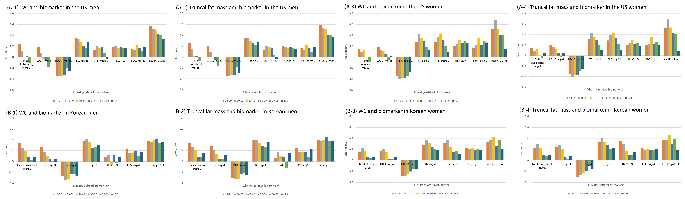

Supplementary Figure 8. Area under the curve (AUC) for identifying insulin resistance by body mass index, waist-height ratio (WHtR), waist circumference, fat mass index, and percentage body fat in the US population and Korean

abbreviation: National Health and Nutrition Examination Survey [NHANES], Korea NHANES [KNHANES]

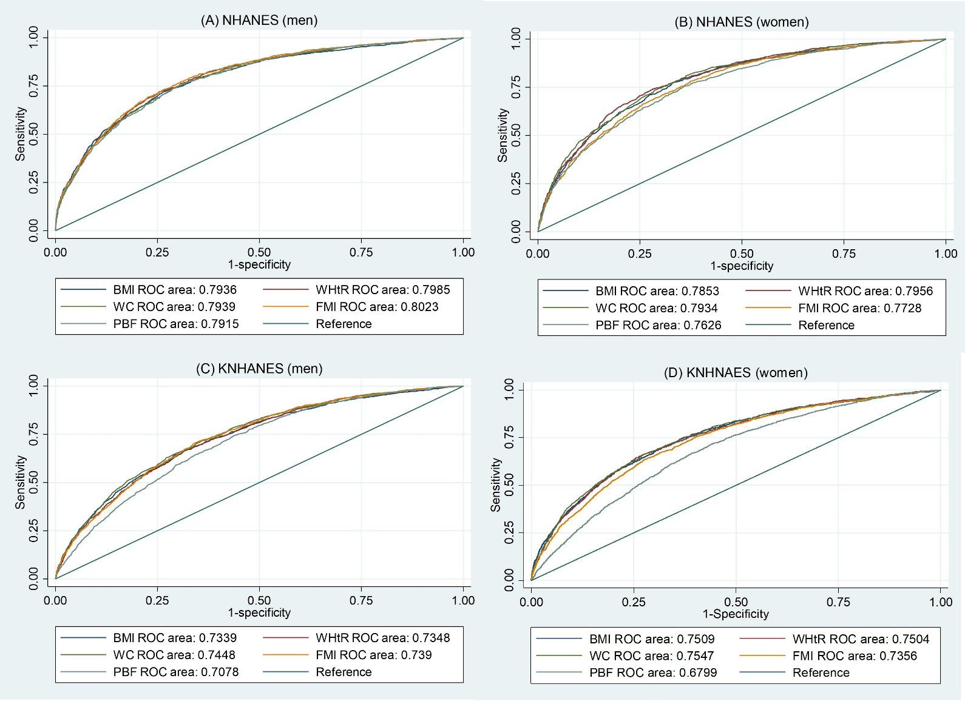
Supplementary Figure 9. Scatter plots for body mass index and fat mass index by sex in Korean

Legend: The plots of A - F show relationships between body mass index and fat mass index in (A) 18-29 years (B) 30-39 years (C) 40-49 years, (D) 50-59 years (E) 60-69 years, and (F) ≥ 70 years.

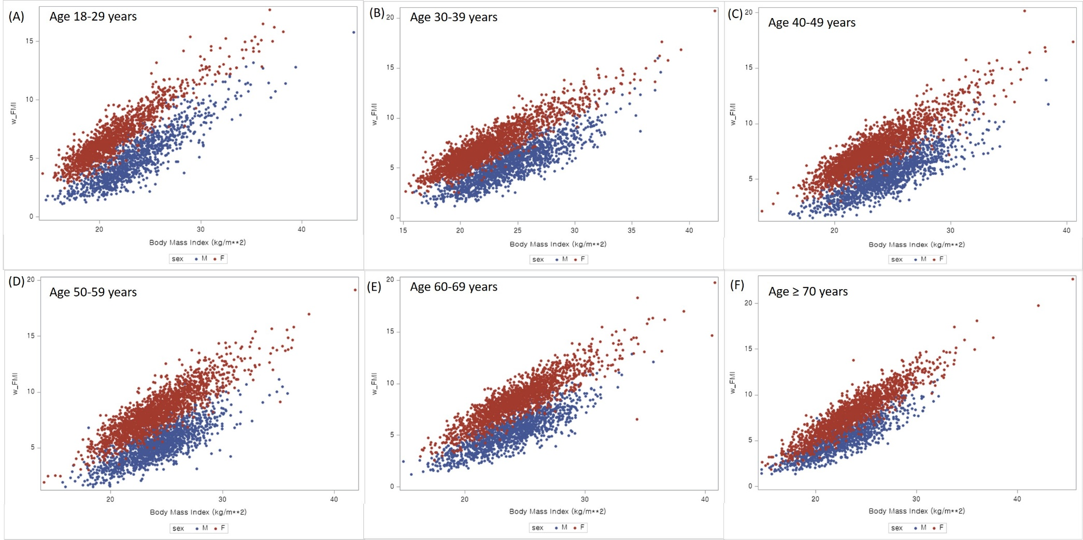

Supplementary Figure 10. Scatter plots for body mass index and percentage body fat by sex in Korean

Legend: The plots of A - F show relationships between body mass index and percentage body fat in (A) 18-29 years (B) 30-39 years (C) 40-49 years, (D) 50-59 years (E) 60-69 years, and (F) ≥ 70 years.

