Supplementary Materials for

A near real-time web-system for predicting fire spread across the Cerrado Biome

Ubirajara Oliveira*, Britaldo Soares Filho, Hermann Rodrigues, Danilo Figueira, Leticia Gomes, William Leles, Christian Berlinck, Fabiano Morelli, Mercedes Bustamante, Jean Ometto, Heloísa Miranda
*Corresponding author: ubiologia@yahoo.com.br

This PDF file includes:

Figs. S1 to S6
Tables S1 to S4
Equation S1

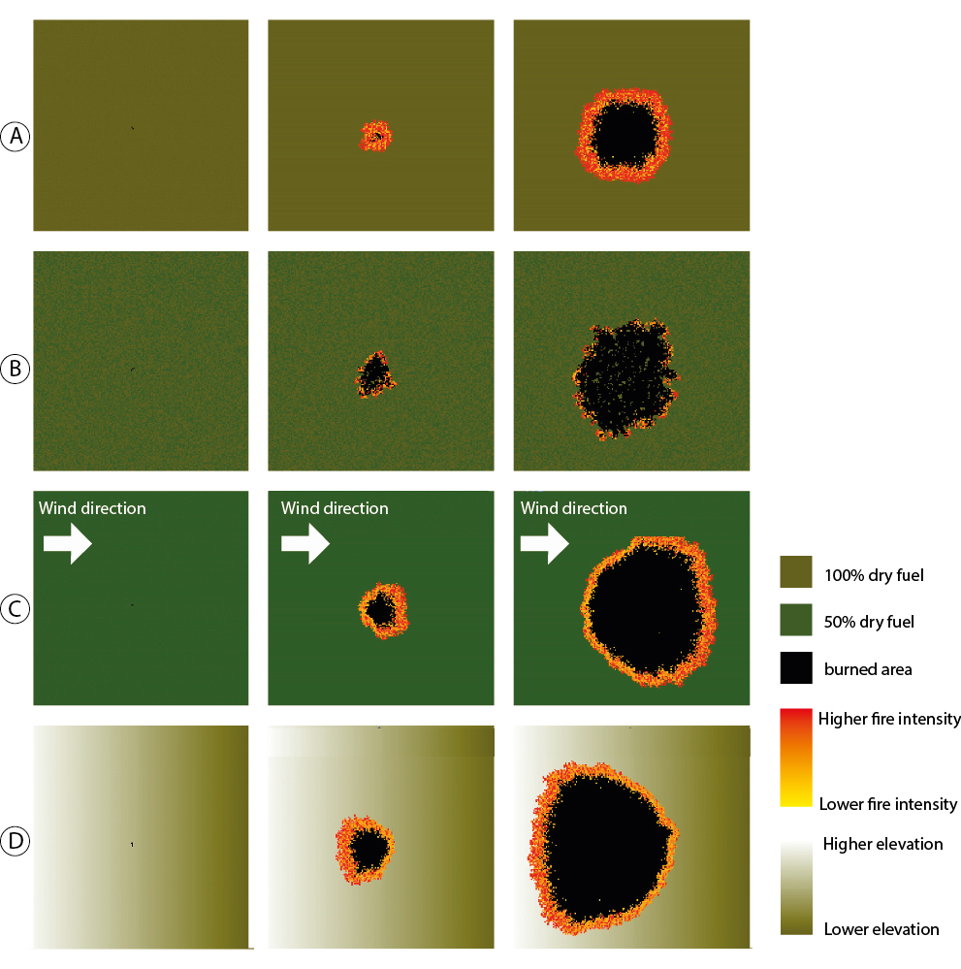

Fig. S1. Fire spread tests. A) control conditions, without wind, slope =0 and constant moisture; B) with random moisture, without wind and slope = 0; C) with wind; and D) with slope > 0.

Fig. S2. Blue points, average moisture measured at six meteorological stations in Serra do Cipó (2011 - 2018). Red points depict the polynomial model.

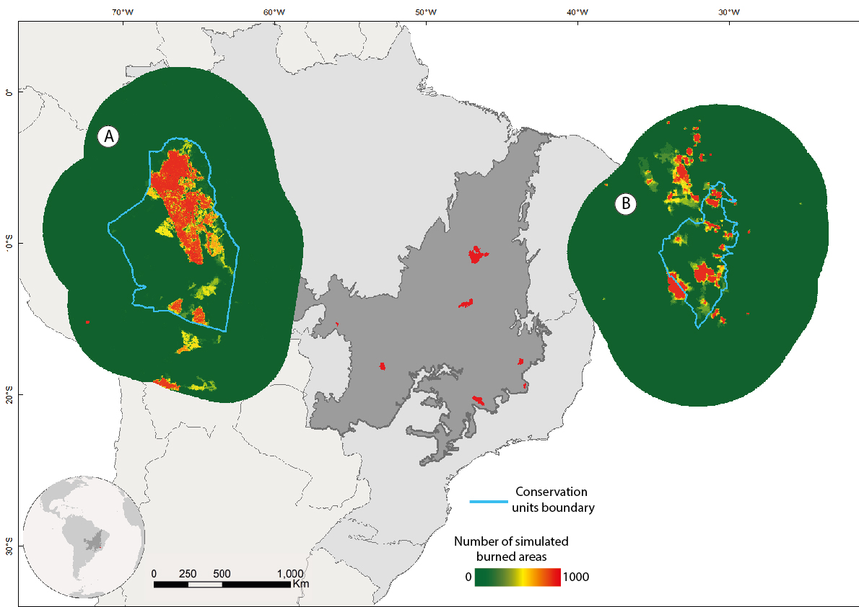

Fig. S3. Probability maps from Monte Carlo simulations for A) Emas National Park and for B) Serra do Cipó National Park in B). The areas surrounding the conservation units are also included in the Monte Carlo simulations. The bar color indicates the propensity to fire (from 0 to 100). Map created in ArcGIS 10.1 (http://www.esri.com).

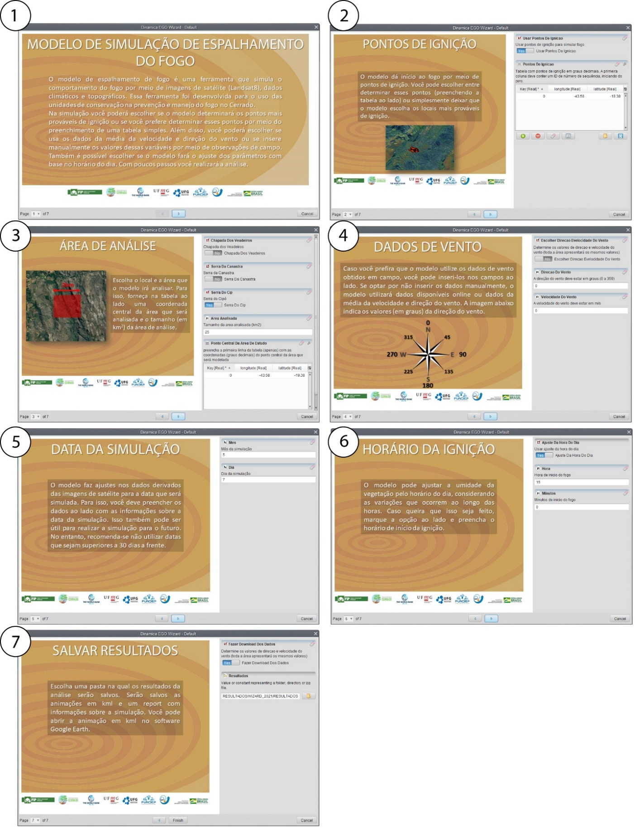
Fig. S4. Wizard-interface for easy and customized set up. 1: Model presentation, 2: Ignition source coordinates, 3: CU selection and area boundary, 4: Wind direction and speed, 5: Simulation date; 6: simulation hour, 7: folder selection for saving results.

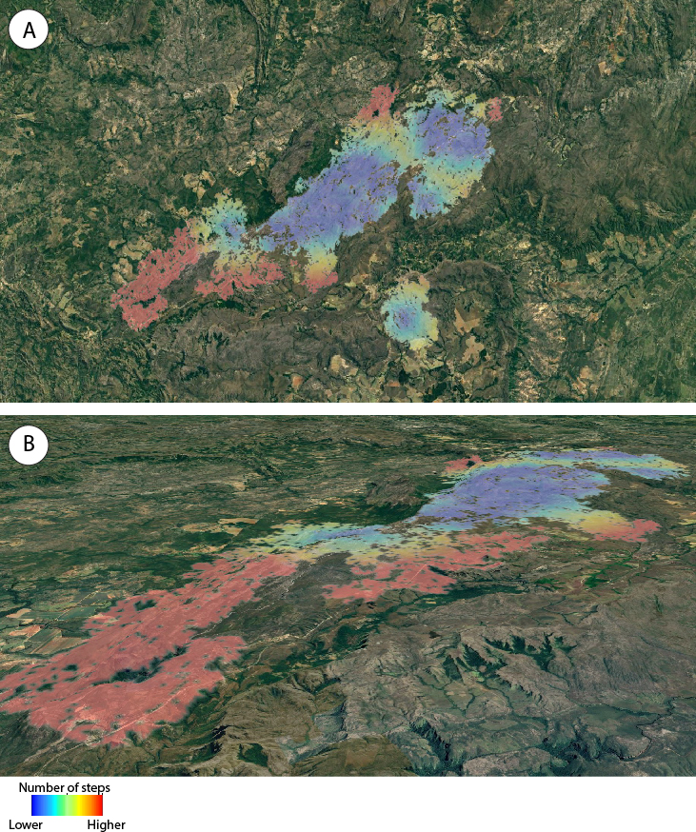
Fig. S5. Simulated fire in the Chapada dos Veadeiros Park. A) nadir view and B) 3 D view over Google Earth. Color bar indicates the number of time-steps a fire has propagated from its ignition source. Map created in Google Earth (https://earth.google.com).

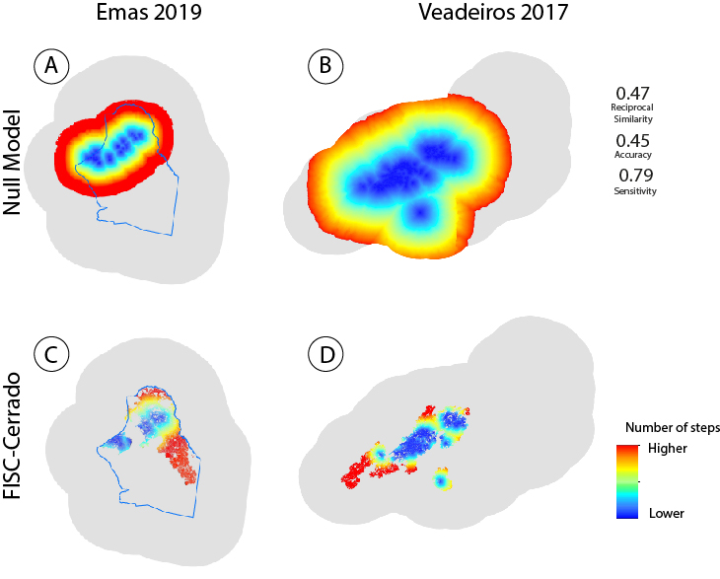

Fig. S6. Null Model and FISC-Cerrado simulations. A and B: Null model simulations for Emas and Chapada dos Veadeiros; C and D: FISC-Cerrado Simulation for the same parks. Average validation values for null models depicted on the right top. Color bar indicates the number of time-steps a fire has propagated from its ignition source.

Table S1. Satellites used for mapping hot pixels.
Instrument | Spatial resolution | Temporal frequency
Terra-MODIS | 250m | 1 day
Aqua-MODIS | 250m | 1 day
GOES16 | 1km | 30 minutes
NOAA-18 | 1.1km | 2 hours
NOAA-19 | 1km | 2 hours
MSG-03 | 7km | 15 minutes
METOP-B | 1km | 1 day
METOP-C | 1km | 1 day
NPP-375 | 750m | 1day

Table S2. Values for empirical constants. α is an empirical angular constant, cw₁, cw₂ and cw₃ are empirical constants for the wind equations, and b₁ and b₂ empirical constants for the vegetation moisture equation.

Empirical Constant | Value |  | Equation | Reference
α |  | 0.05 | 1 | Almeida, R. M. & Macau, E. E. N. Stochastic cellular automata model for wildland fire spread dynamics. J. Phys. Conf. Ser. 285, 12038 (2011).
cw₁ |  | 0.33 | 2 | Alexandridis, A., Vakalis, D., Siettos, C. I. & Bafas, G. V. A cellular automata model for forest fire spread prediction: The case of the wildfire that swept through Spetses Island in 1990. Appl. Math. Comput. 204, 191–201 (2008).
cw₂ |  | 0.99 | 2 | Alexandridis, A., Vakalis, D., Siettos, C. I. & Bafas, G. V. A cellular automata model for forest fire spread prediction: The case of the wildfire that swept through Spetses Island in 1990. Appl. Math. Comput. 204, 191–201 (2008).
cw₃ |  | 0.06 | 2 | Alexandridis, A., Vakalis, D., Siettos, C. I. & Bafas, G. V. A cellular automata model for forest fire spread prediction: The case of the wildfire that swept through Spetses Island in 1990. Appl. Math. Comput. 204, 191–201 (2008).
b₁ |  | 0.0001 | 3 | Alexandridis, A., Vakalis, D., Siettos, C. I. & Bafas, G. V. A cellular automata model for forest fire spread prediction: The case of the wildfire that swept through Spetses Island in 1990. Appl. Math. Comput. 204, 191–201 (2008).
b₂ |  | 0.0005 | 5 | Alexandridis, A., Vakalis, D., Siettos, C. I. & Bafas, G. V. A cellular automata model for forest fire spread prediction: The case of the wildfire that swept through Spetses Island in 1990. Appl. Math. Comput. 204, 191–201 (2008).
v1 |  | 0.48
v2 |  | 0.59

Table S3. Simulation videos
Simulation | link
PARNA da Serra do Cipó | https://www.youtube.com/watch?v=1G1khvFIKrU&t=21s
PARNA da Serra da Canastra | https://www.youtube.com/watch?v=Z_O0-QuBw5c
PARNA da Chapada dos Veadeiros | https://www.youtube.com/watch?v=9avKyb-2oIU

The colors follow the same color bar of Figure S1. FISC website allows downloading the simulation results in KMZ format that enables this type of animation on Google Earth.

Table S4. News about wildfire events used in FISC-Cerrado validation.
Fire Event | date | fonte
Canastra_2018 | 21/08/2018 | https://g1.globo.com/mg/centro-oeste/noticia/2018/08/23/incendio-no-parque-nacional-da-serra-da-canastra-chega-ao-3-dia-brigadistas-e-bombeiros-seguem-em-meio-a-mata.ghtml
Canastra_2020 | 20/08/2020 | https://g1.globo.com/mg/centro-oeste/noticia/2020/08/20/chega-ao-fim-o-incendio-na-serra-da-canastra-apos-6-dias-de-combate-e-quase-24-mil-hectares-atingidos.ghtml
Emas_2019 | 03/09/2019 | https://www.correiobraziliense.com.br/app/noticia/cidades/2019/09/03/interna_cidadesdf,780602/incendio-no-parque-nacional-das-emas-consome-6-mil-hectares-do-parque.shtml
Emas_2021 | 13/07/2021 | https://g1.globo.com/go/goias/noticia/2021/07/13/incendio-no-parque-nacional-das-emas-e-controlado-apos-atingir-mais-de-20-mil-hectares-diz-diretor.ghtml
Veadeiros_2017 | 18/10/2017 | https://www.jornaldocomercio.com/_conteudo/2017/10/geral/590792-incendio-no-parque-da-chapada-dos-veadeiros-esta-controlado-mas-surge-novo-foco.html
Cipo_2020 | 06/10/2020 | https://www.em.com.br/app/noticia/gerais/2020/10/06/interna_gerais,1192266/depois-de-10-dias-incendio-e-controlado-na-serra-do-cipo.shtml

Equation S1

$pFl=\left(2e-13 * d^{5}+ 3e-11 * d^{4}- 9e-08 * d^{3}+ 3e-05 * d^{2}- 0.0023 * d+ 0.288\right)-\left(oFl\right)*aFl$ Eq. (S1)
Where $pFl$ is the estimated fuel loads at day d, oFl is the observed fuel loads mean, cFl is the average of fuel loads, and e the Euler's number.

