Supplementary information

Table S1: Wheat, barley, and potato area (decare) and percentage in each county in 2018. Note that Trøndelag comprises Sør-Trøndelag and Nord-Trøndelag.
County | Agricultural area  (decare) | Wheat  (decare) | Wheat  % | Barley  (decare) | Barley  % | Potato  (decare) | Potato  %
Total | 8977512 | 586496 | 6.5 | 1477618 | 16.45 | 111856 | 1.2
Østfold | 727136 | 190987 | 26 | 190994 | 26 | 4708 | 0.64
Oslo & Akershus | 756284 | 99853 | 13 | 237977 | 31 | 5921 | 0.78
Buskerud | 508924 | 66708 | 13 | 67961 | 13 | 2913 | 0.57
Hedmark | 1055978 | 59519 | 6 | 339313 | 32 | 47656 | 4.51
Oppland | 1002326 | 16838 | 2 | 139431 | 14 | 8777 | 0.87
Vestfold | 403335 | 119915 | 30 | 57988 | 14 | 14351 | 3.55
Telemark | 245677 | 20782 | 8 | 16789 | 7 | 1719 | 0.69
Aust-Agder | 112711 | 241 | 0.01 | 1698 | 2 | 1946 | 1.72
Vest-Agder | 188592 | 0 | 0 | 1957 | 1 | 912 | 0.48
Rogaland | 996774 | 1118 | 0.01 | 18411 | 2 | 5526 | 0.55
Hordaland | 408335 | 0 | 0 | 174 | 0.01 | 64 | 0.01
Sogn & Fjordane | 425845 | 0 | 0 | 0 | 0 | 922 | 0.21
Møre & Romsdal | 539979 | 0 | 0 | 9764 | 2 | 1856 | 0.34
Trøndelag | 1605616 | 10535 | 1 | 395161 | 25 | 14585 | 0.90

Table S2: Number of years of available crop yield data for each county in southern Norway 1980–2019 (full time series = 40 years).
County | Wheat | Barley | Potato
Aust-Agder | 14 | 32 | 40
Buskerud | 39 | 39 | 39
Hedmark | 40 | 40 | 40
Hordaland | 0 | 6 | 40
Møre og Romsdal | 4 | 30 | 40
Nord-Trøndelag | 26 | 38 | 38
Oppland | 40 | 40 | 40
Oslo & Akershus | 40 | 40 | 40
Østfold | 40 | 40 | 40
Rogaland | 11 | 37 | 40
Sogn og Fjordane | 0 | 3 | 40
Sør-Trøndelag | 14 | 38 | 38
Telemark | 36 | 40 | 40
Vest-Agder | 5 | 33 | 40
Vestfold | 40 | 40 | 40

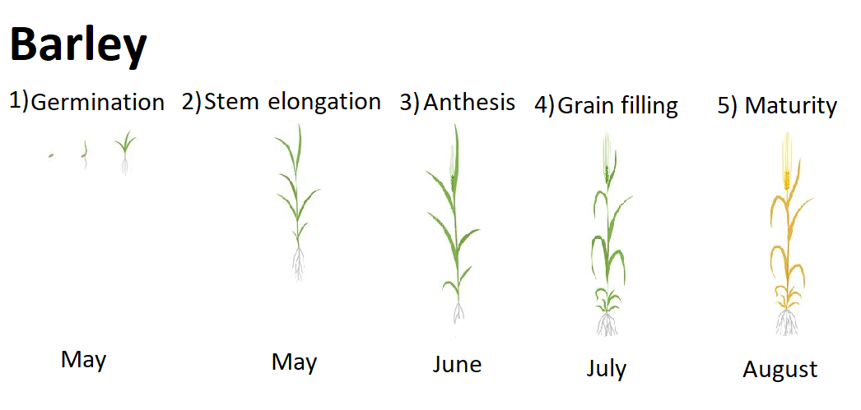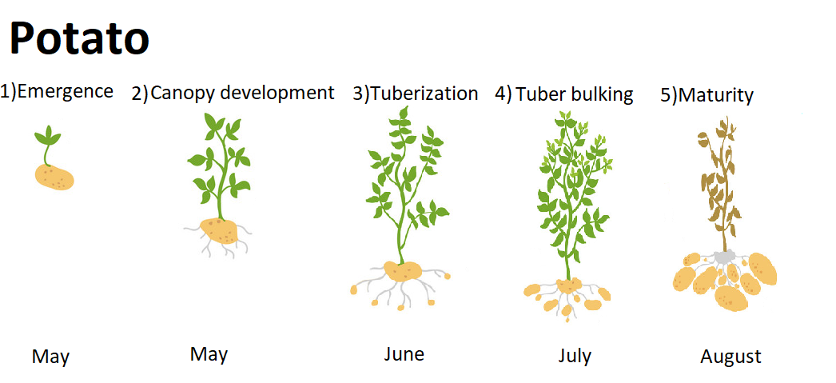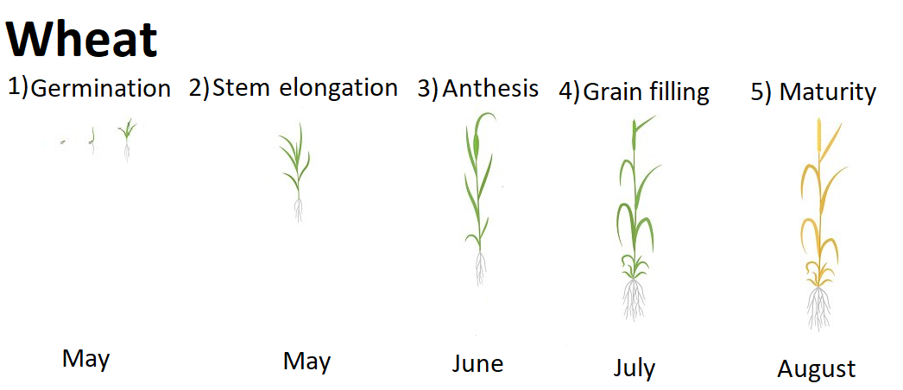

Figure S1: Phenological stages of the three focal crops and the months of the growing season that they generally occur in Norway

Table S3. Information of the selected meteorological stations for climate data in each county.

County | Station with temperature and precipitation data |  | Station with precipitation data |  | Station with temperature data
 | Name | Number | Name | Number | Name | Number
Østfold | Rygge | SN17150 | Strømsfoss | SN1650
 |  |  | Fløter | SN17500
Oslo & Akershus | Blindern | SN18700 | Skedsmo | SN4260
 | Ås | SN17850 | Eidsvoll Verk | SN11120
 | Asker | SN19710
Buskerud | Kongsberg | SN28380 | Hole | SN20250
 | Blindern | SN18700
Hedmark | Kise | SN12550 | Nord-odal | SN5350
Oppland | Kise | SN12550 | Biri | SN11900
Vestfold | Melsom | SN27450 | Sandefjord | SN27600
 | Blindern | SN18700 | Hedrum | SN27800
 |  |  | Notodden | SN30530
 |  |  | Høidalen I | SN32780
 |  |  | Kviteseid | SN32850
Aust-Agder | Nelaug | SN36560 | Eikeland | SN35090
 | Landvik | SN38140
Vest-Agder | Kjevik | SN39040 | Tonstad | SN42810
 | Lista Fyr | SN42160
Telemark | Nelaug | SN36560 | Eikeland | SN35090
 | Landvik | SN38140
Rogaland | Sola | SN44560 | Egersund | SN43360
 | Sauda | SN46610 | Karmøy | SN47240
Hordaland | Sauda | SN46610 | Hatlestrand | SN50150 | Flesland | SN50500
 | Takle | SN52860 | Eikemo | SN47820
Sogn og Fjordane | Takle | SN52860 | Aurland | SN53700
 | Sandane | SN58070 | Vik I Sogn Iii | SN53070
Møre og Romsdal | Fiskåbygd | SN59610 | Sunndalsøra Iii | SN63420
 | Tafjord | SN60500 | Sæbø | SN59900
 | Vigra | SN60990
Sør-Trøndelag | Værnes | SN69100 | Løksmyr | SN68270 | Sula | SN65940
 | Ørland Iii | SN71550
Nord-Trøndelag | Værnes | SN69100 | Otterøy | SN75020
 | Snåsa - Ki | SN70850 | Buran | SN69960

Table S4: Mean values and measures of spread of the two climate gradients for each county.
 | Inland |  |  |  |  | Altitude
County | Mean | sd | Minimum | Maximum |  | Mean | sd | Minimum | Maximum
Aust-Agder | -0.87 | 0.25 | -1.36 | -0.27 |  | 2.71 | 1.01 | 0.64 | 4.27
Buskerud | 0.83 | 0.64 | -0.29 | 2.31 |  | 2.19 | 1.10 | -1.29 | 3.36
Hedmark | 1.68 | 0.53 | -1.14 | 2.96 |  | 1.43 | 1.19 | -1.49 | 3.21
Hordaland | -2.60 | 0.92 | -3.86 | -1.07 |  | 2.44 | 0.99 | 0.38 | 4.13
More & Romsdal | -1.98 | 0.80 | -3.60 | 0.02 |  | 2.32 | 0.76 | 0.00 | 3.51
Nord-Trøndelag | -0.51 | 0.68 | -2.39 | 1.46 |  | 2.02 | 0.72 | 0.00 | 3.91
Oppland | 1.63 | 0.50 | 0.35 | 3.10 |  | 0.37 | 1.00 | -1.77 | 2.39
Oslo & Akershus | 0.84 | 0.30 | 0.12 | 1.49 |  | 2.94 | 0.38 | 1.86 | 3.99
Østfold | 0.51 | 0.19 | -2.56 | 0.83 |  | 3.49 | 0.36 | 0.00 | 4.11
Rogaland | -2.28 | 0.63 | -3.64 | -0.85 |  | 3.66 | 0.53 | 2.07 | 4.49
Sogn & Fjordane | -2.56 | 0.91 | -4.23 | 0.22 |  | 1.90 | 0.91 | 0.11 | 4.05
Sør-Trøndelag | -0.45 | 1.08 | -2.33 | 2.23 |  | 1.55 | 1.09 | -0.84 | 3.39
Telemark | 0.03 | 0.35 | -0.73 | 0.67 |  | 2.31 | 1.01 | -0.39 | 3.71
Vest-Agder | -1.88 | 0.48 | -2.42 | -0.64 |  | 3.03 | 1.09 | 0.81 | 4.44
Vestfold | -0.02 | 0.25 | -0.46 | 0.49 |  | 3.70 | 0.29 | 3.11 | 4.08

Table S5: Coefficients and 95% confidence intervals for linear mixed models with detrended yield of each crop as response, with the extreme year of 2018 removed. Values in bold indicate those estimates with confidence intervals that do not encompass zero. RMSE = Root mean squared error. LOOCV = leave-one-out cross validation
 | Wheat |  | Barley |  | Potato
 | Estimate | 95% CI | Estimate | 95% CI | Estimate | 95% CI
Intercept | 6.51 | [-32.93, 45.94] | 2.92 | [-12.66, 18.50] | 15.02 | [-76.71, 106.75]
Average temperature (detrended) | -9.01 | [-58.87, 40.84] | -2.97 | [-24.03, 18.10] | 35.13 | [-89.34, 159.60]
Precipitation (detrended) | -0.15 | [-0.74, 0.45] | -0.30 | [-0.56, -0.04] | -2.19 | [-3.66, -0.72]
Oceanity | 3.46 | [-14.93, 21.85] | 1.84 | [-2.77, 6.45] | 6.08 | [-16.26, 28.42]
Climate | -0.87 | [-13.35, 11.60] | 0.52 | [-5.61, 6.64] | -4.53 | [-41.28, 32.21]
Average temperature x Inland | -4.27 | [-27.76, 19.23] | -6.98 | [-13.47, -0.49] | -12.62 | [-44.20, 18.96]
Precipitation x Inland | -0.19 | [-0.47, 0.08] | -0.04 | [-0.11, 0.02] | -0.19 | [-0.49, 0.11]
Average temperature x Altitude | -1.03 | [-17.19, 15.13] | -1.35 | [-9.80, 7.10] | -32.29 | [-83.26, 18.69]
Precipitation x Altitude | 0.02 | [-0.18, 0.21] | 0.02 | [-0.08, 0.12] | 0.39 | [-0.17, 0.95]
Random slopes | 0.19 | [0.03, 1.36] | 0.00 | [0.00, Inf] | 0.00 | [0.00, Inf]
R-squared | 0.05 |  | 0.08 |  | 0.05
RMSE | 80.9 |  | 54.2 |  | 359.5
LOOCV RMSE | 98.5 |  | 65.2 |  | 372.3

Table S6: The deviance ratio for each of the LASSO models, with corresponding values for models without 2018 in brackets. Deviance ratios indicate the fraction of deviance explained by the models.
County | Wheat | Barley | Potato
Aust-Agder | - | 0.43 (0.43) | 0.00 (0.00)
Buskerud | 0.00 (0.00) | 0.00 (0.00) | 0.00 (0.13)
Hedmark | 0.60 (0.55) | 0.00 (0.32) | 0.11 (0.25)
Hordaland | - | - | 0.13 (0.13)
Møre og Romsdal | - | 0.07 (0.07) | 0.00 (0.00)
Nord-Trøndelag | 0.00 (0.00) | 0.21 (0.21) | 0.00 (0.00)
Oppland | 0.00 (0.00) | 0.00 (0.00) | 0.23 (0.00)
Oslo & Akershus | 0.29 (0.21) | 0.00 (0.00) | 0.00 (0.00)
Østfold | 0.32 (0.27) | 0.23 (0.00) | 0.10 (0.09)
Rogaland | - | 0.50 (0.61) | 0.26 (0.23)
Sogn og Fjordane | - | - | 0.40 (0.00)
Sør-Trøndelag | - | 0.47 (0.47) | 0.00 (0.00)
Telemark | 0.51 (0.47) | 0.44 (0.45) | 0.23 (0.34)
Vest-Agder | - | 0.00 (0.00) | 0.00 (0.09)
Vestfold | 0.22 (0.15) | 0.00 (0.00) | 0.10 (0.08)

