Supplementary information

Cre-dependent ACR2-expressing reporter mouse strain for efficient long-lasting inhibition of neuronal activity
Yasutaka Mukai^{1,2,†}, Yan Li^{1,2,†}, Akiyo Nakamura¹, Noriaki Fukatsu¹, Daisuke Iijima¹, Manabu Abe³, Kenji Sakimura³, Keiichi Itoi⁴, and Akihiro Yamanaka^{1,2,5,6,7,*}
1. Department of Neuroscience II, Research Institute of Environmental Medicine, Nagoya University, Nagoya, 464-8601, Japan
2. Department of Neural Regulation, Nagoya University Graduate School of Medicine, Nagoya, 466-8550, Japan
3. Department of Animal Model Development, Brain Research Institute, Niigata University, Niigata, 951-8585, Japan
4. Department of Nursing, Faculty of Health Sciences, Tohoku Fukushi University, Sendai, 981-8522, Japan
5. Chinese Institute for Brain Research, Beijing, 102206, China
6. National Institute for Physiological Sciences, National Institutes of Natural Sciences, Aichi, 444-8585, Japan
7. Department of Neuropsychiatry, Keio University School of Medicine, Tokyo, 160-8582, Japan
† These authors contributed equally to this work.
* Corresponding author: yamank@cibr.ac.cn

Supplementary Figures & Legends
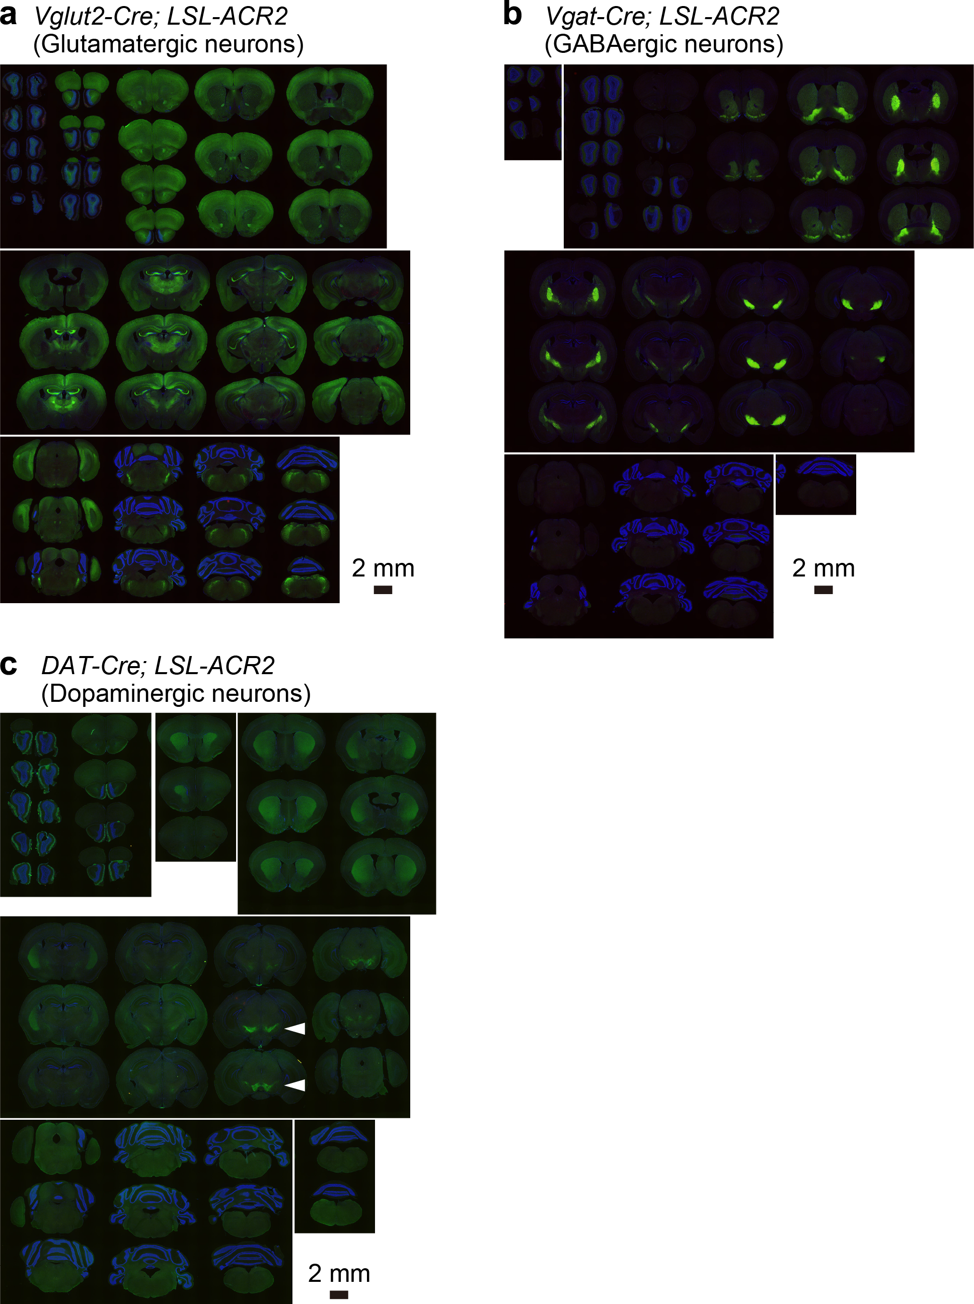

Supplementary Figure S1. Expression of ACR2-EYFP in siblings of LSL-ACR2 mice bred with Cre-driver animals
(a–c) Immunostaining images of whole brain slices from Vglut2-Cre; LSL-ACR2 (a), Vgat-Cre; LSL-ACR2 (b), and DAT-Cre; LSL-ACR2 (c) mice. Each animal showed different expression patterns throughout the brain. Blue: DAPI, Green: ACR2, scale bar: 2 mm, arrowheads in (c), putative dopaminergic neurons in the ventral tegmental area.
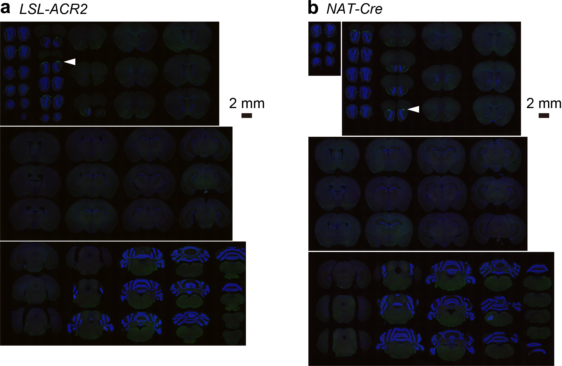

Supplementary Figure S2. Immunostaining of ACR2-EYFP in negative control animals
(a & b) Representative immunostaining images of whole brain slices from LSL-ACR2 (a) and NAT-Cre (b) mice. Both of animals showed no ACR2-EYFP-derived fluorescence (LSL-ACR2, n = 4 animals; NAT-Cre, n = 2 animals). Green fluorescence was observed only in the accessory olfactory bulb in both animals (arrowheads), which was not attributed to ACR2-EYFP. Blue: DAPI, Green: GFP-immunoreactivity, scale bar: 2 mm.
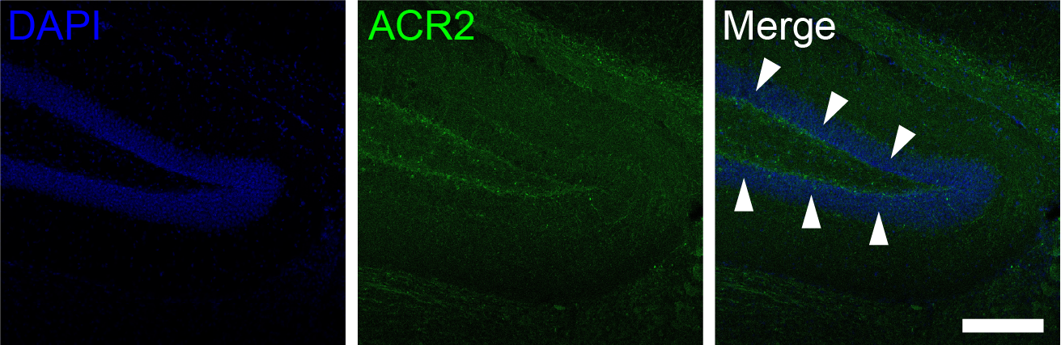

Supplementary Figure S3. Axonal ACR2-EYFP signal in the hippocampal dentate gyrus of a NAT-ACR2 mouse
Representative immunostaining images of the hippocampal dentate gyrus (DG) of a NAT-ACR2 mouse. Axonal ACR2-EYFP signal (arrowheads) was observed in the DG. Blue: DAPI, Green: ACR2, scale bar: 200 µm.

