Supplemental Figure S1: Scatterplot of the causal relationships between LDL and DVT
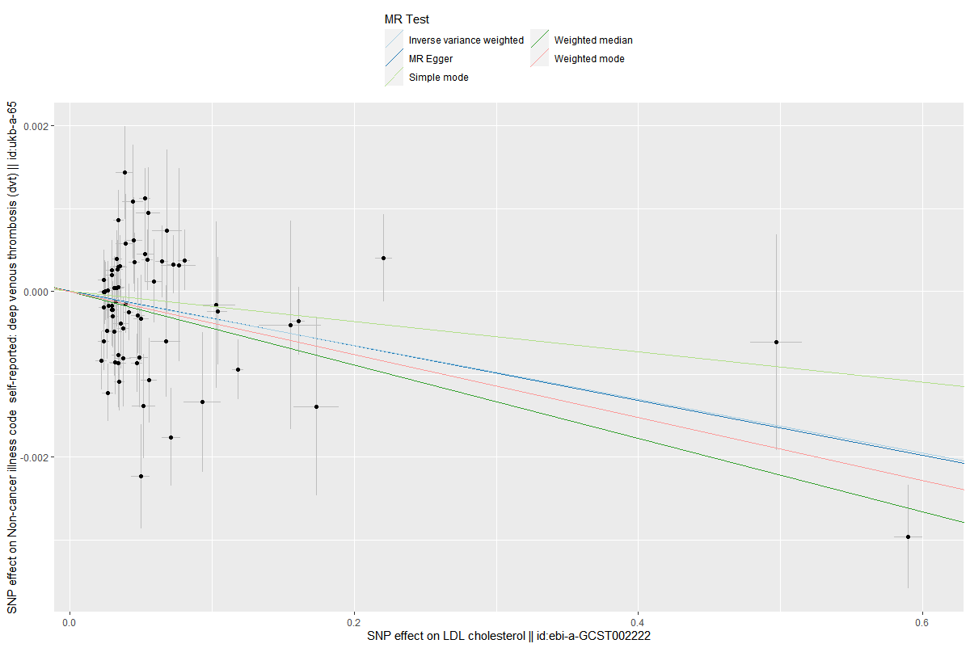

Supplemental Figure S2: Scatterplot of the causal relationships between HDL and DVT
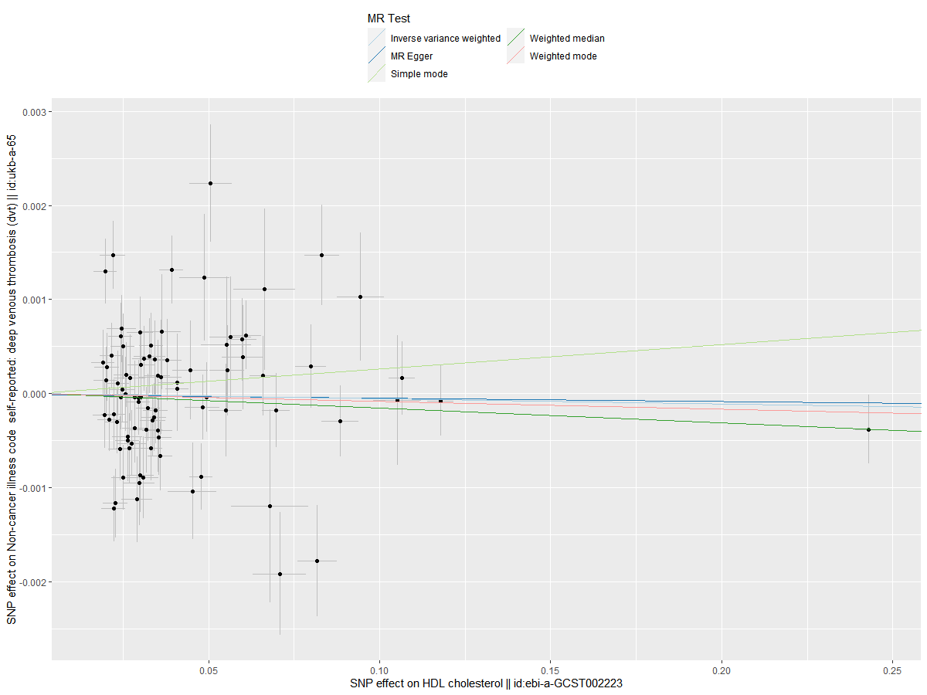

Supplemental Figure S3: Scatterplot of the causal relationships between TG and
DVT
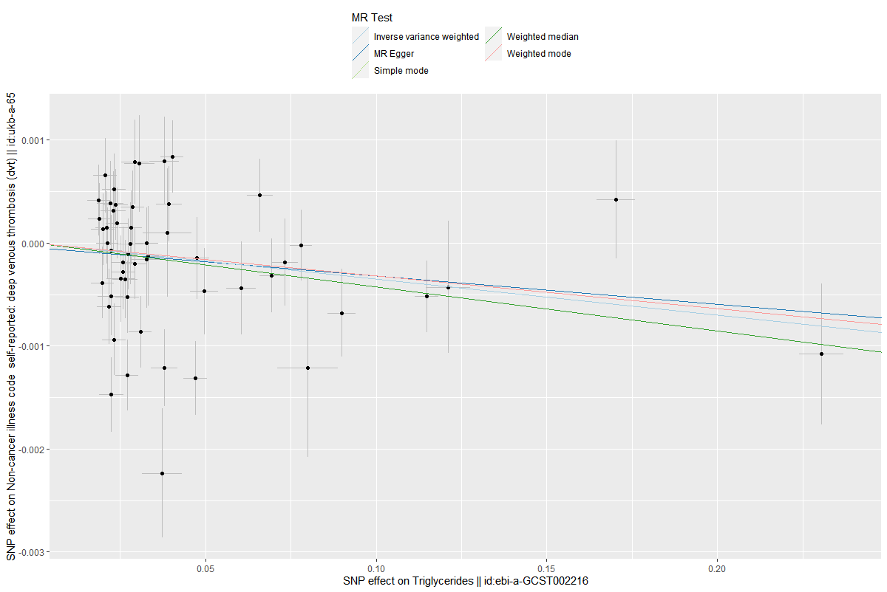

Supplemental Figure S4: Scatterplot of the causal relationships between LDL and PE
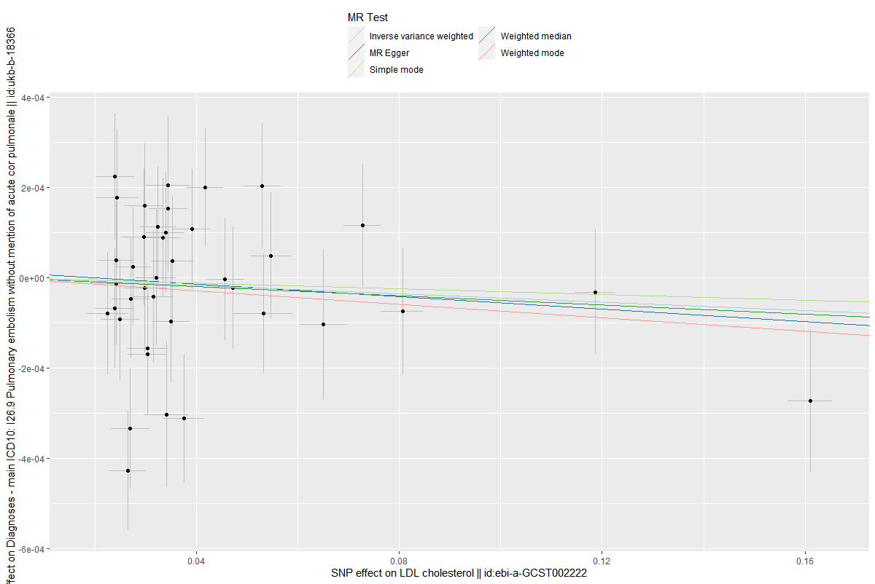

Supplemental Figure S5: Scatterplot of the causal relationships between HDL and PE
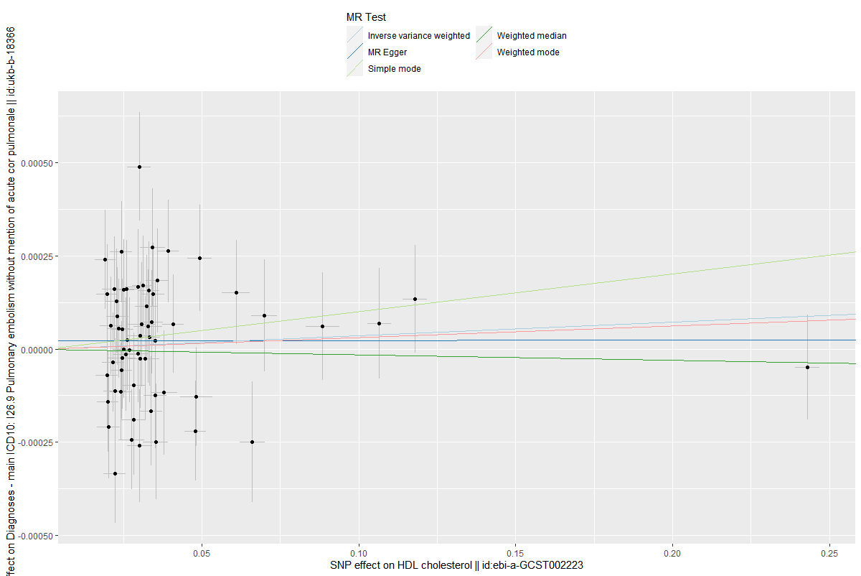

Supplemental Figure S6: Scatterplot of the causal relationships between TG and PE

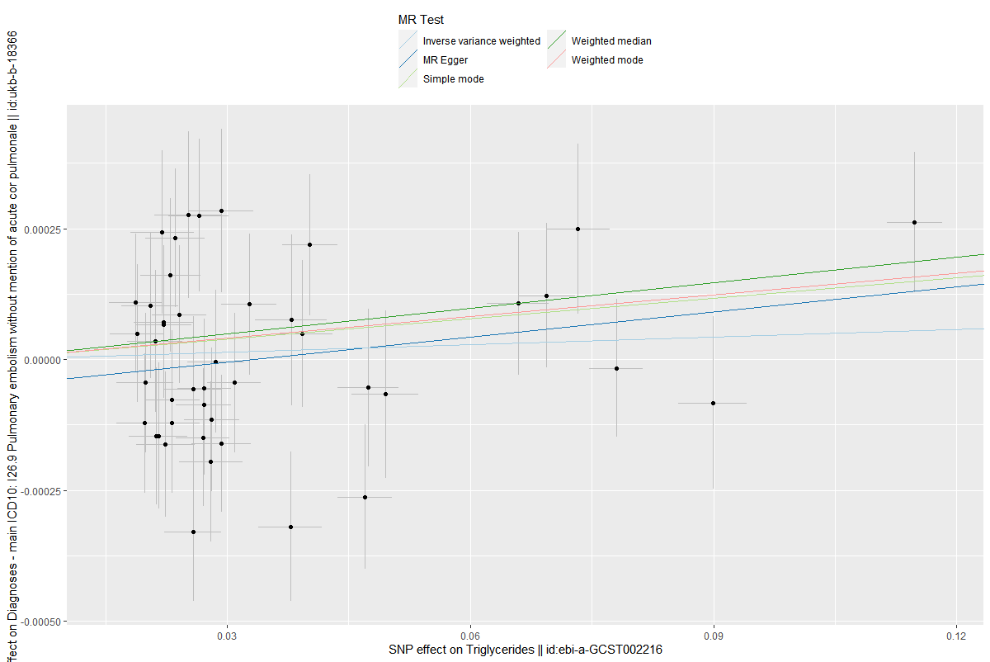

Supplemental Figure S7: Funnel plot of the causal association between LDL and DVT
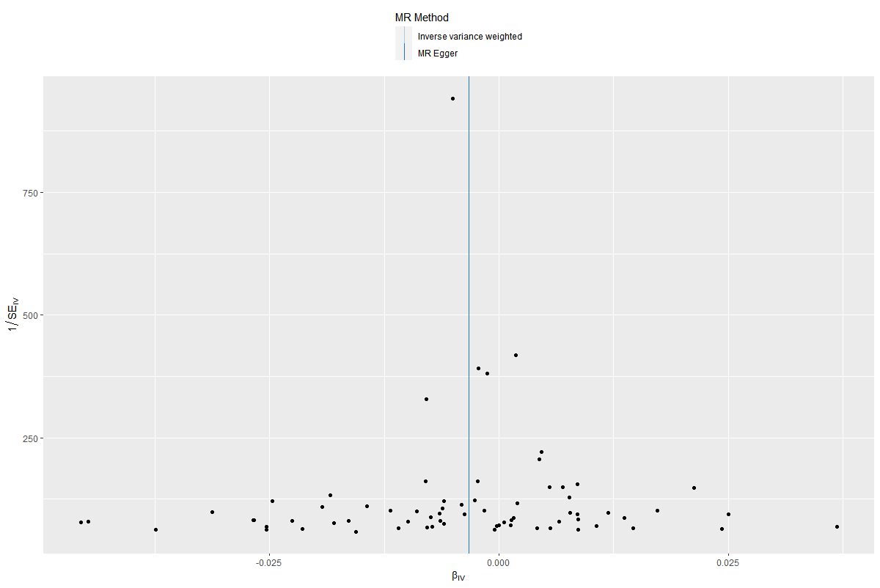

Supplemental Figure S8: Funnel plot of the causal association between HDL
and DVT
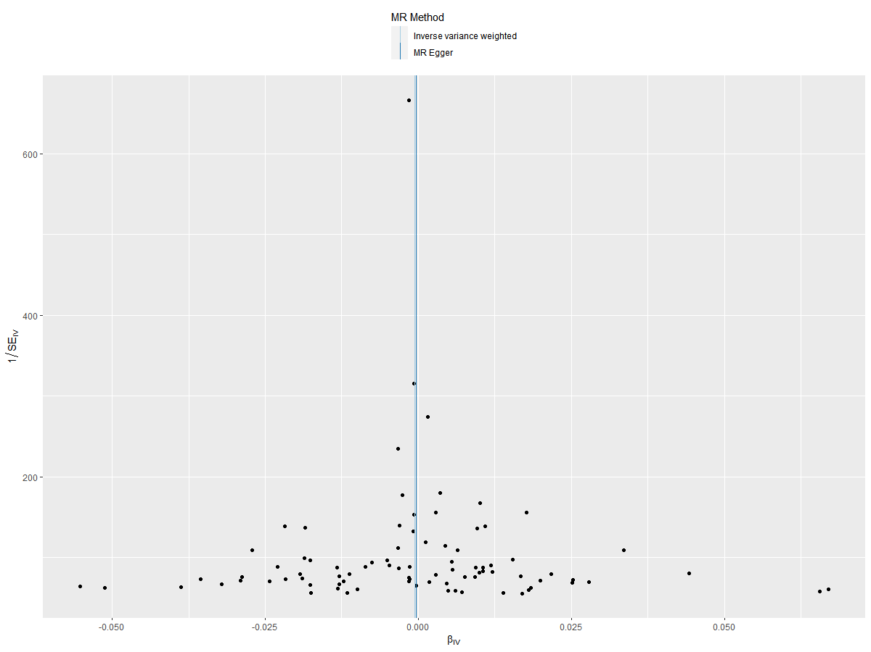

Supplemental Figure S9: Funnel plot of the causal association between TG
and DVT
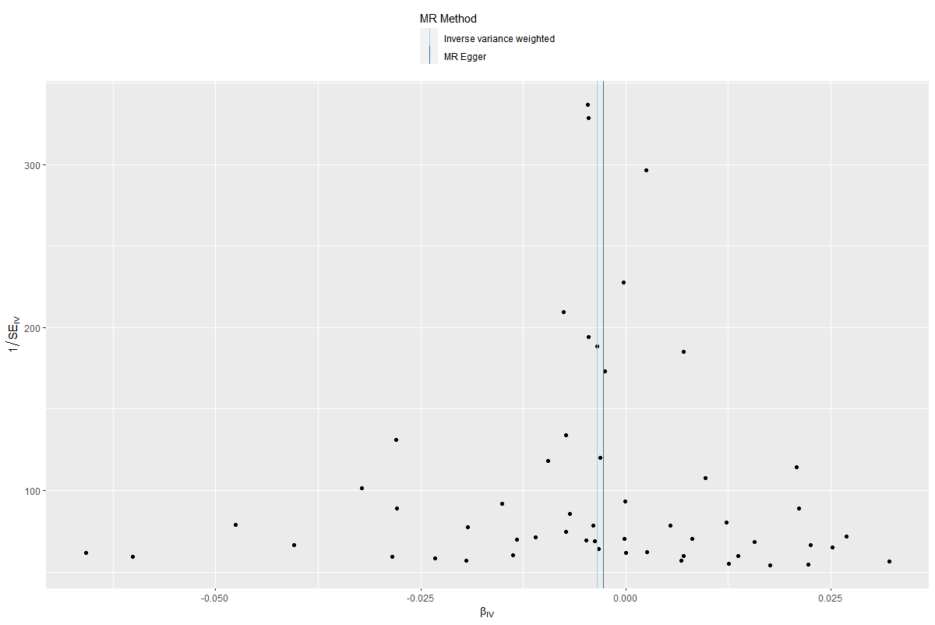

Supplemental Figure S10: Funnel plot of the causal association between LDL and PE

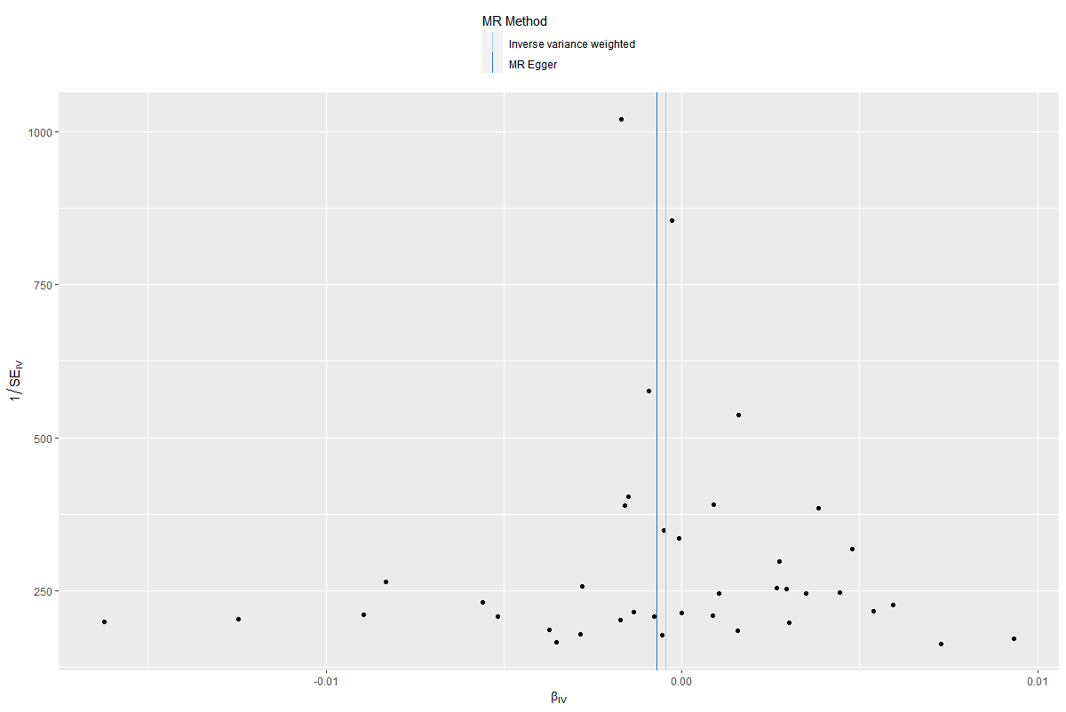

Supplemental Figure S11: Funnel plot of the causal association between HDL and PE
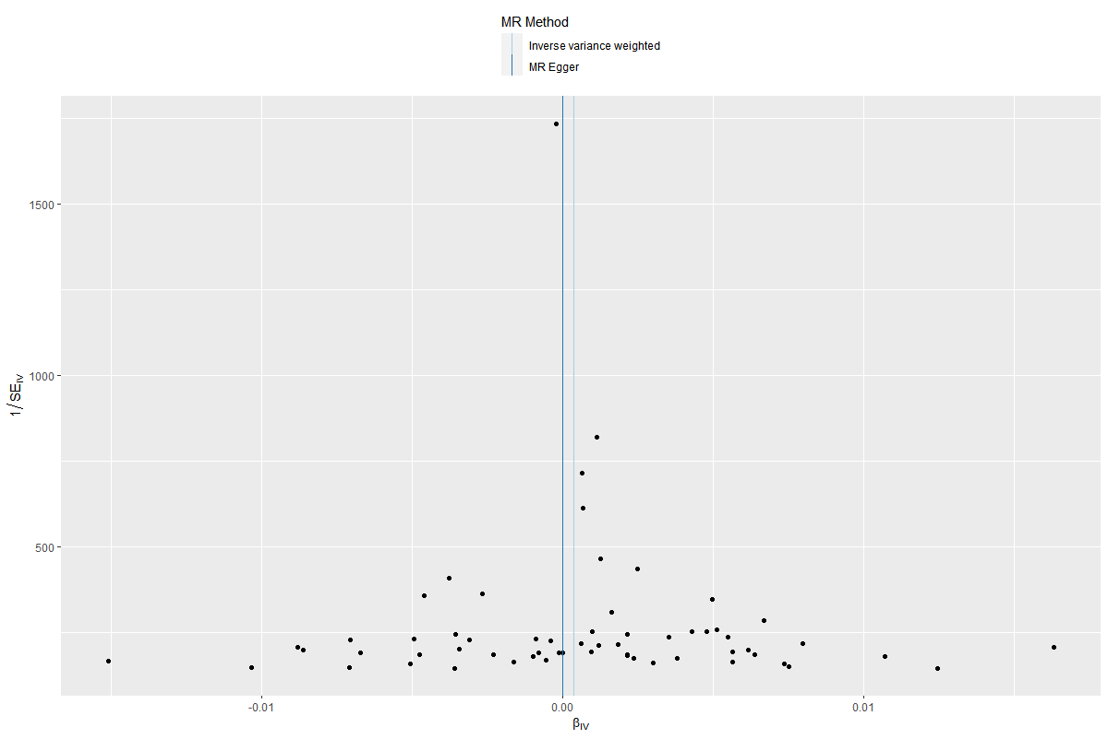

Supplemental Figure S12: Funnel plot of the causal association between TG
and PE
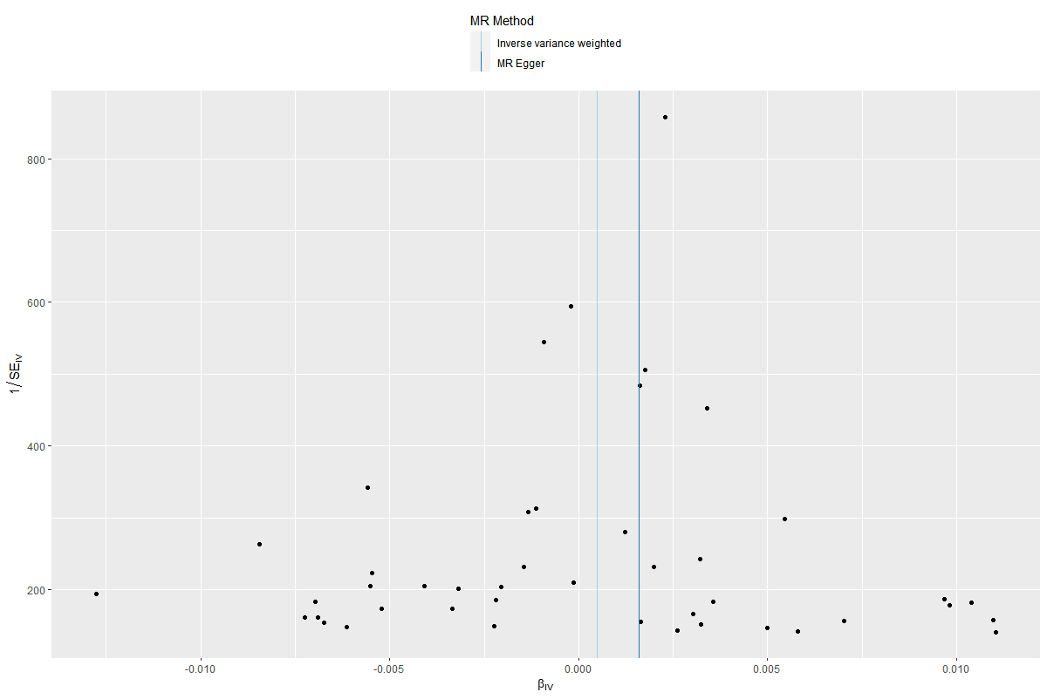

Supplemental Figure S13: Leave-one-out test plot of the causal association between LDL and DVT
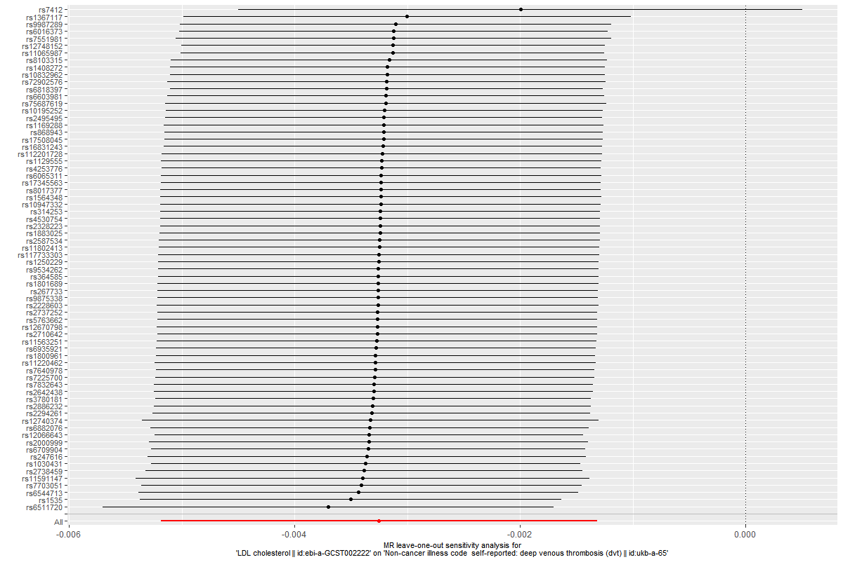

Supplemental Figure S14: Leave-one-out test plot of the causal association between HDL and DVT
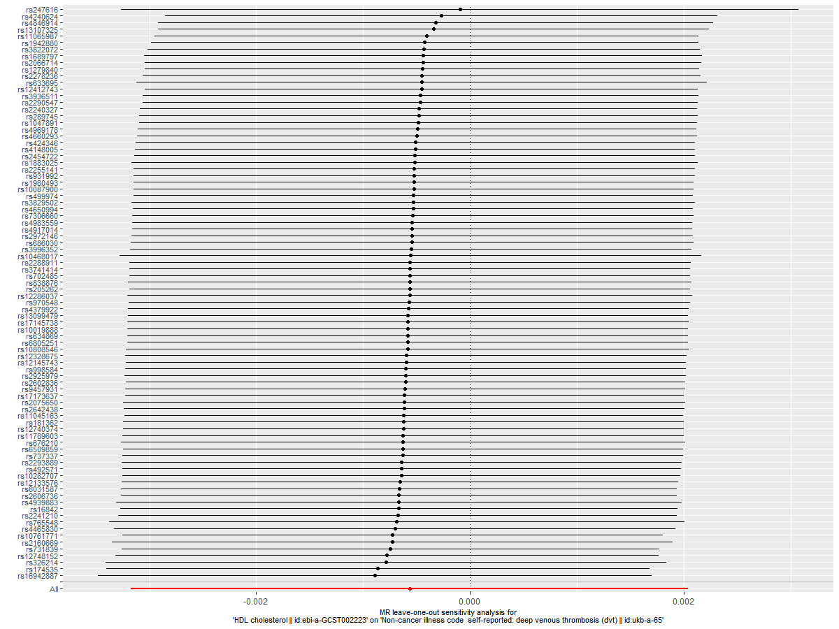
Supplemental Figure S15: Leave-one-out test plot of the causal association between TG and DVT
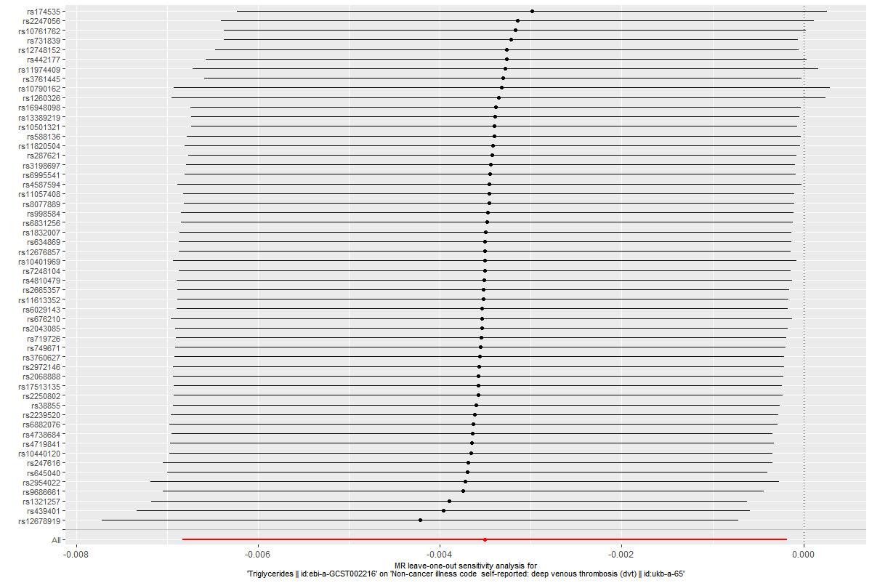

Supplemental Figure S16: Leave-one-out test plot of the causal association between LDL and PE
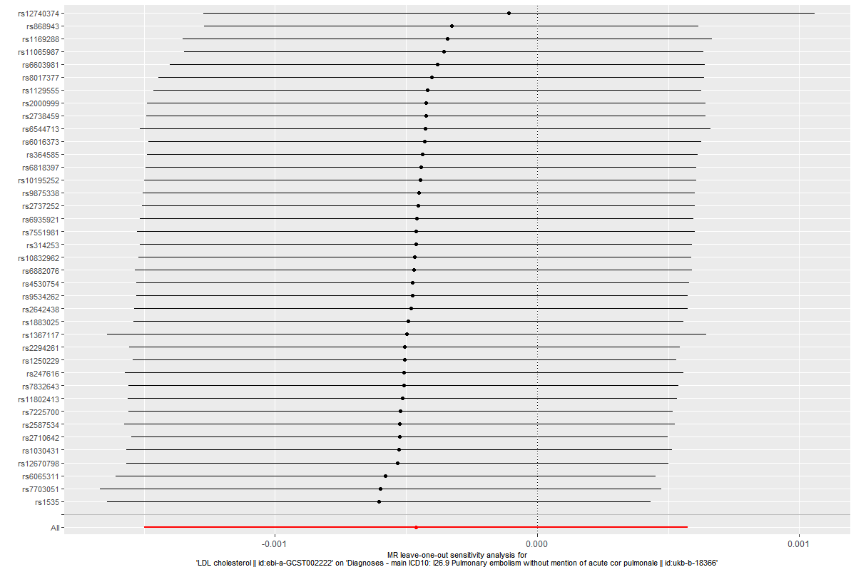

Supplemental Figure S17: Leave-one-out test plot of the causal association between HDL and PE
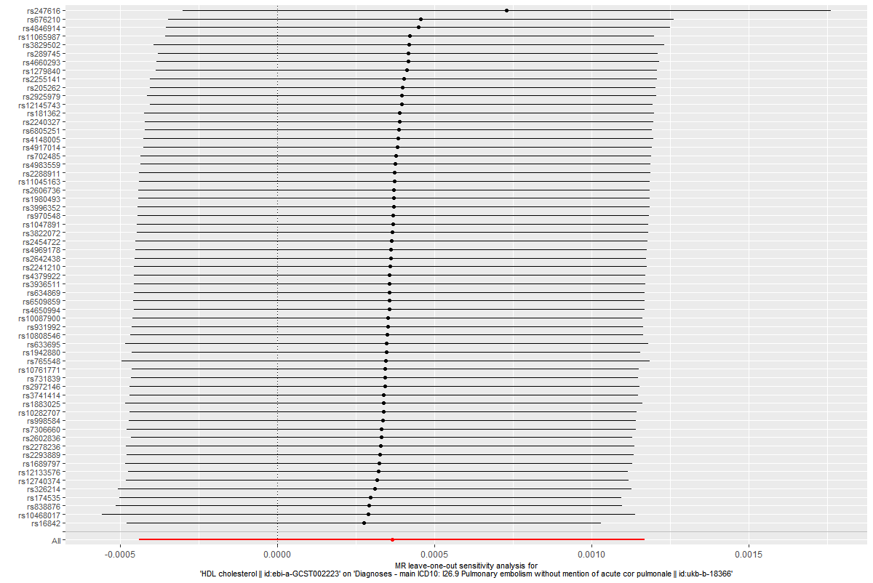

Supplemental Figure S18: Leave-one-out test plot of the causal association between TG and PE

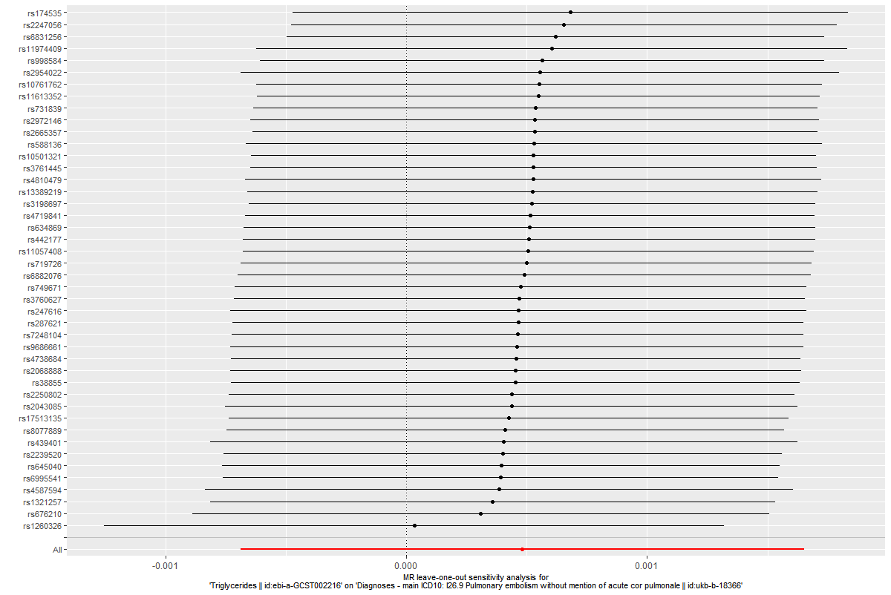

Supplemental Figure S19: Scatterplot of the causal relationships between DVT and LDL
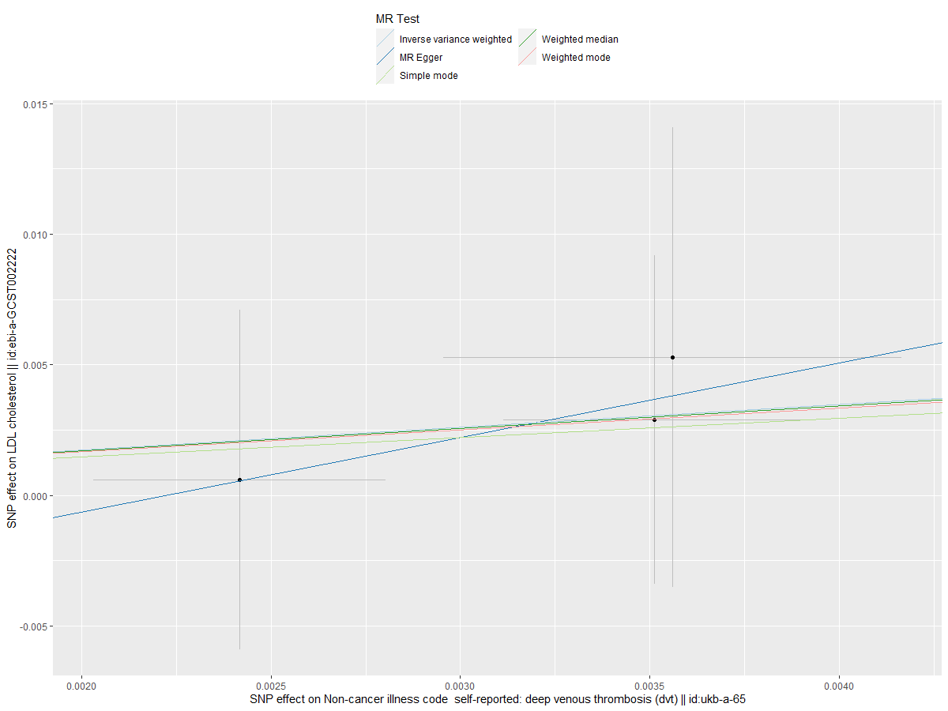
Supplemental Figure S20: Scatterplot of the causal relationships between PE
and LDL
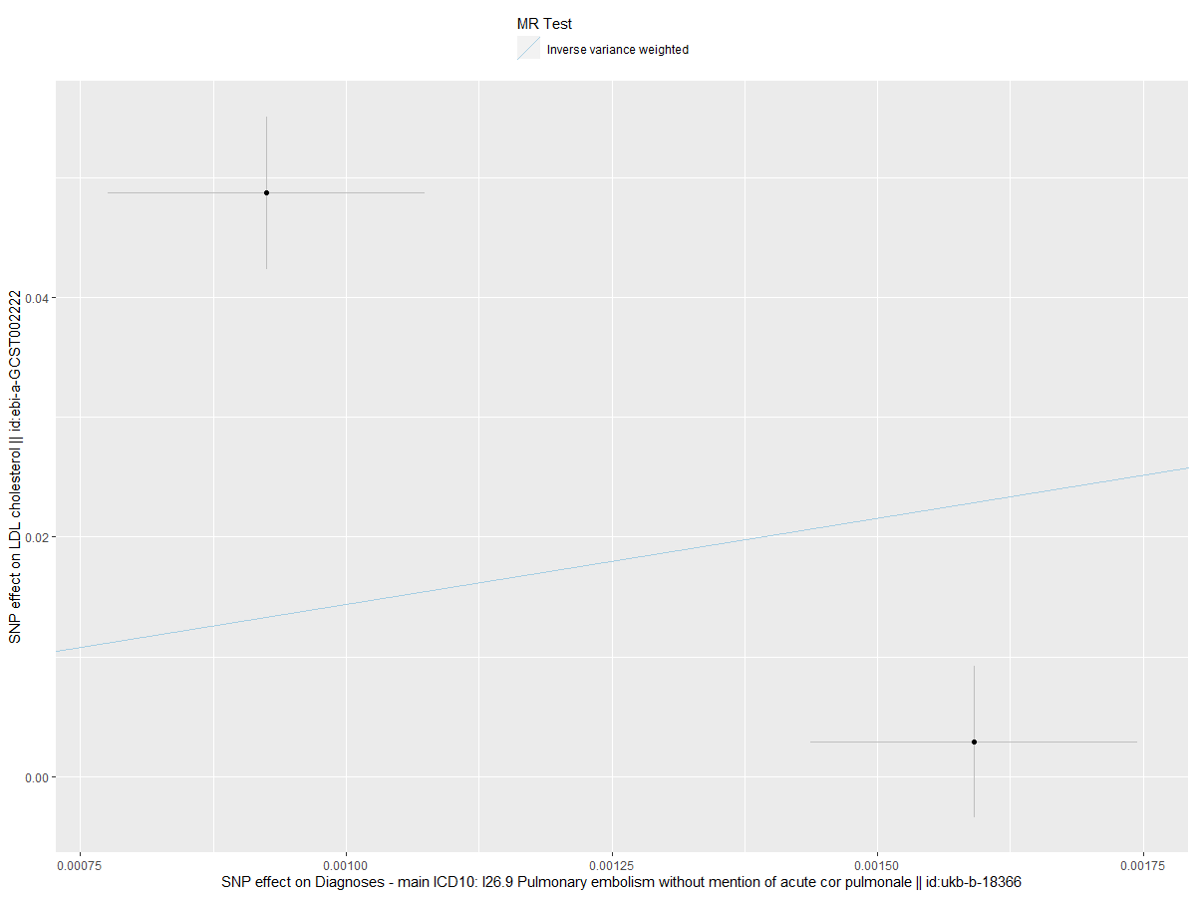
Supplemental Figure S21: Scatterplot of the causal relationships between DVT and HDL
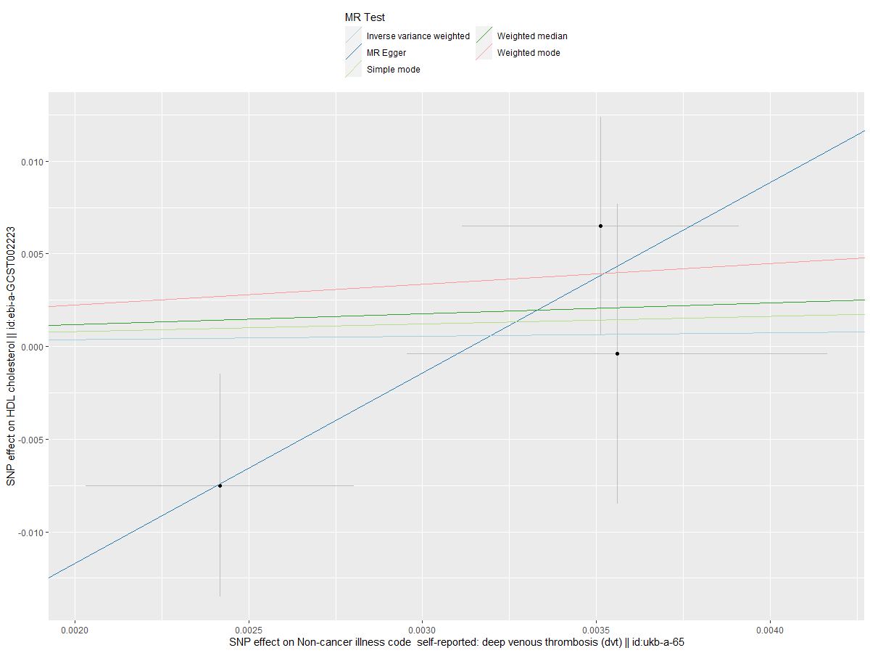

Supplemental Figure S22: Scatterplot of the causal relationships between PE and HDL
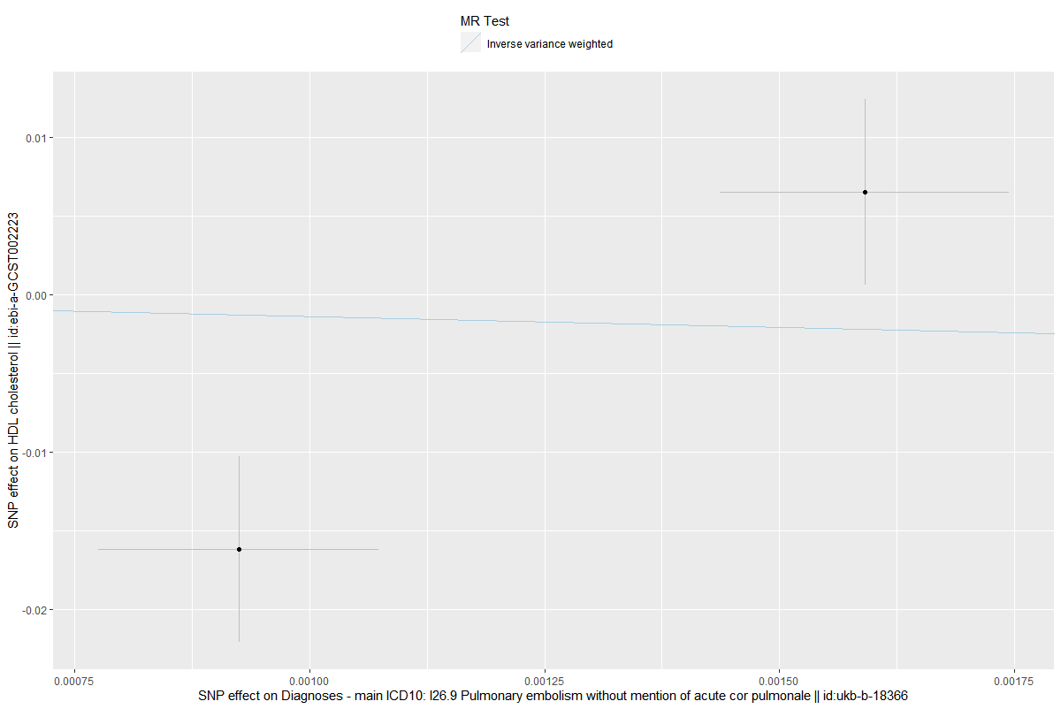

Supplemental Figure S23: Scatterplot of the causal relationships between DVT and TG
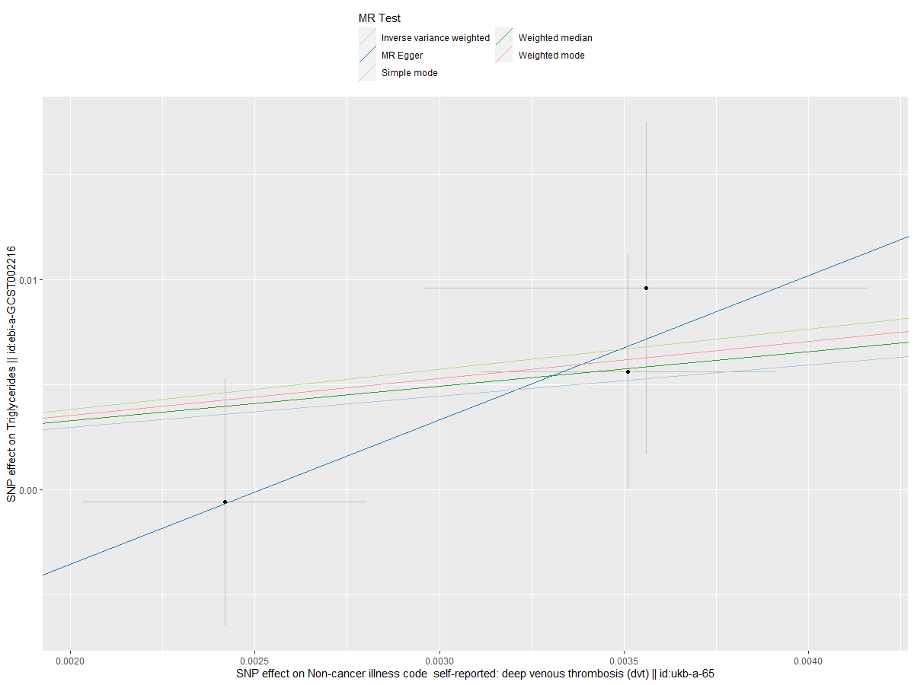
Supplemental Figure S24: Scatterplot of the causal relationships between PE and TG
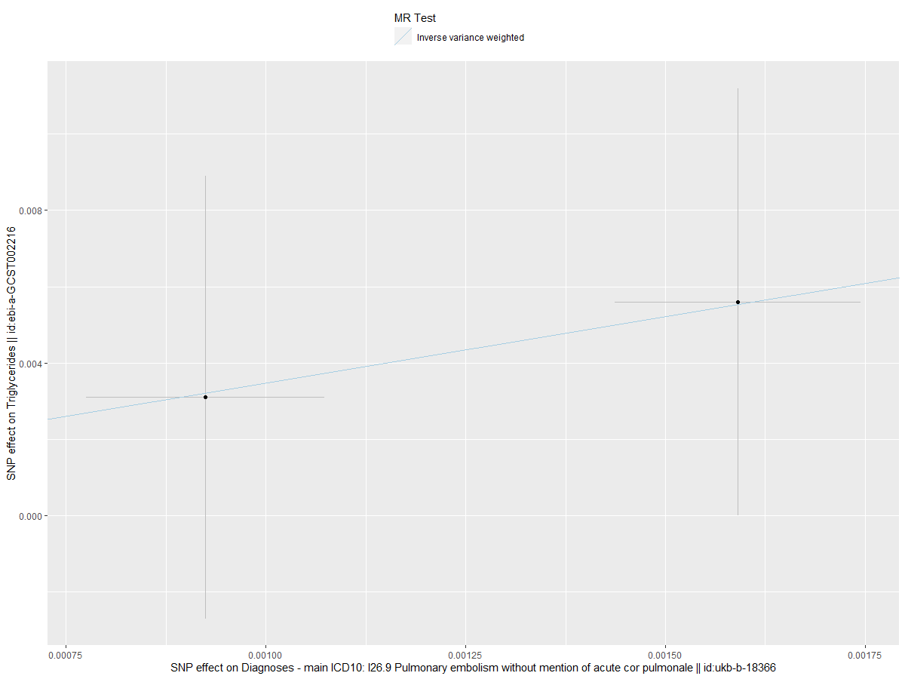

Supplemental Figure S25: Leave-one-out test plot of the causal association between DVT and LDL
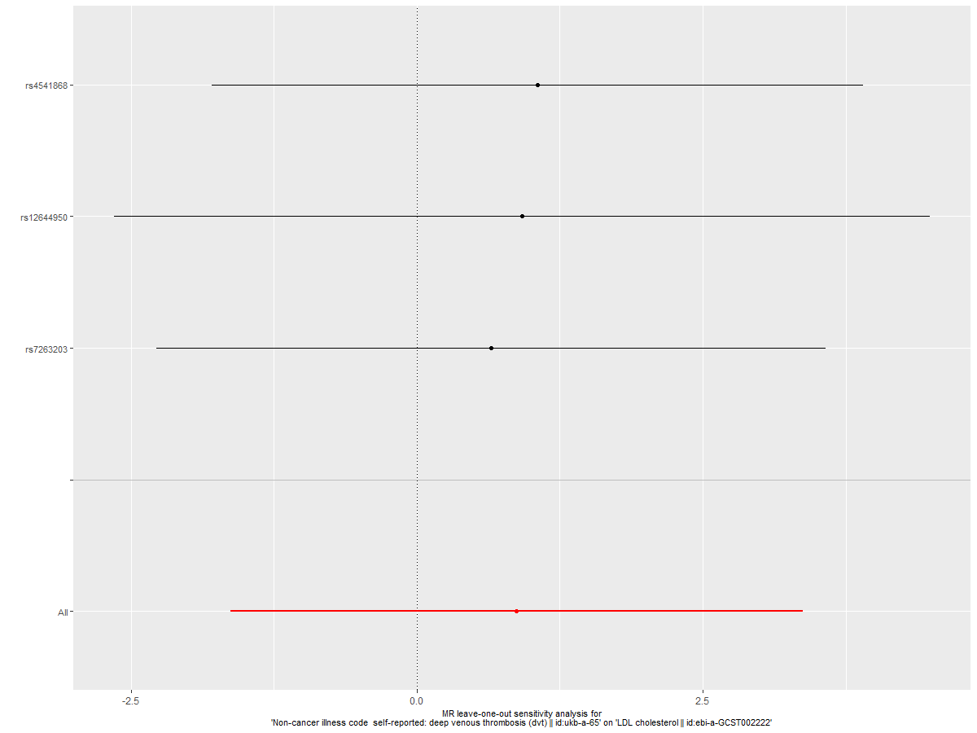
Supplemental Figure S26: Leave-one-out test plot of the causal association between DVT and HDL
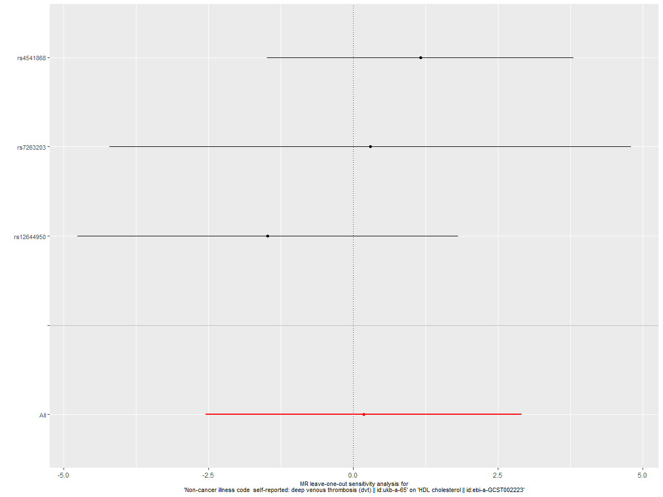
Supplemental Figure S27: Leave-one-out test plot of the causal association between DVT and TG
