Supplementary Information
Insert Figure S1. here
Figure S1. Sample comments page.

Insert Figure S2. here
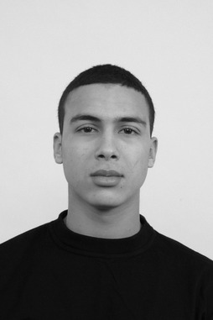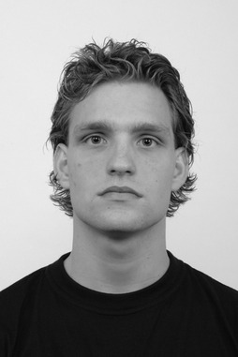
Figure S2. Examples of images from the Radboud Faces Database ^{[40]} used in the study.

