Supplementary Information
Supplementary information Figure S1. Nest sites used to calculate nest density using both the polygon method and the maximum packed nest density method (MNPD). Nest densities were estimated at 1.55-3.30 nests/100km² of forest in panel A, and 1.97-4.84 nests/100km² of forest in panel B. Mapping data are based on 2019 Landsat imagery geoprocessed as part of the MapBiomas project (mapbiomas.org collection 5; year 2019; QGIS V.3.16; https://www.qgis.org).
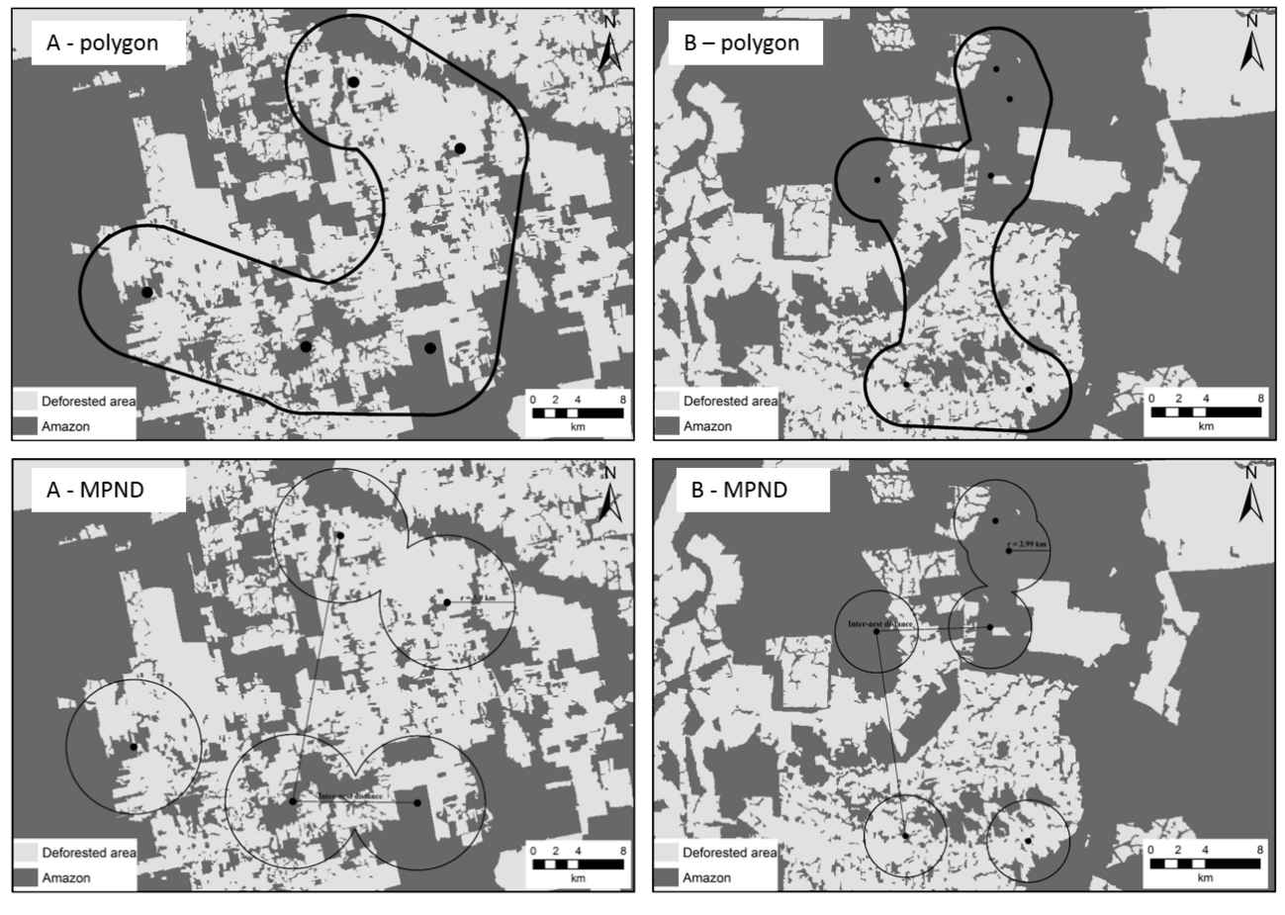
Supplementary information Table S1. Nest density calculate by maximum packed nest density (MPND) and polygon method, for two nest clusters in the study site.
 | Site | Nests | Total area (km²) | Forest area (km²) | Density (nests/100km²)
MPND
 | A | 5 | 632.85 | 253.66 | 1.97
 | B | 6 | 195.12 | 123.9 | 4.84
Polygon
 | A | 5 | 742.3 | 322.63 | 1.55
 | B | 6 | 271.62 | 181.63 | 3.30

Supplementary information Table S2. Summary statistics of models ran for different nutrients in different stratum. Parameters of the model (parameter column), coefficient estimation (coefficient), lower and upper 95% interval confidence (lower and upper), degrees of freedom (df), t statistic (t-value) and probability associate (p-value).
stratum | nutrient | parameter | coefficient | lower | upper | df | t-value | p-value
Soil | Phosphorous | Intercept | 3.18 | 1.796 | 4.563 | 347 | 4.52 | <0.001
Soil | Phosphorous | Nest | -0.928 | -1.503 | -0.353 | 347 | -3.175 | 0.002
Soil | Phosphorous | Inactive | -0.594 | -1.532 | 0.344 | 347 | -1.246 | 0.214
Soil | Phosphorous | Circumference | 0.093 | -0.164 | 0.35 | 347 | 0.71 | 0.478
Soil | Phosphorous | Nest:inactive | 0.189 | -0.65 | 1.028 | 347 | 0.444 | 0.657
Soil | Potassium | Intercept | 40.22 | 24.137 | 56.304 | 347 | 4.918 | <0.001
Soil | Potassium | Nest | -2.586 | -10.406 | 5.234 | 347 | -0.65 | 0.516
Soil | Potassium | Inactive | -7.916 | -17.931 | 2.1 | 347 | -1.555 | 0.121
Soil | Potassium | Circumference | 3.638 | 0.400 | 6.875 | 347 | 2.21 | 0.028
Soil | Potassium | Nest:inactive | 2.456 | -8.929 | 13.84 | 347 | 0.424 | 0.672
Soil | Calcium | Intercept | 40.22 | 24.137 | 56.304 | 347 | 4.918 | <0.001
Soil | Calcium | Nest | -2.586 | -10.406 | 5.234 | 347 | -0.65 | 0.516
Soil | Calcium | Inactive | -7.916 | -17.931 | 2.1 | 347 | -1.555 | 0.121
Soil | Calcium | Circumference | 3.638 | 0.400 | 6.875 | 347 | 2.21 | 0.028
Soil | Calcium | Nest:inactive | 2.456 | -8.929 | 13.84 | 347 | 0.424 | 0.672
Soil | Magnesium | Intercept | 40.22 | 24.137 | 56.304 | 347 | 4.918 | <0.001
Soil | Magnesium | Nest | -2.586 | -10.406 | 5.234 | 347 | -0.65 | 0.516
Soil | Magnesium | Inactive | -7.916 | -17.931 | 2.1 | 347 | -1.555 | 0.121
Soil | Magnesium | Circumference | 3.638 | 0.400 | 6.875 | 347 | 2.21 | 0.028
Soil | Magnesium | Nest:inactive | 2.456 | -8.929 | 13.84 | 347 | 0.424 | 0.672
Soil | Alumnium | Intercept | 40.22 | 24.137 | 56.304 | 347 | 4.918 | <0.001
Soil | Alumnium | Nest | -2.586 | -10.406 | 5.234 | 347 | -0.65 | 0.516
Soil | Alumnium | Inactive | -7.916 | -17.931 | 2.1 | 347 | -1.555 | 0.121
Soil | Alumnium | Circumference | 3.638 | 0.4 | 6.875 | 347 | 2.21 | 0.028
Soil | Alumnium | Nest:inactive | 2.456 | -8.929 | 13.84 | 347 | 0.424 | 0.672
Undergrowth | Nitrogen | Intercept | 19.911 | 13.662 | 26.16 | 48 | 6.407 | <0.001
Undergrowth | Nitrogen | Nest | 2.033 | -1.415 | 5.481 | 48 | 1.186 | 0.242
Undergrowth | Nitrogen | Inactive | -2.643 | -5.39 | 0.104 | 18 | -2.021 | 0.058
Undergrowth | Nitrogen | Circumference | 0.19 | -1.233 | 1.612 | 48 | 0.268 | 0.79
Undergrowth | Nitrogen | Nest:inactive | 2.489 | -2.569 | 7.546 | 48 | 0.989 | 0.327
Undergrowth | Phosphorous | Intercept | 0.173 | 0.038 | 0.308 | 48 | 2.569 | 0.013
Undergrowth | Phosphorous | Nest | 0.037 | -0.02 | 0.094 | 48 | 1.31 | 0.196
Undergrowth | Phosphorous | Inactive | 0.034 | -0.025 | 0.092 | 18 | 1.212 | 0.241
Undergrowth | Phosphorous | Circumference | -0.006 | -0.036 | 0.025 | 48 | -0.374 | 0.71
Undergrowth | Phosphorous | Nest:inactive | 0.015 | -0.069 | 0.098 | 48 | 0.355 | 0.724
Undergrowth | Potassium | Intercept | 13.031 | 7.871 | 18.19 | 48 | 5.078 | <0.001
Undergrowth | Potassium | Nest | 2.151 | 0.209 | 4.093 | 48 | 2.227 | 0.031
Undergrowth | Potassium | Inactive | 0.533 | -1.733 | 2.8 | 18 | 0.494 | 0.627
Undergrowth | Potassium | Circumference | -0.007 | -1.162 | 1.148 | 48 | -0.012 | 0.99
Undergrowth | Potassium | Nest:inactive | -3.172 | -6.027 | -0.318 | 48 | -2.234 | 0.03
Nest-tree | Nitrogen | Intercept | 19.911 | 13.662 | 26.16 | 48 | 6.407 | <0.001
Nest-tree | Nitrogen | Nest | 2.033 | -1.415 | 5.481 | 48 | 1.186 | 0.242
Nest-tree | Nitrogen | Inactive | -2.643 | -5.39 | 0.104 | 18 | -2.021 | 0.058
Nest-tree | Nitrogen | Circumference | 0.19 | -1.233 | 1.612 | 48 | 0.268 | 0.79
Nest-tree | Nitrogen | Nest:inactive | 2.489 | -2.569 | 7.546 | 48 | 0.989 | 0.327
Nest-tree | Phosphorous | Intercept | 0.173 | 0.038 | 0.308 | 48 | 2.569 | 0.013
Nest-tree | Phosphorous | Nest | 0.037 | -0.02 | 0.094 | 48 | 1.31 | 0.196
Nest-tree | Phosphorous | Inactive | 0.034 | -0.025 | 0.092 | 18 | 1.212 | 0.241
Nest-tree | Phosphorous | Circumference | -0.006 | -0.036 | 0.025 | 48 | -0.374 | 0.71
Nest-tree | Phosphorous | Nest:inactive | 0.015 | -0.069 | 0.098 | 48 | 0.355 | 0.724
Nest-tree | Potassium | Intercept | 13.031 | 7.871 | 18.19 | 48 | 5.078 | <0.001
Nest-tree | Potassium | Nest | 2.151 | 0.209 | 4.093 | 48 | 2.227 | 0.031
Nest-tree | Potassium | Inactive | 0.533 | -1.733 | 2.8 | 18 | 0.494 | 0.627
Nest-tree | Potassium | Circumference | -0.007 | -1.162 | 1.148 | 48 | -0.012 | 0.99
Nest-tree | Potassium | Nest:inactive | -3.172 | -6.027 | -0.318 | 48 | -2.234 | 0.03
Canopy surrounding | Nitrogen | Intercept | 19.365 | 15.062 | 23.668 | 194 | 8.877 | <0.001
Canopy surrounding | Nitrogen | Nest | 16.95 | 14.385 | 19.515 | 194 | 13.033 | <0.001
Canopy surrounding | Nitrogen | Inactive | 0.79 | -1.732 | 3.313 | 18 | 0.658 | 0.519
Canopy surrounding | Nitrogen | Circumference | -0.213 | -1.159 | 0.733 | 194 | -0.444 | 0.657
Canopy surrounding | Nitrogen | Nest:inactive | 4.197 | 0.335 | 8.059 | 194 | 2.143 | 0.033
Canopy surrounding | Phosphorous | Intercept | 0.225 | 0.127 | 0.322 | 194 | 4.561 | <0.001
Canopy surrounding | Phosphorous | Nest | 0.319 | 0.268 | 0.371 | 194 | 12.241 | <0.001
Canopy surrounding | Phosphorous | Inactive | 0.023 | -0.039 | 0.086 | 18 | 0.787 | 0.442
Canopy surrounding | Phosphorous | Circumference | -0.008 | -0.029 | 0.013 | 194 | -0.78 | 0.437
Canopy surrounding | Phosphorous | Nest:inactive | -0.012 | -0.09 | 0.065 | 194 | -0.312 | 0.755
Canopy surrounding | Potassium | Intercept | 12.808 | 9.209 | 16.408 | 194 | 7.018 | <0.001
Canopy surrounding | Potassium | Nest | 10.116 | 7.717 | 12.515 | 194 | 8.316 | <0.001
Canopy surrounding | Potassium | Inactive | 0.303 | -1.715 | 2.322 | 18 | 0.316 | 0.756
Canopy surrounding | Potassium | Circumference | 0.213 | -0.583 | 1.01 | 194 | 0.528 | 0.598
Canopy surrounding | Potassium | Nest:inactive | -7.498 | -11.115 | -3.881 | 194 | -4.089 | <0.001

Supplementary information Figure S2. Map showing the geographic location of all 20 harpy eagle nests (white circles) sampled in terms of soil and plant chemistry within our southern Amazonian study region in northern Mato Grosso. Prey composition and delivery rates was also monitored at all active nests for up to 24 months. Background map shows forest cover (dark gray) and deforestation areas (light gray). Mapping data are based on 2019 Landsat imagery geoprocessed as part of the MapBiomas project (mapbiomas.org collection 5; year 2019; QGIS V.3.16; https://www.qgis.org).
