Supplementary Material 2 – EIS fitting details

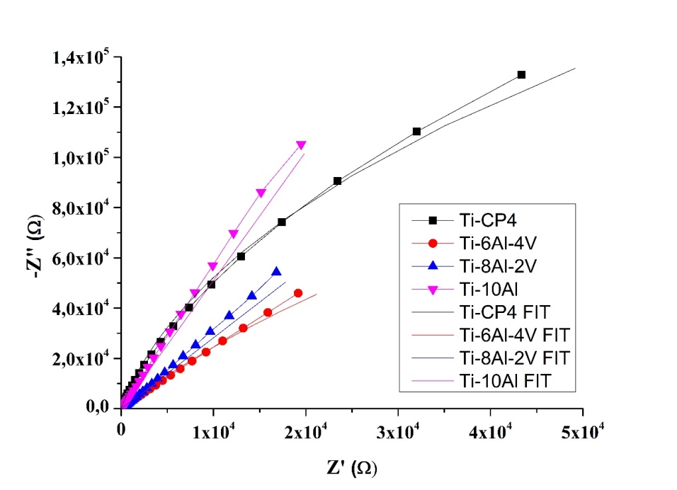
(a)
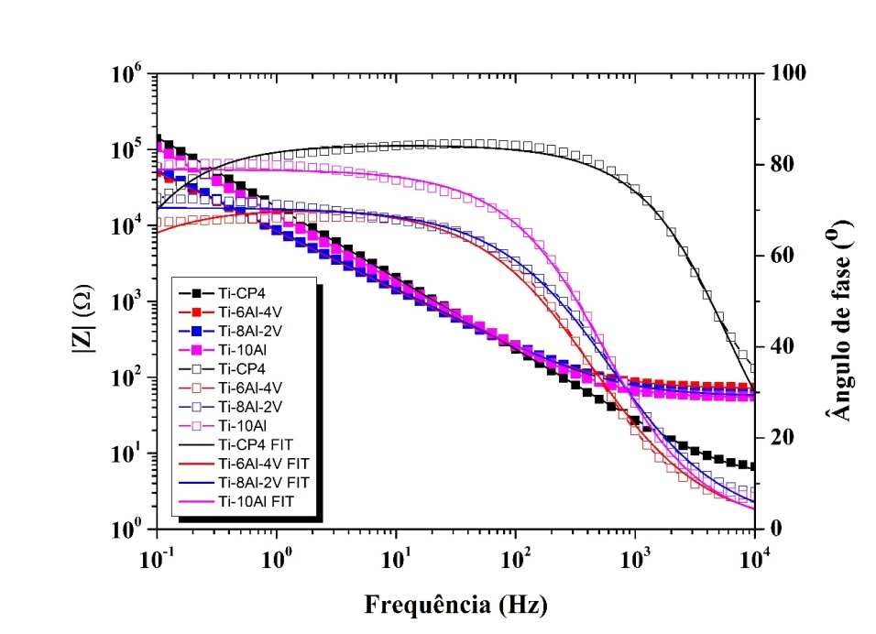
(b)
Fig. S2-1 – EIS fitting plots of the samples: (a) Nyquist and (b) Bode curves.

Table S2-1 - Equivalent electric circuits.

Ti-CP4 | 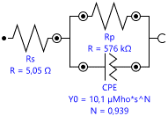
Ti6Al4V | 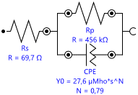
Ti8Al2V | 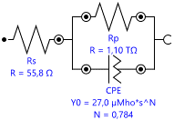
Ti10Al | 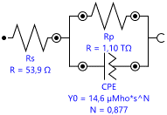

Table S2-2 - EIS fitted parameters from the equivalent electric circuit.
 | CP-Ti | Ti-10Al | Ti-8Al-2V | Ti-6A-4V
R_{s} (Ω) | 5.05 | 53.95 | 55.77 | 69.71
R_{p} (Ω) | 5.76 x 10⁵ | 1.10 x 10¹² | 1.10 x 10¹² | 4.56 x 10⁵
CPE (C) | 1.01 x 10⁻⁵ | 1.46 x 10⁻⁵ | 2.70 x 10⁻⁵ | 2.76 x 10⁻⁵
α | 0.94 | 0.88 | 0.78 | 0.79
χ² | 0.05 | 0.04 | 0.03 | 0.03

Symbols caption:
- R_{s}: Solution Resistance [Ω]
- R_{p}: Polarization Resistance [Ω]
- CPE: Constant Phase Elements (Q)
- α: Charge transfer coefficient (used to define kinetics of electrochemical reaction)
- χ²: Chi-square value (for better the fitting, it should remain closer to zero)

