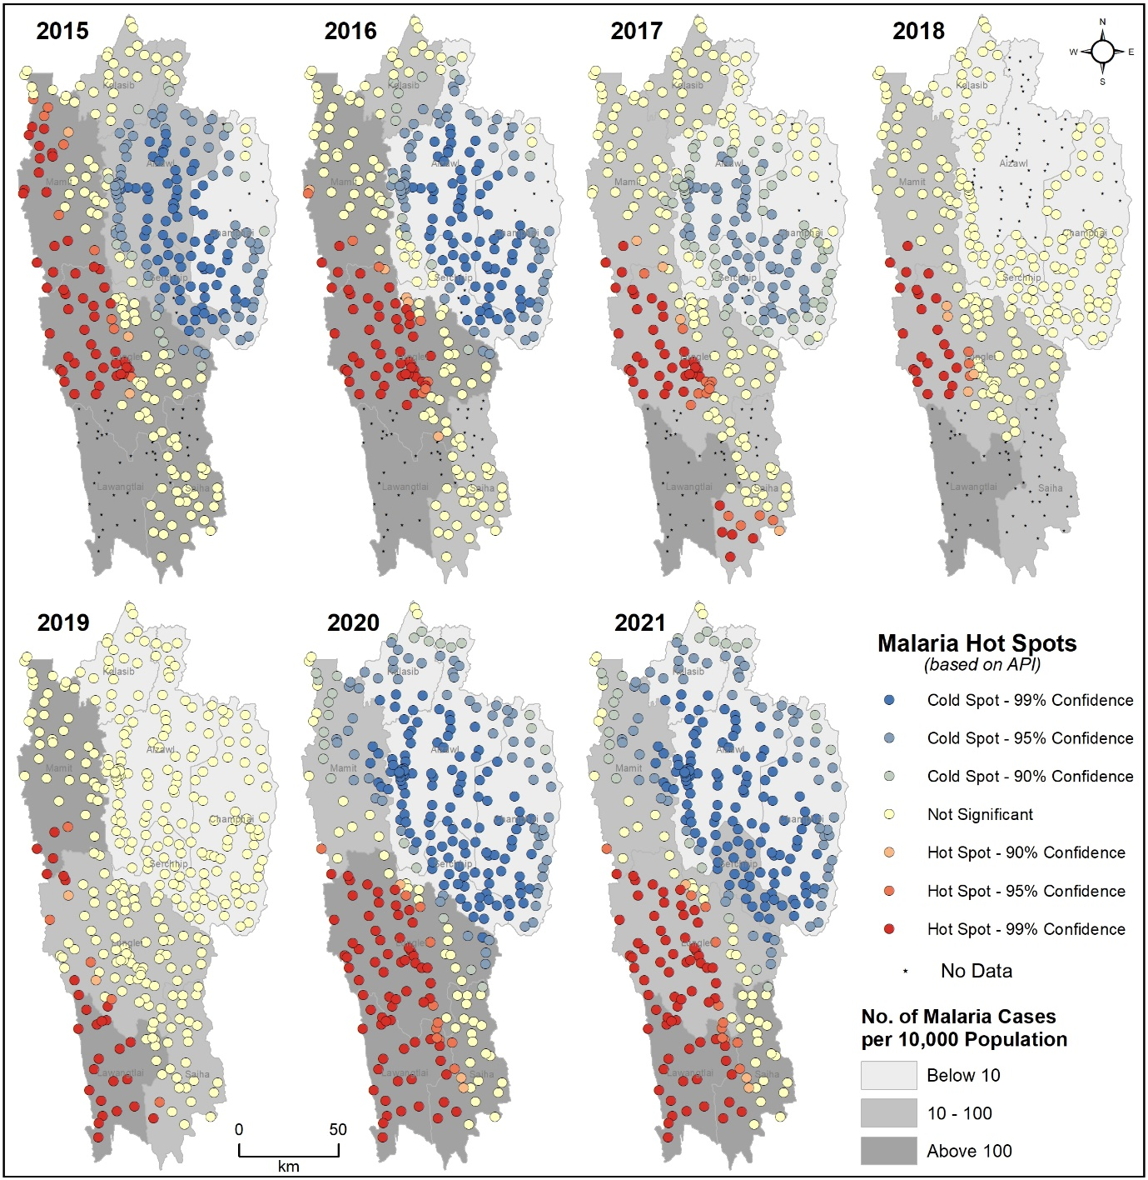
Supplementary Figure S10. Evolution of malaria hotspot over the years (2015-2021) in Mizoram.

