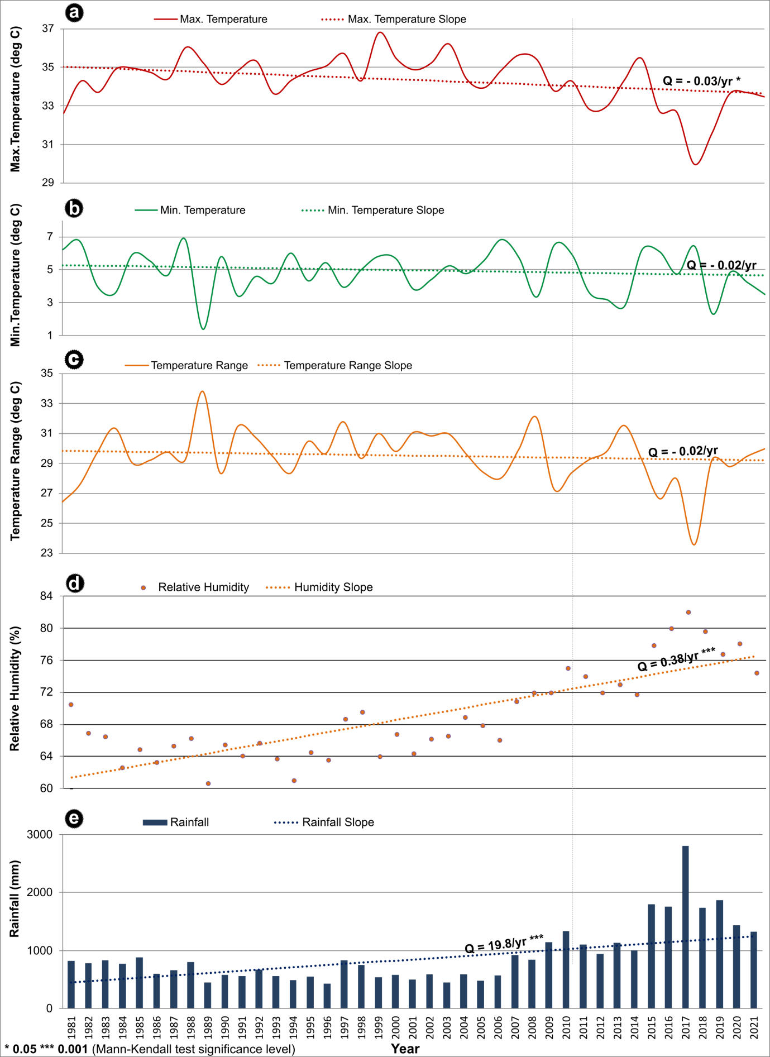
Supplementary Figure S13. Long-term trends in (a) Maximum temperature; (b) Minimum temperature; (c) Temperature range; (d) Relative humidity; (e) Rainfall in the Eastern regions of Mizoram. The dotted lines in the graphs show Sen’s slope, the rate of change per year (Q), and statistical significance (based on Z-value).

