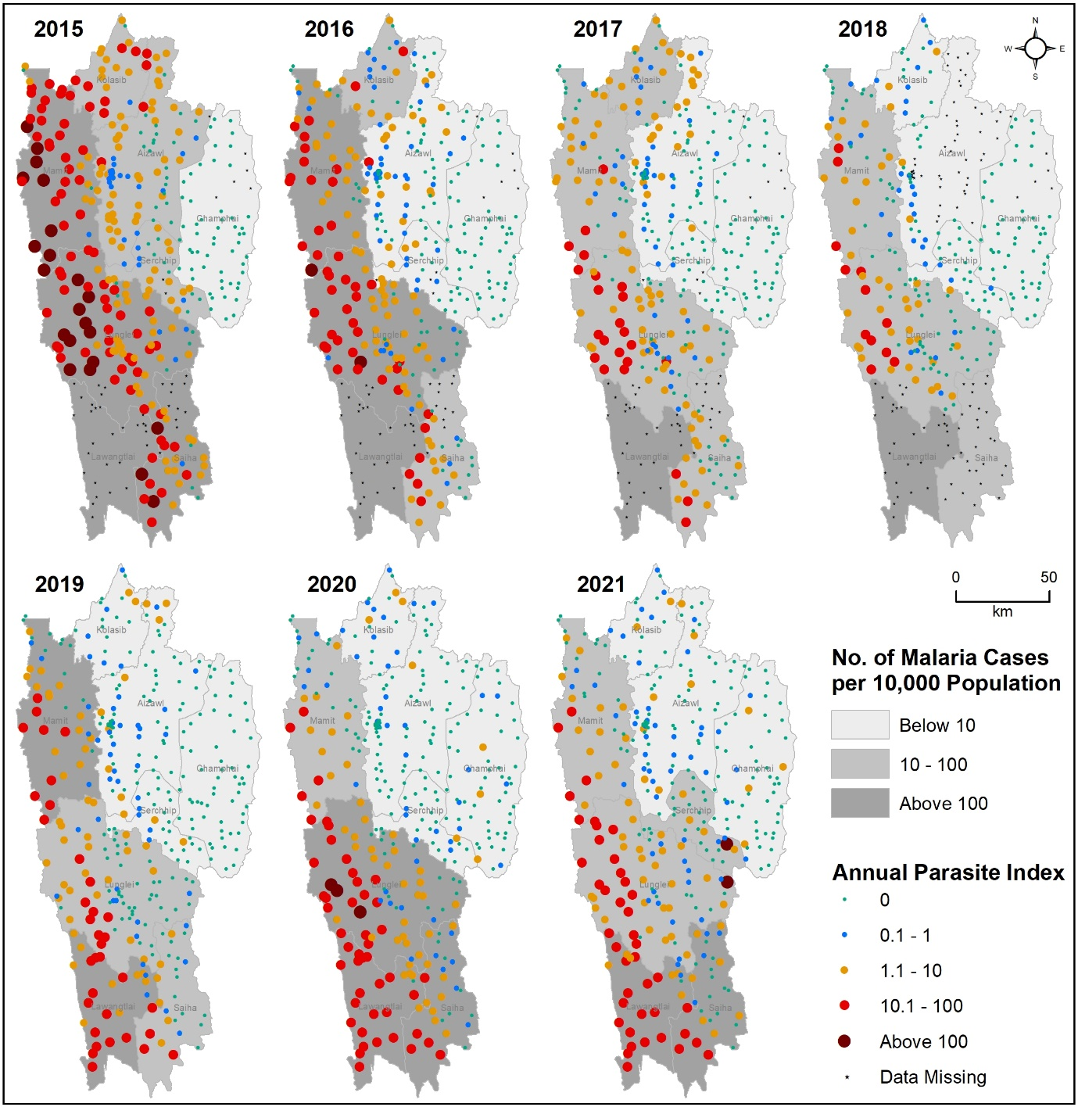
Supplementary Figure S9. Distribution of Annual Parasite Index (API) across 385 sub-centers of Mizoram from 2015 to 2021. The size (larger) and color (darker) of the dots show the distribution (higher) of API. The background grey shade represents district-wise normalised malaria cases where the darker shade shows the higher number of malaria cases per 10,000 population. Note that sub-center-wise data is not available for some of the years in Lawngtlai (2015-2018), Siaha (2018), and Aizawl East (2018) districts. The map was created using licensed version of ArcGIS 10.4 software by Esri. For more information about Esri® software, please visit www.esri.com.

