Supplementary material
Revisiting the baby schema: a geometric morphometric approach reveals shared infant facial characteristics across great apes
Yuri Kawaguchi, Koyo Nakamura, Tomoyuki Tajima, Bridget Waller

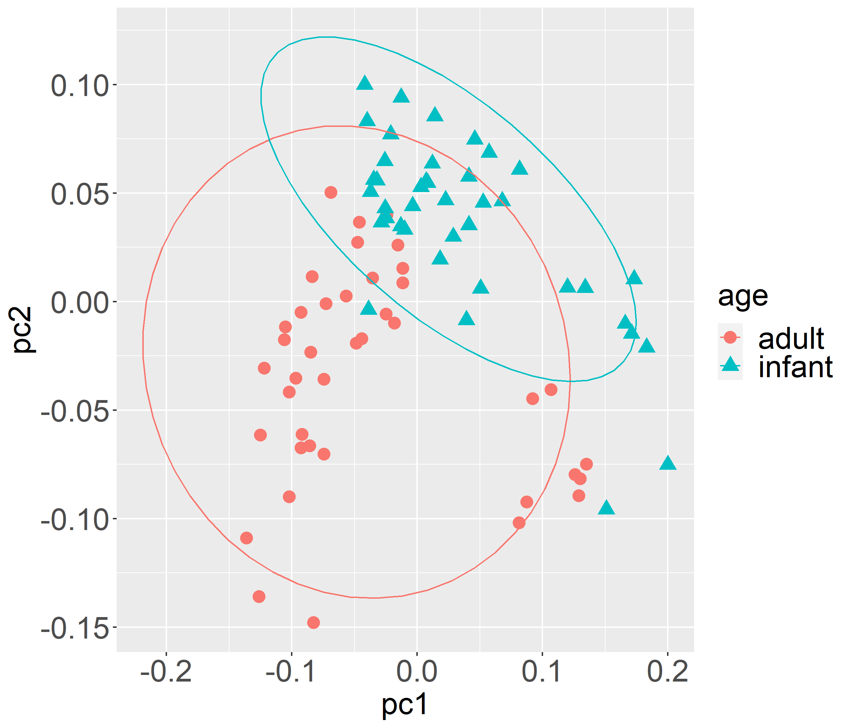
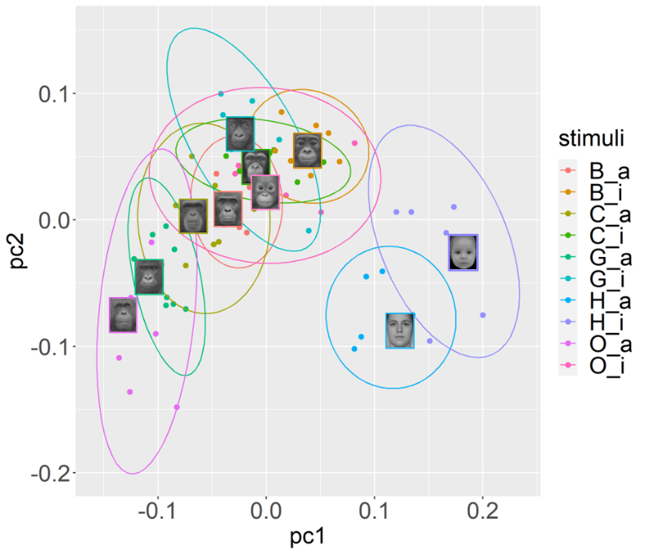

Fig. A.1. Scores of PC 1 and 2 for each face.

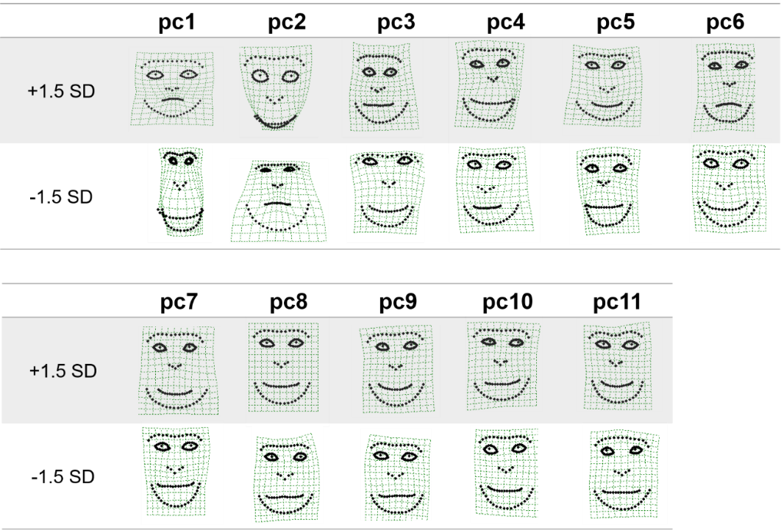
Fig. A.2. The landmark configurations of high (+1.5 SD) and low (-1.5 SD) PC scores (PC1-11).

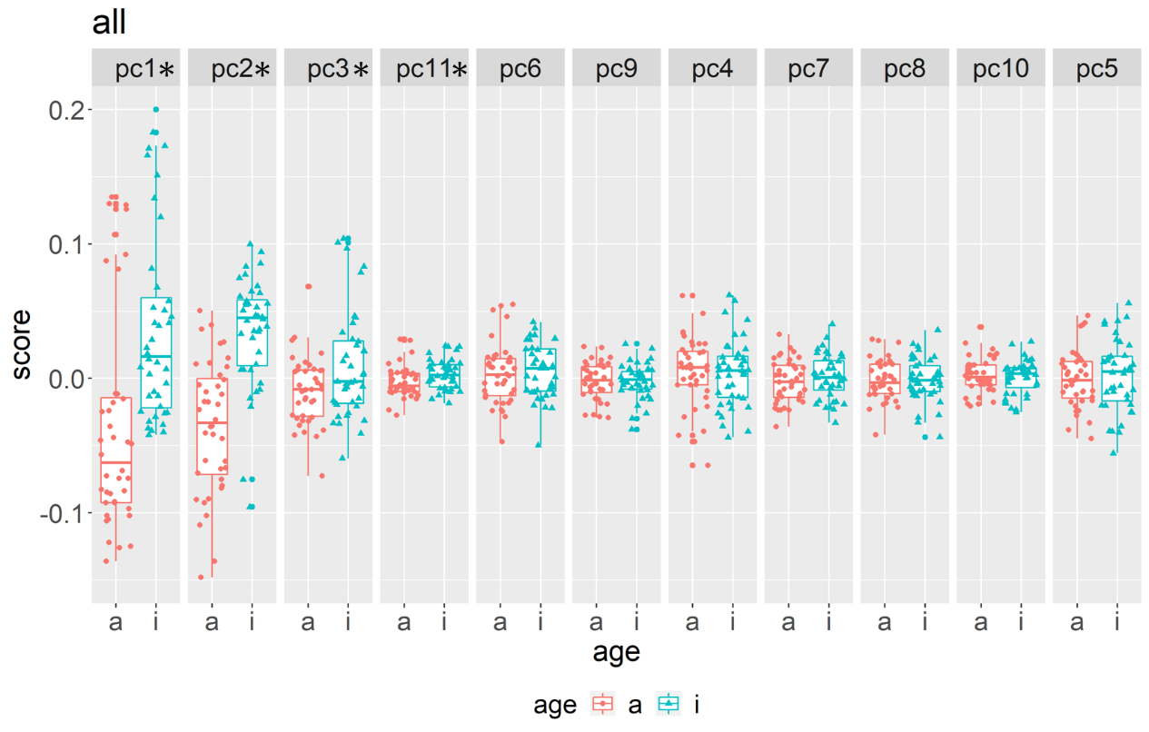
Fig. A.3. PC scores of all species.

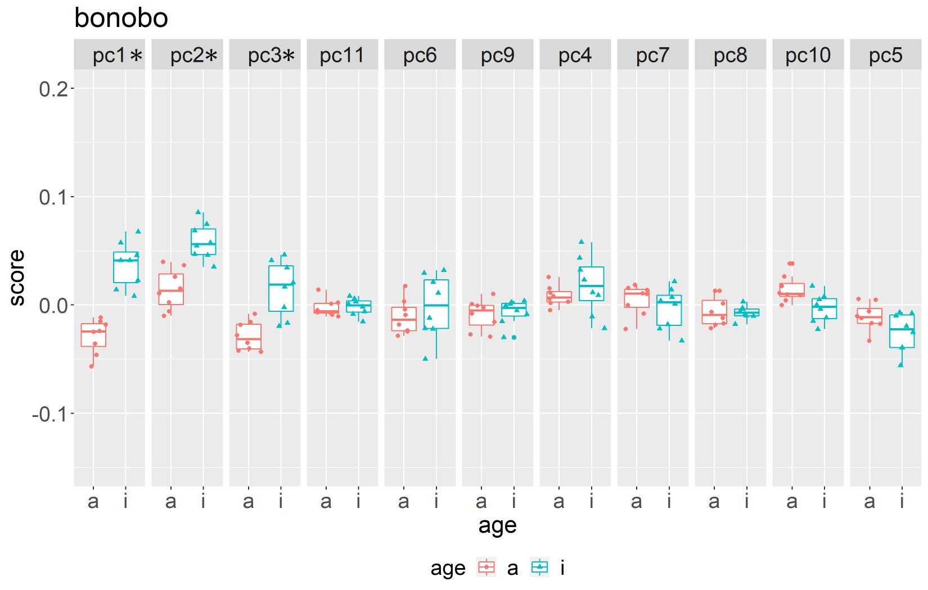
Fig. A.4. PC scores of bonobos.
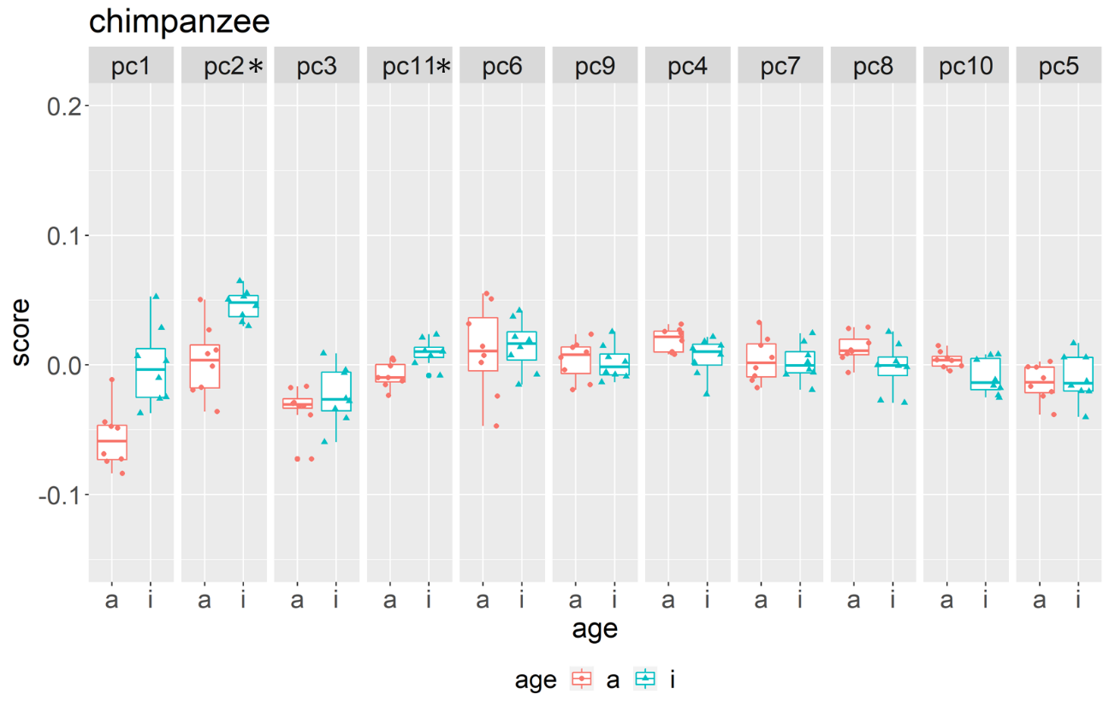
Fig. A.5. PC scores of chimpanzees.
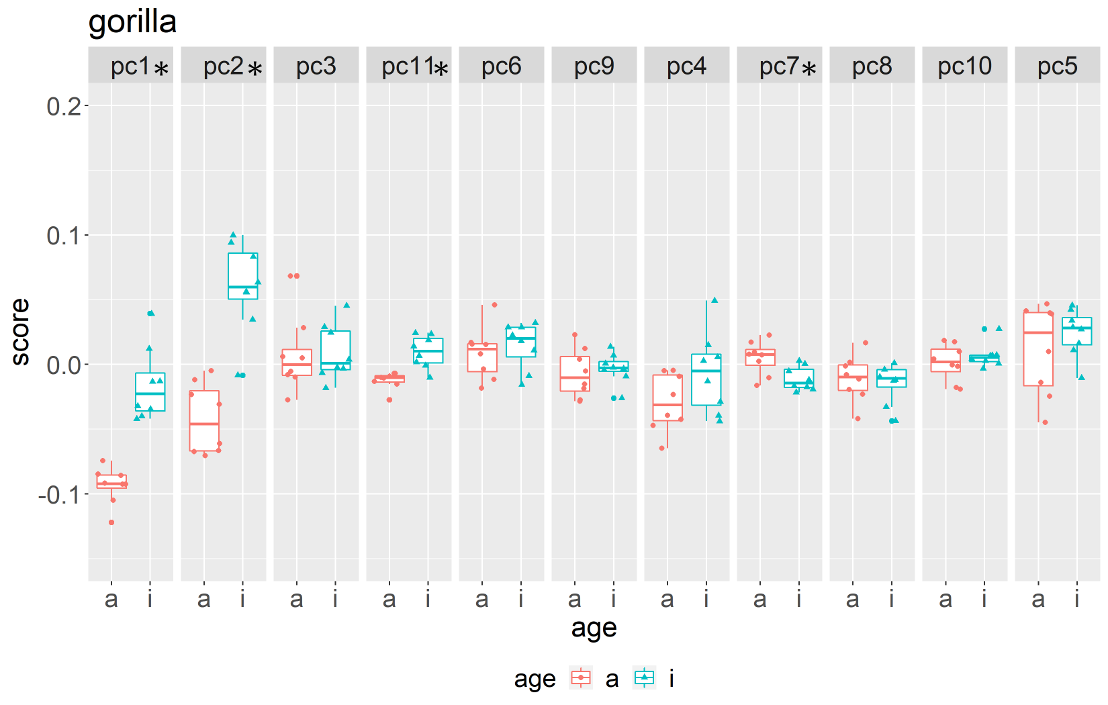
Fig. A.6. PC scores of gorillas.

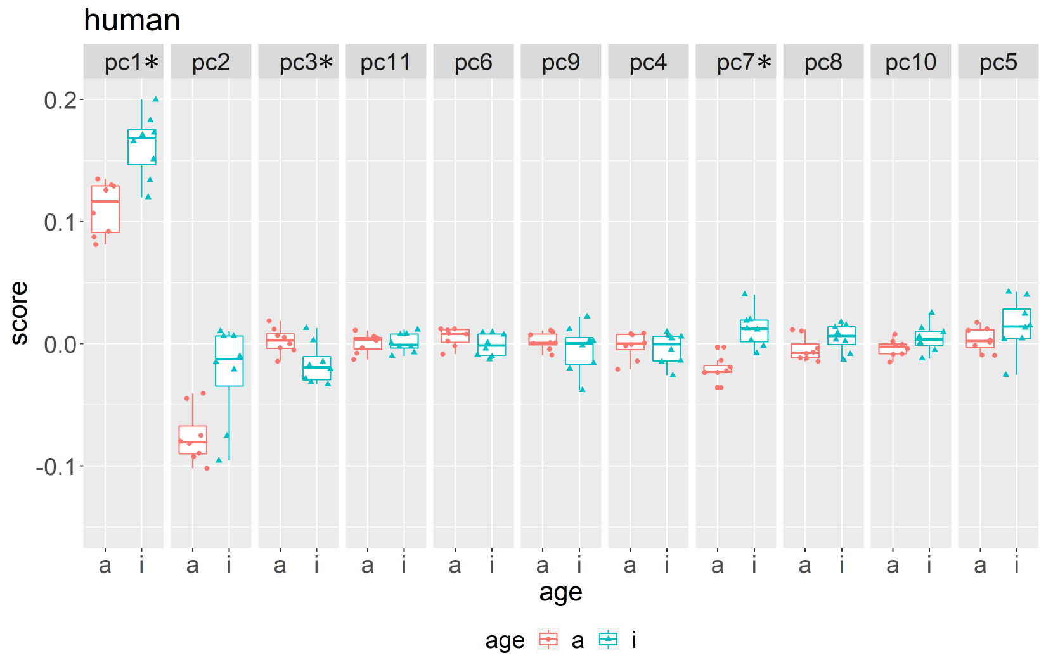
Fig. A.7. PC scores of humans.

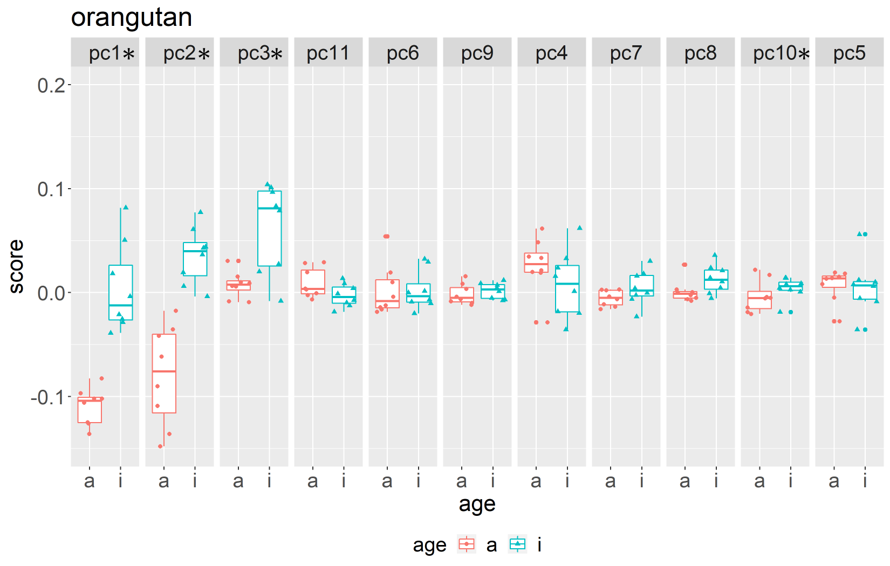
Fig. A.8. PC scores of orangutans.

