SUPPLEMENTAL MATERIALS
A blood and bronchoalveolar lavage protein signature of rapid FEV₁ decline
in smoking-associated COPD

Katarina M. DiLillo¹, Katy C. Norman¹, Christine M. Freeman^{2,3,4}, Stephanie A. Christenson⁵,
Neil E. Alexis⁶, Wayne H. Anderson⁷, Igor Z. Barjaktarevic⁸, R. Graham Barr⁹,
Alejandro P. Comellas¹⁰, Eugene R. Bleecker¹¹, Richard C. Boucher¹², David J. Couper¹³,
Gerard J. Criner¹⁴, Claire M. Doerschuk¹², J. Michael Wells¹⁵, MeiLan K. Han³,
Eric A. Hoffman¹⁶, Nadia N. Hansel¹⁷, Annette T. Hastie¹⁸, Robert J. Kaner¹⁹,
Jerry A. Krishnan²⁰, Wassim W. Labaki³, Fernando J. Martinez¹⁹, Deborah A. Meyers¹¹,
Wanda K. O’Neal¹², Victor E. Ortega²¹, Robert Paine, III²², Stephen P. Peters¹⁸,
Prescott G. Woodruff⁵, Christopher B. Cooper⁸, Russell P. Bowler²³, Jeffrey L. Curtis^{3,4,24, +},
Kelly B. Arnold^{1,+,}*, for the SPIROMICS investigators#.

¹ Department of Biomedical Engineering, University of Michigan, Ann Arbor, MI
² Research Service, VA Ann Arbor Healthcare System, Ann Arbor, MI
³ Division of Pulmonary & Critical Care Medicine, University of Michigan, Ann Arbor, MI
⁴ Graduate Program in Immunology, University of Michigan, Ann Arbor, MI
⁵ Division of Pulmonary, Critical Care, Allergy and Sleep Medicine, University of California San Francisco, San Francisco, CA
⁶ Center for Environmental Medicine, Asthma, and Lung Biology, University of North Carolina at Chapel Hill, Chapel Hill, NC
⁷ Marsico Lung Institute/Pulmonary and Critical Care Medicine, University of North Carolina at Chapel Hill, Chapel Hill, NC
⁸ Division of Pulmonary and Critical Care Medicine, Department of Medicine, University of California Los Angeles, Los Angeles, CA
⁹ Department of Medicine, Columbia University Medical Center, New York, NY
¹⁰ Division of Pulmonary, Critical Care and Occupational Medicine, University of Iowa, Iowa City, IA
¹¹ Division of Genetics, Genomics and Precision Medicine, University of Arizona Health Sciences, Tucson, AZ
¹² Marsico Lung Institute/Cystic Fibrosis Research Center, Department of Medicine, University of North Carolina at Chapel Hill, Chapel Hill, NC
¹³ Collaborative Studies Coordinating Center, Department of Biostatistics, University of North Carolina at Chapel Hill, Chapel Hill, NC
¹⁴ Department of Thoracic Medicine and Surgery, Temple University, Philadelphia, PA
¹⁵ Department of Medicine, University of Alabama at Birmingham, Birmingham, AL
¹⁶ Department of Radiology, University of Iowa, Iowa City, IA
¹⁷ Division of Pulmonary and Critical Care Medicine, Johns Hopkins University School of Medicine, Baltimore, MD
¹⁸ Department of Internal Medicine, Wake Forest School of Medicine, Atrium Health, Wake Forest Baptist, Winston Salem, NC
¹⁹ Department of Medicine, Weill Cornell Medical Center, New York, NY
²⁰ Division of Pulmonary, Critical Care, Sleep and Allergy, University of Illinois at Chicago, Chicago, IL
²¹ Department of Internal Medicine, Division of Respiratory Medicine, Mayo Clinic, Scottsdale, AZ
²² Division of Respiratory, Critical Care, and Occupational Pulmonary Medicine, University of Utah, Salt Lake City, UT
²³ Division of Pulmonary and Critical Care, National Jewish Health, Denver, CO
²⁴ Medical Service, VA Ann Arbor Healthcare System, Ann Arbor, MI
# A list of authors and their affiliations appears at the end of the paper
⁺ Co-senior authors
* Corresponding author
Supplementary Table S1. Baseline characteristics of COPD cases and TEPPS reference group
 |  | TEPPS§  (N=40) | Greater Decliners** (N=14) | Lesser Decliners (N=31) | P-Value
Age* |  | 59.3 (± 8.67) | 64.2 (± 6.24) | 63.1 (± 8.41) | 0.068
Currently Smoking* |  | 13 (32.5%) | 5 (35.7%) | 10 (32.3%) | 0.97
BMI* |  | 29.3 (± 5.01) | 27.9 (± 3.67) | 27.8 (± 5.43) | 0.41
Sex (Male) |  | 17 (42.5%) | 12 (85.7%) | 17 (54.8%) | 0.02†
Race  (White/Other) |  | 29/11 (72.5%) | 12/2 (85.7%) | 25/6 (80.6%) | 0.52
ICS use* (yes) |  | 2 (5.0%) | 3 (21.4%) | 14 (45.2%) | 0.0003‡
FEV₁* (% predicted) |  | 100.4 (± 13.1) | 84.2 (± 13.1) | 71.1 (± 17.7) | < 0.0001†‡
FEV₁/FVC* |  | 0.78 (± 0.04) | 0.60 (± 0.08) | 0.57(± 0.10) | < 0.0001†‡
FEV₁* (L) |  | 2.89 (± 0.69) | 2.63 (± 0.60) | 2.11 (± 0.66) | < 0.0001‡
Visit 5 FEV₁ (L) |  | 2.74 (± 0.77) | 1.97 (± 0.67) | 1.93 (± 0.68) | < 0.0001†‡
Time from baseline  to Visit 5 (yrs) |  | 6.18 (± 0.93) | 6.25 (± 0.76) | 6.33 (± 0.91) | 0.77
Time from baseline to  bronchoscopy (months) |  | 12.5 (±11.1) | 20.4 (± 10.0) | 20.3 (± 12.5) | 0.0107‡
∆FEV₁ (mL/yr) |  | -25.7 (± 47.5) | -104.6 (± 32.0) | -28.8 (±21.5) | < 0.0001†
One-way ANOVA with Tukey’s post hoc test or chi-squared test were used to determine significance.
* Demographic information from baseline visit (Visit 1)
† Significant difference between TEPPS and greater decliners
‡ Significant difference between TEPPS and lesser decliners
§ Tobacco-exposed people with preserved spirometry (TEPPS); n=2 removed prior to analysis due to identification as outliers (see methods)
** Defined as annualized decline in FEV₁ ≥ 70 mL/year (see Methods)

Supplemental Table S2. Demographics of study group compared to full SPIROMICS bronchoscopy sub-study cohort
 | Study Group  (N=85) | Full Bronchoscopy Cohort  (N=188) | P-Value
Age* | 61.5 (± 8.41) | 60.1 (± 8.89) | 0.24
Currently Smoking* | 28 (32.9%) | 81 (43.1%) | 0.11
BMI* | 28.5 (± 5.01) | 28.5 (± 4.97) | 0.99
Sex (Male) | 46 (54.1%) | 104 (55.3%) | 0.85
Race  (White/Other) | 66/19 (77.6%) | 131/57 (69.7%) | 0.17
ICS use* (yes) | 19 (22.4%) | 37 (19.7%) | 0.61
FEV₁* (% predicted) | 87.0 (± 19.9) | 88.1 (± 19.1) | 0.67
FEV₁/FVC* | 0.67 (± 0.12) | 0.68 (± 0.12) | 0.75
FEV₁* (L) | 2.56 (± 0.75) | 2.59 (± 0.76) | 0.75
Visit 5 FEV₁ (L) | 2.32 (± 0.82) | 2.33 (± 0.80) | 0.87
Time from baseline  to Visit 5 (yrs) | 6.25 (± 0.89) | 6.28 (± 0.97) | 0.81
Time from baseline to  bronchoscopy (months) | 16.6 (± 12.0) | 15.2 (± 12.4) | 0.37
∆FEV₁ (mL/yr) | -39.8 (± 47.0) | -34.4 (± 51.7) | 0.46
Unpaired two-tailed t-test or chi-squared test were used to determine significance.

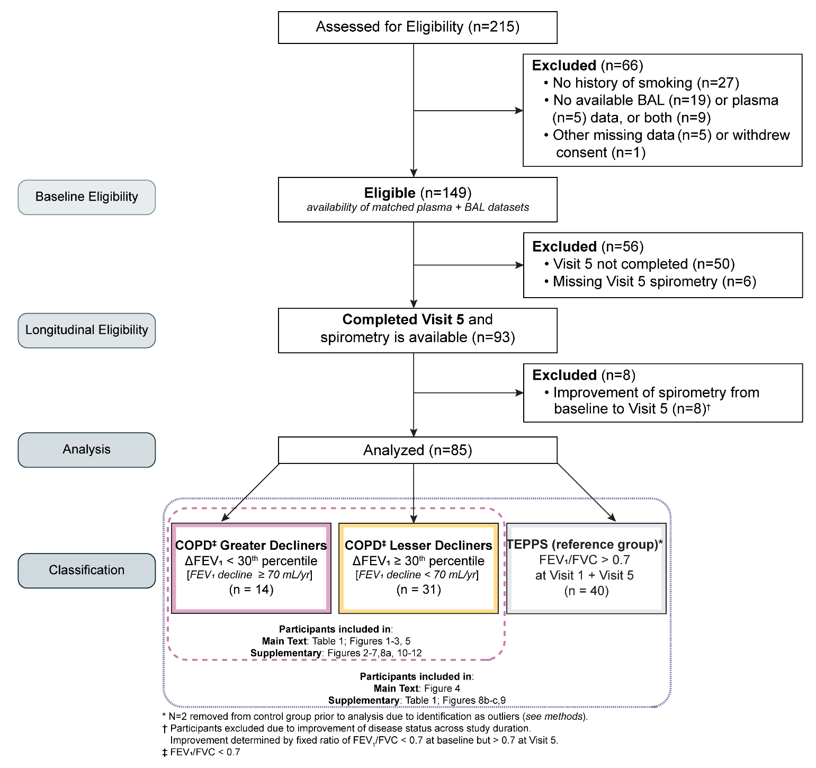
Supplementary Figure S1. Schematic illustrating the inclusion criteria and patient breakdown of participants with a history of smoking from SPIROMICS I bronchoscopy sub-study (n=215) included in analysis.

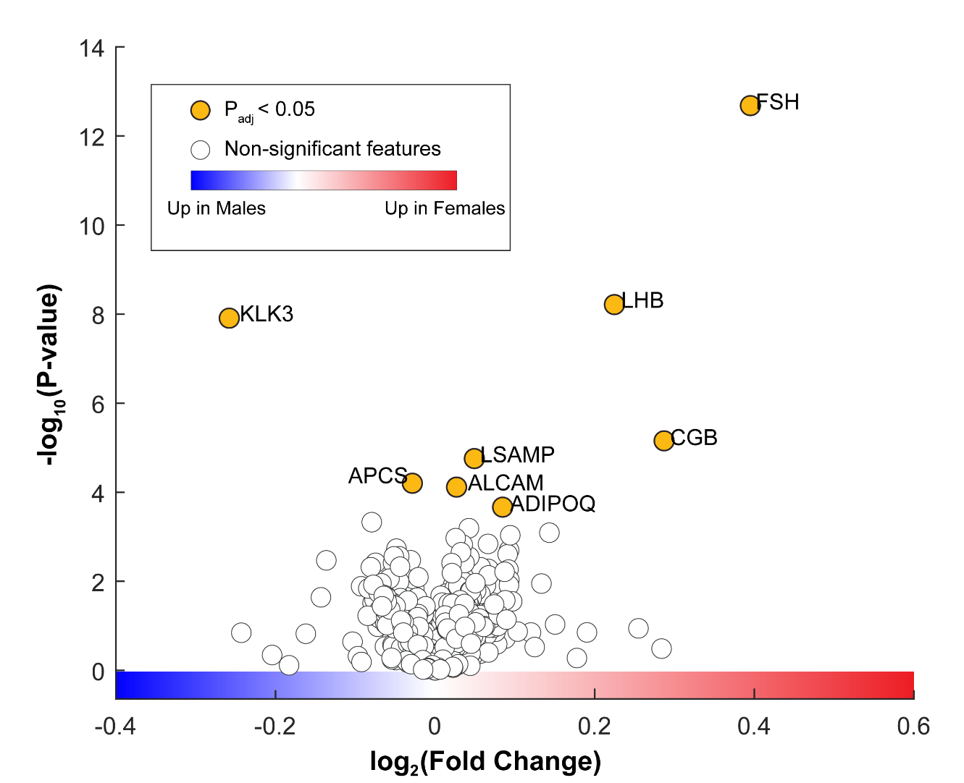
Supplementary Figure S2. Differential expression of cross-compartment proteins between sexes. Volcano plot of blood and BAL proteins (two-sampled, two tailed t-test). Yellow markers represent proteins which have p-value < 0.05 after correction for multiple comparison using Benjamini-Hochberg false discovery rate (FDR) (α = 0.05).

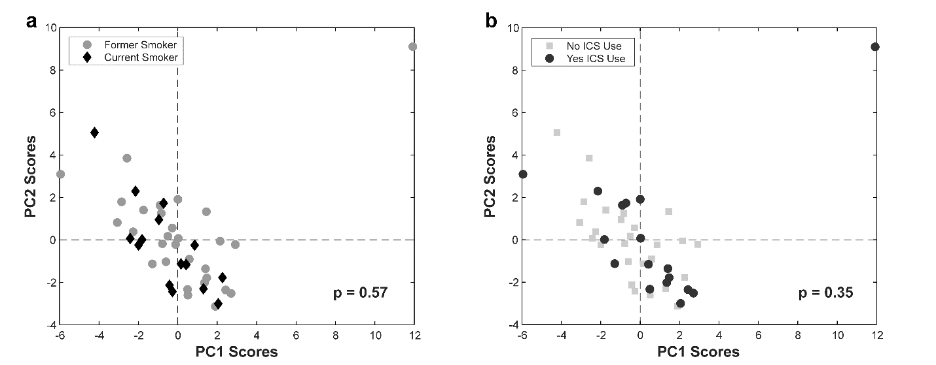
Supplementary Figure S3. 52-ft cross-compartment signature is not influenced by participants’ smoking status or ICS use. PCA was completed with the 52 (blood and BAL) proteins identified in the multi-compartment progression signature (Figure 2; n=45). Participants (n=45) are classified into two groups using self-reported (a) baseline smoking status (current/ former) or (b) ICS use within three months of the baseline visit (yes/no). P-values reported from a permutation test (n = 2000 permutations) between groups’ mean scores across PC1 and PC2.

Supplementary Figure S4. The 52-feature elastic net-identified signature outperforms random variants of equal size. Comparison of optimal model CV accuracy (98.4%) to average performance of 1000 random variant signatures, generated by selecting randomized feature sets (proteins) from the original dataset (1322 proteins) at a size equal to our optimal signature (52 features; two-tailed two-sample t-test; ****p < 0.0001).

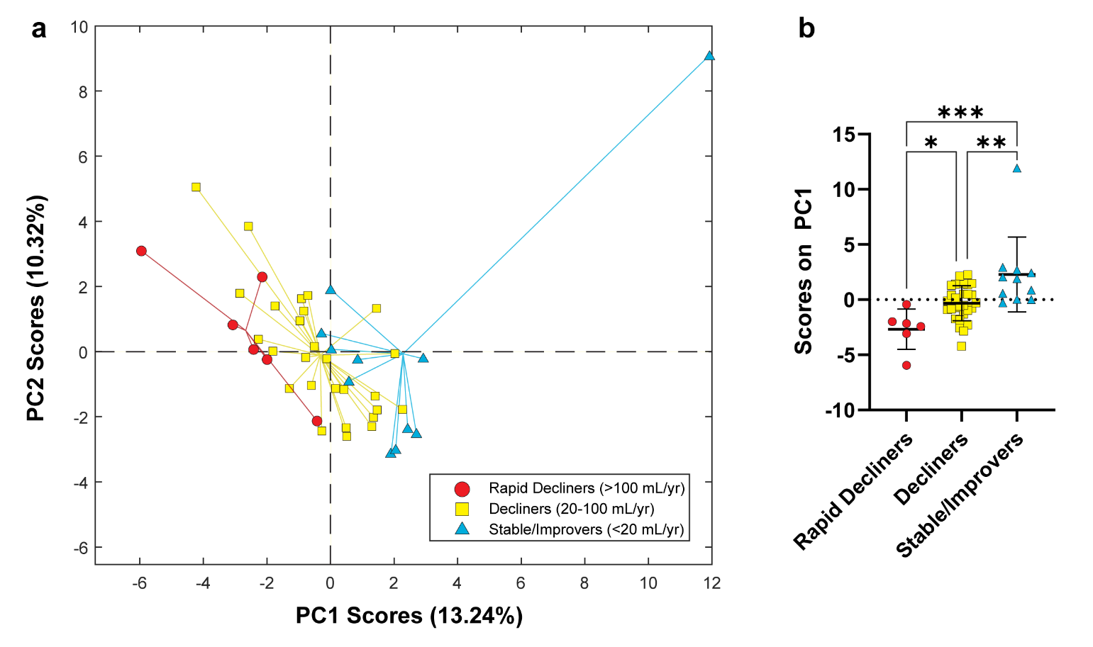
Supplementary Figure S5. Multi-compartment progression signature is significantly enriched in an alternative, more stringent definition of rapid lung function decline. (a) PCA completed with the 52 (blood and BAL) proteins identified in the multi-compartment progression signature (Figure 2). Participants (n=45) are classified into 3 groups using the alternative progression definitions proposed by Anderson et al.²⁸: rapid decliners (circles; >100 mL/year), decliners (squares; 20 – 100 mL/year), stable/improvers (triangles; < 20 mL/year). (b) Comparisons of participant scores across PC1 show significant enrichment of signature in rapid decliners by this definition, compared to decliners and stable/improvers (one-way ANOVA with Holm-Šídák's multiple comparisons test; *p < 0.05, ** p < 0.01, *** p < 0.001).

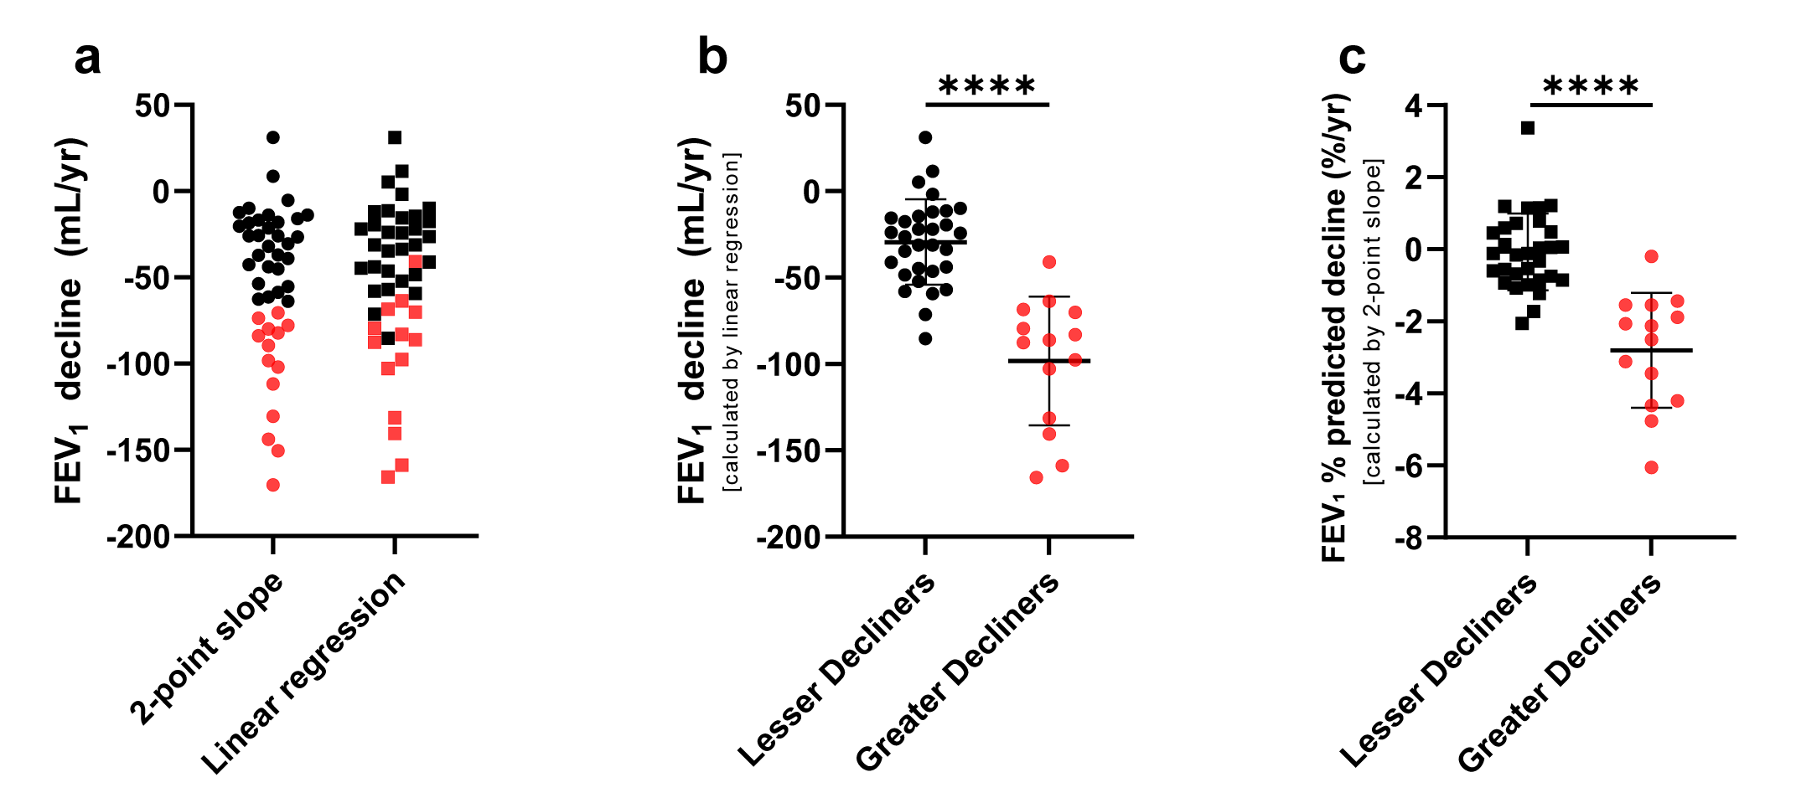
Supplementary Figure S6. Classifications are not largely affected by alternative calculation approaches. (a) Visualization of the impact of calculating FEV₁ decline using 2 data points (Visit 1 and Visit 5) versus all available longitudinal spirometry. FEV₁ declines using 2 data points (left) were calculated using the 2-point slope equation: $\frac{V5 FEV_{1}-V1 FEV_{1}}{Time from V5 to V1}$ . The multiple point estimate (right) was defined as the slope ($β_{1}$) of the linear regression equation $FEV_{1 }=β_{0}+β_{1}\left(Time since V1\right)$ for each participant. (b) Plot of FEV₁ (mL/yr) values generated from the linear regression approach, grouped into greater or lesser decliners based on their 2-point slope evaluations scheme. A two-sample t-test suggests that using only Visit 1 and 5 data is sufficient to capture more complex progression trends. (c) Plot of lung function decline calculated using FEV₁ % predicted at Visit 1 and 5 exhibit similar distributions as the original calculations, which use absolute FEV₁ (two-sample t-test; ****p < 0.0001). Red points denote participants classified as greater decliners in all plots as per the 2-point evaluation calculations completed with absolute FEV₁. For all estimates, the change in time was calculated using the visit dates for each participant; calculations assumed a fixed-length year equal to 365.2425 days.

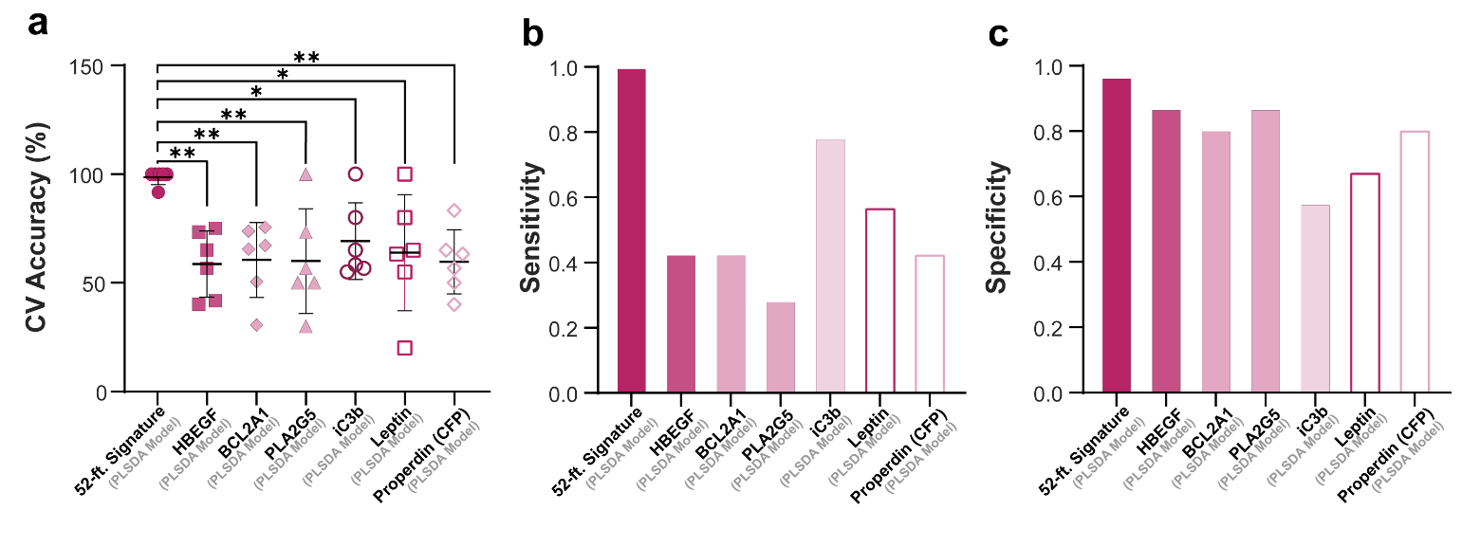
Supplementary Figure S7. The 52-feature significantly outperforms analyses based on individual proteins. (a) Comparison of 6-fold cross-validation (CV) accuracies, (b) sensitivities, and (c) specificities between optimized data-driven signature and the top six individually identified proteins in Fig. 1b. One-way ANOVA with Dunnett’s post hoc test; *p<0.05, **p<0.01.
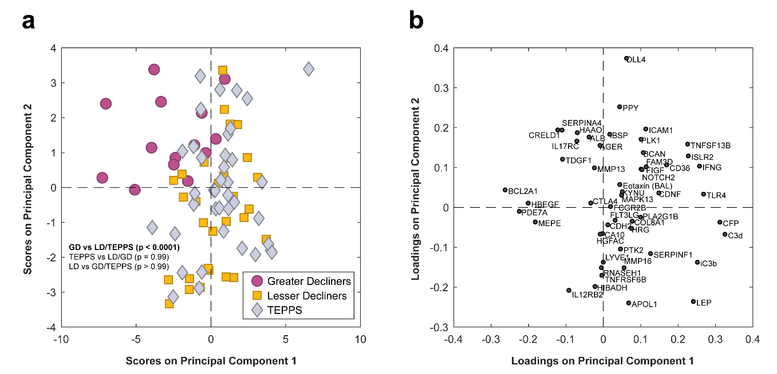
Supplementary Figure S8. 52-feature cross-compartment signature can differentiate TEPPS from Greater Decliners but not Lesser Decliners. (a) PCA scores plot generated with the 52 signature-identified cross-compartment proteins of greater decliners (circles), lesser decliners (squares), and a reference group of tobacco-exposed people with preserved spirometry (TEPPS) (diamonds). First two principal components (PCs) capture 17% of the variance in the dataset. P-values reported from a permutation test (n = 2000 permutations) between groups’ mean scores across PC1 and PC2. (b) Protein loadings across PC1 and PC2.

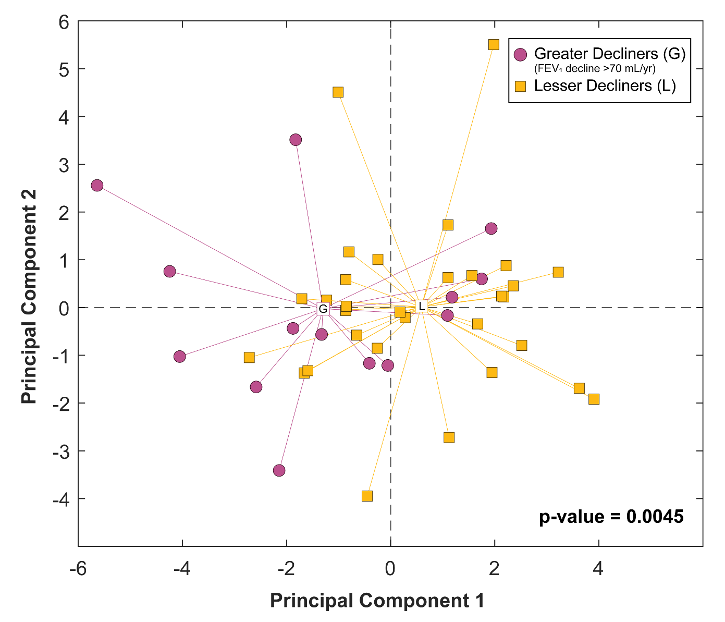
Supplementary Figure S9. At baseline, greater decliners have unique complement profiles. PCA of all complement proteins measured in plasma (including C1q, C1qBP, C1r, C2, C3d, C3b, C3, C3a, iC3b, C3a des Arg, C4, C4b, C5, C5a, C5-6, C6, C7, C8, C9, Factor B, Factor D, Properdin). The first two principal components collectively capture 34.8% of total variance. P-value shown for two sample, two-tailed t-test of PC1 scores across groups.

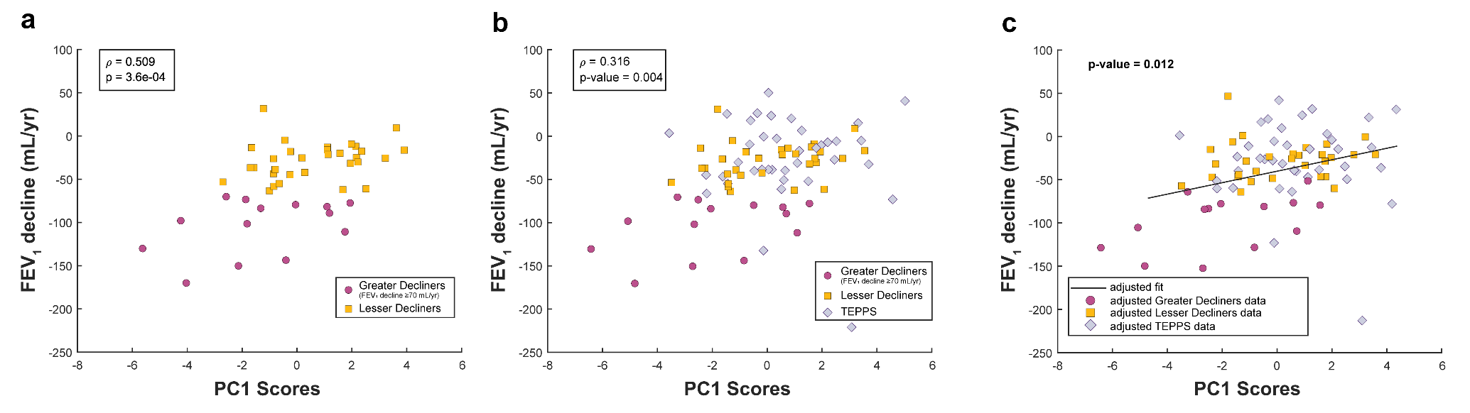
Supplementary Figure S10. PC1 scores from the complement-specific PCA highly correlate with decline in FEV₁ (mL/yr). This analysis uses the PC1 scores from Supplementary Figure 6. (a) Pearson correlation of PC1 scores and FEV₁ mL/ year in a model with greater decliners and lesser decliners alone and (b) with the addition of a reference group of tobacco smoke-exposed persons with preserved spirometry (TEPPS). (c) Observed relationship between complement protein profiles on PC1 and FEV₁ decline remains significant after adjusting for clinical covariates (p-value shown for linear regression adjusted for age, race, height, sex, baseline FEV₁% predicted, smoking status, ICS use within three months of baseline visit, and pack-years).

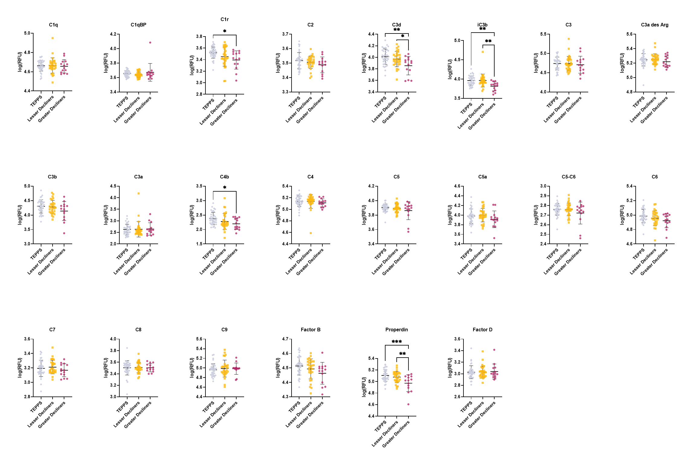
Supplementary Figure S11. Univariate comparison of complement cascade proteins in blood. Participant groups are as in the legend to Supplementary Figure 7. Individual levels of complement-associated proteins in greater decliners, lesser decliners, and TEPPS reference group (one-way ANOVA with Tukey’s post hoc test; *p<0.05, **p<0.01, ***p < 0.001).

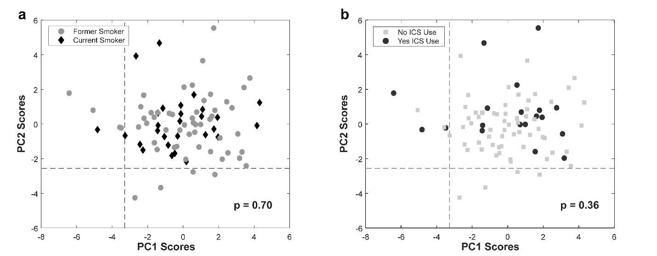
Supplementary Figure S12. Complement profiles are not influenced by participants’ smoking status or ICS use. Complement PCA profile (Figure 4; n=83) classified into two groups using self-reported (a) baseline smoking status (current/ former) or (b) ICS use within three months of the baseline visit (yes/no). P-values reported from a permutation test (n = 2000 permutations) between groups’ mean scores across PC1 and PC2.

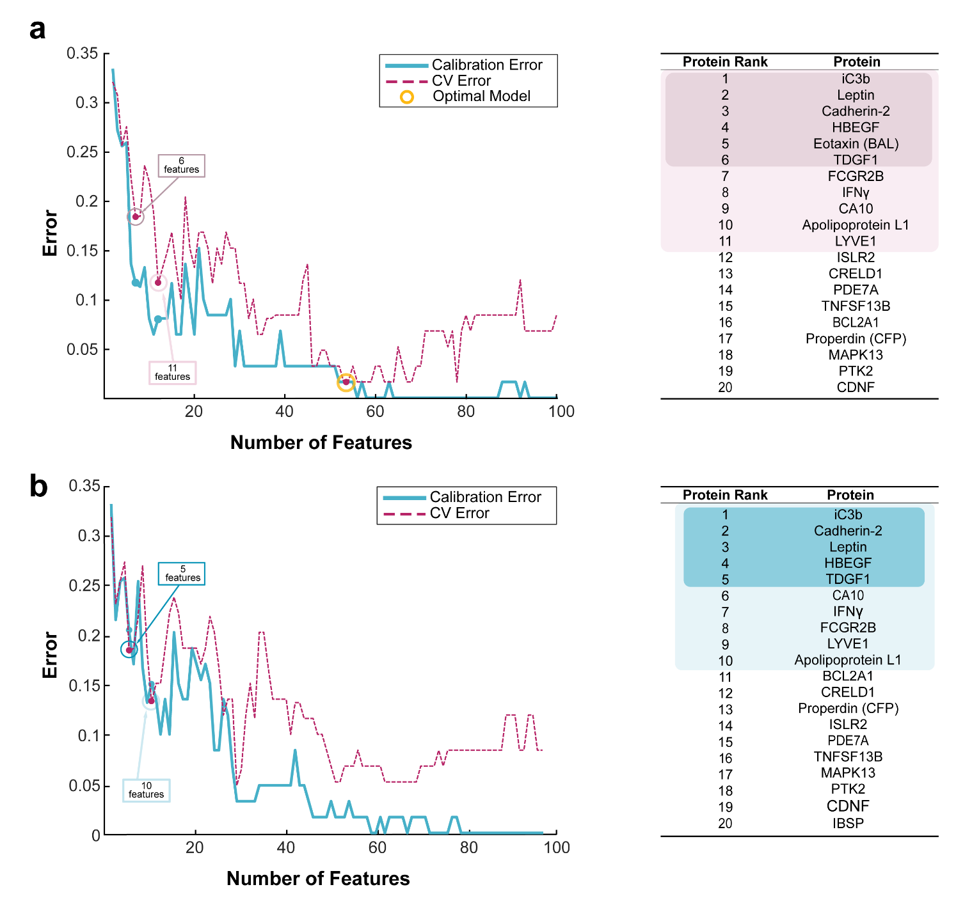
Supplementary Figure S13. Stepwise PLSDA identified minimal signatures with strong cross-validated performance. Plot of calibration and CV errors from stepwise PLSDA models for (a) cross-compartment and (b) blood-only datasets. Smaller models that separated groups with statistically comparable CV accuracies to the 52-feature models are highlighted with call out boxes (11-feature signature: 88.4%; 6-feature signature: 81.6%; 10-feature signature: 86.8%; 5-feature signature: 81.6%). Accompanying lists on the right depict the order of proteins added in models based on Elastic Net resampling selection frequency of proteins (1 = most frequently selected). Highlighted proteins denote those in the identified minimal signatures displayed in the plots.

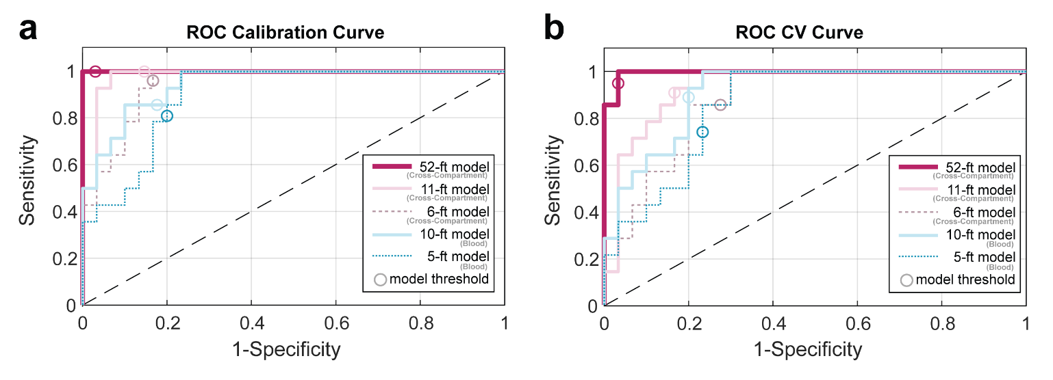
Supplementary Figure S14. ROC curves from PLSDA models generated from minimal signatures. ROC curves from cross-compartment and blood minimal signatures generated from (a) calibration and (b) CV PLSDA models.

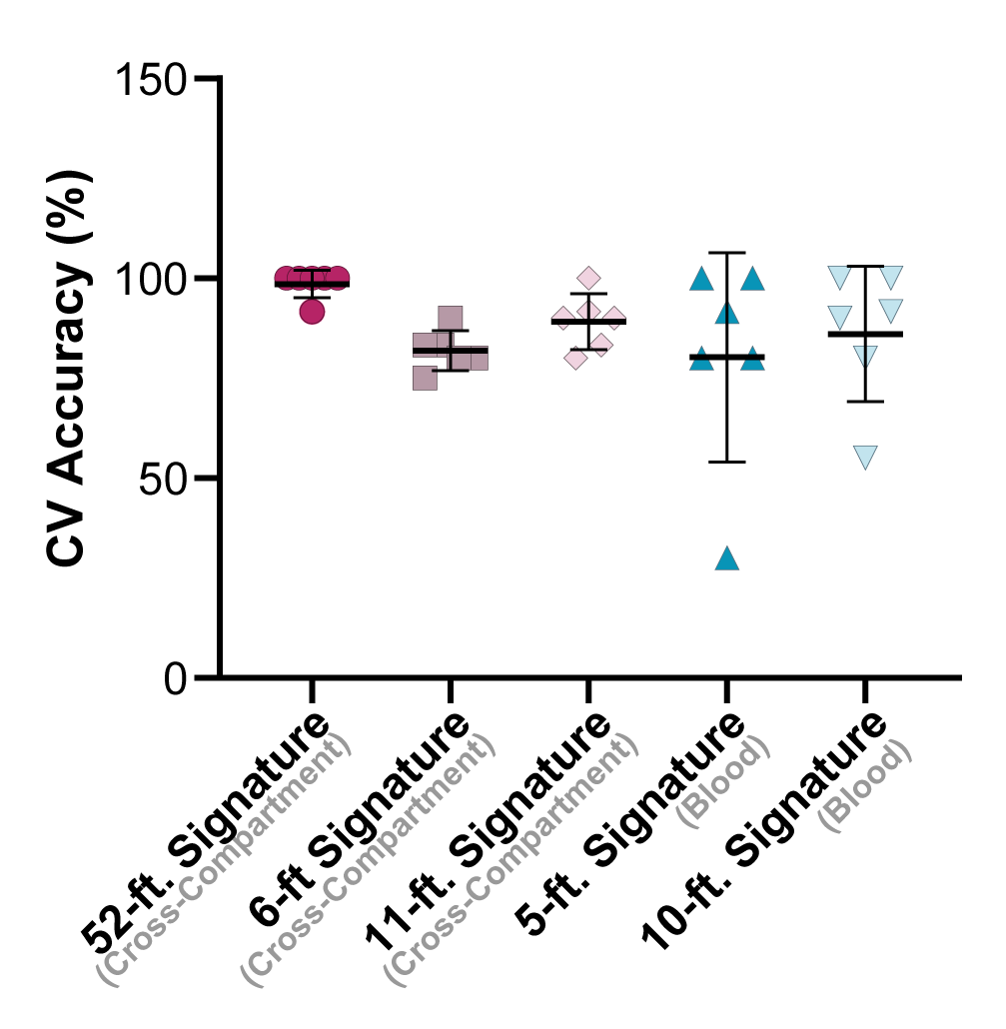
Supplementary Figure S15. Cross-validation accuracies do not significantly vary between optimal model and smaller variants. Comparisons of 6-fold CV accuracies between models (one-way ANOVA with Dunnett’s post hoc test).

