The Impact of Biosynthesized ZnO Nanoparticles from Olea europaea (Common Olive) on Pseudomonas Aeruginosa Growth and Biofilm Formation
Hafez Al-Momaniª, Dua’A Al Balawi^{b}, Saja Hamed^{c}, Borhan Aldeen Albiss ^{d}, Muna Almasri^{b}, Hadeel AlGhawrie^{e}, Logen Ibraheem^{b}, Hadeel Al Balawi^{b}, Sameer Al Haj Mahmoud^{f}, Jeffrey Pearson^{g}, Christopher Ward^{g}

Table S1: Primers used in assess the expression of quorum sensing genes ¹⁻³
Gene Primer sequence
lasI F 5′-CGCACATCTGGGAACTCA-3′
R 5′-CGGCACGGATCATCATCT-3′
rhlR F 5′-GCCAGCGTCTTGTTCGG-3′
R 5′-CGGTCTGCCTGAGCCATC-3′
ropD F 5′-CGAACTGCTTGCCGACTT-3′
R 5′-GCGAGAGCCTCAAGGATAC-3
pqsA F 5′-GACCGGCTGTATTCGATTC-3′
R 5′-GCTGAACCAGGGAAAGAAC-3′
pqsR F 5′-CTGATCTGCCGGTAATTGG-3′
R 5′-ATCGACGAGGAACTGAAGA-3′
lasR F 5′-CTGTGGATGCTCAAGGACTAC-3′
R 5′-AACTGGTCTTGCCGATGG-3′
rhlI F 5′-GTAGCGGGTTTGCGGATG-3′
R 5′-CGGCATCAGGTCTTCATCG-3′
lasB F 5′-GGAATGAACGAAGCGTTCTCCGAC-3′
R 5′-TGGCGTCGACGAACACCTCG-3′

Table S2: Interpretavie categories and zone Diameter breakpoint, nearest whole millimeter (mm) for PA ATCC 27853 and the six clinical strains, Abbreviations: ATCC , American type culture collection, I , intermediate, R resistance, S susceptible
 | Piperacillin (PRL) | Cefepime (FEP) | Ceftazidime (CAZ) | Aztreonam (ATM) | Imipenem (IPM) | Meropenem (MEM) | Gentamicin (CN) | Amikacin (AK) | Levofloxacin (LEV) | Ciprofloxacin (CIP)
ATCC | 29 (S) | 29(S) | 29(S) | 30(S) | 21(S) | 29(S) | 20(S) | 24(S) | 26(S) | 34(S)
PA1 | 42(S) | 36(S) | 34(S) | 40(S) | 35(S) | 44(S) | 20(S) | 19(S) | 44(S) | 48(S)
PA2 | 32(S) | 28(S) | 29(S) | 30(S) | 25(S) | 36(S) | 14(I) | 19(S) | 32(S) | 36(S)
PA3 | 33(S) | 14(R) | 28(S) | 34(S) | 36(S) | 34(S) | 17(S) | 19(S) | 23(S) | 28(S)
PA4 | 25(S) | 25(S) | 25(S) | 24(S) | 18(I) | 35(S) | 29(S) | 29(S) | 21(I) | 40(S)
PA5 | 29(S) | 14(R) | 26(S) | 25(S) | 32(S) | 18(I) | 14(I) | 16(I) | 20(I) | 24(I)
PA6 | 28(S) | 16R | 24(S) | 23(S) | 17(I) | 19(S) | 13(I) | 18(S) | 16(I) | 22(I)

Table S3: Biofilm characteristics of the strain used in this study
 | Odc | OD of positive control | 2*Odc | 4*Odc
ATCC | 0.09 | 1.01 | 0.18 | 0.36 | strong-biofilm producer
PA1 | 0.06 | 0.475 | 0.12 | 0.24 | strong-biofilm producer
PA2 | 0.06 | 0.764 | 0.12 | 0.24 | strong-biofilm producer
PA3 | 0.07 | 0.627 | 0.14 | 0.28 | strong-biofilm producer
PA4 | 0.08 | 0.676 | 0.16 | 0.32 | strong-biofilm producer
PA5 | 0.07 | 0.642 | 0.14 | 0.28 | strong-biofilm producer
PA6 | 0.06 | 0.712 | 0.12 | 0.24 | strong-biofilm producer

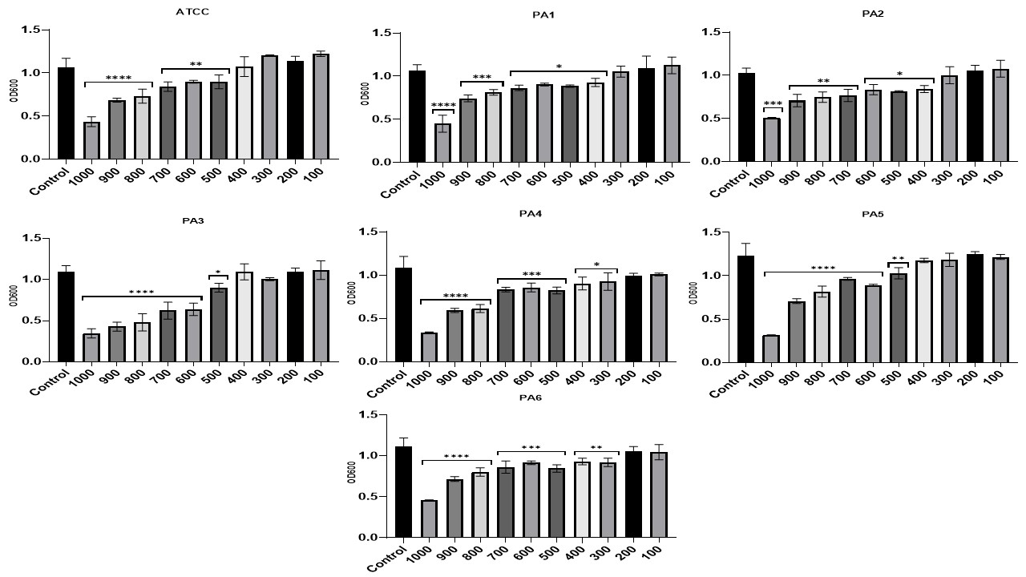
Supplementary Figure 1: The effect of various concentrations (100-1000 µg/ml) of ZnO NPs on the planktonic growth of 1-day mature biofilm after incubation for 24 hours with ZnO NPs

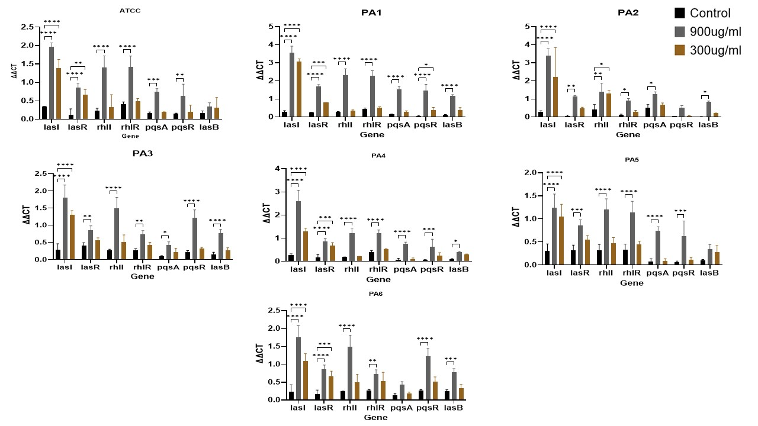

Supplementary Figure 2: The effect of ZnO NPs at concentrations of 900 µg/ml and 300 µg/ml on delta CT values compared to the delta CT values of control samples

1. Naga, N.G., El-Badan, D.E., Rateb, H.S., Ghanem, K.M. & Shaaban, M.I. Quorum Sensing Inhibiting Activity of Cefoperazone and Its Metallic Derivatives on Pseudomonas aeruginosa. Frontiers in cellular and infection microbiology 11, 716789 (2021).
2. Béatrice, J. et al. Relative expression of Pseudomonas aeruginosa virulence genes analyzed by a real time RT-PCR method during lung infection in rats. FEMS microbiology letters 243, 271-278 (2005).
3. El‐Mowafy, S., Shaaban, M. & Abd El Galil, K. Sodium ascorbate as a quorum sensing inhibitor of P seudomonas aeruginosa. Journal of applied microbiology 117, 1388-1399 (2014).

