Supplementary Materials

Evaluation of Mycobacterium tuberculosis enrichment in metagenomic samples using ONT adaptive sequencing and amplicon sequencing for identification and variant calling

Junhao Su, Wui Wang Lui, YanLam Lee, Zhenxian Zheng, Gilman Kit-Hang Siu, Timothy Ting-Leung Ng, Tong Zhang, Tommy Tsan-Yuk Lam, Hiu-Yin Lao, Wing-Cheong Yam, Kingsley King-Gee Tam, Kenneth Siu-Sing Leung, Tak-Wah Lam, Amy Wing-Sze Leung, Ruibang Luo

Supplementary Figures 2
Supplementary Figure 1. Number of active pores overtime during standard sequencing or adaptive sequencing. 2
Supplementary Tables 3
Supplementary Table 1. Read composition at different samples. 3
Supplementary Table 2. Simulation of different adaptive sequencing settings. 5
Supplementary Table 3. TB gene coverage in different samples. 6
Supplementary Table 4. Coverage of the 19 amplicon sequencing regions in different samples. 8

Supplementary Figures

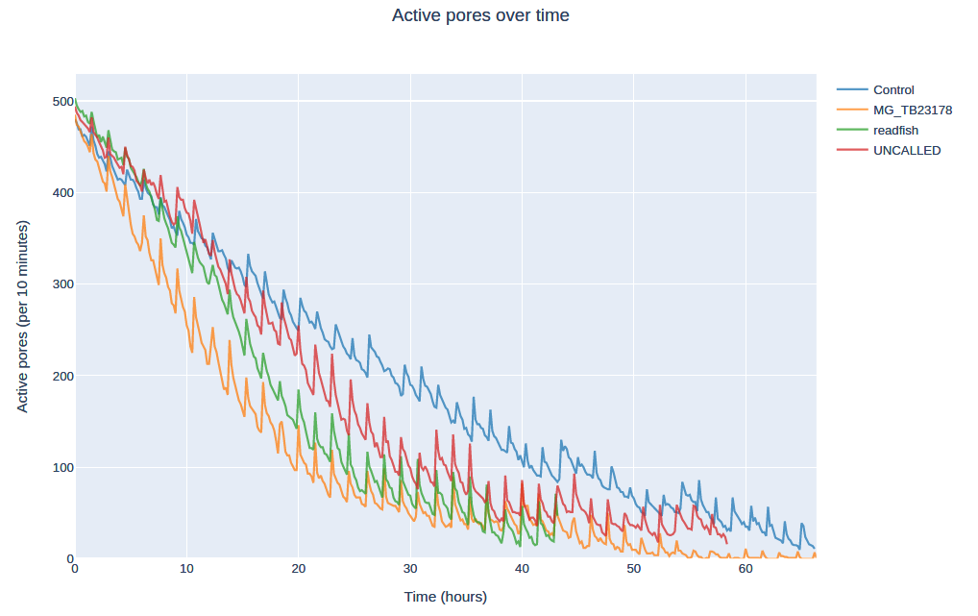

Supplementary Figure 1. Number of active pores overtime during standard sequencing or adaptive sequencing.
“MG_TB23178” is a real clinical sample. Adaptive sequencing was applied to “readfish”, “UNCALLED” and “MG_TB23178”. Standard ONT sequencing was applied to “Control”.

Supplementary Tables

Supplementary Table 1. Read composition at different samples.
Zymo: ZymoBIOMICS Microbial Community Standards, TB: Mycobacterium tuberculosis, PA: Pseudomonas Aeruginosa, EC: Escherichia Coli, SE: Salmonella Enterica, EF: Enterococcus Faecalis, SA: Staphylococcus Aureus, LM: Listeria Monocytogenes, BS: Bacillus Subtilis, SC: Saccharomyces Cerevisiae.

Samples | Species | # of read | median | mean | N50 | bp (Mb) | # of read (%) | bp (%)
Control | Human | 1,517,867 | 5,259 | 6,238.62 | 10,072 | 9,469.4 | 92.17 | 92.29
Control | TB | 1,974 | 3,643 | 5,404.63 | 9,434 | 10.7 | 0.12 | 0.10
Control | Zymo | 127,005 | 3,903 | 6,144.28 | 11,442 | 780.4 | 7.71 | 7.61
Control | All | 1,646,846 | 5,179 | 6,230.35 | 10,166 | 10,260.4 | 100.00 | 100.00
Control | PA | 9,882 | 8,954 | 8,889.59 | 12,163 | 87.9 | 0.60 | 0.86
Control | EC | 31,478 | 1,222 | 3,422.46 | 10,129 | 107.7 | 1.91 | 1.05
Control | SE | 31,803 | 1,879 | 3,496.56 | 6,861 | 111.2 | 1.93 | 1.08
Control | EF | 15,389 | 7,217 | 7,628.75 | 11,516 | 117.4 | 0.93 | 1.14
Control | SA | 14,151 | 9,179 | 8,952.95 | 12,393 | 126.7 | 0.86 | 1.23
Control | LM | 11,881 | 9,709 | 9,459.71 | 12,458 | 112.4 | 0.72 | 1.10
Control | BS | 10,798 | 9,713 | 9,493.50 | 12,465 | 102.5 | 0.66 | 1.00
Control | SC | 1,623 | 9,103 | 8,983.22 | 12,486 | 14.6 | 0.10 | 0.14
readfish | Human | 8,505,147 | 383 | 393.78 | 404 | 3,349.2 | 92.35 | 91.46
readfish | TB | 10,834 | 1,595 | 3,876.52 | 9,791 | 42.0 | 0.12 | 1.15
readfish | Zymo | 693,409 | 378 | 390.23 | 399 | 270.6 | 7.53 | 7.39
readfish | All | 9,209,390 | 382 | 397.61 | 405 | 3,661.8 | 100.00 | 100.00
readfish | PA | 55,211 | 375 | 391.09 | 396 | 21.6 | 0.60 | 0.59
readfish | EC | 166,765 | 374 | 380.16 | 393 | 63.4 | 1.81 | 1.73
readfish | SE | 172,930 | 375 | 379.74 | 394 | 65.7 | 1.88 | 1.79
readfish | EF | 87,058 | 384 | 401.26 | 406 | 34.9 | 0.95 | 0.95
readfish | SA | 78,688 | 385 | 401.67 | 408 | 31.6 | 0.85 | 0.86
readfish | LM | 64,547 | 383 | 403.50 | 407 | 26.0 | 0.70 | 0.71
readfish | BS | 58,574 | 380 | 400.68 | 403 | 23.5 | 0.64 | 0.64
readfish | SC | 9,636 | 384 | 402.61 | 407 | 3.9 | 0.10 | 0.11
UNCALLED | Human | 4,402,901 | 1,235 | 1,435.06 | 1,893 | 6,318.4 | 92.43 | 92.73
UNCALLED | TB | 5,447 | 2,474 | 4,306.84 | 8,472 | 23.5 | 0.11 | 0.34
UNCALLED | Zymo | 355,144 | 1,084 | 1,329.37 | 1,733 | 472.1 | 7.46 | 6.93
UNCALLED | All | 4,763,492 | 1,223 | 1,430.46 | 1,887 | 6,814.0 | 100.00 | 100.00
UNCALLED | PA | 27,149 | 1,332 | 1,489.68 | 1,925 | 40.4 | 0.57 | 0.59
UNCALLED | EC | 88,123 | 841 | 1,087.10 | 1,269 | 95.8 | 1.85 | 1.41
UNCALLED | SE | 94,381 | 971 | 1,218.28 | 1,493 | 115.0 | 1.98 | 1.69
UNCALLED | EF | 43,141 | 1,293 | 1,484.52 | 1,925 | 64.0 | 0.91 | 0.94
UNCALLED | SA | 37,785 | 1,342 | 1,521.47 | 1,990 | 57.5 | 0.79 | 0.84
UNCALLED | LM | 31,291 | 1,377 | 1,538.22 | 1,995 | 48.1 | 0.66 | 0.71
UNCALLED | BS | 28,626 | 1,378 | 1,539.56 | 1,987 | 44.1 | 0.60 | 0.65
UNCALLED | SC | 4,648 | 1,396 | 1,539.49 | 2,003 | 7.2 | 0.10 | 0.11
Amplicon | Human | 2,852 | 884 | 1,355.76 | 2,091 | 3.9 | 0.03 | 0.04
Amplicon | TB | 10,602,938 | 832 | 865.07 | 952 | 9,172.3 | 99.97 | 99.95
Amplicon | All | 10,605,790 | 832 | 865.20 | 952 | 9,176.1 | 100.00 | 100.00
MG_TB23178 | Human | 5,037,611 | 405 | 410.56 | 436 | 2,068.22 | 100.00 | 100.00
MG_TB23178 | TB | 32 | 464 | 862.94 | 1,516 | 0.03 | 0.00 | 0.00
MG_TB23178 | All | 5,037,643 | 405 | 410.56 | 436 | 2,068.25 | 100.00 | 100.00

Supplementary Table 2. Simulation of different adaptive sequencing settings.

Setting/results | Setting 1 | Setting 2
mode | readfish enrichment | readfish enrichment
host sequences | GRCh38 + NC_000962.3 | GRCh38 + NC_000962.3
targets | NC_000962.3 | NC_000962.3
no_seq | unblock | process
no_map | unblock | process
single_on | stop_receiving | stop_receiving
multip_on | stop_receiving | stop_receiving
single_off | unblock | unblock
multip_off | unblock | unblock
# of TB read | 18 | 16
mean TB read length | 4871 | 3509
TB N50 | 21135 | 20609
# of human read | 128096 | 128192
mean human read length | 407.3 | 407.3
human N50 | 423.0 | 423.4

Supplementary Table 3. TB gene coverage in different samples.

Reference | Regions |  |  | Original Coverage
Reference |  |  |  | Control | readfish | UNCALLED | Amplicon
NC_000962.3 | whole genome |  |  | 2.36 | 9.30 | 5.20 | NA
NC_000962.3 | 5240 | 7267 | gyrB | 3.94 | 9.75 | 4.70 | 212317.70
NC_000962.3 | 7302 | 9818 | gyrA | 3.45 | 7.10 | 6.12 | 191954.48
NC_000962.3 | 759807 | 763325 | rpoB | 2.17 | 16.21 | 5.24 | 129634.12
NC_000962.3 | 778990 | 779487 | Rv0678 | 1.55 | 11.42 | 7.91 | 893276.92
NC_000962.3 | 781560 | 781934 | rpsL | 3.91 | 8.83 | 5.82 | 720359.48
NC_000962.3 | 800809 | 801462 | rplC | 2.41 | 4.66 | 1.99 | 860951.25
NC_000962.3 | 1461045 | 1461290 | atpE | 2.94 | 12.28 | 1.30 | 861528.96
NC_000962.3 | 1471846 | 1473382 | rrs | 1.99 | 13.02 | 5.05 | 239816.10
NC_000962.3 | 1473658 | 1476795 | rrl | 3.05 | 12.90 | 5.95 | 134403.83
NC_000962.3 | 1674202 | 1675011 | inhA | 3.35 | 11.42 | 4.85 | 135781.81
NC_000962.3 | 1833542 | 1834987 | rpsA | 4.21 | 10.36 | 4.17 | 166901.77
NC_000962.3 | 1917940 | 1918746 | tlyA | 0.95 | 9.54 | 4.76 | 595159.24
NC_000962.3 | 2153889 | 2156111 | katG | 1.73 | 6.67 | 7.09 | 195592.47
NC_000962.3 | 2288681 | 2289241 | pncA | 6.66 | 7.30 | 3.64 | 664184.18
NC_000962.3 | 2714124 | 2715332 | eis | 3.03 | 8.88 | 6.33 | 308059.90
NC_000962.3 | 3568401 | 3568679 | whiB7 | 1.68 | 7.30 | 0.00 | 727769.09
NC_000962.3 | 4246514 | 4249810 | embB | 2.16 | 11.92 | 3.87 | 165897.88
NC_000962.3 | 4268925 | 4269833 | ubiA | 2.06 | 7.38 | 6.25 | 403959.49
NC_000962.3 | AMR genes mean |  |  | 2.85 | 9.83 | 4.72 | 422641.59
NC_000962.3 | AMR genes 25th percentiles |  |  | 2.01 | 7.32 | 3.95 | 173164.95
NC_000962.3 | AMR genes median |  |  | 2.68 | 9.65 | 4.95 | 273938.00
NC_000962.3 | AMR genes 75th percentiles |  |  | 3.43 | 11.80 | 6.08 | 706315.66
NC_000962.3 | AMR genes standard deviation |  |  | 1.32 | 2.88 | 2.02 | 292507.34
NC_000962.3 | % of position in genome covered by at least one read |  |  | 89.36% | 99.94% | 99.38% | 0.59%

Supplementary Table 4. Coverage of the 19 amplicon sequencing regions in different samples.

Reference | Regions |  |  | Original Coverage
Reference |  |  |  | Control | readfish | UNCALLED | Amplicon
NC_000962.3 | 5958 | 6969 | gyrB | 3.93 | 9.62 | 4.78 | 425,112.07
NC_000962.3 | 7388 | 8095 | gyrA | 3.95 | 9.48 | 4.67 | 682,120.97
NC_000962.3 | 760076 | 761389 | rpoB | 2.51 | 15.79 | 6.33 | 347,009.81
NC_000962.3 | 778924 | 779513 | Rv0678 | 1.50 | 11.42 | 7.90 | 891,074.55
NC_000962.3 | 781529 | 782000 | rpsL | 3.90 | 8.74 | 5.90 | 717,429.06
NC_000962.3 | 800811 | 801476 | rplC | 2.42 | 4.65 | 1.99 | 861,739.55
NC_000962.3 | 1461012 | 1461437 | atpE | 2.93 | 12.42 | 1.31 | 856,858.94
NC_000962.3 | 1472290 | 1473458 | rrs | 1.99 | 13.38 | 4.69 | 336,659.09
NC_000962.3 | 1475575 | 1476633 | rrl | 3.64 | 13.44 | 6.88 | 398,151.60
NC_000962.3 | 1673292 | 1674532 | mabA-inhA | 3.94 | 12.53 | 5.17 | 331,163.91
NC_000962.3 | 1833451 | 1835007 | rpsA | 4.30 | 10.32 | 4.12 | 166,522.34
NC_000962.3 | 1917862 | 1918762 | tlyA | 0.88 | 9.56 | 4.68 | 593,787.05
NC_000962.3 | 2154044 | 2155443 | katG | 1.81 | 5.55 | 6.89 | 181,217.25
NC_000962.3 | 2155505 | 2156396 | FurA-KatG | 1.47 | 10.07 | 7.57 | 297,863.92
NC_000962.3 | 2288651 | 2289419 | pncA | 6.39 | 7.40 | 3.69 | 662,905.19
NC_000962.3 | 2714908 | 2715456 | eis | 2.97 | 9.83 | 6.46 | 873,868.65
NC_000962.3 | 3568312 | 3569115 | whiB7 | 2.11 | 8.16 | 0.00 | 723,702.49
NC_000962.3 | 4247152 | 4248111 | embB | 2.07 | 11.79 | 2.98 | 569,647.89
NC_000962.3 | 4268836 | 4269954 | ubiA | 2.15 | 7.43 | 6.45 | 402,008.98
NC_000962.3 | AMR genes mean |  |  | 2.89 | 10.08 | 4.87 | 543,097.02
NC_000962.3 | AMR genes 25th percentiles |  |  | 2.03 | 8.45 | 3.91 | 341,834.45
NC_000962.3 | AMR genes median |  |  | 2.51 | 9.83 | 4.78 | 569,647.89
NC_000962.3 | AMR genes 75th percentiles |  |  | 3.92 | 12.11 | 6.46 | 720,565.78
NC_000962.3 | AMR genes standard deviation |  |  | 1.32 | 2.81 | 2.15 | 240,851.10

