<Supplementary Information>

Recellularized lymph node scaffolds with human adipose-derived stem cells enhance lymph node regeneration to improve lymphedema

Hyo Jin Kang¹, Soo Young Moon¹, Baek-Kyu Kim², Yujin Myung², Ju-Hee Lee³,
and Jae Hoon Jeong^{2,}*

¹ Department of Biomedical Laboratory Science, Honam University, Gwangju, 62399, Republic of Korea
² Department of Plastic and Reconstructive Surgery, Seoul National University Bundang Hospital, Seongnam, Gyeonggi-do, 13620, Republic of Korea
³ College of Korean Medicine, Dongguk University, Goyang, Gyeonggi-do, 10326, Republic of Korea

*Corresponding author:
Jae Hoon Jeong, MD, Ph D.
Seoul National University Bundang Hospital
82, Gumi-ro 173 Beon-gil, Bundang-gu
Seongnam-si Gyeonggi-do 13620, Republic of Korea
psdrj2h@gmail.com

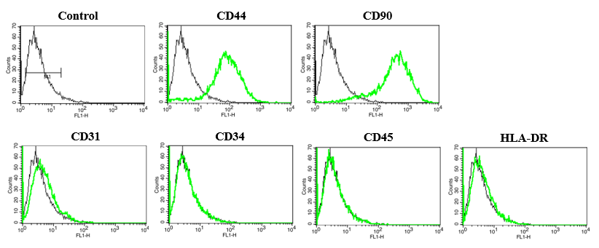
Figure S1. hADSCs characterization. The hADSCs were identified based on cell surface markers. Positive markers of primary cultured hADSCs included CD44 and CD90; the negative markers were CD31, CD34, CD45, and HLA-DR.

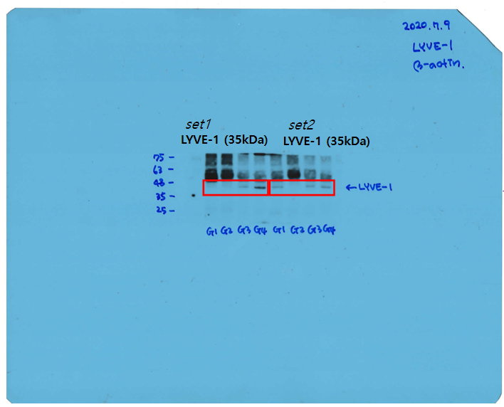

Figure S2. The Western blot of LYVE-1 in the four group. The original uncropped western blot images of LYVE-1. LYVE-1, Lymphatic vessel endothelial hyaluronan receptor 1.

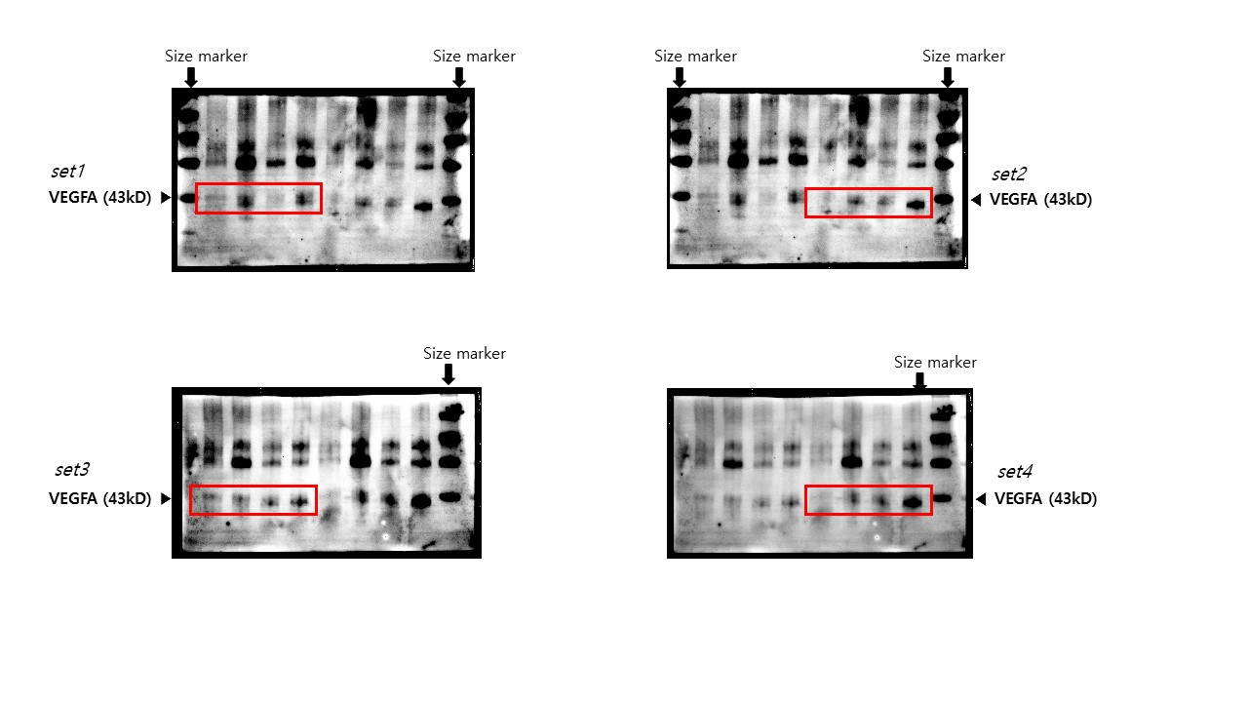

Figure S3. The Western blot of VEGFA in the four group. The original uncropped western blot images of VEGFA. VEGFA, vascular endothelial growth factor A.
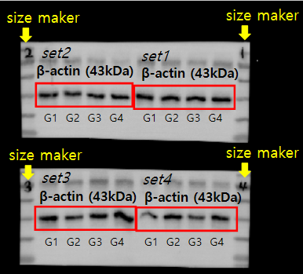

Figure S4. The Western blot of β–acting in the four group. The original, uncropped western blot images of β–acting.

