Counter-gradient variation and the expensive tissue hypothesis explain parallel brain size reductions at high elevation in Cricetid and Murid rodents
Aluwani Nengovhela*, Catherine M. Ivy, Graham R. Scott, Christiane Denys, Peter J. Taylor

Supplementary Information

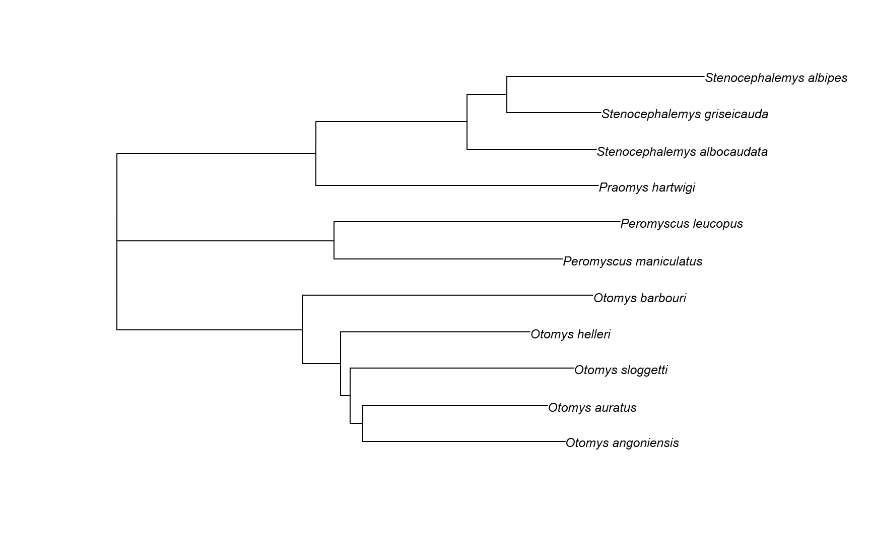

Figure S1. Phylogram tree produced by neighbour-joining method with branch length. Cytochrome b sequences obtained from the GenBank.

Figure S2. Residuals for 11 rodent species from the phylogenetical regression model of ECV with skull length from Fig. 1b. Full details for species explained in Table 1.

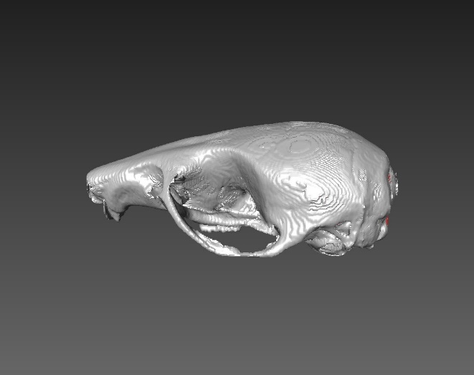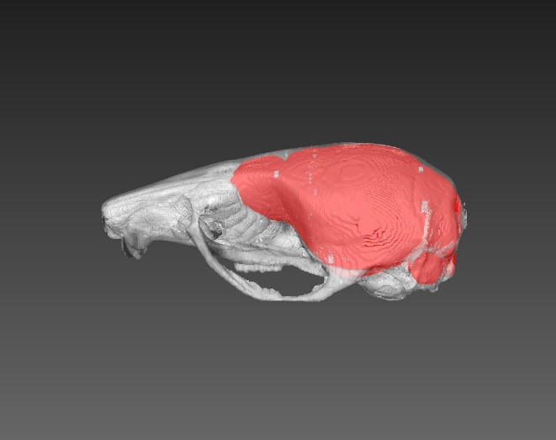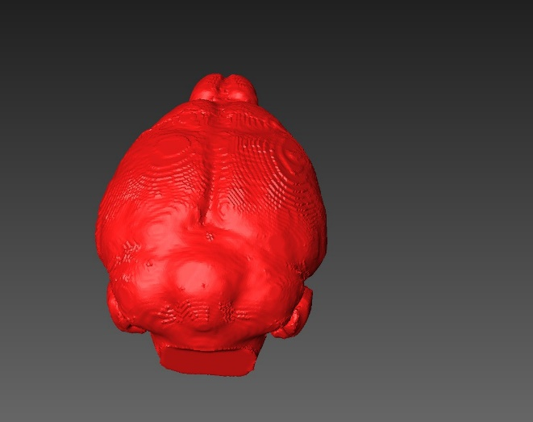
Peromyscus
a)
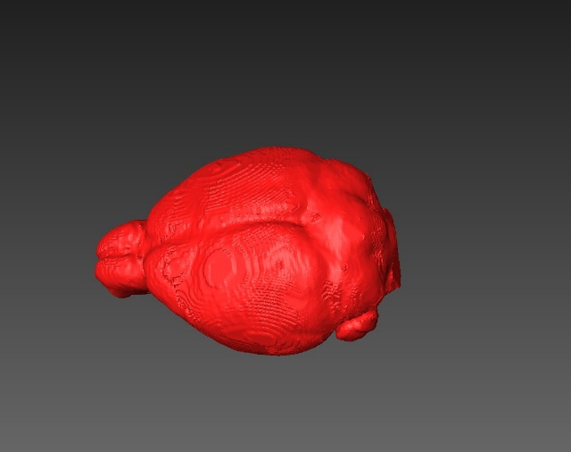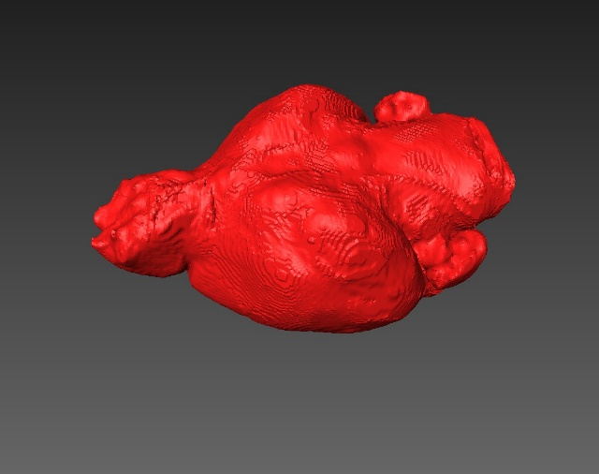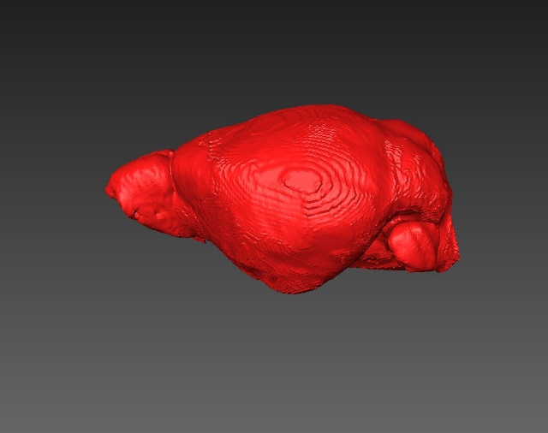

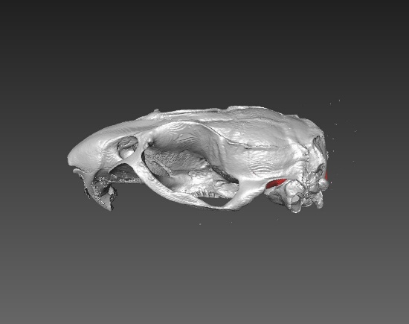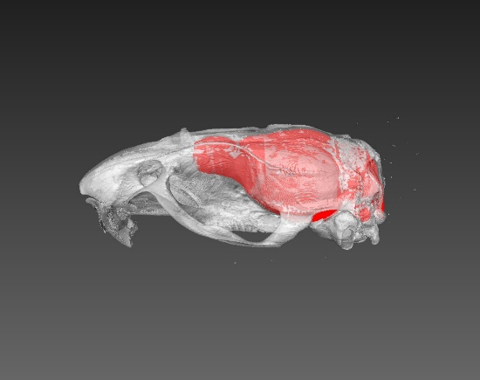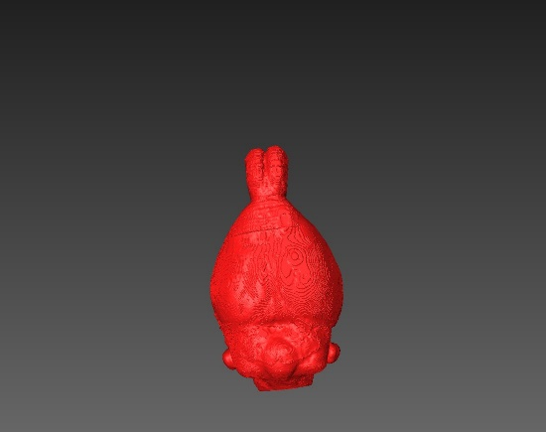
Otomys
b)
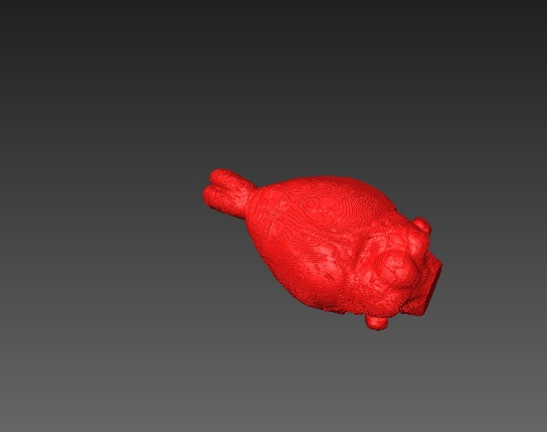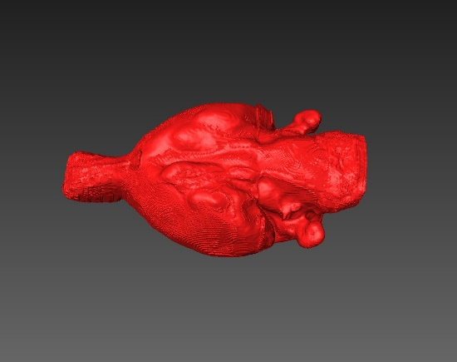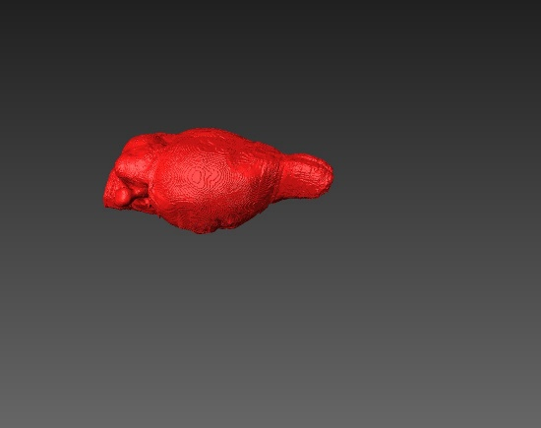

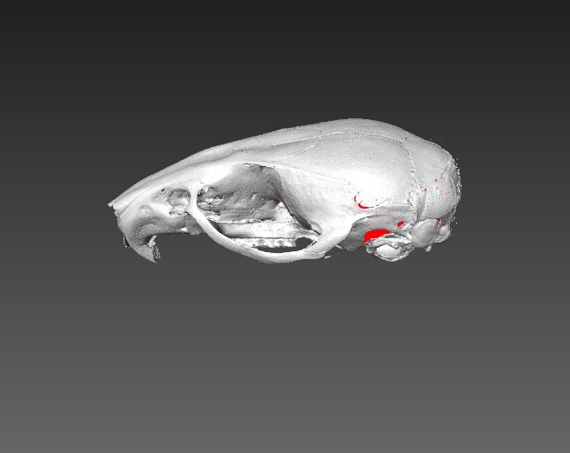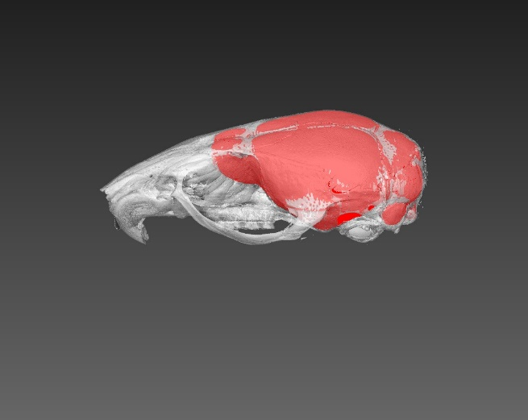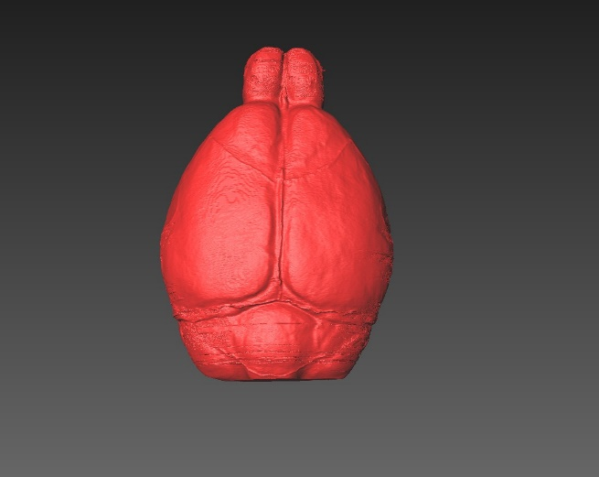
Praomys
c)
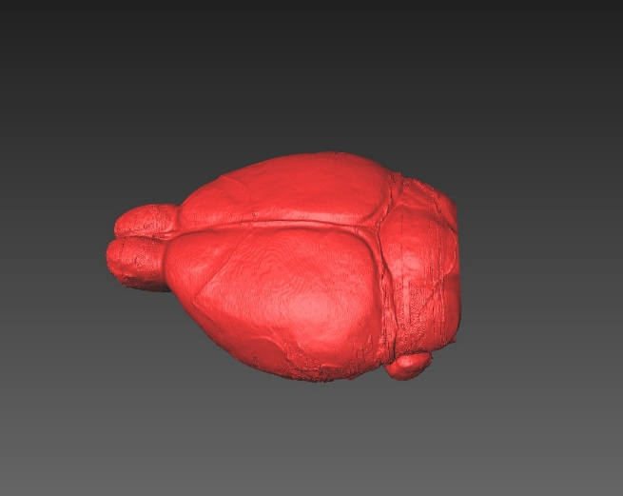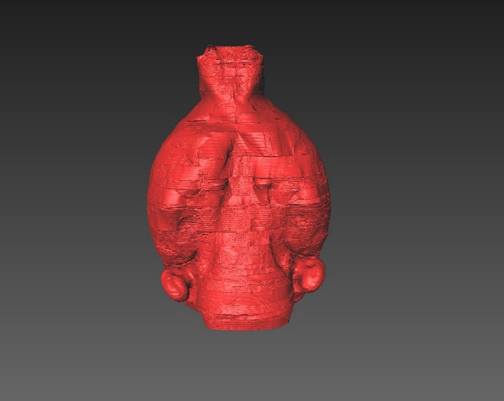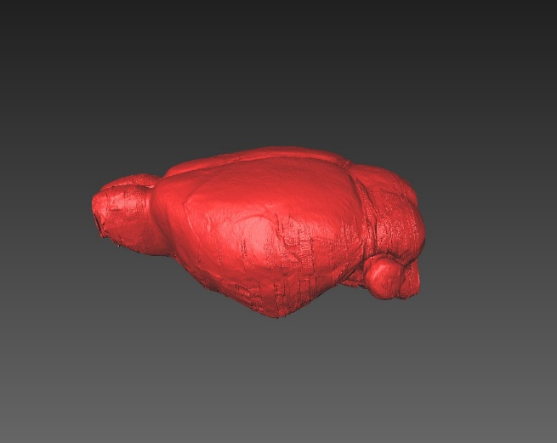

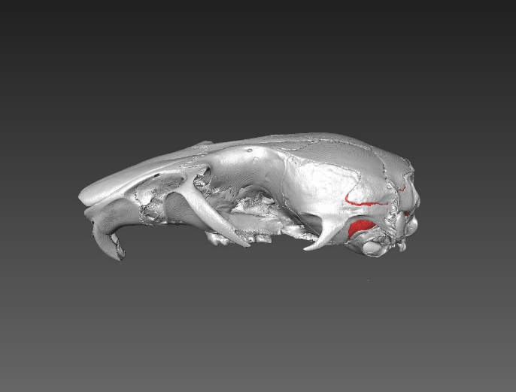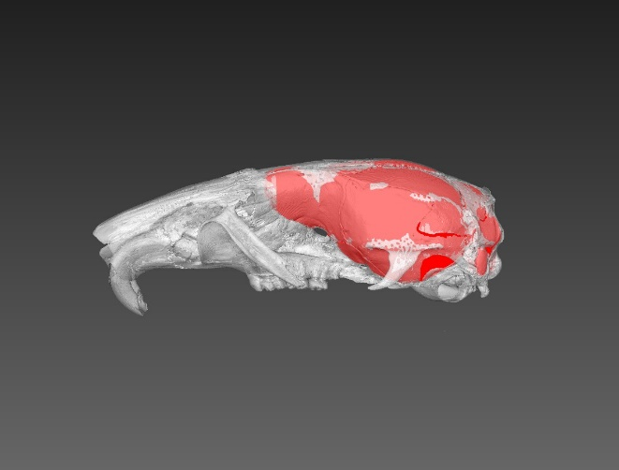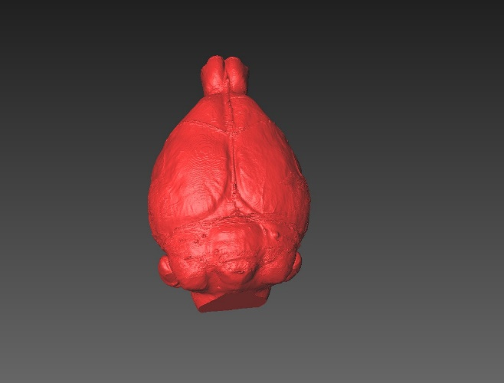
Stenocephalemys
d)
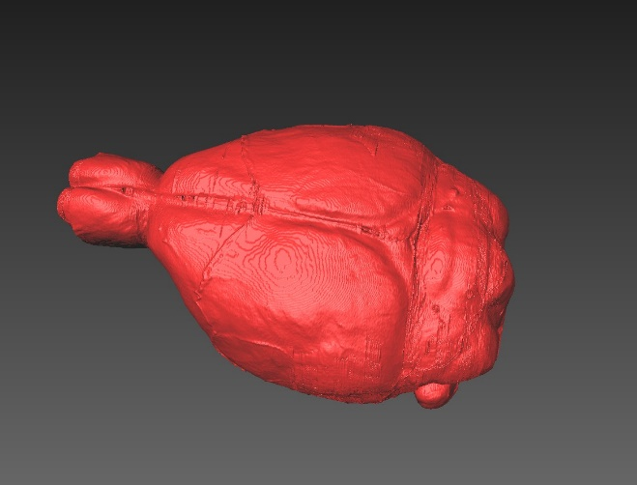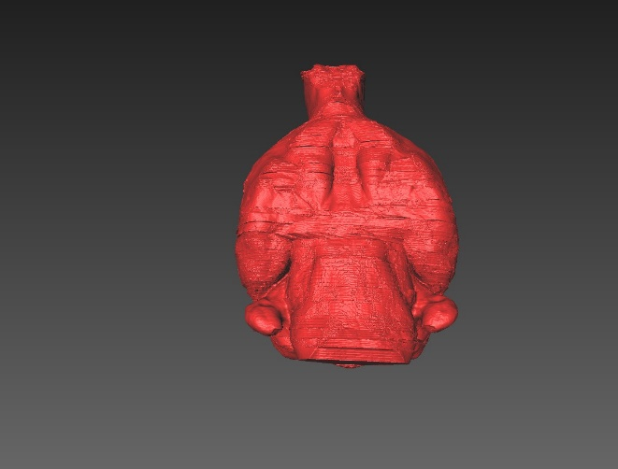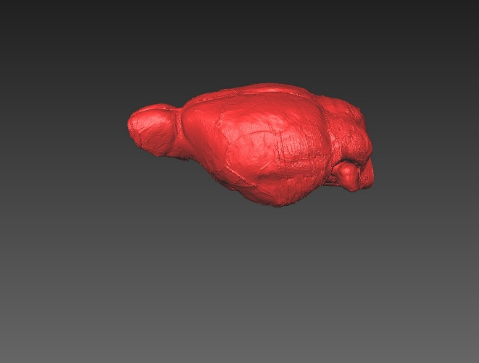

Figure S3. Different views of the skulls and endocasts visualized in Aviso v8.0 and used to calculate endocranial volume (ECV) for each genus a) Peromyscus, b) Otomys, c) Praomys and d) Stenocephalemys.

Table S1. Raw data used in the study with endocranial volume (ECV), skull length (GLS), elevation and description indicated.

Species name | Collections number | Sex (g) | Skull length (GLS_mm) | ECV_cm3 | Elevation | Description | Country
Otomys angoniensis | TM103 | Female | 39.22 | 1.430067627 | Low | N/A | South Africa
Otomys angoniensis | TM123 | Female | 46.3 | 2.042627686 | Low | N/A | Zimbabwe
Otomys angoniensis | TM22700 | Male | 39.93 | 1.446628418 | Low | N/A | South Africa
Otomys angoniensis | TM22876 | Male | 37.97 | 1.546006958 | Low | N/A | Swaziland
Otomys angoniensis | TM24415 | Male | 34.4 | 1.250133398 | Low | N/A | South Africa
Otomys angoniensis | TM25623 | Male | 40.29 | 1.443271118 | Low | N/A | South Africa
Otomys angoniensis | TM35027 | Male | 39.3 | 1.460794189 | Low | N/A | Zimbabwe
Otomys angoniensis | TM44987 | Female | 38.17 | 1.754024048 | Low | N/A | Swaziland
Otomys angoniensis | TM4504 | Male | 45.52 | 1.55356543 | Low | N/A | South Africa
Otomys angoniensis | TM45584 | Female | 35.13 | 1.2808 | Low | N/A | South Africa
Otomys angoniensis | TM6485 | Female | 44.8 | 1.957693115 | Low | N/A | Zambia
Otomys auratus | TM10282 | Female | 40.01 | 1.777526367 | Low | N/A | South Africa
Otomys auratus | TM15012 | Female | 38.92 | 1.65731665 | Low | N/A | South Africa
Otomys auratus | TM19287 | Male | 40.31 | 1.987977783 | Low | N/A | South Africa
Otomys auratus | TM2916 | Female | 38.76 | 1.704628296 | Low | N/A | South Africa
Otomys auratus | TM35182 | Male | 42.36 | 1.825832 | Low | N/A | South Africa
Otomys auratus | TM3611 | Male | 40.74 | 1.687761475 | Low | N/A | South Africa
Otomys auratus | TM3614 | Female | 39.45 | 1.570219116 | Low | N/A | South Africa
Otomys auratus | TM41608 | Male | 39.56 | 1.763111 | Low | N/A | South Africa
Otomys auratus | TM46864 | Female | 40.27 | 1.880129 | Low | N/A | South Africa
Otomys auratus | TM7597 | Male | 38.4 | 1.770856323 | Low | N/A | South Africa
Otomys auratus | TM9052 | Female | 39.38 | 1.78917981 | Low | N/A | South Africa
Otomys barbouri | PM1933-2758 | Female | 35.32 | 1.429014282 | High | N/A | Uganda
Otomys barbouri | PM1933-2759 | Female | 32.53 | 1.256418213 | High | N/A | Uganda
Otomys barbouri | PM1933-2760 | Male | 39.84 | 1.487712402 | High | N/A | Uganda
Otomys barbouri | PM1933-2762 | Male | 38.28 | 1.552892822 | High | N/A | Uganda
Otomys barbouri | PM1933-2764 | Male | 36.3 | 1.383681519 | High | N/A | Uganda
Otomys barbouri | PM1933-2765 | Male | 34.65 | 1.203698364 | High | N/A | Uganda
Otomys barbouri | PM1933-2766 | Male | 30.9 | 1.201383545 | High | N/A | Uganda
Otomys helleri | PM1972-218 | Male | 38.82 | 1.562871094 | High | N/A | Ethiopia
Otomys helleri | PM1972-220 | Male | 36.17 | 1.298947876 | High | N/A | Ethiopia
Otomys helleri | PM1972-221 | Male | 37.49 | 1.33310144 | High | N/A | Ethiopia
Otomys helleri | PM1972-223 | Female | 36.22 | 1.271706665 | High | N/A | Ethiopia
Otomys helleri | PM1972-224 | Female | 37.48 | 1.37260376 | High | N/A | Ethiopia
Otomys helleri | PM1972-225 | Female | 36.32 | 1.285870361 | High | N/A | Ethiopia
Otomys helleri | PM1972-226 | Female | 38.06 | 1.296744995 | High | N/A | Ethiopia
Otomys helleri | PM1972-227 | Female | 35.02 | 1.104815796 | High | N/A | Ethiopia
Otomys helleri | PM1972-228 | Male | 35.01 | 1.417505615 | High | N/A | Ethiopia
Otomys sloggetti | TM1203 | Male | 39.22 | 1.577509033 | High | N/A | South Africa
Otomys sloggetti | TM12915 | Female | 38.47 | 1.389318726 | High | N/A | Lesotho
Otomys sloggetti | TM13730 | Female | 38.75 | 1.635035645 | High | N/A | Lesotho
Otomys sloggetti | TM16519 | Male | 39.87 | 1.820356323 | High | N/A | Lesotho
Otomys sloggetti | TM22664 | Male | 39.53 | 1.404328979 | High | N/A | South Africa
Otomys sloggetti | TM22670 | Female | 37.78 | 1.644431763 | High | N/A | Lesotho
Otomys sloggetti | TM22676 | Female | 39.9 | 1.414764893 | High | N/A | South Africa
Otomys sloggetti | TM22684 | Male | 38.81 | 1.381087036 | High | N/A | South Africa
Otomys sloggetti | TM7606 | Male | 39.07 | 1.538748535 | High | N/A | South Africa
Otomys sloggetti | TM7780 | Male | 40.49 | 1.571743164 | High | N/A | South Africa
Otomys sloggetti | TM7781 | Female | 38.67 | 1.697815796 | High | N/A | South Africa
Peromyscus leucopus | AN002 | Male | 26.62 | 0.6777441 | Low | Wild | USA
Peromyscus leucopus | AN003 | Male | 27.01 | 0.6772032 | Low | Lab | USA
Peromyscus leucopus | AN004 | Male | 26.04 | 0.7118267 | Low | Lab | USA
Peromyscus leucopus | AN005 | Male | 27.78 | 0.7618431 | Low | Lab | USA
Peromyscus leucopus | AN006 | Male | 26.99 | 0.7017256 | Low | Lab | USA
Peromyscus leucopus | LN17B | Male | 25.87 | 0.6609509 | Low | Wild | USA
Peromyscus leucopus | LN17D | Male | 28.1 | 0.7461515 | Low | Wild | USA
Peromyscus leucopus | LN17G | Male | 26.41 | 0.6397844 | Low | Wild | USA
Peromyscus leucopus | LN17H | Male | 27.71 | 0.7441191 | Low | Wild | USA
Peromyscus leucopus | LN17J | Female | 27.6 | 0.7363071 | Low | Wild | USA
Peromyscus leucopus | LN17N | Female | 25.75 | 0.6494713 | Low | Wild | USA
Peromyscus leucopus | LNF1104ak | Female | 28.36 | 0.7395663 | Low | Lab | USA
Peromyscus leucopus | LNF1112ah | Male | 26.25 | 0.6805291 | Low | Lab | USA
Peromyscus leucopus | LNF1112aj | Male | 26.03 | 0.6824985 | Low | Lab | USA
Peromyscus leucopus | LNF112ai | Male | 26.04 | 0.6448302 | Low | Lab | USA
Peromyscus leucopus | LNF1153a3 | Female | 27.73 | 0.7491603 | Low | Lab | USA
Peromyscus leucopus | LNF1155bq | Male | 28.28 | 0.7860842 | Low | Lab | USA
Peromyscus leucopus | LNF1159ag | Male | 27.25 | 0.6948113 | Low | Lab | USA
Peromyscus leucopus | LNF1159au | Male | 26.81 | 0.7112853 | Low | Lab | USA
Peromyscus leucopus | LNF1159bn | Male | 26.86 | 0.6961703 | Low | Lab | USA
Peromyscus leucopus | LNF1160al | Male | 26.99 | 0.7634993 | Low | Lab | USA
Peromyscus leucopus | LNF1160am | Male | 28.1 | 0.7993542 | Low | Lab | USA
Peromyscus leucopus | LNF1160aq | Male | 26.58 | 0.7359981 | Low | Lab | USA
Peromyscus leucopus | LNF124 | - | 28.86 | 0.7456226 | Low | Lab | USA
Peromyscus leucopus | LNF135 | - | 27.4 | 0.7218648 | Low | Lab | USA
Peromyscus leucopus | LNF145 | - | 26.22 | 0.7249745 | Low | Lab | USA
Peromyscus maniculatus | AN001 | Male | 26.17 | 0.6263092 | Low | Wild | USA
Peromyscus maniculatus | AN007 | - | 25.53 | 0.5679921 | Low | Lab | USA
Peromyscus maniculatus | AN008 | Female | 25.52 | 0.5525744 | Low | Lab | USA
Peromyscus maniculatus | AN009 | Female | 25.38 | 0.598588 | Low | Lab | USA
Peromyscus maniculatus | LN17A | Male | 24.42 | 0.5378608 | Low | Wild | USA
Peromyscus maniculatus | LN17E | Male | 23.7 | 0.5726445 | Low | Wild | USA
Peromyscus maniculatus | LN17I | Male | 23.09 | 0.459368 | Low | Wild | USA
Peromyscus maniculatus | LN17L | Male | 24.68 | 0.6044445 | Low | Wild | USA
Peromyscus maniculatus | ME0817_001 | Male | 26.39 | 0.6613286 | High | Wild | USA
Peromyscus maniculatus | ME0817_002 | Female | 26.44 | 0.5721016 | High | Wild | USA
Peromyscus maniculatus | ME0817_004 | Male | 26.54 | 0.6623459 | High | Wild | USA
Peromyscus maniculatus | ME0817_005 | Male | 25.18 | 0.5793192 | High | Wild | USA
Peromyscus maniculatus | ME0817_011 | Male | 27.91 | 0.6784481 | High | Wild | USA
Peromyscus maniculatus | ME0817_018 | Female | 26.72 | 0.6659232 | High | Wild | USA
Peromyscus maniculatus | ME0817_022 | Female | 27.8 | 0.7032895 | High | Wild | USA
Peromyscus maniculatus | ME0817_024 | Female | 27.1 | 0.7224584 | High | Wild | USA
Peromyscus maniculatus | ME0817_026 | Male | 27.05 | 0.6771785 | High | Wild | USA
Peromyscus maniculatus | ME0817_046 | Male | 26.13 | 0.6107458 | High | Wild | USA
Peromyscus maniculatus | ME0817_050 | Female | 26.91 | 0.641103 | High | Wild | USA
Peromyscus maniculatus | MEF1134at | Female | 26.44 | 0.5935914 | High | Lab | USA
Peromyscus maniculatus | MEF1146av | Female | 26.97 | 0.6059408 | High | Lab | USA
Peromyscus maniculatus | MEF1146aw | Female | 26.51 | 0.6014285 | High | Lab | USA
Peromyscus maniculatus | MEF1146ax | Female | 26.35 | 0.5757155 | High | Lab | USA
Peromyscus maniculatus | MEF1148d | Male | 26.6 | 0.6392412 | High | Lab | USA
Peromyscus maniculatus | MEF1149aL | Male | 25.94 | 0.5925216 | High | Lab | USA
Peromyscus maniculatus | MEF1149am | Male | 26.14 | 0.6002584 | High | Lab | USA
Peromyscus maniculatus | MEF1149L | Female | 26.62 | 0.5916082 | High | Lab | USA
Praomys hartwigi | MNHN CG 2011_218 | Female | 31.62 | 0.9878971 | Low | N/A | Cameroon
Praomys hartwigi | MNHN CG 2011_221 | Male | 32.83 | 1.094851 | Low | N/A | Cameroon
Praomys hartwigi | MNHN CG 2011_236 | Male | 32.74 | 1.096526 | Low | N/A | Cameroon
Stenocephalemys albipes | MNHN 1972_167 | Male | 36.38 | 1.117667 | Low | N/A | Ethiopia
Stenocephalemys albipes | MNHN 1972_186 | Female | 34.06 | 1.089158 | Low | N/A | Ethiopia
Stenocephalemys albipes | MNHN 1972_187 | Female | 33.74 | 0.9682756 | Low | N/A | Ethiopia
Stenocephalemys albocaudata | MNHN 1972_208 | Male | 40.01 | 1.616297 | High | N/A | Ethiopia
Stenocephalemys albocaudata | MNHN 1972_217 | Female | 42.24 | 1.536755 | High | N/A | Ethiopia
Stenocephalemys griseicauda | MNHN 1972_155 | Male | 37.58 | 1.266717 | High | N/A | Ethiopia
Stenocephalemys griseicauda | MNHN 1972_158 | Female | 34.8 | 1.189752 | High | N/A | Ethiopia
Stenocephalemys griseicauda | MNHN 1972_162 | Female | 34.18 | 1.142264 | High | N/A | Ethiopia

Table S2. Settings of the CT scanner as well as the location of the scanner and date of each scan.

Subfamily/tribe | Segmented taxa | Collection number | Sex | Location of CT scanner and date of the scan | Energy settings  Kv µA |  | Number of views | Interslice spacing/interpixel distance (mm)
Otomyini | Otomys angoniensis | TM103 | Female | Necsa - 2016 | 110 | 100 | 1001 | 0.022556
Otomyini | Otomys angoniensis | TM123 | Female | Necsa - 2016 | 110 | 100 | 1001 | 0.0255
Otomyini | Otomys angoniensis | TM22700 | Male | Necsa - 2016 | 110 | 100 | 1001 | 0.023
Otomyini | Otomys angoniensis | TM22876 | Male | Necsa - 2016 | 110 | 100 | 1001 | 0.021
Otomyini | Otomys angoniensis | TM24415 | Male | Necsa - 2016 | 110 | 100 | 1001 | 0.0194
Otomyini | Otomys angoniensis | TM25623 | Male | Necsa - 2016 | 110 | 100 | 1001 | 0.022
Otomyini | Otomys angoniensis | TM35027 | Male | Necsa - 2016 | 110 | 100 | 1001 | 0.0212
Otomyini | Otomys angoniensis | TM44987 | Female | Necsa - 2016 | 110 | 100 | 1001 | 0.0195
Otomyini | Otomys angoniensis | TM4504 | Male | Necsa - 2016 | 110 | 100 | 1001 | 0.0246
Otomyini | Otomys angoniensis | TM45584 | Female | Necsa - 2016 | 110 | 100 | 1001 | 0.0207
Otomyini | Otomys angoniensis | TM6485 | Female | Necsa - 2016 | 110 | 100 | 1001 | 0.024
Otomyini | Otomys auratus | TM10282 | Female | Necsa - 2015 | 100 | 100 | 1001 | 0.0214
Otomyini | Otomys auratus | TM15012 | Female | Necsa - 2015 | 100 | 100 | 1001 | 0.0202
Otomyini | Otomys auratus | TM19287 | Male | Necsa - 2015 | 100 | 100 | 1001 | 0.0239
Otomyini | Otomys auratus | TM2916 | Female | Necsa - 2015 | 100 | 100 | 1001 | 0.0226
Otomyini | Otomys auratus | TM35182 | Male | Necsa - 2015 | 100 | 100 | 1001 | 0.0231
Otomyini | Otomys auratus | TM3611 | Male | Necsa - 2016 | 110 | 100 | 1001 | 0.0225
Otomyini | Otomys auratus | TM3614 | Female | Necsa - 2015 | 100 | 100 | 1001 | 0.0224
Otomyini | Otomys auratus | TM41608 | Male | Necsa - 2015 | 100 | 100 | 1001 | 0.0213
Otomyini | Otomys auratus | TM46864 | Female | Necsa - 2015 | 100 | 100 | 1001 | 0.0212
Otomyini | Otomys auratus | TM7597 | Male | Necsa - 2015 | 100 | 100 | 1001 | 0.0214
Otomyini | Otomys auratus | TM9052 | Female | Necsa - 2015 | 100 | 100 | 1001 | 0.0215
Otomyini | Otomys barbouri | PM1933-2758 | Female | CIRIMAT-2016 | 130 | 180 | 2031 | 0.019608
Otomyini | Otomys barbouri | PM1933-2759 | Female | CIRIMAT-2016 | 130 | 180 | 1789 | 0.019608
Otomyini | Otomys barbouri | PM1933-2760 | Male | CIRIMAT-2017 | 130 | 180 | 2296 | 0.019608
Otomyini | Otomys barbouri | PM1933-2762 | Male | CIRIMAT-2016 | 130 | 180 | 2122 | 0.019608
Otomyini | Otomys barbouri | PM1933-2764 | Male | CIRIMAT-2016 | 130 | 180 | 2003 | 0.019608
Otomyini | Otomys barbouri | PM1933-2765 | Male | CIRIMAT-2017 | 130 | 180 | 1971 | 0.019608
Otomyini | Otomys barbouri | PM1933-2766 | Male | CIRIMAT-2017 | 130 | 180 | 1824 | 0.019608
Otomyini | Otomys helleri | PM1972-218 | Male | CIRIMAT-2017 | 130 | 180 | 2298 | 0.019608
Otomyini | Otomys helleri | PM1972-220 | Male | CIRIMAT-2016 | 130 | 180 | 2124 | 0.019608
Otomyini | Otomys helleri | PM1972-221 | Male | CIRIMAT-2017 | 130 | 180 | 2116 | 0.019608
Otomyini | Otomys helleri | PM1972-223 | Female | CIRIMAT-2017 | 130 | 180 | 2044 | 0.019608
Otomyini | Otomys helleri | PM1972-224 | Female | CIRIMAT-2016 | 130 | 180 | 2148 | 0.019608
Otomyini | Otomys helleri | PM1972-225 | Female | CIRIMAT-2017 | 130 | 180 | 2144 | 0.019608
Otomyini | Otomys helleri | PM1972-226 | Female | CIRIMAT-2016 | 130 | 180 | 2148 | 0.019608
Otomyini | Otomys helleri | PM1972-227 | Female | CIRIMAT-2016 | 130 | 180 | 2028 | 0.019608
Otomyini | Otomys helleri | PM1972-228 | Male | CIRIMAT-2016 | 130 | 180 | 2124 | 0.019608
Otomyini | Otomys sloggetti | TM1203 | Male | Necsa - 2016 | 110 | 100 | 1001 | 0.0219
Otomyini | Otomys sloggetti | TM12915 | Female | Necsa - 2016 | 110 | 100 | 1001 | 0.0216
Otomyini | Otomys sloggetti | TM13730 | Female | Necsa - 2016 | 110 | 100 | 1001 | 0.0212
Otomyini | Otomys sloggetti | TM16519 | Male | Necsa - 2016 | 110 | 100 | 1001 | 0.0222
Otomyini | Otomys sloggetti | TM22664 | Male | Necsa - 2016 | 110 | 100 | 1001 | 0.023
Otomyini | Otomys sloggetti | TM22670 | Female | Necsa - 2016 | 110 | 100 | 1001 | 0.021
Otomyini | Otomys sloggetti | TM22676 | Female | Necsa - 2016 | 110 | 100 | 1001 | 0.023
Otomyini | Otomys sloggetti | TM22684 | Male | Necsa - 2016 | 110 | 100 | 1001 | 0.0212
Otomyini | Otomys sloggetti | TM7606 | Male | Necsa - 2016 | 110 | 100 | 1001 | 0.0212
Otomyini | Otomys sloggetti | TM7780 | Male | Necsa - 2016 | 110 | 100 | 1001 | 0.0226
Otomyini | Otomys sloggetti | TM7781 | Female | Necsa - 2016 | 110 | 100 | 1001 | 0.0209
Neotominae | Peromyscus leucopus | AN002 | Male | Necsa - 2019 | 100 | 100 | 1001 | 0.015585
Neotominae | Peromyscus leucopus | AN003 | Male | Necsa - 2019 | 100 | 100 | 1001 | 0.015585
Neotominae | Peromyscus leucopus | AN004 | Male | Necsa - 2019 | 100 | 100 | 1001 | 0.015585
Neotominae | Peromyscus leucopus | AN005 | Male | Necsa - 2019 | 100 | 100 | 1001 | 0.01665
Neotominae | Peromyscus leucopus | AN006 | Male | Necsa - 2019 | 100 | 100 | 1001 | 0.015585
Neotominae | Peromyscus leucopus | LN17B | Male | Necsa - 2018 | 100 | 100 | 1001 | 0.016360
Neotominae | Peromyscus leucopus | LN17D | Male | Necsa - 2018 | 100 | 100 | 1001 | 0.016360
Neotominae | Peromyscus leucopus | LN17G | Male | Necsa - 2018 | 100 | 100 | 1001 | 0.016360
Neotominae | Peromyscus leucopus | LN17H | Male | Necsa - 2018 | 100 | 100 | 1001 | 0.016749
Neotominae | Peromyscus leucopus | LN17J | Female | Necsa - 2018 | 100 | 100 | 1001 | 0.016360
Neotominae | Peromyscus leucopus | LN17N | Female | Necsa - 2018 | 100 | 100 | 1001 | 0.016360
Neotominae | Peromyscus leucopus | LNF1104ak | Female | Necsa - 2019 | 100 | 100 | 1001 | 0.016263
Neotominae | Peromyscus leucopus | LNF1112ah | Male | Necsa - 2019 | 100 | 100 | 1001 | 0.015382
Neotominae | Peromyscus leucopus | LNF1112aj | Male | Necsa - 2019 | 100 | 100 | 1001 | 0.014287
Neotominae | Peromyscus leucopus | LNF112ai | Male | Necsa - 2019 | 100 | 100 | 1001 | 0.015368
Neotominae | Peromyscus leucopus | LNF1153a3 | Female | Necsa - 2019 | 100 | 100 | 1001 | 0.016036
Neotominae | Peromyscus leucopus | LNF1155bq | Male | Necsa - 2019 | 100 | 100 | 1001 | 0.017183
Neotominae | Peromyscus leucopus | LNF1159ag | Male | Necsa - 2019 | 100 | 100 | 1001 | 0.015043
Neotominae | Peromyscus leucopus | LNF1159au | Male | Necsa - 2019 | 100 | 100 | 1001 | 0.015165
Neotominae | Peromyscus leucopus | LNF1159bn | Male | Necsa - 2019 | 100 | 100 | 1001 | 0.015165
Neotominae | Peromyscus leucopus | LNF1160al | Male | Necsa - 2019 | 100 | 100 | 1001 | 0.015382
Neotominae | Peromyscus leucopus | LNF1160am | Male | Necsa - 2019 | 100 | 100 | 1001 | 0.016036
Neotominae | Peromyscus leucopus | LNF1160aq | Male | Necsa - 2019 | 100 | 100 | 1001 | 0.015165
Neotominae | Peromyscus leucopus | LNF124 | - | Necsa - 2019 | 100 | 100 | 1001 | 0.016738
Neotominae | Peromyscus leucopus | LNF135 | - | Necsa - 2019 | 100 | 100 | 1001 | 0.016036
Neotominae | Peromyscus leucopus | LNF145 | - | Necsa - 2019 | 100 | 100 | 1001 | 0.015165
Neotominae | Peromyscus maniculatus | AN001 | Male | Necsa - 2019 | 100 | 100 | 1001 | 0.015585
Neotominae | Peromyscus maniculatus | AN007 | - | Necsa - 2019 | 100 | 100 | 1001 | 0.015585
Neotominae | Peromyscus maniculatus | AN008 | Female | Necsa - 2019 | 100 | 100 | 1001 | 0.015200
Neotominae | Peromyscus maniculatus | AN009 | Female | Necsa - 2019 | 100 | 100 | 1001 | 0.014490
Neotominae | Peromyscus maniculatus | LN17A | Male | Necsa - 2018 | 100 | 100 | 1001 | 0.016360
Neotominae | Peromyscus maniculatus | LN17E | Male | Necsa - 2018 | 100 | 100 | 1001 | 0.016365
Neotominae | Peromyscus maniculatus | LN17I | Male | Necsa - 2018 | 100 | 100 | 1001 | 0.016360
Neotominae | Peromyscus maniculatus | LN17L | Male | Necsa - 2018 | 100 | 100 | 1001 | 0.016360
Neotominae | Peromyscus maniculatus | ME0817_001 | Male | Necsa - 2018 | 100 | 100 | 1001 | 0.016360
Neotominae | Peromyscus maniculatus | ME0817_002 | Female | Necsa - 2018 | 100 | 100 | 1001 | 0.016360
Neotominae | Peromyscus maniculatus | ME0817_004 | Male | Necsa - 2018 | 100 | 100 | 1001 | 0.016360
Neotominae | Peromyscus maniculatus | ME0817_005 | Male | Necsa - 2018 | 100 | 100 | 1001 | 0.016360
Neotominae | Peromyscus maniculatus | ME0817_011 | Male | Necsa - 2018 | 100 | 100 | 1001 | 0.016360
Neotominae | Peromyscus maniculatus | ME0817_018 | Female | Necsa - 2018 | 100 | 100 | 1001 | 0.016360
Neotominae | Peromyscus maniculatus | ME0817_022 | Female | Necsa - 2018 | 100 | 100 | 1001 | 0.016360
Neotominae | Peromyscus maniculatus | ME0817_024 | Female | Necsa - 2018 | 100 | 100 | 1001 | 0.016360
Neotominae | Peromyscus maniculatus | ME0817_026 | Male | Necsa - 2018 | 100 | 100 | 1001 | 0.016360
Neotominae | Peromyscus maniculatus | ME0817_046 | Male | Necsa - 2018 | 100 | 100 | 1001 | 0.016360
Neotominae | Peromyscus maniculatus | ME0817_050 | Female | Necsa - 2018 | 100 | 100 | 1001 | 0.016360
Neotominae | Peromyscus maniculatus | MEF1134at | Female | Necsa - 2019 | 100 | 100 | 1001 | 0.015089
Neotominae | Peromyscus maniculatus | MEF1146av | Female | Necsa - 2019 | 100 | 100 | 1001 | 0.015200
Neotominae | Peromyscus maniculatus | MEF1146aw | Female | Necsa - 2019 | 100 | 100 | 1001 | 0.015200
Neotominae | Peromyscus maniculatus | MEF1146ax | Female | Necsa - 2019 | 100 | 100 | 1001 | 0.015200
Neotominae | Peromyscus maniculatus | MEF1148d | Male | Necsa - 2019 | 100 | 100 | 1001 | 0.014808
Neotominae | Peromyscus maniculatus | MEF1149aL | Male | Necsa - 2019 | 100 | 100 | 1001 | 0.014808
Neotominae | Peromyscus maniculatus | MEF1149am | Male | Necsa - 2019 | 100 | 100 | 1001 | 0.015200
Neotominae | Peromyscus maniculatus | MEF1149L | Female | Necsa - 2019 | 100 | 100 | 1001 | 0.015089
Praomyini | Praomys hartwigi | MNHN CG 2011_218 | Female | Necsa - 2018 | 100 | 100 | 1001 | 0.018414
Praomyini | Praomys hartwigi | MNHN CG 2011_221 | Male | Necsa - 2018 | 100 | 100 | 1001 | 0.019003
Praomyini | Praomys hartwigi | MNHN CG 2011_236 | Male | Necsa - 2018 | 100 | 100 | 1001 | 0.019003
Praomyini | Stenocephalemys albipes | MNHN 1972_167 | Male | Necsa - 2018 | 100 | 100 | 1001 | 0.02096
Praomyini | Stenocephalemys albipes | MNHN 1972_186 | Female | Necsa - 2018 | 100 | 100 | 1001 | 0.020209
Praomyini | Stenocephalemys albipes | MNHN 1972_187 | Female | Necsa - 2018 | 100 | 100 | 1001 | 0.020307
Praomyini | Stenocephalemys albocaudata | MNHN 1972_208 | Male | Necsa - 2018 | 100 | 100 | 1001 | 0.022234
Praomyini | Stenocephalemys albocaudata | MNHN 1972_217 | Female | Necsa - 2018 | 100 | 100 | 1001 | 0.023557
Praomyini | Stenocephalemys griseicauda | MNHN 1972_155 | Male | Necsa - 2018 | 100 | 100 | 1001 | 0.022732
Praomyini | Stenocephalemys griseicauda | MNHN 1972_158 | Female | Necsa - 2018 | 100 | 100 | 1001 | 0.019074
Praomyini | Stenocephalemys griseicauda | MNHN 1972_162 | Female | Necsa - 2018 | 100 | 100 | 1001 | 0.020987

Supplementary file S6: R-script (code) for running the Phylogenetic Generalized Least Squares (PGLS). Comments and information about the scrip (not run) are preceded by a hash symbol (#). GLS and ECV_cm3 are depicted by 6:7 on the script.
### Loading the packages into R environment
library(geiger)
library(nlme)
library(phytools)
library(tidyverse)
library(car)
library (ggplot2)
library(ggpubr)
library(emmeans)
library(rstatix)

### Filling in the phylogenetic tree of the study species
NJ_Oto="(((((angoniensis:0.03958621,auratus:0.03623826)0.2930:0.00239071,sloggetti:0.04376772)0.2560:0.00189915,helleri:0.03701508)0.4760:0.00750619,barbouri:0.05691242)0.9940:0.03636444,(maniculatus:0.04468228,leucopus:0.05600263)0.9990:0.04258696,(hartwigi:0.05527921,(albocaudata:0.02529677,(griseicauda:0.01844171,albipes:0.03872090)0.7620:0.00786460)0.9880:0.02947775)0.9980:0.03908674);"
NJ_Oto.tree <-read.tree(text=NJ_Oto)

### Specifying path to the file containing raw data for the study
setwd ("C:/Users/taylorpj/Dropbox/Papers/Alu_endocranium/Combined MS")
endocranium<-read.csv("Endocranium_vol_September2019Updated.csv")
attach(endocranium)

### Aggegate dataset into means
endocranium_final<-aggregate(endocranium [, 6:7], list(endocranium$Species), mean)
View(endocranium_final)
colnames(endocranium_final)[1]<-"Species"
endocranium_final
attach(endocranium_final)

### Phylogenetic regression of ECV and skull length
pglsModel <- gls(ECV_cm3 ~ GLS, correlation =corBrownian(phy = NJ_Oto.tree, form = ~Species),
data = endocranium_final, method = "ML")
summary(pglsModel)

### Add variable for Subfamily
subfamily<-c(1,1,2,2,2,1,1,2,3,3,2)
endocranium_final$subfamily<-subfamily
View(endocranium_final)
par(mar = c(4.1, 4.4, 4.1, 1.9))

###Plots
plot(ECV_cm3~ GLS,pch=c(16,16,17,17,17,16,16,17,15,15,17),col=factor (subfamily),
xlab= "Skull length (GLS)", ylab = "Endocranial volume (cm3)")
abline(lm(ECV_cm3 ~ GLS))
text(GLS, ECV_cm3, Species, font = 1.5, cex = 0.9)

### Subset Otomys
Otomys <- subset(endocranium, Genus == "Otomys")
attach(Otomys)

## Conduct analysis of covariance for ECV and elevation for Otomys
ancova1 <- aov(log(ECV_cm3) ~ as.factor(Elevation) + log(GLS))
shapiro.test(resid(aov(log(ECV_cm3) ~ as.factor(Elevation) + log(GLS), Otomys)))
Anova(ancova1, type = "III")
ggscatter(Otomys, x = "GLS", y = "ECV_cm3",color = "Elevation", add = "reg.line")+ stat_regline_equation(aes(label = paste(..eq.label.., ..rr.label.., sep = "~~~~"), color = Elevation))

## log variables for plots
Otomys$GLS_log <- log(Otomys$GLS)
Otomys$ECV_cm3_log <- log (Otomys$ECV_cm3)
ggscatter(Otomys, x = "GLS_log", y = "ECV_cm3_log",color = "Elevation", add = "reg.line")+ stat_regline_equation(aes(label = paste(..eq.label.., ..rr.label.., sep = "~~~~"), color = Elevation))

## Conduct analysis of covariance for ECV and elevation for high/low Peromyscus
ancova2 <- aov(log(ECV_cm3) ~ as.factor(Elevation) + log(GLS))
shapiro.test(resid(aov(log(ECV_cm3) ~ as.factor(Elevation) + log(GLS), Pero)))
Anova(ancova2, type = "III")
ggscatter(Pero, x = "GLS", y = "ECV_cm3",color = "Elevation", add = "reg.line")+ stat_regline_equation(aes(label = paste(..eq.label.., ..rr.label.., sep = "~~~~"), color = Elevation))

## log variables for plots
Pero$GLS_log <- log(Pero$GLS)
Pero$ECV_cm3_log <- log (Pero$ECV_cm3)
ggscatter(Pero, x = "GLS_log", y = "ECV_cm3_log",color = "Elevation", add = "reg.line")+ stat_regline_equation(aes(label = paste(..eq.label.., ..rr.label.., sep = "~~~~"), color = Elevation))

## Conduct analysis of covariance for ECV and elevation for high/low/lab/wild Peromyscus
ancova3 <- aov(log(ECV_cm3) ~ as.factor(description) + log(GLS))
Anova(ancova3, type = "III")
ggscatter(Pero, x = "GLS_log", y = "ECV_cm3_log",color = "description", add = "reg.line")+ stat_regline_equation(aes(label = paste(..eq.label.., ..rr.label.., sep = "~~~~"), color = description))

## posthoc test of adjusted ECV_cm3 means
library(dplyr)
# group_by() on department
grp_Pero <- Pero %>% group_by(description)
grp_Pero
emmeans_test(data = Pero, formula = ECV_cm3 ~ description, covariate = GLS, p.adjust.method = "fdr")

### Subset Praomys/Stenocephalemys
Praomyini <- subset(endocranium, Genus %in% c('Praomys','Stenocephalemys'))
attach(Praomyini)

## Conduct analysis of covariance for ECV and elevation for high/low Praomyini
ancova5 <- aov(log(ECV_cm3) ~ as.factor(Elevation) + log(GLS))
shapiro.test(resid(aov(log(ECV_cm3) ~ as.factor(Elevation) + log(GLS), Praomyini)))
Anova(ancova5, type = "III")
ggscatter(Praomyini, x = "GLS", y = "ECV_cm3",color = "Elevation", add = "reg.line")+ stat_regline_equation(aes(label = paste(..eq.label.., ..rr.label.., sep = "~~~~"), color = Elevation))

## log variables for plots
Praomyini$GLS_log <- log(Praomyini$GLS)
Praomyini$ECV_cm3_log <- log (Praomyini$ECV_cm3)
ggscatter(Praomyini, x = "GLS_log", y = "ECV_cm3_log",color = "Elevation", add = "reg.line")+ stat_regline_equation(aes(label = paste(..eq.label.., ..rr.label.., sep = "~~~~"), color = Elevation))

