Online Supplementary Material

Impact of frailty on long-term mortality in older patients receiving intensive care via the emergency department

Mototaka Inaba, Hiromichi Naito, Takashi Yorifuji, Chikaaki Nakamichi, Hiroki Maeyama, Hideki Ishikawa, Nobuaki Shime, Sadayori Uemori, Satoshi Ishihara, Makoto Takaoka, Tsuyoshi Ohtsuka, Masahiro Harada, Satoshi Nozaki, Keisuke Kohama, Ryota Sakurai, Shuho Sato, Shun Muramatsu, Kazunori Yamashita, Toshihiko Mayumi, Kaoruko Aita, Atsunori Nakao, for the LIFE Study Investigators

eTable 1. Participating facilities and ethics committee names
eTable 2. Characteristics of patients with and without six-month survey
eTable 3. Follow-up patient data
eTable 4: Treatment limitations by Clinical Frailty Scale score
eTable 5. Sensitivity analyses that included only patients with complete case data (n=504)
eFigure 1. Stratified analysis of the primary outcome

eTable 1. Participating facilities and ethics committee names
Participating Facility | Beds | ICU Beds | ED Visits
National Hospital Organization Yokohama Medical Center | 510 | 10 | 13464
Saiseikai Senri Hospital | 300 | 8 | 7845
Yodogawa Christian Hospital | 582 | 12 | 28729
National Hospital Organization Nagasaki Medical Center | 639 | 4 | 14000
Okayamasaiseikai General Hospital | 473 | 10 | 18308
Tsuyama Chuo Hospital | 518 | 20 | 17088
Teikyo University Hospital | 1078 | 30 | 13717
Nagasaki University Hospital | 874 | 19 | 2277
Hyogo College of Medicine | 963 | 18 | 846
Hiroshima University Hospital | 726 | 20 | 3390
Hyogo Emergency Medical Center | 30 | 12 | 1203
National Hospital Organization Kumamoto Medical Center | 550 | 6 | 18139
Steel Memorial Hirohata Hospital | 783 | 18 | 9900
Faculty of Medicine, Saga University | 604 | 6 | 3806
University of Occupational and Environmental Health Hospital | 678 | 10 | 11681
Okayama University Hospital | 855 | 12 | 1472
Japanese Red Cross Medical Center | 708 | 8 | 23055
ICU=Intensive care unit, ED=Emergency department

eTable 2. Characteristics of patients with and without six-month survey
Characteristic | Total  (n=729) | Six-Month Survey Available  (n=650) | Without Six-Month Survey  (n=79)
Age, median (IQR), years | 78 (72-84) | 79 (72-85) | 77 (70-84)
Sex (male) | 420 (57.6) | 380 (58.5) | 40 (50.6)
CCI score, median (IQR) | 5 (4-6) | 5 (4-6) | 5 (3-7)
APACHE II score, median (IQR) | 22 (16-29) | 22 (16-29) | 23.5 (19-31)
SOFA score, median (IQR) | 6 (4-9) | 6 (4-9) | 8 (4-10)
SAPS2 score, median (IQR) | 45 (34-60) | 44 (34-60) | 47 (34-63)
Lactate, median (IQR) | 2.3 (1.4-4.55) | 2.3 (1.4-4.5) | 2.6 (1.4-4.6)
ICU admission category
Cardiology | 156 (21.4) | 145 (22.3) | 11 (13.9)
Pulmonary | 79 (10.8) | 71 (10.9) | 8 (10.1)
Gastrointestinal | 107 (14.7) | 93 (14.3) | 14 (17.7)
Neurology | 168 (23.0) | 151 (23.2) | 17 (21.5)
Trauma | 110 (15.1) | 96 (14.8) | 14 (17.7)
Endocrine | 38 (5.2) | 33 (5.1) | 5 (6.3)
Skin/tissue | 9 (1.2) | 7 (1.1) | 2 (2.5)
Urology | 8 (1.1) | 7 (1.1) | 1 (1.3)
Others | 54 (7.4) | 47 (7.2) | 7 (8.9)
Exacerbation of chronic diseases | 113 (15.5) | 90 (13.8) | 23 (29.1)
Sepsis
none | 625 (85.7) | 562 (86.5) | 63 (80.8)
Sepsis | 48 (6.6) | 42 (6.5) | 6 (7.7)
Septic shock | 55 (7.6) | 46 (7.1) | 9 (11.5)
Living situation
Home without assistance | 613 (84.1) | 548 (84.3) | 65 (82.3)
Home with assistance | 51 (7.0) | 44 (6.8) | 7 (8.9)
Nursing home | 48 (6.6) | 42 (6.5) | 6 (7.6)
Hospital | 17 (2.3) | 16 (2.5) | 1 (1.3)
Less than high school education | 241 (33.1) | 211 (32.5) | 30 (38.0)
Dementia | 199 (27.3) | 169 (26.0) | 30 (38.0)
CFS scoreª
1 | 86 (11.8) | 81 (12.5) | 5 (6.3)
2 | 73 (10.0) | 66 (10.2) | 7 (8.9)
3 | 206 (28.3) | 187 (28.8) | 19 (24.1)
4 | 167 (22.9) | 143 (22.0) | 24 (30.4)
5 | 64 (8.8) | 58 (8.9) | 6 (7.6)
6 | 69 (9.5) | 59 (9.1) | 10 (12.7)
7 | 49 (6.7) | 43 (6.6) | 6 (7.6)
8 | 15 (2.1) | 13 (2.0) | 2 (2.5)
Barthel Index score, median (IQR) | 100 (85-100) | 100 (85-100) | 100 (75-100)
High income | 230 (31.6) | 205 (31.5) | 25 (31.6)
APACHE II=Acute Physiology and Chronic Health Evaluation II; CCI=Charlson Comorbidity Index; CFS=Clinical Frailty Scale; ICU=intensive care unit; SAPS 2=Simplified Acute Physiology; SOFA=Sequential Organ Failure Assessment.
Barthel Index: Ordinal scale used to measure performance in activities of daily living
Data are presented as median (IQR) for continuous measures, and n (%) for categorical measures
ªNo patient was scored as CFS 9.

eTable 3. Follow up patient data
 | No (%)
 | Total  (n=650) | Survivors  (n=514) | Death within Six Months  (n=136)
Mechanical ventilation
IPPV | 222 (34.2) | 152 (29.6) | 70 (51.5)
NPPV | 42 (6.5) | 31 (6.0) | 11 (8.1)
Tracheostomy | 42 (6.5) | 29 (5.6) | 13 (9.6)
ECMO | 13 (2.0) | 9 (1.8) | 4 (2.9)
Renal replacement therapy | 59 (9.1) | 36 (7.0) | 23 (16.9)
Limitation of medical treatments | 121 (18.6) | 42 (8.2) | 79 (58.1)
DNAR | 104 (16.0) | 36 (7.0) | 68 (50.0)
withhold / withdraw | 41 (6.3) | 12 (2.3) | 29 (21.3)
ICU length of stay, days | 3.4 (1.6-7.7) | 3.1 (1.5-6.9) | 4.9 (1.7-10.7)
Hospital length of stay, days | 16.1 (7.8-29.0) | 17.6 (9.3-29.6) | 10.9 (3.9-26.6)
Place of dischargeª
Other hospital | 314 (48.5) | 267 (52.1) | 47 (34.6)
Nursing home | 14 (2.2) | 14 (2.7) | 0 (0.0)
Home | 238 (36.7) | 231 (45.1) | 7 (5.1)
Treatment costs, median (IQR), US dollars | $15,655  (8,942-27,520) | $15,850  (9,085-27,324) | $14,407  (7,475-28,181)
DNAR=do not attempt resuscitation order; ECMO=extracorporeal membrane oxygenation; IPPV=invasive positive-pressure ventilation; IQR=interquartile range; ICU=intensive care unit; NPPV=noninvasive positive-pressure ventilation.
Data are presented as median (IQR) for continuous measures, and n (%) for categorical measures.
Missing data: ICU length of stay, one patient; Hospital length of stay, two patients; Place of discharge, two patients.
ª82 patients died in the hospital and were not included in the number of discharges

eTable 4: Treatment limitations by Clinical Frailty Scale (CFS) score
 | Total  (n=649) | CFS 1  (n-81) | CFS 2  (n=66) | CSF 3  (n=186) | CFS 4  (n=143) | CFS 5  (n=58) | CFS 6  (n=59) | CFS 7  (n=43) | CFS 8  (n=13)
Any limitation of  medical treatments | 121 (18.6) | 3 (3.7) | 6 (9.1) | 19 (10.2) | 32 (22.4) | 15 (25.9) | 23 (39.0) | 16 (37.2) | 7 (53.8)
DNAR | 104 (16.0) | 2 (2.5) | 6 (9.1) | 16 (8.6) | 29 (20.3) | 12 (20.7) | 18 (30.5) | 15 (34.9) | 6 (46.2)
Withhold / Withdraw | 41 (6.3) | 1 (1.2) | 1 (1.5) | 8 (4.3) | 9 (6.3) | 7 (12.1) | 9 (15.3) | 4 (9.3) | 2 (15.4)
Data are presented as n (%). DNAR=do not attempt resuscitation order.

eTable 5. Sensitivity analyses that included only patients with complete case data (n=504)
 | Six-Month Mortality  n/N (%) | Risk Ratio (95% CI)
 | Six-Month Mortality  n/N (%) | Crude | Adjustedª
One point increase in CFS score |  | 1.32 (1.22 to 1.43) | 1.17 (1.07 to 1.29)
CFS score
1 | 5/65 (7.7) | Reference | Reference
2 | 8/50 (16.0) | 2.08 (0.72 to 5.98) | 1.99 (0.71 to 5.59)
3 | 17/140 (12.1) | 1.58 (0.61 to 4.10) | 1.28 (0.52 to 3.19)
4 | 36/114 (31.6) | 4.11 (1.69 to 9.95) | 2.65 (1.11 to 6.35)
5 | 18/47 (38.3) | 4.98 (1.99 to 12.47) | 2.58 (1.02 to 6.52)
6 | 14/42 (33.3) | 4.33 (1.68 to 11.15) | 2.54 (0.96 to 6.71)
>7 | 22/46 (47.8) | 6.22 (2.54 to 15.22) | 3.16 (1.26 to 7.94)
CFS=Clinical Frailty Scale; CI=confidence interval
ªAdjusted for age, sex, CCI score, and APACHE II score

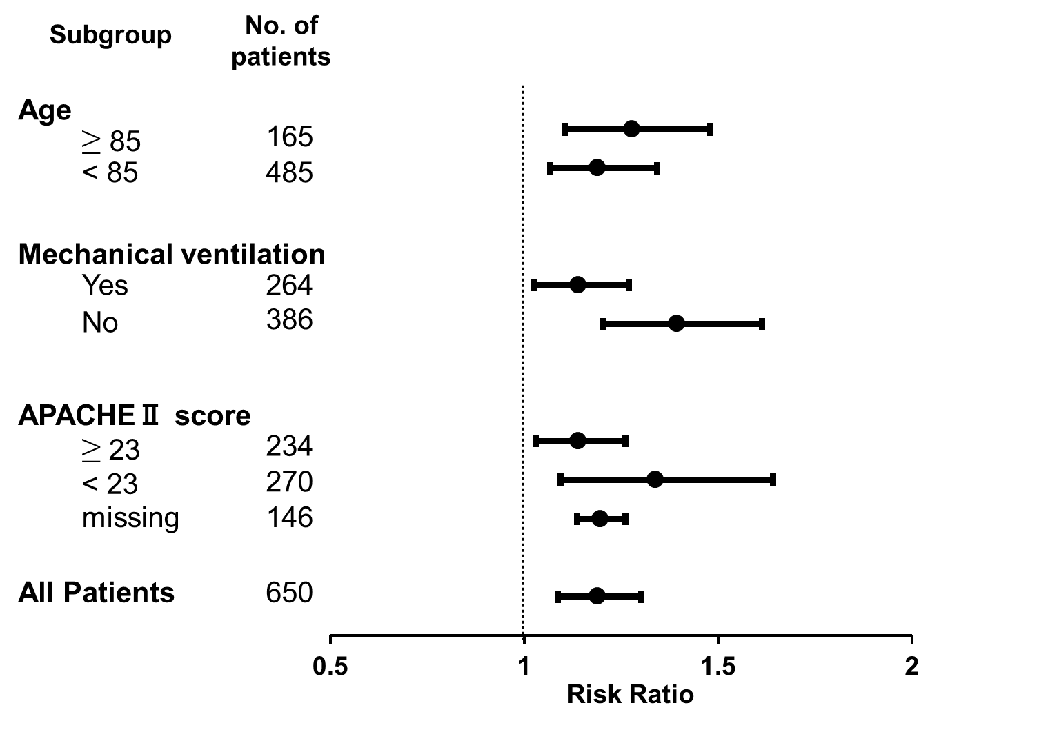
eFigure 2. Stratified analysis of the primary outcome.

The stratified analyses were conducted by mutually adjusting for other confounders in each stratum (e.g., age, sex, and CCI for APACHE II category). APACHE II score was imputed using multiple imputation in the adjustment for age and mechanical ventilation categories as well as for all patients. Error bars indicate 95% confidence intervals.

