Supplemental materials
Supplemental Figure 1. Concentration-assay response curves for HTT Q46 spiked in surrogate matrix or pooled human CSF from healthy volunteers (remnant samples), processed and analysed on the same assay plate.
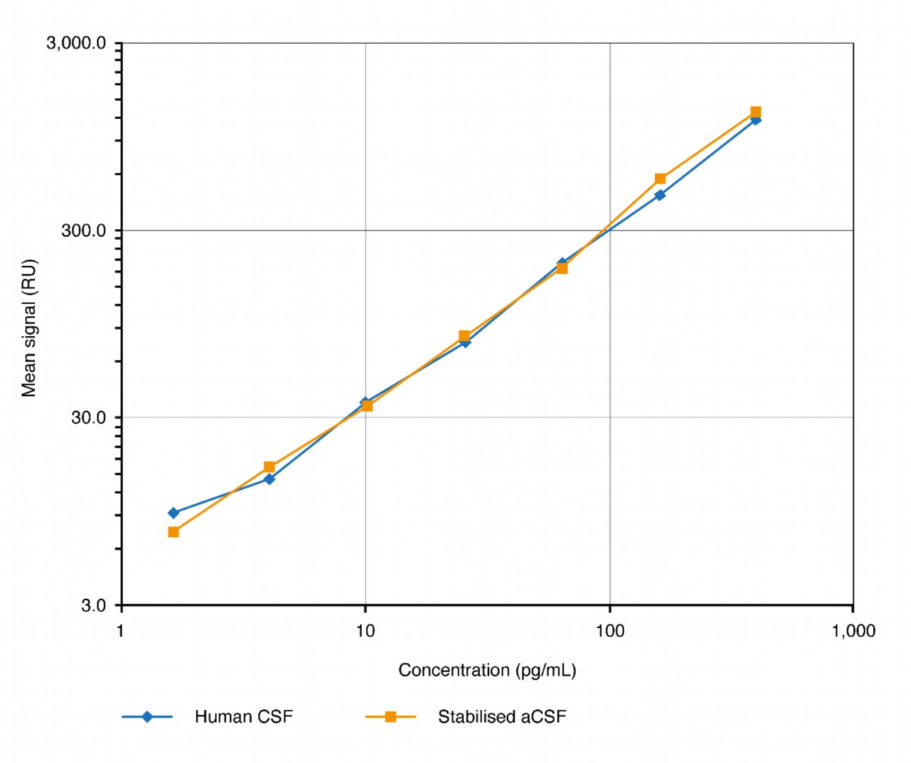
aCSF, artificial CSF; CSF, cerebrospinal fluid; HTT, huntingtin protein; RU, Relative Unit.

Supplemental Figure 2. Blank signals and signal-to-noise ratios at the lowest (LLOQ, [a]) and highest (ULOQ, [b]) calibration samples before and after optimisation of critical reagents. 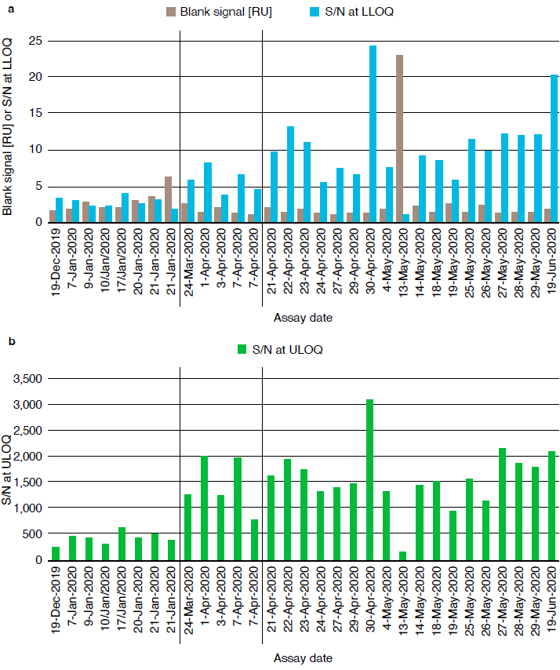
19 Dec 2020 to 21 Jan 2020: assay optimisation, research-grade reagents. 24 Mar 2020 to 07 Apr 2020: assay pre-validation, qualified reagent lots 2B7 BR02 and MW1 BR08. 21 Apr 2020 to 19 Jun 2020: assay validation at Roche, qualified reagent lots 2B7 BR02 and MW1 BR08. LLOQ, lower limit of quantification; RU, Relative Unit; S/N, signal-to-noise ratio; ULOQ, upper limit of quantification.
Supplemental Figure 3. Concentration-response of different recombinant HTT, separated by protein size.
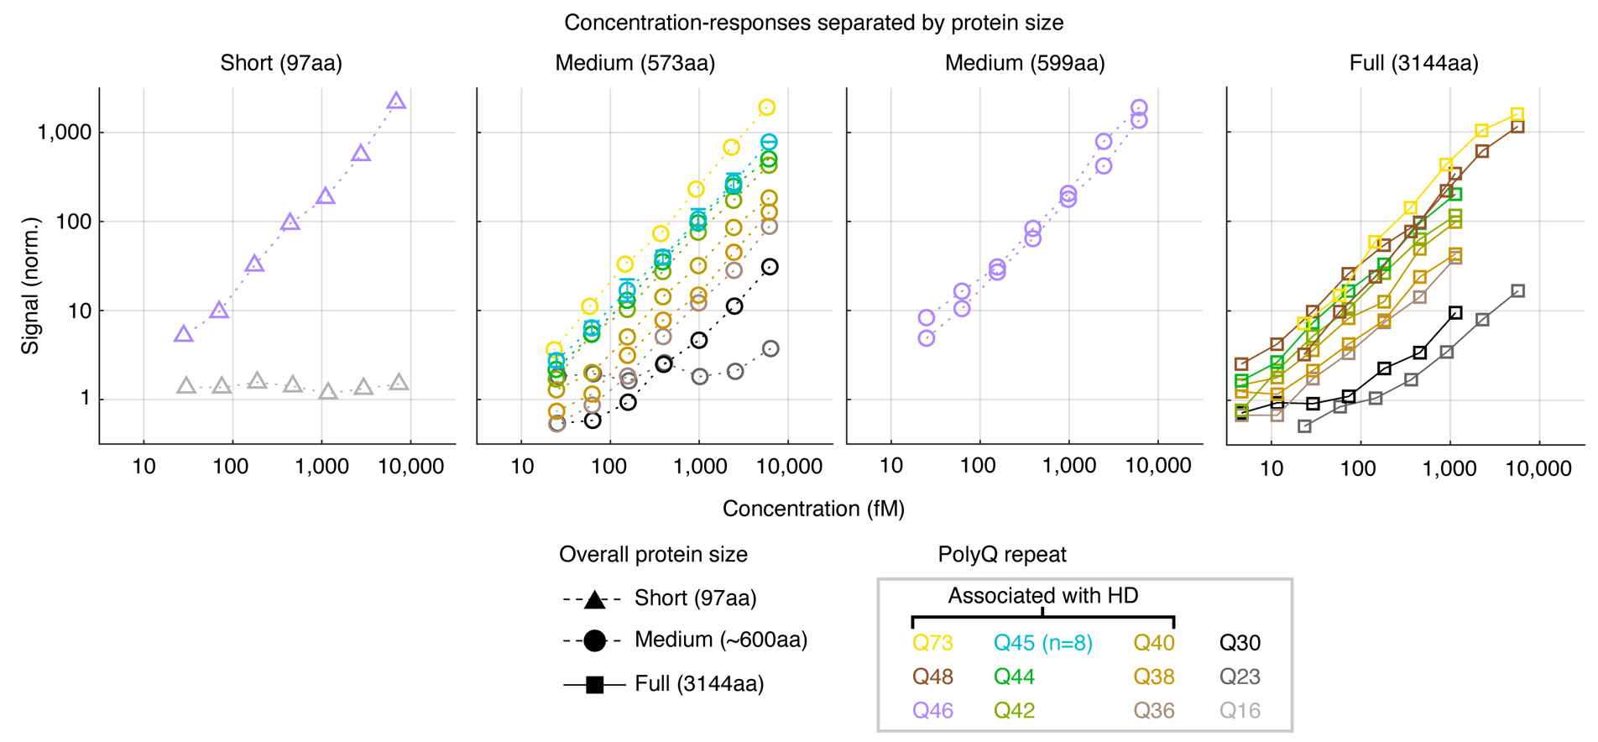
aa, amino acid; HD, Huntington’s disease; HTT, huntingtin protein; fM, femtomolar; norm., normalised; polyQ, polyglutamine.

Supplemental Figure 4. Strategy for ISS assessment using overlapping storage time periods.
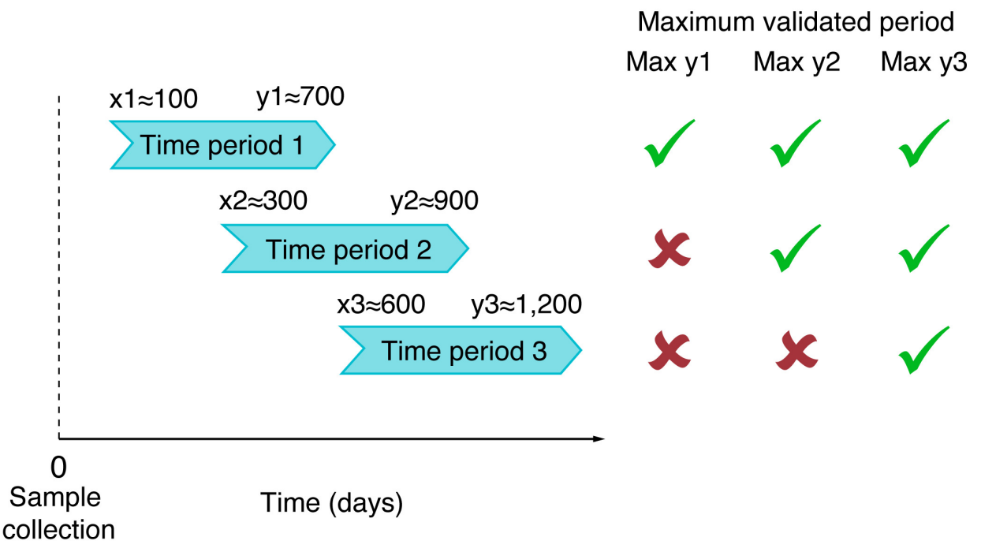
ISS, incurred sample stability; Max, maximum valid y time; x, time point denoting first analysis; y, time point denoting incurred sample stability analysis.
Supplemental Table 1. Antibody labelling outputs for 2B7 and MW1.
Labelling antibody and batch | Labelling date | Labelling ratio | Starting material  [mg] | Amount labelled antibody  [mg] | Yield  [%] | Purity  (SEC-HPLC) | Incorporation rate | Emission at 0.01 mg/mL | Antibody pairs used for assay performance testing  (S/N assessment)
2B7 BR01 | 28 Jan 2020 | NA | 1.0 | 0.48 | 48.0 | 99.7% | 0.7* | NA | x | x
2B7 BR02 | 11 Mar 2020 | NA | 2.0 | 0.92 | 46.0 | 99.1% | 0.7* | NA |  |  | x | x
MW1 BR05 | 24 Feb 2020 | 1:3.5 | 0.32 | 0.27 | 84.4 | 98.4 | 2.8** | 272.1
MW1 BR06 | 24 Feb 2020 | 1:5 | 0.32 | 0.27 | 84.4 | 98.3 | 3.9** | 343.6
MW1 BR07 | 24 Feb 2020 | 1:7.5 | 0.32 | 0.27 | 84.4 | 98.1 | 5.5** | 376.3 | x |  | x
MW1 BR08 | 09 Mar 2020 | 1:8 | 2.0 | 1.72 | 86.0 | 98.4 | 5.9** | 411.2 |  | x |  | x
MW1 BR09 | 09 Jul 2020 | 1:8 | 2.0 | 1.66 | 79.5 | 98.3 | 5.9** | 412.5
S/N |  |  |  |  |  |  |  |  | 5.2 | 7.1 | 5.2 | 6.2
* Label/IgG via ESI-MS. ** Label/IgG via absorbance. ESI-MS, electrospray ionisation mass spectrometry; HTT, huntingtin protein; IgG, immunoglobulin G; LLOQ, lower limit of quantification; NA, not applicable; SEC-HPLC, size exclusion-high-performance liquid chromatography; S/N, response/background signal ratio at LLOQ of 1.63 pg/mL HTT Q46.
Supplemental Table 2. Parallelism data for mHTT in CSF of patients with low polyQ-repeat lengths (Q41 and Q42) in surrogate matrix.
Sample and polyQ-repeat length | Sample dilution | Results w/o dilution factor correction (pg/mL) | Dilution- adjusted result  (pg/mL) | Recovery based on undiluted sample | Dilutions within the working range*
1 | 1:1.1 | 3.49 | 3.83 | 100.0 | Mean | 4.00
1 | 1:2.2 | 1.77 | 3.90 | 101.8 | SD | 0.24
1 | 1:3.3 | 1.30 | 4.27 | 111.5 | %CV | 5.9
1 | 1:4.4 | BLQ | 4.80 | 125.3
1 | 1:6.6 | BLQ | 3.19 | 83.3
1 | 1:8.8 | BLQ | 2.56 | 66.8
2 | 1:1.1 | 3.42 | 3.76 | 100.0 | Mean | 3.97
2 | 1:2.2 | 1.77 | 3.89 | 103.5 | SD | 0.26
2 | 1:3.3 | 1.29 | 4.26 | 113.3 | %CV | 6.5
2 | 1:4.4 | BLQ | 4.82 | 128.2
2 | 1:6.6 | BLQ | 5.49 | 146.0
2 | 1:8.8 | BLQ | 6.08 | 161.7
* Dilution level leading to concentrations slightly below LLOQ taken into consideration for precision calculation. Italic bold: result outside ±30% recovery. Underlined: result below LLOQ of 1.63 pg/mL, but result was taken into consideration for precision calculation. BLQ, below LLOQ of 1.63 pg/mL; CSF, cerebrospinal fluid; CV, coefficient of variation; LLOQ, lower limit of quantification; mHTT, mutant huntingtin protein; polyQ, polyglutamine; SD, standard deviation; w/o, without.

Supplemental Table 3. Microplate homogeneity of mHTT in surrogate matrix. Accuracy of the LLOQ samples analysed.
 | Found mHTT concentration (pg/mL) |  | Accuracy (%)
Sample ID | Roche | ICON | Roche | ICON
1 | 1.54* | 1.63 | 94.5 | 99.6
2 | 1.74 | 1.38 | 106.7 | 84.1
3 | 1.68 | 1.19 | 103.1 | 72.5
4 | 1.73 | 1.55 | 106.1 | 94.3
5 | 1.84 | 1.37 | 112.9 | 83.7
6 | 1.70 | 1.79 | 104.3 | 109.2
7 | 1.61* | 1.69 | 98.8 | 103.0
8 | 1.35* | 1.57 | 82.8 | 95.5
9 | 1.42* | 1.77 | 87.1 | 107.8
10 | 1.93 | 1.68 | 118.4 | 102.5
11 | 1.72 | 1.53 | 105.5 | 93.1
12 | 1.58* | 1.77 | 96.9 | 107.8
13 | 1.82 | 1.47 | 111.7 | 89.9
14 | 1.78 | 1.53 | 109.2 | 93.4
15 | 1.56* | 1.55 | 95.7 | 94.7
16 | 1.99 | 1.42 | 122.1 | 86.3
17 | 1.50* | 1.79 | 92.0 | 109.2
18 | 1.85 | NA | 113.5 | NA
* RO7234292 concentration extrapolated. LLOQ, lower limit of quantification; mHTT, mutant huntingtin protein; NA, not available.

Supplemental Table 4. Interference of wtHTT. Accuracy of specificity samples in surrogate matrix spiked with wtHTT (HTT-Q23 1-3144).
Spiked HTT Q46 concentration (pg/mL) | Spiked HTT-Q23 1-3144 concentration (pg/mL) | Accuracy (%)
Spiked HTT Q46 concentration (pg/mL) | Spiked HTT-Q23 1-3144 concentration (pg/mL) | Roche | ICON
Unspiked | 200 | BLQ | BLQ
Unspiked | 200 | BLQ | BLQ
Unspiked | 200 | BLQ | BLQ
Unspiked | 20 | BLQ | BLQ
Unspiked | 20 | BLQ | BLQ
Unspiked | 20 | BLQ | BLQ
Unspiked | 0.00 | BLQ | BLQ
Unspiked | 0.00 | BLQ | BLQ
Unspiked | 0.00 | NA | BLQ
1.63 (Roche)  1.64 (ICON) | 200 | 129.4 | 105.9
1.63 (Roche)  1.64 (ICON) | 200 | 118.4 | 136.3
1.63 (Roche)  1.64 (ICON) | 200 | 141.1 | 121.2
1.63 (Roche)  1.64 (ICON) | 20 | 124.5 | 90.1
1.63 (Roche)  1.64 (ICON) | 20 | 133.7 | 115.6
1.63 (Roche)  1.64 (ICON) | 20 | 118.4 | 97.2
1.63 (Roche)  1.64 (ICON) | 0.00 | 100.6 | 98.9
1.63 (Roche)  1.64 (ICON) | 0.00 | 106.7 | 104.5
1.63 (Roche)  1.64 (ICON) | 0.00 | 117.8 | 103.2
400 | 200 | 100.3 | 95.5
400 | 200 | 92.3 | 54.4
400 | 200 | 91.3 | 81.4
400 | 20 | 95.0 | 78
400 | 20 | 88.8 | 91.3
400 | 20 | 95.0 | 84.4
400 | 0.00 | 98.5 | 108.9
400 | 0.00 | 98.0 | 81.9
400 | 0.00 | 99.8 | 108.5
Underlined values are out of acceptance criteria. BLQ, below limit of quantification; HTT, huntingtin protein; NA, not available; wtHTT, wild-type HTT.

Supplemental Table 5. Interference of drug. Accuracy of specificity samples in surrogate matrix spiked with tominersen.
Spiked HTT Q46 concentration (pg/mL) | Spiked tominersen concentration (µg/mL) | Accuracy (%)
Spiked HTT Q46 concentration (pg/mL) | Spiked tominersen concentration (µg/mL) | Roche |  | ICON
0 | 100 | BLQ |  | BLQ
0 | 100 | BLQ |  | BLQ
0 | 100 | BLQ |  | BLQ
0 | 1 | BLQ |  | BLQ
0 | 1 | BLQ |  | BLQ
0 | 1 | BLQ |  | BLQ
0 | 0.1 | BLQ |  | BLQ
0 | 0.1 | BLQ |  | BLQ
0 | 0.1 | BLQ |  | BLQ
1.63 (Roche)  1.64 (ICON) | 100 | 103.1 |  | 115.9
1.63 (Roche)  1.64 (ICON) | 100 | 109.2 |  | 117.8
1.63 (Roche)  1.64 (ICON) | 100 | 112.3 |  | 91.0
1.63 (Roche)  1.64 (ICON) | 1 | 119.0 |  | 185
1.63 (Roche)  1.64 (ICON) | 1 | 96.3 |  | 88.7
1.63 (Roche)  1.64 (ICON) | 1 | 87.7 |  | 75.2
1.63 (Roche)  1.64 (ICON) | 0.1 | 120.2 |  | 107.8
1.63 (Roche)  1.64 (ICON) | 0.1 | 96.3 |  | 105.1
1.63 (Roche)  1.64 (ICON) | 0.1 | 95.1 |  | 148.5
400 | 100 | 81.0 | 108.2
400 | 100 | 88.0 | 82.0
400 | 100 | 98.8 | 77.7
400 | 1 | 91.5 | 58.7
400 | 1 | 91.3 | 73.4
400 | 1 | 97.0 | 73.8
400 | 0.1 | 86.3 | 90.0
400 | 0.1 | 100.3 | 79.4
400 | 0.1 | 90.5 | 96.2
Underlined values are out of acceptance criteria. BLQ, below limit of quantification; HTT, huntingtin protein.
Supplemental Table 6. Interference of blood. Accuracy of specificity samples in surrogate matrix spiked with haemolysed full blood.
 |  | Accuracy (%)
Spiked HTT Q46 concentration (pg/mL) | Spiked full blood (v/v) (%) | Roche | ICON
0 | 1 | BLQ | Result in quantification range (10.8 pg/mL)
0 | 1 | BLQ | Result in quantification range (9.40 pg/mL)
0 | 1 | BLQ | Result in quantification range (6.86 pg/mL)
0 | 0.1 | BLQ | BLQ
0 | 0.1 | BLQ | BLQ
0 | 0.1 | BLQ | BLQ
0 | 0 | BLQ | BLQ
0 | 0 | BLQ | BLQ
0 | 0 | BLQ | BLQ
1.63 (Roche)  1.64 (ICON) | 1 | 138.0 | 482.3
1.63 (Roche)  1.64 (ICON) | 1 | 116.6 | 636.4
1.63 (Roche)  1.64 (ICON) | 1 | 126.4 | 482.1
1.63 (Roche)  1.64 (ICON) | 0.1 | 106.1 | 115.4
1.63 (Roche)  1.64 (ICON) | 0.1 | 120.2 | 116.6
1.63 (Roche)  1.64 (ICON) | 0.1 | 110.4 | 108.7
1.63 (Roche)  1.64 (ICON) | 0 | 95.7 | 142.6
1.63 (Roche)  1.64 (ICON) | 0 | 90.2 | 97.7
1.63 (Roche)  1.64 (ICON) | 0 | 128.2 | 116.3
400 | 1 | 147.5 | 98.9
400 | 1 | 100.3 | 94.9
400 | 1 | 121.3 | 95.1
400 | 0.1 | 105.0 | 95.4
400 | 0.1 | 110.8 | 116.7
400 | 0.1 | 94.3 | 121.9
400 | 0 | 94.0 | 103.8
400 | 0 | 99.0 | 70.7
400 | 0 | 123.3 | 91.3
Underlined values are out of acceptance criteria. BLQ, below limit of quantification; HTT, huntingtin protein.

Supplemental Table 7. Stability of reference standard in surrogate matrix, shock frozen and analysed after 4 hours storage at room temperature.
Found mHTT concentration (pg/mL)
 | LQC ( nominal concentration 4.50 pg/mL) |  | HQC (nominal concentration 300.0 pg/mL)
 | Roche | ICON | Roche | ICON
Replicate 1 | 3.59 | 4.72 | 270 | 285
Replicate 2 | 5.21 | 4.49 | 235 | 328
Replicate 3 | 4.60 | 4.43 | 233 | 345
Mean conc. (pg/mL) | 4.47 | 4.55 | 246 | 319
Accuracy (%) | 99.3 | 101.1 | 82.0 | 106.5
Precision (%CV) | 18.3 | 3.3 | 8.5 | 9.7
Conc., concentration; CV, coefficient of variation; HQC, high quality control; LQC, low quality control; mHTT, mutant huntingtin protein.
Supplemental Table 8. Roche data: Stability of reference standard in surrogate matrix, shock frozen and analysed after 32, 94, 183 and 365 days of storage at –60 °C to –85 °C.
Found mHTT concentration (pg/mL)
 | LQC ( nominal concentration 4.50 pg/mL) | HQC (nominal concentration 300.0 pg/mL)
Storage period: 32 days of storage at –60 °C to –85 °C
Replicate 1 | 3.67 | 199
Replicate 2 | 3.34 | 210
Replicate 3 | 3.03 | 211
Mean conc. (pg/mL) | 3.35 | 207
Accuracy (%) | 74.4 | 69.0
Precision (%CV) | 9.6 | 3.2
Storage period: 94 days of storage at –60 °C to –85 °C
Replicate 1 | 5.94 | 282
Replicate 2 | 5.43 | 249
Replicate 3 | 5.09 | 273
Mean conc. (pg/mL) | 5.49 | 268
Accuracy (%) | 122.0 | 89.3
Precision (%CV) | 7.8 | 6.4
Storage period: 183 days of storage at –60 °C to –85 °C
Replicate 1 | 4.56 | 334
Replicate 2 | 4.05 | 371
Replicate 3 | 4.22 | 347
Mean conc. (pg/mL) | 4.28 | 351
Accuracy (%) | 95.1 | 117.0
Precision (%CV) | 6.1 | 5.4
Storage period: 365 days of storage at –60 °C to –85 °C
Replicate 1 | 4.95 | 245
Replicate 2 | 4.51 | 221
Replicate 3 | 3.79 | 300
Mean conc. (pg/mL) | 4.42 | 255
Accuracy (%) | 98.2 | 85.0
Precision (%CV) | 13.3 | 15.9
Conc., concentration; CV, coefficient of variation; HQC, high quality control; LQC, low quality control; mHTT, mutant huntingtin protein.

Supplemental Table 9. ICON data: stability of reference standard in surrogate matrix, shock frozen and analysed after 7, 28, 85, 182 and 422 days of storage at –70 °C.
Found mHTT concentration (pg/mL)
 | LQC ( nominal concentration 4.50 pg/mL) | HQC (nominal concentration 300.0 pg/mL)
Storage period: 7 days at –70 °C
Replicate 1 | 4.52 | 227
Replicate 2 | 3.84 | 267
Replicate 3 | 4.39 | 231
Mean conc. (pg/mL) | 4.25 | 242
Accuracy (%) | 94.5 | 80.6
Precision (%CV) | 8.5 | 9.2
Storage period: 28 days at –70 °C
Replicate 1 | 6.04 | 298
Replicate 2 | 4.44 | NA
Replicate 3 | 4.56 | 314
Mean conc. (pg/mL) | 5.01 | 306
Accuracy (%) | 111.4 | 102
Precision (%CV) | 17.8 | 3.9
Storage period: 85 days at –70 °C
Replicate 1 | 3.88 | 328
Replicate 2 | 4.50 | 290
Replicate 3 | 4.50 | 330
Mean conc. (pg/mL) | 4.29 | 316
Accuracy (%) | 95.4 | 105.3
Precision (%CV) | 8.3 | 7.1
Storage period: 182 days at –70 °C
Replicate 1 | 8.79 | 359
Replicate 2 | 8.06 | 383
Replicate 3 | 5.03 | 325
Mean conc. (pg/mL) | 7.29 | 356
Accuracy (%) | 162.0 | 118.6
Precision (%CV) | 27.3 | 8.2
Storage period: 422 days at –70 °C
Replicate 1 | 4.93 | 203
Replicate 2 | 4.37 | 199
Replicate 3 | 2.99 | 199
Mean conc. (pg/mL) | 4.09 | 200
Accuracy (%) | 91.0 | 66.8
Precision (%CV) | 24.4 | 1.3
Conc., concentration; CV, coefficient of variation; HQC, high quality control; LQC, low quality control; mHTT, mutant huntingtin protein; NA, not available – insufficient sample volume for analysis.

Supplemental Table 10. ISS performed on CSF samples collected from patients with HD within clinical studies of the tominersen programme and stored at -70 °C.
CSF sample | Sample collection date | Original mHTT concentration (pg/mL) | Original analysis date | ISS mHTT concentration (pg/mL) | ISS analysis date | Bias (%) | Time of storage at ISS (days)
1 | 22 Oct 2020 | 5.39 | 11 Mar 2021 | 5.65 | 24 Nov 2022 | 4.9 | 763
2 | 12 Nov 2020 | 4.52 | 16 Mar 2021 | 4.65 | 24 Nov 2022 | 2.9 | 742
3 | 04 Nov 2020 | 4.14 | 19 Mar 2021 | 3.42 | 24 Nov 2022 | –7.5 | 750
4 | 04 Jan 2021 | 4.10 | 20 May 2021 | 1.75 | 24 Nov 2022 | –57.2 | 689
5 | 26 Oct 2020 | 6.04 | 19 Mar 2021 | 4.62 | 24 Nov 2022 | –23.6 | 759
6 | 16 Apr 2020 | 6.01 | 05 Mar 2021 | 4.49 | 24 Nov 2022 | –25.2 | 952
7 | 23 Apr 2020 | 4.81 | 18 Mar 2021 | 2.30 | 24 Nov 2022 | –52.2 | 945
8 | 13 May 2020 | 4.91 | 19 Mar 2021 | 3.80 | 24 Nov 2022 | –22.6 | 925
9 | 24 Apr 2020 | 2.79 | 11 Mar 2021 | 2.70 | 24 Nov 2022 | –3.1 | 944
10 | 01 Jun 2020 | 6.78 | 19 Mar 2021 | 6.39 | 24 Nov 2022 | –5.7 | 906
11 | 20 Aug 2019 | 3.59 | 25 May 2021 | 5.11 | 24 Nov 2022 | 42.3 | 1,192
12 | 20 Aug 2019 | 4.04 | 25 May 2021 | 11.4 | 24 Nov 2022 | 182.6 | 1,192
13 | 05 Jun 2019 | 7.46 | 11 Mar 2021 | 1.76 | 24 Nov 2022 | –76.4 | 1,268
14 | 04 Jun 2019 | 4.66 | 11 Mar 2021 | 3.37 | 24 Nov 2022 | –27.7 | 1,269
15 | 20 Aug 2019 | 3.74 | 25 May 2021 | 4.11 | 24 Nov 2022 | 9.8 | 1,192

Samples 1–5: time period 1; Samples 6–10: time period 2; Samples 11–15: time period 3. An overview of the three overlapping time periods used for ISS analysis is shown in Supplemental Figure 4. Underlined samples: samples out of acceptance criteria. CSF, cerebrospinal fluid; HD, Huntington’s disease; ISS, incurred sample stability; mHTT, mutant huntingtin protein.

