Identification of novel p-cresol inhibitors that reduce Clostridioides difficile’s ability to compete with species of the gut microbiome
Mark A. Harrison¹, Rebecca J. Farthing², Nyasha Allen¹, Lucy M. Ahern¹, Kristian Birchall⁴, Michael Bond⁴, Harparkash Kaur³, Brendan W. Wren¹, Julien R.C Bergeron² and Lisa F. Dawson¹*

Supplementary figures and tables

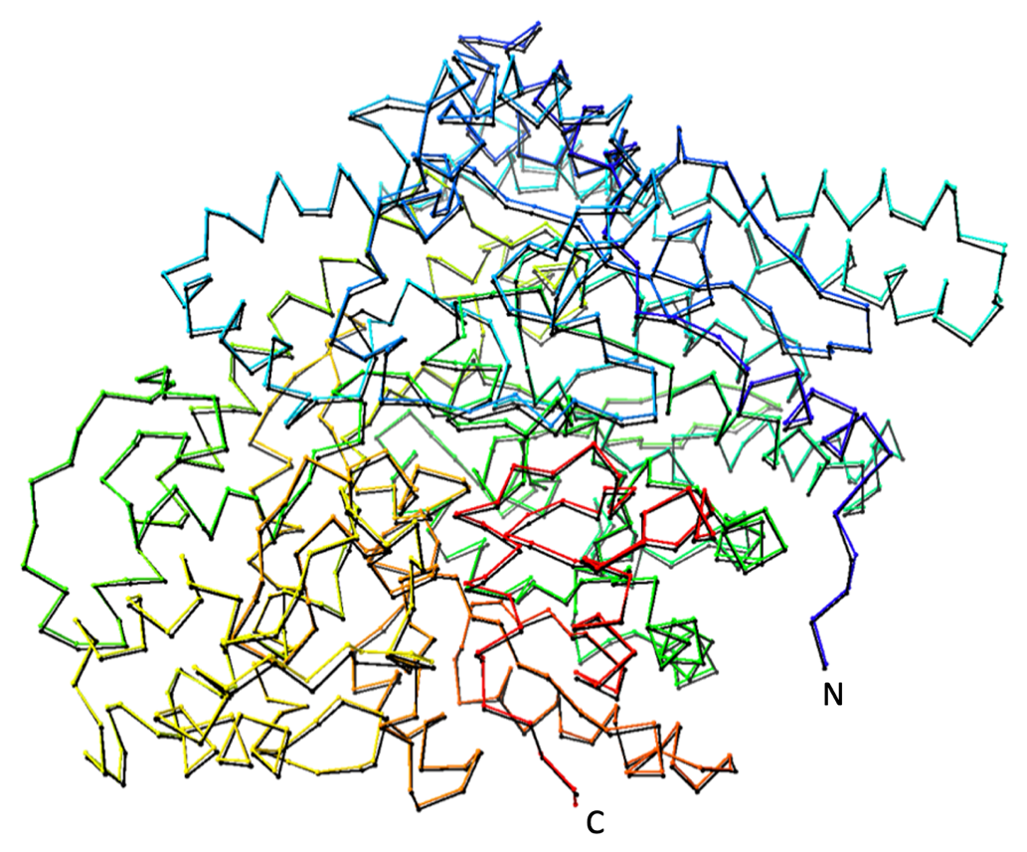

Supplementary figure 1. Structural alignment of C. difficile HpdB homology model with crystal structure of C. scatologenes HpdB (PDB ID: 2YAJA) (25). C. difficile is displayed in black and C. scatologenes in rainbow (from N to C terminus). The carbon trace only is displayed. Figure generated in UCSF ChimeraX.

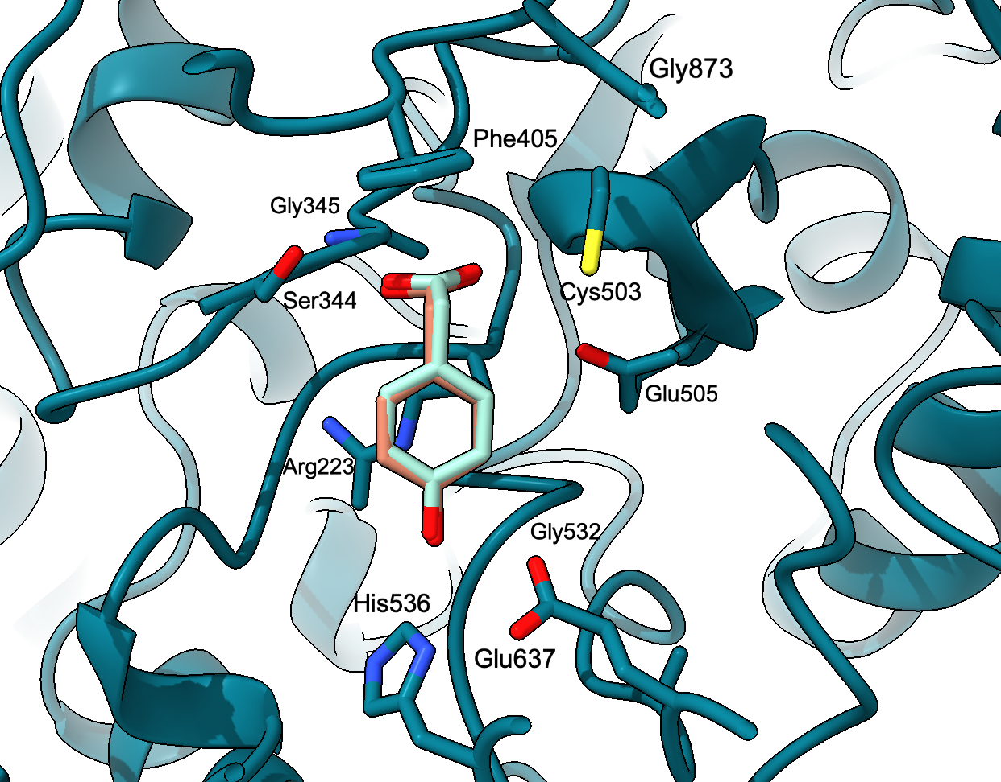

Supplementary Figure 2. Docking of the substrate p-hydroxyphenylacetate leads to the same binding mode as observed in the experimentally determined structure. The C. scatologenes HpdB crystal structure (PDB ID: 2YAJA) is shown in teal, in cartoon representation (25). p-HPA from the experimentally determined complex structure is shown in orange, and the lowest-energy solution from the docking procedure is in mint green. Side chains of the active site residues for HpdB are displayed as sticks, and the residue numbers correspond to the C. difficile sequence. Figure generated in UCSF ChimeraX.

para-hydroxyphenylacetic acid  (p-HPA) | 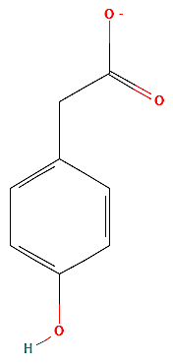 | 4-Hydroxyphenylacetonitrile  (Compound 8) | 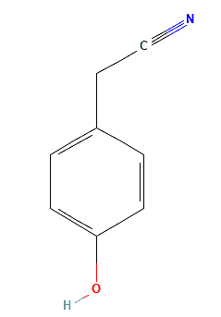
3-(4-Hydroxyphenyl)propionic acid  (Compound 1) | 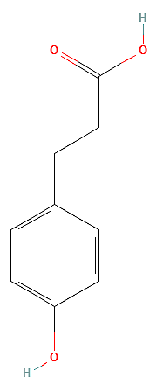 | 3,4-Dihydroxyphenylacetic acid  (Compound 9) | 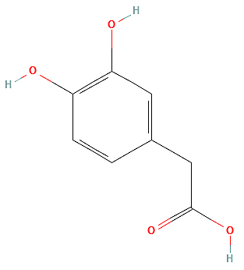
Methyl 4-hydroxyphenylacetate  (Compound 2) | 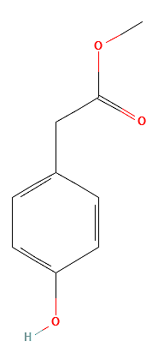 | 4-Hydroxybenzoic acid  (Compound 17) | 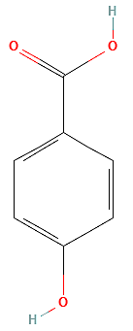
2-(4-Hydroxyphenyl)ethanol  (Compound 3) | 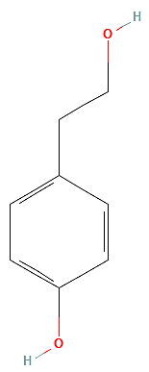 | DL-4-Hydroxy-3-methoxymandelic acid  (Compound 19) | 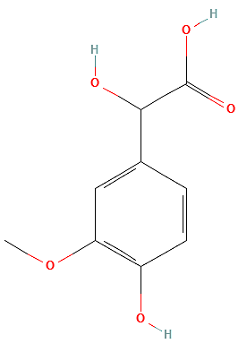
4-Hydroxyphenylacetamide  (Compound 6) | 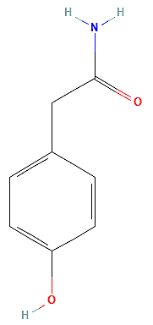 | (2RS)-2-(4-Hydroxyphenyl)propionic acid | 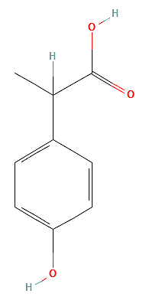
2-(4-Hydroxyphenyl)-2-methylpropanoic acid | 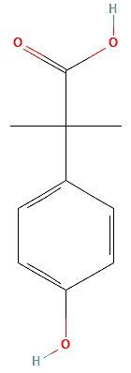 | 2-(3-amino-4-hydroxyphenyl)acetic acid | 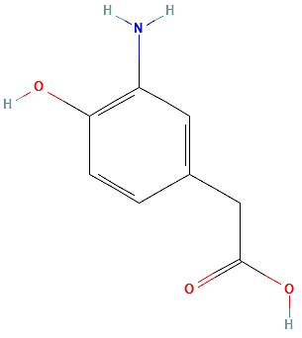
4-Bromophenylacetic acid | 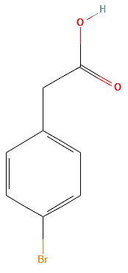 | 3-Bromo-4-hydroxyphenylacetic acid | 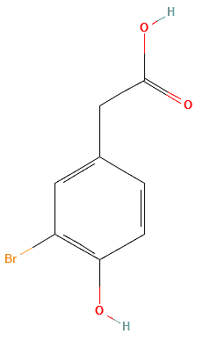
4-(2-Methoxyethyl)phenol | 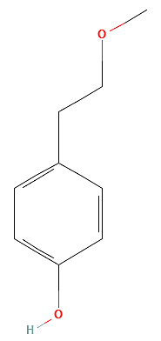 | 3-Chloro-4-hydroxyphenylacetic acid | 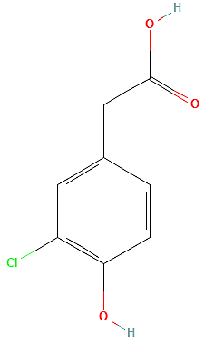
4-aminophenylacetic acid | 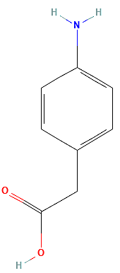 | 4-Hydroxy-3-methoxyphenylacetic acid | 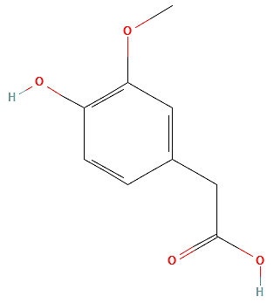
4-Tolylacetic acid | 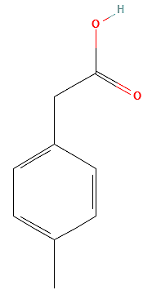 | 2-Fluoro-4-hydroxyphenylacetic acid | 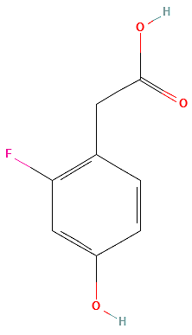
2-Hydroxy-2-(4-hydroxyphenyl)acetic acid | 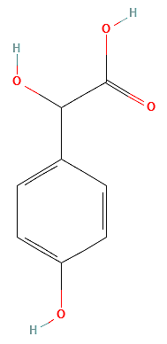 | 2-Amino-2-(4-hydroxyphenyl)acetic acid | 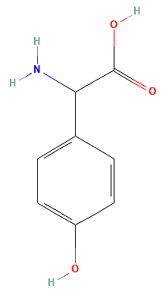
1-(4-Hydroxyphenyl)propan-2-one | 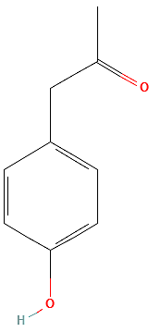 | 3-Hydroxyphenylacetic acid | 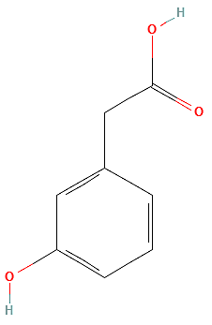
2-(4-Hydroxycyclohexyl)acetic acid | 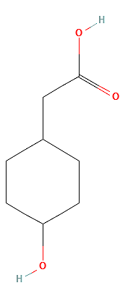 | 3-Methyl-4-hydroxyphenylacetic acid | 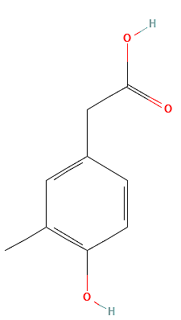
2-(4-aminopiperidin-1-yl)acetic acid | 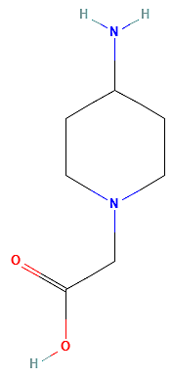 | 3-Fluoro-4-hydroxyphenylacetic acid | 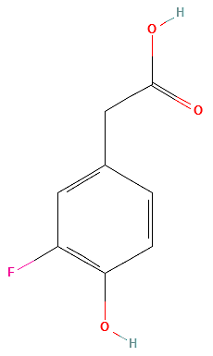
4-Methoxyphenylacetic acid | 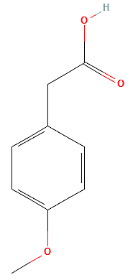 | Phenylacetic acid | 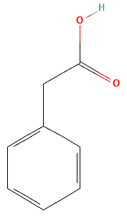

Supplementary table 1. Structures of p-HPA and the compounds identified through substructure and similarity searching of catalogues of commercially available compounds as analogues of p-HPA. Structural images are from the PubChem database (1).

References
- Kim S, Chen J, Cheng T, Gindulyte A, He J, He S, et al. PubChem in 2021: new data content and improved web interfaces. Nucleic Acids Research. 2020;49(D1):D1388-D95.

