Supplementary Material

Figure S1.
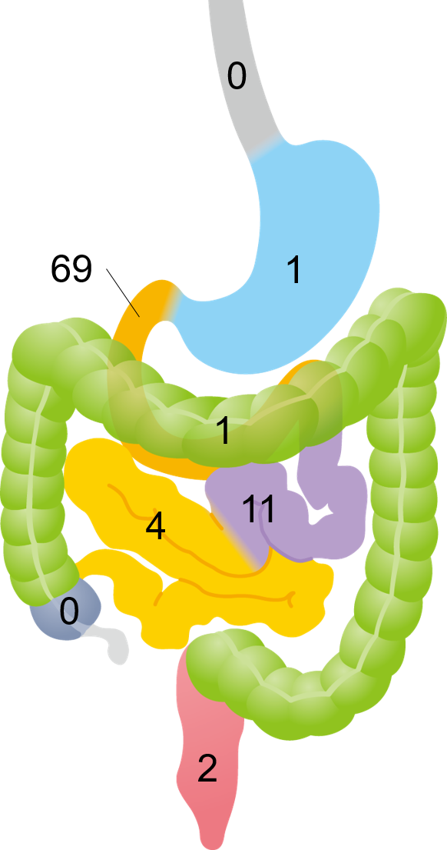
Figure S1. Schematic illustration showing the organs affected by follicular lymphoma

