Appendices
An updated meta-analysis of effects of curcumin on metabolic dysfunction-associated fatty liver disease based on available evidence from Iran and Thailand
- Search terms
- Assessment of the methodological quality using the ROBIS instrument for the systematic reviews included.
- Study-citation matrix for aspartate aminotransferase and alanine aminotransferase outcomes
- Forest plots of pooled effect sizes from included systematic review and meta-analyses: aspartate aminotransferase
- Forest plots of pooled effect sizes from included systematic review and meta-analyses: alanine aminotransferase
- Risk of bias summary assessment for randomized-controlled trials included within the updated meta-analysis
- Risk of bias assessment for randomized-controlled trials included within the updated meta-analysis
- Forest plots demonstrating the effects of curcumin on aspartate aminotransferase: bioavailability-enhanced form
- Forest plots demonstrating the effects of curcumin on alanine aminotransferase: bioavailability-enhanced form
- Forest plots of the effects of curcumin on alkaline phosphatase
- Forest plots of the effects of curcumin on gamma-glutamyl transpeptidase
- Forest plots demonstrating the effects of curcumin on the improvement of hepatic steatosis assessed by ultrasonography
- Forest plots demonstrating the effects of curcumin on liver stiffness assessed by transient elastography
- Forest plots demonstrating the effects of curcumin on platelet count
- Forest plots demonstrating the effects of curcumin on fasting blood sugar
- Forest plots demonstrating the effects of curcumin on HbA1c
- Forest plots demonstrating the effects of curcumin on body mass index (BMI)
- Forest plots demonstrating the effects of curcumin on total cholesterol (TC)
- Forest plots demonstrating the effects of curcumin on LDL-C
- Forest plots demonstrating the effects of curcumin on HDL-C
- Forest plots demonstrating the effects of curcumin on triglycerides (TG)
- Forest plots demonstrating the effects of curcumin on systolic blood pressure (SBP)
- Forest plots demonstrating the effects of curcumin on diastolic blood pressure (DBP)
- Sensitivity analysis by excluding studies with high risk of bias: aspartate aminotransferase
- Sensitivity analysis by excluding studies with high risk of bias: alanine aminotransferase
- Sensitivity analysis by excluding studies with high risk of bias: the resolution of hepatic steatosis
- Funnel plots of aspartate aminotransferase
- Funnel plots of alanine aminotransferase
- Funnel plots of alkaline phosphatase
- Funnel plots of the resolution of hepatic steatosis
- Funnel plots of BMI
- Funnel plots of TC
- Funnel plots of TG
- Funnel plots of the improvement of hepatic steatosis
- Contour-enhanced funnel plots of the improvement of hepatic steatosis
- Funnel plots of fasting blood sugar
- Contour-enhanced funnel plots of fasting blood sugar
- Funnel plots of HbA1c
- Funnel plots of LDL-C
- Contour-enhanced funnel plots of LDL-C
- Funnel plots of HDL-C
- Contour-enhanced funnel plots of HDL-C
- Funnel plots of SBP
- Contour-enhanced funnel plots of SBP
- Funnel plots of DBP
- Contour-enhanced funnel plots of DBP

Appendix A. Search terms
Domain | Search | Search Term
P | #1 | nonalcoholic
P | #2 | non-alcoholic
P | #3 | “non alcoholic”
P | #4 | “fatty liver disease”
P | #5 | Steatosis
P | #6 | NAFLD
P | #7 | “metabolic associated fatty liver disease”
P | #8 | MAFLD
P | #9 | steatohepatitis
P | #10 | NASH
P | #11 | ((nonalcoholic OR non-alcoholic OR “non alcoholic”) AND “fatty liver disease”)  OR (NAFLD OR “metabolic associated fatty liver disease” OR MAFLD OR steatosis OR steatohepatitis OR NASH)
I | #12 | Curcumin
I | #13 | “curcuma domestica”
I | #14 | “curcuma longa”
I | #15 | Turmeric
I | #16 | tumeric
I | #17 | curcuminoid
I | #18 | curcumin OR “curcuma domestica” OR “curcuma longa” OR turmeric OR tumeric OR curcuminoid
P & I | #19 | (((nonalcoholic OR non-alcoholic OR “non alcoholic”) AND “fatty liver disease”) OR (NAFLD OR “metabolic associated fatty liver disease” OR MAFLD OR steatosis OR steatohepatitis OR NASH))  AND (curcumin OR “curcuma domestica” OR “curcuma longa” OR turmeric OR tumeric OR curcuminoid)

Appendix B. Assessment of the methodological quality using the ROBIS instrument for the systematic reviews included.
First author, year | 1. STUDY ELIGIBILITY CRITERIA | 2. IDENTIFICATION AND SELECTION OF STUDIES | 3. DATA COLLECTION AND STUDY APPRAISAL | 4. SYNTHESIS AND FINDINGS | RISK OF BIAS IN THE REVIEW
Goodarzi, 2019
Mansour-Ghanaei, 2019 |  |  | ?
Wei, 2019
Jalali, 2020 |  |  | ?
Zhou, 2021
Khalili, 2022
= low risk; = high risk; and ? = unclear risk.

Appendix C. Study-citation matrix for aspartate aminotransferase and alanine aminotransferase outcomes
First author, Year |  | Systematic review and meta-analysis |  |  |  |  |  | Total
 |  | Goodazi,  2019 | Mansour-Ghanaei, 2019 | Wei, 2020 | Jalali, 2020 | Zhou, 2021 | Khalili, 2022 | Total
Randomized controlled trial | Chirapongsathorn, 2012 | 1 | 0 | 1 | 0 | 0 | 0 | 2
Randomized controlled trial | Moradi, 2016 | 1 | 1 | 0 | 0 | 0 | 0 | 2
Randomized controlled trial | Panahi, 2016 | 0 | 1 | 0 | 0 | 0 | 0 | 1
Randomized controlled trial | Rahmani, 2016 | 1 | 1 | 1 | 1 | 1 | 1 | 6
Randomized controlled trial | Navekar, 2017 | 1 | 1 | 0 | 0 | 1 | 0 | 3
Randomized controlled trial | Panahi, 2017 | 1 | 0 | 0 | 1 | 1 | 0 | 3
Randomized controlled trial | Sadaati, 2018 | 0 | 0 | 0 | 0 | 0 | 1 | 1
Randomized controlled trial | Chashmniam, 2019 | 0 | 0 | 0 | 1 | 1 | 0 | 2
Randomized controlled trial | Panahi, 2019 | 0 | 0 | 0 | 0 | 1 | 0 | 1
Randomized controlled trial | Jazayeri-Tehrani, 2019 | 0 | 0 | 0 | 1 | 1 | 1 | 3
Randomized controlled trial | Mirhafez, 2019a | 0 | 0 | 0 | 1 | 1 | 1 | 3
Randomized controlled trial | Saadati, 2019a | 0 | 0 | 0 | 1 | 0 | 1 | 2
Randomized controlled trial | Saadati, 2019b | 0 | 0 | 0 | 1 | 1 | 1 | 3
Randomized controlled trial | Cicero, 2020 | 0 | 0 | 0 | 0 | 1 | 1 | 2
Randomized controlled trial | Hariri, 2020 | 0 | 0 | 0 | 0 | 1 | 1 | 2
Randomized controlled trial | Husain, 2020 | 0 | 0 | 0 | 0 | 0 | 1 | 1
Randomized controlled trial | Moradi, 2020 | 0 | 0 | 0 | 0 | 1 | 1 | 2
Randomized controlled trial | Nouri-Vaskeh, 2020 | 0 | 0 | 0 | 0 | 0 | 1 | 1
Randomized controlled trial | Saberi-Karimian, 2020 | 0 | 0 | 0 | 0 | 1 | 1 | 2
Randomized controlled trial | Jarhahzadeh, 2021 | 1 | 0 | 0 | 0 | 0 | 0 | 1
Randomized controlled trial | Mirhafez, 2021b | 0 | 0 | 0 | 0 | 1 | 0 | 1
Total |  | 6 | 4 | 2 | 7 | 13 | 12 | 44

Appendix D. Forest plots of pooled effect sizes from included systematic review and meta-analyses: aspartate aminotransferase
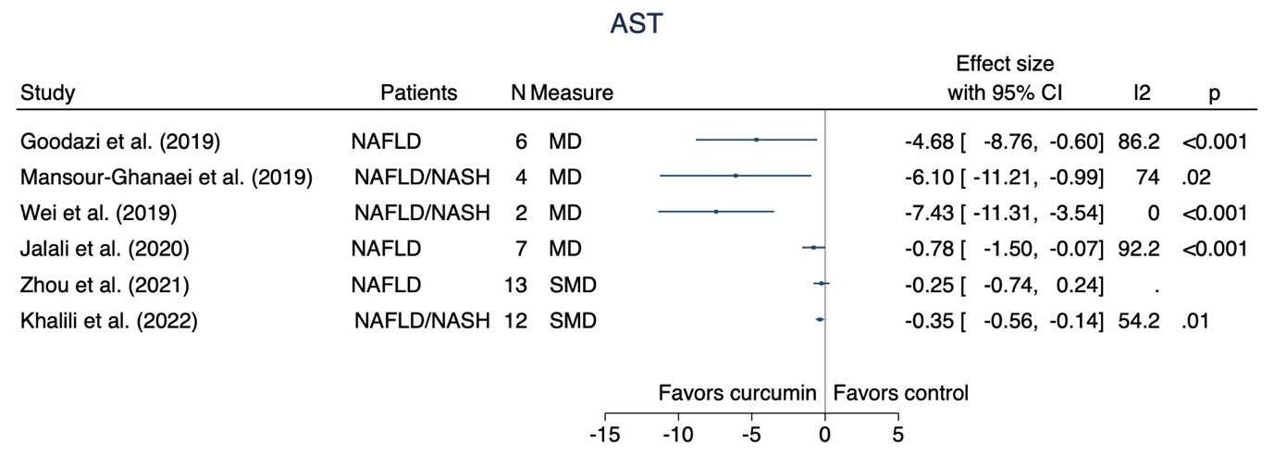

Appendix E. Forest plots of pooled effect sizes from included systematic review and meta-analyses: alanine aminotransferase
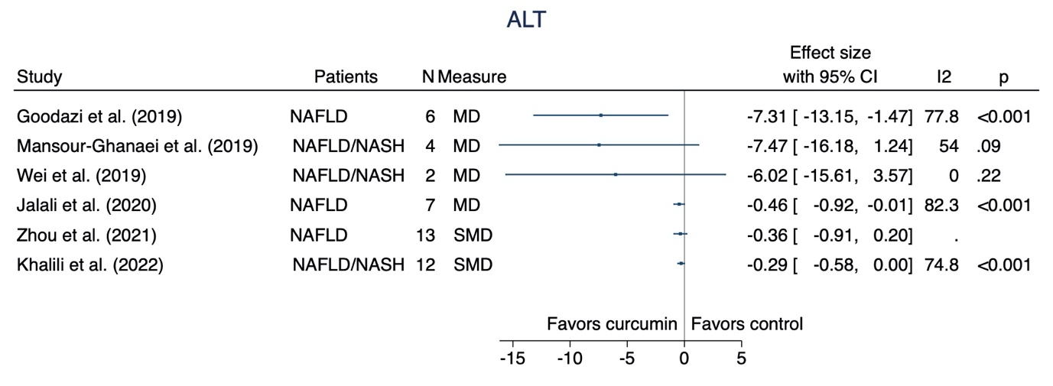

Appendix F. Risk of bias summary assessment for randomized-controlled trials included within the updated meta-analysis
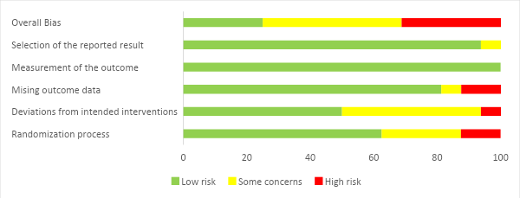

Appendix G. Risk of bias assessment for randomized-controlled trials included within the updated meta-analysis
Study | Randomization | Protocol deviation | Missing outcome | Outcome measurement | Reporting | Overall
Chirapongsathorn 2012 | S | H | L | L | S | H
Rahmani 2016 | S | S | L | L | L | S
Navekar 2017 | L | S | L | L | L | S
Panahi 2017 | L | S | S | L | L | S
Saadati 2018 | L | L | L | L | L | L
Chashmniam 2019 | S | L | L | L | L | S
Jazayeri-Tehrani 2019 | L | L | L | L | L | L
Mirhafez 2019a | H | L | L | L | L | H
Panahi 2019 | H | L | L | L | L | H
Saadati 2019a | L | L | L | L | L | L
Hariri 2020 | L | S | L | L | L | S
Moradi-Kelardeh 2020 | L | L | L | L | L | L
Saberi-Karimian 2020 | L | S | L | L | L | S
Jarhahzadeh 2021 | S | L | L | L | L | S
Mirhafez 2021a | L | S | H | L | L | H
Mirhafez 2021c | L | S | H | L | L | H
H = high; L = low; S = some concerns

Appendix H. Forest plots demonstrating the effects of curcumin on aspartate aminotransferase: bioavailability-enhanced form

Appendix I. Forest plots demonstrating the effects of curcumin on alanine aminotransferase: bioavailability-enhanced form

Appendix J. Forest plots of the effects of curcumin on alkaline phosphatase
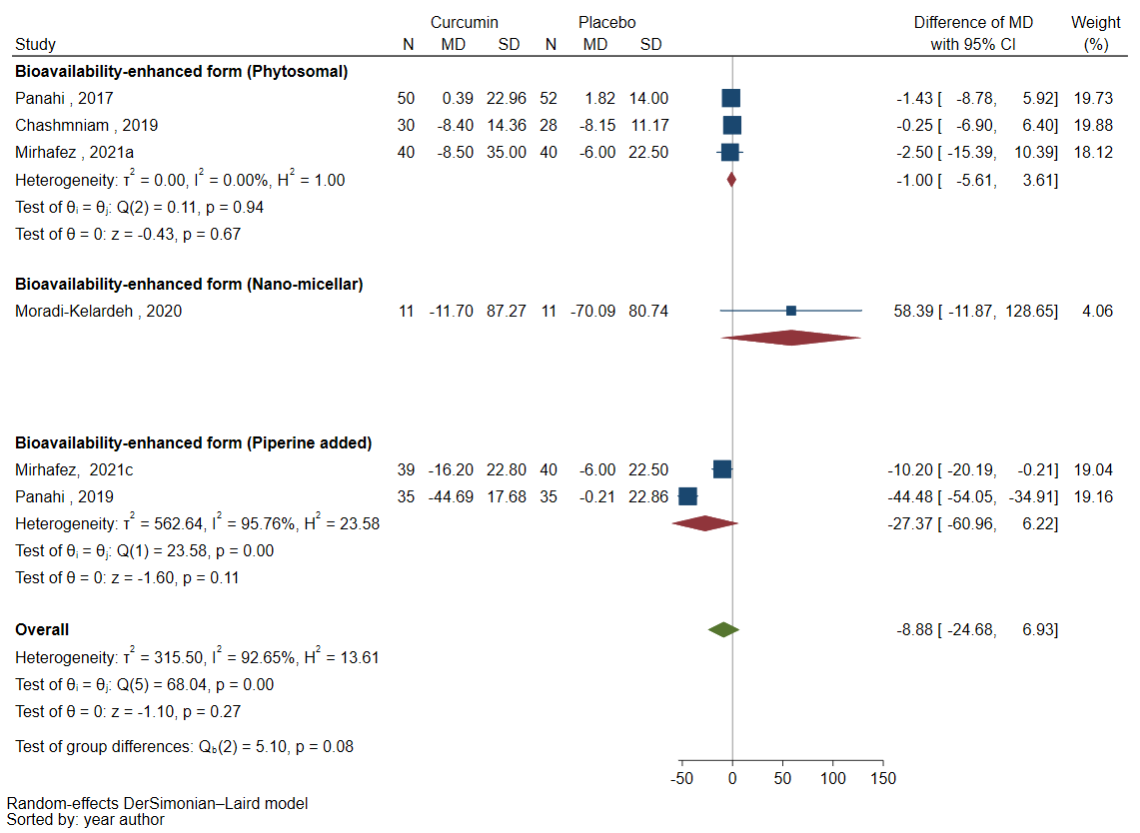

Appendix K. Forest plots of the effects of curcumin on gamma-glutamyl transpeptidase
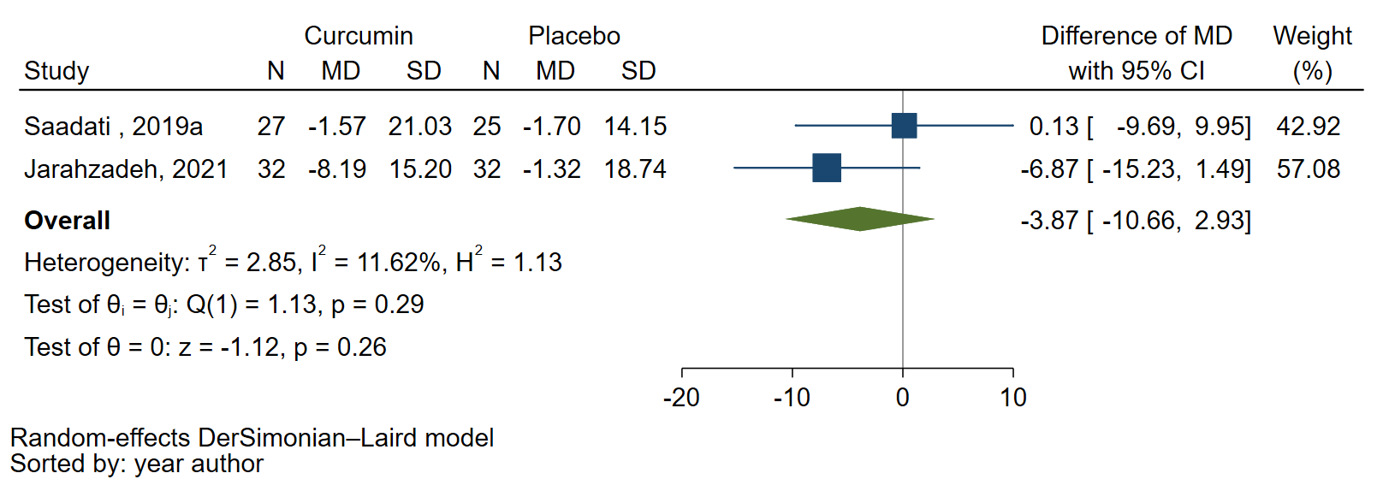

Appendix L. Forest plots demonstrating the effects of curcumin on the improvement of hepatic steatosis assessed by ultrasonography

Appendix M. Forest plots demonstrating the effects of curcumin on liver stiffness assessed by transient elastography

Appendix N. Forest plots demonstrating the effects of curcumin on platelet count

Appendix O. Forest plots demonstrating the effects of curcumin on reduction of fasting blood sugar after receiving curcumin supplementation
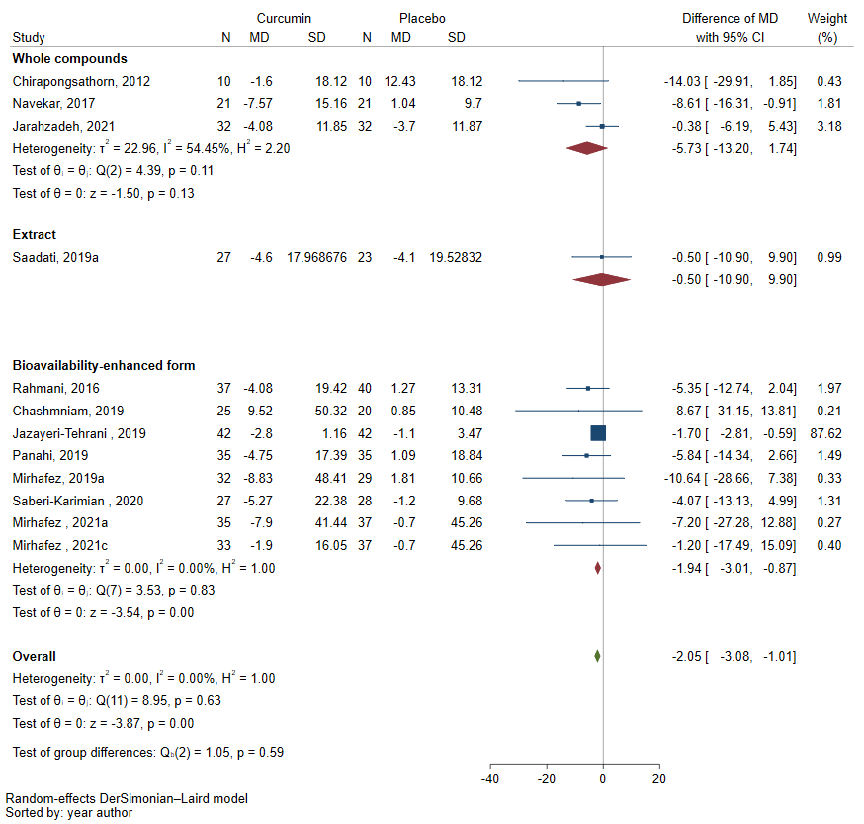

Appendix P. Forest plots demonstrating the effects of curcumin on reduction of HbA1c
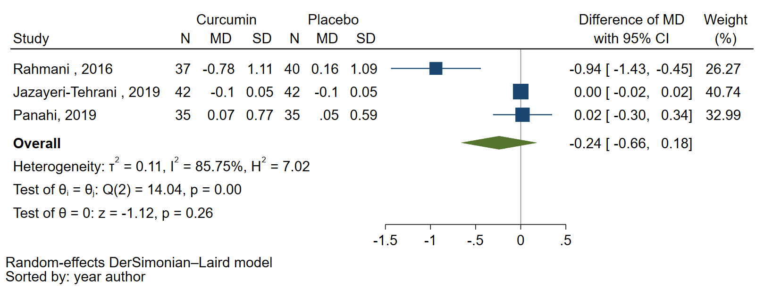

Appendix Q. Forest plots demonstrating the effects of curcumin on body mass index (BMI)

Appendix R. Forest plots demonstrating the effects of curcumin on total cholesterol (TC)

Appendix S. Forest plots demonstrating the effects of curcumin on LDL-C

Appendix T. Forest plots demonstrating the effects of curcumin on HDL-C

Appendix U. Forest plots demonstrating the effects of curcumin on triglycerides (TG)

Appendix V. Forest plots demonstrating the effects of curcumin on systolic blood pressure (SBP)

Appendix W. Forest plots demonstrating the effects of curcumin on diastolic blood pressure (DBP)

Appendix X. Sensitivity analysis by excluding studies with high risk of bias: aspartate aminotransferase
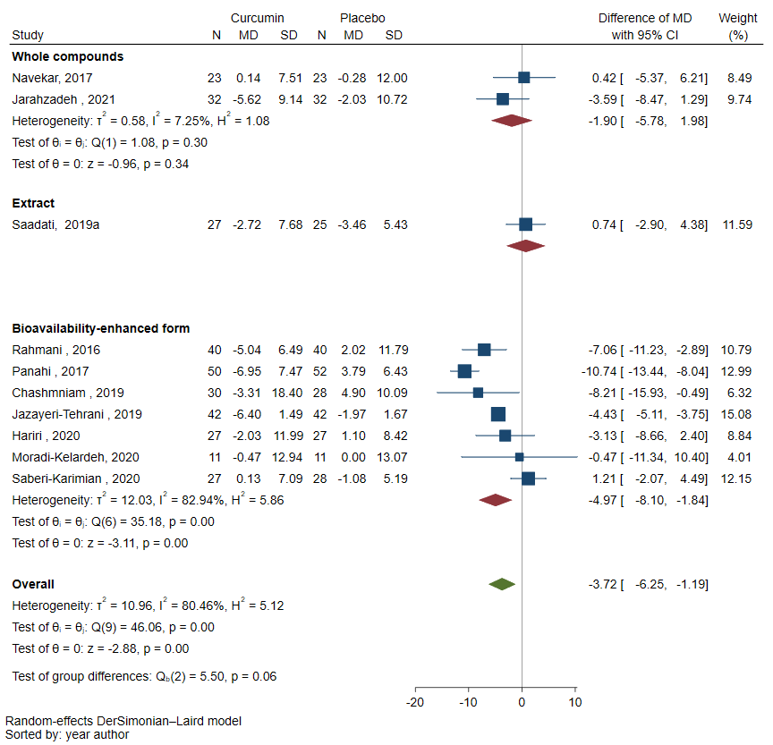

Appendix Y. Sensitivity analysis by excluding studies with high risk of bias: alanine aminotransferase
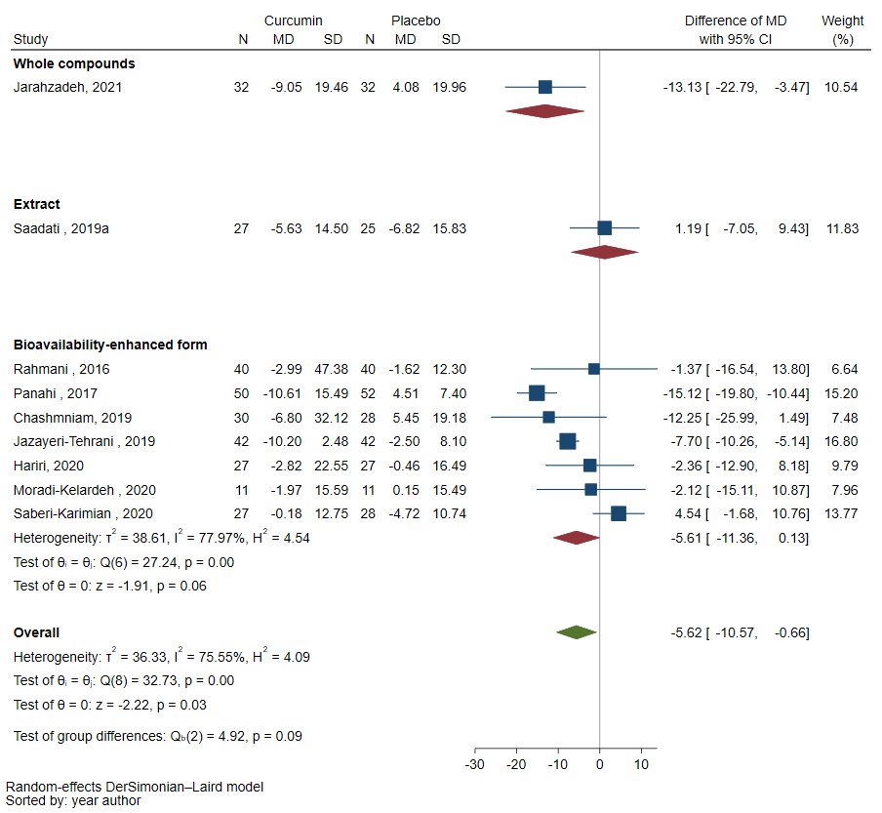

Appendix Z. Sensitivity analysis by excluding studies with high risk of bias: the resolution of hepatic steatosis
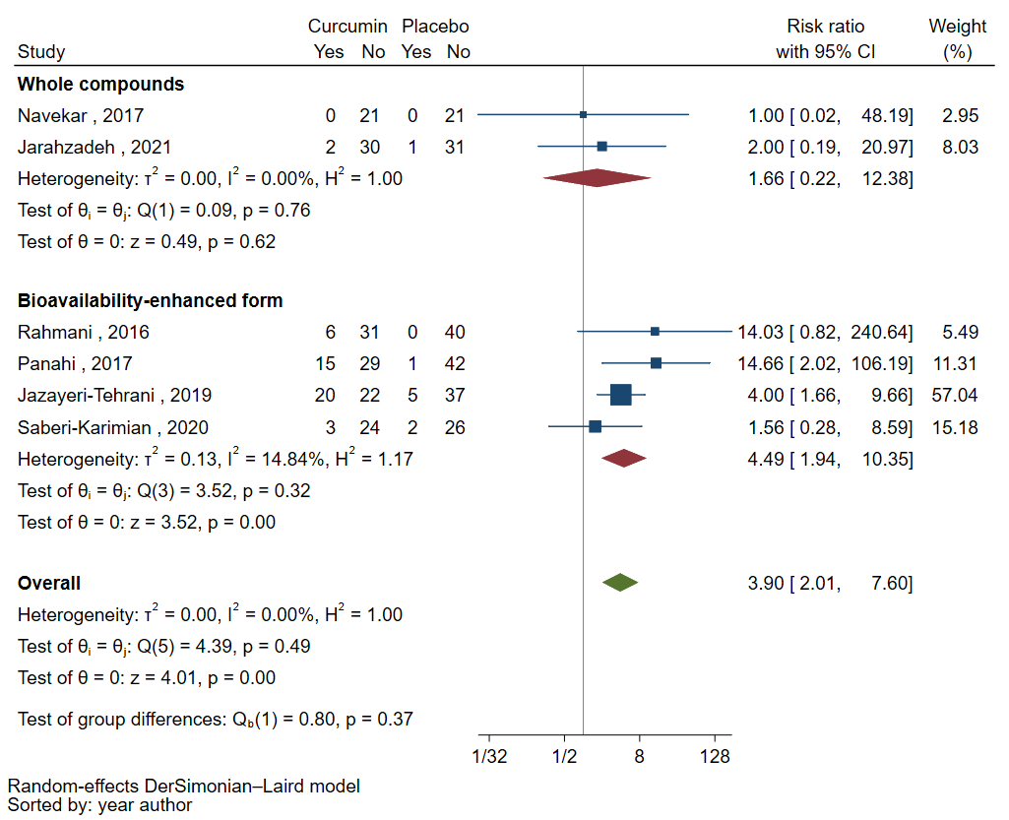

Appendix AA. Funnel plots of aspartate aminotransferase
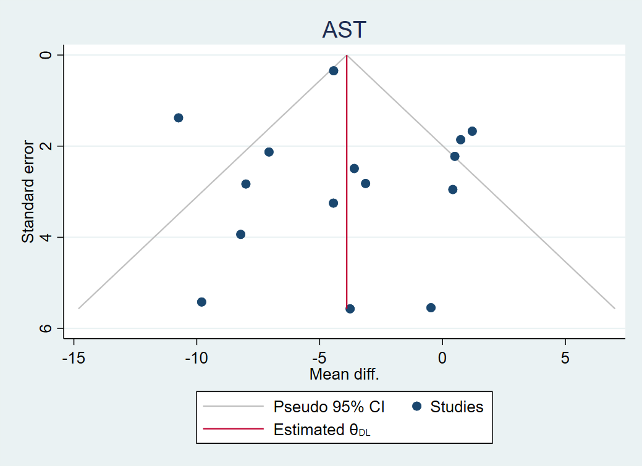

Appendix BB. Funnel plots of alanine aminotransferase
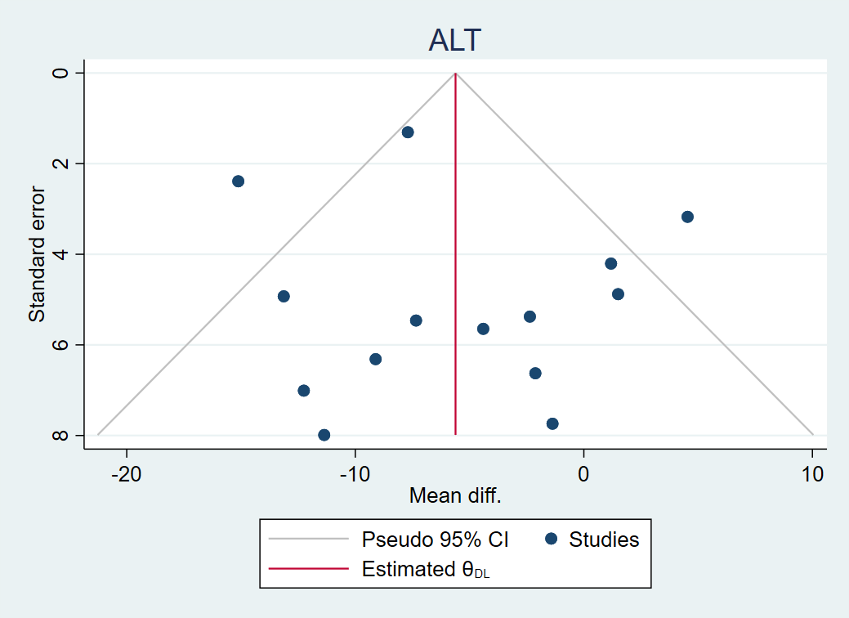

Appendix CC. Funnel plots of alkaline phosphatase
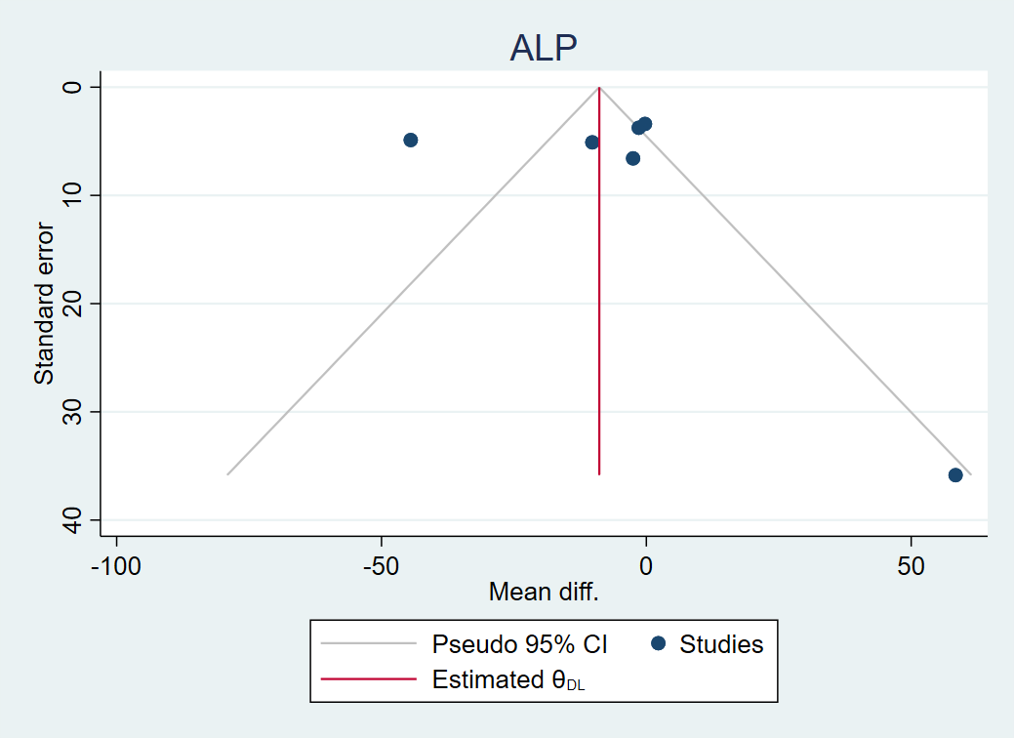

Appendix DD. Funnel plots of the resolution of hepatic steatosis
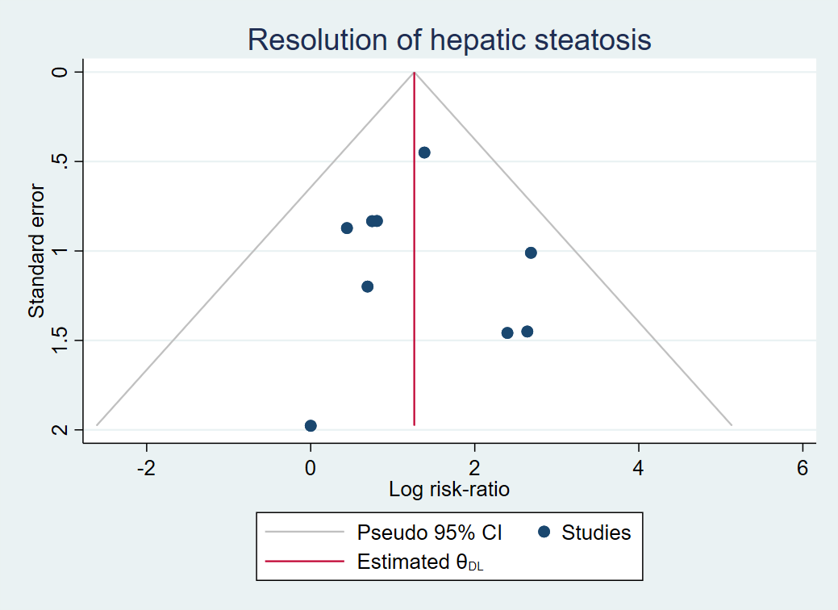

Appendix EE. Funnel plots of BMI

Appendix FF. Funnel plots of TC

Appendix GG. Funnel plots of TG

Appendix HH. Funnel plots of the improvement of hepatic steatosis
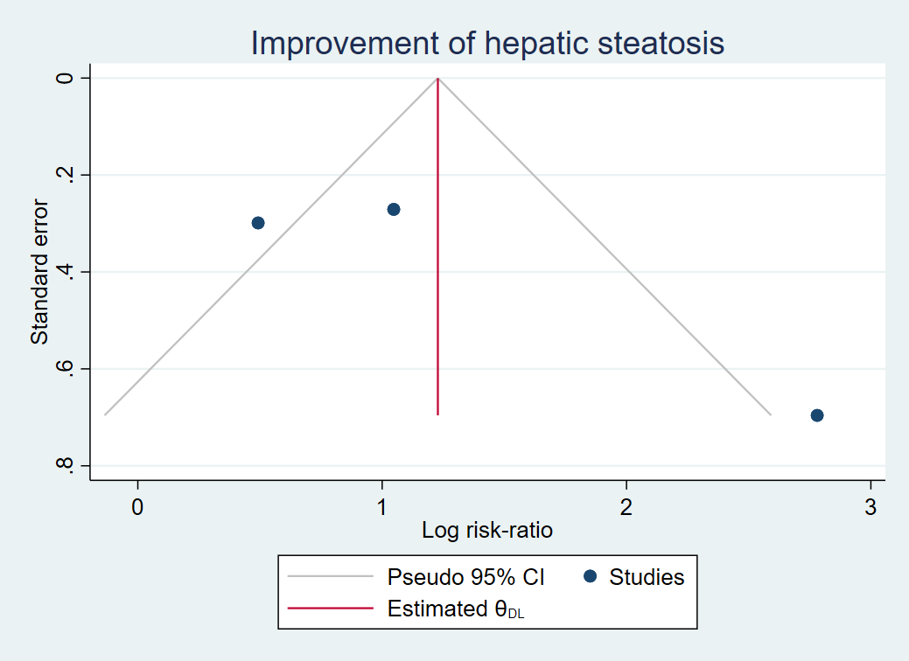

Appendix II. Contour-enhanced funnel plots of the improvement of hepatic steatosis
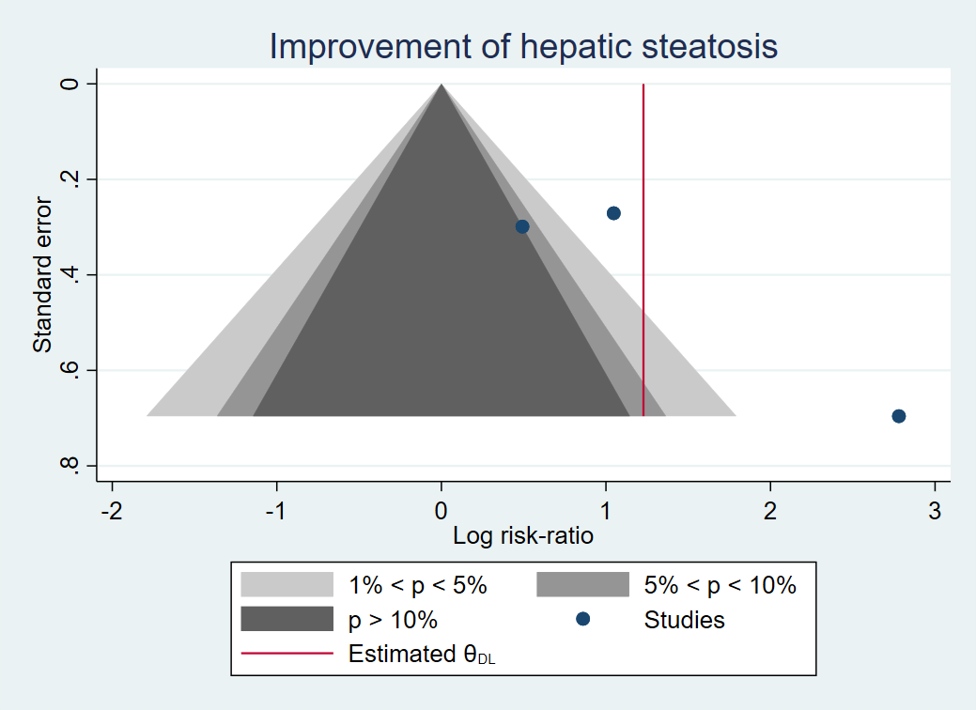

Appendix JJ. Funnel plots of fasting blood sugar
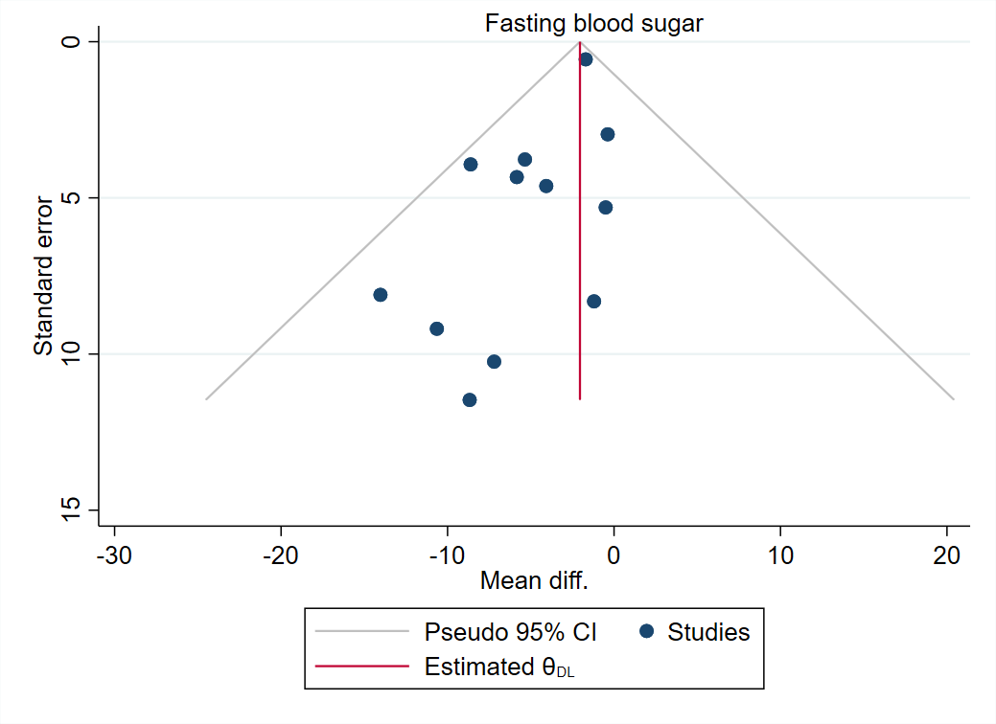

Appendix KK. Contour-enhanced funnel plots of fasting blood sugar
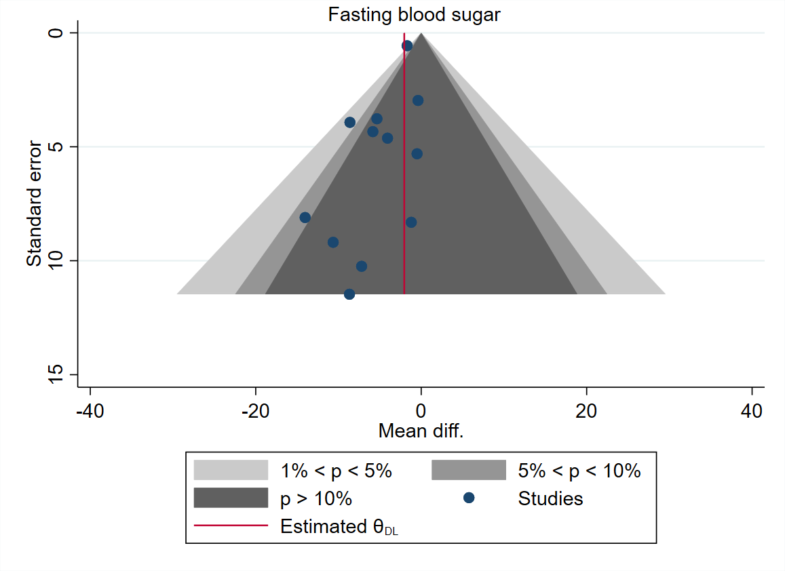

Appendix LL. Funnel plots of HbA1c
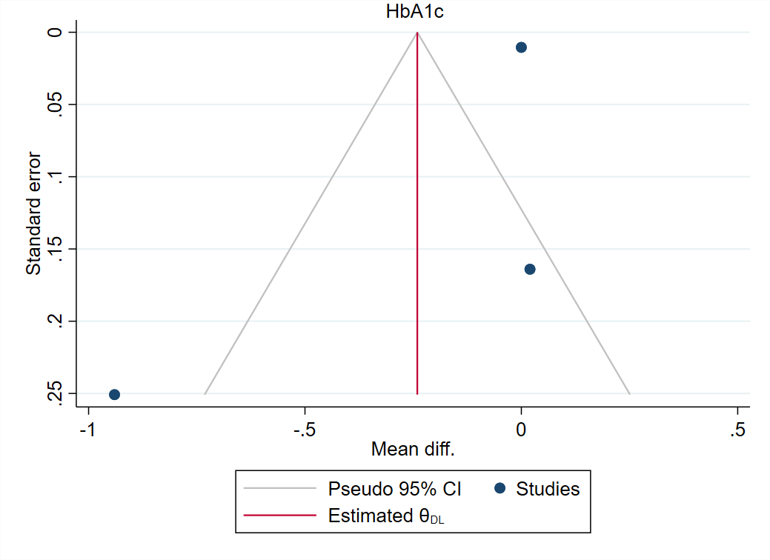

Appendix MM. Funnel plots of LDL-C

Appendix NN. Contour-enhanced funnel plots of LDL-C

Appendix OO. Funnel plots of HDL-C

Appendix PP. Contour-enhanced funnel plots of HDL-C

Appendix QQ. Funnel plots of SBP

Appendix RR. Contour-enhanced funnel plots of SBP

Appendix SS. Funnel plots of DBP

Appendix TT. Contour-enhanced funnel plots of DBP

