SUPPLEMENTARY MATERIAL

The role of presepsin in pediatric patients with oncological and hematological diseases experiencing febrile neutropenia

Sara Cerasi¹, Davide Leardini*¹, Nunzia Lisanti¹, Tamara Belotti¹, Luca Pierantoni², Daniele Zama², Marcello Lanari², Arcangelo Prete¹, Riccardo Masetti¹

¹ Pediatric Oncology and Hematology “Lalla Seràgnoli”, IRCCS Azienda Ospedaliero-Universitaria di Bologna, 40138 Bologna, Italy
² Pediatric Emergency Unit, IRCCS Azienda Ospedaliero-Universitaria di Bologna, 40138 Bologna, Italy

Correspondence:
Davide Leardini; Pediatric Oncology and Hematology “Lalla Seràgnoli”, IRCCS Azienda Ospedaliero-Universitaria di Bologna, Via Giuseppe Massarenti 11, 40138, Bologna, Italy; Tel: +39 051 214 4665; email: davide.leardini3@studio.unibo.it.
Leukocytes (/mmc)
Presepsin (pg/mL)
Leukocytes (/mmc)

 | P value | Spearman Rho
Presepsin T0 – leukocytes T0 | 0.796 | -.038 | 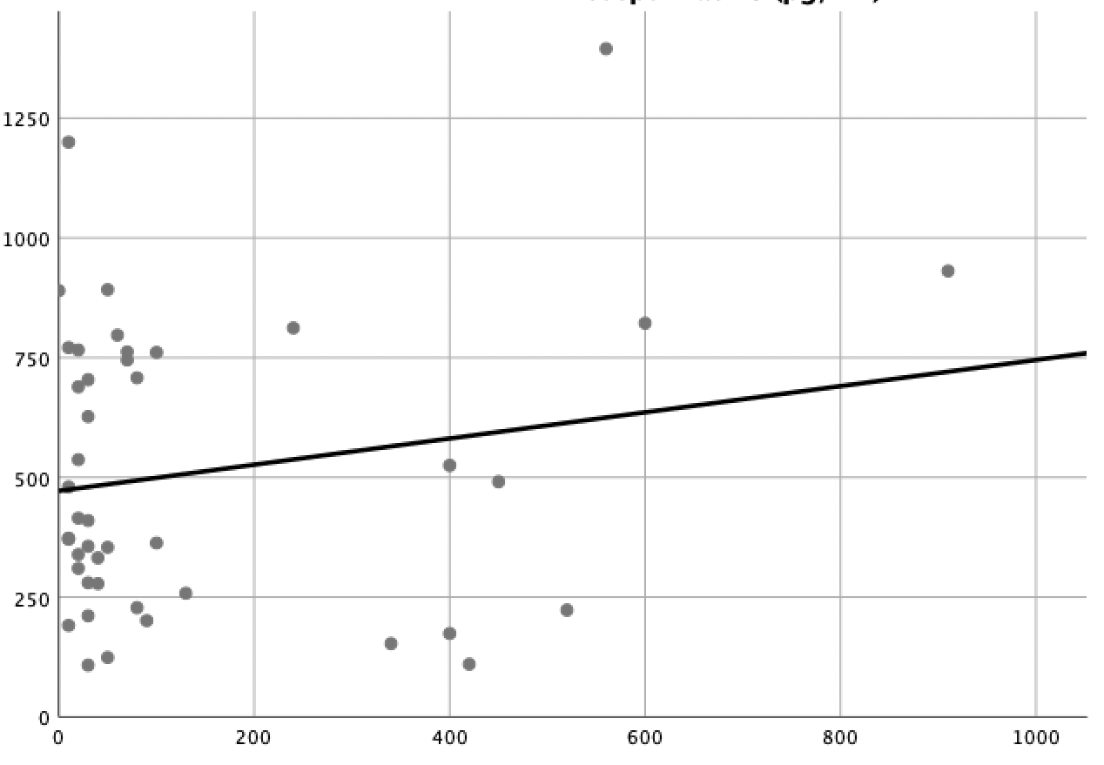  Leukocytes (/mmc)  Presepsin (pg/mL)
Presepsin T1 – leukocytes T1 | 0.446 | -.114 | 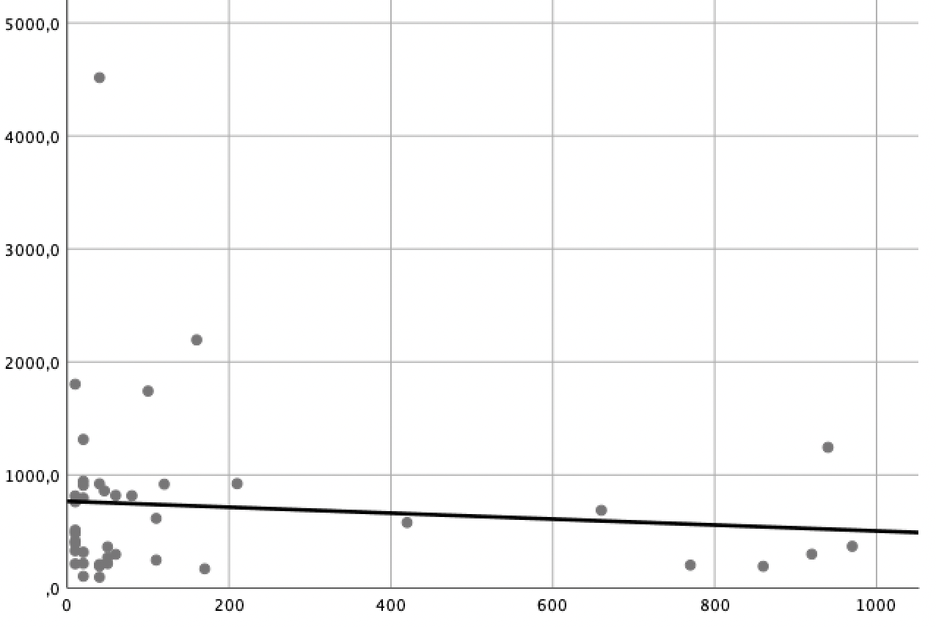  Leukocytes (/mmc)  Presepsin (pg/mL)
Presepsin in controls – leukocytes in controls | 0.216 | -.125 | 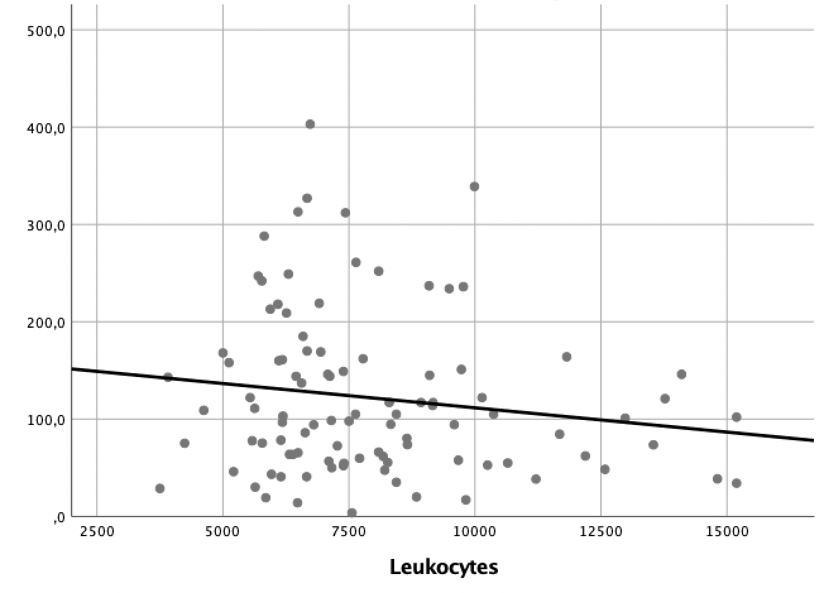  Leukocytes (/mmc)  Presepsin (pg/mL)

Supplementary Figure S1: Spearmann correlation between presepsin levels and leukocytes.

1 - Specificity
Sensitivity
Reference line
- AUC 0.508
- AUC 0.610
- AUC 0.793
- AUC 0.748

Supplementary Figure S2: ROC curves and AUC in predicting bacteremia at T0.

Sensitivity
1 - Specificity
Reference line
- AUC 0.423
- AUC 0.739
- AUC 0.782
- AUC 0.658

Supplementary Figure S3: ROC curves and AUC in predicting bacteremia at T1.

Reference line
- AUC 0.546
- AUC 0.663
- AUC 0.539
- AUC 0.795
Sensitivity
1 - Specificity

Supplementary Figure S4: ROC curves and AUC in predicting unfavorable outcome at T0.

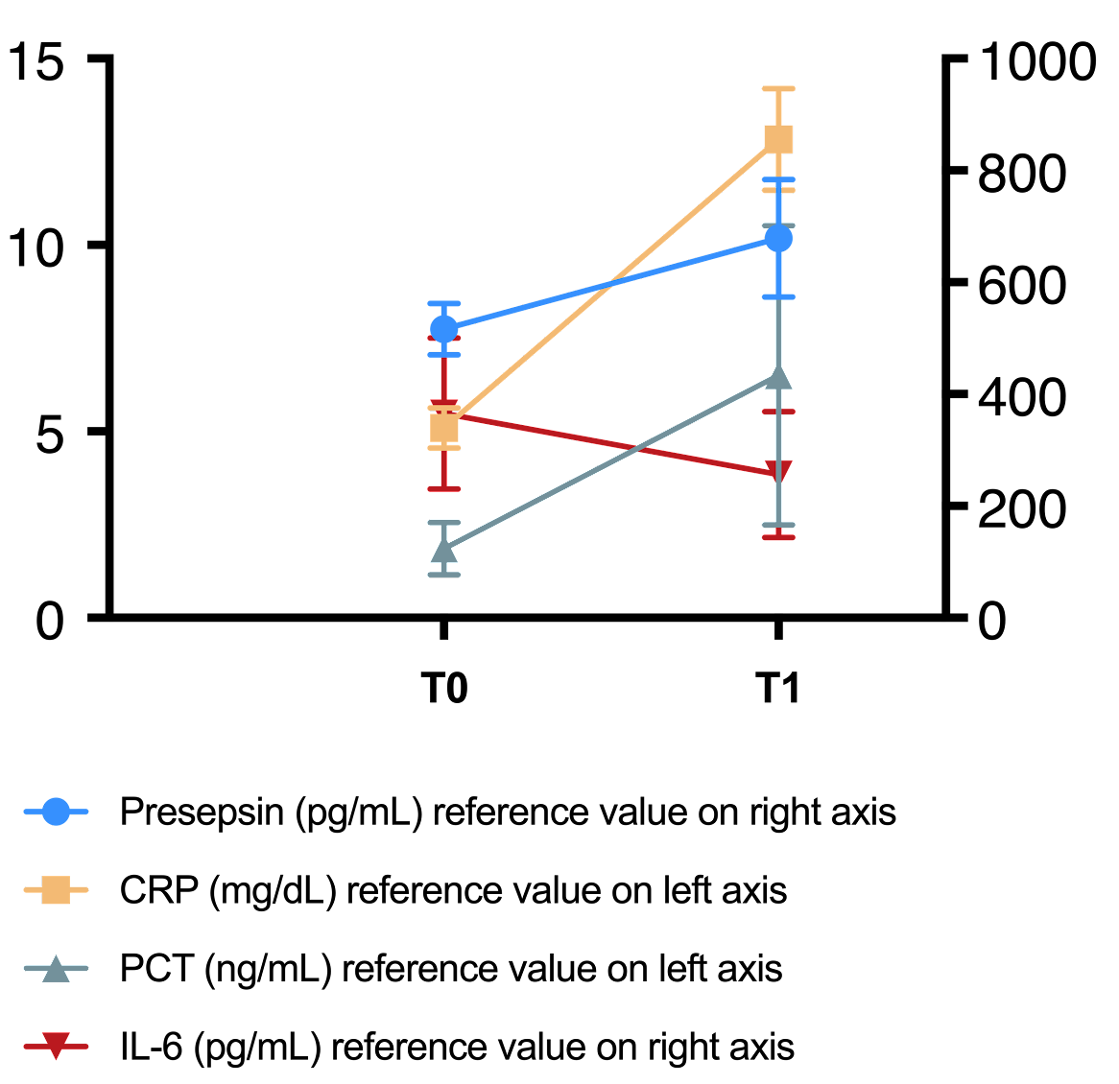

Supplementary Figure S5: Representation of the biomarkers’ trend.

 | HSCT (31 episodes) | Non HSCT (19 episodes) | P value
Presepsin (pg/mL)  Median  IQR  Range | 445  315.5-765  108-3560 | 415  197.5-739.5  110-1395 | 0.989
Supplementary Table S1: Comparison of presepsin values in the subgroup analysis comparing patients who underwent HSCT and patients who did not

Gram +
Streptococcus mitis | 1
Staphilococcus aureus + Micrococcus luteus | 1
Gram -
Escherichia coli | 3
Enterobacter cloacae | 1
Pseudomonas aeruginosa | 1
Pseudomonas aeruginosa + Klebsiella pneumoniae | 1
Klebsiella pneumoniae | 1
Supplementary Table S2: Bacterial species isolated from blood cultures

 | Bacteremia | Non-bacteremia | P value
Presepsin in HSCT patients (pg/mL)  Median  IQR  Range | n=7  373  291-645.5  191-1200 | n=24  480  315.5-757.8  108-3560 | 0.961
Presepsin in non-HSCT patients (pg/mL)  Median  IQR  Range | n=2  493  385.5-600.5  278-708 | n=17  415  194-761  110-1395 | 0.997
Supplementary Table S3: Comparison of presepsin values in the subgroup analysis comparing presepsin in the bacteremia and non bacteremia group in patients who underwent HSCT and patients who did not at T0.

 | Gram positive bacteremia (n=2) | Gram negative bacteremia (n=7) | P value
Presepsin at T0 (pg/mL)  Median  IQR  Range | 358  274.5-441.5  191-525 | 373  324.5-737  211-1200 | 0.485
Presepsin at T1 (pg/mL)  Median  IQR  Range | 99.3  97.3-101.1  95.5-103 | 944  283-1882.3  169-4516 | 0.206
Supplementary Table S4: Comparison of presepsin values in the subgroup analysis comparing presepsin in the Gram positive and Gram negative bacteremia at T0 and at T1.

T0 | Bacteremia (n=9) | Non bacteremia (n=41) | P value
Presepsin (pg/mL)  Median  IQR  Range | 373  278-708  191-1200 | 415  243-761.5  108-1395 | 0.989
CRP (mg/L)  Median  IQR  Range | 5.83  2.95-10.67  1.16-12.37 | 4.25  1.65-6.36  0.3-14.03 | 0.261
PCT (ng/mL)  Median  IQR  Range | 2.2  0.6-7.6  0.2-30.8 | 0.2  0.15-0.6  0.1-8.5 | 0.005
IL6 (pg/mL)  Median  IQR  Range | 165.6  130.5-1172.4  77.7-4794 | 84.2  54.9-202.9  12.5-812.1 | 0.022
Supplementary Table S5: Values of biomarkers according to the cause of FN at T0.

T0 | Sensitivity (95% CI) | Specificity (95% CI) | PPV | NPV | LR+ | LR- | DOR
Presepsin (≥410 pg/mL) | 0.53  (0.37-0.69) | 0.55  (0.21-0.86) | 0.84 | 0.22 | 1.21 | 0.83 | 1.45
CRP (≥4.86 mg/dL) | 0.67  (0.29-0.92) | 0.56  (0.39-0.72) | 0.25 | 0.88 | 1.52 | 0.59 | 2.55
PCT (≥0.60 ng/mL) | 0.78  (0.39-0.97) | 0.71  (0.55-0.85) | 0.39 | 0.93 | 2.76 | 0.31 | 8.91
IL6 (≥130.50 pg/mL) | 0.78  (0.39-0.97) | 0.64  (0.47-0.79) | 0.33 | 0.93 | 2.17 | 0.35 | 6.25
Supplementary Table S6: Sensitivity. specificity. positive predictive value (PPV), negative predictive value (NPV), positive likelihood ratio (LR+), negative likelihood ratio (LR-), diagnostic odds ratio in predicting bacteremia at T0.
T1 | Bacteremia (n=9) | Non bacteremia (n=41) | P value
Presepsin (pg/mL)  Median  IQR  Range | 359  152.5-1256.8  95.5-4516 | 446  289.8-816.8  181-1803 | 0.619
CRP (mg/L)  Median  IQR  Range | 17.7  11.2-27.5  1.6-38.17 | 10.56  4.4-16.5  0.75-31.48 | 0.089
PCT (ng/mL)  Median  IQR  Range | 4.6  1.9-10.3  0.3-178.3 | 0.4  0.2-1.4  0.1-36.2 | 0.008
IL6 (pg/mL)  Median  IQR  Range | 77  27.7-366.4  2.4-4875 | 53.1  27.6-114.4  2.2-1039.8 | 0.574
Supplementary Table S7: Values of biomarkers according to the cause of FN at T1.

T1 | Sensitivity (95% CI) | Specificity (95% CI) | PPV | NPV | LR+ | LR- | DOR
Presepsin (≥213 pg/mL) | 0.90  (0.76-0.97) | 0.50  (0.16-0.84) | 0.90 | 0.50 | 1.80 | 0.20 | 9.00
CRP (≥12.01 mg/dL) | 0.75  (0.35-0.97) | 0.62  (0.45-0.77) | 0.285 | 0.923 | 1.95 | 0.41 | 4.80
PCT (≥3.30 ng/mL) | 0.72  (0.29-0.96) | 0.92  (0.79-0.98) | 0.63 | 0.95 | 9.05 | 0.31 | 29.17
IL6 (≥293.6 pg/mL) | 0.43  (0.09-0.82) | 0.89  (0.75-0.97) | 0.43 | 0.89 | 3.96 | 0.64 | 6.19
Supplementary Table S8: Sensitivity, specificity, positive predictive value (PPV), negative predictive value (NPV), positive likelihood ratio (LR+), negative likelihood ratio (LR-), diagnostic odds ratio in predicting bacteremia at T1.

T0 | Unfavorable outcome (n=5) | Favorable outcome (n=45) | P value
Presepsin (pg/mL)  Median  IQR  Range | 373  371-766  110-1200 | 415  256.1-753  108-1395 | 0.774
CRP (mg/L)  Median  IQR  Range | 7.5  4.9-10.7  1.4-12.1 | 4.25  1.65-6.36  0.3-14 | 0.201
PCT (ng/mL)  Median  IQR  Range | 0.2  0.2-7.6  0.1-30.8 | 0.3  0.2-0.7  0.1-11.2 | 0.758
IL6 (pg/mL)  Median  IQR  Range | 205.2  130.5-4584  130-4794 | 87.3  56-202.9  12.5-1172.4 | 0.032
Supplementary Table S9: Values of biomarkers according to the outcome of FN at T0.

T0 | Sensitivity (95% CI) | Specificity (95% CI) | PPV | NPV | LR+ | LR- | DOR
Presepsin (≥371 pg/mL) | 0.80  (0.28-0.99) | 0.47  (0.31-0.62) | 0.15 | 0.95 | 1.49 | 0.43 | 3.47
CRP (≥7.52 mg/dL) | 0.60  (0.16-0.95) | 0.82  (0.68-0.92) | 0.28 | 0.95 | 3.38 | 0.49 | 6.94
PCT (≥7.60 ng/mL) | 0.40  (0.05-0.85) | 0.95  (0.84-0.99) | 0.50 | 0.93 | 8.6 | 0.63 | 13.67
IL6 (≥130 pg/mL) | 1  (0.47-1) | 0.60  (0.44-0.75) | 0.23 | 1 | 2.53 | 0.00
Supplementary Table S10: Sensitivity, specificity, positive predictive value (PPV), negative predictive value (NPV), positive likelihood ratio (LR+), negative likelihood ratio (LR-), diagnostic odds ratio in predicting unfavorable outcome at T0.

