Mapping Tropical Forest Above-ground Biomass using Airborne SAR Tomography
Naveen Ramachandran^{1, *}, Sassan Saatchi², Stefano Tebaldini³, Mauro Mariotti d’Alessandro³, and Onkar Dikshit¹
¹ Department of Civil Engineering, Indian Institute of Technology Kanpur, Kanpur 208016, India
² National Aeronautics and Space Administration (NASA), Jet Propulsion Laboratory (JPL), California Institute of Technology, Pasadena, CA 91125, USA
³ Dipartimento di Elettronica, Informazione e Bioingegneria, Politecnico di Milano, 20133 Milan, Italy.
* naveenr342@gmail.com

Supplementary material

Supplementary Method

Supplementary Method S1. The TomoSAR reflectivity profiles are reconstructed for the BP, Capon, and MUSIC estimators as
$$P_{BP}\left(x,r, v\right)=\frac{1}{K}{\left|\sum_{k=1}^{K}{〈{S_{k}\left(x,r\right)e}^{\left(-j{K_{z}}_{k}v\right)}〉}\right|}^{2}$$  $$P_{CB}\left(x,r, v\right)= \frac{1}{a^{H}\left(v\right).{\hat{R}}^{-1}.a(v)}$$  $$P_{MU}\left(x,r,v\right)= \frac{1}{a^{H}\left(v\right).W_{n}.W_{n}^{H}.a(v)}$$ | (1)
Here,$P_{BP}, P_{CB}$are the average scene complex reflectivity and $P_{MU}$is the average scene complex pseudo-reflectivity within the azimuth-slant range resolution at height layer $z$from the ground level using estimator $m$ ($m$ can be BP or CB or MUSIC). $〈∙〉$ is the averaging performed in the range-azimuth direction. $S_{k}\left(x,r\right)$denotes the complex-valued pixel located at azimuth, slant range position $\left(x,r\right)$ from the k^{th} sensor,$v$ is the cross-range coordinate perpendicular to the platform motion and direction of the radar signal. Further, $\hat{R }$is the estimated covariance matrix, and $a(z)$ denotes the steering vector given by equations (2b) and (3) and${ W}_{n}$ represents the eigenvectors of the noise subspace.
$$S_{MB}={\left[\begin{matrix}S_{1}\left(x,r\right) & S_{2}\left(x,r\right) & \begin{matrix}… & S_{K}\left(x,r\right)\end{matrix}\end{matrix} \right]}^{T}$$ | (2a)
$${〈\hat{R}〉}_{K×K}= 〈S_{MB}S_{MB}^{H}〉$$ | (2b)
$$a\left(z\right)={\left[\begin{matrix}1, & exp⁡(jK_{z_{2}}z), & \begin{matrix}exp⁡jK_{z_{3}}z), & …, & exp⁡(jK_{z_{K}}z)\end{matrix}\end{matrix}\right]}^{T}$$ | (3)
Here, $K_{z}$ represents the vertical wave number and can be related to the Height of Ambiguity (HoA) between the interferometric pairs.
$$K_{z}=\frac{2π}{HoA}=\frac{4π}{λr_{0}}b_{n}$$ | (4)
The geometrical resolution ($Δv$) in the cross-range can be expressed as in [1] and TomoSAR grids are sampled at 1 m. The resolution in the vertical direction can be expressed by the exploitation of a simple geometrical relation $z=v.\sin{θ}$, where $θ$ is the elevation angle.
$$Δv≈\frac{λr_{0}}{2.L_{tomo}}≈\frac{2π}{Max\left(K_{z}\right)-Min(K_{z})}\sin{θ}$$ | (5)
Supplementary Method S2. The forest tree height is estimated from the TomoSAR reflectivity cube. This approach's key idea is to investigate the shape formed by the vertical distribution of reflectivity ($P_{m}$ (z, g, r)) for each azimuth-ground range index at height layer $z$from the ground level using estimator $m$ ($m$ can be BP or CB or MUSIC). Here, we assume that the shape of the reflectivity function along the vertical may be divided into three zones: backscattering from the canopy layer, especially the phase center ($H_{c}$), power loss region (K), and noise region. The height is retrieved by varying the power loss value from the phase center located along the upper envelope in the vertical direction. This is given by
$$FTH\left(x,g\right)=argmin\left\{\left|P_{m}\left(z^{'},x,g\right)-P_{m}\left(H_{c},x,g\right)-K\right|\right\}$$ | (6)
Here, $P_{m}\left(H_{c},x,g\right)$ is the backscattered power at $H_{c}$, $P_{m}\left(z^{'},x,g\right)$is the backscattered power at a different elevation ranging from $H_{c}$ to the upper part of the profile, x stands for BP, Capon (CB), or MUSIC (MU) estimators. The effective phase center is therefore estimated as:
$$H_{c}\left(x,g\right)=argmax\left\{P_{m}(z,x,g)\right\}$$ | (7)

Supplementary Tables

Table S1: The ground AGB stats using all 0.25-ha plots, selected 0.25-ha plots for 4-ha plot generation, and 4-ha plots
 | All 0.25 ha plots |  | Selected 0.25 ha plots |  | Aggregated 4-ha plots
 | AGB (Mg ha⁻¹) | Height (m) | AGB (Mg ha⁻¹) | Height (m) | AGB (Mg ha⁻¹) | Height (m)
Min | 169.0 | 19.25 | 169.0 | 20.25 | 246.57 | 23.00
Max | 618.0 | 36.83 | 618.0 | 36.83 | 385.66 | 31.34
Mean | 338.45 | 26.90 | 340.26 | 27.29 | 340.26 | 27.29
Standard Deviation | 71.08 | 3.20 | 71.08 | 3.22 | 44.64 | 2.57

Table S2: The Pearson correlation coefficients between reflectivity and field AGB at different heights using BP, Capon, and MUSIC estimators at 4-ha resolution.
Method | Pol. | Height
Method | Pol. | 0 | 5 | 10 | 15 | 20 | 25 | 30 | 35 | 40 | 45 | 50
BP | HH | -0.21 | -0.28 | -0.39 | -0.19 | 0.30 | 0.76 | 0.87 | 0.77 | 0.41 | 0.01 | -0.19
BP | HV | -0.52 | -0.58 | -0.52 | -0.19 | 0.48 | 0.86 | 0.92 | 0.89 | 0.67 | 0.16 | -0.16
BP | VV | -0.21 | -0.37 | -0.52 | -0.38 | 0.05 | 0.63 | 0.85 | 0.83 | 0.67 | 0.24 | -0.10
Capon | HH | -0.14 | -0.34 | -0.42 | -0.25 | 0.12 | 0.59 | 0.75 | 0.65 | 0.45 | 0.18 | -0.01
Capon | HV | -0.50 | -0.52 | -0.46 | -0.18 | 0.31 | 0.76 | 0.85 | 0.79 | 0.64 | 0.39 | 0.16
Capon | VV | -0.16 | -0.36 | -0.46 | -0.27 | 0.18 | 0.65 | 0.80 | 0.78 | 0.62 | 0.35 | 0.10
MUSIC | HH | -0.12 | -0.44 | -0.61 | -0.44 | 0.01 | 0.63 | 0.79 | 0.61 | 0.31 | 0.03 | -0.09
MUSIC | HV | -0.68 | -0.54 | -0.52 | -0.38 | 0.09 | 0.67 | 0.78 | 0.76 | 0.51 | 0.08 | -0.08
MUSIC | VV | -0.22 | -0.50 | -0.46 | -0.37 | 0.00 | 0.63 | 0.80 | 0.75 | 0.45 | 0.08 | -0.07

Table S3: The Pearson correlation coefficients between the backscattered power at the 30 m layer with different TomoSAR compensation and filed AGB for HV polarization at 4-ha resolution. Here UC and RC stand for uncorrected and radiometric corrected. TGS and TGV stand for slope and volumetric correction. Refer to [2] for a detailed explanation of RC, TGS, and TGV corrections.
 | BP | Capon |  | MUSIC
 |  | UC | RC | UC | RC
UC | 0.77 | 0.82 | 0.78 | 0.72 | 0.79
TGS | 0.92 | 0.78 | 0.85 | 0.69 | 0.78
TGV | 0.90 | - | - | - | -

Table S4:Accuracy analysis of the backscattered power at the 30 m layer-based AGB Models. Here P represents the backscattered power at the 30 m layer layer
Model | Polarimetric based models | BP |  | Capon |  | MUSIC
Model | Polarimetric based models | RMSE | r² | RMSE | r² | RMSE | r²
P1 | $$y=a_{0}+a_{1}P_{HH}$$ | 21.96 | 0.75 | 29.47 | 0.56 | 27.36 | 0.62
P2 | $$y=a_{0}+a_{1}P_{HV}$$ | 17.07 | 0.85 | 23.32 | 0.72 | 27.41 | 0.62
P3 | $$y=a_{0}+a_{1}P_{VV}$$ | 23.24 | 0.73 | 26.57 | 0.64 | 26.50 | 0.64
P4 | $$y=a_{0}+a_{1}P_{HH}+a_{2}P_{HH}^{2}$$ | 23.19 | 0.75 | 29.25 | 0.57 | 24.95 | 0.68
P5 | $$y=a_{0}+a_{1}P_{HV}+a_{2}P_{HV}^{2}$$ | 16.60 | 0.86 | 21.93 | 0.76 | 25.67 | 0.67
P6 | $$y=a_{0}+a_{1}P_{VV}+a_{2}P_{VV}^{2}$$ | 23.75 | 0.73 | 24.79 | 0.69 | 25.90 | 0.67
P7 | $$y=a_{0∙}\exp{(a_{1}P_{HH})}$$ | 40.42 | 0.70 | 35.94 | 0.39 | 35.00 | 0.37
P8 | $$y=a_{0∙}\exp{(a_{1}P_{HV})}$$ | 42.20 | 0.81 | 41.96 | 0.52 | 35.20 | 0.37
P9 | $$y=a_{0∙}\exp{(a_{1}P_{VV})}$$ | 39.34 | 0.66 | 35.15 | 0.37 | 35.22 | 0.39
P10 | $$y=a_{0}P_{HH}^{a_{1}}$$ | 23.91 | 0.74 | 34.04 | 0.54 | 28.09 | 0.60
P11 | $$y=a_{0}P_{HV}^{a_{1}}$$ | 23.19 | 0.84 | 24.35 | 0.70 | 28.10 | 0.60
P12 | $$y=a_{0}P_{VV}^{a_{1}}$$ | 24.21 | 0.70 | 27.77 | 0.61 | 27.21 | 0.62
P13 | $$y=a_{0}/{(a}_{1}+exp⁡(-a_{2}P_{HH}))$$ | 27.43 | 0.63 | 37.94 | 0.36 | 24.67 | 0.69
P14 | $$y=a_{0}/{(a}_{1}+exp⁡(-a_{2}P_{HV}))$$ | 22.11 | 0.75 | 24.09 | 0.45 | 32.49 | 0.46
P15 | $$y=a_{0}/{(a}_{1}+exp⁡(-a_{2}P_{VV}))$$ | 28.69 | 0.59 | 39.60 | 0.36 | 23.60 | 0.72
Table S5: The backscattered power at the 30 m layer-based AGB Models based on the combination of linear polarization. Here P represents the backscattered power at the 30 m layer layer
Model | Polarimetric based models | BP |  | Capon |  | MUSIC
Model | Polarimetric based models | RMSE | r² | RMSE | r² | RMSE | r²
P16 | $$y=a_{0}+{a_{1}P_{HV}+a}_{2}P_{VV}$$ | 16.50 | 0.87 | 23.23 | 0.73 | 26.63 | 0.64
P17 | $$y=a_{0}+{a_{1}P_{HV}+a}_{2}P_{HH}$$ | 16.63 | 0. 86 | 19.60 | 0.81 | 26.88 | 0.63
P18 | $$y=a_{0}+{a_{1}P_{HH}+a}_{2}P_{VV}$$ | 22.29 | 0.75 | 26.10 | 0.66 | 30.18 | 0.65
P19 | $$y=a_{0}+{a_{1}P_{HV}+a_{2}P_{HV}^{2}+a}_{3}P_{VV}+a_{4}P_{VV}^{2}$$ | 16.14 | 0.87 | 22.84 | 0.75 | 26.40 | 0.66
P20 | $$y=a_{0}+{a_{1}P_{HV}+a_{2}P_{HV}^{2}+a}_{3}P_{HH}+a_{4}P_{HH}^{2}$$ | 16.86 | 0.86 | 16.66 | 0.86 | 25.35 | 0.68
P21 | $$y=a_{0}+{a_{1}P_{HH}+a_{2}P_{HH}^{2}+a}_{3}P_{VV}+a_{4}P_{VV}^{2}$$ | 20.96 | 0.78 | 22.14 | 0.76 | 25.50 | 0.68
P22 | $$y=a_{0}+{a_{1}P_{HH}+a}_{2}P_{HV}+a_{3}P_{VV}$$ | 16.27 | 0.86 | 19.69 | 0.81 | 26.64 | 0.64
P23 | $$y=a_{0}+{a_{1}P_{HH}+a_{2}P_{HH}^{2}+a}_{3}P_{HV}+a_{4}P_{HV}^{2}+a_{5}P_{VV}+a_{6}P_{VV}^{2}$$ | 16.27 | 0.86 | 19.69 | 0.82 | 26.64 | 0.64
P24 | $$y=a_{0}+{a_{1}P_{HV}+a}_{2}{(P}_{HH}-P_{VV})$$ | 17.25 | 0.85 | 21.75 | 0.76 | 27.82 | 0.60
Table S6:The backscattered power at the 30 m layer-based AGB is based on the combination of linear and non-linear polarizations. Here P represents the backscattered power at the 30 m layer layer
Model | Polarimetric based models | BP |  | Capon |  | MUSIC
Model | Polarimetric based models | RMSE | r² | RMSE | r² | RMSE | r²
P25 | $$y=a_{0}+{a_{1}P_{HH}+a}_{2}P_{HV}+a_{3}P_{PiH}$$ | 14.31 | 0.90 | 19.74 | 0.80 | 26.91 | 0.63
P26 | $$y=a_{0}+{a_{1}P_{VV}+a}_{2}P_{HV}+a_{3}P_{PiV}$$ | 16.85 | 0.86 | 20.66 | 0.79 | 26.60 | 0.64
P27 | $$y=a_{0}+{a_{1}P_{HH}+a}_{2}P_{HV}+a_{3}P_{RH}$$ | 15.51 | 0.88 | 19.11 | 0.81 | 26.98 | 0.63
P28 | $$y=a_{0}+{a_{1}P_{VV}+a}_{2}P_{HV}+a_{3}P_{RV}$$ | 15.48 | 0.88 | 23.66 | 0.72 | 24.48 | 0.69
P29 | $$y=a_{0}+{a_{1}P_{HH}+a}_{2}P_{VV}+a_{3}P_{RL}$$ | 22.63 | 0.75 | 24.48 | 0.70 | 24.84 | 0.69
P30 | $$y=a_{0}{{+a}_{1}P_{HH}+a_{2}P_{HH}^{2}+a}_{3}P_{HV}+a_{4}P_{HV}^{2}+a_{5}P_{PiH}+a_{6}P_{PiH}^{2}$$ | 14.73 | 0.89 | 19.74 | 0.80 | 26.91 | 0.63
P31 | $$y=a_{0}+{a_{1}P_{VV}+a_{2}P_{VV}^{2}+a}_{3}P_{HV}+a_{4}P_{HV}^{2}+a_{5}P_{PiV}+a_{6}P_{PiV}^{2}$$ | 15.62 | 0.88 | 20.66 | 0.79 | 26.60 | 0.64
P32 | $$y=a_{0}{{+a}_{1}P_{HH}+a_{2}P_{HH}^{2}+a}_{3}P_{HV}+a_{4}P_{HV}^{2}+a_{5}P_{RH}+a_{6}P_{RV}^{2}$$ | 15.48 | 0.88 | 19.11 | 0.82 | 26.98 | 0.63
P33 | $$y=a_{0}+{a_{1}P_{VV}+a_{2}P_{VV}^{2}+a}_{3}P_{HV}+a_{4}P_{HV}^{2}+a_{5}P_{RV}+a_{6}P_{RV}^{2}$$ | 15.46 | 0.88 | 23.66 | 0.72 | 24.48 | 0.69
P34 | $$y=a_{0}+a_{1}P_{HH}+a_{2}P_{HH}^{2}+a_{3}P_{VV}+a_{4}P_{VV}^{2}+a_{5}P_{RL}+a_{6}P_{RL}^{2}$$ | 22.46 | 0.75 | 24.48 | 0.70 | 24.84 | 0.69
Table S7: Tomographic FH -based AGB Models. Here H represents FH retrieved from the TomoSAR cube estimated using BP, Capon, and MUSQC estimator.
Models | Height based models | BP |  | Capon |  | MUSIC
Models | Height based models | RMSE | r² | RMSE | r² | RMSE | r²
H1 | $$y=a_{0}+a_{1}H_{HH}$$ | 36.63 | 0.31 | 31.48 | 0.51 | 36.77 | 0.37
H2 | $$y=a_{0}+a_{1}H_{HV}$$ | 23.14 | 0.72 | 28.01 | 0.61 | 28.69 | 0.59
H3 | $$y=a_{0}+a_{1}H_{VV}$$ | 26.82 | 0.63 | 30.83 | 0.63 | 34.82 | 0.5
H4 | $$y=a_{0}+a_{1}H_{HH}+a_{2}H_{HH}^{2}$$ | 33.48 | 0.41 | 31.18 | 0.51 | 36.88 | 0.37
H5 | $$y=a_{0}+a_{1}H_{HV}+a_{2}H_{HV}^{2}$$ | 23.06 | 0.73 | 26.48 | 0.64 | 27.31 | 0.63
H6 | $$y=a_{0}+a_{1}H_{VV}+a_{2}H_{VV}^{2}$$ | 25.80 | 0.66 | 30.25 | 0.54 | 34.45 | 0.47
H7 | $$y=a_{0}exp⁡(-a_{1}H_{HH})$$ | 37.22 | 0.29 | 31.78 | 0.49 | 36.88 | 0.37
H8 | $$y=a_{0}exp⁡(-a_{1}H_{HV})$$ | 23.77 | 0.71 | 28.66 | 0.59 | 29.38 | 0.57
H9 | $$y=a_{0}exp⁡(-a_{1}H_{VV})$$ | 27.60 | 0.61 | 31.27 | 0.51 | 34.98 | 0.45
H10 | $$y=a_{0}H_{HH}^{a_{1}}$$ | 36.21 | 0.32 | 31.41 | 0.51 | 36.77 | 0.37
H11 | $$y=a_{0}H_{HV}^{a_{1}}$$ | 23.14 | 0.73 | 27.70 | 0.61 | 28.39 | 0.60
H12 | $$y=a_{0}H_{VV}^{a_{1}}$$ | 26.74 | 0.64 | 30.73 | 0.53 | 33.98 | 0.46
H13 | $$y=a_{0}/{(a}_{1}+exp⁡(-a_{2}H_{HH}))$$ | 33.67 | 0.41 | 31.20 | 0.52 | 36.83 | 0.37
H14 | $$y=a_{0}/{(a}_{1}+exp⁡(-a_{2}H_{HV}))$$ | 22.95 | 0.73 | 26.56 | 0.64 | 27.42 | 0.62
H15 | $$y=a_{0}/{(a}_{1}+exp⁡(-a_{2}H_{VV}))$$ | 25.84 | 0.66 | 30.28 | 0.54 | 34.53 | 0.47
Table S8: The backscattered power at the 30 m layer-based AGB and tree height combined AGB Models. Here P represents the backscattered power at the 30 m layer, and H represents FH retrieved from the TomoSAR cube estimated using BP, Capon, and MUSIC estimator.
Models | Combined models | BP |  | Capon |  | MUSIC
Models | Combined models | RMSE | r² | RMSE | r² | RMSE | r²
C1 | $$y=a_{0}+a_{1}P_{HH}+a_{2}H_{HH}$$ | 20.01 | 0.81 | 25.28 | 0.67 | 24.36 | 0.70
C2 | $$y=a_{0}+a_{1}P_{HV}+a_{2}H_{HV}$$ | 13.82 | 0.90 | 20.72 | 0.78 | 23.60 | 0.72
C3 | $$y=a_{0}+a_{1}P_{VV}+a_{2}H_{VV}$$ | 15.95 | 0.87 | 21.34 | 0.77 | 21.27 | 0.77
C4 | $$y=a_{0}+{a_{1}P_{HH}+a_{2}P_{HH}^{2}+a}_{3}H_{HH}+a_{4}H_{HH}^{2}$$ | 22.87 | 0.79 | 24.58 | 0.69 | 23.65 | 0.72
C5 | $$y=a_{0}+{a_{1}P_{HV}+a_{2}P_{HV}^{2}+a}_{3}H_{HV}+a_{4}H_{HV}^{2}$$ | 12.23 | 0.92 | 17.87 | 0.84 | 22.13 | 0.75
C6 | $$y=a_{0}+{a_{1}P_{VV}+a_{2}P_{VV}^{2}+a}_{3}H_{VV}+a_{4}H_{VV}^{2}$$ | 17.47 | 0.85 | 20.19 | 0.79 | 22.40 | 0.75
C7 | $$y={a_{0}\exp\left(-a_{1}P_{HH}\right)+a}_{2}exp⁡(-a_{3}H_{HH})$$ | 23.50 | 0.75 | 26.34 | 0.65 | 24.97 | 0.68
C8 | $$y={a_{0}\exp\left(-a_{1}P_{HV}\right)+a}_{2}exp⁡(-a_{3}H_{HV})$$ | 15.05 | 0.88 | 21.94 | 0.76 | 24.50 | 0.70
C9 | $$y={a_{0}\exp\left(-a_{1}P_{VV}\right)+a}_{2}exp⁡(-a_{3}H_{VV})$$ | 16.87 | 0.86 | 22.56 | 0.74 | 21.99 | 0.75
C10 | $$y=a_{0}+{a_{1}P_{HV}+a}_{2}P_{VV}+{a_{3}H}_{vv}$$ | 13.00 | 0.91 | 20.97 | 0.78 | 21.44 | 0.77
C11 | $$y=a_{0}+{a_{1}P_{HV}+a}_{2}P_{HH}+{a_{3}H}_{HV}$$ | 14.20 | 0.90 | 19.44 | 0.81 | 23.54 | 0.72
C12 | $$y=a_{0}+{a_{1}P_{HH}+a}_{2}P_{VV}+{a_{3}H}_{VV}$$ | 15.35 | 0.88 | 21.53 | 0.77 | 21.95 | 0.76
C13 | $$y=a_{0}+{a_{1}P_{HV}+a_{2}P_{HV}^{2}+a}_{3}P_{VV}+a_{4}P_{VV}^{2}+{a_{5}H}_{VV}+a_{6}H_{VV}^{2}$$ | 14.04 | 0.90 | 20.44 | 0.79 | 22.13 | 0.76
C14 | $$y=a_{0}+{a_{1}P_{HV}+a_{2}P_{HV}^{2}+a}_{3}P_{HH}+a_{4}P_{HH}^{2}+{a_{5}H}_{HV}+a_{6}H_{HV}^{2}$$ | 13.97 | 0.90 | 14.40 | 0.87 | 22.91 | 0.74
C15 | $$y=a_{0}+{a_{1}P_{HH}+a_{2}P_{HH}^{2}+a}_{3}P_{VV}+a_{4}P_{VV}^{2}+{a_{5}H}_{VV}+a_{6}H_{VV}^{2}$$ | 16.33 | 0.88 | 20.44 | 0.80 | 24.43 | 0.72
C16 | $$y=a_{0}+{a_{1}P_{HH}+a}_{2}P_{HV}+a_{3}P_{VV}+{a_{4}H}_{VV}$$ | 13.59 | 0.91 | 19.42 | 0.81 | 21.76 | 0.76
C17 | $$y=a_{0}+{a_{1}P_{HH}+a_{2}P_{HH}^{2}+a}_{3}P_{HV}+a_{4}P_{HV}^{2}+a_{5}P_{VV}+a_{6}P_{VV}^{2}+{a_{7}H}_{HV}+a_{8}H_{HV}^{2}$$ | 15.85 | 0.88 | 18.2 | 0.84 | 23.98 | 0.73
C18 | $$y=a_{0}+{a_{1}P_{HV}+a}_{2}{(P}_{HH}-P_{VV}){{+a}_{3}H}_{HV}$$ | 13.21 | 0.91 | 19.83 | 0.80 | 25.33 | 0.68
Table S9: TomoSAR backscattered power metrics (Q1-Q5) derived AGB Models. Here $Q_{n}$ represents different TomoSAR metrics, and H represents tree height retrieved from the TomoSAR cube estimated using the BP estimator.
 | Model | Polarimetric based models | Q1 |  | Q2 |  | Q3 |  | Q4 |  | Q5
 | Model | Polarimetric based models | RMSE | r² | RMSE | r² | RMSE | r² | RMSE | r² | RMSE | r²
QP1 |  | $$y=a_{0}+a_{1}{Q_{n}}_{HH}$$ | 42.21 | 0.09 | 43.96 | 0.07 | 43.28 | 0.05 | 35.86 | 0.33 | 44.12 | 0.05
 | QP2 | $$y=a_{0}+a_{1}{Q_{n}}_{HV}$$ | 45.22 | 0.009 | 47.88 | 0.001 | 43.78 | 0.02 | 20.90 | 0.81 | 45.61 | 0.02
 | QP3 | $$y=a_{0}+a_{1}{Q_{n}}_{VV}$$ | 44.59 | 0.01 | 48.44 | 0.00 | 44.11 | 0.01 | 33.69 | 0.42 | 45.78 | 0.01
 | QP4 | $$y=a_{0}+a_{1}{Q_{n}}_{HH}+a_{2}{Q_{n}}_{HH}^{2}$$ | 42.23 | 0.09 | 43.78 | 0.08 | 43.52 | 0.05 | 32.86 | 0.44 | 43.81 | 0.06
 | QP5 | $$y=a_{0}+a_{1}{Q_{n}}_{HV}+a_{2}{Q_{n}}_{HV}^{2}$$ | 44.01 | 0.02 | 42.82 | 0.08 | 42.91 | 0.06 | 16.28 | 0.87 | 44.32 | 0.05
 | QP6 | $$y=a_{0}+a_{1}{Q_{n}}_{VV}+a_{2}{Q_{n}}_{VV}^{2}$$ | 45.51 | 0.02 | 62.22 | 0.00 | 43.84 | 0.04 | 28.86 | 0.56 | 51.42 | 0.00
 | QP7 | $$y=a_{0∙}\exp{(a_{1}{Q_{n}}_{HH})}$$ | 42.00 | 0.09 | 42.56 | 0.07 | 42.97 | 0.05 | 36.88 | 0.31 | 43.25 | 0.05
 | QP8 | $$y=a_{0∙}\exp{(a_{1}{Q_{n}}_{HV})}$$ | 44.17 | 0.00 | 44.25 | 0.00 | 43.81 | 0.02 | 20.86 | 0.78 | 43.84 | 0.02
 | QP9 | $$y=a_{0∙}\exp{(a_{1}{Q_{n}}_{VV})}$$ | 43.90 | 0.01 | 44.22 | 0.00 | 44.02 | 0.01 | 34.49 | 0.39 | 44.06 | 0.01
 | QP10 | $$y=a_{0}{Q_{n}}_{HH}^{a_{1}}$$ | 42.00 | 0.09 | 42.56 | 0.07 | 42.97 | 0.05 | 36.88 | 0.31 | 43.25 | 0.05
 | QP11 | $$y=a_{0}{Q_{n}}_{HV}^{a_{1}}$$ | 44.17 | 0.00 | 44.25 | 0.00 | 43.81 | 0.02 | 20.86 | 0.78 | 43.84 | 0.02
 | QP12 | $$y=a_{0}{Q_{n}}_{VV}^{a_{1}}$$ | 43.90 | 0.01 | 44.22 | 0.00 | 44.02 | 0.01 | 34.48 | 0.39 | 44.06 | 0.01
 | QP13 | $$y=a_{0}/{(a}_{1}+exp⁡(-a_{2}{Q_{n}}_{HH}))$$ | 41.99 | 0.09 | 42.50 | 0.08 | 43.07 | 0.05 | 36.48 | 0.32 | 43.15 | 0.05
 | QP14 | $$y=a_{0}/{(a}_{1}+exp⁡(-a_{2}{Q_{n}}_{HV}))$$ | 44.16 | 0.00 | 44.25 | 0.00 | 43.98 | 0.02 | 23.22 | 0.73 | 43.93 | 0.02
 | QP15 | $$y=a_{0}/{(a}_{1}+exp⁡(-a_{2}{Q_{n}}_{VV}))$$ | 43.86 | 0.01 | 44.28 | 0.00 | 44.17 | 0.00 | 33.64 | 0.42 | 44.12 | 0.01
 | QP16 | $$y=a_{0}+{a_{1}{Q_{n}}_{HV}+a}_{2}{Q_{n}}_{VV}$$ | 44.06 | 0.02 | 44.93 | 0.00 | 41.01 | 0.14 | 17.48 | 0.85 | 44.69 | 0.01
 | QP17 | $$y=a_{0}+{a_{1}{Q_{n}}_{HV}+a}_{2}{Q_{n}}_{HH}$$ | 40.28 | 0.19 | 43.62 | 0.08 | 38.40 | 0.25 | 18.20 | 0.85 | 44.72 | 0.04
 | QP18 | $$y=a_{0}+{a_{1}{Q_{n}}_{HH}+a}_{2}{Q_{n}}_{VV}$$ | 40.45 | 0.18 | 45.91 | 0.05 | 42.12 | 0.24 | 33.47 | 0.43 | 44.39 | 0.04
 | QP19 | $$y=a_{0}+{a_{1}{Q_{n}}_{HV}+a_{2}{Q_{n}}_{HV}^{2}+a}_{3}{Q_{n}}_{VV}+a_{4}{Q_{n}}_{VV}^{2}$$ | 44.98 | 0.05 | 45.63 | 0.09 | 40.54 | 0.21 | 15.83 | 0.88 | 46.35 | 0.03
 | QP20 | $$y=a_{0}+{a_{1}{Q_{n}}_{HV}+a_{2}{Q_{n}}_{HV}^{2}+a}_{3}{Q_{n}}_{HH}+a_{4}{Q_{n}}_{HH}^{2}$$ | 39.27 | 0.23 | 36.92 | 0.29 | 43.32 | 0.20 | 19.00 | 0.85 | 37.47 | 0.33
 | QP21 | $$y=a_{0}+{a_{1}{Q_{n}}_{HH}+a_{2}{Q_{n}}_{HH}^{2}+a}_{3}{Q_{n}}_{VV}+a_{4}{Q_{n}}_{VV}^{2}$$ | 40.61 | 0.19 | 42.01 | 0.13 | 33.52 | 0.45 | 28.56 | 0.59 | 42.89 | 0.10
 | QP22 | $$y=a_{0}+{a_{1}{Q_{n}}_{VV}+a_{2}{Q_{n}}_{VV}^{2}+a}_{3}{Q_{n}}_{HV}+a_{4}{Q_{n}}_{HV}^{2}+a_{5}{Q_{n}}_{PiV}+a_{6}{Q_{n}}_{PiV}^{2}$$ | 42.28 | 0.11 | 45.68 | 0.01 | 38.88 | 0.23 | 17.73 | 0.84 | 43.57 | 0.06
 | QP23 | $$y=a_{0}{{+a}_{1}{Q_{n}}_{HH}+a_{2}{Q_{n}}_{HH}^{2}+a}_{3}{Q_{n}}_{HV}+a_{4}{Q_{n}}_{HV}^{2}+a_{5}{Q_{n}}_{RH}+a_{6}{Q_{n}}_{RV}^{2}$$ | 37.29 | 0.29 | 42.09 | 0.12 | 39.85 | 0.23 | 16.99 | 0.85 | 36.67 | 0.33
 | QP24 | $$y=a_{0}+{a_{1}{Q_{n}}_{HV}+a}_{2}{(Q_{n}}_{HH}-{Q_{n}}_{VV})$$ | 41.13 | 0.14 | 43.17 | 0.05 | 40.92 | 0.15 | 19.07 | 0.82 | 43.23 | 0.05
Table S10 Combined FH and TomoSAR metrics (Q1-Q5) derived AGB Models. Here $Q_{n}$ represents different TomoSAR metrics, and H represents FH estimated from the TomoSAR cube of the BP estimator.
Models | Combined models | Q1 |  | Q2 |  | Q3 |  | Q4 |  | Q5
Models | Combined models | RMSE | r² | RMSE | r² | RMSE | r² | RMSE | r² | RMSE | r²
QC1 | $$y=a_{0}+a_{1}{Q_{n}}_{HH}+a_{2}H_{HH}$$ | 34.42 | 0.40 | 37.19 | 0.29 | 35.86 | 0.35 | 33.45 | 0.44 | 37.46 | 0.29
QC2 | $$y=a_{0}+a_{1}{Q_{n}}_{HV}+a_{2}H_{HV}$$ | 37.92 | 0.27 | 38.05 | 0.26 | 38.55 | 0.24 | 19.47 | 0.81 | 38.55 | 0.25
QC3 | $$y=a_{0}+a_{1}{Q_{n}}_{VV}+a_{2}H_{VV}$$ | 35.73 | 0.35 | 36.43 | 0.33 | 36.00 | 0.34 | 30.19 | 0.54 | 36.60 | 0.32
QC4 | $$y=a_{0}+{a_{1}{Q_{n}}_{HH}+a_{2}{Q_{n}}_{HH}^{2}+a}_{3}H_{HH}+a_{4}H_{HH}^{2}$$ | 37.61 | 0.55 | 32.59 | 0.44 | 36.42 | 0.47 | 37.93 | 0.30 | 32.29 | 0.46
QC5 | $$y=a_{0}+{a_{1}{Q_{n}}_{HV}+a_{2}{Q_{n}}_{HV}^{2}+a}_{3}H_{HV}+a_{4}H_{HV}^{2}$$ | 15.75 | 0.88 | 29.77 | 0.76 | 19.97 | 0.80 | 14.49 | 0.89 | 19.95 | 0.84
QC6 | $$y=a_{0}+{a_{1}{Q_{n}}_{VV}+a_{2}{Q_{n}}_{VV}^{2}+a}_{3}H_{VV}+a_{4}H_{VV}^{2}$$ | 21.47 | 0.77 | 26.17 | 0.68 | 21.62 | 0.76 | 24.41 | 0.70 | 26.14 | 0.68
QC7 | $$y={a_{0}\exp\left(-a_{1}{Q_{n}}_{HH}\right)+a}_{2}exp⁡(-a_{3}H_{HH})$$ | 19.26 | 0.81 | 18.86 | 0.81 | 22.80 | 0.74 | 22.10 | 0.78 | 20.20 | 0.79
QC8 | $$y={a_{0}\exp\left(-a_{1}{Q_{n}}_{HV}\right)+a}_{2}exp⁡(-a_{3}H_{HV})$$ | 34.64 | 0.38 | 38.42 | 0.25 | 36.27 | 0.33 | 37.10 | 0.30 | 37.66 | 0.27
QC9 | $$y={a_{0}\exp\left(-a_{1}{Q_{n}}_{VV}\right)+a}_{2}exp⁡(-a_{3}H_{VV})$$ | 23.38 | 0.72 | 25.51 | 0.66 | 25.36 | 0.67 | 26.67 | 0.64 | 26.69 | 0.64
QC10 | $$y=a_{0}+{a_{1}{Q_{n}}_{HV}+a}_{2}{Q_{n}}_{VV}+{a_{3}H}_{vv}$$ | 36.34 | 0.33 | 36.20 | 0.34 | 33.90 | 0.42 | 17.22 | 0.85 | 37.28 | 0.30
QC11 | $$y=a_{0}+{a_{1}{Q_{n}}_{HV}+a}_{2}{Q_{n}}_{HH}+{a_{3}H}_{HV}$$ | 35.25 | 0.37 | 35.91 | 0.35 | 34.68 | 0.39 | 17.40 | 0.85 | 38.80 | 0.24
QC12 | $$y=a_{0}+{a_{1}{Q_{n}}_{HH}+a}_{2}{Q_{n}}_{VV}+{a_{3}H}_{VV}$$ | 35.11 | 0.38 | 35.61 | 0.36 | 34.15 | 0.41 | 34.74 | 0.40 | 36.72 | 0.32
QC13 | $$y=a_{0}+{a_{1}{Q_{n}}_{HV}+a_{2}{Q_{n}}_{HV}^{2}+a}_{3}{Q_{n}}_{VV}+a_{4}{Q_{n}}_{VV}^{2}+{a_{5}H}_{VV}+a_{6}H_{VV}^{2}$$ | 38.28 | 0.34 | 37.38 | 0.38 | 36.83 | 0.39 | 17.92 | 0.85 | 37.43 | 0.39
QC14 | $$y=a_{0}+{a_{1}{Q_{n}}_{HV}+a_{2}{Q_{n}}_{HV}^{2}+a}_{3}{Q_{n}}_{HH}+a_{4}{Q_{n}}_{HH}^{2}+{a_{5}H}_{HV}+a_{6}H_{HV}^{2}$$ | 36.27 | 0.38 | 35.83 | 0.38 | 37.26 | 0.37 | 19.24 | 0.82 | 34.72 | 0.43
QC15 | $$y=a_{0}+{a_{1}{Q_{n}}_{HH}+a_{2}{Q_{n}}_{HH}^{2}+a}_{3}{Q_{n}}_{VV}+a_{4}{Q_{n}}_{VV}^{2}+{a_{5}H}_{VV}+a_{6}H_{VV}^{2}$$ | 38.04 | 0.33 | 37.42 | 0.36 | 27.68 | 0.64 | 40.59 | 0.34 | 40.14 | 0.26
QC16 | $$y=a_{0}+{a_{1}{Q_{n}}_{HH}+a}_{2}{Q_{n}}_{HV}+a_{3}{Q_{n}}_{VV}+{a_{4}H}_{VV}$$ | 32.93 | 0.45 | 34.60 | 0.40 | 32.19 | 0.48 | 17.20 | 0.85 | 37.71 | 0.29
QC17 | $$y=a_{0}+{a_{1}{Q_{n}}_{HH}+a_{2}P_{HH}^{2}+a}_{3}{Q_{n}}_{HV}+a_{4}P_{HV}^{2}+a_{5}{Q_{n}}_{VV}+a_{6}{Q_{n}}_{VV}^{2}+{a_{7}H}_{HV}+a_{8}H_{HV}^{2}$$ | 35.90 | 0.44 | 37.75 | 0.39 | 28.85 | 0.63 | 21.02 | 0.80 | 38.56 | 0.80
QC18 | $$y=a_{0}+{a_{1}{Q_{n}}_{HV}+a}_{2}{(Q_{n}}_{HH}-{PQ_{n}}_{VV}){{+a}_{3}H}_{HV}$$ | 35.55 | 0.36 | 35.71 | 0.36 | 35.14 | 0.38 | 25.95 | 0.66 | 36.63 | 0.32

Supplementary Figure

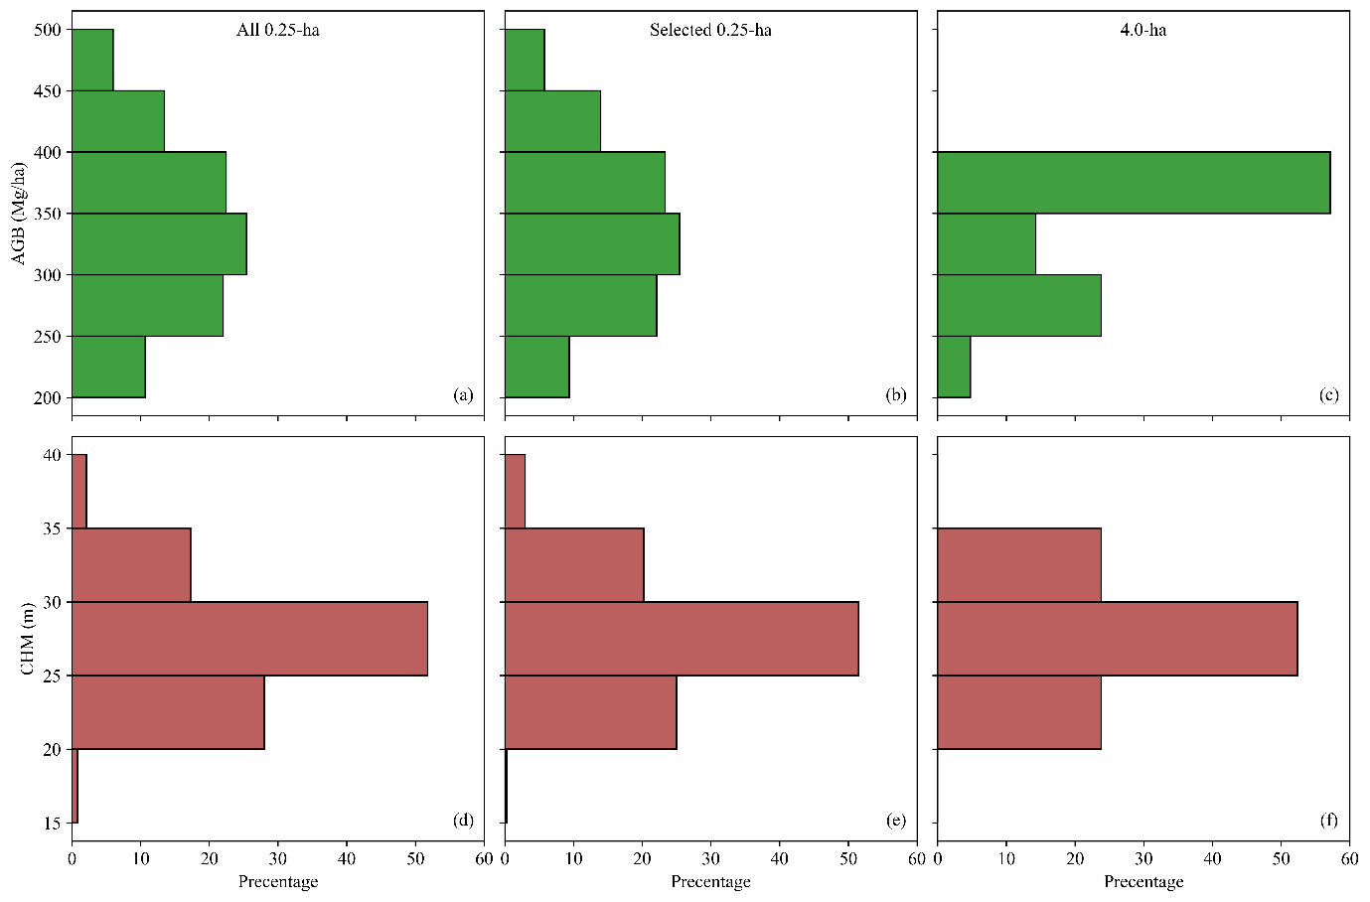

Fig. S1: The distribution of AGB (a-c) and FH (d-f) in all 0.25-ha plots, selected 0.25-ha plots used for generating 4-ha plots, and 4-ha plots
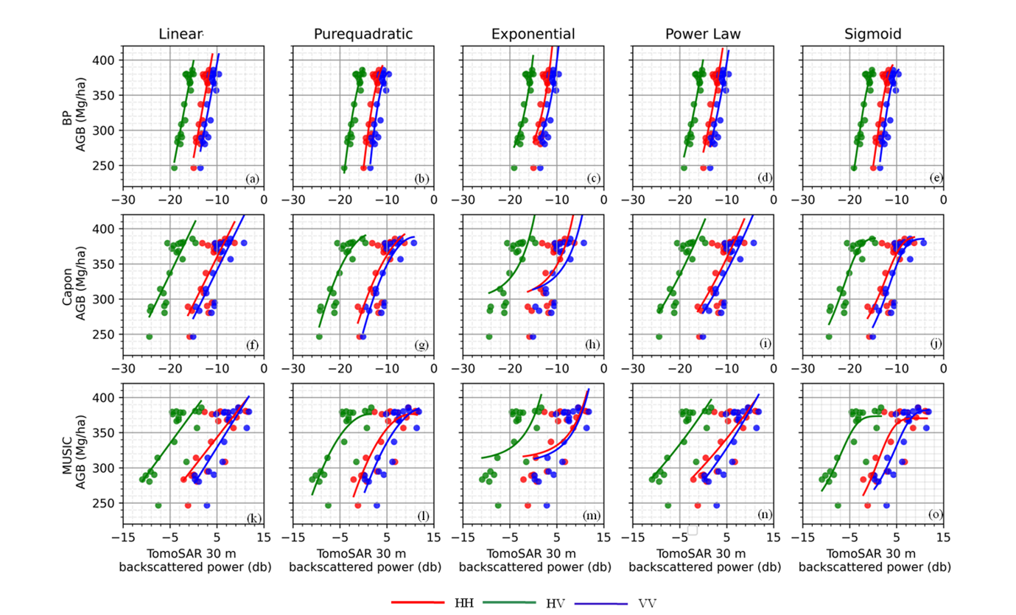Fig. S2: The relationship between TomoSAR 30 m layer backscattered power and AGB was established using linear, pure-quadratic, exponential, power law, and sigmoid form for BP (a-e), Capon (f-j), and MUSIC (k-o) estimators.

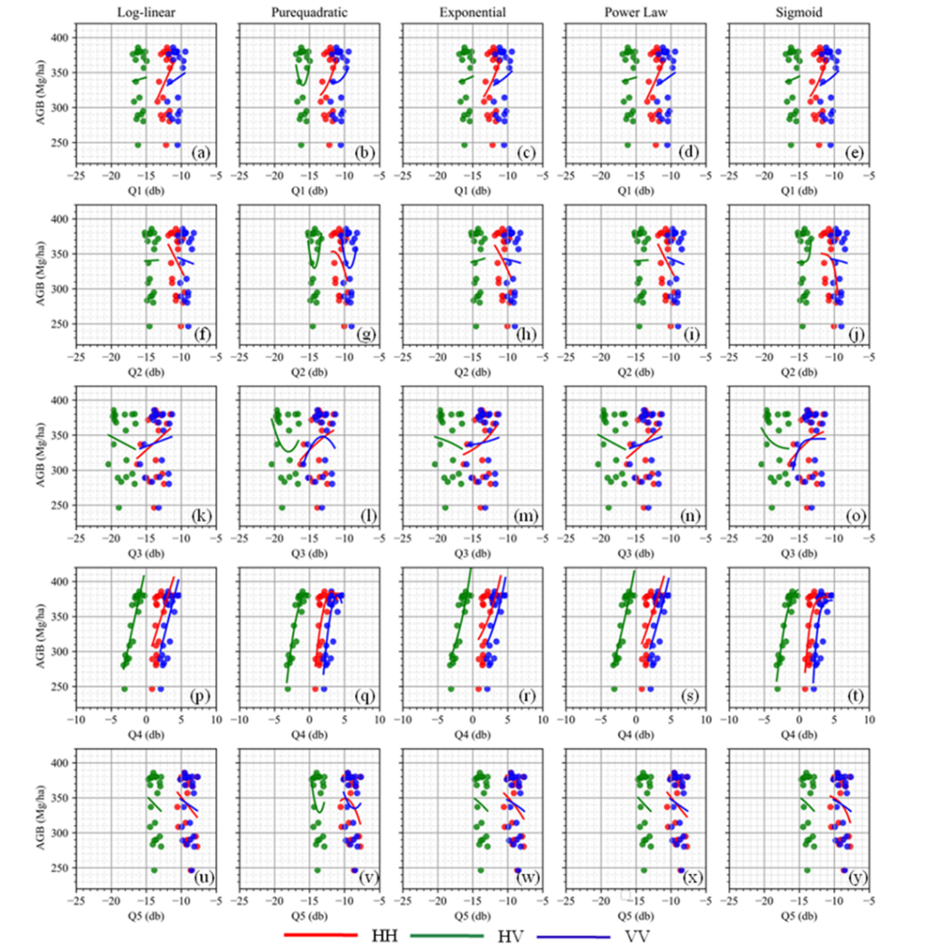
Fig. S3: The relationship between TomoSAR backscattered power metric Q1 (a-e), Q2 (f-j), Q3 (k-o), Q4 (p-t), Q5 (u-y), and AGB established using linear, pure-quadratic, exponential, power law and sigmoid form for BP estimators.

References
1. Reigber, A. & Moreira, A. First demonstration of airborne SAR tomography using multibaseline L-band data. IEEE Trans. Geosci. Remote Sensing 38, 2142–2152 (2000).
2. Ramachandran, N., Saatchi, S., Tebaldini, S., d’Alessandro, M. M. & Dikshit, O. Evaluation of P-Band SAR Tomography for Mapping Tropical Forest Vertical Backscatter and Tree Height. Remote Sensing 13, 1485 (2021).

