Supplementary Information

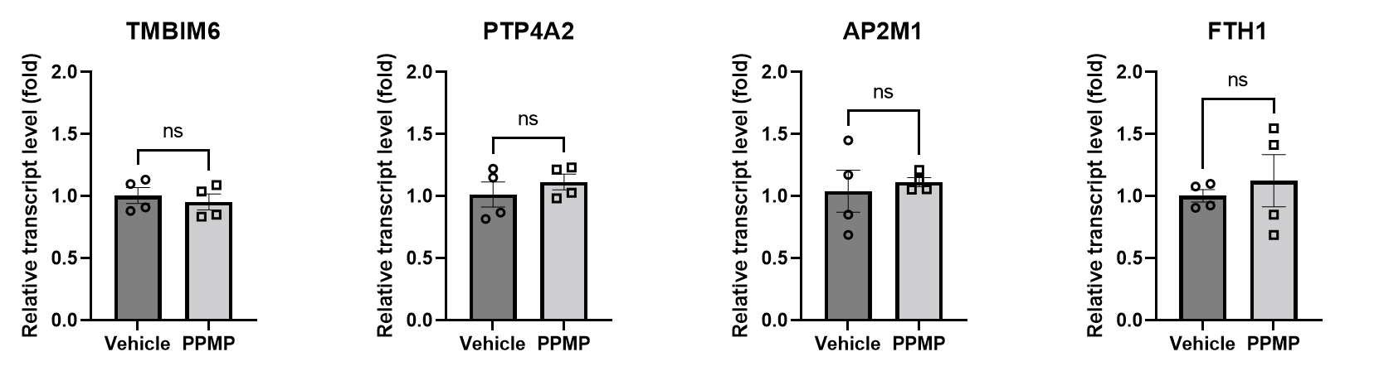

Supplementary Figure 1. Cell cycle related gene expression by PPMP incubation with MCF 10A cells.
Human normal breast epithelial cell line, MCF 10A cells were incubated with PPMPs for 24 h and then, transcript level of TMBIM6, AP2M1, PTP4A2, and FTH1 were evaluated by qRT-PCR in MCF 10A cells (unpaired t-test, n.s., not significant).

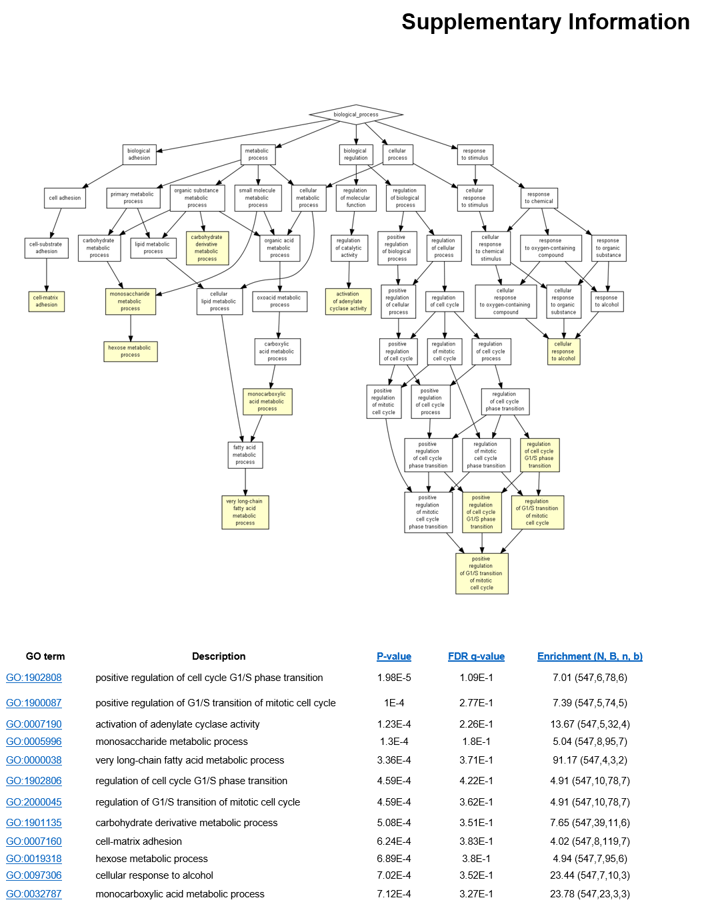
Supplementary Figure 2. Activated pathways by PPMP incubation with MDA-MB-231 cells.
Based on the GO of the DEGs from the RNA-seq analysis, G1/S phase transition, mitotic cell cycle, and cell-matrix adhesion related pathways were activated by PPMP incubation with breast cancer cells.

