Release systems based on self-assembling RADA16-I hydrogels with a signal sequence which improves wound healing processes

Maria Dzierżyńska^{1,#}, Justyna Sawicka^{1,#}, Milena Deptuła², Paweł Sosnowski³, Piotr Sass³, Barbara Peplińska⁴, Zuzanna Pietralik-Molińska⁵, Martyna Fularczyk¹, Franciszek Kasprzykowski¹, Jacek Zieliński⁶, Maciej Kozak⁵, Paweł Sachadyn³, Michał Pikuła², Sylwia Rodziewicz-Motowidło^{1,*}

¹ Department of Biomedical Chemistry, Faculty of Chemistry, University of Gdańsk, Poland
² Laboratory of Tissue Engineering and Regenerative Medicine, Department of Embryology, Medical University of Gdańsk, Gdańsk, Poland
³ Laboratory for Regenerative Biotechnology, Faculty of Chemistry, Gdańsk University of Technology, Gdańsk, Poland
⁴ NanoBioMedical Centre, Adam Mickiewicz University, Poznań, Poland.
⁵ Department of Macromolecular Physics, Faculty of Physics, Adam Mickiewicz University, Poznań, Poland
⁶ Department of Surgical Oncology, Medical University of Gdańsk, Poland
#These authors contributed equally to this work.
* Correspondence: s.rodziewicz-motowidlo@ug.edu.pl (S.R-M.)

Supplementary data

Table 1S. Peptides theoretical and experimental masses and retention times
Peptide ID | Theoretical monoisotopic mass [Da] | Experimental monoisotopic mass [Da] | Retention time [min]*
RADA-16-I | 1711.846 | 1711.858 | 2.769
RADA-IM | 3209.621 | 3209.562 | 3.371
RADA-GHK | 2657.324 | 2657.260 | 2.971
RADA-KGHK | 2842.441 | 2844.370 | 2.909
*UHPLC conditions 5-100% B in 15 min, where A – 0.1% TFA in water, B – 80% acetonitrile in water with 0.1% TFA, Kinetex 2.6 µm C8 100Å, 2.1x100 mm

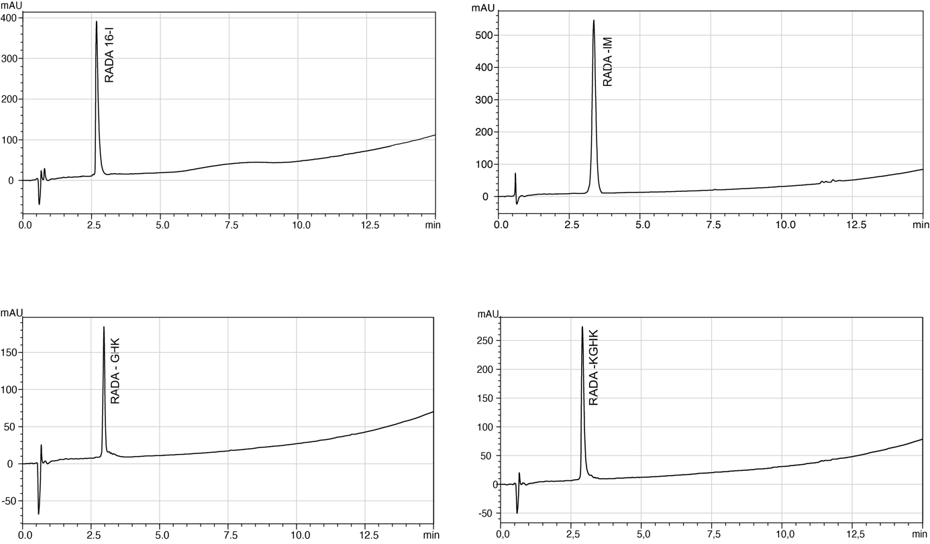
Figure 1S. Chromatograms of pure RADA hybrids.
Table 2S. Masses of RADA hybrids observed during ESI ionization
 | +3 | +4 | +5 | +6
RADA-16-I | 428.9563 | 571.6243
RADA-IM |  | 803.6498 | 643.1198 | 536.0914
RADA-GHK |  | 665.6063 | 532.6763 | 444.0661
RADA-KGHK | 945.8053 | 711.8451 | 569.6920

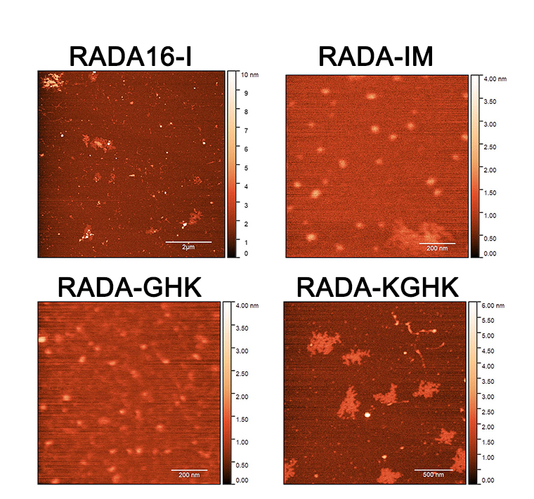
Figure 2S. AFM images of RADA16-I and RADA hybrids after sonication.
Figure 3S. G’ and G” of RADA16-I hybrids as a function of shear stress at ω=6.28 rad/s and 37°C.

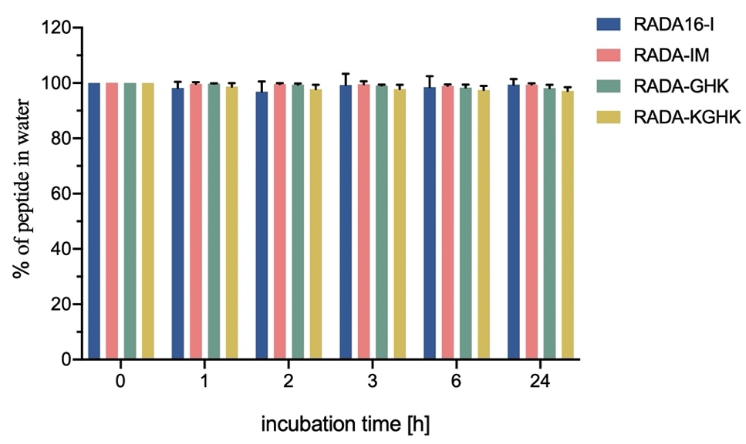
Figure 4S. Stability of peptides in aqueous solution. The graph shows results from 3 independent experiments. Results are presented as mean with SD.
Table 3S. Most abundant signals in mass spectrometry corresponding to identified fragments of peptides after elastase digestion.
PEPTIDE | Sequence | Mass [Da]
RADA-IM | Ac-(RADA)₄-GGG-AAPV-COOH | 2222.08
RADA-IM | NH₂-GGRDKVYR-NH₂ | 948.49
RADA-IM | NH₂-GGGRDKVYR -NH₂ | 1005.51
RADA-GHK | Ac-(RADA)₄-GGG-AAPV-COOH | 2222.03
RADA-GHK | NH₂ -GHK-NH₂ | 339.93
RADA-KGHK | Ac-(RADA)₄-GGG-AAPV-COOH | 2222.03
RADA-KGHK | NH₂-PV-GGG-KGHK-NH₂ | 834.45
RADA-KGHK | NH₂-APV-GGG-KGHK-NH₂ | 905.47

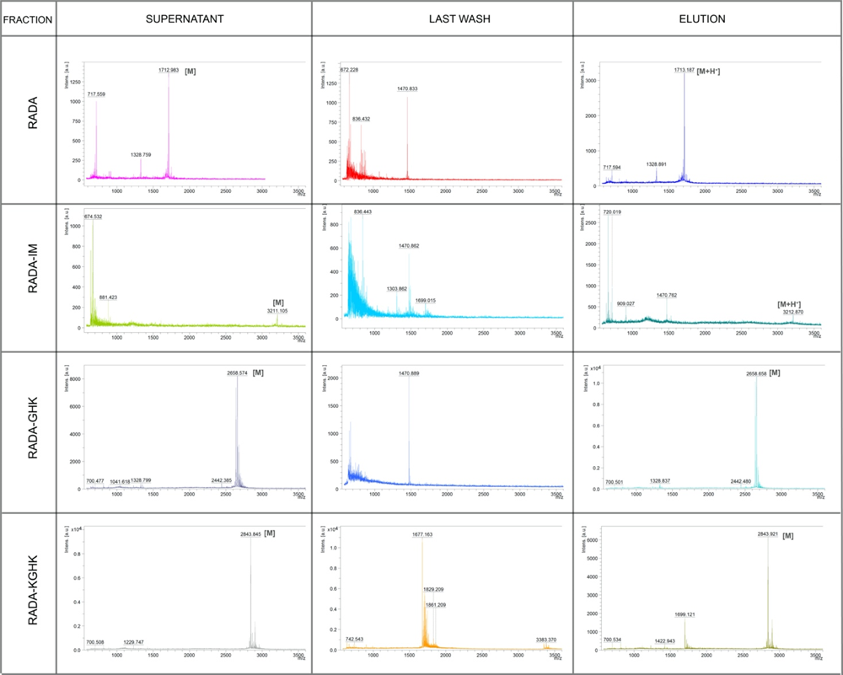
Figure 5S. Affinity studies of RADA hybrids.

Figure 6S. RADA hybrids proliferation test for 46BR.1N fibroblasts and HaCaT keratinocytes after 48h. The graph shows results from 3 independent experiments (4 replicates in each, n=12). Results are presented as mean with SD. *- statistically significant differences compared to control, Mann-Whitney U test, p<0.05. FBS - positive control - cells grown in medium containing 10% FBS.

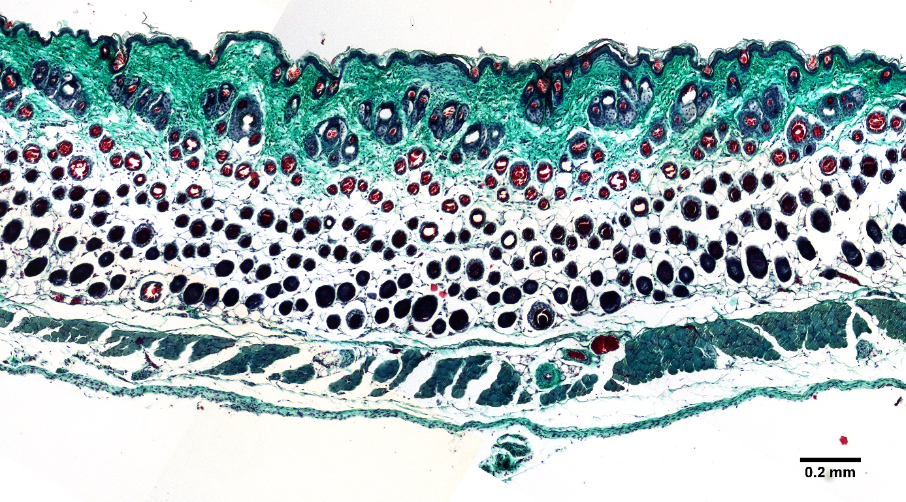
Figure 7S. Histological image of healthy skin.

