Supplementary Material

 | Gene | p_val | avg_log2FC | pct.1 | pct.2 | p_val_adj
ASTROCYTES | Cmss1 | 5.14E-95 | -2.10 | 0.88 | 0.99 | 2.39E-90
ASTROCYTES | Cdk8 | 8.55E-104 | -1.86 | 0.80 | 0.99 | 3.98E-99
ASTROCYTES | Rn18s-rs5 | 7.69E-61 | -1.60 | 0.73 | 0.94 | 3.58E-56
ASTROCYTES | Gm42418 | 2.81E-53 | -1.26 | 1.00 | 1.00 | 1.31E-48
ASTROCYTES | Mir6236 | 2.70E-30 | -1.23 | 0.56 | 0.87 | 1.26E-25
ASTROCYTES | Gm20417 | 5.36E-23 | -1.15 | 0.44 | 0.75 | 2.50E-18
ASTROCYTES | Sod1 | 8.37E-144 | 3.29 | 0.92 | 0.43 | 3.90E-139
ASTROCYTES | Gm8566 | 1.28E-158 | 4.18 | 0.93 | 0.00 | 5.97E-154
MICROGLIA | Cdk8 | 0.00E+00 | -2.09 | 0.75 | 1.00 | 0.00E+00
MICROGLIA | Cmss1 | 0.00E+00 | -1.93 | 0.91 | 1.00 | 0.00E+00
MICROGLIA | Rn18s-rs5 | 6.41E-240 | -1.64 | 0.80 | 0.99 | 2.98E-235
MICROGLIA | Gm42418 | 2.06E-223 | -1.38 | 1.00 | 1.00 | 9.60E-219
MICROGLIA | Mir6236 | 4.94E-75 | -1.09 | 0.61 | 0.89 | 2.30E-70
MICROGLIA | Gm20417 | 1.57E-61 | -1.02 | 0.17 | 0.61 | 7.31E-57
MICROGLIA | Sod1 | 0.00E+00 | 3.21 | 0.98 | 0.27 | 0.00E+00
MICROGLIA | Gm8566 | 0.00E+00 | 3.92 | 0.98 | 0.00 | 0.00E+00
OLIGODENDROCYTES | Cdk8 | 5.33E-182 | -2.41 | 0.79 | 1.00 | 2.48E-177
OLIGODENDROCYTES | Cmss1 | 2.49E-183 | -2.12 | 0.95 | 1.00 | 1.16E-178
OLIGODENDROCYTES | Rn18s-rs5 | 2.44E-103 | -1.60 | 0.90 | 1.00 | 1.14E-98
OLIGODENDROCYTES | Gm42418 | 2.06E-145 | -1.58 | 1.00 | 1.00 | 9.57E-141
OLIGODENDROCYTES | Gm20417 | 6.94E-62 | -1.42 | 0.32 | 0.86 | 3.23E-57
OLIGODENDROCYTES | Mir6236 | 2.44E-50 | -1.23 | 0.43 | 0.88 | 1.13E-45
OLIGODENDROCYTES | Gm23935 | 1.14E-98 | -1.21 | 0.87 | 1.00 | 5.31E-94
OLIGODENDROCYTES | Cst3 | 8.42E-43 | -1.16 | 0.00 | 0.69 | 3.92E-38
OLIGODENDROCYTES | Camk1d | 2.10E-58 | -1.04 | 0.71 | 0.97 | 9.78E-54
OLIGODENDROCYTES | Sod1 | 2.57E-298 | 5.51 | 1.00 | 0.57 | 1.20E-293
OLIGODENDROCYTES | Gm8566 | 0.00E+00 | 6.43 | 1.00 | 0.00 | 0.00E+00
Supplementary Table 1
DEA results. Genes differentially expressed in 4M SOD1 samples in all three cell types, calculated by FindMarkers function using t-test (Bonferroni correction). The significance thresholds were set to |log₂FC| > 1 and p_{adj} < 0.05.

Study | Model | Sex | CNS Region | Time Points | Cell Types | Labelling | Collection | Analysis
Ferraiuolo, et al. ¹ | SOD1(G93A) | male | lumbar SC | 60 days | ASTRO | ALDH1L1 | LCM | microarray
Sun, et al. ² | SOD1(G37R) | - | SC | 8, 10.5 months | ASTRO, OLIGO | EGFP | TRAP (Aldh1l1, Cnp1) | RNA-seq
Phatnani, et al. ³ | SOD1(G93A) | both | SC (culture) | - | primary ASTRO | - | - | RNA-seq
Miller, et al. ⁴ | SOD1(G93A) | - | entire cortex | 120 days | ASTRO | ALDH1L1 | FACS | microarray
Liu, et al. ⁵ | SOD1 (G93A) | female | brainstem | 100 days | all | - | - | sc-RNAseq
Keren-Shaul, et al. ⁶ | SOD1 (G93A) | male | SC | 80, 135 days | all immune | CD45, CD11c | FACS | sc-RNAseq
Butovsky, et al. ⁷ | SOD1 (G93A) | - | SC | 60 days, onset, end-stage | MG | CD39 | FACS | Nanostring nCounter
Butovsky, et al. ⁸ | SOD1 (G93A) | - | SC | 30, 60 days, onset, end-stage | MG | FCRLS, CD11b | FACS | Nanostring nCounter
Fukada, et al. ⁹ | SOD1(L126delTT) | - | SC | 98, 154, 176 days | all | - | - | microarray
Yoshihara, et al. ¹⁰ | SOD1 (G93A) | - | lumbar SC | 17 weeks | all | - | - | microarray
Kudo, et al. ¹¹ | SOD1 (G93A) | female | lumbar SC | 8 weeks | all | - | LCM | microarray
Chen, et al. ¹² | SOD1 (G93A) | female | lumbar SC | onset | all | - | - | microarray
Wang, et al. ¹³ | SOD1 (G93A) | female | lumbar SC | 60 days | all | - | - | microarray
D'Arrigo, et al. ¹⁴ | SOD1 (G93A) | male | lumbar SC | 55, 110 days | all | - | - | microarray
Baker, et al. ¹⁵ | SOD1 (G93A) | male | lumbar SC | 90, 120 days | ASTRO | ALDH1L1 | LCM | microarray

Supplementary Table 2
Reference gene set information summary. A table summarizing the gene sets acquired from the reference studies that were used in the meta-analysis including essential information about samples and their processing. SC – spinal cord, ASTRO – astrocytes, OLIGO – oligodendrocytes, MG – microglia, TRAP – translating ribosome affinity purification, LCM – laser capture microdissection.

Supplementary Table 3 (excel table)
Marker genes of clusters of astrocytes, microglia and oligodendrocytes calculated by Seurat’s FindAllMarkers function, using Wilcoxon Rank Sum test. Default log₂FC > 0.25 and minimal percentage of expressing cells = 0.1 filters were applied by the function. Genes are ordered based on p_{adj} value (Bonferroni correction). The most relevant marker genes can be further examined by setting a p_{adj} value threshold.

Supplementary Table 4
Numerical details of individual samples. A table summarizing numerical information about individual samples in the data set. The column ‘# Cells after all QC’ shows numbers of cells of all cell types after empty droplets, doublets and Undefined were removed and filters for number of transcripts, genes and percentage of mitochondrial reads were applied. QC – quality control, ASTRO – astrocytes, OLIGO – oligodendrocytes, MG – microglia, DEA – differential expression analysis.
 | Sequencing Data Details |  |  |  | # Cells Entering DEA |  |  | # Cells in Subpopulation Analysis
Sample | # Reads per Sample | % Reads Mapped to Unique Genes | # Cells after emptyDrops | # Cells after all QC | ASTRO | MG | OLIGO | ASTRO | MG | OLIGO
1M CTRL | 148890042 | 53 | 2509 | 812 | 185 | 306 | 205 | 185 | 306 | 205
1M SOD1 | 158980711 | 56 | 4394 | 2285 | 521 | 1006 | 477 | 521 | 1006 | 477
2M CTRL | 151611697 | 53 | 5484 | 3173 | 1069 | 949 | 922 | 1069 | 949 | 922
2M SOD1 | 98385405 | 50 | 5505 | 3193 | 1248 | 972 | 775 | 1248 | 972 | 775
3M CTRL | 149987478 | 55 | 5865 | 3110 | 913 | 966 | 982 | 726 | 966 | 709
3M SOD1 | 150892591 | 56 | 6172 | 3327 | 894 | 1431 | 726 | 886 | 1431 | 721
4M CTRL | 179574132 | 45 | 2693 | 1178 | 287 | 560 | 269 | 287 | 560 | 269
4M SOD1 | 207933457 | 60 | 6795 | 4502 | 370 | 2224 | 1798 | 370 | 2224 | 1798
 |  | Total | 39417 | 21580 | 5487 | 8414 | 6154 | 5292 | 8414 | 5876

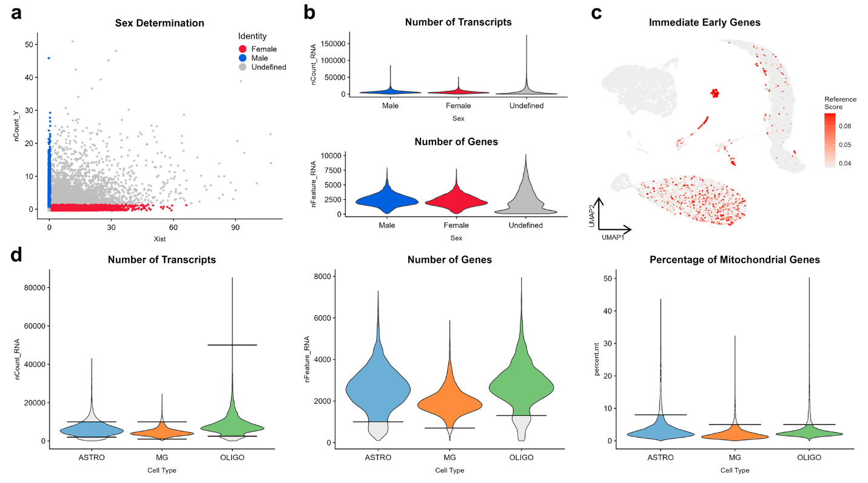
Supplementary Figure 1
Initial quality control and filtering of the scRNA-seq data. (a) Xist and Y chromosome gene counts of each cell visualised in a plot, with the assigned genders highlighted by colours. Undefined cells represented 29 % of all cells after removal of empty droplets and doublets. (b) Distribution of number of transcripts and genes detected in the Undefined group suggested it comprised of low-quality cells, therefore it was removed from the data. (c) A set of the immediate early genes projected onto the UMAP showing their minimal artificial activation in our data. (d) Plots of variables based on which the cell types of interest were filtered, with the cut-offs indicated by horizontal lines in the plots and the coloured areas representing cells that remained after filtering.

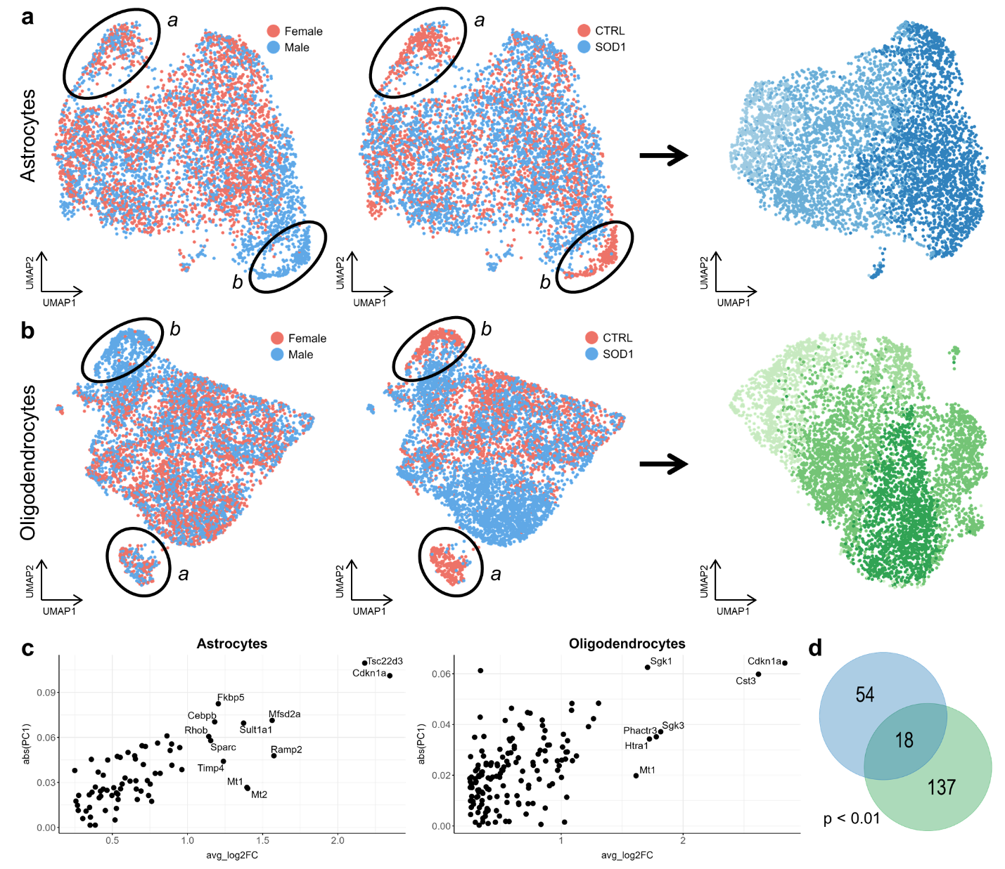
Supplementary Figure 2
Subclustering quality control. (a, b) A cluster marked by expression of Cdk8 and Cmss1 (a) included almost all 4M CTRL cells regardless of sex was present in astrocytes, oligodendrocytes and in microglia as well. Another cluster (b) was present exclusively in 3M CTRL male samples in astrocytes (n = 187) and oligodendrocytes (n = 273) but was not apparent in microglia. Exclusion of these genes and the cluster resulted in the final visualisation on the right. (c) Marker genes of the 3M male cluster were responsible for the shift along the PC1 axis in the pseudobulk analysis, as the strongest markers had the most extreme absolute values of loading of PC1 as shown in the plots. (d) Markers of this cluster in astrocytes (blue) and oligodendrocytes (green) significantly overlapped and were possibly related to stress response. abs(PC1) – absolute value of loading of PC1, avg_log2FC – log₂FC of cluster marker genes.

Supplementary References
1 Ferraiuolo, L. et al. Dysregulation of astrocyte-motoneuron cross-talk in mutant superoxide dismutase 1-related amyotrophic lateral sclerosis. Brain 134, 2627-2641, doi:10.1093/brain/awr193 (2011).
2 Sun, S. et al. Translational profiling identifies a cascade of damage initiated in motor neurons and spreading to glia in mutant SOD1-mediated ALS. Proc Natl Acad Sci U S A 112, E6993-7002, doi:10.1073/pnas.1520639112 (2015).
3 Phatnani, H. P. et al. Intricate interplay between astrocytes and motor neurons in ALS. Proc Natl Acad Sci U S A 110, E756-765, doi:10.1073/pnas.1222361110 (2013).
4 Miller, S. J., Glatzer, J. C., Hsieh, Y. C. & Rothstein, J. D. Cortical astroglia undergo transcriptomic dysregulation in the G93A SOD1 ALS mouse model. J Neurogenet 32, 322-335, doi:10.1080/01677063.2018.1513508 (2018).
5 Liu, W. et al. Single-cell RNA-seq analysis of the brainstem of mutant SOD1 mice reveals perturbed cell types and pathways of amyotrophic lateral sclerosis. Neurobiol Dis 141, 104877, doi:10.1016/j.nbd.2020.104877 (2020).
6 Keren-Shaul, H. et al. A unique microglia type associated with restricting development of Alzheimer's disease. Cell 169, 1276-1290 e1217, doi:10.1016/j.cell.2017.05.018 (2017).
7 Butovsky, O. et al. Modulating inflammatory monocytes with a unique microRNA gene signature ameliorates murine ALS. J Clin Invest 122, 3063-3087, doi:10.1172/JCI62636 (2012).
8 Butovsky, O. et al. Targeting miR-155 restores abnormal microglia and attenuates disease in SOD1 mice. Ann Neurol 77, 75-99, doi:10.1002/ana.24304 (2015).
9 Fukada, Y. et al. Gene expression analysis of the murine model of amyotrophic lateral sclerosis: studies of the Leu126delTT mutation in SOD1. Brain Res 1160, 1-10, doi:10.1016/j.brainres.2007.05.044 (2007).
10 Yoshihara, T. et al. Differential expression of inflammation- and apoptosis-related genes in spinal cords of a mutant SOD1 transgenic mouse model of familial amyotrophic lateral sclerosis. J Neurochem 80, 158-167, doi:10.1046/j.0022-3042.2001.00683.x (2002).
11 Kudo, L. C. et al. Integrative gene-tissue microarray-based approach for identification of human disease biomarkers: application to amyotrophic lateral sclerosis. Hum Mol Genet 19, 3233-3253, doi:10.1093/hmg/ddq232 (2010).
12 Chen, H. et al. Differential expression and alternative splicing of genes in lumbar spinal cord of an amyotrophic lateral sclerosis mouse model. Brain Res 1340, 52-69, doi:10.1016/j.brainres.2010.03.075 (2010).
13 Wang, R., Yang, B. & Zhang, D. Activation of interferon signaling pathways in spinal cord astrocytes from an ALS mouse model. Glia 59, 946-958, doi:10.1002/glia.21167 (2011).
14 D'Arrigo, A. et al. Transcriptional profiling in the lumbar spinal cord of a mouse model of amyotrophic lateral sclerosis: a role for wild-type superoxide dismutase 1 in sporadic disease? J Mol Neurosci 41, 404-415, doi:10.1007/s12031-010-9332-2 (2010).
15 Baker, D. J. et al. Lysosomal and phagocytic activity is increased in astrocytes during disease progression in the SOD1 (G93A) mouse model of amyotrophic lateral sclerosis. Front Cell Neurosci 9, 410, doi:10.3389/fncel.2015.00410 (2015).

