Contents of Supplementary Information

A. Supplementary tables and figures

B. Supplementary Methods

C. Supplementary Data (in a separate folder)

A. Supplementary tables and figures

Supplementary Table S1 Mouse samples used in this study
sample ID | group | sex | RNA-Seq | Bisulfite-seq | DIABLO
12 | Wt | female | yes | yes | yes
32 | Tg | female | yes | yes | yes
41 | Wt | male | yes | yes | yes
48 | Tg | male | no | yes | no
67 | Tg | male | yes | yes | yes
68 | Tg | male | yes | yes | yes
69 | Tg | male | yes | yes | yes
79 | Wt | female | yes | yes | yes
80 | Wt | female | yes | yes | yes
91 | Tg | female | yes | yes | yes
92 | Tg | female | yes | yes | yes
93 | Tg | female | yes | yes | yes
95 | Wt | male | yes | no | no
All mice are ~ 11-months- old; Bisulfite-seq = BS-seq for DNA methylomics; DIABLO is an integrative method used for combined analysis of both omics data. Refer to the main text for details).

Supplementary Table S2 100 DEGs output by DESeq2
Gene | lfc | lfcSE | stat | pval | padj
App | 1.65 | 0.142 | 11.68 | 1.55E-31 | 4.69E-27
Gm8215 | 18.51 | 3.13 | 5.91 | 3.34E-09 | 8.87E-06
Gm24515 | 18.39 | 3.177 | 5.79 | 7.16E-09 | 8.87E-06
Agr2 | 18.39 | 3.177 | 5.79 | 7.17E-09 | 8.87E-06
Gm10375 | 18.39 | 3.177 | 5.79 | 7.17E-09 | 8.87E-06
Gm11313 | 18.39 | 3.177 | 5.79 | 7.17E-09 | 8.87E-06
Gm15169 | 18.39 | 3.177 | 5.79 | 7.17E-09 | 8.87E-06
Gm17171 | 18.39 | 3.177 | 5.79 | 7.17E-09 | 8.87E-06
Gm24135 | 18.39 | 3.177 | 5.79 | 7.17E-09 | 8.87E-06
Gm24368 | 18.39 | 3.177 | 5.79 | 7.17E-09 | 8.87E-06
Olfr314 | 18.39 | 3.177 | 5.79 | 7.17E-09 | 8.87E-06
Tdpoz4 | 18.39 | 3.177 | 5.79 | 7.17E-09 | 8.87E-06
Prlr | 1.78 | 0.302 | 5.91 | 3.45E-09 | 8.87E-06
Prnp | 0.82 | 0.138 | 5.93 | 3.00E-09 | 8.87E-06
2010110K18Rik | 17.86 | 3.178 | 5.62 | 1.91E-08 | 1.49E-05
2210010C04Rik | 17.86 | 3.178 | 5.62 | 1.91E-08 | 1.49E-05
Bpifa6 | 17.86 | 3.178 | 5.62 | 1.91E-08 | 1.49E-05
D930032P07Rik | 17.86 | 3.178 | 5.62 | 1.91E-08 | 1.49E-05
Gm11771 | 17.86 | 3.178 | 5.62 | 1.91E-08 | 1.49E-05
Gm15658 | 17.86 | 3.178 | 5.62 | 1.91E-08 | 1.49E-05
Gm23275 | 17.86 | 3.178 | 5.62 | 1.91E-08 | 1.49E-05
Gm26147 | 17.86 | 3.178 | 5.62 | 1.91E-08 | 1.49E-05
H2-M10.6 | 17.86 | 3.178 | 5.62 | 1.91E-08 | 1.49E-05
RP23-402K6.2 | 17.86 | 3.178 | 5.62 | 1.91E-08 | 1.49E-05
RP24-329K22.1 | 17.86 | 3.178 | 5.62 | 1.91E-08 | 1.49E-05
Ssxb2 | 17.86 | 3.178 | 5.62 | 1.91E-08 | 1.49E-05
Tff3 | 17.86 | 3.178 | 5.62 | 1.91E-08 | 1.49E-05
Xlr3e-ps | 17.86 | 3.178 | 5.62 | 1.91E-08 | 1.49E-05
Slc37a2 | 1.13 | 0.211 | 5.37 | 7.92E-08 | 6.02E-05
Gm26232 | 0.79 | 0.156 | 5.08 | 3.87E-07 | 2.87E-04
Gfap | 1.00 | 0.203 | 4.91 | 8.92E-07 | 6.45E-04
Gm24305 | 0.52 | 0.106 | 4.87 | 1.14E-06 | 8.07E-04
Gm25813 | 0.87 | 0.185 | 4.72 | 2.37E-06 | 1.64E-03
Agt | 0.74 | 0.157 | 4.69 | 2.68E-06 | 1.81E-03
Gm14058 | 5.40 | 1.168 | 4.62 | 3.78E-06 | 2.50E-03
Baiap2l1 | 1.62 | 0.364 | 4.43 | 9.24E-06 | 5.84E-03
Col18a1 | 0.94 | 0.22 | 4.30 | 1.70E-05 | 1.05E-02
Plxnb3 | 0.96 | 0.226 | 4.26 | 2.09E-05 | 1.24E-02
mt-Tn | 0.94 | 0.22 | 4.26 | 2.07E-05 | 1.24E-02
D130058E05Rik | 3.96 | 0.957 | 4.14 | 3.46E-05 | 1.98E-02
Prr5l | 1.22 | 0.296 | 4.13 | 3.66E-05 | 2.06E-02
Gm25394 | 0.53 | 0.129 | 4.10 | 4.18E-05 | 2.31E-02
Plek2 | 2.55 | 0.624 | 4.09 | 4.30E-05 | 2.33E-02
Rnu1a1 | 0.48 | 0.117 | 4.06 | 4.97E-05 | 2.65E-02
Inmt | 2.40 | 0.601 | 4.00 | 6.32E-05 | 3.25E-02
Greb1 | 1.60 | 0.4 | 4.00 | 6.24E-05 | 3.25E-02
Cst7 | 4.51 | 1.135 | 3.98 | 6.99E-05 | 3.54E-02
Msx1 | 1.36 | 0.344 | 3.97 | 7.21E-05 | 3.59E-02
Lyz2 | 1.11 | 0.282 | 3.92 | 8.71E-05 | 4.07E-02
Slc4a2 | 0.93 | 0.238 | 3.92 | 8.71E-05 | 4.07E-02
Gm25089 | 0.57 | 0.145 | 3.93 | 8.59E-05 | 4.07E-02
Tppp3 | 0.53 | 0.134 | 3.93 | 8.43E-05 | 4.07E-02
Gm22317 | 0.47 | 0.121 | 3.89 | 9.96E-05 | 4.58E-02
Gm24046 | 0.85 | 0.217 | 3.89 | 1.02E-04 | 4.61E-02
Gm24830 | 0.67 | 0.174 | 3.83 | 1.29E-04 | 5.66E-02
Col9a3 | 1.22 | 0.32 | 3.82 | 1.36E-04 | 5.89E-02
Slc16a8 | 4.81 | 1.268 | 3.79 | 1.48E-04 | 6.25E-02
Tmprss5 | 1.57 | 0.413 | 3.80 | 1.46E-04 | 6.25E-02
Gm25085 | 0.54 | 0.143 | 3.79 | 1.53E-04 | 6.29E-02
Gm23804 | 0.38 | 0.101 | 3.78 | 1.55E-04 | 6.29E-02
Syne3 | 1.16 | 0.308 | 3.77 | 1.66E-04 | 6.64E-02
Neat1 | 0.67 | 0.178 | 3.76 | 1.70E-04 | 6.72E-02
B230323A14Rik | 4.16 | 1.117 | 3.73 | 1.94E-04 | 7.39E-02
Aspa | 1.20 | 0.322 | 3.72 | 1.96E-04 | 7.39E-02
Abca4 | 1.13 | 0.303 | 3.73 | 1.94E-04 | 7.39E-02
Ace | 0.87 | 0.235 | 3.72 | 1.97E-04 | 7.39E-02
Gng11 | 0.99 | 0.268 | 3.72 | 2.03E-04 | 7.52E-02
Prom2 | 3.46 | 0.934 | 3.71 | 2.11E-04 | 7.53E-02
Nqo1 | 0.98 | 0.265 | 3.71 | 2.10E-04 | 7.53E-02
Gm26444 | 0.46 | 0.124 | 3.71 | 2.07E-04 | 7.53E-02
Gm23286 | 0.54 | 0.145 | 3.70 | 2.15E-04 | 7.59E-02
Gm26392 | 0.46 | 0.125 | 3.69 | 2.22E-04 | 7.75E-02
Cfap43 | 0.94 | 0.254 | 3.69 | 2.27E-04 | 7.82E-02
Oca2 | 2.60 | 0.707 | 3.68 | 2.30E-04 | 7.84E-02
Stard4 | 0.45 | 0.121 | 3.68 | 2.38E-04 | 8.02E-02
Acss3 | 1.43 | 0.39 | 3.67 | 2.44E-04 | 8.09E-02
Slc2a12 | 1.19 | 0.323 | 3.67 | 2.45E-04 | 8.09E-02
Col4a4 | 2.14 | 0.586 | 3.66 | 2.54E-04 | 8.31E-02
Il1r1 | 0.91 | 0.251 | 3.65 | 2.67E-04 | 8.64E-02
Gm25790 | 0.93 | 0.255 | 3.63 | 2.81E-04 | 8.95E-02
Ppfibp2 | 0.85 | 0.234 | 3.63 | 2.83E-04 | 8.95E-02
Ctsd | 0.35 | 0.097 | 3.62 | 3.00E-04 | 9.40E-02
Elovl7 | 1.25 | 0.345 | 3.61 | 3.09E-04 | 9.55E-02
Scg5 | 0.48 | 0.134 | 3.61 | 3.12E-04 | 9.55E-02
4933406M09Rik | -18.27 | 3.158 | -5.78 | 7.30E-09 | 8.87E-06
Gimap7 | -18.27 | 3.158 | -5.78 | 7.30E-09 | 8.87E-06
Gm28177 | -18.27 | 3.158 | -5.78 | 7.30E-09 | 8.87E-06
Gm4131 | -18.27 | 3.158 | -5.78 | 7.30E-09 | 8.87E-06
RP23-56M2.5 | -18.27 | 3.158 | -5.78 | 7.30E-09 | 8.87E-06
1700067G17Rik | -18.41 | 3.157 | -5.83 | 5.56E-09 | 8.87E-06
Gm19585 | -18.41 | 3.157 | -5.83 | 5.56E-09 | 8.87E-06
Gpr119 | -18.41 | 3.157 | -5.83 | 5.56E-09 | 8.87E-06
Mir192 | -18.41 | 3.157 | -5.83 | 5.56E-09 | 8.87E-06
4930512H18Rik | -18.62 | 3.157 | -5.90 | 3.66E-09 | 8.87E-06
Traj26 | -18.62 | 3.157 | -5.90 | 3.66E-09 | 8.87E-06
Slit3 | -0.46 | 0.102 | -4.46 | 8.15E-06 | 5.26E-03
Kcng3 | -0.61 | 0.145 | -4.20 | 2.72E-05 | 1.59E-02
Xist | -5.88 | 1.522 | -3.87 | 1.11E-04 | 4.94E-02
Ccnd2 | -0.47 | 0.123 | -3.79 | 1.51E-04 | 6.26E-02
Ism1 | -0.67 | 0.185 | -3.60 | 3.14E-04 | 9.55E-02
lfc=log₂(fold change); lfcSE=standard error of lfc; stat=lfc/lfcSE; padj=Benjamini-Hochberg-adjusted p-value

Supplementary Table S3 Significant GO terms output by gprofiler2
term_id | source | term_name | padj | precision
GO:0005576 | GO:CC | extracellular region | 0.003 | 0.297
GO:0005615 | GO:CC | extracellular space | 0.005 | 0.234
GO:0005764 | GO:CC | lysosome | 0.013 | 0.109
GO:0000323 | GO:CC | lytic vacuole | 0.013 | 0.109
GO:0098656 | GO:BP | anion transmembrane transport | 0.019 | 0.092
GO:0061098 | GO:BP | positive regulation of protein tyrosine kinase activity | 0.019 | 0.062
GO:0061097 | GO:BP | regulation of protein tyrosine kinase activity | 0.019 | 0.062
GO:0045229 | GO:BP | external encapsulating structure organization | 0.019 | 0.092
GO:0043068 | GO:BP | positive regulation of programmed cell death | 0.019 | 0.123
GO:0043065 | GO:BP | positive regulation of apoptotic process | 0.019 | 0.123
GO:0043062 | GO:BP | extracellular structure organization | 0.019 | 0.092
GO:0030198 | GO:BP | extracellular matrix organization | 0.019 | 0.092
GO:0006116 | GO:BP | NADH oxidation | 0.02 | 0.031
GO:0030020 | GO:MF | extracellular matrix structural constituent conferring tensile strength | 0.023 | 0.052
GO:1990535 | GO:BP | neuron projection maintenance | 0.031 | 0.031
GO:0010942 | GO:BP | positive regulation of cell death | 0.031 | 0.123
GO:0005773 | GO:CC | vacuole | 0.032 | 0.109
GO:0055085 | GO:BP | transmembrane transport | 0.034 | 0.185
GO:1903596 | GO:BP | regulation of gap junction assembly | 0.034 | 0.031
GO:0010873 | GO:BP | positive regulation of cholesterol esterification | 0.036 | 0.031
GO:0090647 | GO:BP | modulation of age-related behavioral decline | 0.036 | 0.031
GO:1902950 | GO:BP | regulation of dendritic spine maintenance | 0.039 | 0.031
GO:0006820 | GO:BP | anion transport | 0.039 | 0.108
GO:0071914 | GO:CC | prominosome | 0.04 | 0.016
GO:0120202 | GO:CC | rod photoreceptor disc membrane | 0.04 | 0.016
GO:0098852 | GO:CC | lytic vacuole membrane | 0.04 | 0.063
GO:0097449 | GO:CC | astrocyte projection | 0.04 | 0.031
GO:0031410 | GO:CC | cytoplasmic vesicle | 0.04 | 0.188
GO:0097708 | GO:CC | intracellular vesicle | 0.04 | 0.188
GO:0005791 | GO:CC | rough endoplasmic reticulum | 0.04 | 0.047
GO:0005783 | GO:CC | endoplasmic reticulum | 0.04 | 0.188
GO:0005765 | GO:CC | lysosomal membrane | 0.04 | 0.063
GO:0005604 | GO:CC | basement membrane | 0.04 | 0.047
GO:0005581 | GO:CC | collagen trimer | 0.04 | 0.047
GO:0012505 | GO:CC | endomembrane system | 0.04 | 0.297
GO:1900272 | GO:BP | negative regulation of long-term synaptic potentiation | 0.042 | 0.031
GO:0051234 | GO:BP | establishment of localization | 0.042 | 0.354
GO:0045860 | GO:BP | positive regulation of protein kinase activity | 0.045 | 0.092
GO:0010872 | GO:BP | regulation of cholesterol esterification | 0.045 | 0.031
GO:0051179 | GO:BP | localization | 0.048 | 0.415
GO:0042976 | GO:BP | activation of Janus kinase activity | 0.048 | 0.031
GO:0034435 | GO:BP | cholesterol esterification | 0.048 | 0.031
GO:0034433 | GO:BP | steroid esterification | 0.048 | 0.031
GO:0034434 | GO:BP | sterol esterification | 0.048 | 0.031
GO:0006810 | GO:BP | transport | 0.048 | 0.338
GO:0001934 | GO:BP | positive regulation of protein phosphorylation | 0.048 | 0.123
GO:0006801 | GO:BP | superoxide metabolic process | 0.048 | 0.046
GO:0016264 | GO:BP | gap junction assembly | 0.048 | 0.031
GO:0061135 | GO:MF | endopeptidase regulator activity | 0.048 | 0.069
GO:0004857 | GO:MF | enzyme inhibitor activity | 0.048 | 0.086
GO:0004866 | GO:MF | endopeptidase inhibitor activity | 0.048 | 0.069
GO:0004925 | GO:MF | prolactin receptor activity | 0.048 | 0.017
GO:0015169 | GO:MF | glycerol-3-phosphate transmembrane transporter activity | 0.048 | 0.017
GO:0019807 | GO:MF | aspartoacylase activity | 0.048 | 0.017
GO:0030414 | GO:MF | peptidase inhibitor activity | 0.048 | 0.069
GO:0140347 | GO:MF | N-retinylidene-phosphatidylethanolamine flippase activity | 0.048 | 0.017
GO:0031703 | GO:MF | type 2 angiotensin receptor binding | 0.048 | 0.017
GO:0042277 | GO:MF | peptide binding | 0.048 | 0.086
GO:0042802 | GO:MF | identical protein binding | 0.048 | 0.224
GO:0140323 | GO:MF | solute:anion antiporter activity | 0.048 | 0.034
GO:0102707 | GO:MF | S-adenosyl-L-methionine:beta-alanine N-methyltransferase activity | 0.048 | 0.017
GO:0098615 | GO:MF | dimethyl selenide methyltransferase activity | 0.048 | 0.017
GO:0030748 | GO:MF | amine N-methyltransferase activity | 0.048 | 0.017
GO:0004790 | GO:MF | thioether S-methyltransferase activity | 0.048 | 0.017
GO:0097386 | GO:CC | glial cell projection | 0.049 | 0.031
padj=FDR-adjusted pval; precision=the proportion of genes in the input list that are annotated to the function; BP=biological process; CC=cellular component; MF=molecular function

Supplementary Table S4 Differentially expressed genes and genes linked to differentially methylated CpG sites.
Category | Genes
Upregulated genes (84) | 2010110K18Rik, 2210010C04Rik, Abca4, Ace, Acss3, Agr2, Agt, App, Aspa, B230323A14Rik, Baiap2l1, Bpifa6, Cfap43, Col18a1, Col4a4, Col9a3, Cst7  Ctsd, D130058E05Rik, D930032P07Rik, Elovl7, Gfap, Gm10375, Gm11313, Gm11771, Gm14058, Gm15169, Gm15658,Gm17171, Gm22317, Gm23275, Gm23286, Gm23804, Gm24046, Gm24135, Gm24305, Gm24368, Gm24515, Gm24830, Gm25085, Gm25089  Gm25394, Gm25790, Gm25813, Gm26147, Gm26232, Gm26392  Gm26444, Gm8215, Gng11, Greb1, H2-M10.6, Il1r1, Inmt, Lyz2, Msx1, mt-Tn, Neat1, Nqo1, Oca2, Olfr314, Plek2, Plxnb3, Ppfibp2, Prlr, Prnp, Prom2, Prr5l, Rnu1a1, RP23-402K6.2, RP24-329K22.1, Scg5, Slc16a8, Slc2a12, Slc37a2, Slc4a2, Ssxb2, Stard4, Syne3, Tdpoz4, Tff3, Tmprss5, Tppp3, Xlr3e-ps
Downregulated genes (16) | 1700067G17Rik, 4930512H18Rik, 4933406M09Rik, Ccnd2, Gimap7, Gm19585, Gm28177, Gm4131, Gpr119, Ism1, Kcng3, Mir192, RP23-56M2.5, Slit3, Traj26
Hypermethylated genes (71) | 7530416G11Rik, Adcy8, Arfgef1, Arl6ip6, Atp2b2, C1qtnf5, Ccdc167, Ccdc96, Cela2a, Cep192, Col9a2, Crhr2, Cryab, Crym, Cyp2c67, Defb33, Dlgap4, Ect2l, Epc2, Fam50b, Fam72a, Fstl4, Fzd8, Ggnbp1, Gjd4, Gm14092, Gpr146, Hexim1, Hsd17b8, Hspa12b, Hspb1, Il1rap, Inafm1, Irx2, Isx, Lbx1, Lpp, Mab21l1, Magea14, Mamdc2, Map1a, Mif, Mtpn, Myo18b, Nnat, Nphp3, Nrxn2, Or2w4, Or7g33, Plagl1, Prkacb, Psmd7, Rab11fip5, Rai1, Ranbp9, Rassf5, Rbm20, Sarm1, Scn5a, Shisa2, Slc22a1, Sox13, Spock1, Tdrp, Tex43, Timeless, Traf1, Trim36, Vmn2r82, Zc3h15, Zfp366
Hypomethylated genes (111) | Abcb7, Ablim3, Acsl4, Arfip1, Arx, Arxes1, Atf3, Atp7a, Bcap29, Bclaf3, C1ql3, Cacng3, Camk2n1, Ccdc85c, Cdkn2a, Commd8, Cspg4, D430019H16Rik, Dgat1, Diaph2, Dnajb8, Dock11, Drd2, Duox1, Eef2, Erich2, F11r, Fgf16, Frrs1l, Ftsj1, Gpr25, Hoxc9, Hspg2, Ihh, Ints12, Iqcj, Iqsec2, Kat6a, Kcna6, Lin7b, Ltf, Lyn, Magee1, Mamld1, Man1a2, Map3k9, Map7, Mecp2, Med14, Mkx, Mmp16, Mpp1, Mroh1, Mtmr3, Nhs, Nhsl2, Nlgn2, Olig1, Or4x6, Oxt, Pax3, Pcdh7, Pdk3, Pgr, Phlpp1, Pld1, Pmaip1, Prr12, Rai2, Rasgrf2, Rbmxl2, Rhov, Rilpl1, Rragc, Scx, Sh3kbp1, Shmt2, Shroom2, Slc22a3, Slc25a14, Slc27a2, Slc30a3, Slc6a8, Smc1a, Sox14, Sox3, Sp6, Spata20, Spef1, Speg, Sstr4, Stk26, Tbl1x, Tbx1, Tmem200c, Tmem47, Trim72, Trpc5, Ttn, Ube2q1, Vma21, Vps54, Xk, Zfp185, Zfp280c, Zfp382, Zfp449, Zfp534, Zfp992, Zkscan17, Zmym3
Genes starting with 'Gm-' or ending with 'Rik' are annotated genes that do not have a canonical name (yet).

Supplementary Table S5 Genes that are commonly present in each latent variable component pair
Component | Genes
RNA component 1 | diablo_r1.csv in Supplementary Data
DNA methylation component 1 | Diablo_d1_gene.csv
Genes common between RNA component 1 and DNA methylation component 1 | Entrez ID 14950 = H13  Official Full Name = histocompatibility 13  Predicted to enable aspartic endopeptidase activity, intramembrane cleaving; protein homodimerization activity; and ubiquitin protein ligase binding activity
RNA component 2 | diablo_r2.csv
DNA methylation component 2 | Diablo_d2_gene.csv
Genes common between RNA component 2 and DNAm component 2 | Entrez ID 12653 = Chgb  Official Full Name = chromogranin B  Predicted to localize in extracellular region. Predicted to be active in extracellular space and secretory granule.  Entrez ID 332934 = Zmynd12  Official Full Name = zinc finger, MYND domain containing 12  Orthologous to human ZMYND12 (zinc finger MYND-type containing 12)  Entrez ID 338521 = Fa2  Official Full Name=fatty acid 2-hydroxylase  Enables fatty acid alpha-hydroxylase activity. Involved in galactosylceramide biosynthetic process; glucosylceramide biosynthetic process; and plasma membrane raft organization. Acts upstream of or within several processes, including lipid modification; myelin maintenance; and sebaceous gland cell differentiation.  Entrez ID 433931 = Pigg  Official Full Name=phosphatidylinositol glycan anchor biosynthesis, class G  Predicted to enable CP2 mannose-ethanolamine phosphotransferase activity. Predicted to be involved in GPI anchor biosynthetic process. Predicted to be in endoplasmic reticulum.  Entrez ID 629059 = Fam124a  Official Full Name=family with sequence similarity 124, member A  Orthologous to human FAM124A (family with sequence similarity 124 member A)

Supplementary Figure S1

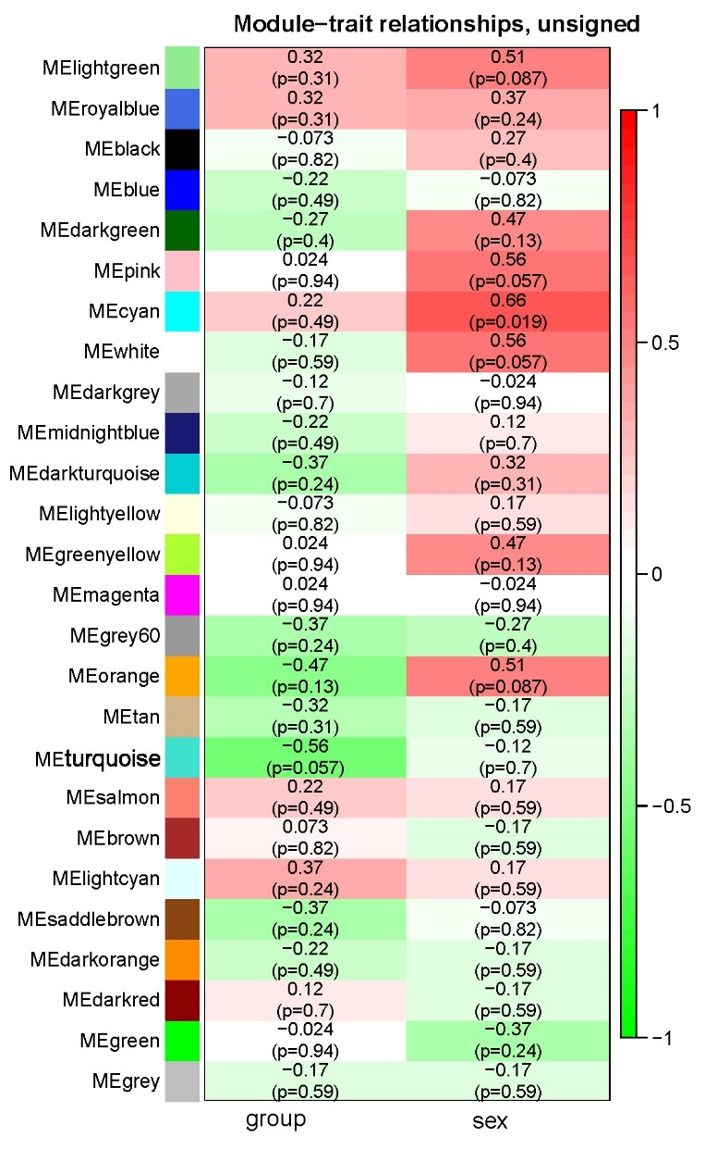
Module-trait associations using an unsigned gene network. Rows and columns represent eigengenes and traits, respectively. The group column is for Tg vs. Wt and sex is for female vs. male. The number in each cell represents Spearman’s correlation coefficient, along with its pval (p). Cells are colored according to their correlation coefficients.

Supplementary Figure S2

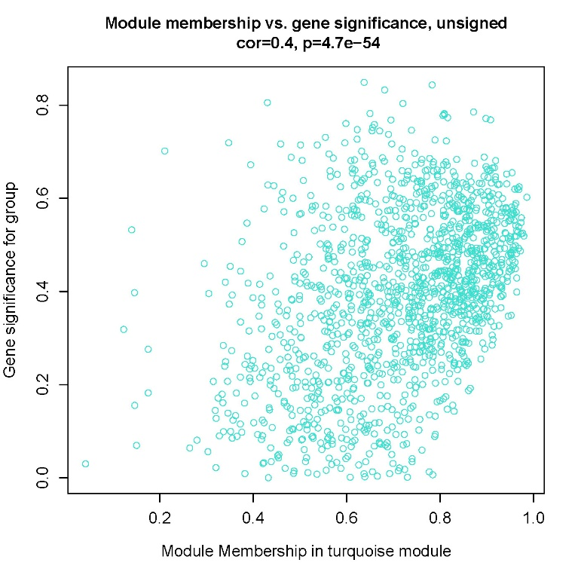
A scatterplot of gene significance vs module membership in the turquoise module. The two are significantly correlated, with Pearson’s correlation coefficient (cor)=0.4, and pval (p) close to 0.

Supplementary Figure S3

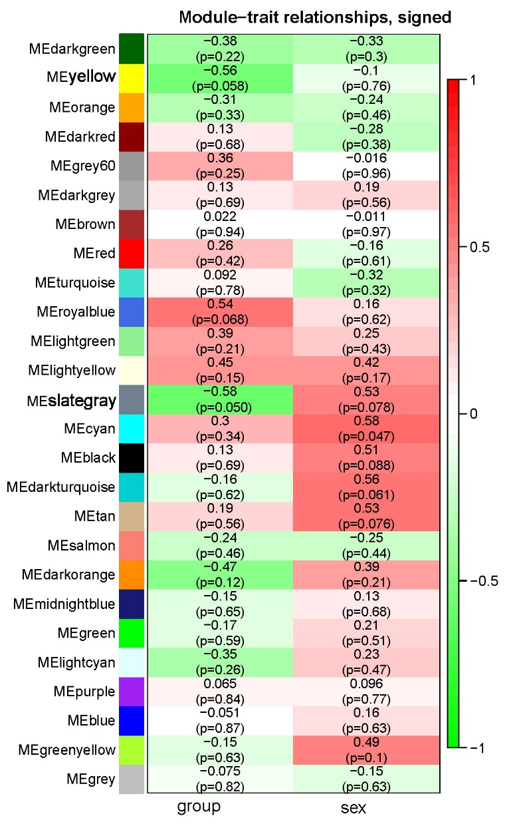
Module-trait associations using a signed gene network. Rows and columns represent eigengenes and traits, respectively. The group column is for Tg vs. Wt and sex is for female vs. male. The number in each cell represents Spearman’s correlation coefficient, along with its pval (p). Cells are colored according to their correlation coefficients.

Supplementary Figure S4

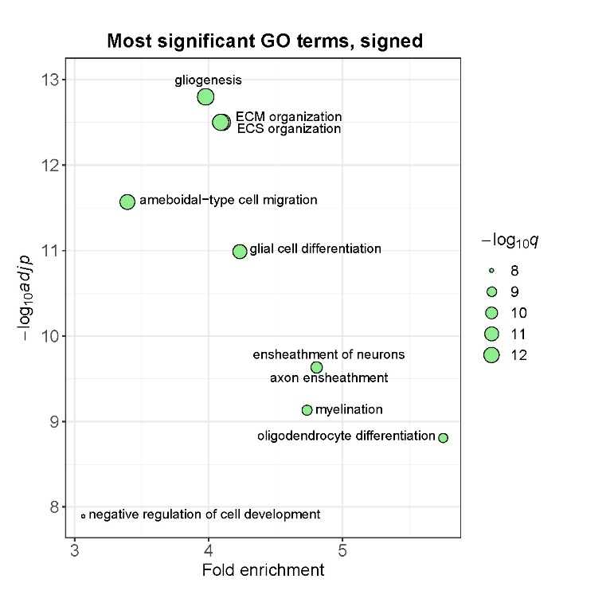
A bubble plot of top 10 GO terms enriched among the genes in the yellow module. Fold enrichment is the ratio of the proportion of input genes annotated in each GO term to the proportion of all genes annotated in the same term; padj=Benjamini-Hochberg-adjusted pval; q=FDR-adjusted pval. All terms in the plot belong to the biological process category.

Supplementary Figure S5
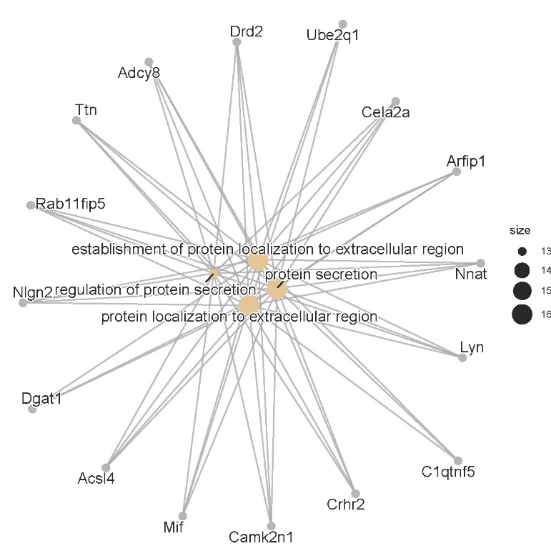

A “cnetplot” that displays the top four GO terms (Table 2) and related genes in the input gene list. It was generated using the cnetplot function available in the R enrichplot package. “size” refers to the number of genes assigned to each GO category

B. Supplementary Methods

Note that all raw datasets and how they were processed are available in GEO repository with accession numbers GSE223417 for RNA-seq and GSE223348 for BS-seq.

B.1. RNA-seq
RNA preparation was done in one batch, but library preparation and sequencing were done in two batches (batches 1 and 2 in B.1.5 below) because each library kit can accommodate a maximum of 8 samples. Each sample is tagged with a unique sample-specific barcode; so, samples were pooled together for cost-effective sequencing. The average number of total reads was 33.2 million per sample, which included all non-unique alignments. Following preprocessing and quality control, the average number of unambiguous, unique reads was 18 million per sample (B.1.2). The entire output from DESeq2 contains data from 30,372 genes (2.4 Mb in size), but most of them are not significant at all, with their p-val = 1. Only 100 of them are significant as differentially expressed genes between the control and Tg mice. In case, however, we uploaded a manageable Excel file containing 1,685 genes, including the top 100, and relevant statistical values (Deseq_out_1685.csv in Supplementary Data).

B.1.1. Downloading transcript count data from Ion Torrent Server

B.1.2. Transformation of Count data to an edgeR object using the DGEList function in the edgeR package

ID group lib.size* norm.factors sample_names sex
12 WT 16936130 1 12 F
32 TG 19496827 1 32 F
41 WT 18824542 1 41 M
67 TG 17781219 1 67 M
68 TG 19229417 1 68 M
69 TG 20995113 1 69 M
79 WT 21042580 1 79 F
80 WT 16251483 1 80 F
91 TG 18762170 1 91 F
92 TG 15803401 1 92 F
93 TG 17931268 1 93 F
95 WT 17994452 1 95 M
*The total number of unambiguous, unique reads

B.1.3. The edgeR object was analyzed by the R WGCNA package as directed by the package
# WGCNA recommends using unfiltered and unnormalized data

B.1.4. Filtering and normalization of data using calcNormFactors and cpm functions in edgeR

B.1.5. Setting up Design matrix using the model.matrix function in R DESeq2 package

model.matrix(~0+sex+batch+group)

sexF sexM batch2 groupWT
1 1 0 0 1
2 1 0 0 0
3 0 1 0 1
4 0 1 0 0
5 0 1 1 0
6 0 1 1 0
7 1 0 1 1
8 1 0 1 1
9 1 0 0 0
10 1 0 0 0
11 1 0 0 0
12 0 1 0 1

B.1.6. Selection of differentially expressed genes (DEG) using DESeqDataSetFromMatrix, DESeq, and results functions as directed by DESeq2 (Deseq_out_1685.csv)

---
out of 30377 with nonzero total read count
adjusted p-value < 0.1
LFC > 0 (up) : 84, 0.28%
LFC < 0 (down) : 16, 0.053%
outliers [1] : 5, 0.016%
low counts [2] : 0, 0%
---

B.1.7. 100 DEGs (deseq2_Deg.csv)

B.2. DNA methylomics using the R methylKit package
The raw DNA methylation dataset containing data for all 12 samples is 894 MB in size. Following the methylKit pipeline, the raw data were re-organized, using the unite function, to cover only the methylation sites that are covered in all samples. The resulting united dataset is 132 MB in size. After applying the 10% cutoff for absolute value of methylation percentage change and qvalue cutoff of 0.1, we have 443 differentially methylated sites (Diff_10per.csv). Positive meth.diff values indicate hypermethylation in Tg mice and negative meth.diff hypomethylation.

B.2.1. Reading in processed Bam files provided by ZymoResearch using methRead

obj.brn.11 = methRead(report.files, sample.id = list('12', '32','41', '48','67','68', '69', '79', '80', '91', '92', '93'),
assembly = "mm10", context = "CpG", treatment = c(0, 1, 0, 1, 1, 1, 1, 0, 0, 1, 1, 1))

# treatment = 0 (Wt) or 1 (Tg)
# obj.brn.11 is ~ 894 MB in size

B.2.2. Combining methyl data using the unite function

meth.brn.11 = unite(obj.brn.11, destrand = FALSE)
meth.brn.11, 131 MB in size, contains information for 981,122 DNA methylation sites for 11 samples.

B.2.3. Selection of Methy CpG sites where absolute methylation difference ≥ 10%, qvalue ≤ 0.1, and covariate adjustment for sex specified as ('F','F','M','M','M','M','M','F','F','F','F','F') using calculateDiffMeth and getMethylDiff functions (‘F’ = female and ‘M’=male)

# in Diff.10p.csv, positive meth.diff indicates hypermethylation in Tg mice and negative meth.diff indicates hypomethylation

B.2.4. Annotation of each methyl sites using biomaRt and org.Mm.eg.db packages

B.2.5. GO over-representation using enrichGO in clusterProfiler and cnetplot in enrichplot packages.

B6. Multi-block Discriminant Analysis DIABLO (Data Integration Analysis for Biomarker discovery using a Latent cOmponents)

RNA and DNA methylation datasets from 11 samples were analyzed using the block.splsda function in the R mixOmics package. The parameters include two input datasets (x1=RNA data; x2=DNA methylation data) and the response variable (y = Wt or Tg). The goal was to select 500 features for the first two components that discriminate between the two groups of samples. The two components were selected using selectVar function (diablo_r1.csv, diablo_r2.csv, diablo_d1_raw.csv, diablo_d2_raw.csv in Supplementary Data) and gene names (diablo_d1_gene.csv, diablo_d2_gene.csv) of the selected DNA methylation sites were retrieved using biomaRt and org.Mm.eg.db packages.

C. Supplementary Data

Supplementary_Data.zip contains the following files:

dms_443-gene_182.cvs
Diff_10per.csv
diablo_r1.csv
diablo_r2.csv
diablo_d1_raw.csv
diablo_d1_gene.csv
diablo_d2_raw.csv
diablo_d2_gene.csv
Deseq_out_1685.csv
ego_10p.csv
ego_diablo_r2.csv

