Table S1 The number and percentage (%) of antimicrobial resistant isolates in different serotypes of S. suis.
Antimicrobials | Serotype 1 |  |  | Serotype 2 |  |  | Serotype 3 |  |  | Serotype 7 |  |  | Serotype 8 |  |  | Serotype 9 |  |  | Untypable |  |  | Other |  | Total
Antimicrobials | (n = 28) |  |  | (n = 32) |  |  | (n = 79) |  |  | (n = 50) |  |  | (n = 45) |  |  | (n = 32) |  |  | (n = 73) |  |  | (n = 49) |  | (n = 388)
Antimicrobials | No. |  | R% | No. |  | R% | No. |  | R% | No. |  | R% | No. |  | R% | No. |  | R% | No. |  | R% | No. | R% | No. | R%
Penicillin G | 1 |  | 3.6 | 1 |  | 3.1 | 7 |  | 8.9 | 28 |  | 56.0 | 37 |  | 82.2 | 26 |  | 81.3 | 43 |  | 58.9 | 20 | 40.8 | 163 | 42.0
Amoxicillin | 1 |  | 3.6 | 2 |  | 6.3 | 12 |  | 15.2 | 19 |  | 38.0 | 36 |  | 80.0 | 26 |  | 81.3 | 35 |  | 47.9 | 20 | 40.8 | 151 | 38.9
Cefazolin | 0 |  | 0.0 | 0 |  | 0.0 | 2 |  | 2.5 | 7 |  | 14.0 | 2 |  | 4.4 | 1 |  | 3.1 | 18 |  | 24.7 | 5 | 10.2 | 35 | 9.0
Ceftiofur | 0 |  | 0.0 | 0 |  | 0.0 | 0 |  | 0.0 | 3 |  | 6.0 | 1 |  | 2.2 | 0 |  | 0.0 | 9 |  | 12.3 | 1 | 2.0 | 14 | 3.6
Vancomycin | 0 |  | 0.0 | 0 |  | 0.0 | 0 |  | 0.0 | 0 |  | 0.0 | 1 |  | 2.2 | 0 |  | 0.0 | 0 |  | 0.0 | 0 | 0.0 | 1 | 0.3
Gentamicin | 9 |  | 32.1 | 5 |  | 15.6 | 13 |  | 16.5 | 14 |  | 28.0 | 3 |  | 6.7 | 5 |  | 15.6 | 21 |  | 28.8 | 9 | 18.4 | 79 | 20.4
Oxytetracycline | 28 |  | 100.0 | 31 |  | 96.9 | 75 |  | 94.9 | 42 |  | 84.0 | 38 |  | 84.4 | 29 |  | 90.6 | 65 |  | 89.0 | 49 | 100.0 | 357 | 92.0
Doxycycline | 22 |  | 78.6 | 16 |  | 50.0 | 20 |  | 25.3 | 16 |  | 32.0 | 15 |  | 33.3 | 21 |  | 65.6 | 40 |  | 54.8 | 25 | 51.0 | 175 | 45.1
Erythromycin | 24 |  | 85.7 | 25 |  | 78.1 | 78 |  | 98.7 | 35 |  | 70.0 | 39 |  | 86.7 | 27 |  | 84.4 | 59 |  | 80.8 | 44 | 89.8 | 331 | 85.3
Clarithromycin | 25 |  | 89.3 | 20 |  | 62.5 | 71 |  | 89.9 | 32 |  | 64.0 | 36 |  | 80.0 | 24 |  | 75.0 | 51 |  | 69.9 | 38 | 77.6 | 297 | 76.5
Tylosin | 28 |  | 100.0 | 28 |  | 87.5 | 78 |  | 98.7 | 40 |  | 80.0 | 38 |  | 84.4 | 29 |  | 90.6 | 66 |  | 90.4 | 47 | 95.9 | 354 | 91.2
Lincomycin | 28 |  | 100.0 | 31 |  | 96.9 | 78 |  | 98.7 | 41 |  | 82.0 | 40 |  | 88.9 | 31 |  | 96.9 | 70 |  | 95.9 | 49 | 100.0 | 368 | 94.8
Lincospectin | 6 |  | 21.4 | 20 |  | 62.5 | 62 |  | 78.5 | 29 |  | 58.0 | 35 |  | 77.8 | 28 |  | 87.5 | 45 |  | 61.6 | 34 | 69.4 | 259 | 66.8
Florfenicol | 13 |  | 46.4 | 4 |  | 12.5 | 15 |  | 19.0 | 17 |  | 34.0 | 12 |  | 26.7 | 11 |  | 34.4 | 35 |  | 47.9 | 14 | 28.6 | 121 | 31.2
Tiamulin | 3 |  | 10.7 | 4 |  | 12.5 | 16 |  | 20.3 | 27 |  | 54.0 | 23 |  | 51.1 | 24 |  | 75.0 | 40 |  | 54.8 | 18 | 36.7 | 155 | 39.9
Enrofloxacin | 4 |  | 14.3 | 5 |  | 15.6 | 11 |  | 13.9 | 21 |  | 42.0 | 35 |  | 77.8 | 28 |  | 87.5 | 29 |  | 39.7 | 22 | 44.9 | 155 | 39.9
Sulfamethoxazole-  trimethoprim | 9 |  | 32.1 | 2 |  | 6.3 | 3 |  | 3.8 | 7 |  | 14.0 | 3 |  | 6.7 | 6 |  | 18.8 | 17 |  | 23.3 | 4 | 8.2 | 51 | 13.1
No.: number of isolates; R%: percentage of antimicrobial resistant isolates

Table S2 Organ distribution among feeding periods.
Feeding period | Brain/ Spinal cord |  | Lung/ Bronchus |  | Liver |  | Joint |  | Other# |  | Total
Feeding period | (n = 42) |  | (n = 270) |  | (n = 36) |  | (n = 24) |  | (n = 16) |  | (n = 388)
Suckling pigs | 15 | *** | 23 | *** | 9 |  | 12 | *** | 5 |  | 64
Nursery pigs | 26 |  | 178 |  | 26 |  | 11 |  | 4 |  | 245
Growing pigs |  |  | 43 | ** | 1 |  | 1 |  | 5 |  | 50
Fattening pigs | 1 |  | 18 | * |  |  |  |  |  |  | 19
Breeding pigs |  |  | 2 |  |  |  |  |  | 2 |  | 4
Unknow |  |  | 6 |  |  |  |  |  |  |  | 6
#: include heart, pericardial fluid, pleural fibrin, spleen, stomach, eye, and nasal.
No.: number of isolates
*: p < 0.05; **: p < 0.01; ***: p < 0.001

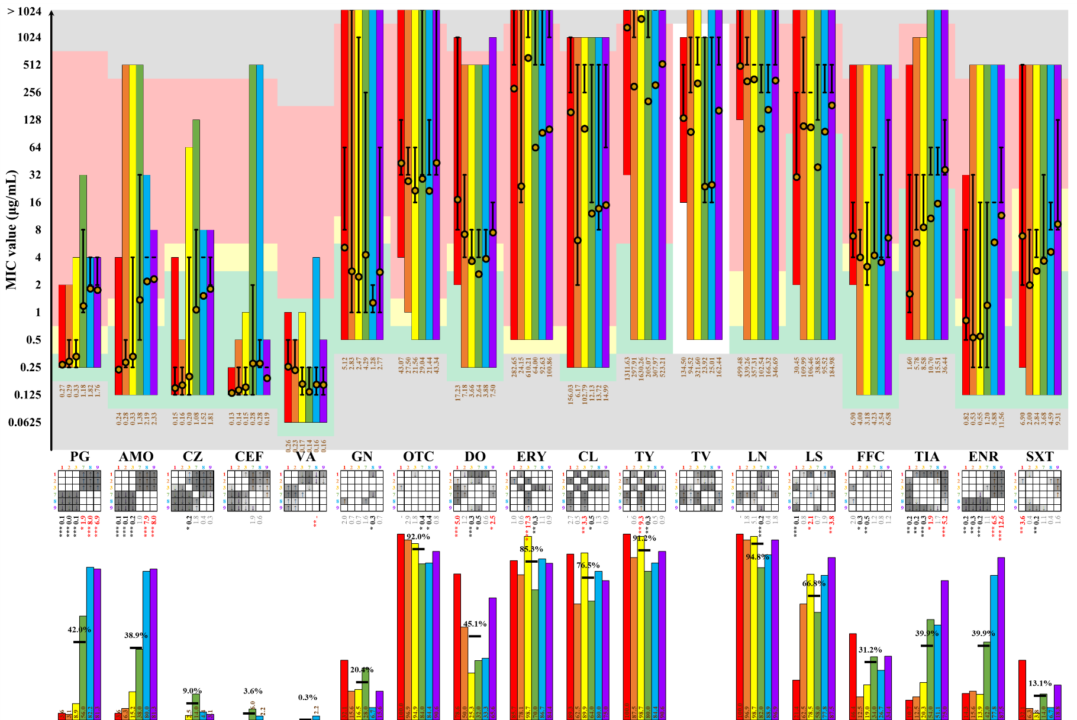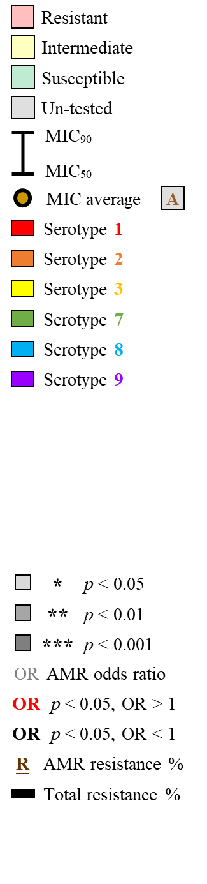

Figure S1 MIC values of antimicrobials in different serotypes of S. suis.

