Supplemental Figures

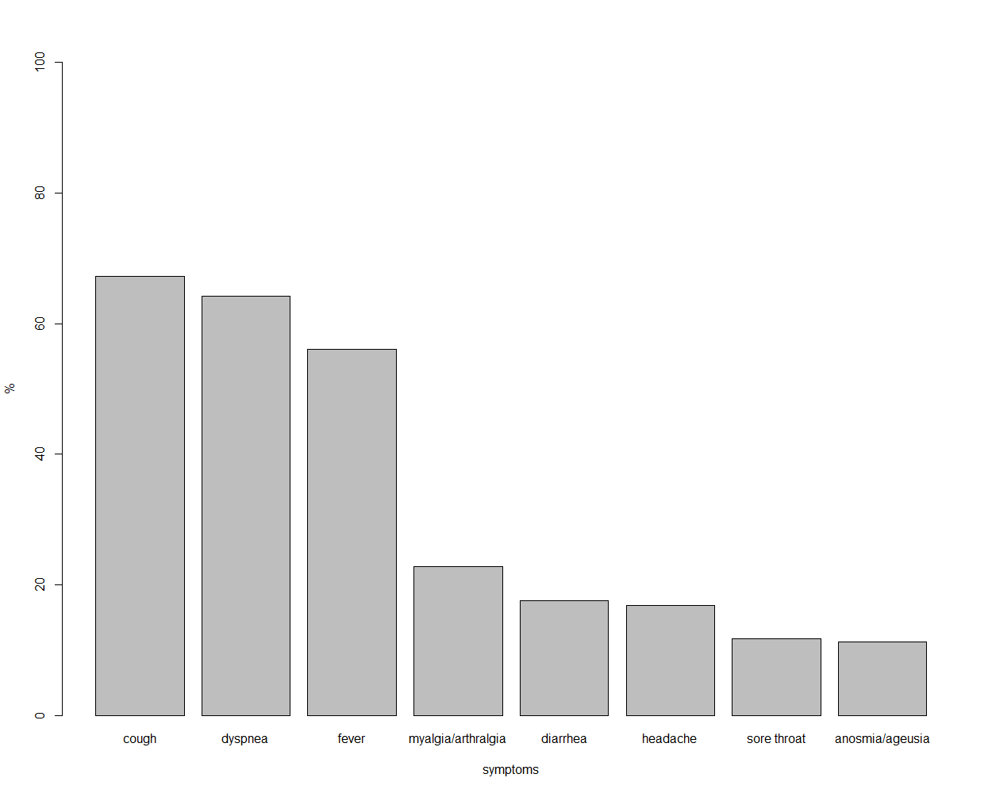
Supplemental Figure 1: COVID-19 symptoms among 469 symptomatic SARS-CoV-2 infected patients

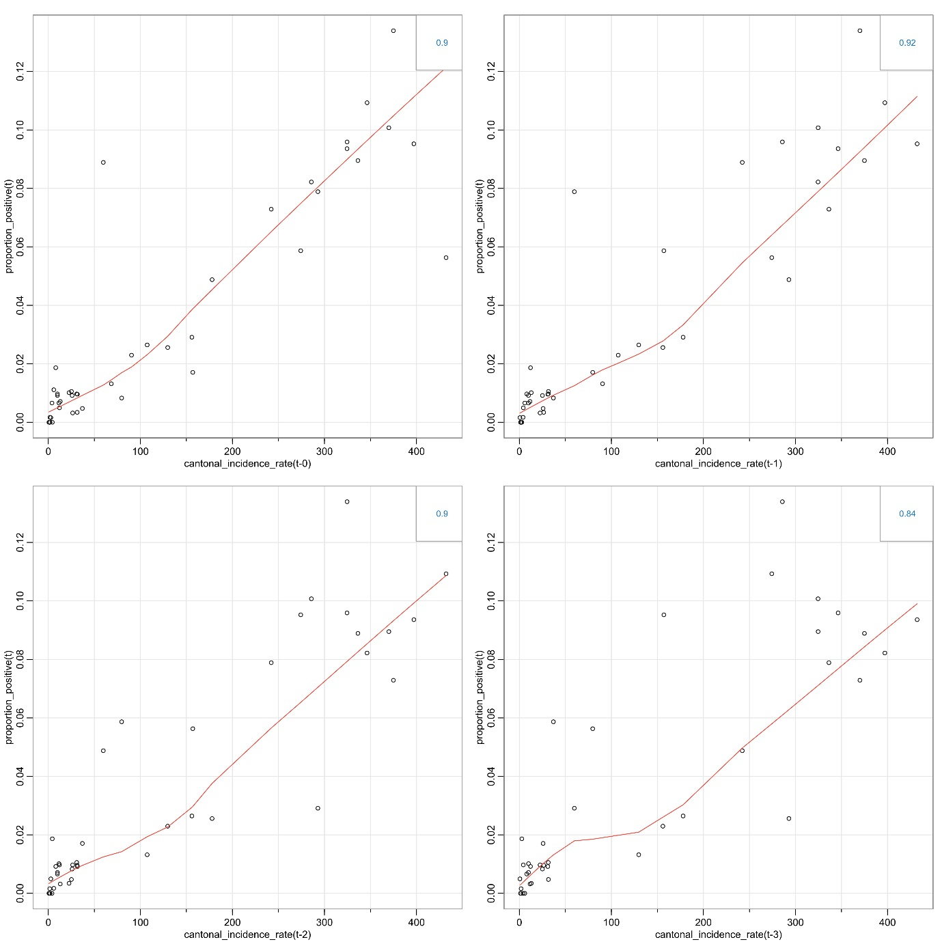
Supplemental Figure 2: Lag plot for correlation of cantonal SARS-CoV-2 incidence rate and proportion of individuals with a positive SARS-CoV-2 test on admission

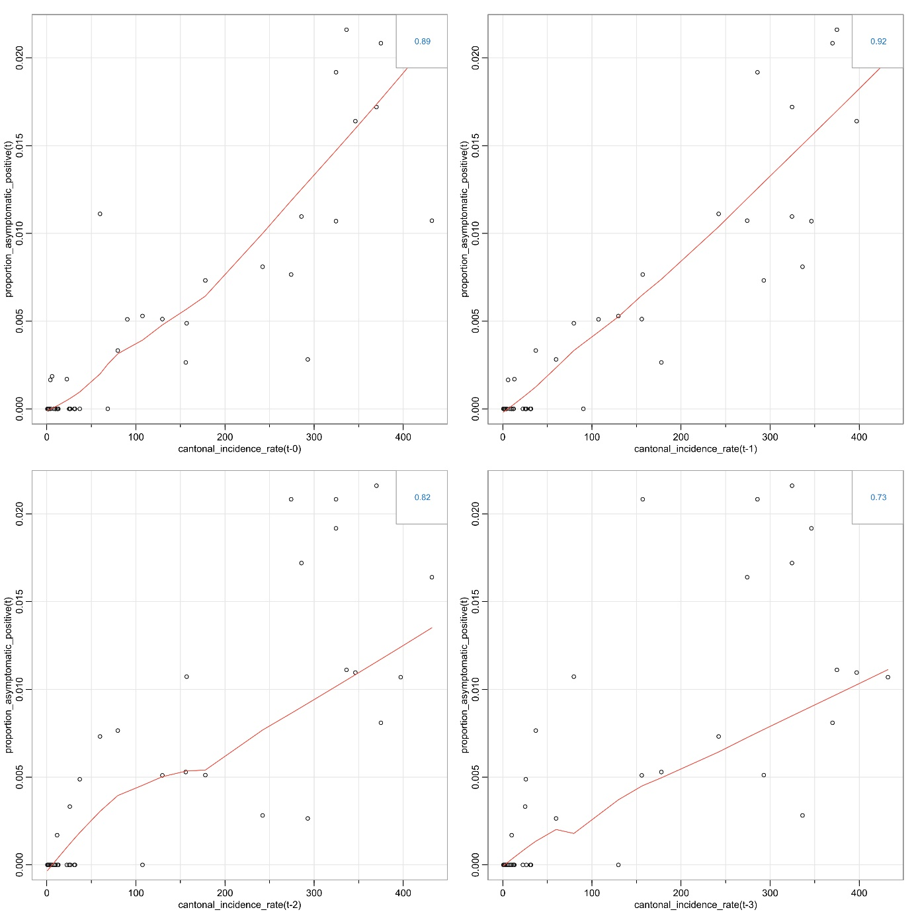
Supplemental Figure 3: Lag plot for correlation of cantonal SARS-CoV-2 incidence rate and the proportion of asymptomatic patients with a positive SARS-CoV-2 test on admission

