Supplementary Information

Supplement to:

Beloconi A., Nyawanda B.O., Bigogo G., Khagayi S., Obor D., Danquah I., Kariuki S., Munga S.,

& Vounatsou P. Malaria, climate variability, and interventions: modelling transmission dynamics.

Contents:

Figure S1: Malaria cases, rainfall and air temperature

Figure S2: Effect of climatic and bed net use variables on malaria transmission

Table S1: Fitted parameters of the best malaria stochastic transmission model with splines, rainfall, air temperature and bed net use covariates.

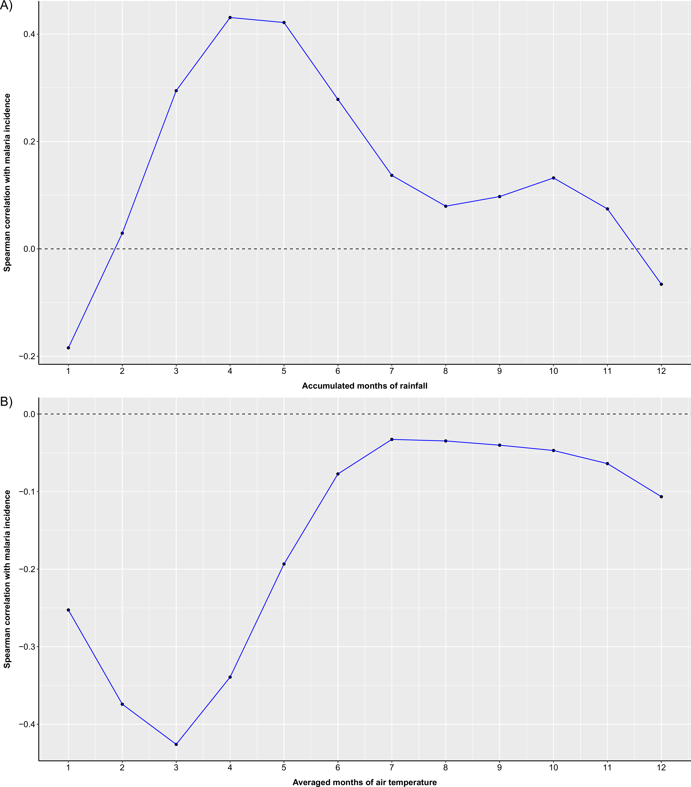

Figure S1: Malaria cases, rainfall and air temperature. A. Correlation between accumulated rainfalls in different time windows preceding the month of reported malaria cases. A maximum positive correlation is observed when rainfall is accumulated over 4 months (i.e. during the current and previous three months). B. Correlation between averaged air temperatures during different time windows preceding the month of reported malaria cases. A maximum negative correlation is observed when air temperature is averaged over 3 months (i.e. during the current and previous two months).
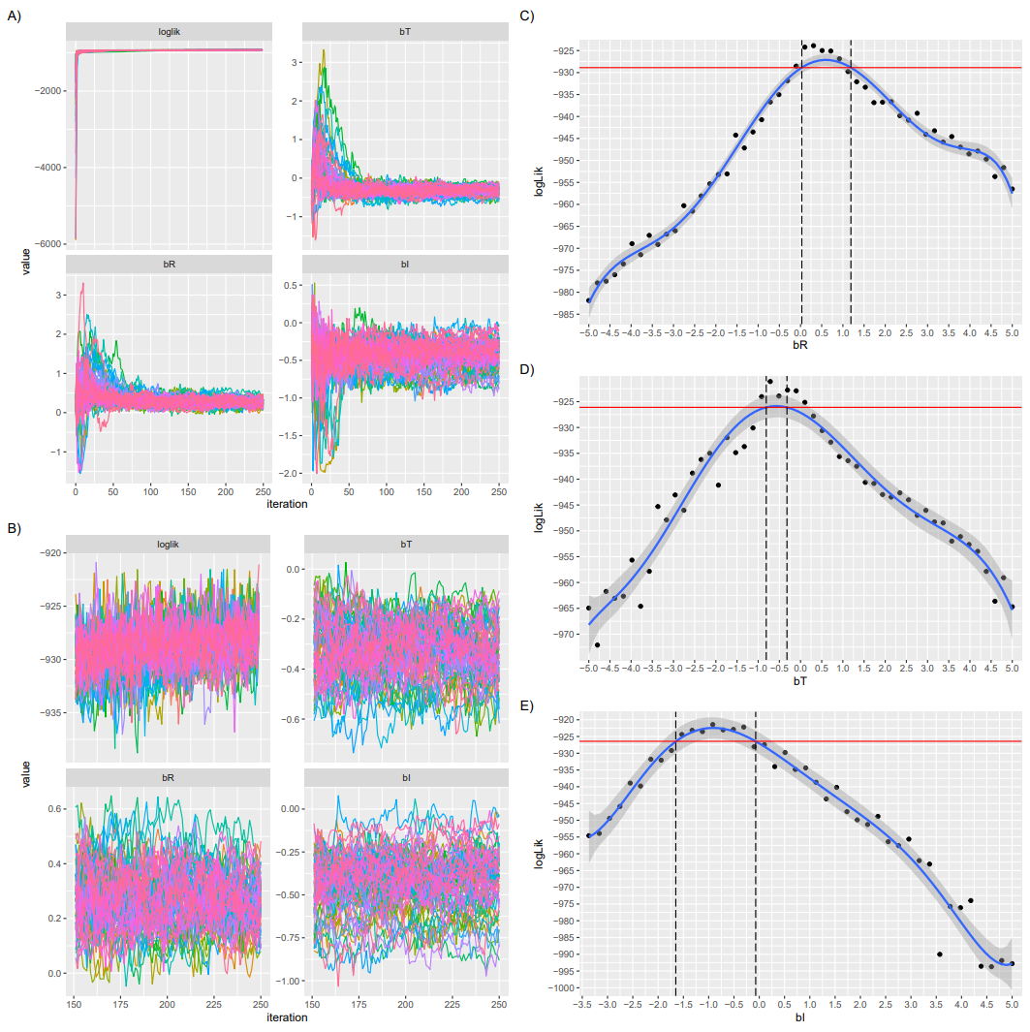
Figure S2: Effect of climatic and bed net use variables on malaria transmission. A. Convergence of the regression coefficients $b_{T}$, $b_{R}$ and $b_{I}$ corresponding to the temperature, rainfall and proportion of bed net use variables, respectively. The plot shows the changes in these parameters and the log-likelihood (loglik) during the 250 iterations of the iterative filtering algorithm. Starting from random values within a [-5, 5] interval, all the three regression coefficients indicate small variability after 50th iteration. B. Same plot as in A but zoomed in the last 100 iterations. C, D, E. Profile likelihood curves of regression coefficients for air temperature (C), rainfall (D), and proportion of bed net use (E), and the corresponding confidence intervals (computed as the points at which the profile curve crosses the horizontal line five log-likelihood units below the maximum likelihood estimate).
Table S1: Fitted parameters of the best malaria stochastic transmission model with splines, rainfall, air temperature and bed net use covariates.
Parameter | Description | Starting Values | Estimate
Temperature ($b_{T}$ ) | Air temperature (2m above ground) regression coefficient | [-5, 5] | -0.278
Rainfall ($b_{R}$) | Accumulated Rainfall (CHIRPS) regression coefficient | [-5, 5] | 0.284
Intervention ($b_{I}$) | % Bed net use (PBIDS/HDSS) regression coefficient | [-5, 5] | -0.517
Spline coefficient b₁ | B-spline regression coefficient | [-10, 10] | 3.430
Spline coefficient b₂ | B-spline regression coefficient | [-10, 10] | 0.382
Spline coefficient b₃ | B-spline regression coefficient | [-10, 10] | 6.076
Spline coefficient b₄ | B-spline regression coefficient | [-10, 10] | 1.479
Spline coefficient b₅ | B-spline regression coefficient | [-10, 10] | 2.182
Spline coefficient b₆ | B-spline regression coefficient | [-10, 10] | 2.624
1/µ_{EI}1 | Time from exposed to infected | [1, 365] | 25.2 days
1/µI1S1 | Time from infected to susceptible | [1, 365] | 20.5 days
1/µI1I2 | Time from symptomatic to asymptomatic | [1, 365] | 236.3 days
1/µI2S2 | Time from asymptomatic to recovered | [1, 365] | 645.8 days
1/µS2S1 | Time from recovered to susceptible | [1, 365] | 950.3 days
ψ | Dispersion parameter of the observation noise | [0, 0.5] | 0.179
σ | Standard deviation of the process noise | [0, 0.5] | 0.244
ρ | Reporting rate | [0, 1] | 0.161
q | Relative infectivity of partially immune individuals | [0, 1] | 0.680
c | Coefficient of reinfection with clinical immunity | [0, 1] | 0.053
[S₁]₀ | Initial susceptible population | [0%, 100%] | 3.2%
[E]₀ | Initial exposed population | [0%, 100%] | 7.7%
[I₁]₀ | Initial infected symptomatic population | [0%, 100%] | 28.1%
[I₂]₀ | Initial infected asymptomatic population | [0%, 100%] | 6.1%
[S₂]₀ | Initial protected population | [0%, 100%] | 54.8%
[λ₁]₀ | Initial values for the latent force of infection | [0, 10] | 2.55
[λ₂]₀ | Initial values for the latent force of infection | [0, 10] | 0.25

