Investigating the association between glycaemic traits and colorectal cancer in the Japanese population using Mendelian randomisation

Akiko Hanyuda, Atsushi Goto, Ryoko Katagiri, Yuriko N. Koyanagi, Masahiro Nakatochi, Yoichi Sutoh, Shiori Nakano, Isao Oze, Hidemi Ito, Taiki Yamaji, Norie Sawada, Masao Iwagami, Aya Kadota, Teruhide Koyama, Sakurako Katsuura-Kamano, Hiroaki Ikezaki, Keitaro Tanaka, Toshiro Takezaki, Issei Imoto, Midori Suzuki, Yukihide Momozawa, Kenji Takeuchi, Akira Narita, Atsushi Hozawa, Kengo Kinoshita, Atsushi Shimizu, Kozo Tanno, Keitaro Matsuo, Shoichiro Tsugane, Kenji Wakai, Makoto Sasaki, Masayuki Yamamoto, Motoki Iwasaki

Supplementary materials

Supplementary Table S1. Studies selected from the GWAS Catalog
Supplementary Table S2. Single nucleotide polymorphisms used as instrumental variables for fasting glucose, HbA1c, and fasting C-peptide
Supplementary Table S3. Single nucleotide polymorphisms used as instrumental variables for colorectal cancer
Supplementary Table S4. Study description in terms of exposure (fasting glucose, HbA1c, and fasting C-peptide)
Supplementary Table S5. Information on genotyping methods, quality controls for single nucleotide polymorphisms, imputation, and statistical analysis for studies
Supplementary Table S6. Study description in terms of outcome (colorectal cancer)
Supplementary Table S7. Characteristics of the studies considered for the analysis of SNP-glycaemic trait associations
Supplementary Table S8. Characteristics of the studies considered for the analysis of SNP-colorectal cancer associations

Supplementary Figure S1. Flow chart of single nucleotide polymorphism selection from the literature
Supplementary Figure S2. Analyses of fasting glucose and colorectal cancer risk
a). Scatter plots of genetic association with colorectal cancer (outcome) over genetic association with fasting glucose (exposure)
b). Leave-one-out sensitivity analysis of genetic association with colorectal cancer (outcome) over genetic association with fasting glucose (exposure)
c). Funnel plot of IV precisions (1/SE_{IV}) against the IV estimates (β_{IV}) for fasting glucose
Supplementary Figure S3. Analyses of HbA1c and colorectal cancer risk
a). Scatter plots of genetic association with colorectal cancer (outcome) over genetic association with HbA1c (exposure)
b). Leave-one-out sensitivity analysis of genetic association with colorectal cancer (outcome) over genetic association with HbA1c (exposure)
c). Funnel plot of IV precisions (1/SE_{IV}) against the IV estimates (β_{IV}) for HbA1c
Supplementary Figure S4. Analyses of fasting C-peptide and colorectal cancer risk
a). Scatter plots of genetic association with colorectal cancer (outcome) over genetic association with fasting C-peptide (exposure)
b). Leave-one-out sensitivity analysis of genetic association with colorectal cancer (outcome) over genetic association with fasting C-peptide (exposure)
c). Funnel plot of IV precisions (1/SE_{IV}) against the IV estimates (β_{IV}) for fasting C-peptide

Supplementary Table S1. Studies selected from the GWAS Catalog

Phenotype | Publication | Populations | Sample size | Number of SNPs | First author | Journal | Publication date
Fasting glucose | 17903298 | NR | 1,027 individuals | 1 | Meigs JB | BMC Med Genet | 2007/9/19
Fasting glucose | 20081858 | Europeans | 100,502 individuals | 9 | Dupuis J | Nat Genet | 2010/1/17
Fasting glucose | 22581228 | Europeans | 85,573 individuals | 3 | Manning AK | Nat Genet | 2012/5/13
Fasting glucose | 22885924 | Europeans | 133,010 non-diabetic individuals | 11 | Scott RA | Nat Genet | 2012/8/12
Fasting glucose | 25187374 | East Asians | 46,085 individuals | 5 | Hwang JY | Diabetes | 2014/9/3
Fasting glucose | 25631608 | Trans-ethnic | 50,900 European ancestry non-diabetic individuals,  9,664 African American non-diabetic individuals | 1 | Wessel J | Nat Commun | 2015/1/29
Fasting glucose | 28270201 | Europeans | 19,965 individuals | 1 | Nagy R | Genome Med | 2017/3/7
Fasting glucose | 31021400 | Europeans | 46,186 individuals | 1 | Masotti M | Biometrics | 2019/4/25
Fasting glucose | 31170924 | Koreans | 9,932 individuals | 1 | Kong S | BMC Med Genet | 2019/6/6
Fasting glucose | 31217584 | Trans-ethnic | 9,720 African American individuals, 17,373 Hispanic/Latino individuals, 2,316 Asian ancestry individuals, 1,900 Native Hawaiian ancestry individuals, 591 Native American ancestry individuals, 321 individuals | 1 | Wojcik GL | Nature | 2019/6/19
HbA1c | 24647736 | Asians | 17,290 East Asian ancestry individuals, 1,727 Malay ancestry individuals, 13585 East Asian individuals | 2 | Chen P | Diabetes | 2014/3/19
HbA1c | 28887542 | Europeans | 35623 Europeans | 1 | Prins BP | Sci Rep | 2017/9/8
HbA1c | 28898252 | South Asians | 7,572 South Asians | 23 | Wheeler E | PLoS Med | 2017/9/12
HbA1c | 29403010 | Japanese | 42,790 Japanese individuals | 17 | Kanai M | Nat Genet | 2018/2/5
Fasting C-peptide* | 20081858 | Europeans | 100,502 | 1 | Dupuis J | Nat Genet | 2010/1/17
Fasting C-peptide* | 22581228 | Europeans | 85,573 | 2 | Manning AK | Nat Genet | 2012/5/13
Fasting C-peptide* | 22885924 | Europeans | 108,557 non-diabetic individuals | 10 | Scott RA | Nat Genet | 2012/8/12
Fasting C-peptide* | 28898252 | South Asians | 7,572 South Asians | 1 | Wheeler E | PLoS Med | 2017/9/12
Fasting C-peptide* | 31217584 | Trans-ethnic | 9,720 African American individuals, 17,373 Hispanic/Latino individuals, 2,316 Asian ancestry individuals, 1,900 Native Hawaiian ancestry individuals, 591 Native American ancestry individuals, 321 individuals | 3 | Wojcik GL | Nature | 2019/6/19

*Due to the unavailability of selecting SNPs for FC, we substituted fasting insulin for FC when selecting instrumental variables.
Abbreviations: HbA1c, haemoglobin A1c.

Supplementary Table S2. Single nucleotide polymorphisms used as instrumental variables for fasting glucose, HbA1c, and fasting C-peptide

Trait | Nearby gene | Chr | Chr position (hg19) | rs ID | REF | ALT | Effect | SE | P-value | EAF | I² | q-pvalue†
FG | PROX1 | 1 | 214159256 | rs340874 | T | C | 0.219206 | 0.101255 | 3.04×10⁻² | 0.391485 | 0 | 0.5438
FG | KRTCAP2P1, SIX3 | 2 | 45188353 | rs895636 | C | T | 0.783856 | 0.099623 | 3.60×10⁻¹⁵ | 0.421699 | 0 | 0.6913
FG | GCKR | 2 | 27741237 | rs780094 | T | C | 0.852007 | 0.099789 | 1.37×10⁻¹⁷ | 0.443599 | 0 | 0.4331
FG | G6PC2 | 2 | 169763148 | rs560887 | T | C | 0.705426 | 0.32061 | 2.78×10⁻² | 0.974460 | 42 | 0.1783
FG | DPYSL5 | 2 | 27152874 | rs1371614 | C | T | 0.227719 | 0.136922 | 9.63×10⁻² | 0.153309 | 0 | 0.8472
FG | SLC2A2 | 3 | 170713290 | rs1280 | T | C | 0.025754 | 0.341432 | 9.40×10⁻² | 0.021026 | 0 | 0.6037
FG | IGF2BP2 | 3 | 185513392 | rs7651090 | A | G | 0.186265 | 0.106662 | 8.08×10⁻² | 0.308554 | 0 | 0.8642
FG | ZBED3-AS1 | 5 | 76425867 | rs7708285 | G | A | 0.018747 | 0.367308 | 9.59×10⁻² | 0.982870 | 0 | 0.844
FG | MIR583HG | 5 | 95539448 | rs4869272 | C | T | 0.279131 | 0.117397 | 1.74×10⁻² | 0.768765 | 57.1 | 0.0972
FG | CDKAL1 | 6 | 20685486 | rs9356744 | T | C | 0.499253 | 0.100795 | 7.30×10⁻⁷ | 0.414930 | 40.1 | 0.1883
FG | RREB1 | 6 | 7213200 | rs17762454 | C | T | 0.097844 | 0.102161 | 3.38×10⁻² | 0.367189 | 47.4 | 0.1493
FG | GTF3AP5 | 7 | 15064309 | rs2191349 | G | T | 0.795411 | 0.10941 | 3.59×10⁻¹³ | 0.670149 | 21.7 | 0.2789
FG | YKT6 | 7 | 44245853 | rs917793 | A | T | 0.765311 | 0.122253 | 3.85×10⁻¹⁰ | 0.201035 | 34.1 | 0.2191
FG | ZMAT4 | 8 | 40484239 | rs2722425 | T | C | -0.18227 | 0.110742 | 9.98×10⁻² | 0.727011 | 41.6 | 0.1802
FG | RNU6-526P, RNU6-1151P | 8 | 9177732 | rs983309 | T | G | -1.52082 | 0.466519 | 1.11×10⁻³ | 0.977364 | 9.1 | 0.333
FG | SLC30A8 | 8 | 118185733 | rs11558471 | A | G | -0.57015 | 0.098911 | 8.20×10⁻⁹ | 0.449801 | 21.8 | 0.2786
FG | CDKN2B-AS1 | 9 | 22134094 | rs10811661 | T | C | -0.53487 | 0.099881 | 8.55×10⁻⁸ | 0.437637 | 11.2 | 0.3244
FG | GLIS3 | 9 | 4293150 | rs10814916 | A | C | 0.228968 | 0.102991 | 2.62×10⁻² | 0.458665 | 0 | 0.4727
FG | KANK1 | 9 | 622523 | rs10815355 | G | T | 0.422827 | 0.155652 | 6.60×10⁻³ | 0.142533 | 0 | 0.9904
FG | DNLZ | 9 | 139256766 | rs3829109 | G | A | -0.34261 | 0.144251 | 1.76×10⁻² | 0.139511 | 0 | 0.6534
FG | BTBD7P2 | 10 | 113042093 | rs10885122 | T | G | 0.305823 | 0.167322 | 6.76×10⁻² | 0.901746 | 83.7 | 0.002202
FG | TCF7L2 | 10 | 114754088 | rs7901695 | T | C | 0.600784 | 0.23533 | 1.07×10⁻² | 0.045795 | 0 | 0.6668
FG | FADS1 | 11 | 61571478 | rs174550 | T | C | -0.37234 | 0.099902 | 1.94×10⁻⁴ | 0.417274 | 0 | 0.8006
FG | ARAP1 | 11 | 72432985 | rs11603334 | G | A | -0.55186 | 0.269613 | 4.07×10⁻² | 0.036191 | 0 | 0.9705
FG | MTNR1B | 11 | 92708710 | rs10830963 | C | G | 0.599059 | 0.100752 | 2.75×10⁻⁹ | 0.417156 | 6.9 | 0.3417
FG | MADD | 11 | 47346723 | rs11039182 | T | C | -0.41529 | 0.449181 | 3.55×10⁻¹ | 0.013595 | 55.7 | 0.1046
FG | GLS2 | 12 | 56865338 | rs2657879 | A | G | 0.167869 | 0.162102 | 3.00×10⁻¹ | 0.103048 | 18.3 | 0.2942
FG | PDX1 | 13 | 28491198 | rs2293941 | G | A | 0.417594 | 0.098711 | 2.33×10⁻⁵ | 0.458882 | 0 | 0.4629
FG | TOMM22P3 | 13 | 33554302 | rs576674 | G | A | -0.44406 | 0.147568 | 2.62×10⁻³ | 0.873439 | 0 | 0.5293
FG | WARS1 | 14 | 100839261 | rs3783347 | G | T | -0.18215 | 0.167075 | 2.76×10⁻¹ | 0.096857 | 56.8 | 0.09863
FG | NPM1P47 | 15 | 62383155 | rs4502156 | T | C | -0.23047 | 0.098344 | 1.91×10⁻² | 0.485988 | 27.9 | 0.2496
FG | DHRS7B | 17 | 21073289 | rs118084662 | A | G | 0.121639 | 0.411434 | 7.68×10⁻¹ | 0.012583 | 31.4 | 0.2327
FG | LNCNEF | 20 | 22581268 | rs6048216 | T | C | -0.70521 | 0.125503 | 1.92×10⁻⁸ | 0.190365 | 0 | 0.4592
FG | DSCAM | 21 | 41939569 | rs455489 | A | C | 0.000646 | 0.238584 | 9.98×10⁻¹ | 0.042756 | 61.6 | 0.07385
HbA1c | TMEM79 | 1 | 156255456 | rs6684514 | G | A | -0.03594 | 0.002361 | 2.56×10⁻⁵² | 0.212549 | 0 | 0.7305
HbA1c | SPTA1 | 1 | 158626378 | rs857691 | C | T | 0.014333 | 0.002088 | 6.70×10⁻¹² | 0.325222 | 82.2 | 0.003687
HbA1c | ATAD2B | 2 | 24021231 | rs17509001 | T | C | 0.011995 | 0.008889 | 1.77×10⁻¹ | 0.013197 | 50.8 | 0.1312
HbA1c | KRTCAP2P1, SIX3 | 2 | 45192080 | rs12712928 | G | C | 0.027315 | 0.001977 | 2.09×10⁻⁴³ | 0.423123 | 0 | 0.6325
HbA1c | G6PC2 | 2 | 169763148 | rs560887 | T | C | 0.034282 | 0.006654 | 2.58×10⁻⁷ | 0.976991 | 34.1 | 0.2194
HbA1c | LINC00690 | 3 | 12267648 | rs7616006 | A | G | -0.00304 | 0.002144 | 1.56×10⁻¹ | 0.291713 | 51.7 | 0.1264
HbA1c | SLC2A2 | 3 | 170724883 | rs8192675 | T | C | -0.01999 | 0.002405 | 9.46×10⁻¹⁷ | 0.204862 | 0 | 0.8509
HbA1c | IGF2BP2 | 3 | 185518921 | rs76922886 | G | A | 0.008939 | 0.002115 | 2.38×10⁻⁵ | 0.305273 | 0 | 0.5245
HbA1c | USP4 | 3 | 49382925 | rs9818758 | G | A | -0.00242 | 0.004 | 5.46×10⁻¹ | 0.060026 | 0 | 0.9367
HbA1c | FREM3 | 4 | 144659795 | rs13134327 | G | A | 0.004479 | 0.002213 | 4.30×10⁻² | 0.263115 | 0 | 0.9474
HbA1c | CDKAL1 | 6 | 20675792 | rs35261542 | C | A | 0.023255 | 0.001991 | 1.65×10⁻³¹ | 0.413167 | 0 | 0.3826
HbA1c | CCDC162P | 6 | 109562035 | rs11964178 | A | G | -0.00537 | 0.00228 | 1.86×10⁻² | 0.245248 | 0 | 0.5134
HbA1c | HBS1L | 6 | 135418916 | rs7776054 | A | G | -0.02741 | 0.002067 | 3.95×10⁻⁴⁰ | 0.340758 | 82.4 | 0.003439
HbA1c | MIR129-1 | 7 | 127841626 | rs4728092 | C | A | 0.012418 | 0.003194 | 1.01×10⁻⁴ | 0.112819 | 0 | 0.4983
HbA1c | YKT6 | 7 | 44235668 | rs4607517 | G | A | 0.02936 | 0.002372 | 3.44×10⁻³⁵ | 0.210306 | 0 | 0.5928
HbA1c | ANK1 | 8 | 41630405 | rs4737009 | G | A | 0.019487 | 0.001956 | 2.19×10⁻²³ | 0.440431 | 80 | 0.006752
HbA1c | SLC30A8 | 8 | 118185733 | rs11558471 | A | G | -0.01969 | 0.001957 | 7.95×10⁻²⁴ | 0.447656 | 14.4 | 0.3109
HbA1c | SLC20A2 | 8 | 42383084 | rs6980507 | G | A | 0.011094 | 0.00197 | 1.78×10⁻⁰⁸ | 0.569075 | 0 | 0.7228
HbA1c | CDKN2B-AS1 | 9 | 22130065 | rs10965243 | A | G | -0.01944 | 0.001987 | 1.30×10⁻²² | 0.418884 | 0 | 0.9913
HbA1c | ABO | 9 | 136154168 | rs579459 | T | C | 0.009499 | 0.00251 | 1.54×10⁻⁴ | 0.267114 | 74.2 | 0.02059
HbA1c | INPP5E | 9 | 139328722 | rs7851507 | G | T | 0.009806 | 0.002236 | 1.16×10⁻⁵ | 0.260796 | 90.2 | 3.72E-05
HbA1c | CDC123 | 10 | 12253597 | rs12221133 | G | A | -0.01062 | 0.002159 | 8.68×10⁻⁷ | 0.443710 | 96.5 | 3.85E-13
HbA1c | Y_RNA, HHEX | 10 | 94466439 | rs12219514 | A | G | 0.007158 | 0.002097 | 6.43×10⁻⁴ | 0.870169 | 94.1 | 4.80E-08
HbA1c | TCF7L2 | 10 | 114754088 | rs7901695 | T | C | -0.0111 | 0.003217 | 5.58×10⁻⁴ | 0.046450 | 71.6 | 0.02973
HbA1c | HK1 | 10 | 71091013 | rs10823343 | A | G | 0.009879 | 0.003811 | 9.53×10⁻³ | 0.153003 | 76.6 | 0.01397
HbA1c | ARAP1 | 11 | 72432985 | rs11603334 | G | A | -0.00552 | 0.003014 | 6.69×10⁻² | 0.038080 | 65.9 | 0.05318
HbA1c | MTNR1B | 11 | 92708710 | rs10830963 | C | G | 0.009658 | 0.00347 | 5.38×10⁻³ | 0.421125 | 94.3 | 2.27E-08
HbA1c | KCNQ1 | 11 | 2858440 | rs2237896 | G | A | -0.02432 | 0.002064 | 4.76×10⁻³² | 0.403453 | 0 | 0.7717
HbA1c | FADS2 | 11 | 61619829 | rs174594 | C | A | 0.012661 | 0.001989 | 1.96×10⁻¹⁰ | 0.580290 | 57.3 | 0.09634
HbA1c | SINHCAF | 12 | 31466613 | rs147538848 | G | A | 0.014802 | 0.002506 | 3.49×10⁻⁹ | 0.189345 | 0 | 0.5218
HbA1c | COL2A1, SENP1 | 12 | 48409054 | rs12819124 | C | A | -0.00923 | 0.003521 | 8.75×10⁻³ | 0.085340 | 38.7 | 0.1957
HbA1c | ATP11A | 13 | 113351662 | rs282587 | G | A | -0.03186 | 0.008065 | 7.82×10⁻⁵ | 0.984398 | 0 | 0.955
HbA1c | HMG20A | 15 | 77799657 | rs4886869 | A | G | 0.010824 | 0.002001 | 6.31×10⁻⁸ | 0.399140 | 69.2 | 0.03896
HbA1c | FAM234A | 16 | 293562 | rs11248914 | T | C | -0.0089 | 0.001998 | 8.41×10⁻⁶ | 0.607096 | 0 | 0.9531
HbA1c | FTO | 16 | 53803574 | rs1558902 | T | A | 0.005185 | 0.002452 | 3.44×10⁻² | 0.195987 | 79.8 | 0.007156
HbA1c | PIEZO1 | 16 | 88853729 | rs837763 | C | T | 0.025298 | 0.001997 | 8.92×10⁻³⁷ | 0.623320 | 82.8 | 0.002955
HbA1c | ERAL1 | 17 | 27183104 | rs9914988 | G | A | 0.012048 | 0.001961 | 8.12×10⁻¹⁰ | 0.551768 | 75.6 | 0.01657
HbA1c | HROB, ASB16 | 17 | 42241929 | rs12602486 | T | G | -0.01034 | 0.003096 | 8.38×10⁻⁴ | 0.111487 | 0 | 0.4665
HbA1c | TMC6 | 17 | 76121864 | rs2748427 | A | G | 0.04666 | 0.002577 | 2.99×10⁻⁷³ | 0.188480 | 0 | 0.4692
HbA1c | FN3K | 17 | 80694826 | rs8067360 | T | C | 0.02974 | 0.001937 | 3.49×10⁻⁵³ | 0.505095 | 58.7 | 0.08883
HbA1c | MYO9B | 19 | 17256523 | rs17533903 | G | A | 0.009543 | 0.003116 | 2.19×10⁻³ | 0.105150 | 84.6 | 0.001487
HbA1c | RN7SL836P | 19 | 46159986 | rs57601949 | C | T | 0.007926 | 0.002111 | 1.74×10⁻⁴ | 0.431709 | 47.1 | 0.1512
HbA1c | TMPRSS6 | 22 | 37469591 | rs4820268 | G | A | -0.01299 | 0.001993 | 7.13×10⁻¹¹ | 0.455693 | 0 | 0.7171
FC | LYPLAL1-AS1, ZC3H11B | 1 | 2.2E+08 | rs4846565 | G | A | 0.009441 | 0.015885 | 5.52×10⁻¹ | 0.363512 | - | -
FC | MAP3K19 | 2 | 1.36E+08 | rs1530559 | A | G | 0.005295 | 0.035139 | 8.80×10⁻¹ | 0.924597 | - | -
FC | NEU2 | 2 | 2.27E+08 | rs2943645 | C | T | 0.038661 | 0.026888 | 1.51×10⁻¹ | 0.908764 | - | -
FC | GCKR | 2 | 27741237 | rs780094 | T | C | 0.028882 | 0.015602 | 6.43×10⁻² | 0.446279 | - | -
FC | COBLL1 | 2 | 1.66E+08 | rs10195252 | T | C | -0.06471 | 0.029568 | 2.87×10⁻² | 0.073341 | - | -
FC | PPARG | 3 | 12390484 | rs17036328 | T | C | -0.03554 | 0.046924 | 4.49×10⁻¹ | 0.027011 | - | -
FC | TET2 | 4 | 1.06E+08 | rs974801 | A | G | 0.030388 | 0.015842 | 5.53×10⁻² | 0.62455 | - | -
FC | FAM13A | 4 | 89741269 | rs3822072 | G | A | 0.003089 | 0.01582 | 8.45×10⁻¹ | 0.633965 | - | -
FC | C5orf67, RPL26P19 | 5 | 55806751 | rs459193 | A | G | 0.020484 | 0.015325 | 1.82×10⁻¹ | 0.466907 | - | -
FC | UHRF1BP1 | 6 | 34764922 | rs6912327 | T | C | -0.00127 | 0.015948 | 9.36×10⁻¹ | 0.363614 | - | -
FC | RSPO3 | 6 | 1.27E+08 | rs2745353 | C | T | 0.033626 | 0.01528 | 2.79×10⁻² | 0.570554 | - | -
FC | HIP1 | 7 | 75176196 | rs1167800 | G | A | -0.02081 | 0.028187 | 4.60×10⁻¹ | 0.678352 | - | -
FC | RNU6-526P, RNU6-1151P | 8 | 9183596 | rs4841132 | A | G | 0.07969 | 0.059278 | 1.79×10⁻¹ | 0.952374 | - | -
FC | TCF7L2 | 10 | 1.15E+08 | rs7903146 | C | T | -0.00467 | 0.034416 | 8.92×10⁻¹ | 0.05102 | - | -
FC | IGF1 | 12 | 1.03E+08 | rs35747 | G | A | 0.020081 | 0.016332 | 2.19×10⁻¹ | 0.670768 | - | -
FC | FTO | 16 | 53800954 | rs1421085 | T | C | 0.043691 | 0.019219 | 2.31×10⁻² | 0.204082 | - | -
FC | PEPD | 19 | 33899065 | rs731839 | G | A | -0.0348 | 0.014871 | 1.94×10⁻² | 0.471489 | - | -

Abbreviations: ALT, alternative allele; Chr, chromosome; EAF, effect allele frequency; FC, fasting C-peptide; FG, fasting glucose; HbA1c, haemoglobin A1c; REF, reference allele;
SE, standard error.
†P value for heterogeneity.
Supplementary Table S3. Single nucleotide polymorphisms used as instrumental variables for colorectal cancer

Trait | Chr | Chr position (hg19) | rsID | REF | ALT | Effect | SE | P-value | I² | q-pvalue†
FG | 1 | 214159256 | rs340874 | T | C | -0.00428 | 0.01843 | 0.816322 | 0 | 0.600193
FG | 2 | 45188353 | rs895636 | C | T | -0.01152 | 0.018775 | 0.539626 | 0 | 0.776672
FG | 2 | 27741237 | rs780094 | T | C | 0.025502 | 0.018397 | 0.165693 | 0 | 0.424805
FG | 2 | 169763148 | rs560887 | T | C | -0.09301 | 0.058133 | 0.109608 | 8.78336 | 0.359984
FG | 2 | 27152874 | rs1371614 | C | T | -0.00168 | 0.024889 | 0.946252 | 18.4811 | 0.293441
FG | 3 | 170713290 | rs1280 | T | C | 0.038543 | 0.062624 | 0.538247 | 0 | 0.434326
FG | 3 | 185513392 | rs7651090 | A | G | -0.0228 | 0.019409 | 0.240114 | 10.0157 | 0.351788
FG | 5 | 76425867 | rs7708285 | G | A | 0.031037 | 0.067083 | 0.643609 | 0 | 0.422771
FG | 5 | 95539448 | rs4869272 | C | T | 0.023 | 0.021154 | 0.276914 | 0 | 0.658501
FG | 6 | 20685486 | rs9356744 | T | C | -0.023 | 0.018404 | 0.211494 | 14.4536 | 0.321617
FG | 6 | 7213200 | rs17762454 | C | T | 0.029916 | 0.018434 | 0.104613 | 0 | 0.625085
FG | 7 | 15064309 | rs2191349 | G | T | -0.01369 | 0.01965 | 0.486066 | 48.3845 | 0.084605
FG | 7 | 44245853 | rs917793 | A | T | 0.009572 | 0.022137 | 0.665446 | 45.7878 | 0.100493
FG | 8 | 40484239 | rs2722425 | T | C | -0.00849 | 0.020271 | 0.675496 | 0 | 0.584561
FG | 8 | 9177732 | rs983309 | T | G | - | - | - | - | -
FG | 8 | 118185733 | rs11558471 | A | G | -0.0368 | 0.018401 | 0.0455 | 41.5345 | 0.128322
FG | 9 | 22134094 | rs10811661 | T | C | -0.00627 | 0.019957 | 0.753485 | 6.99119 | 0.371753
FG | 9 | 4293150 | rs10814916 | A | C | 0.00978 | 0.018693 | 0.600862 | 0 | 0.992868
FG | 9 | 622523 | rs10815355 | G | T | 0.000603 | 0.028136 | 0.982895 | 0 | 0.825997
FG | 9 | 139256766 | rs3829109 | G | A | 0.006794 | 0.027492 | 0.804814 | 16.6186 | 0.306556
FG | 10 | 113042093 | rs10885122 | T | G | -0.01432 | 0.030308 | 0.636473 | 0 | 0.441275
FG | 10 | 114754088 | rs7901695 | T | C | -0.05236 | 0.044621 | 0.240594 | 0 | 0.615429
FG | 11 | 61571478 | rs174550 | T | C | -0.10741 | 0.018426 | 5.57×10⁻⁹ | 0 | 0.944032
FG | 11 | 72432985 | rs11603334 | G | A | -0.03304 | 0.046086 | 0.473446 | 0 | 0.618419
FG | 11 | 92708710 | rs10830963 | C | G | 0.001348 | 0.018511 | 0.941943 | 0.737942 | 0.411361
FG | 11 | 47346723 | rs11039182 | T | C | 0.123338 | 0.079736 | 0.121902 | 5.56831 | 0.380968
FG | 12 | 56865338 | rs2657879 | A | G | 0.057787 | 0.028537 | 0.042866 | 0 | 0.43786
FG | 13 | 28491198 | rs2293941 | G | A | 0.015434 | 0.018374 | 0.400916 | 0 | 0.909926
FG | 13 | 33554302 | rs576674 | G | A | 0.047396 | 0.027389 | 0.083553 | 13.971 | 0.324945
FG | 14 | 100839261 | rs3783347 | G | T | 0.025668 | 0.030137 | 0.394366 | 11.8108 | 0.339703
FG | 15 | 62383155 | rs4502156 | T | C | -0.03122 | 0.018354 | 0.088964 | 11.2537 | 0.343472
FG | 17 | 21073289 | rs118084662 | A | G | - | - | - | - | -
FG | 20 | 22581268 | rs6048216 | T | C | 0.009447 | 0.022903 | 0.679991 | 0 | 0.61513
FG | 21 | 41939569 | rs455489 | A | C | 0.021201 | 0.044068 | 0.630442 | 0 | 0.7578
HbA1c | 1 | 156255456 | rs6684514 | G | A | 0.010283 | 0.022108 | 0.641864 | 2.47173 | 0.400612
HbA1c | 1 | 158626378 | rs857691 | C | T | 0.005558 | 0.019333 | 0.773758 | 0 | 0.7936
HbA1c | 2 | 24021231 | rs17509001 | T | C | 0.050103 | 0.074382 | 0.500576 | 10.5202 | 0.348409
HbA1c | 2 | 45192080 | rs12712928 | G | C | -0.00958 | 0.018812 | 0.610665 | 0 | 0.808799
HbA1c | 2 | 169763148 | rs560887 | T | C | -0.09301 | 0.058133 | 0.109608 | 8.78336 | 0.359984
HbA1c | 3 | 12267648 | rs7616006 | A | G | 0.002904 | 0.020238 | 0.885885 | 0 | 0.634422
HbA1c | 3 | 170724883 | rs8192675 | T | C | 0.035569 | 0.022138 | 0.108122 | 0 | 0.674978
HbA1c | 3 | 185518921 | rs76922886 | G | A | -0.02297 | 0.019412 | 0.236654 | 10.274 | 0.350059
HbA1c | 3 | 49382925 | rs9818758 | G | A | 0.051194 | 0.039271 | 0.192367 | 0 | 0.906397
HbA1c | 4 | 144659795 | rs13134327 | G | A | 0.020351 | 0.021077 | 0.334252 | 0 | 0.46226
HbA1c | 6 | 20675792 | rs35261542 | C | A | -0.02452 | 0.019184 | 0.201282 | 13.411 | 0.328793
HbA1c | 6 | 109562035 | rs11964178 | A | G | -0.01169 | 0.021224 | 0.58162 | 16.5468 | 0.307058
HbA1c | 6 | 135418916 | rs7776054 | A | G | 0.061013 | 0.01927 | 0.001545 | 0 | 0.602
HbA1c | 7 | 127841626 | rs4728092 | C | A | 0.009621 | 0.030988 | 0.756197 | 73.7328 | 0.001893
HbA1c | 7 | 44235668 | rs4607517 | G | A | 0.006496 | 0.022049 | 0.768287 | 41.6672 | 0.127425
HbA1c | 8 | 41630405 | rs4737009 | G | A | -0.02128 | 0.022141 | 0.336487 | 29.1017 | 0.216775
HbA1c | 8 | 118185733 | rs11558471 | A | G | -0.0368 | 0.018401 | 0.0455 | 41.5345 | 0.128322
HbA1c | 8 | 42383084 | rs6980507 | G | A | -0.00578 | 0.018508 | 0.754761 | 15.0161 | 0.317724
HbA1c | 9 | 22130065 | rs10965243 | A | G | -0.01728 | 0.019258 | 0.369616 | 42.3737 | 0.12268
HbA1c | 9 | 136154168 | rs579459 | T | C | -0.01517 | 0.020303 | 0.455025 | 0 | 0.863818
HbA1c | 9 | 139328722 | rs7851507 | G | T | -0.00331 | 0.02127 | 0.876332 | 21.1091 | 0.274717
HbA1c | 10 | 12253597 | rs12221133 | G | A | -0.01938 | 0.018425 | 0.292978 | 63.4862 | 0.017679
HbA1c | 10 | 94466439 | rs12219514 | A | G | 0.007331 | 0.026641 | 0.783195 | 0 | 0.779281
HbA1c | 10 | 114754088 | rs7901695 | T | C | -0.05236 | 0.044621 | 0.240594 | 0 | 0.615429
HbA1c | 10 | 71091013 | rs10823343 | A | G | 0.027744 | 0.02504 | 0.267877 | 0 | 0.49169
HbA1c | 11 | 72432985 | rs11603334 | G | A | -0.03304 | 0.046086 | 0.473446 | 0 | 0.618419
HbA1c | 11 | 92708710 | rs10830963 | C | G | 0.001348 | 0.018511 | 0.941943 | 0.737942 | 0.411361
HbA1c | 11 | 2858440 | rs2237896 | G | A | 0.007605 | 0.018434 | 0.679919 | 0 | 0.631633
HbA1c | 11 | 61619829 | rs174594 | C | A | 0.11097 | 0.019221 | 7.76E-09 | 0 | 0.877069
HbA1c | 12 | 31466613 | rs147538848 | G | A | -0.0325 | 0.024722 | 0.18867 | 48.7498 | 0.08245
HbA1c | 12 | 48409054 | rs12819124 | C | A | -0.03116 | 0.032263 | 0.334161 | 0 | 0.964923
HbA1c | 13 | 113351662 | rs282587 | G | A | 0.063939 | 0.071193 | 0.369133 | 6.40409 | 0.375569
HbA1c | 15 | 77799657 | rs4886869 | A | G | -0.01194 | 0.018425 | 0.517052 | 0 | 0.568774
HbA1c | 16 | 293562 | rs11248914 | T | C | -0.01019 | 0.01841 | 0.579862 | 0 | 0.884572
HbA1c | 16 | 53803574 | rs1558902 | T | A | 0.05557 | 0.022903 | 0.015254 | 0 | 0.576636
HbA1c | 16 | 88853729 | rs837763 | C | T | 0.017692 | 0.018473 | 0.338217 | 0 | 0.579403
HbA1c | 17 | 27183104 | rs9914988 | G | A | 0.027494 | 0.018427 | 0.135671 | 0.688996 | 0.411661
HbA1c | 17 | 42241929 | rs12602486 | T | G | -0.04415 | 0.029316 | 0.132089 | 0 | 0.820124
HbA1c | 17 | 76121864 | rs2748427 | A | G | 0.060139 | 0.027007 | 0.025962 | 0 | 0.50104
HbA1c | 17 | 80694826 | rs8067360 | T | C | -0.01771 | 0.018376 | 0.335207 | 0 | 0.772246
HbA1c | 19 | 17256523 | rs17533903 | G | A | -0.00689 | 0.031308 | 0.825775 | 51.3893 | 0.06753
HbA1c | 19 | 46159986 | rs57601949 | C | T | -0.02413 | 0.018592 | 0.194332 | 0 | 0.839558
HbA1c | 22 | 37469591 | rs4820268 | G | A | 0.013887 | 0.018378 | 0.449874 | 47.0674 | 0.092545
FC | 1 | 2.2E+08 | rs4846565 | G | A | -0.00594 | 0.018502 | 0.74803 | 0 | 0.452903
FC | 2 | 1.36E+08 | rs1530559 | A | G | 0.009937 | 0.046844 | 0.83201 | 0 | 0.551121
FC | 2 | 2.27E+08 | rs2943645 | C | T | 0.04643 | 0.033263 | 0.162754 | 0 | 0.540561
FC | 2 | 27741237 | rs780094 | T | C | 0.025502 | 0.018397 | 0.165693 | 0 | 0.424805
FC | 2 | 1.66E+08 | rs10195252 | T | C | 0.006149 | 0.033204 | 0.853073 | 0 | 0.819185
FC | 3 | 12390484 | rs17036328 | T | C | 0.066816 | 0.051932 | 0.19823 | 34.847 | 0.175126
FC | 4 | 1.06E+08 | rs974801 | A | G | 0.008012 | 0.018425 | 0.663671 | 0 | 0.442235
FC | 4 | 89741269 | rs3822072 | G | A | -0.00559 | 0.019267 | 0.771839 | 46.9039 | 0.093547
FC | 5 | 55806751 | rs459193 | A | G | 0.035203 | 0.018359 | 0.05518 | 0.417322 | 0.413328
FC | 6 | 34764922 | rs6912327 | T | C | -0.02583 | 0.019342 | 0.181704 | 60.816 | 0.025732
FC | 6 | 1.27E+08 | rs2745353 | C | T | 0.000683 | 0.018382 | 0.970349 | 0 | 0.483207
FC | 7 | 75176196 | rs1167800 | G | A | -0.01279 | 0.019791 | 0.518119 | 0 | 0.971937
FC | 8 | 9183596 | rs4841132 | A | G | - | - | - | - | -
FC | 10 | 1.15E+08 | rs7903146 | C | T | -0.05725 | 0.044646 | 0.199706 | 0 | 0.695057
FC | 12 | 1.03E+08 | rs35747 | G | A | -0.02696 | 0.019331 | 0.163035 | 0 | 0.857074
FC | 16 | 53800954 | rs1421085 | T | C | 0.053526 | 0.022898 | 0.019411 | 0 | 0.571526
FC | 19 | 33899065 | rs731839 | G | A | -0.00526 | 0.018349 | 0.774469 | 0 | 0.738187

Abbreviations: ALT, alternative allele; Chr, chromosome; EAF, effect allele frequency; FC, fasting C-peptide; FG, fasting glucose; HbA1c, haemoglobin A1c; REF, reference allele;
SE, standard error.
†P value for heterogeneity.

Supplementary Table S4. Study description in terms of exposure (fasting glucose, HbA1c, and fasting C-peptide)

Study | Description
JPHC | The JPHC Study was initiated in 1990 (cohort I) and 1993–1994 (cohort II). All subjects were of Japanese descent. They were recruited from 11 public health centres. At the time of their first (baseline) survey, the subjects were aged 40–59 years in 1990 (cohort I) and 40–69 years in 1993 (cohort II). The JPHC Study has been described in detail previously [PMID: 25104790]. In the current study, the subjects were drawn from a cohort of 33,736 residents in 9 public health centres. These individuals not only returned the self-administered questionnaires but also donated 10 mL of venous blood at the time of the baseline survey. In the first step of sample selection, we stratified the cohort according to the sex of the subjects, the 5-year age categories, and the 9 public health centres. We performed random sampling by selecting a similar proportion of subjects from each stratum. Subsequently, we identified 12,645 subjects for inclusion in genotyping, following which we performed the standard quality control of GWAS (see Table S3). Prior to the performance of genetic research on the JPHC samples, we obtained approval from the institutional review board of the National Cancer Center (Approval No.: 2011-044), Tokyo, Japan, and provided eligible subjects with the option of refusing participation in the research.
TMM | The Tohoku Medical Megabank Community-Based Cohort (TMM CommCohort) study was designed as previously described [PMID: 31932529]. Briefly, 20–75-year-old residents from Iwate and Miyagi, Pacific coast prefectures in Northeast Japan, were recruited between May 2013 and March 2016. The customised genotyping array designed by the TMM based on the Axiom platform (Thermo Fisher Scientific, Waltham, MA USA), denoted as Japonica array version 2 (JPAv2), was used for the genotyping of the 53,599 participants. After quality control, 40,797 subjects remained and were considered for subsequent analysis. Genotype imputation was performed for 5,000 subjects and the remaining subjects were included in the last group. The imputed datasets were combined by qctool v2.0.8, and 81,706,044 variants were finally considered for GWAS. The subjects who lacked phenotypes or covariates were removed before each analysis. The TMM CommCohort Study was approved by the Institutional Review Boards of the Iwate Medical University and Tohoku University, and all participants provided written informed consent. The study was conducted in accordance with the Declaration of Helsinki.
J-MICC | In the J-MICC Study [PMID: 32963210], 14,550 eligible participants were selected for GWAS from 13 study areas throughout Japan, considering an area distribution of respondents and minimum sample size (n = 500) for one area. The participants filled in a questionnaire and donated blood samples for genotyping and accounted for 15.7% of the 92,527 participants in the survey. A total of 14,531 DNA samples were successfully genotyped for GWAS. The standard quality control for GWAS was further performed. The J-MICC study, including genotyping, was approved by the ethics committee of the Nagoya University Graduate School of Medicine (Approval No.: 2010-0939), Nagoya, Japan, and written informed consent was obtained from all the participants in the present study.

Abbreviations: HbA1c, haemoglobin A1c; GWAS, genome-wide association study; J-MICC, the Japan Multi-Institutional Collaborative Cohort; JPHC, Japan Public Health Center; TMM, the Tohoku Medical Megabank.
Supplementary Table S5. Information on genotyping methods, quality controls for single nucleotide polymorphisms, imputation, and statistical analysis for studies

 | Study name | Genotyping |  |  |  |  | Imputation |  | Statistical analysis
 | Study name | Platform | QC |  |  |  | Software | Reference | Software | Covariates
 | Study name | Platform | MAF | Call rate | HWE | Other criteria
Exposure | JPHC | Illumina HumanOmni2.5  /Express/ExpressExome | ≥1% | ≥98% | ≥1×10⁻⁶ | Sex mismatches, related samples  (IBD≥0.1875) | SHAPEIT2  IMPUTE2 | 1000G phase3v5;  individuals of ALL | SNP  TEST | age, sex,  top5PC
Exposure | TMM | Axiom Japonica array version 2 (JPAv2) | ≥1% | ≥99% | ≥1×10⁻⁴ | Sex mismatches, related samples  (IBD≥0.1875) | SHAPEIT2  IMPUTE2 | 1000 Genomes phase3v5;  individuals of ALL | SNP  TEST | age, sex,  top5PC
Exposure | J-MICC | Illumina HumanOmni  ExpressExome | ≥1% | ≥98% | ≥1×10⁻⁶ | Sex mismatches, related samples  (IBD≥0.1875) | SHAPEIT2  IMPUTE2 | 1000G phase3v5;  individuals of ALL | SNP  TEST | age, sex,  top5PC
Outcome | JPHC-base | Illumina HumanOmni2.5  /Express/ExpressExome | ≥1% | ≥98% | ≥1×10⁻⁶ | Sex mismatches, related samples  (IBD≥0.1875) | SHAPEIT2  IMPUTE2 | 1000G phase3v5;  individuals of ALL | SNP  TEST | age, sex,  top10PC
Outcome | JPHC-5 year | Illumina Human  OmniExpressExome | ≥1% | ≥98% | ≥1×10⁻⁶ | Sex mismatches, related samples  (IBD≥0.1875) | SHAPEIT2  IMPUTE2 | 1000G phase3v5;  individuals of ALL | SNP  TEST | age, sex,  top10PC
Outcome | NAGANO | Illumina1M-duo | ≥1% | ≥98% | ≥1×10⁻⁶ | Sex mismatches, related samples  (IBD≥0.1875) | SHAPEIT2  IMPUTE2 | 1000G phase3v5;  individuals of ALL | SNP  TEST | age, sex,  top3PC
Outcome | HERPACC | Illumina Human CoreExome 12/24 | ≥1% | ≥98% | ≥1×10⁻⁶ | Sex mismatches, related samples  (IBD≥0.1875) | SHAPEIT2  minimac3 | 1000G phase3v5;  individuals of ALL | PLINK2 | age, sex,  top10PC
Outcome | J-MICC | Illumina Asian Screening Array | ≥1% | ≥98% | ≥1×10⁻⁶ | Sex mismatches, related samples  (IBD≥0.1875) | SHAPEIT2  minimac3 | 1000G phase3v5;  individuals of ALL | SNP  TEST | age, sex,  top10PC
Outcome | BBJ | Illumina OmniExpressExome  /OmniExpress/HumanExome | ≥1% | ≥99% | ≥1×10⁻⁶ | ND | MaCH  minimac3 | 1000G phase1;  individuals of JPT/CHS/CHD | ND | top2PC

Abbreviations: BBJ, Biobank Japan; GWAS, genome-wide association study; HERPACC, Hospital-based Epidemiologic Research Program at Aichi Cancer Center; J-MICC, the Japan Multi-Institutional Collaborative Cohort; JPHC, Japan Public Health Center; PC, principal component; TMM, the Tohoku Medical Megabank.
Supplementary Table S6. Study description in terms of outcome (colorectal cancer)

Study | Description
JPHC-base | The JPHC Study was initiated in 1990 (cohort I) and 1993–1994 (cohort II). All subjects were of Japanese descent. They were recruited from 11 public health centres. At the time of their first (baseline) survey, the subjects were aged 40–59 years in 1990 (cohort I) and 40–69 years in 1993 (cohort II). The JPHC Study has been described in detail previously [PMID: 25104790]. A case-cohort design (called JPHC-base in this study) was applied to examine the association between glycaemic trait-associated SNPs and colorectal cancer risk. In this case-cohort study, 33,736 subjects from nine public health centres across Japan, who responded to the baseline questionnaire and provided blood samples during the health check-up, were recruited. Following the application of standard sample exclusion criteria and standard quality control for GWAS (see Table S3), 2,510 sub-cohort subjects (including 76 incident colorectal cancer cases) were chosen. Additionally, 406 incident colorectal cancer cases occurring outside the sub-cohort were included in the analysis. Among these 2,434 non-cases and 482 cases, we conducted an ordinary prospective logistic regression analysis to estimate the odds ratio and standard error adjusted for age, sex, and top 3 PCs. We used the ICD-O-3 code: C18,19,20, to identify the colorectal cancer cases. Our study was approved by the institutional review board of the National Cancer Center, Japan, and we provided eligible subjects with the option of refusing participation in the research.
JPHC-5year | The JPHC Study was initiated in 1990 (cohort I) and 1993–1994 (cohort II). All subjects were of Japanese descent. The subjects were recruited from 11 public health centres. At the time of their first (baseline) survey, the subjects were aged 40–59 years in 1990 (cohort I) and 40–69 years in 1993 (cohort II). The JPHC Study has been described in detail previously [PMID: 25104790]. A case-cohort design (called JPHC-5year in this study) was used to examine the association between glycaemic trait- associated SNPs and colorectal cancer risk. In this case-cohort study, 10,950 subjects who responded to the five-year-follow up questionnaire and provided blood samples during the health check-up were recruited from nine public health centres across Japan. This population did not take part in the baseline questionnaire, and hence these participants were not included in JPHC-base. Following the application of standard sample exclusion criteria and standard quality control for GWAS (see Table 3), 3,688 sub-cohort subjects (including 81 incident cancer cases) were randomly chosen and 113 incident colorectal cancer cases occurring outside of the sub-cohort were included in the analysis. Among these, 3607 subjects were non-cases and 194 subjects were cases. We conducted an ordinary prospective logistic regression analysis to estimate the odds ratio and standard error adjusted for age, sex, and top 3 PCs. We used the ICD-O-3 code: C18,19,20, to identify the colorectal cancer cases. The study was approved by the institutional review board of the National Cancer Center, Japan, and provided eligible subjects with the option of refusing participation in the research.
NAGANO | A hospital-based case-control study of gastrointestinal cancer (called NAGANO Study) was conducted between October 1998 and March 2002, in four hospitals, in Nagano Prefecture, Japan [PMID: 4690789]. The eligible cases included colorectal cancer patients aged 20–74 years newly diagnosed during the survey in the hospitals. We recruited 121 colorectal cancer patients to the study; none of the patients refused to participate in the study. We selected controls from the medical check-up examinees in the four hospitals. Eligible healthy controls were those confirmed with no cancer during the medical check-up, which included upper gastrointestinal endoscopy or X-ray, faecal occult blood test, and abdominal ultrasound. Following screening during the medical check-up, the subjects were confirmed using a detailed check-up. The controls were chosen from the respective hospitals and matched for sex, age (within 3 years), and residential area during the study period. Following the application of standard sample exclusion criteria and standard quality control for GWAS (see Table 3), we identified 103 non-cases and 105 cases. We conducted logistic regression analysis to estimate the odds ratios and standard error adjusted for age, sex, and top 3 PCs. All cases were histopathologically confirmed according to the General Rules for Clinical and Pathological Studies on Cancer of the Colon, Rectum, and Anus. We obtained written informed consent from all cases and controls. Our study was approved by the Institutional Review Board of the National Cancer Center, Tokyo, Japan.
HERPACC | The HERPACC-2 study was conducted between January 2001 and November 2005 at Aichi Cancer Center. Details of HERPACC is described elsewhere [PMID: 12718640]. Briefly, all first-visit outpatients (n = 29,736) during the study period were asked to complete a self-administered questionnaire and provide blood samples. Of these, 28,776 (96.7%) participated in the study following written informed consent and 13,824 subjects (48.0% of participants) further provided blood samples. All the subjects were asked to fill out a self-administered questionnaire. Among 13,824 subjects, 7,053 were confirmed to have no detectable cancer and no history of neoplasia within a one-year window period from participation. We confirmed 553 cases of colorectal cancer incidence. The study protocol was approved by ethics committees at Aichi Cancer Center, Nagoya, Japan. For replication analysis for colorectal cancer MR analysis, genotyping data of randomly selected 163 colorectal cancer cases and 3,819 non-cancer subjects based on Illumina Human Core Exome 12/24 chips were used.
J-MICC | In the J-MICC Study [PMID: 32963210], participants were followed for cancer incidence from the baseline survey through 2015. Cancer cases were ascertained by using population- and/or hospital-based cancer registries, surveys in principal hospitals in study areas, and self-reports by participants followed by confirmation with medical records. Colorectal cancer was defined by the ICD-O-3 code C18, C19, and C20. Genotyping with Illumina Asian Screening Array was conducted in cancer cases and selected non-cancer participants. After excluding those with history of cancer at baseline, incidence of cancer other than colorectal cancer, incidence of cancer after 2015, genotype data based on the Illumina HumanOmni ExpressExome, and the data that failed to pass the standard quality control for GWAS, 306 cases of colorectal cancer and 921 non-cancer controls were included in the analysis of SNP-outcome associations. The J-MICC study, including genotyping, was approved by the ethics committee of the Nagoya University Graduate School of Medicine (Approval No.: 2010-0939), Nagoya, Japan, and written informed consent was obtained from all the participants in the present study.
BBJ | We used public summary-data in the BBJ study from JENGER (http://jenger.riken.jp/result). The study description is shown previously [PMID: 29471430].

Abbreviations: BBJ, Biobank Japan; GWAS, genome-wide association study; HERPACC, Hospital-based Epidemiologic Research Program at Aichi Cancer Center; J-MICC, the Japan Multi-Institutional Collaborative Cohort; JPHC, Japan Public Health Center; PC, principal component; TMM, the Tohoku Medical Megabank.

Supplementary Table S7. Characteristics of the studies considered for the analysis of SNP-glycaemic trait associations

Phenotype | Source | N | Age  mean ± SD | Women  %
Fasting glucose levels | JPHC | 3,537 | 54.0 ± 7.9 | 64.1
 | TMM | 9,900 | 58.7 ± 11.7 | 66.4
 | J-MICC | 3,852 | 53.3 ± 9.2 | 46.3
HbA1c | JPHC | 8,207 | 63.0 ± 7.1 | 69.8
 | TMM | 36,647 | 60.2 ± 11.2 | 63.4
 | J-MICC | 7,948 | 55.5 ± 9.1 | 46.1
Fasting C-peptide levels | JPHC | 1,666 | 54.5 ± 7.7 | 62.2

Abbreviations: J-MICC, the Japan Multi-Institutional Collaborative Cohort; JPHC, Japan Public Health Center; SD, standard deviation; SNP, single nucleotide polymorphism; TMM, the Tohoku Medical Megabank.
Supplementary Table S8. Characteristics of the studies considered for the analysis of SNP-colorectal cancer associations

 | All |  |  | Cases |  |  | Controls
Source | N | Age  mean ± SD | Women  % | N | Age  mean ± SD | Women  % | N | Age  mean ± SD | Women  %
JPHC-base | 2,916 | 54.3 ± 7.9 | 62.3 | 482 | 57.0 ± 7.3 | 49.0 | 2,434 | 53.8 ± 7.9 | 65.0
JPHC-5year | 3,801 | 52.9 ± 7.4 | 57.8 | 194 | 55.5 ± 6.8 | 42.3 | 3,607 | 52.8 ± 7.4 | 58.6
NAGANO | 208 | 59.3 ± 8.9 | 37.0 | 105 | 59.4 ± 9.0 | 37.1 | 103 | 59.2 ± 8.8 | 36.9
HERPACC | 3,982 | 52.1 ± 12.2 | 50.1 | 163 | 59.4 ± 10.1 | 36.8 | 3,819 | 52.1 ± 12.2 | 50.5
J-MICC | 1,201 | 56.6 ±9.5 | 47.5 | 300 | 60.0 ±6.5 | 38.0 | 901 | 55.4 ±10.0 | 50.6
BBJ | 33,870 | - | 55.9 | 6,692 | 66.9 ± 10.1 | 36.3 | 27,178 | 60.7 ± 10.0 | 60.7

Abbreviations: BBJ, Biobank Japan; HERPACC, Hospital-based Epidemiologic Research Program at Aichi Cancer Center; J-MICC, the Japan Multi-Institutional Collaborative Cohort; JPHC, Japan Public Health Center; SD, standard deviation; SNP, single nucleotide polymorphism; TMM, the Tohoku Medical Megabank.
Supplementary Figure S1. Flow chart of single nucleotide polymorphism selection from the literature
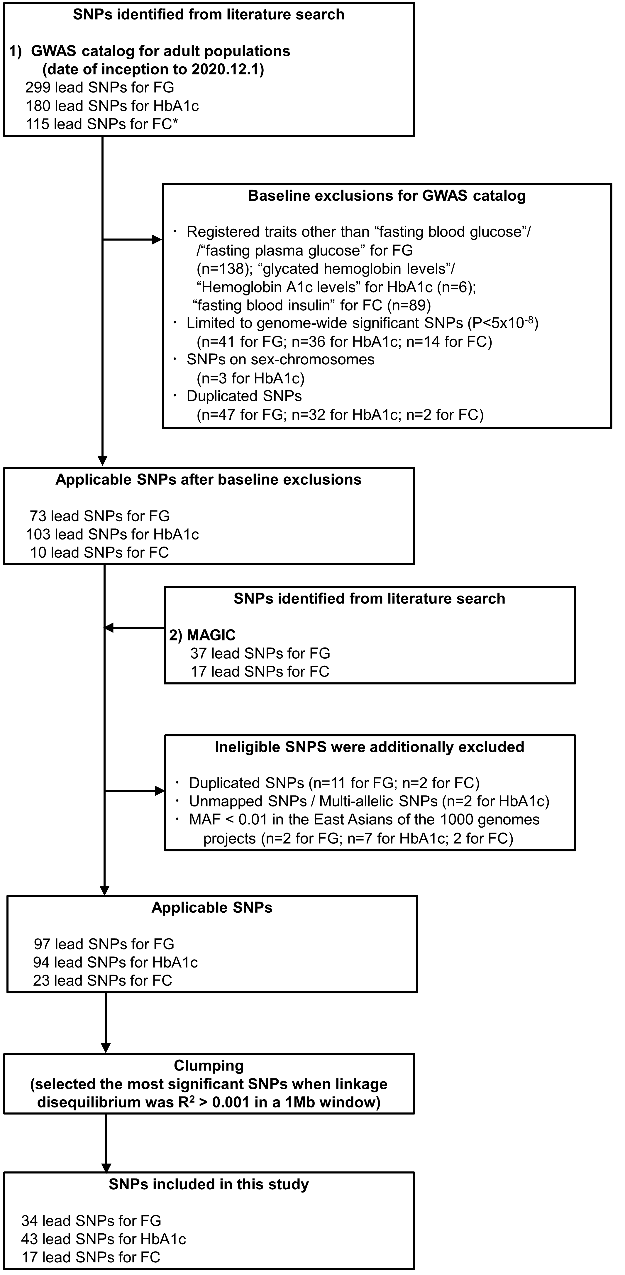

*Due to the unavailability of selecting SNPs for FC, we substituted fasting insulin for FC when selecting instrumental variables.

Abbreviation: FC, fasting C-peptide; FG, fasting glucose; HbA1c, haemoglobin A1c; MAGIC, the Meta-Analysis of Glucose and Insulin related traits Consortium; SNP, single nucleotide polymorphism.

Supplementary Figure S2. Analyses of fasting glucose and colorectal cancer risk

a). Scatter plots of genetic association with colorectal cancer (outcome) over genetic association with fasting glucose (exposure).

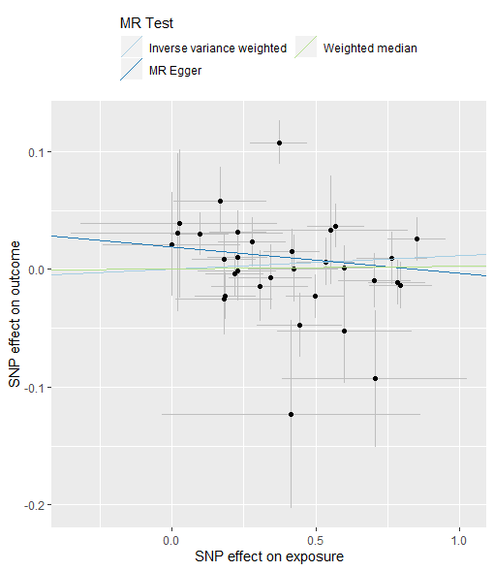

Abbreviation: SNP, single nucleotide polymorphism.

b). Leave-one-out sensitivity analysis of genetic association with colorectal cancer (outcome) over genetic association with fasting glucose (exposure).

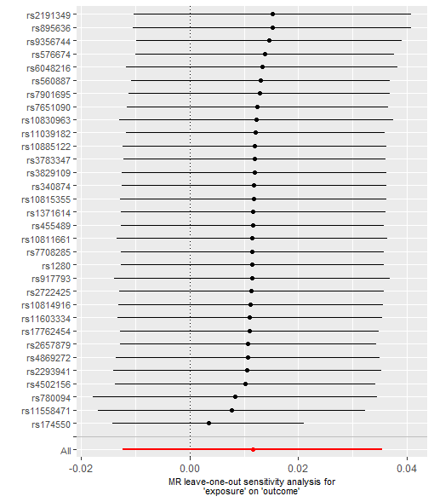

c). Funnel plot of IV precisions (1/SE_{IV}) against the IV estimates (β_{IV}) for fasting glucose.

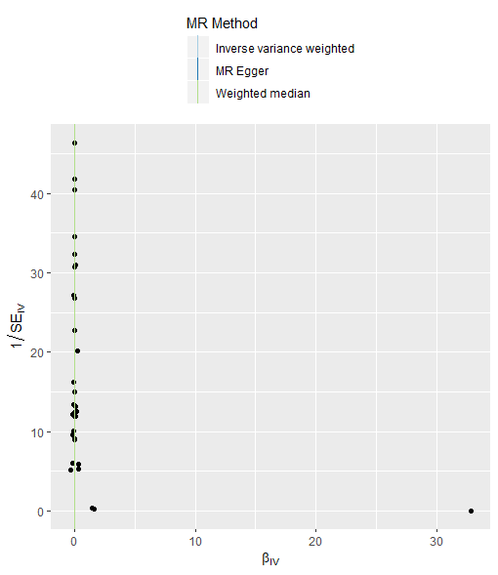

Abbreviation: IV, instrumental variable.

Supplementary Figure S3. Analyses of HbA1c and colorectal cancer risk

a). Scatter plot of genetic association with colorectal cancer (outcome) over genetic association with HbA1c (exposure).

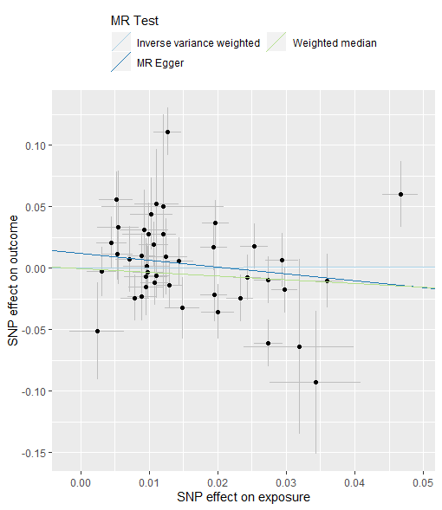

Abbreviation: HbA1c, haemoglobin A1c; SNP, single nucleotide polymorphism.

b). Leave-one-out sensitivity analysis of genetic association with colorectal cancer (outcome) over genetic association with HbA1c (exposure).

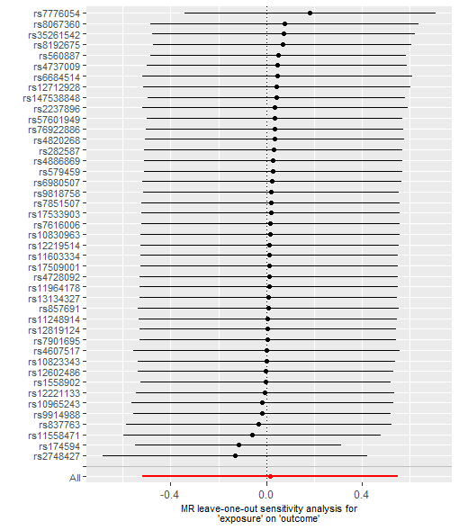

Abbreviation: HbA1c, haemoglobin A1c.

c). Funnel plot of IV precisions (1/SE_{IV}) against the IV estimates (β_{IV}) for HbA1c.

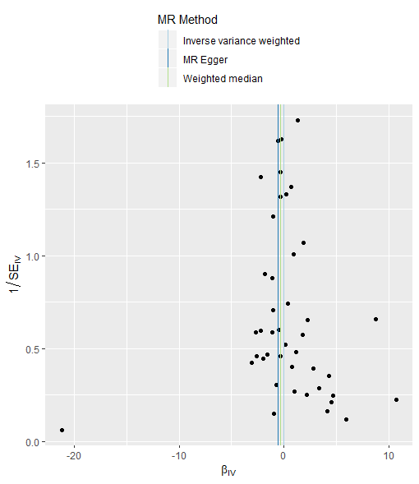

Abbreviation: HbA1c, haemoglobin A1c; IV, instrumental variable.

Supplementary Figure S4. Analyses of fasting C-peptide and colorectal cancer risk

a). Scatter plot of genetic association with colorectal cancer (outcome) over genetic association with fasting C-peptide (exposure).

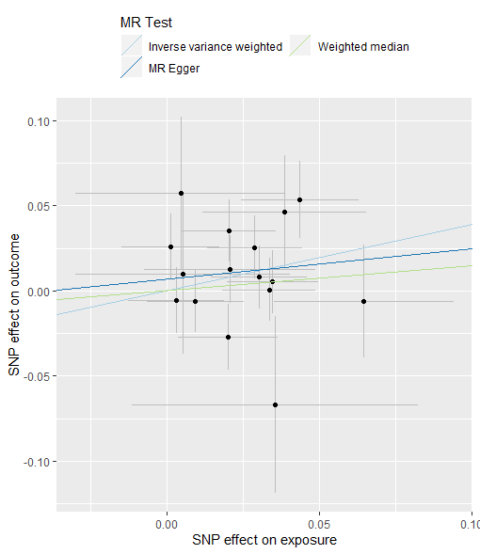

Abbreviation: SNP, single nucleotide polymorphism.

b). Leave-one-out sensitivity analysis of genetic association with colorectal cancer (outcome) over genetic association with fasting C-peptide (exposure).

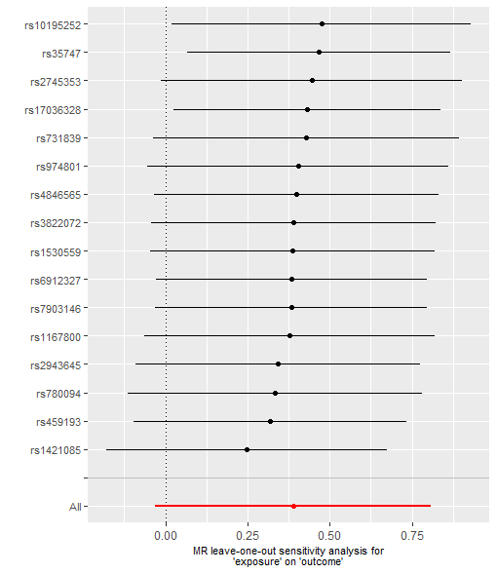

c). Funnel plot of IV precisions (1/SE_{IV}) against the IV estimates (β_{IV}) for fasting C-peptide.

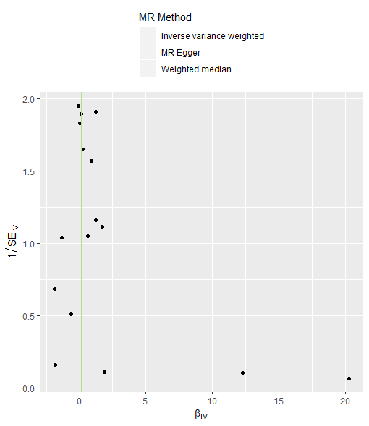

Abbreviation: IV, instrumental variable.

