Supplementary Information

Improving Josephson junction reproducibility for superconducting quantum circuits: junction area fluctuation

Anastasiya A. Pishchimova,1,2,a) Nikita S. Smirnov,1,a) Daria A. Ezenkova,1 Elizaveta A. Krivko,1 Evgeniy V. Zikiy,1 Dmitriy O. Moskalev,1 Anton I. Ivanov,1 Nikita D. Korshakov,1 and Iliya A. Rodionov1,2*

¹FMN Laboratory, Bauman Moscow State Technical University, Moscow, Russia
²Dukhov Automatics Research Institute, (VNIIA), Moscow, Russia

Resistance and linewidth measurements

Test junctions were defined into resist bilayer of 500 nm MMA(8.5)MAA copolymer and 100 nm of CSAR 62 using followed exposure parameters: 100 um field size and 2 nm step size (see Materials and methods). Next, we deposited 50 nm of Al at 0° angle, performed lift-off and measured the “shadows” of the mask features using an automatic SEM tool. Our test chip contained 98 junctions of different nominal top electrode linewidths: 100, 103, 105, 150, 300, 500 nm. The measurement results for different scanning algorithms (across the electrode and along the electrode) are presened in Table 1.

Table 1. Measurements of resist mask linewidth
Scanning direction | along |  |  |  |  |  | across
LW_{nom,} nm | 100 | 103 | 105 | 150 | 300 | 500 | 100 | 103 | 105 | 150 | 300 | 500
LW, nm | 99 | 99 | 104 | 150 | 302 | 502 | 96 | 99 | 101 | 144 | 300 | 500
3σ, nm | 4.4 | 4.4 | 5.1 | 5.5 | 6.0 | 6.6 | 4.5 | 4.4 | 5.8 | 8.3 | 5.6 | 5.2
N | 98 | 98 | 96 | 97 | 95 | 97 | 93 | 94 | 84 | 88 | 89 | 98

The heat maps of both top and bottom electrodes linewidths and junctions resistance across the 22x22 mm² area are presented in Table 2. Mean measured value with 99.7% confidence limit is shown on the corresponding heat map. We obtained the gradient in resistance, which is also reproduced in top electrode linewidth. We assumed that the gradient originates from evaporation source imperfectness. To test this, we fabricated another substrate and evaporated both electrodes at 0° angle to eliminate any significant angle variations. The heat maps of features linewidths are shown in Table 3. The gradient in the top electrode linewidth was no longer visible and the variation was lower in comparison to the electrodes evaporated at an angle.

Table 2. Measurements of fabricated josephson junctions
area | linewidth | resistance
0,008 um² | 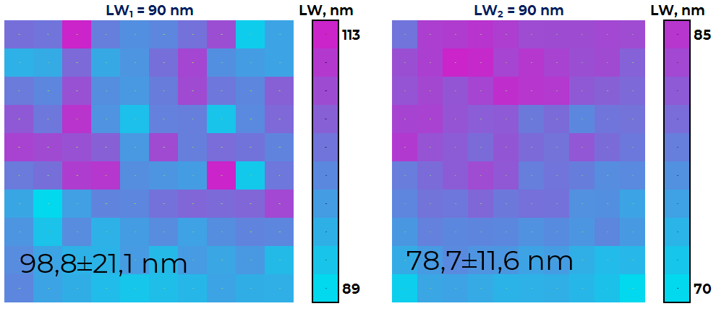 | 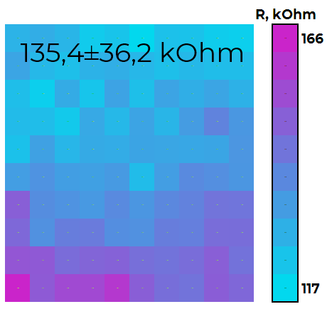
0,025 um² | 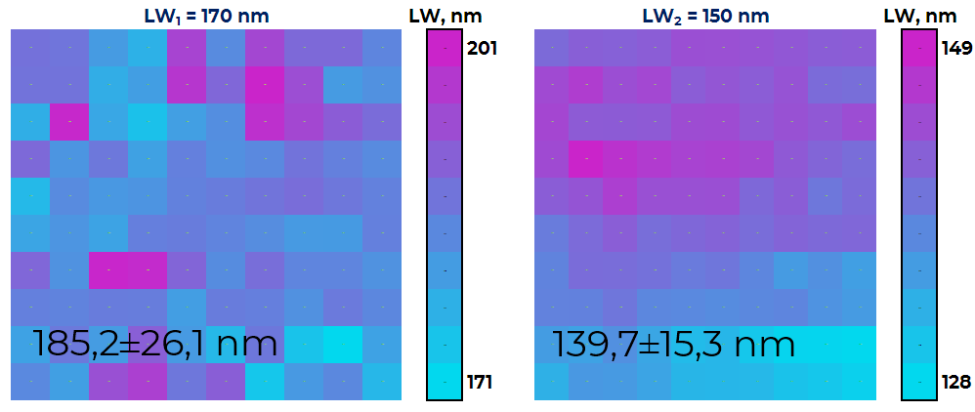 | 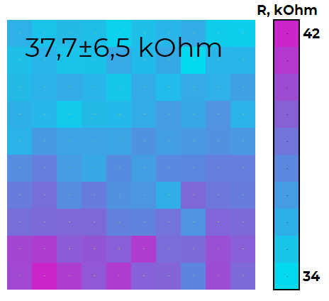
0,12 um² | 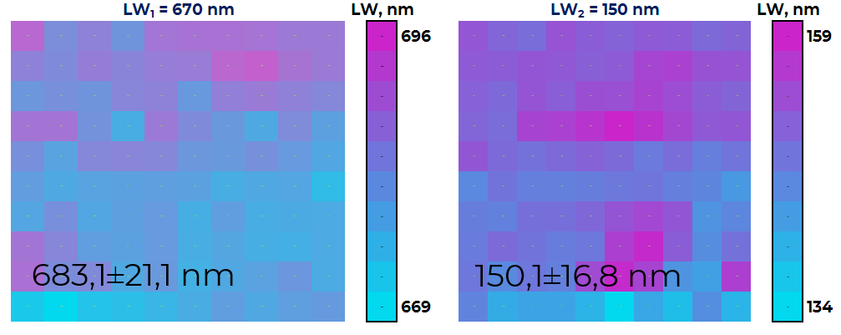 | 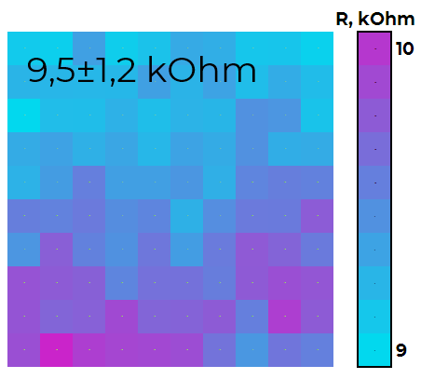

 | Table 3. Measurements of resist mask linewidth
area | Heat map
0,008 um² | 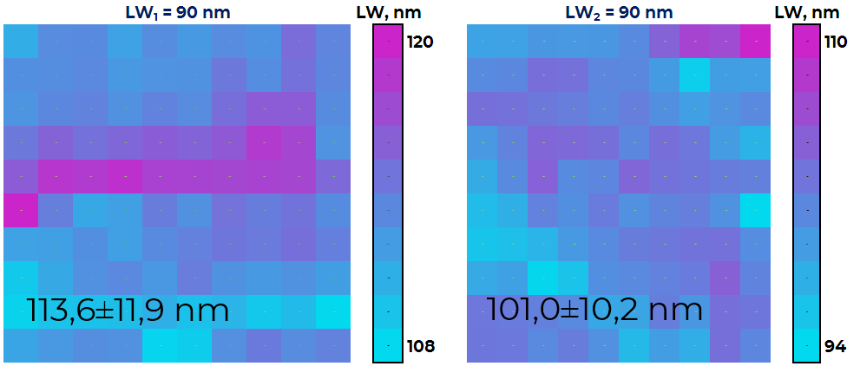
0,025 um² | 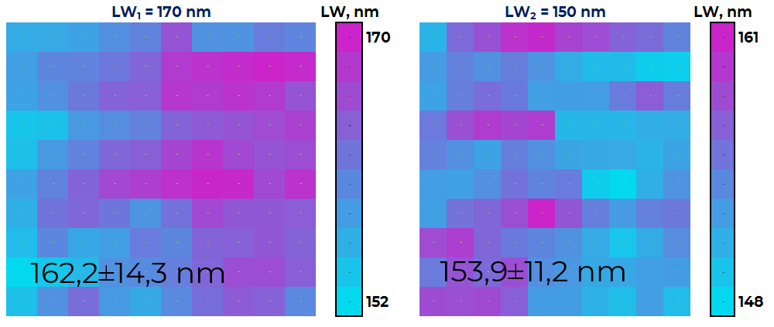
0,12 um² | 