Eyestalk transcriptome and methyl farnesoate titers provide insight into the physiological changes in the male snow crab, Chionoecetes opilio, after its terminal molt
Kenji Toyota^{1,2,3*}, Takeo Yamamoto⁴, Tomoko Mori⁵, Miyuki Mekuchi⁶, Shinichi Miyagawa², Masaru Ihara⁷, Shuji Shigenobu⁵, Tsuyoshi Ohira^{3*}
¹Noto Marine Laboratory, Institute of Nature and Environmental Technology, Kanazawa University, Ogi, Noto-cho, Ishikawa 927-0553, Japan.
²Department of Biological Science and Technology, Faculty of Advanced Engineering, Tokyo University of Science, 6-3-1 Niijuku, Katsushika-ku, Tokyo 125-8585, Japan.
³Department of Biological Sciences, Faculty of Science, Kanagawa University, 2946 Tsuchiya, Hiratsuka, Kanagawa, 259-1293, Japan.
⁴Miyazu Field Station, Japan Fisheries Research and Education Agency, Miyazu, Kyoto, 626-0052, Japan.
⁵Trans-Omics Facility, National Institute for Basic Biology, Okazaki 444-8585, Japan.
⁶Yokohama Field Station, Fisheries Resources Institute, Japan Fisheries Research and Education Agency, 2-12-4 Hukuura, Kanazawa-ku, Yokohama, Kanagawa, 236-8648, Japan.
⁷Faculty of Agriculture and Marine Science, Kochi University, 200 Monobe-Otsu, Nankoku, Kochi 783-8502, Japan.

* Correspondences:
Dr. Kenji Toyota
toyotak@se.kanazawa-u.ac.jp
Prof. Tsuyoshi Ohira
ohirat-bio@kanagawa-u.ac.jp

Supplementary figures
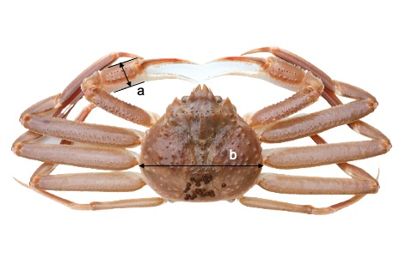

Figure S1
Male snow crab showing the measured part of chela height (A) and carapace width (B).

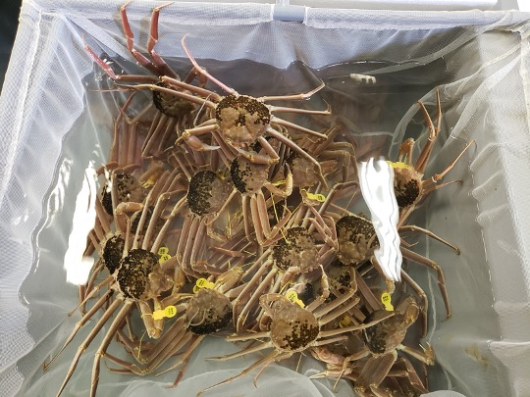

Figure S2
Snapshot of snow crabs used in this study.

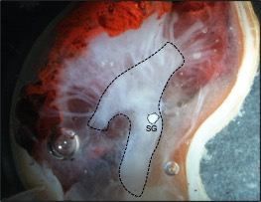

Figure S3
Internal anatomy of the eyestalk of the snow crab. The dotted line indicates the dissected area from which total RNA was extracted. SG: sinus gland.

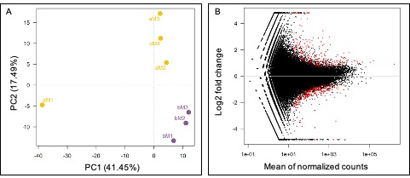

Figure S4
Principal component analysis of our RNAseq (A). "aM" and "bM" indicate the male after or before the terminal molt, respectively. MA plots of the differentially expressed transcripts between snow crabs before and after the terminal molt (B). Red spots indicate transcripts that were significantly different between both groups.

