Supplementary Information

Supplementary Table 1: Proximate analysis, chemical composition and amino acid composition of the basal diets used in this study (as-fed basis).

Analysis: | Unitsa | Starter Feed | Link Feed
Dry Matter | MJ/kg | 18.4 | 17.7
Chemical Analysis:
Neutral Detergent Fibre | % | 4.8 | 5.5
Crude Protein (N x 6.25) Dumas | % | 19.6 | 18.9
Crude Fibre | % | 1.6 | 2.3
Dry Matter | % | 91.6 | 90.3
Ash | % | 5.8 | 5.3
Total Oil (Oil B) | % | 11.8 | 8.0
Amino Acids Composition*:
Alanine | % | 0.72 | 0.71
Arginine | % | 1.06 | 1.08
Aspartic | % | 1.77 | 1.70
Cysteine | % | 0.22 | 0.25
Glutamic | % | 3.28 | 3.31
Glycine | % | 0.63 | 0.66
Histidine | % | 0.47 | 0.45
Iso-Leucine | % | 0.81 | 0.75
Leucine | % | 1.49 | 1.38
Lysine | % | 1.56 | 1.43
Methionine | % | 0.63 | 0.53
Phenylalanine | % | 0.88 | 0.83
Proline | % | 1.10 | 1.08
Serine | % | 0.91 | 0.85
Threonine | % | 1.01 | 0.96
Tyrosine | % | 0.41 | 0.33
Valine | % | 0.99 | 0.94
Tryptophan | % | 0.32 | 0.29
ªMJ per kilogram and percentage (%); *all amino acids are expressed as total e.g. alanine (total).

Supplementary Table 2: Levels of SCFA (mM) detected across treatment groups and time points (average over samples).

Time point | Treatment | Acetate | Isobutyric acid | Isovaleric acid | Propionic acid | Butyrate | Valeric acid
mM (average over samples)
Baseline | Control | 19.280 | 0.939 | 0.605 | 7.644 | 3.731 | 1.018
 | Encapsulant | 13.756 | 0.685 | 0.486 | 5.841 | 2.871 | 0.658
 | Encapsulated Nisin | 14.137 | 0.721 | 0.473 | 5.272 | 2.685 | 0.624
 | Nisin Powder | 16.763 | 0.954 | 0.646 | 6.766 | 3.298 | 1.002
72 h after fed initial treatment | Control | 23.257 | 1.260 | 0.903 | 10.130 | 6.089 | 1.637
72 h after fed initial treatment | Encapsulant | 18.708 | 1.054 | 0.748 | 7.924 | 5.798 | 1.467
72 h after fed initial treatment | Encapsulated Nisin | 16.134 | 0.852 | 0.588 | 8.836 | 4.166 | 1.373
 | Nisin Powder | 13.816 | 0.840 | 0.609 | 8.515 | 2.987 | 1.266
10 days after treatment stopped | Control | 23.025 | 1.080 | 0.769 | 11.174 | 7.183 | 1.750
10 days after treatment stopped | Encapsulant | 20.627 | 0.999 | 0.711 | 9.741 | 6.355 | 1.734
10 days after treatment stopped | Encapsulated Nisin | 19.806 | 0.874 | 0.625 | 9.369 | 5.023 | 1.240
 | Nisin Powder | 16.383 | 0.893 | 0.659 | 7.140 | 4.493 | 1.176

(a)

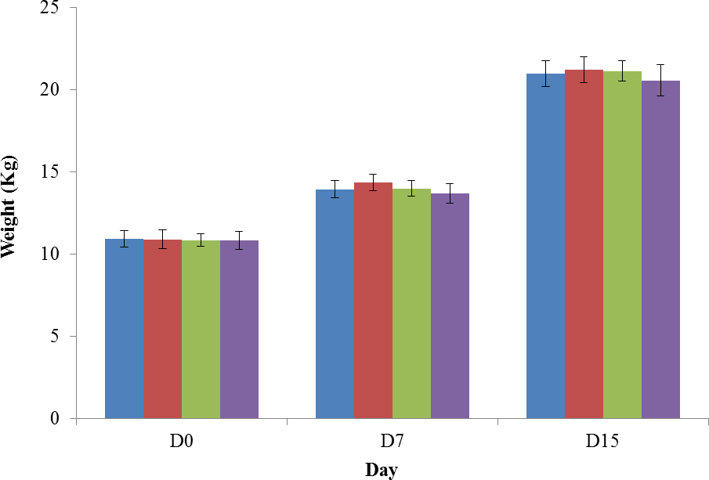

(b)
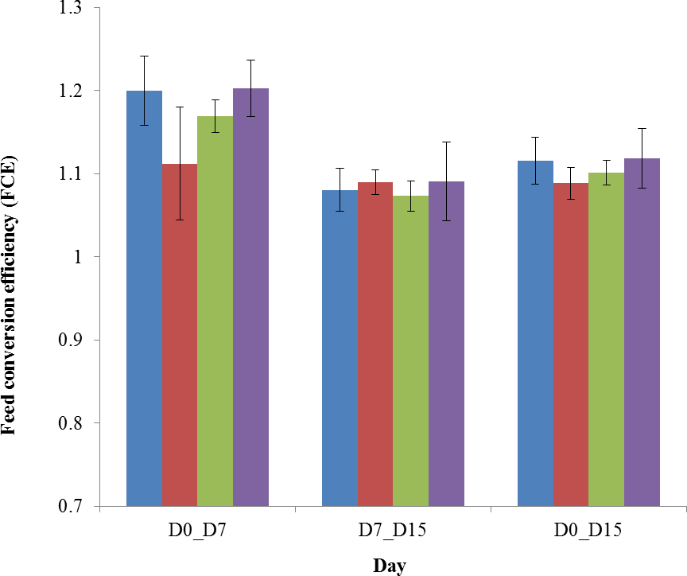

Supplementary Figure 1. Mean live weight (a) and feed conversion efficiency (FCE) (b) of post-weaning piglets by across the days of weighing over the trial period. Treatments;  Ctl,
- Encap,  Nis-pdr and  Nis-en.

Relative abundance (%)

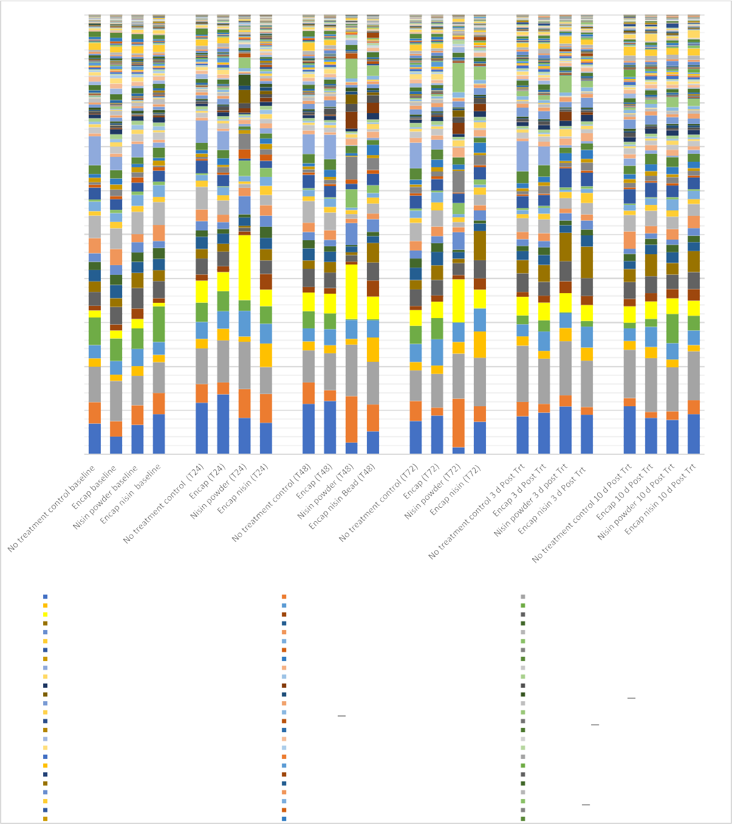Supplementary Figure 2. Relative abundance (%) at the genus level across time points and treatment groups. The four treatment diets are shown here: no treatment control (Ctl); encapsulant material (Encap); encapsulated nisin (Nis-en) and nisin powder (Nis-pdr). Time points: Baseline (BL), 24 h after initial treatment fed (T24), 48 h after initial treatment fed (T48), 72 h after initial treatment fed (T72), 3 days after feeding treatments ceased (3d PT) and 10 days after feeding treatments ceased (10d PT).
100%
90%
80%
70%
60%
50%
40%
30%
20%
10%
0%
Treatment by Day
Lactobacillus
Faecalibacterium Megasphaera Catenibacterium Phascolarctobacterium Ruminococcaceae.UCG.002 Blautia Ruminococcaceae.UCG.010 Streptococcus Holdemanella Ruminococcus.1
Klebsiella Roseburia
Lachnospiraceae.NK4A136.group Ruminiclostridium.6 Lachnospiraceae.XPB1014.group Unassigned.Other Solobacterium
Oribacterium Gastranaerophilales.uncultured.bacterium. Ruminococcaceae.UCG.013 Candidatus.Soleaferrea Ruminococcaceae.UCG.014
Prevotella 2 Oscillibacter Asteroleplasma
Prevotella 1
BacteroidalesS247groupunculturedbacterium Prevotella 7
Rikenellaceae.RC9.gut.group Treponema.2 Peptoclostridium Erysipelotrichaceae.UCG.004 Subdoligranulum
.Eubacterium..coprostanoligenes.group Campylobacter
EscherichiaShigella Fibrobacter Lachnoclostridium Veillonellaceae uncultured Sphaerochaeta Family.XIII.AD3011.group
.Eubacterium..hallii.group Methanobrevibacter Desulfovibrio Clostridium.sensu.stricto.6 Fusicatenibacter Lachnospiraceae.FCS020.group Marvinbryantia
Helicobacter Candidatus.Saccharimonas Collinsella
Prevotella 9
Clostridium.sensu.stricto.1 FLachnospiraceae.Other Christensenellaceae.R.7.group uncultured
Parabacteroides Succinivibrio
Prevotellaceae.NK3B31.group Ruminococcaceae.UCG.005 Ruminococcaceae.NK4A214.group Anaerovibrio
Clostridiales.vadinBB60.group. uncultured.bacterium Lachnospiraceae.ND3007.group
Mitsuokella
Planctomycetaceae p.1088.a5.gut.group Alloprevotella BacteroidalesRF16groupunculturedbacterium Clostridiales uncultured
Butyricicoccus Anaerostipes
Clostridiales.vadinBB60.group.Other Coprococcus.1 Prevotellaceaeuncultured
Bradymonadales uncultured.bacterium Lachnospiraceae.UCG.004 Prevotellaceae.UCG.003

UBISYN-PWY: superpathway of ubiquinol-8 biosynthesis (prokaryotic)­

PWY3O-355: stearate biosynthesis Ill (fungi)­ PWY0-881: super-pathway of fattyacidbiosynthesis I (E. coli) -
PWY- 7446: sulfogtycolysis - PWY-7345: superpathway of anaerobic sucrose deg:radation-
PWY- 7269: NAO/NAOP-NAOH/NAOPH mitochondrial interconversion (yeast) -

PWY-6708: ubiqu.inol-8 OOsynthesis (prokaryotic)- PWY--6285: superpathway of fatty acids biosynthesi.s (E. coli) - PWY-5899: supe-rpathway of menaquinol-13 l)josynthesis - PWY-5898: supe-rpathway of menaquinol-12 biosynthesis - PWY-5897: supe-rpathway of menaquinol-11 biosynthesis - PWY-5896: supe-rpathway of menaquinol-10 biosynthesis -
PWY-5862: superpathway of demethylmenaquinol-9 biosynthesis­ PWY-5861: superpathway of demethylmenaquinol-8 biosynthesis - PWY-5860: supe-rpathway of demethylmenaquinol-6 biosynthesis I - PWY-5857: ubiquinol- tO biosynthesis (prokaryotic) -
PWY-5856: ubiquinol-9 biosynthesis (prokaryotic)­ PWY-5855: ubiquinol- 7 biosynthesis (prokaryotic) -
PWY-5850: supe-rpathway of menaquinol-6 biosynthesis I- PWY-5845: superpathway of menaquinol-9 biosynthesis­ PWY-5840: superpathway of menaquinol- 7 biosynthesis - PWY-5838: supe-rpathway of menaquinol-8 biosynthesis 1- PWY-5837: 1.4-dihydroxy-2-naphthoate biosynthesis I­
PWY-5791: 1,4-dihydroxy-2-naphthoate biosynthesis II {plants)­ PWY-5656: mannosylglycerate biosynthesis I­
PWY-3801: sucrosedegradation II (sucrose synthase) -

P221-PWY: octane oxidation- P162-PWY: L-glutamate degradation V (via hydroxyglutarate) - LPSSYN-PWY: superpathway of li:popolysaocharide biosynthesis - ENTBACSYN-PWY: ente-robactin biosynthesis­
ECASYN-PWY: enterobacterial common antigen biosynthesis- 3-HYOROXYPHENYLACETATE-DEGRAOATION-PWY: 4-hydroxyphenyiacetate degradation -
Ctl Encap Nis-en Nis-pdr

r ,
'

'

Basefine T72 IOd PT Baseline T72 10dPT Baseline T72 10d PT Baseline T72 10d PT

CPM

100

75

50

25

0

Supplementary Figure 3_ Heatmap showing the abundance (HUMAnN count per million) of the most differentially abundant HUMAnN pathways (low level hierarchy, unstTatified) in nisin at baseline vs nisin tTeatment at T72 for all the different groups at the different time points (grey area, conti-ol groups, pink area, tTeatment groups), as found according to the Songbird analysis (model: pathways~ nisin tTeatment x days)

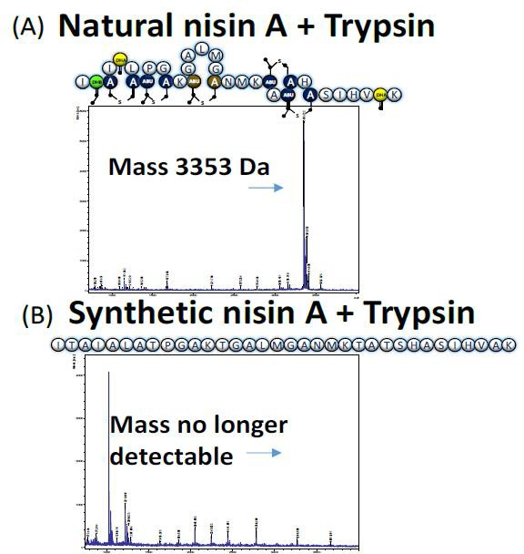

Supplementary Figure 4 (A) Post translationally modified natural nisin treated with trypsin. Nisin mass detected by MS (B) Synthetic nisin with no post-translational modifications treated with trypsin. No nisin mass detected by MS

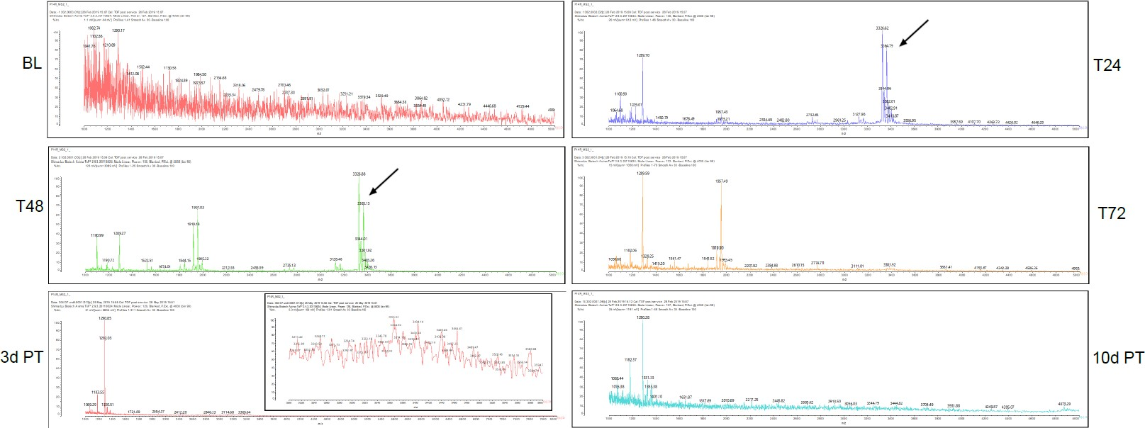

Supplementary Figure 5 MALDI TOF Mass spectrophotometry analysis to detect nisin (black arrows denote intact nisin peaks). Detection of intact nisin in the faeces of pig in the nis-en treated group at Baseline (BL), 24 hr following initial treatment (T24), 48 hr following initial treatment (T48), 72 hr following initial treatment (T72), 72 hr after initial treatment stopped (3d PT) and 10 days after initial treatment stopped (10d PT). Smaller zones and Nisin masses were found in T72 and no zones or masses found on 3d PT and 10d PT (1 in 10 dil).

