
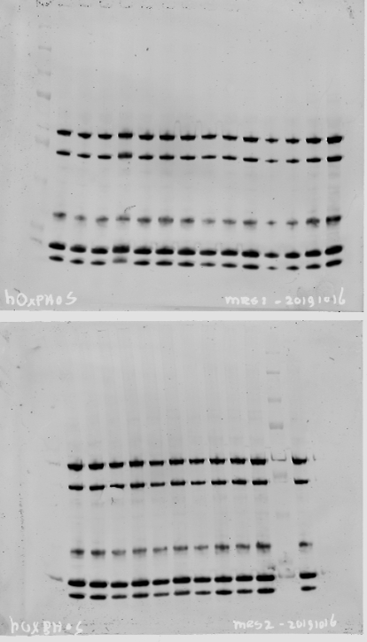

Supplemental Figure 1. Uncropped Western Blots of the different complexes of the respiratory chain (Complex 1-5) with loading control and reference lines (lane 1 and 4 upper panel and lane 1 and 12 lower panel).

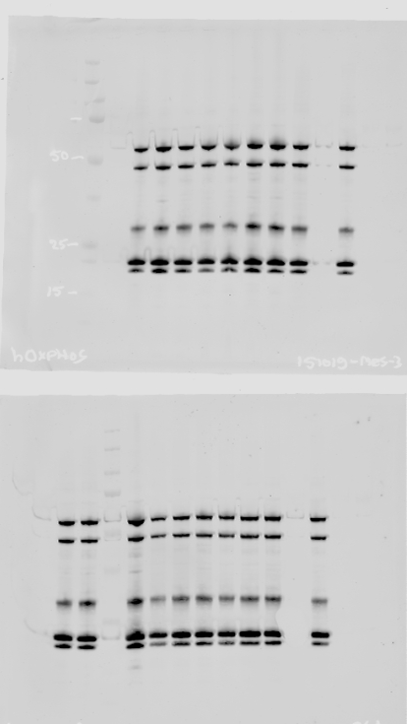

Supplemental Figure 2. Uncropped Western Blots of the different complexes of the respiratory chain (Complex 1-5) in duplicates per subject with loading control and reference lines (lane 9 upper panel and lane 3 and 11 lower panel).

