Supplementary data:
RELIABILITY FROM CONSECUTIVE PAIRS OF TRIALS
Reference: Hopkins WG (2000). Reliability from consecutive pairs of trials using Excel spreadsheet.
The three gas analyzers (Vintus CPX, Oxycon Mobile and Oxycon PRO) were placed in serie, as shown in the image, pumping air with the calibration syringe at different intensities.
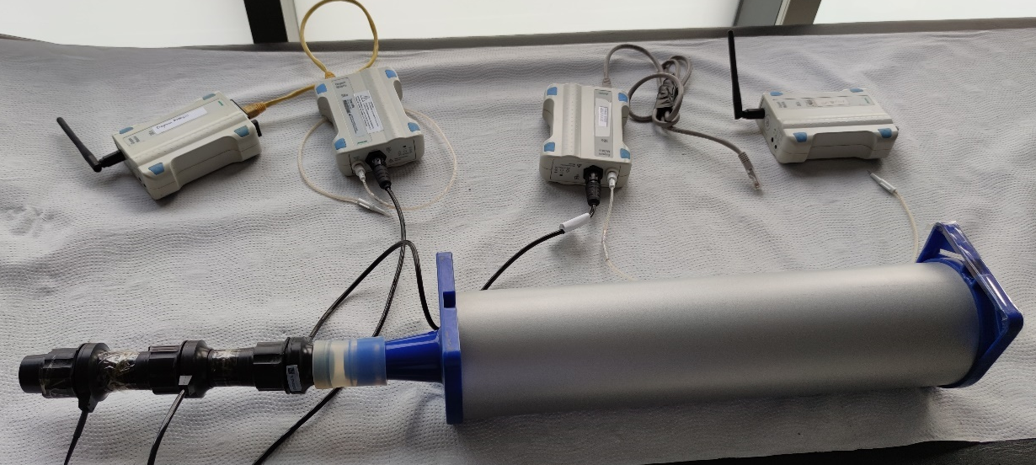
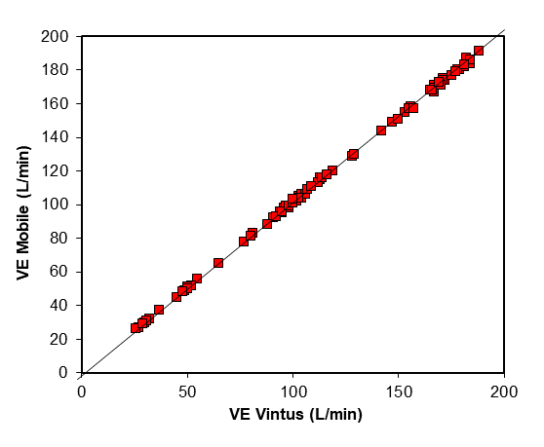
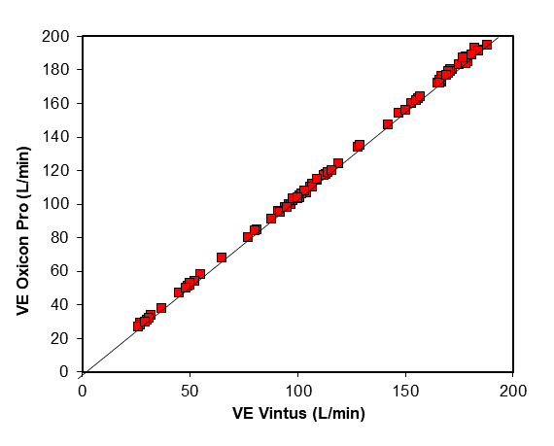
Measures of reliability for VE variable in liters
 | Trial  Mobile-Vintus | Trial  Oxico Pro-Oxycon mobile
Change in mean | 1.30 | 3.46
Lower conf limit | 1.10 | 3.12
Upper conf limit | 1.50 | 3.79
Typical error | 0.82 | 1.35
Lower conf limit | 0.73 | 1.21
Upper conf limit | 0.93 | 1.55
Degrees of freedom | 89 | 89
TE^2 | 0.67 | 1.83
Total error | 0.27 | 1.54
Limits of agreement | 2.30 | 3.80
Pearson r | 0.99985 | 0.99979
Intraclass R | 0.99974 | 0.99932
Lower conf limit | 0.99963 | 0.99904
Upper conf limit | 0.99982 | 0.99952

Total ICC R=0.999 with p<0.001.

Effect of changing the plastic mask envelope for each measurement versus making all 5 measurements with the same plastic for the Hygienic_1, reusable (Emotion) mask. n=25.
 |  | Mean | SD | F | p-valor | t | p-valor
VE AIRin (L/min) | No plastic change | 59.3 | 37.6 | 0.002 | 0.966 | -0.301 | 0.764
VE AIRin (L/min) | Plastic change | 62.5 | 37.8
VE AIRfil (L/min) | No plastic change | 46.9 | 29.9 | 0.04 | 0.842 | -0.099 | 0.922
VE AIRfil (L/min) | Plastic change | 47.7 | 29.0
VE AIRunf (L/min) | No plastic change | 7.5 | 5.3 | 2.192 | 0.145 | -1.047 | 0.300
VE AIRunf (L/min) | Plastic change | 9.4 | 6.9
AIRin= air input to the system for the Jaeger Oxycon Pro analyzer. AIRfil=air filtered by the facemask for the Jaeger Oxycon Mobile analyzer, and finally the Vintus CPX analyzer which collected the air that was not filtered (AIRunf).

