Algorithm Selection for Protein-Ligand Docking: Strategies and Analysis on ACE: Supplementary Information
Tianlai Chen,¹ Xiwen Shu,¹ Huiyuan Zhou,¹ Floyd A. Beckford^{1, †} and Mustafa Misir,^{1, †}

- Division of Natural and Applied Sciences, Duke Kunshan University

†Corresponding authors: floyd.beckford@duke.edu and mustafa.misir@dukekunshan.edu.cn

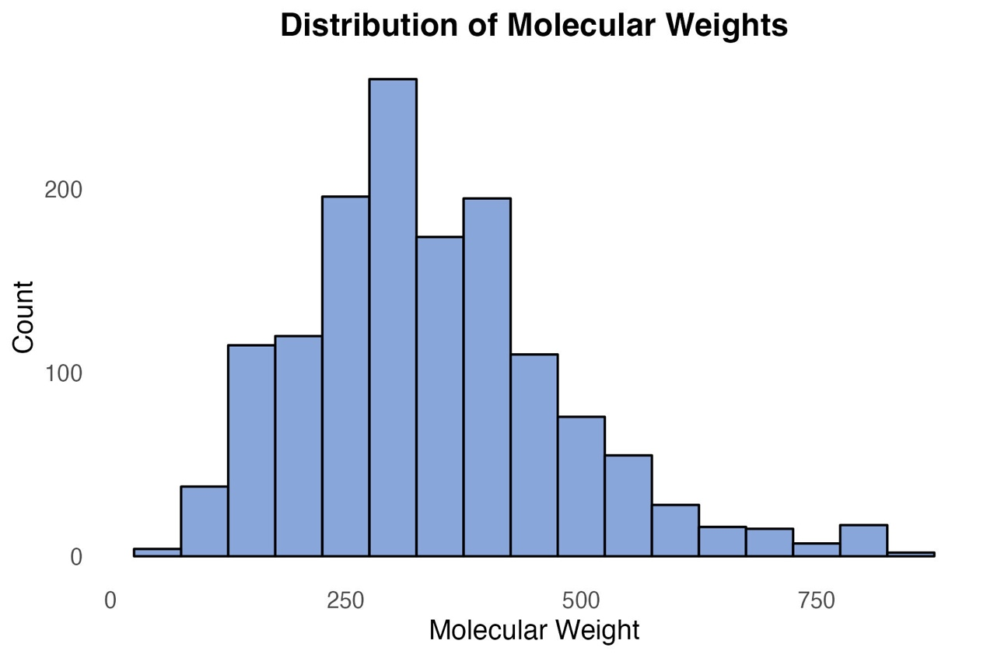
Supplementary Figure 1. Distribution of molecular weights
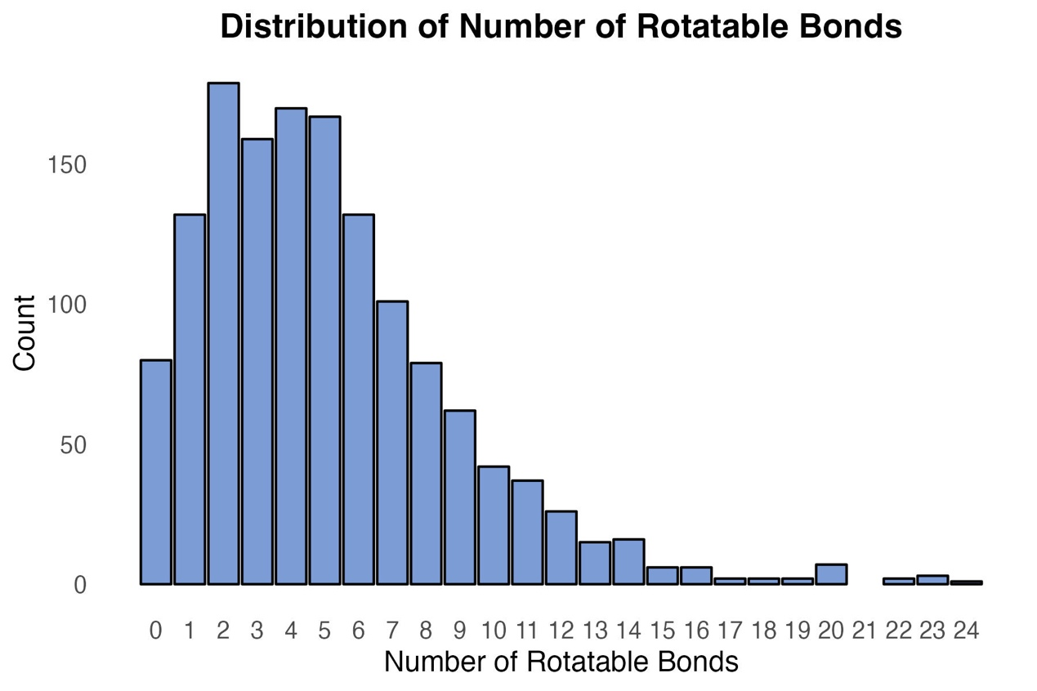
Supplementary Figure 2. Distribution of the number of rotatable bonds
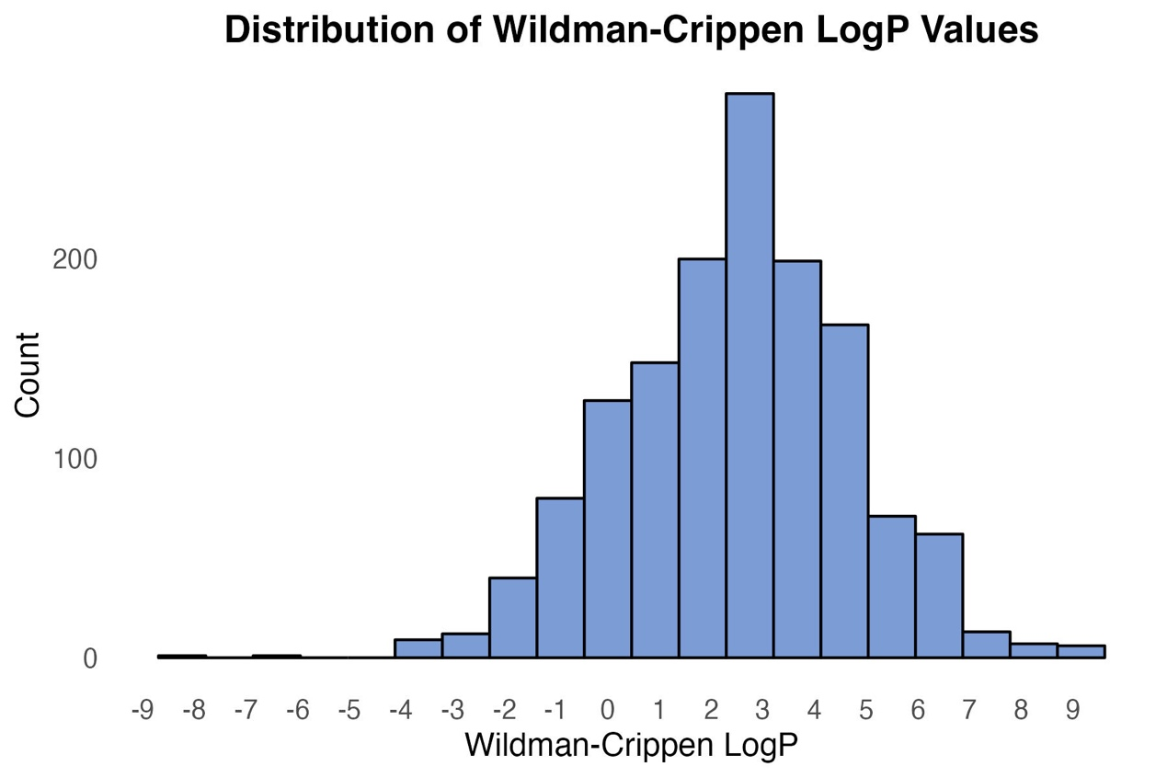
Supplementary Figure 3. Distribution of the Wildman-Crippen LogP values
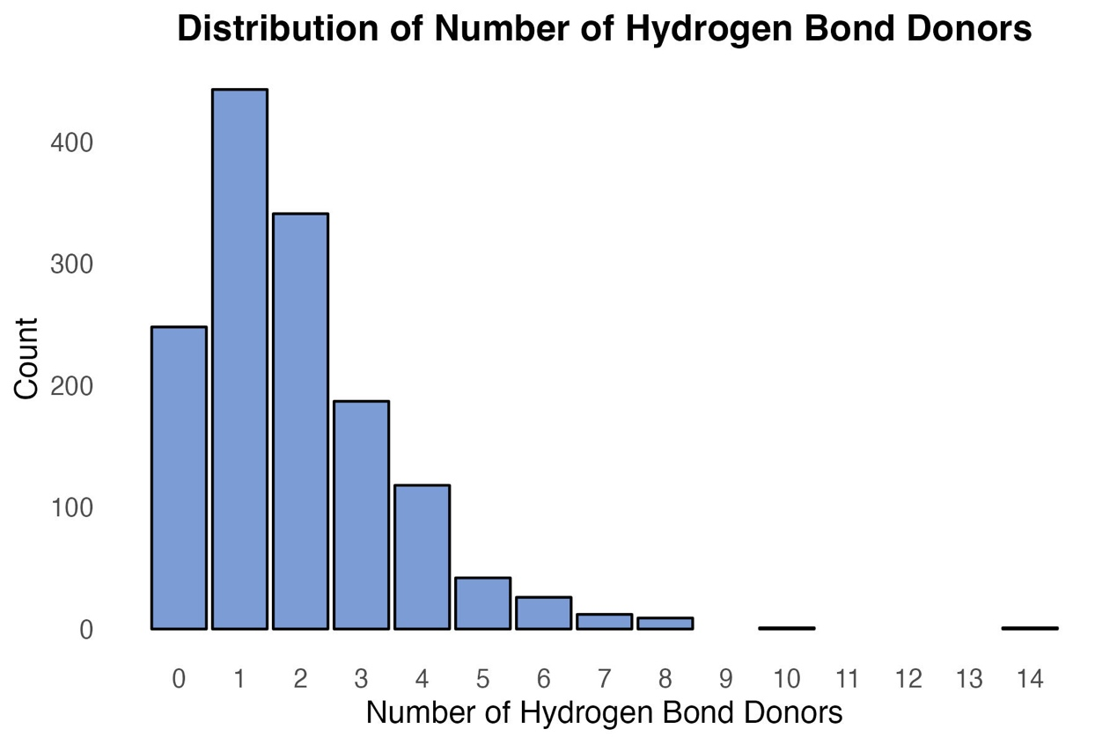
Supplementary Figure 4. Distribution of the number of hydrogen bond donors
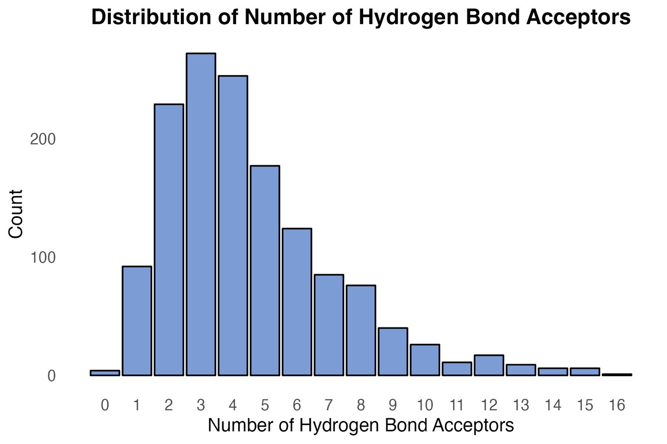
Supplementary Figure 5. Distribution of the number of hydrogen bond acceptors

