Supplementary Information: Comparing the Effects of Four Common Drug Classes on the Progression of Mild Cognitive Impairment to Dementia Using Electronic Health Records

Jie Xu, PhD^{1,2}, Fei Wang, PhD², Chengxi Zang, PhD², Hao Zhang, PhD², Kellyann Niotis, MD², Ava L. Liberman, MD², Cynthia M. Stonnington, MD³, Makoto Ishii, MD, PhD², Prakash Adekkanattu², Yuan Luo, PhD⁴, Chengsheng Mao, PhD⁴, Luke V Rasmussen, PhD⁴, Zhenxing Xu, PhD², Pascal Brandt, PhD⁵, Jennifer A Pacheco, PhD⁴, Yifan Peng, PhD², Guoqian Jiang, MD, PhD⁶, Richard Isaacson, MD², Jyotishman Pathak, PhD^{2,*}
¹University of Florida, Gainesville, FL, USA
²Weill Cornell Medicine, Cornell University, New York, NY, USA
³Mayo Clinic, Scottsdale, Arizona, USA
⁴Feinberg School of Medicine, Northwestern University, Chicago, IL, USA
⁵University of Washington, Seattle, Washington, USA
⁶Mayo Clinic, Rochester, Minnesota, USA
*Corresponding Author

Table S1. The Estimated Treatment Effects for dementia over Balanced Drugs/Drug Classes (Extended Table 2 in the main manuscript, sorted by “ATC codes”).
 | Drug Class/Drug | ATC  Codes | # BT | # Users | # Non-  users | *UR (%) | mean ATE (95% CI)
 |  |  |  | After Reweighting
 | Proton pump inhibitors | A02BC | 100 | 2139 | 758 | 1.71 | 0.0274 | (0.0224, 0.0324)
 | omeprazole; systemic | A02BC01 | 41 | 632 | 1183 | 1.61 | -0.0201 | (-0.0299, -0.0103)
 | ANTIHYPERTENSIVES AND DIURETICS IN COMBINATION | C02L | 100 | 1161 | 381 | 1.09 | 0.0469 | (0.0381, 0.0556)
 | Rauwolfia alkaloids and diuretics in combination | C02LA | 100 | 1477 | 478 | 0.61 | 0.0617 | (0.0546, 0.0688)
 | reserpine and diuretics, combinations with psycholeptics | C02LA71 | 100 | 1474 | 477 | 0.58 | 0.0708 | (0.063, 0.0786)
 | Hydrazinophthalazine derivatives and diuretics | C02LG | 100 | 1226 | 402 | 1.19 | 0.0412 | (0.0333, 0.0492)
 | picodralazine and diuretics, combinations with psycholeptics | C02LG73 | 100 | 1474 | 476 | 0.62 | 0.0663 | (0.0589, 0.0737)
 | DIURETICS | C03 | 83 | 1366 | 1729 | 1.79 | 0.0328 | (0.0255, 0.0401)
 | LOW-CEILING DIURETICS, THIAZIDES | C03A | 100 | 1327 | 474 | 1.78 | 0.0268 | (0.0198, 0.0339)
 | Thiazides, combinations with other drugs | C03AX | 67 | 1667 | 753 | 1.67 | 0.0432 | (0.0364, 0.05)
 | hydrochlorothiazide, combinations | C03AX01 | 73 | 1691 | 759 | 1.73 | 0.038 | (0.0329, 0.0431)
 | BETA BLOCKING AGENTS | C07 | 100 | 1064 | 1860 | 1.73 | 0.0221 | (0.0141, 0.03)
 | BETA BLOCKING AGENTS | C07A | 100 | 1404 | 494 | 1.10 | -0.0266 | (-0.0341, -0.019)
 | Beta blocking agents, selective | C07AB | 100 | 1303 | 1044 | 1.42 | 0.0076 | (0.0009, 0.0143)
 | metoprolol; systemic | C07AB02 | 100 | 842 | 980 | 1.65 | 0.0275 | (0.0196, 0.0353)
 | BETA BLOCKING AGENTS AND THIAZIDES | C07B | 100 | 1520 | 1008 | 1.46 | 0.0233 | (0.0173, 0.0294)
 | Beta blocking agents, selective, and thiazides | C07BB | 100 | 1149 | 1265 | 1.57 | 0.0308 | (0.0232, 0.0384)
 | metoprolol and thiazides | C07BB02 | 100 | 999 | 1231 | 1.58 | 0.0224 | (0.0164, 0.0284)
 | metoprolol and thiazides, combinations | C07BB52 | 100 | 1005 | 1239 | 1.62 | 0.0178 | (0.0115, 0.0241)
 | BETA BLOCKING AGENTS AND OTHER DIURETICS | C07C | 100 | 1583 | 1081 | 1.73 | 0.0341 | (0.0288, 0.0395)
 | Beta blocking agents, selective, and other diuretics | C07CB | 100 | 1390 | 1200 | 1.72 | 0.0297 | (0.0228, 0.0367)
 | metoprolol and other diuretics | C07CB02 | 100 | 1002 | 1064 | 1.66 | 0.026 | (0.0194, 0.0326)
 | BETA BLOCKING AGENTS, OTHER COMBINATIONS | C07F | 100 | 1946 | 697 | 1.11 | 0.0147 | (0.0075, 0.022)
 | Beta blocking agents and calcium channel blockers | C07FB | 100 | 1219 | 1038 | 1.52 | 0.0368 | (0.0311, 0.0424)
 | metoprolol and felodipine | C07FB02 | 100 | 851 | 1152 | 1.55 | 0.0283 | (0.0216, 0.0351)
 | metoprolol and amlodipine | C07FB13 | 100 | 988 | 1027 | 1.58 | 0.0286 | (0.0211, 0.0361)
 | Beta blocking agents, other combinations | C07FX | 100 | 1764 | 869 | 1.38 | 0.0407 | (0.0354, 0.046)
 | metoprolol and acetylsalicylic acid | C07FX03 | 100 | 1599 | 973 | 1.35 | 0.0662 | (0.0597, 0.0728)
 | metoprolol and ivabradine | C07FX05 | 100 | 810 | 1132 | 1.60 | 0.0213 | (0.0148, 0.0277)
 | CALCIUM CHANNEL BLOCKERS | C08 | 100 | 719 | 1083 | 1.75 | 0.0211 | (0.0138, 0.0284)
 | SELECTIVE CALCIUM CHANNEL BLOCKERS WITH MAINLY VASCULAR EFFECTS | C08C | 100 | 743 | 246 | 1.06 | -0.0458 | (-0.0593, -0.0324)
 | Dihydropyridine derivatives | C08CA | 100 | 745 | 248 | 1.05 | -0.0571 | (-0.0692, -0.0451)
 | nifedipine, combinations | C08CA55 |  | 1707 | 1081 | 1.43 | 0.0101 | (0.0037, 0.0164)
 | AGENTS ACTING ON THE RENIN-ANGIOTENSIN SYSTEM | C09 | 93 | 856 | 1140 | 1.68 | 0.027 | (0.0201, 0.0338)
 | ACE INHIBITORS, PLAIN | C09A | 100 | 1146 | 1543 | 1.71 | 0.0345 | (0.0284, 0.0406)
 | ACE inhibitors, plain | C09AA | 100 | 1145 | 1544 | 1.72 | 0.0341 | (0.0283, 0.0399)
 | lisinopril; oral | C09AA03 | 100 | 737 | 1901 | 1.66 | 0.064 | (0.0581, 0.0698)
 | ramipril; oral | C09AA05 | 6 | 166 | 520 | 1.86 | -0.0388 | (-0.0606, -0.0169)
 | ACE INHIBITORS, COMBINATIONS | C09B | 100 | 1279 | 1589 | 1.25 | 0.1205 | (0.1131, 0.1279)
 | ACE inhibitors and diuretics | C09BA | 100 | 1027 | 1816 | 0.95 | 0.1104 | (0.1037, 0.1171)
 | captopril and diuretics | C09BA01 | 69 | 777 | 2043 | 1.44 | 0.0557 | (0.0431, 0.0684)
 | enalapril and diuretics | C09BA02 | 97 | 816 | 2011 | 1.48 | 0.0324 | (0.0223, 0.0425)
 | lisinopril and diuretics | C09BA03 | 100 | 973 | 1874 | 1.00 | 0.0992 | (0.0905, 0.108)
 | perindopril and diuretics | C09BA04 | 67 | 768 | 2051 | 1.61 | 0.0426 | (0.0312, 0.054)
 | ramipril and diuretics | C09BA05 | 70 | 790 | 2034 | 1.55 | 0.0522 | (0.0417, 0.0627)
 | quinapril and diuretics | C09BA06 | 43 | 771 | 2050 | 1.60 | 0.0503 | (0.0348, 0.0657)
 | benazepril and diuretics; oral | C09BA07 | 59 | 773 | 2052 | 1.49 | 0.0498 | (0.037, 0.0625)
 | cilazapril and diuretics | C09BA08 | 66 | 768 | 2051 | 1.50 | 0.0342 | (0.0209, 0.0475)
 | fosinopril and diuretics | C09BA09 | 66 | 773 | 2052 | 1.51 | 0.0471 | (0.0365, 0.0578)
 | delapril and diuretics | C09BA12 | 71 | 772 | 2053 | 1.44 | 0.0548 | (0.0442, 0.0653)
 | moexipril and diuretics | C09BA13 | 65 | 772 | 2053 | 1.43 | 0.0377 | (0.0247, 0.0507)
 | zofenopril and diuretics | C09BA15 | 58 | 773 | 2053 | 1.47 | 0.0489 | (0.0377, 0.0602)
 | ANGIOTENSIN II RECEPTOR BLOCKERS (ARBs), PLAIN | C09C | 100 | 1267 | 1435 | 1.24 | 0.002 | (-0.0037, 0.0077)
 | Angiotensin II receptor blockers (ARBs), plain | C09CA | 100 | 1265 | 1436 | 1.26 | 0.0029 | (-0.0039, 0.0096)
 | losartan; oral | C09CA01 | 100 | 902 | 1723 | 1.31 | -0.0059 | (-0.011, -0.0007)
 | valsartan; oral | C09CA03 | 100 | 214 | 726 | 1.61 | 0.083 | (0.0739, 0.092)
 | ANGIOTENSIN II RECEPTOR BLOCKERS (ARBs), COMBINATIONS | C09D | 100 | 1326 | 1538 | 1.19 | 0.0974 | (0.0899, 0.1049)
 | Angiotensin II receptor blockers (ARBs) and diuretics | C09DA | 100 | 1125 | 1753 | 1.12 | 0.0789 | (0.0724, 0.0854)
 | losartan and diuretics | C09DA01 | 100 | 992 | 1874 | 1.34 | 0.0244 | (0.0165, 0.0324)
 | eprosartan and diuretics | C09DA02 | 66 | 770 | 2052 | 1.49 | 0.0572 | (0.0485, 0.0659)
 | valsartan and diuretics | C09DA03 | 100 | 867 | 1969 | 1.34 | 0.1062 | (0.0972, 0.1151)
 | irbesartan and diuretics | C09DA04 | 70 | 787 | 2030 | 1.48 | 0.0892 | (0.0774, 0.101)
 | candesartan and diuretics | C09DA06 | 69 | 771 | 2052 | 1.54 | 0.0429 | (0.0316, 0.0543)
 | telmisartan and diuretics; oral | C09DA07 | 96 | 787 | 2035 | 1.45 | 0.0601 | (0.0512, 0.069)
 | olmesartan medoxomil and diuretics | C09DA08 | 77 | 795 | 2029 | 1.45 | 0.0811 | (0.0716, 0.0906)
 | azilsartan medoxomil and diuretics | C09DA09 | 65 | 772 | 2053 | 1.43 | 0.0437 | (0.0326, 0.0548)
 | fimasartan and diuretics | C09DA10 | 62 | 769 | 2050 | 1.47 | 0.0567 | (0.0463, 0.0671)
 | HMG CoA reductase inhibitors | C10AA | 100 | 2948 | 1001 | 0.98 | 0.0592 | (0.0543, 0.0641)
 | simvastatin; oral | C10AA01 | 100 | 875 | 3036 | 1.11 | 0.0496 | (0.0441, 0.0551)
 | pravastatin; oral | C10AA03 | 100 | 295 | 1144 | 1.44 | 0.1391 | (0.1327, 0.1455)
 | atorvastatin; oral | C10AA05 | 100 | 2036 | 2267 | 1.53 | 0.0394 | (0.0334, 0.0455)
 | rosuvastatin; oral | C10AA07 | 100 | 828 | 2896 | 1.28 | -0.014 | (-0.0191, -0.0088)
 | Selective serotonin reuptake inhibitors | N06AB | 100 | 1897 | 2658 | 1.63 | -0.021 | (-0.0259, -0.0162)
 | citalopram; systemic | N06AB04 | 73 | 280 | 1050 | 1.65 | -0.1128 | (-0.125, -0.1005)
 | sertraline; oral | N06AB06 | 100 | 395 | 1719 | 1.58 | 0.0206 | (0.0123, 0.0289)
 | escitalopram; oral | N06AB10 | 100 | 745 | 3014 | 1.60 | -0.056 | (-0.0615, -0.0506)
*BT: ​​Balanced Trials; *UR: Unbalanced Ratio

Table S2. The Estimated Treatment Effects for dementia over Drug Classes/Drugs (before reweighting, sorted by “ATC codes”).
 | Drug Class/Drug | ATC  Codes | # Users | # Non-  users | *UR (%) | mean ATE (95% CI)
 | Drug Class/Drug | ATC  Codes | Before Reweighting
 | Proton pump inhibitors | A02BC | 2618 | 804 | 12.59 | 0.0235 | (0.0208, 0.0261)
 | omeprazole; systemic | A02BC01 | 1337 | 2200 | 40.57 | -0.0134 | (-0.02, -0.0068)
 | ANTIHYPERTENSIVES AND DIURETICS IN COMBINATION | C02L | 1738 | 399 | 34.95 | 0.0146 | (0.0109, 0.0182)
 | Rauwolfia alkaloids and diuretics in combination | C02LA | 1617 | 513 | 32.53 | 0.0276 | (0.0243, 0.0309)
 | reserpine and diuretics, combinations with psycholeptics | C02LA71 | 1617 | 513 | 32.20 | 0.0317 | (0.0287, 0.0347)
 | Hydrazinophthalazine derivatives and diuretics | C02LG | 1714 | 421 | 36.26 | 0.0153 | (0.0124, 0.0183)
 | picodralazine and diuretics, combinations with psycholeptics | C02LG73 | 1617 | 513 | 32.48 | 0.0301 | (0.0269, 0.0334)
 | DIURETICS | C03 | 2897 | 2406 | 42.10 | 0.0176 | (0.0117, 0.0234)
 | LOW-CEILING DIURETICS, THIAZIDES | C03A | 2465 | 522 | 11.83 | 0.0407 | (0.037, 0.0443)
 | Thiazides, combinations with other drugs | C03AX | 2221 | 872 | 12.62 | 0.0548 | (0.0513, 0.0584)
 | hydrochlorothiazide, combinations | C03AX01 | 2221 | 872 | 12.50 | 0.0524 | (0.0491, 0.0557)
 | BETA BLOCKING AGENTS | C07 | 2661 | 2631 | 43.30 | 0.0275 | (0.0225, 0.0325)
 | BETA BLOCKING AGENTS | C07A | 2238 | 502 | 34.31 | 0.0271 | (0.0239, 0.0303)
 | Beta blocking agents, selective | C07AB | 1634 | 1118 | 8.58 | 0.0433 | (0.0397, 0.0469)
 | metoprolol; systemic | C07AB02 | 1386 | 1409 | 11.80 | 0.0435 | (0.0393, 0.0477)
 | BETA BLOCKING AGENTS AND THIAZIDES | C07B | 1761 | 1065 | 17.77 | 0.0223 | (0.0194, 0.0253)
 | Beta blocking agents, selective, and thiazides | C07BB | 1457 | 1364 | 15.04 | 0.0354 | (0.0311, 0.0397)
 | metoprolol and thiazides | C07BB02 | 1420 | 1398 | 18.06 | 0.0321 | (0.0285, 0.0357)
 | metoprolol and thiazides, combinations | C07BB52 | 1420 | 1398 | 17.96 | 0.0291 | (0.0257, 0.0326)
 | BETA BLOCKING AGENTS AND OTHER DIURETICS | C07C | 1721 | 1103 | 33.31 | 0.0131 | (0.0105, 0.0158)
 | Beta blocking agents, selective, and other diuretics | C07CB | 1578 | 1243 | 31.16 | 0.0222 | (0.019, 0.0254)
 | metoprolol and other diuretics | C07CB02 | 1551 | 1268 | 36.15 | 0.0261 | (0.0219, 0.0303)
 | BETA BLOCKING AGENTS, OTHER COMBINATIONS | C07F | 2085 | 718 | 26.43 | 0.032 | (0.0294, 0.0345)
 | Beta blocking agents and calcium channel blockers | C07FB | 1640 | 1171 | 23.17 | 0.035 | (0.0317, 0.0384)
 | metoprolol and felodipine | C07FB02 | 1336 | 1468 | 17.17 | 0.0353 | (0.0319, 0.0387)
 | metoprolol and amlodipine | C07FB13 | 1578 | 1243 | 29.64 | 0.0329 | (0.0285, 0.0373)
 | Beta blocking agents, other combinations | C07FX | 1919 | 903 | 22.94 | 0.028 | (0.0257, 0.0304)
 | metoprolol and acetylsalicylic acid | C07FX03 | 1785 | 1029 | 27.96 | 0.0406 | (0.0375, 0.0438)
 | metoprolol and ivabradine | C07FX05 | 1327 | 1478 | 17.91 | 0.0322 | (0.0285, 0.0359)
 | CALCIUM CHANNEL BLOCKERS | C08 | 2797 | 2557 | 44.11 | 0.0274 | (0.0211, 0.0337)
 | SELECTIVE CALCIUM CHANNEL BLOCKERS WITH MAINLY VASCULAR EFFECTS | C08C | 2588 | 260 | 16.18 | 0.0355 | (0.0315, 0.0396)
 | Dihydropyridine derivatives | C08CA | 2588 | 260 | 16.76 | 0.0356 | (0.0319, 0.0393)
 | nifedipine, combinations | C08CA55 | 1834 | 1102 | 26.89 | 0.0255 | (0.0224, 0.0285)
 | AGENTS ACTING ON THE RENIN-ANGIOTENSIN SYSTEM | C09 | 2776 | 2530 | 43.92 | 0.0338 | (0.0283, 0.0393)
 | ACE INHIBITORS, PLAIN | C09A | 1212 | 1637 | 5.70 | 0.013 | (0.0099, 0.0162)
 | ACE inhibitors, plain | C09AA | 1212 | 1637 | 5.74 | 0.012 | (0.0092, 0.0149)
 | lisinopril; oral | C09AA03 | 841 | 2054 | 36.12 | 0.0132 | (0.0104, 0.0159)
 | ramipril; oral | C09AA05 | 184 | 2598 | 9.49 | -0.0153 | (-0.0317, 0.0011)
 | ACE INHIBITORS, COMBINATIONS | C09B | 1312 | 1699 | 63.03 | 0.0205 | (0.0178, 0.0233)
 | ACE inhibitors and diuretics | C09BA | 1058 | 1938 | 62.84 | 0.0189 | (0.0162, 0.0216)
 | captopril and diuretics | C09BA01 | 802 | 2171 | 66.12 | 0.0052 | (0.0021, 0.0084)
 | enalapril and diuretics | C09BA02 | 843 | 2139 | 65.71 | 0.0023 | (-0.0003, 0.0049)
 | lisinopril and diuretics | C09BA03 | 1000 | 1997 | 64.47 | 0.0156 | (0.0126, 0.0187)
 | perindopril and diuretics | C09BA04 | 794 | 2179 | 65.99 | 0.0058 | (0.0026, 0.0089)
 | ramipril and diuretics | C09BA05 | 812 | 2159 | 65.07 | 0.0107 | (0.0072, 0.0143)
 | quinapril and diuretics | C09BA06 | 792 | 2176 | 65.87 | 0.0056 | (0.0011, 0.0101)
 | benazepril and diuretics; oral | C09BA07 | 794 | 2177 | 66.04 | 0.0075 | (0.0037, 0.0112)
 | cilazapril and diuretics | C09BA08 | 794 | 2179 | 66.05 | 0.0061 | (0.003, 0.0093)
 | fosinopril and diuretics | C09BA09 | 795 | 2178 | 66.09 | 0.0038 | (0.0009, 0.0067)
 | delapril and diuretics | C09BA12 | 794 | 2179 | 66.05 | 0.0052 | (0.0021, 0.0084)
 | moexipril and diuretics | C09BA13 | 794 | 2179 | 65.87 | 0.0017 | (-0.0019, 0.0052)
 | zofenopril and diuretics | C09BA15 | 794 | 2179 | 66.16 | 0.0066 | (0.0027, 0.0105)
 | ANGIOTENSIN II RECEPTOR BLOCKERS (ARBs), PLAIN | C09C | 1414 | 1537 | 4.39 | -0.0048 | (-0.0078, -0.0017)
 | Angiotensin II receptor blockers (ARBs), plain | C09CA | 1414 | 1537 | 4.35 | -0.0041 | (-0.0076, -0.0007)
 | losartan; oral | C09CA01 | 1091 | 1891 | 9.76 | -0.021 | (-0.0237, -0.0184)
 | valsartan; oral | C09CA03 | 298 | 2535 | 11.83 | 0.022 | (0.0174, 0.0266)
 | ANGIOTENSIN II RECEPTOR BLOCKERS (ARBs), COMBINATIONS | C09D | 1355 | 1643 | 55.86 | 0.0146 | (0.0112, 0.0179)
 | Angiotensin II receptor blockers (ARBs) and diuretics | C09DA | 1145 | 1863 | 55.40 | 0.0095 | (0.0068, 0.0123)
 | losartan and diuretics | C09DA01 | 1017 | 1996 | 60.85 | -0.0077 | (-0.0106, -0.0048)
 | eprosartan and diuretics | C09DA02 | 794 | 2179 | 65.98 | 0.0065 | (0.003, 0.0099)
 | valsartan and diuretics | C09DA03 | 889 | 2093 | 62.77 | 0.0151 | (0.0119, 0.0184)
 | irbesartan and diuretics | C09DA04 | 814 | 2160 | 65.10 | 0.0134 | (0.01, 0.0168)
 | candesartan and diuretics | C09DA06 | 794 | 2178 | 65.94 | 0.0074 | (0.004, 0.0108)
 | telmisartan and diuretics; oral | C09DA07 | 814 | 2163 | 65.26 | 0.0013 | (-0.0013, 0.004)
 | olmesartan medoxomil and diuretics | C09DA08 | 818 | 2154 | 65.52 | 0.0097 | (0.0071, 0.0124)
 | azilsartan medoxomil and diuretics | C09DA09 | 794 | 2179 | 66.24 | 0.0053 | (0.002, 0.0087)
 | fimasartan and diuretics | C09DA10 | 794 | 2179 | 66.06 | 0.0064 | (0.0033, 0.0094)
 | HMG CoA reductase inhibitors | C10AA | 3611 | 1006 | 4.31 | 0.0646 | (0.0622, 0.067)
 | simvastatin; oral | C10AA01 | 1023 | 3480 | 32.30 | 0.0245 | (0.0225, 0.0265)
 | pravastatin; oral | C10AA03 | 412 | 4083 | 57.66 | 0.0221 | (0.0188, 0.0253)
 | atorvastatin; oral | C10AA05 | 2418 | 2373 | 41.12 | 0.0153 | (0.0123, 0.0182)
 | rosuvastatin; oral | C10AA07 | 992 | 3636 | 42.69 | -0.0142 | (-0.0167, -0.0117)
 | Selective serotonin reuptake inhibitors | N06AB | 2305 | 2921 | 5.22 | -0.0286 | (-0.031, -0.0261)
 | citalopram; systemic | N06AB04 | 474 | 4628 | 7.38 | -0.0754 | (-0.0813, -0.0696)
 | sertraline; oral | N06AB06 | 716 | 4431 | 35.94 | 0.0023 | (-0.0021, 0.0066)
 | escitalopram; oral | N06AB10 | 1119 | 4094 | 13.56 | -0.0536 | (-0.0564, -0.0508)
*UR: Unbalanced Ratio

Weighted Kaplan–Meier survival curves.
Survival curves are estimated for each group, considered separately, using the weighted Kaplan-Meier method. Figures S1-S3 present the Weighted Kaplan–Meier survival curves and associated 95% CIs for the three drug classes. After adjusting the confounders, MCI patients on SSRIs had significantly delayed the progression to dementia compared to patients on other drugs.

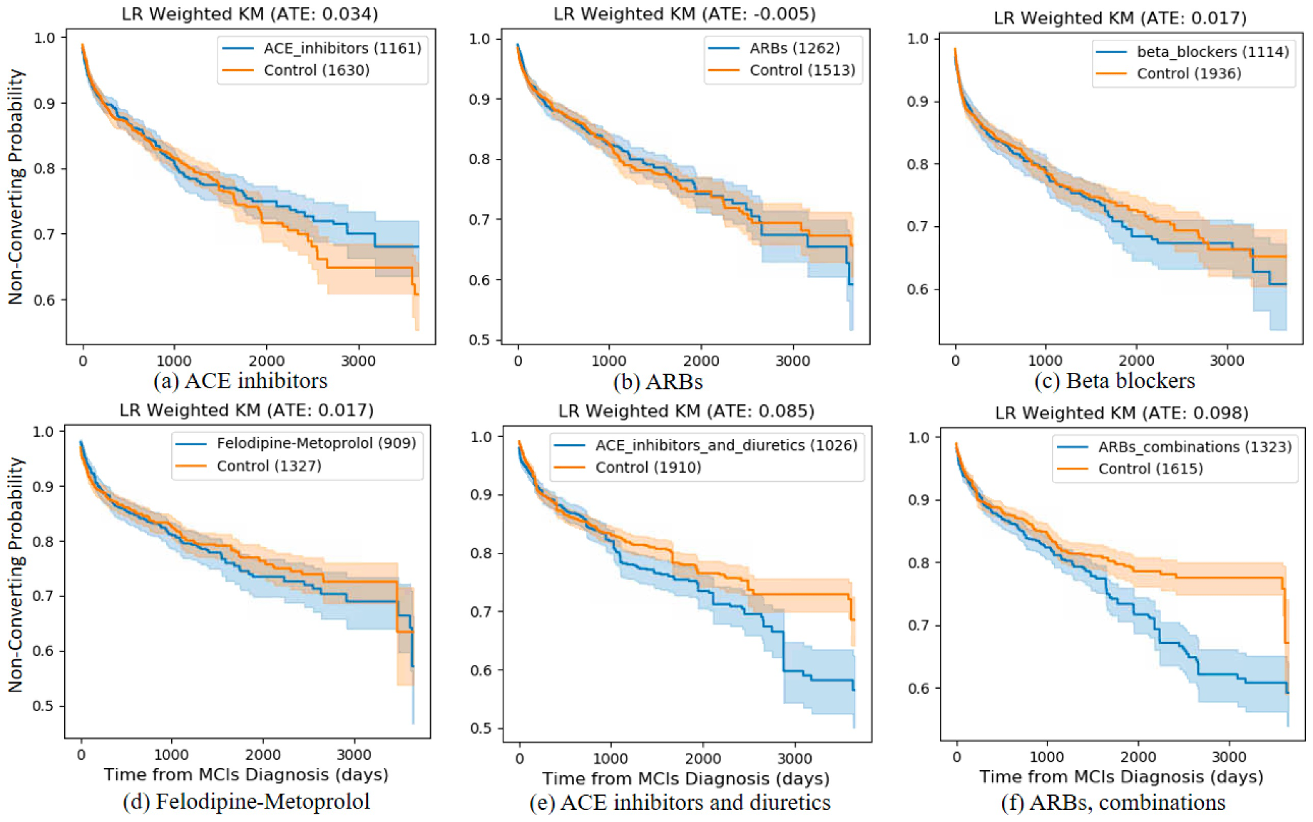

Figure S1. Weighted Kaplan-Meier Plots of antihypertensive. Illustration of the LR model for predicting treatment probability that is used to adjust confounding from data.

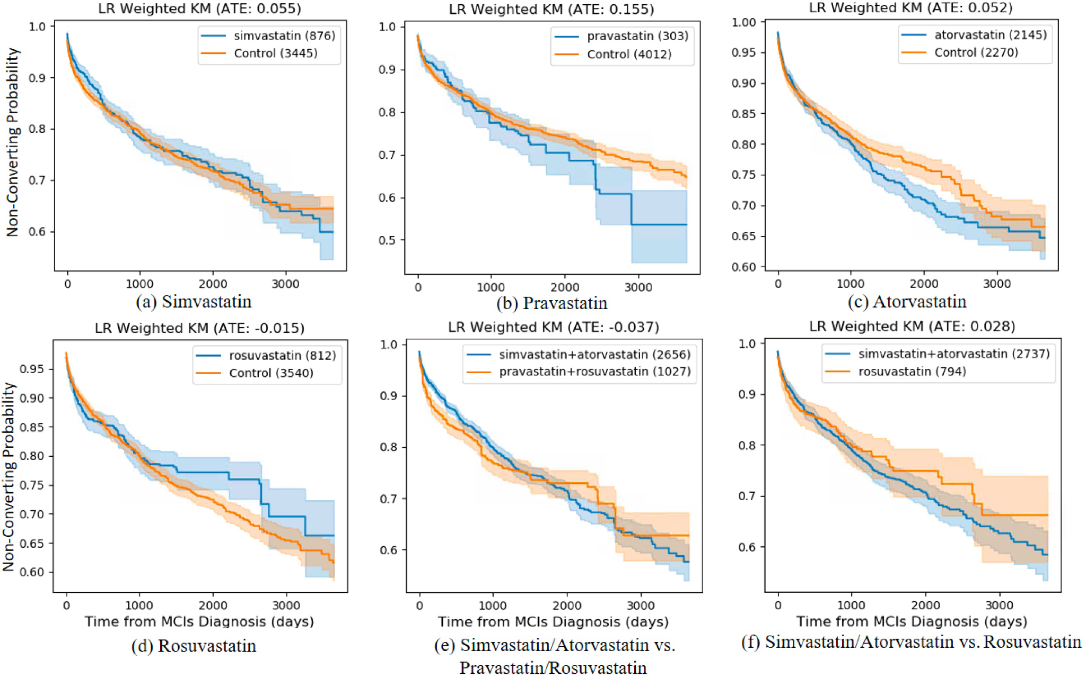

Figure S2. Weighted Kaplan-Meier Plots of Statins. Illustration of the LR model for predicting treatment probability that is used to adjust confounding from data.

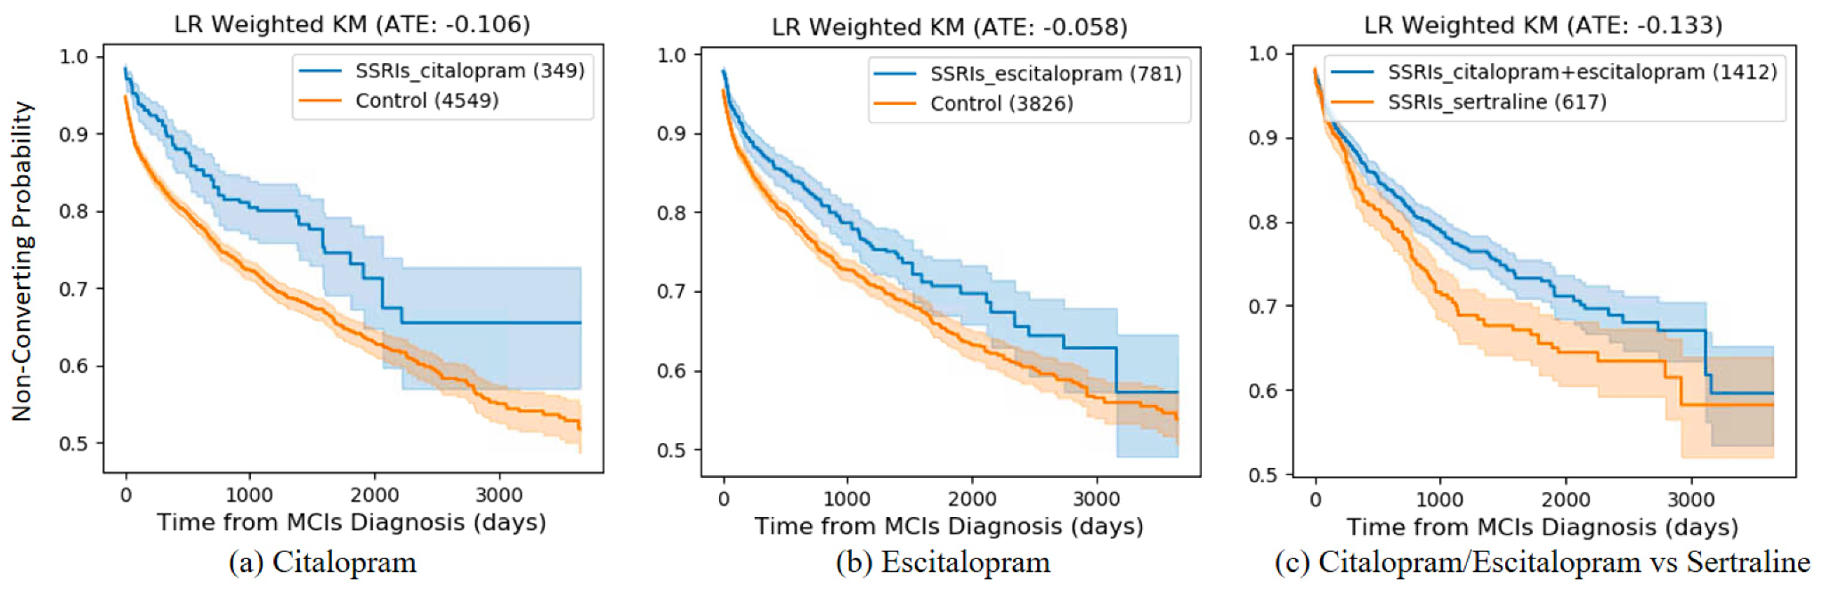

Figure S3. Weighted Kaplan-Meier Plots of SSRIs. Illustration of the LR model for predicting treatment probability that is used to adjust confounding from data.

