Noninvasive ventilation in patients with acute hypoxemic respiratory failure: a systematic review and meta-analysis of randomized controlled trials
Pantaree Aswanetmanee, MD, Chok Limsuwat, MD, Kittipong Maneechotesuwan, MD,
Phunsup Wongsurakiat, MD

Table S1 GRADE Summary of evidence
 |  |  |  |  |  | Summary of findings
Quality assessment |  |  |  |  |  | No. of patients |  | Effect | Strength
Tracheal intubation rate
No. of studies | Risk of bias | Inconsistency | Indirectness | Imprecision | Publication  bias | NIV | COT/HFNC | RRª (95% CI) |  | Low
Seventeen RCTs | Serious^{b} | Serious^{c} | Not serious | serious | Possible^{d} | 288/930 | 354/871 | 0.68 (0.52,0.89) |  | Low
Abbreviations: NIV, noninvasive ventilation; COT, conventional oxygen therapy; HFNC, high-flow nasal cannula; RR, risk ratio; CI, confidence interval. ªAll data based on random effect models. ^{b}No trials were blinded so all were deemed at high risk of bias. ^{c}Moderate to high heterogeneity; I² = 72.4%, P = 0.000. ^{d}Possible existence of publication bias.

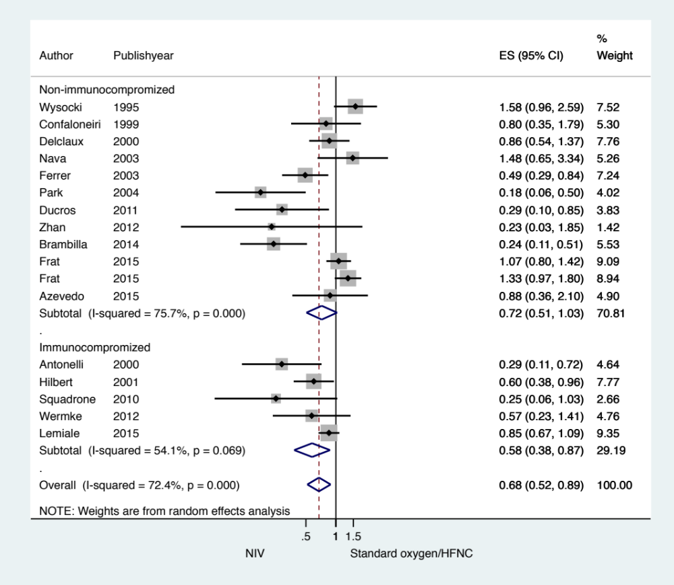

Figure S1 Subgroup analysis according to immune status (nonimmunocompromised or immunocompromised patients): intubation rate in acute hypoxemic respiratory failure patients randomized to noninvasive ventilation (NIV) versus conventional oxygen therapy/high-flow nasal cannula (HFNC). Boxes and horizontal lines represent point estimates and 95% confidence intervals, varying in size according to the weight in the analysis

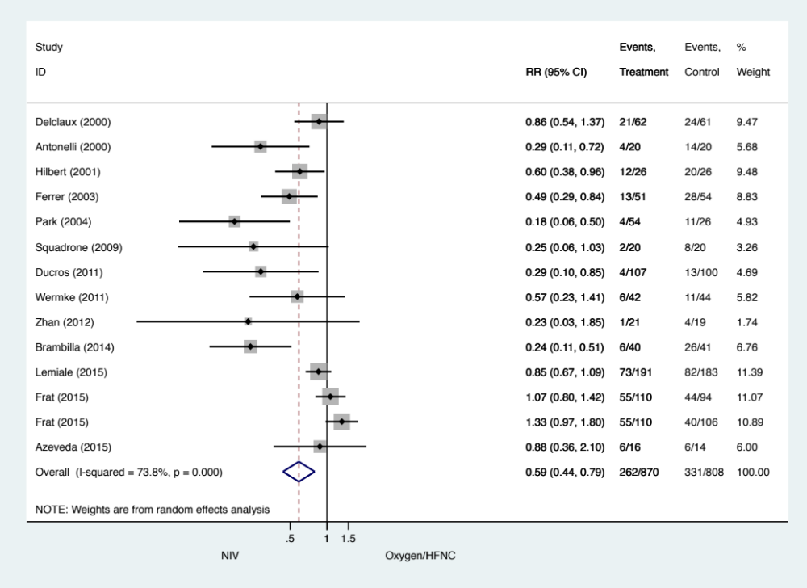

Figure S2 Sensitivity analysis performed by removing 3 RCTs of which including some hypercapnic respiratory failure population: intubation rate in acute hypoxemic respiratory failure patients randomized to noninvasive ventilation (NIV) versus conventional oxygen therapy/high-flow nasal cannula (HFNC). Boxes and horizontal lines represent point estimates and 95% confidence intervals, varying in size according to the weight in the analysis

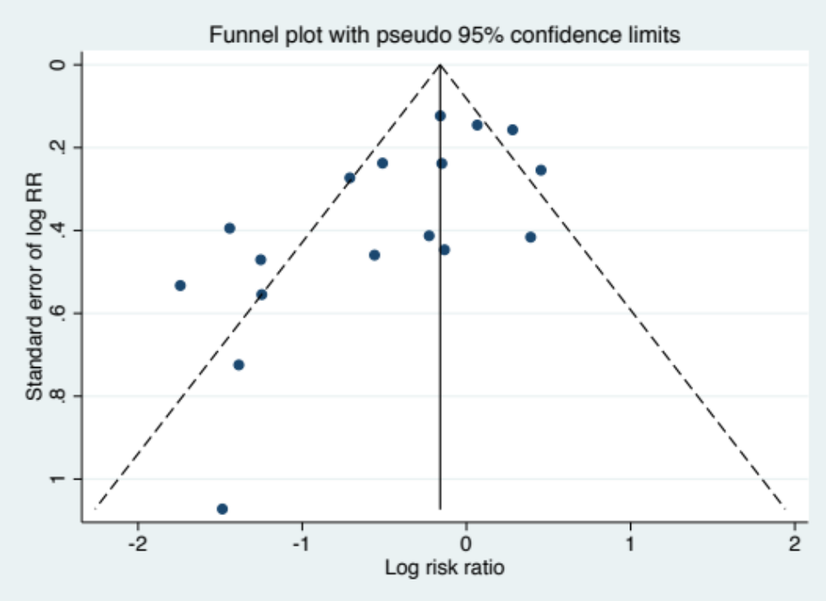
Egger’s test: P = 0.032

Figure S3 Funnel plots for tracheal intubation rate in comparison between NIV and conventional oxygen therapy/high-flow nasal cannula (HFNC) groups

