SUPPLEMENTAL SECTION
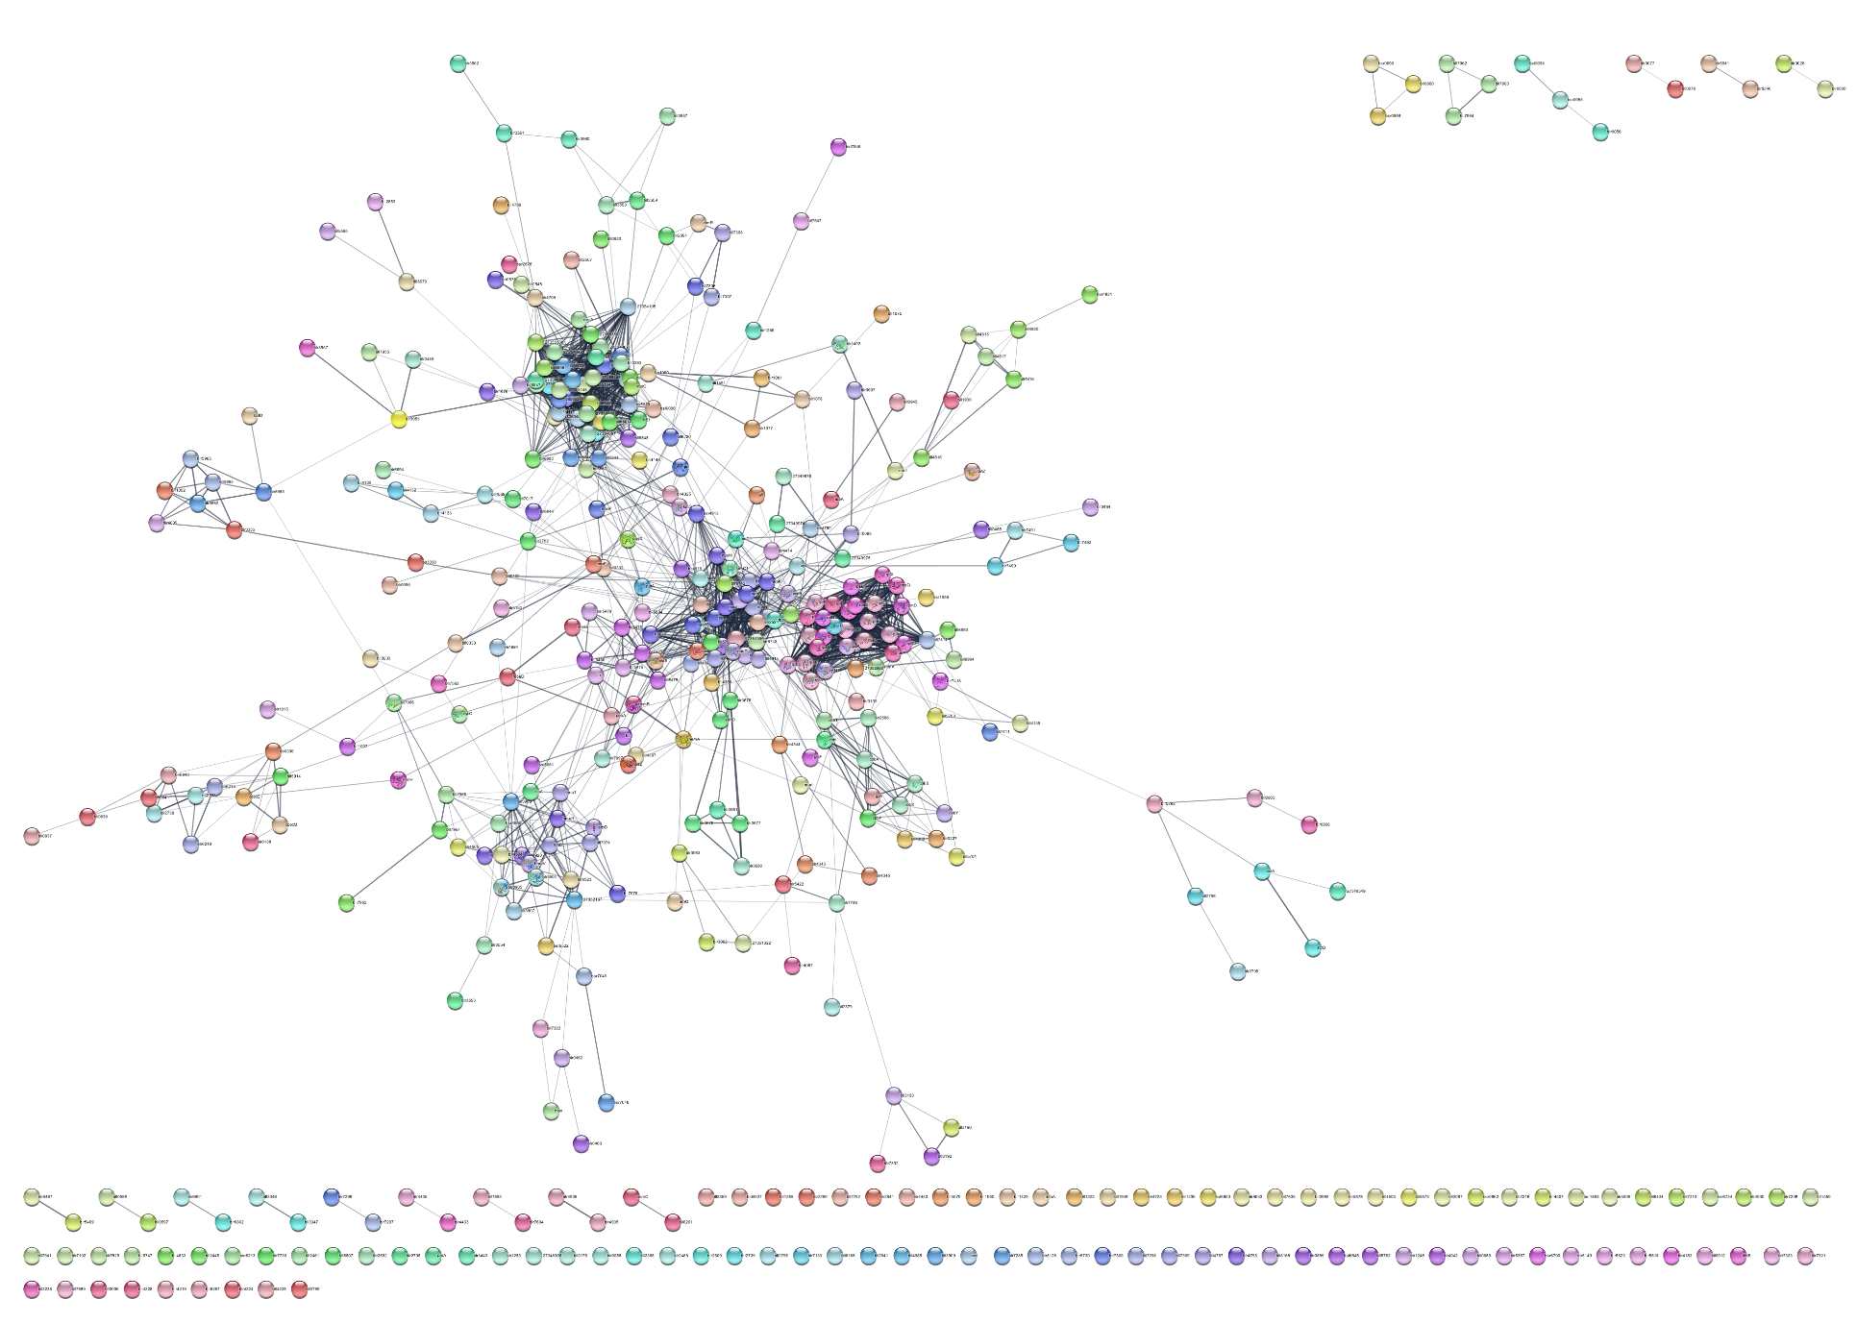 Figure S1. Compete protein–protein interacting network of the differentially expressed genes between Bradyrhizobium japonicum grown in low or high iron conditions. (a) Interacting nodes in the FadD, quorum sensing, and ABC transporters clusters. (b) Flagellar assembly network. (c) Ribosome interacting network. (d) Root nodulation interacting nodes.
(d)
(c)
(b)
(a)
.

(a)
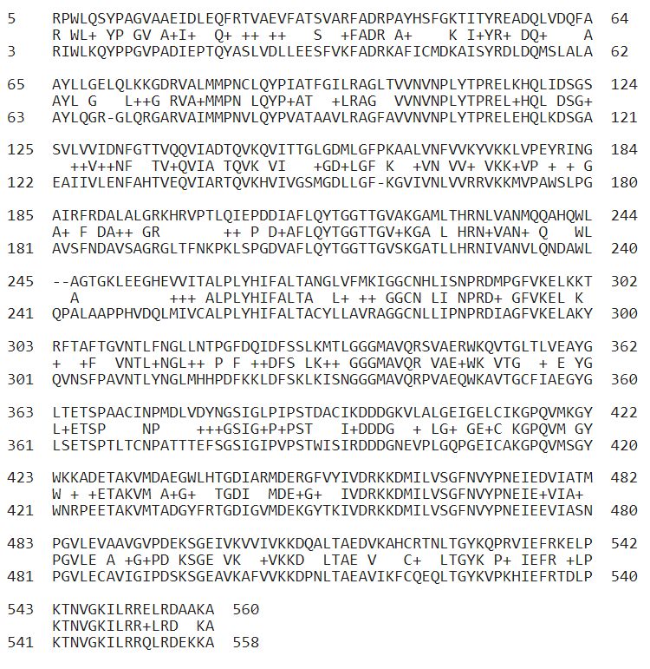

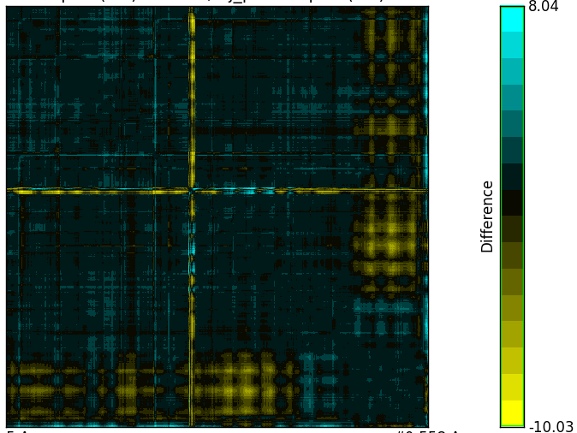
(b)
(c)

Figure S2. Comparative sequence and structure analyses between RpfB and FadD. (a) Alignment of the amino acid sequences of RpfB and FadD. The sequences were obtained from UniProt, and the sequence alignment was analyzed using the NCBI multiple sequence analysis user interfaces. RpfB, semi-transparent gold; FadD, semi-transparent blue. (b) AlphaFold predicted structures of RpfB (AF-Q8P9K5-F1) and FadD (AF-A0A0A3XRM6-F1) were compared using the UCSF Chimera. RpfB, red; FadD, cyan. (c) RRDistMap of RpfB and FadD.

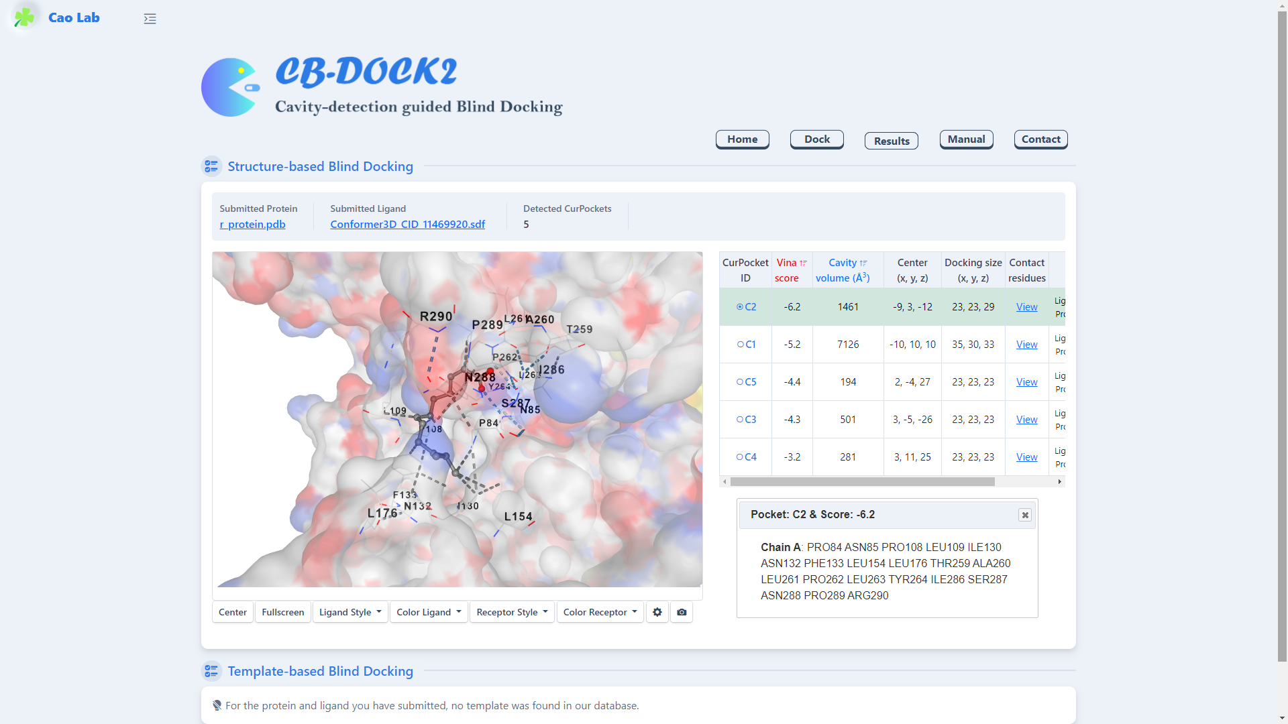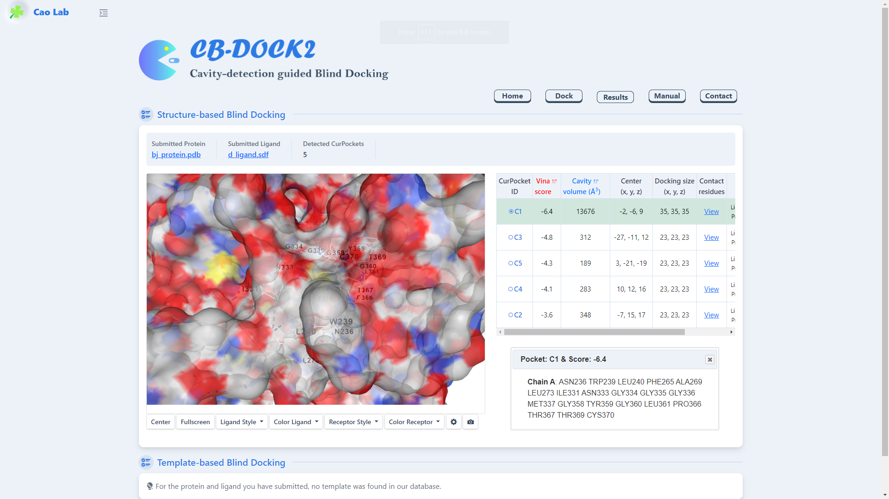
(b)
(a)
Figure S3. Contact residues identified by CB-Dock2 molecular docking. (a) RpfB–DSF and (b) FadD–DSF.

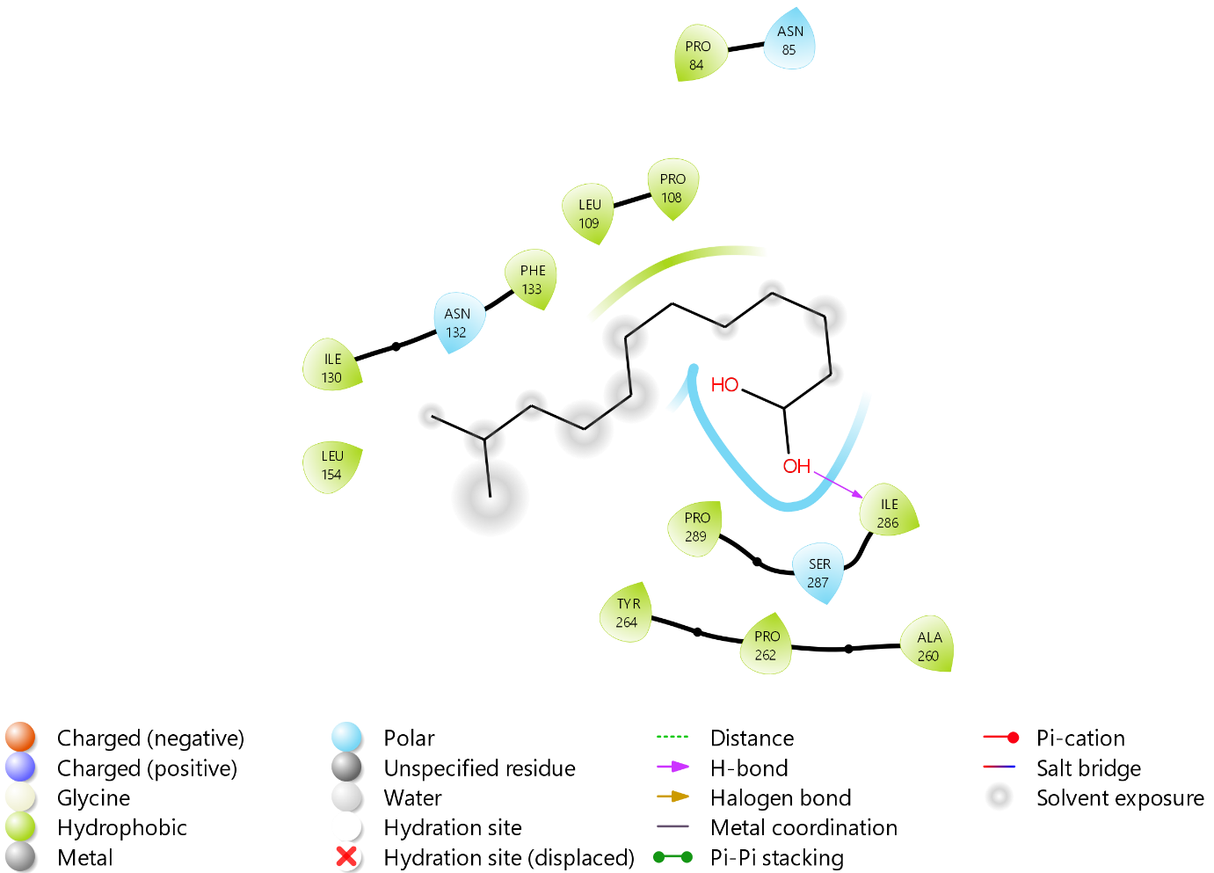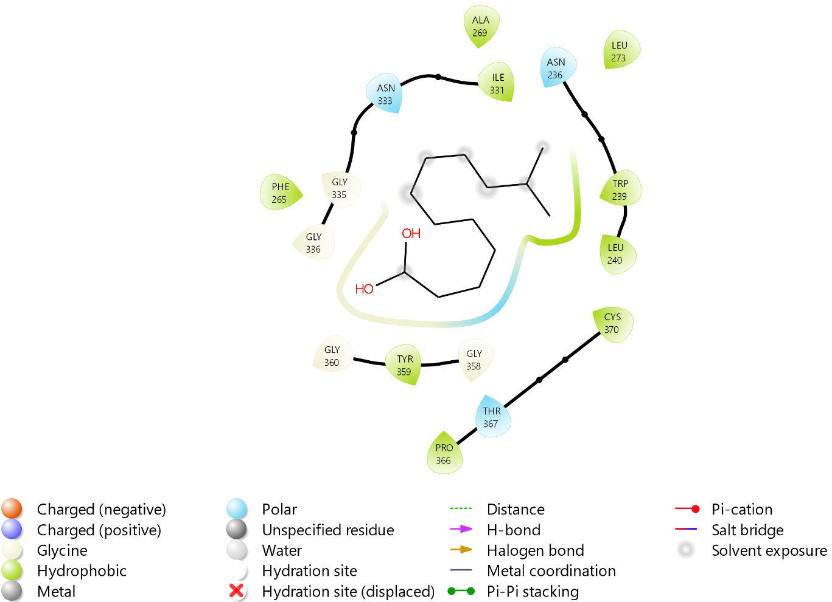
(b)
(a)
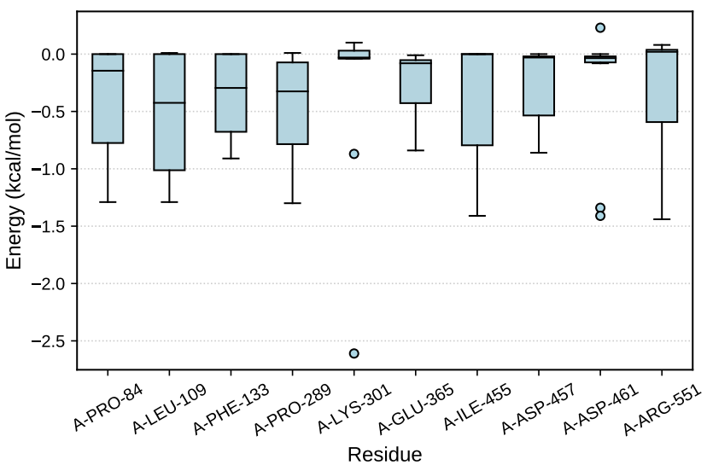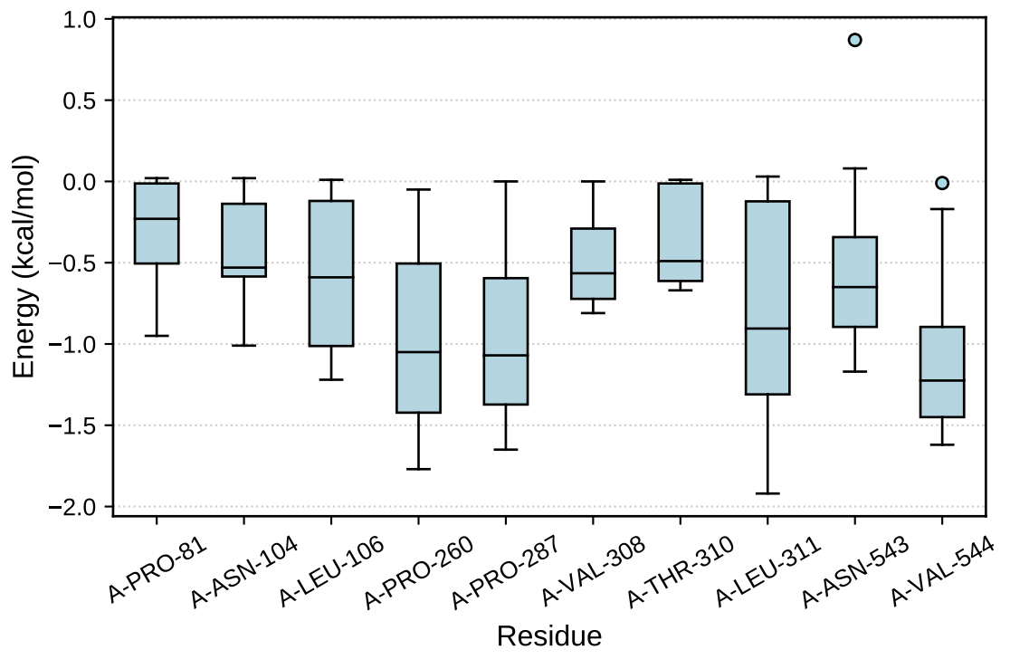
(e)
(c)
(d)
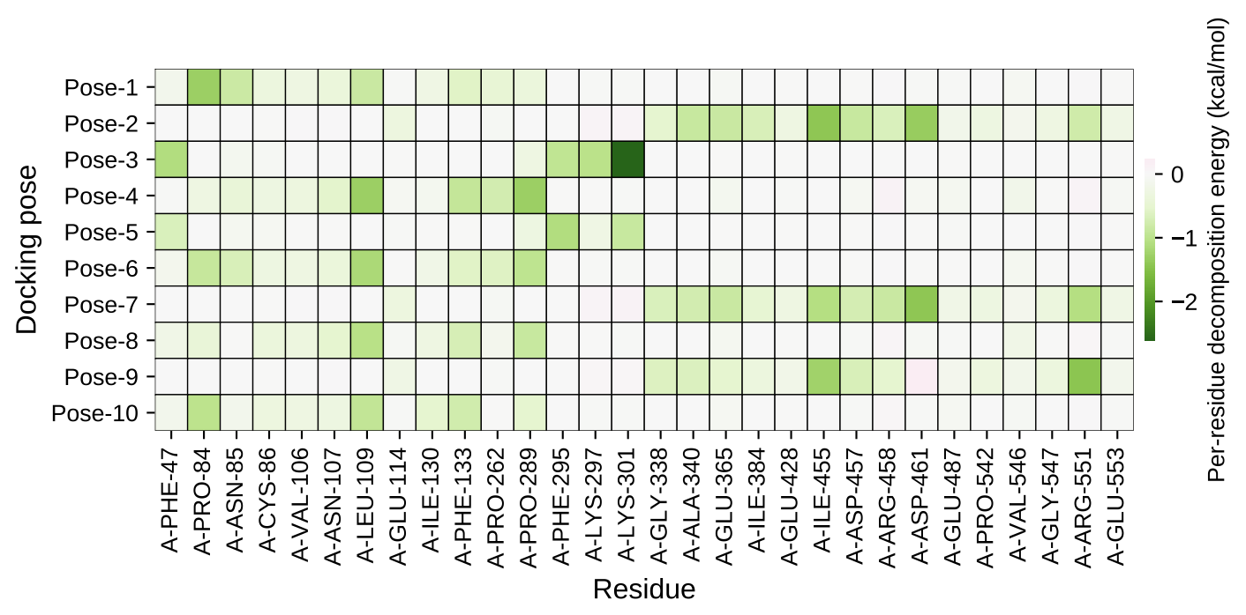
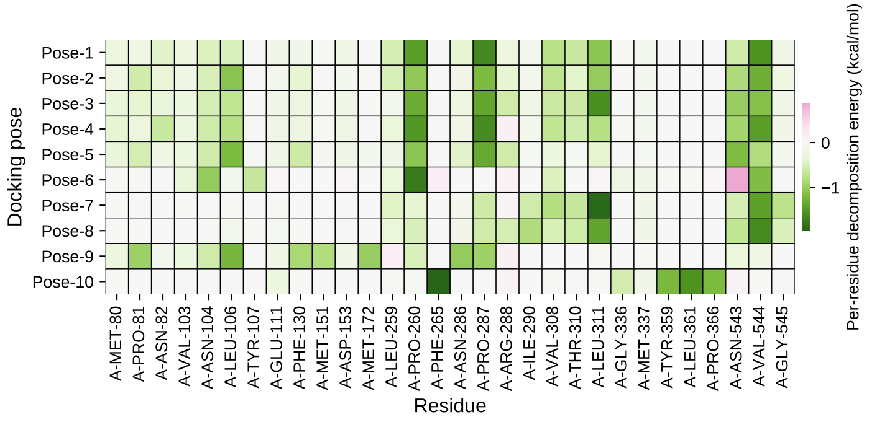
(f)
Figure S4. Molecular docking and rescoring. (a, b) Molecular interactions between DSF and RpfB of Xcc (a) and between DSF and FadD of Bradyrhizobium japonicum (b). (c, d) Binding energy per amino acid residue (MM-PBSA) of the top 10 potential hotspot residues between DSF and RpfB of Xcc (c) and between DSF and FadD of B. japonicum (d). (e, f) Heatmap of the top 30 residues of RpfB (e) and FadD–DSF (f).
Table S2. KEGG pathways of differentially expressed genes of Bradyrhizobium japonicum between low and high iron conditions.
KEGG Pathways | ID | Input number | Background number | Corrected P-Value
Flagellar assembly | bja02040 | 19 | 60 | 9.06e⁻¹⁷
Ribosome | bja03010 | 16 | 58 | 1.60e⁻¹³
Oxidative phosphorylation | bja00190 | 14 | 67 | 1.47e⁻¹⁰
Metabolic pathways | bja01100 | 38 | 1190 | 5.37e⁻⁰⁵
Carbon fixation in photosynthetic organisms | bja00710 | 5 | 29 | 0.0011
Sulfur relay system | bja04122 | 3 | 13 | 0.0114
Porphyrin and chlorophyll metabolism | bja00860 | 4 | 40 | 0.0244
Biosynthesis of secondary metabolites | bja01110 | 14 | 414 | 0.0244
Beta-Lactam resistance | bja01501 | 3 | 21 | 0.0252
Carbon metabolism | bja01200 | 8 | 176 | 0.0266
Microbial metabolism in diverse environments | bja01120 | 14 | 445 | 0.0324
Glyoxylate and dicarboxylate metabolism | bja00630 | 5 | 87 | 0.0432

Table S3. Genes and associated pathways of differentially expressed genes of Bradyrhizobium japonicum between low and high iron conditions.
KEGG Pathways | List of genes
Flagellar assembly | fla ,fliF ,flhA ,flgB ,fliQ ,fliP ,fliR ,flgC ,fliE ,flgA ,fliN ,flgF ,flgE ,flgD ,flgK ,flgI ,flgH ,fliG ,flgL
Ribosome | rpsF ,rplB ,rplX ,rplW ,rpsL ,rpsK ,rplP ,rplC ,rplN ,rpsS ,rpsQ ,rplF ,rplD ,rplE ,rpmC ,rpmD
Oxidative phosphorylation | coxA ,nouD ,nuoB ,nuoC ,coxE ,nuoA ,nuoF ,nuoG ,nuoJ ,nuoI ,nuoN ,sdhD ,nuoL ,nuoM
Metabolic pathways | dapE ,pgsA ,moaE ,cbbA ,acnA ,fadD ,birA ,cbbT ,cbbP ,cbbS ,lipA ,murI ,gph ,nrdE ,dhlB ,fumC ,rbcL ,leuC ,sdhD ,nosZ ,nouD ,coxE ,pyrG ,coxA ,hemB ,hemA ,nuoB ,nuoC ,nuoA ,nuoF ,nuoG ,nuoJ ,glcF ,nuoI ,nuoN ,ispA ,nuoL ,nuoM
Carbon fixation in photosynthetic organisms | cbbT ,cbbA ,cbbP ,cbbS ,rbcL
Sulfur relay system | moaE ,moaD ,mnmA
Porphyrin and chlorophyll metabolism | hemB ,bfr ,hemA ,coxE
Biosynthesis of secondary metabolites | ispA ,gph ,leuC ,hemB ,hemA ,cbbA ,fumC ,rbcL ,cbbT ,glcF ,acnA ,sdhD ,cbbS ,coxE
beta-Lactam resistance | acrB ,ampC ,acrA
Carbon metabolism | cbbA ,fumC ,cbbP ,rbcL ,cbbT ,acnA ,sdhD ,cbbS
Microbial metabolism in diverse environments | dapE ,dhlB ,hemB ,nosZ ,cbbA ,hupL ,fumC ,rbcL ,cbbT ,glcF ,acnA ,cbbP ,cbbS ,sdhD
Glyoxylate and dicarboxylate metabolism | glcF ,gph ,rbcL ,cbbS ,acnA

Table S4. Protein folding patterns and protein family domains shared by FadD of Bradyrhizobium japonicum and RpfB of Xanthomonas campestris pv. campestris.
Types | Accession | FadD | RpfB
Domain | IPR000873  AMP-binding enzyme - PF00501 | 30 – 463 | 31 – 465
Domain | IPR025110  AMP-binding_C - PF13193 | 472 – 546 | 474 – 548
Homologous  superfamily | IPR042099  G3DSA:3.40.50.12780 | 13 – 458 | 14 – 460
Homologous  superfamily | IPR045851  G3DSA:3.30.300.30 | 459 – 560 | 461 - 559
Conserved Site | IPR020845  AMP_BINDING - PS00455 | 209 – 220 | 213 – 224
Unintegrated | FC-FACS_FadD_like - cd05936  Putative AMP binding site  Acyl-activating enzyme (AAE) consensus motif  Putative CoA binding site  Putative active site | 25 – 553 | 27 – 555
Unintegrated | Acetyl-CoA synthetase-like - SSF56801 | 11 – 557 | 23 – 558
Protein sequence, UniProt ID: A0A0A3XRM6 (FadD), Q8P9K5 (RpfB)

