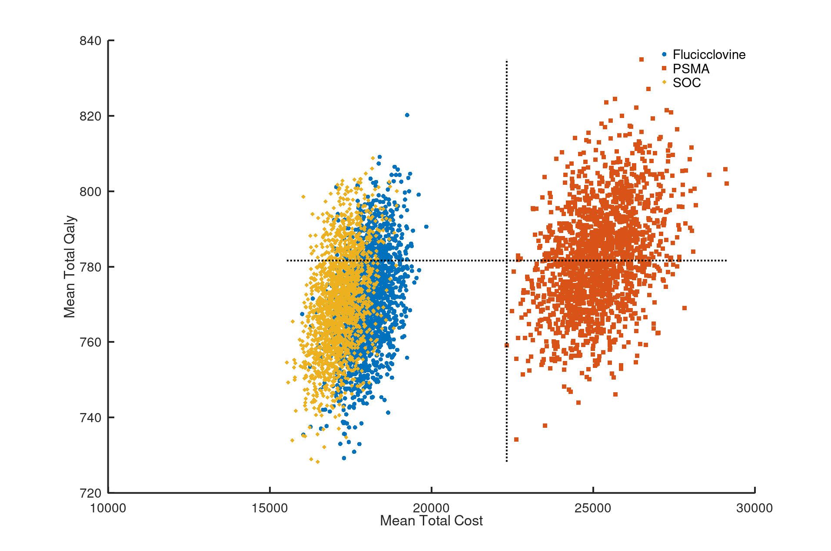

Supplemental Figure 1. Mean Total Cost and mean HRQoL for each iteration of the simulation demonstrated good precision.

